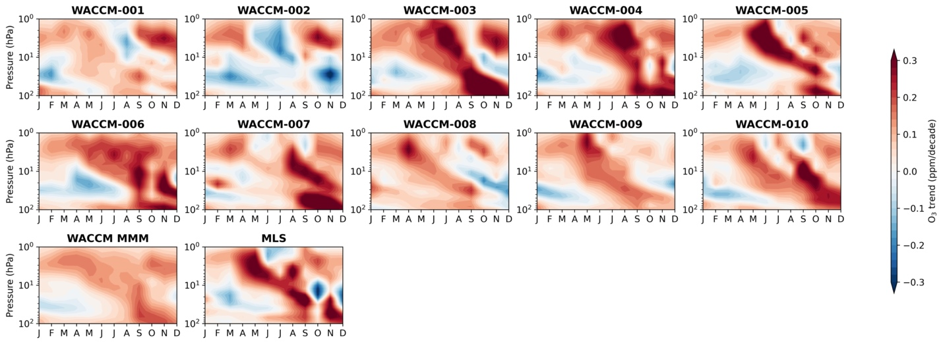
Extended Data Figure 1. Variability superimposed on external forcing. Ozone trends over 2005-2018 from individual WACCM realizations under the refC2 scenario. The multi-member-mean (MMM) and MLS ozone trends are shown in the bottom row.
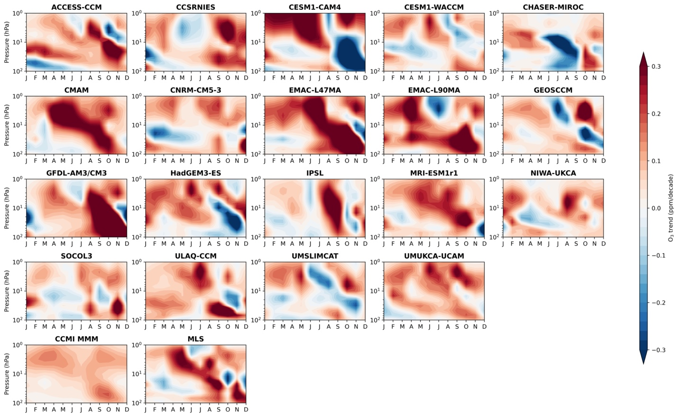
Extended Data Figure 2. Variability superimposed on external forcing. Similar to Extended Data Figure 1 but showing ozone trends over 2005-2018 in the individual models that participated in the CCMI-1.
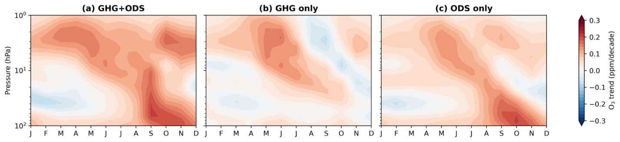
Extended Data Figure 3. Ozone trends due to different forcings. Ensemble-mean ozone trends (2005-2018) averaged over 10 WACCM members for each scenario. Results indicate the forced responses in ozone due to: (a) both evolving GHG and ODS (refC2), (b) only evolving GHG (fODS), (c) only evolving ODS (fGHG). A detailed description of each scenario is given in the Methods section.
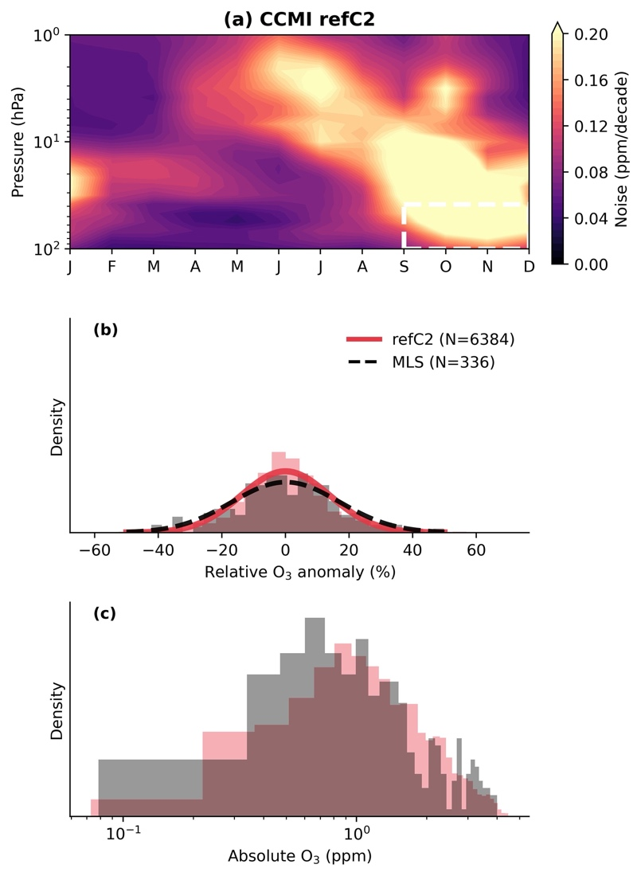
Extended Data Figure 4. Ozone variability modulated by external forcing. Similar to Figure 2 but for the CCMI models. Note that the spread in ozone trends in CCMI arises not only from internal variability, but also from inter-model differences and errors (discussed in detail in the main text and in the Methods section). This convolving of internal variability with model differences and errors contributes to the larger noise in panel a compared to the noise derived from the WACCM single-model refC2 ensemble in Figure 2b.
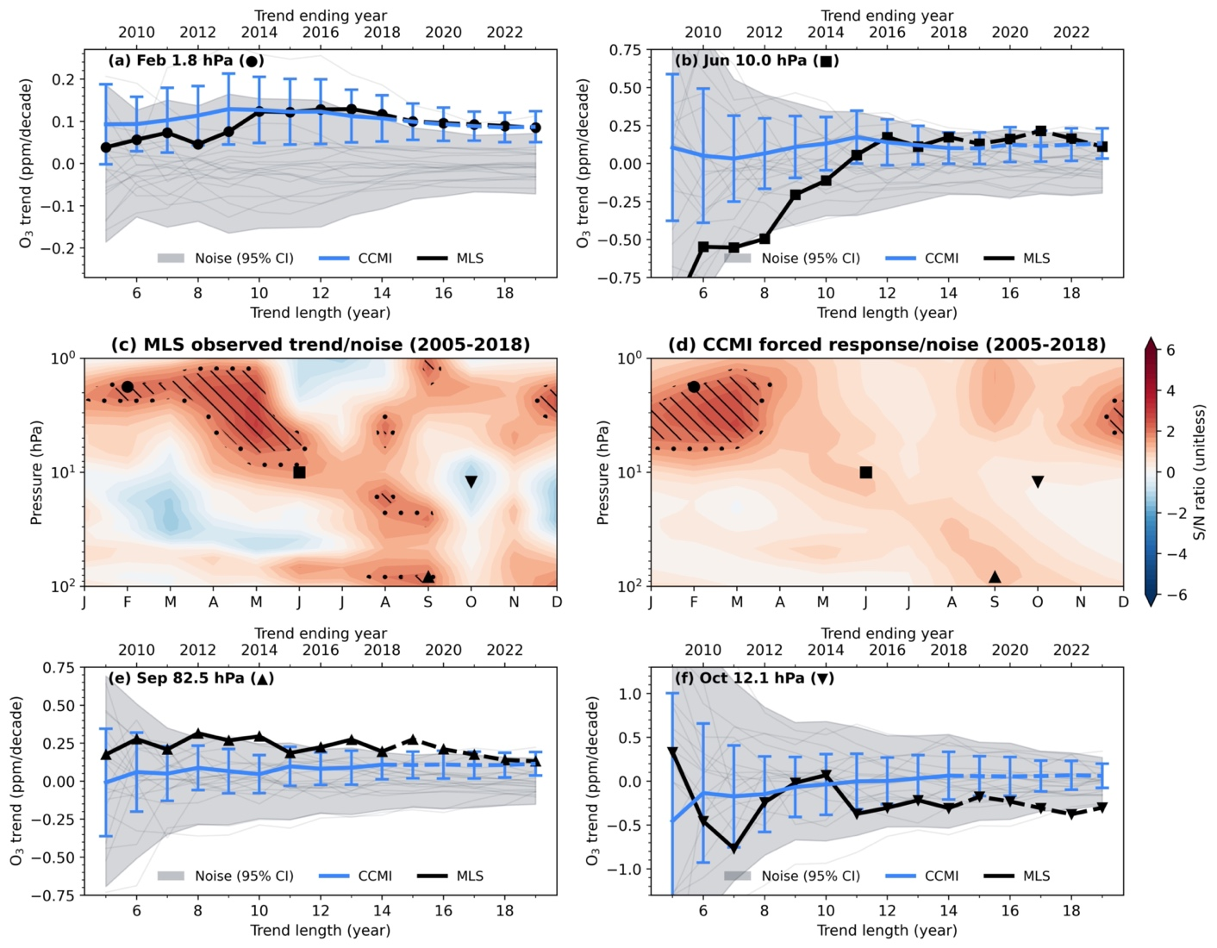
Extended Data Figure 5. The local signal-to-noise characteristics of ozone recovery. Similar to Figure 3 but shows the CCMI models.
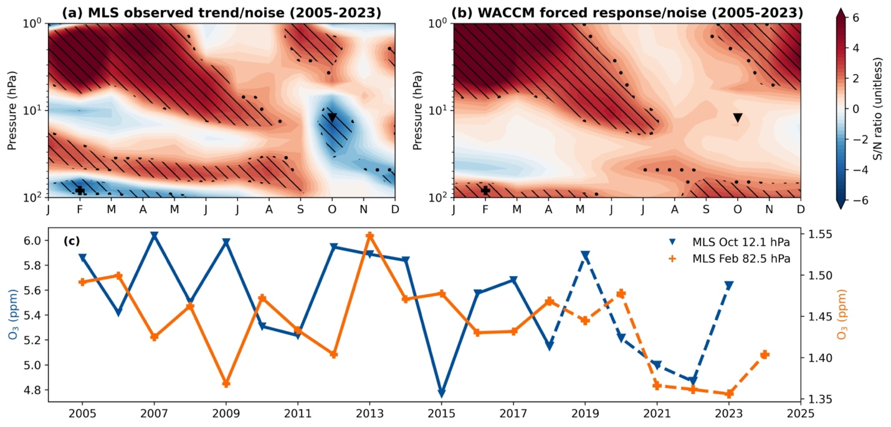
Extended Data Figure 6. The local signal-to-noise pattern of ozone recovery. Similar to Figure 3 but the signal and noise are based on ozone trends over 2005-2023 (rather than over 2005-2018). There is a significant decrease in MLS ozone in October and November in the middle stratosphere, and in January through May in the lowermost stratosphere. This raises the question of whether these two features may be linked. The bottom panel shows the timeseries of ozone mixing ratios from MLS in October at 12.1 hPa (blue) and in February at 82.5 hPa (orange). The decrease in February at 82.5 hPa is mainly due to continued low ozone after 2021 (panel c), which lags the behavior in October by about a season, suggesting that they may be linked.
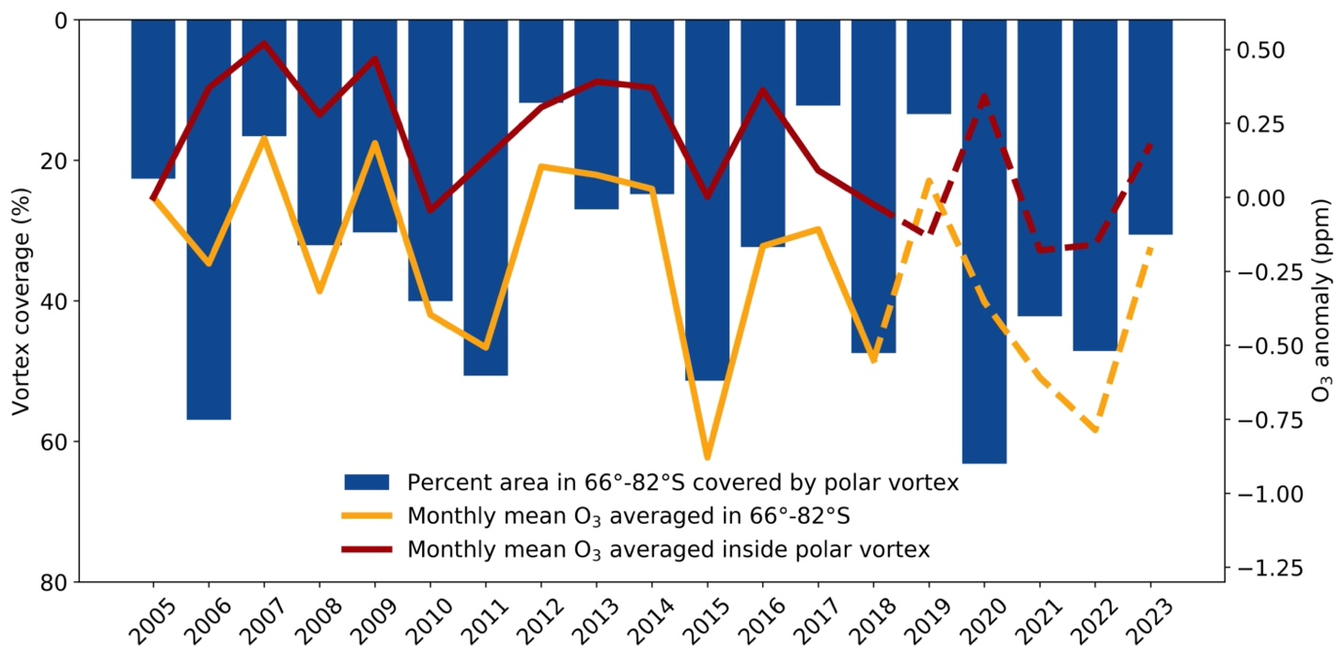
Extended Data Figure 7. Ozone variability associated with polar vortex variation from MLS. The vertical blue bars show the time series of the percent of the cumulative area over 66°-82°S covered by polar vortex in October at 850 K (~12 hPa). The yellow and red lines show the timeseries of ozone at the same theta level averaged over 66°-82°S latitude and averaged inside the polar vortex, respectively (normalized to the 2005 value).
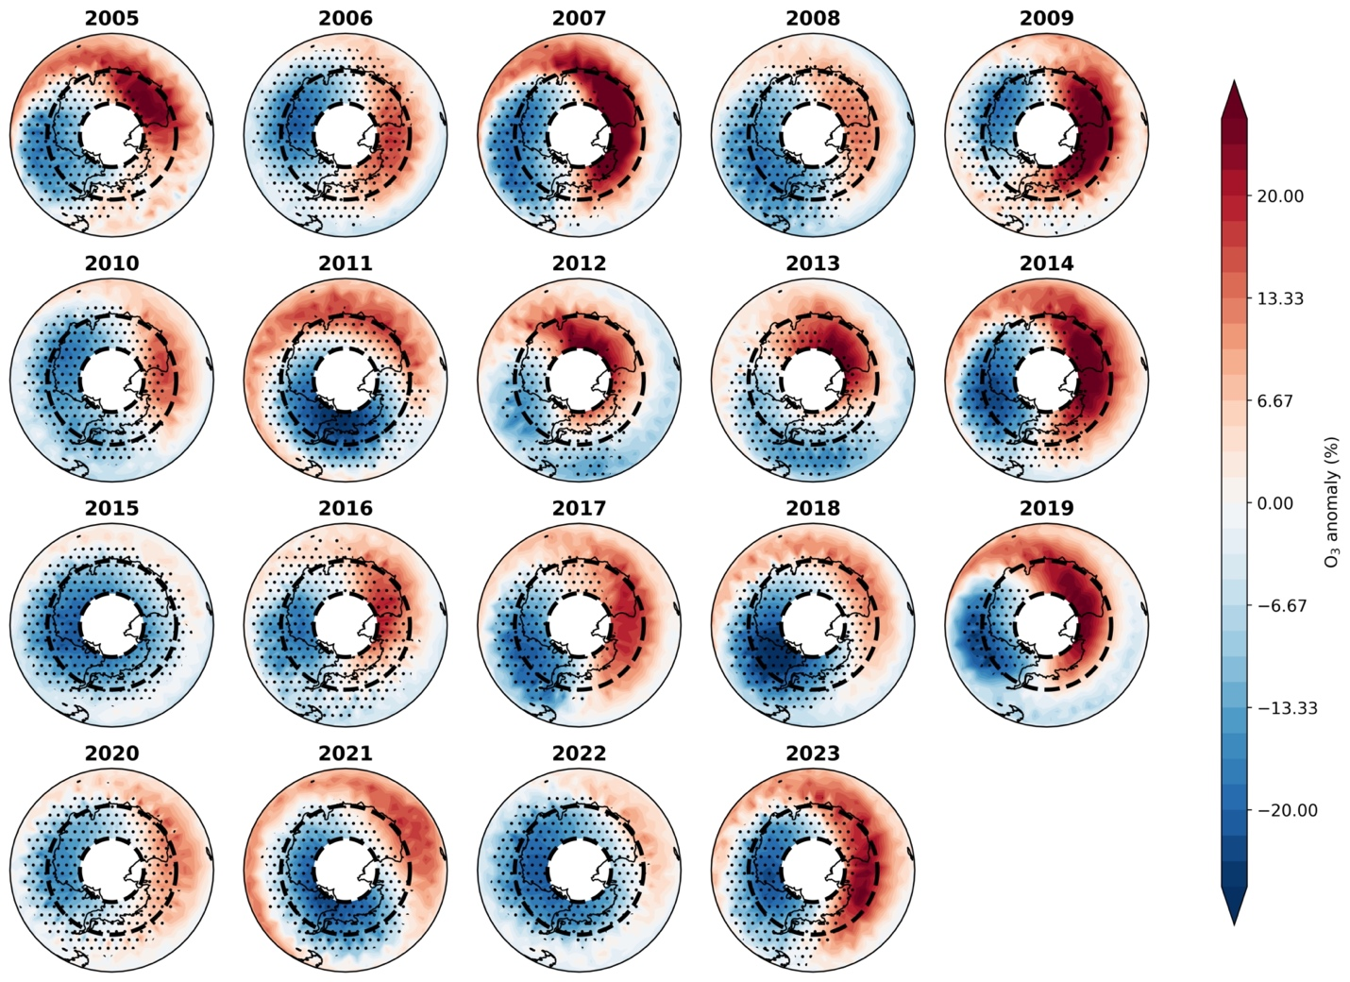
Extended Data Figure 8. Map of MLS ozone anomalies and polar vortex in October at 850 K (~12 hPa). The color shadings indicate the ozone anomaly relative to the zonal mean in 2005-2018. The location of the polar vortex can vary considerably over time; therefore, the dotted markers indicate that the polar vortex has occupied this grid box for more than 10% of the time in that month. Black dashed lines encompass the area between latitudes in 66°-82°S.
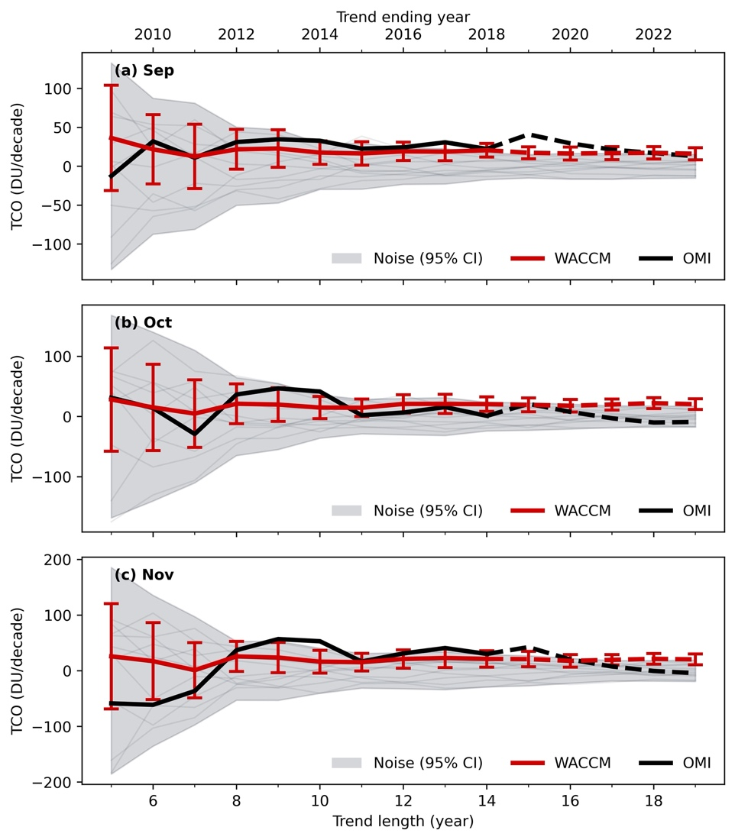
Extended Data Figure 9. Time of emergence of ozone recovery in springtime total column. Similar to the top and bottom panels in Figure 3, except the trends are the TCO from WACCM and OMI.

