Supplement Figure information
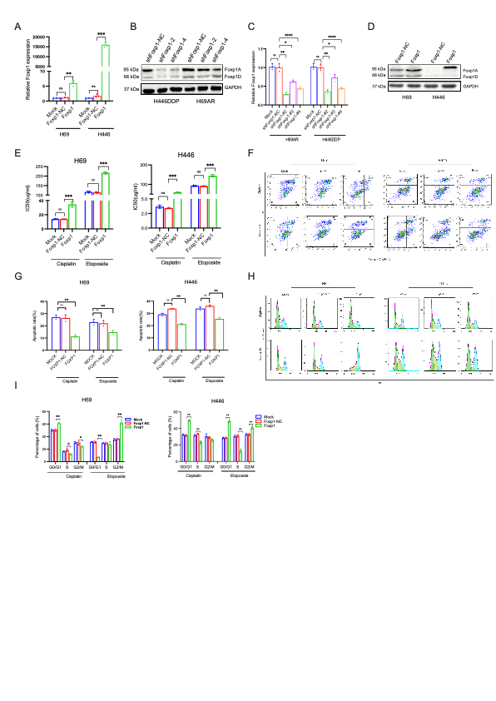
FigureS1: FOXP1 induces chemoresistance, related to Figure1
A-D. qPCR and Western blot weredetected interference with the efficiency of FOXP1in H69AR and H446DDP, and overexpression of FOXP1 in H446 and H69 cells, respectively.
- CCK8 was used to detect the change of IC50 after FOXP1 overexpression in H446 and H69 cells, respectively.
- Flow cytometry was used to detect the effect on apoptosis after knocking down FOXP1 in H69AR and H446DDP
- The difference of apoptosis between each group was analyzed (n=3)
- Flow cytometry was used to detect the effect on cell cycle after overexpression FOXP1 in H69 and H446
- The difference of cell cycle between each group was analyzed (n=3)

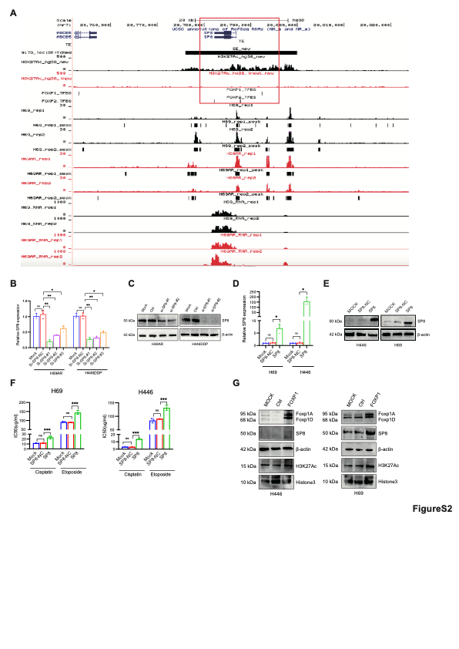
FigureS2: FOXP1 binds to the super-enhancer that target SP8, related to Figure2
- Screen the super-enhancer recruiting FOXP1.
B-E. qPCR and Western blot weredetected interference with the efficiency of SP8 in H69AR and H446DDP, and overexpression of SP8 in H446 and H69 cells, respectively.
F. CCK8 was used to detect the change of IC50 after SP8 overexpression in H446 and H69 cells, respectively.
G. Western blot was detected after overexpression of SP8 in H446 and H69 cells, respectively.

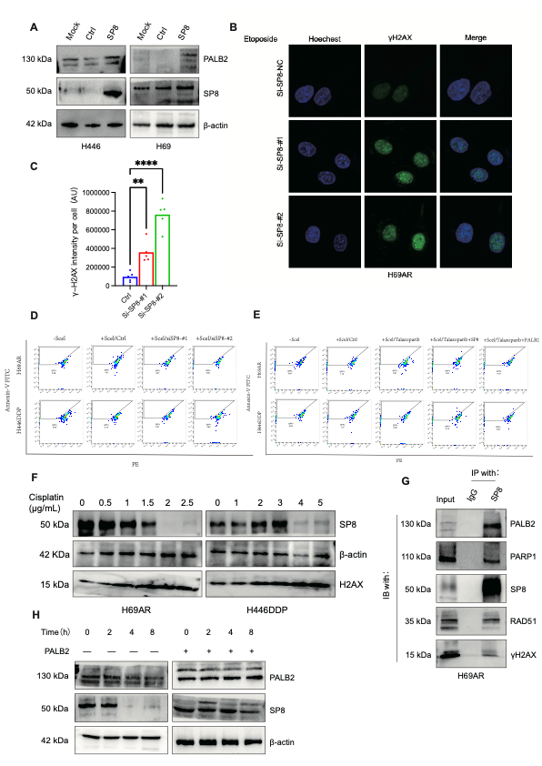
FigureS3: SP8 promotes the chemoresistance by homologous recombination pathway, related to Figure3
- After SP8 overexpressed in H446 and H69 cells, respectively, western blot was used to detect the protein expression level of PALB2;
B,C. H69AR was exposed to cisplatin and etoposide at IC50 value, after interfering with SP8 expression, and the change of intracellular γH2AX density was observed by immunofluorescence.
- H69AR and H446DDP were exposed to cisplatin at IC50 values and a representative flow cytometry image of homologous recombinant repair efficiency was observed by transfer to I-Scel and DR-report plasmids by flow cytometry
- H69AR and H446DDP were exposed to cisplatin at IC50 value, and the effects of addition of PARP inhibitors and overexpression of SP8 and PALB2 after addition of PARP inhibitors on homologous recombinant repair efficiency were observed by transfer to I-Scel and DR-report plasmids by flow cytometry
- Westernblot was used to detect protein expression levels of SP8 when cells exposed to different concertration of cisplatin.
- Co-immunoprecipitation was used to detect protein SP8 in the complex with PALB2,PARP1, RAD51, and γH2AX.
- Westernblot was used to detect protein expression levels of SP8 in the NC group and the overexpression of PALB2 after exposing H69AR to 10um CHX for different time periods

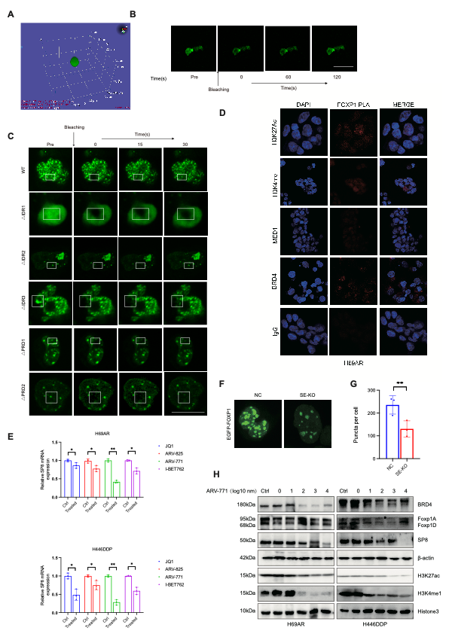
FigureS4: FOXP1 undergoes phase-separation in SCLC, related to Figure4
- 3D Z-stack scanning of droplet images. Rendered 3D shapes of a punctum with panels showing the Y axes.
- Representative images of FRAP of the droplets, Scale bar, 100 μm.
- Representative images of the FRAP analysis of different mutant’s EGFP-FOXP1.Scale bar, 10 μm.
- Proximity ligation assay was detected to confirm the FOXP1 combined with other transcription proteins. Scale bar, 10 μm.

- Change of mRNA of SP8 in H69AR and H446DDP of four different BRD4 inhibitors at 1μM/μL.
- Representative images of the EGFP-FOXP1 between H69AR WT and SP8-SE knock-out.
- Quantitation of puncta of the EGFP-FOXP1 between H69AR WT and SP8-SE knock-out.
- The protein levels of PALB2, RAD51 and H2X were measured by westernblot after H69AR and H446DDP were exposed to different concentrations of ARV-771 for 12 h

FigureS5: FOXP1 phase-separation responds to the chemotherapy, related to Figure5
- Western blot was performed to examine different mutant’s plasmids by protein expression in HEK293T.
- The immunofluorescence results of EGFP-FOXP1 exposed to different concentrations of Etoposide.
- FRAP analysis curve of different mutant’s EGFP-FOXP1.
- The immunofluorescence results of FOXP1 and BRD4 exposed to different BRD4 inhibitors at 1μM/μL.
- Proximity ligation assay was detected to confirm the FOXP1 combined with other transcription proteins in cisplatin or ARV-771. Scale bar, 10 μm.
- H69AR and H446DDP were inhibited in concentration curves of four different BRD4 inhibitors and PARP inhibitors, the X-axis is 10 to the power of the exponent and H69AR and H446DDP were inhibited in concentration curves of four different PARP inhibitors, the X-axis is 10 to the power of the exponent
- After H446DDP was exposed to the gradient combination of Talazoparib and ARV-771, cell activity was measured by CCK8 to calculate cell survival rate and heat map was drawn.

