Effects of Maturation Stage on Physical Fitness in Youth Male Team Sports Players After Plyometric Training: A Systematic Review and Meta-Analysis

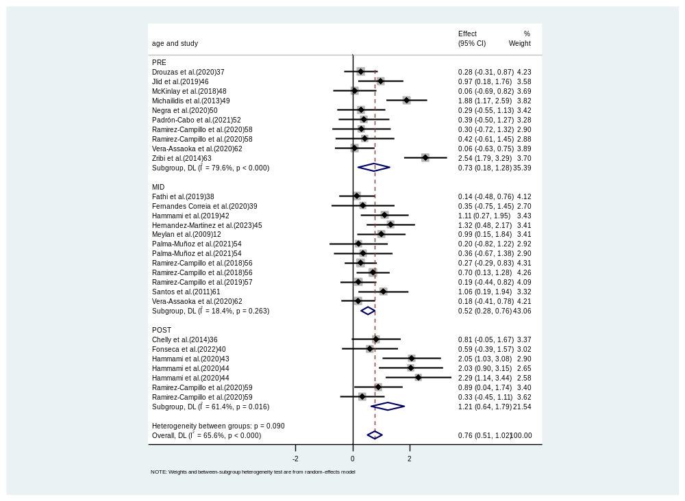
Supplementary Fig. S1.Compared to the control group, the forest plot for changes in countermovement jump height in youth male team sports players participating in plyometric training (PT). The values shown are effect sizes (Hedges's g) with 95% confidence intervals (CI).

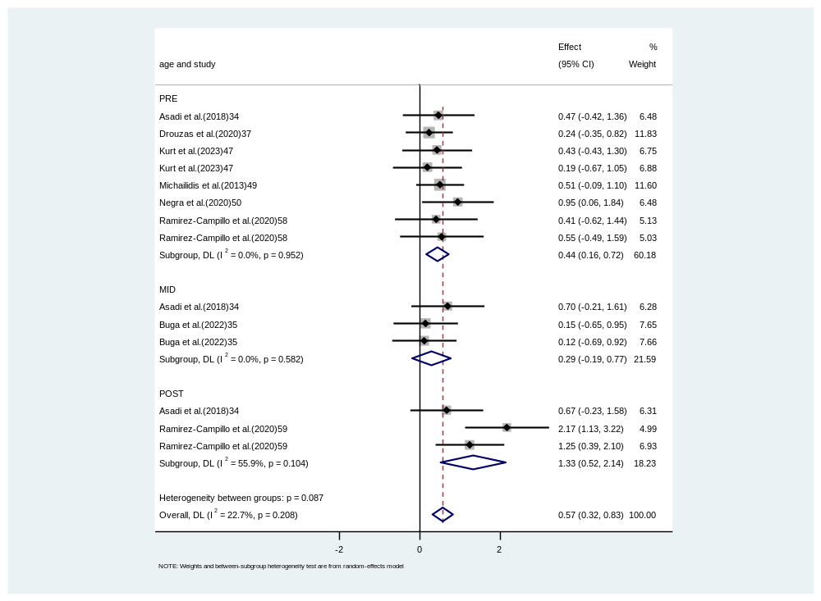

Supplementary Fig. S2.Compared to the control group, the forest plot for changes in Standing long jump distance in youth male team sports players participating in plyometric training (PT). The values shown are effect sizes (Hedges's g) with 95% confidence intervals (CI).

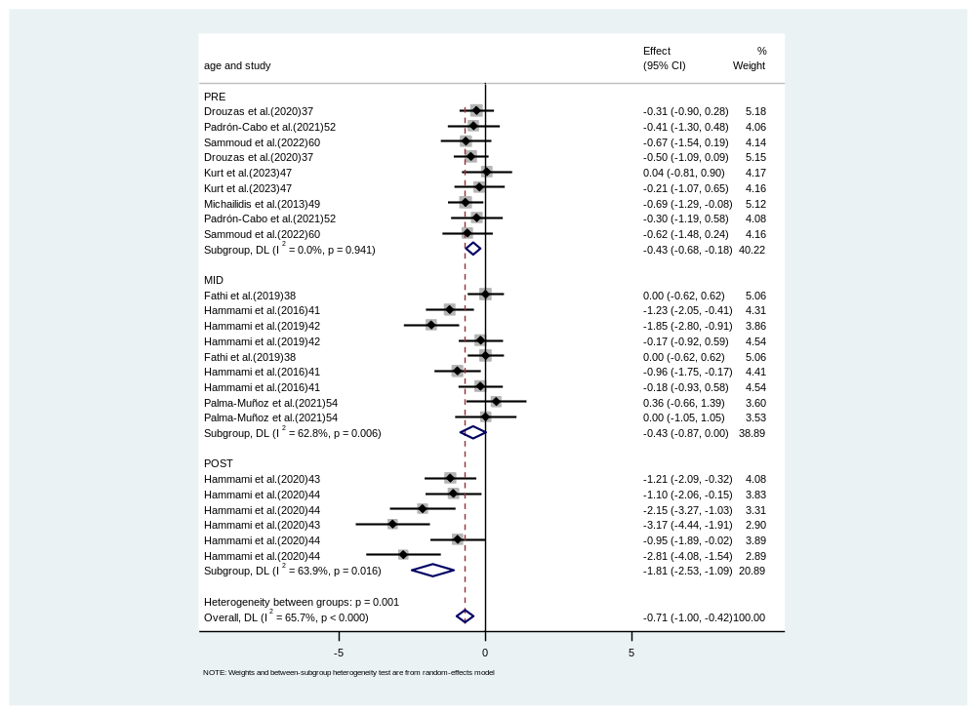
Supplementary Fig. S3.Compared to the control group, the forest plot for changes in ≤10-m linear sprint time in youth male team sports players participating in plyometric training (PT). The values shown are effect sizes (Hedges's g) with 95% confidence intervals (CI).

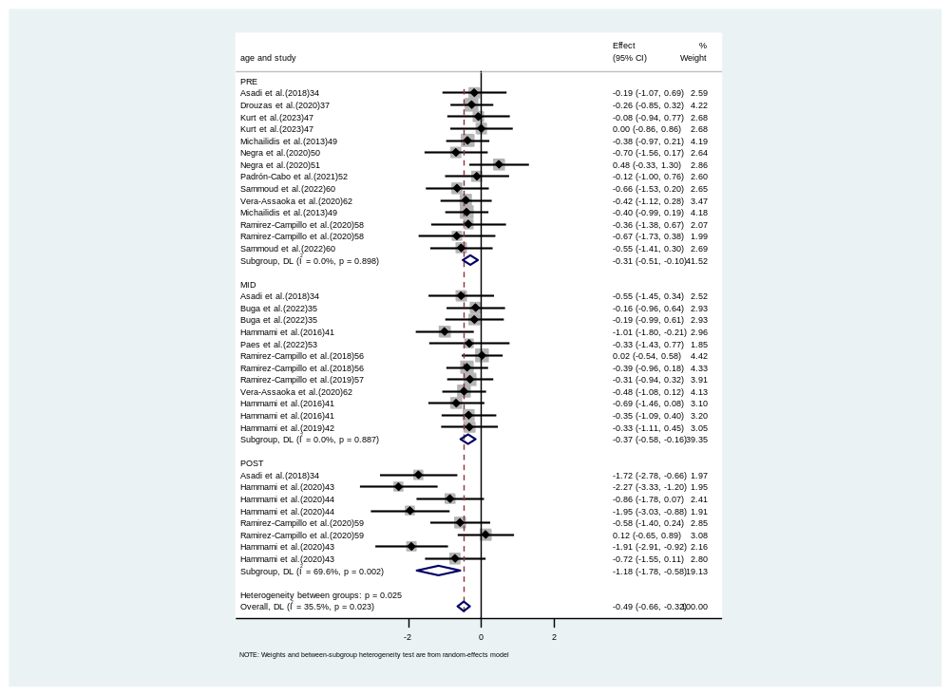
Supplementary Fig. S4.Compared to the control group, the forest plot for changes in ＞10-m linear sprint time in youth male team sports players participating in plyometric training (PT). The values shown are effect sizes (Hedges's g) with 95% confidence intervals (CI).

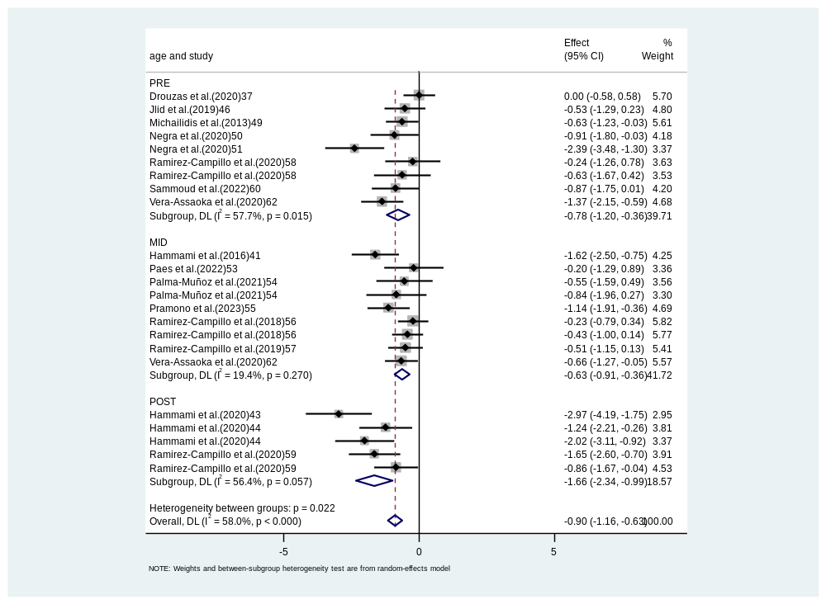
Supplementary Fig. S5.Compared to the control group, the forest plot for changes in change-of-direction time in youth male team sports players participating in plyometric training (PT). The values shown are effect sizes (Hedges's g) with 95% confidence intervals (CI).

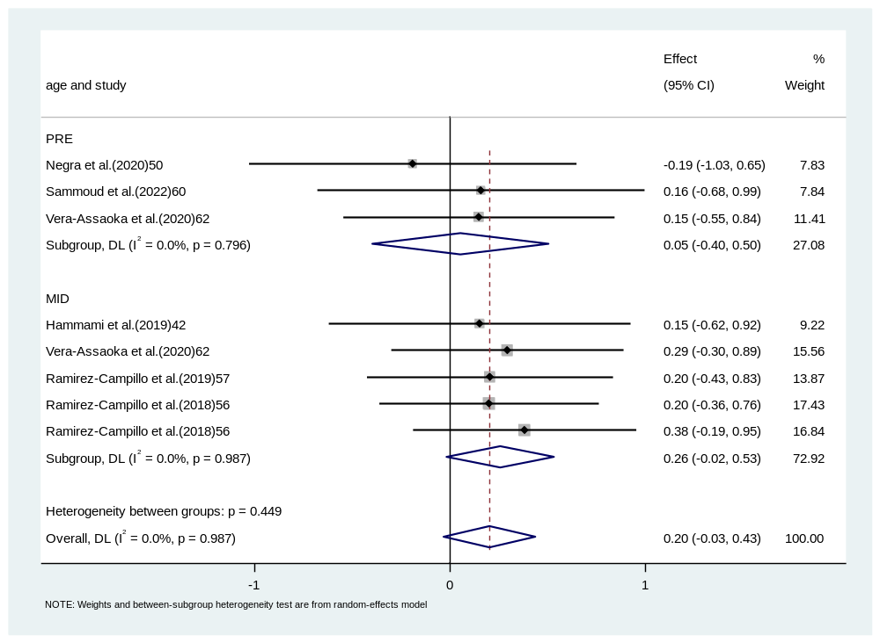
Supplementary Fig. S6.Compared to the control group, the forest plot for changes in maximal strength in youth male team sports players participating in plyometric training (PT). The values shown are effect sizes (Hedges's g) with 95% confidence intervals (CI).

