EXTENDED DATA
Extended Data Fig 1. Weighted gene correlation network analysis reveals Aox expression corrects aberrant TCox10^{-/-} gene expression. (A) Volcano plots demonstrating differential gene expression of TCox10^{-/-}, AOX, and TCox10^{-/-}/AOX T cells against WT T cells, as well as TCox10^{-/-}/AOX against TCox10^{-/-}. (B) Cluster dendrogram of weighted gene correlation network analysis (WGCNA) showing distribution of genes into indicated modules. (C) Heatmap showing the correlation of eigengene intercepts across samples in the detected modules. (D) Heatmap of gene expression from the selected modules in (C). Data represents an RNAseq experiment; n = 3-4.

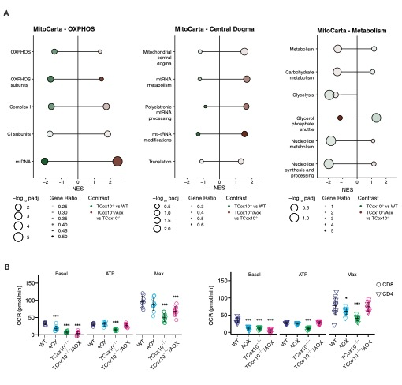Extended Data Fig 2. Aox expression improves OXPHOS and mtRNA gene expression and mitochondrial function. (A) Lollipop plots of gene set enrichment analysis (GSEA) of MitoCarta pathways, separated between OXPHOS, central dogma, and metabolism categories. Point size reflects -log10 B-H adjusted p value, point opacity reflects ratio of enriched genes to genes in the set. Color indicates TCox10^{-/-} vs WT or TCox10^{-/-}/AOX vs TCox10^{-/-} comparisons. Pathways that with padj < 0.25 in either or both comparisons are shown. (B) Quantification of oxidative consumption rate (OCR) following MitoStress Test, including basal consumption rate, ATP consumption rate, and max consumption rate. ATP rate is calculated following the addition of oligomycin, max consumption rate is calculated following the addition of FCCP. Left, CD8⁺, Right, CD4⁺.

Data reflect an RNAseq experiment, n = 3-5 mice, or Seahorse experiment, n = 2 mice. * p < 0.05, ** p < 0.01, *** p < 0.001 by one-way ANOVA and post-hoc Dunnett test. Specific p values (left to right) are as follows. (C) CD8⁺, F(3,39) = 77.81, p < 2x10-16, Dunnett p = 3.3x10⁻⁸, p < 2x10⁻¹⁶, p < 2x10⁻¹⁶, F(3,39) = 37.9, p = 1.22x10⁻¹¹, Dunnett p = 3.1x10⁻¹⁰, F(3,39) = 21.54, p = 2.16x10⁻⁸, Dunnett p = 8.2x10⁻⁸, p = 0.00053; CD4⁺, F(3,42) = 79.68, p < 2x10⁻¹⁶, Dunnett p < 2x10⁻¹⁶, p < 2x10⁻¹⁶, p < 2x10⁻¹⁶, F(3,42) = 92.47, p < 2x10⁻¹⁶, Dunnett p < 2x10⁻¹⁶, F(3,42) = 13.72, p = 2.24x10⁻⁶, Dunnett p = 0.0395, p = 2.2x10⁻⁶.

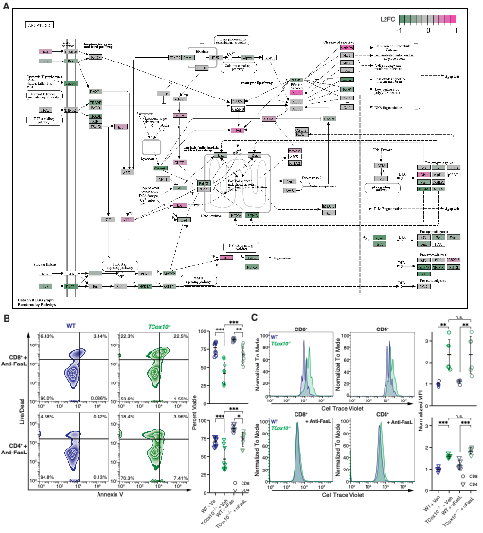Extended Data Fig 3. Aberrant apoptosis in TCox10-/- T cells is abrogated by Aox expression and anti-FasL treatment. (A) KEGG apoptosis pathway with relative expression (L2FC) from TCox10^{-/-}/Aox and TCox10^{-/-} visualized. (B) Viability analysis in CD4⁺ and CD8⁺ WT and TCox10^{-/-} T cells using Live/Dead and Annexin V stains, following treatment with anti-FasL (CD178) blocking antibodies. Left, contour plot; right, quantification of percent viable cells. (C) Proliferation analysis of CD4⁺ and CD8⁺ WT and T cells using Cell Trace Violet. Left, representative density plot. Right, quantification of normalized mean fluorescence intensity (MFI).

Data are representative of two independent experiments and an RNAseq experiment and indicate mean and standard deviation. (A) n = 3-5, (B-C) n = 6. * p < 0.05, ** p < 0.01, *** p < 0.001 by one-way ANOVA and post-hoc Tukey HSD test. Negative controls are not included in statistical calculations. Specific p values (left to right) are as follows. (B) CD8⁺, F(3,20) = 35.12, p = 3.66x10⁻⁸, Tukey p = 3.2x10⁻⁶, p = 5.61x10⁻⁵, p = 0.00296; CD4⁺, F(3,20) = 83.85, p = 1.68x10⁻¹¹, Tukey p < 0.0001, p < 0.0001, p = 4.32x10⁻⁵, (C) CD8⁺, F(3,20) = 10.92, p = 0.000183, Tukey p = 0.0022, 0.005; CD4⁺, F(3,20) = 42.51, p = 7.27x10⁻⁹, Tukey p = 3.8x10⁻⁶, 9.0x10⁻⁷.

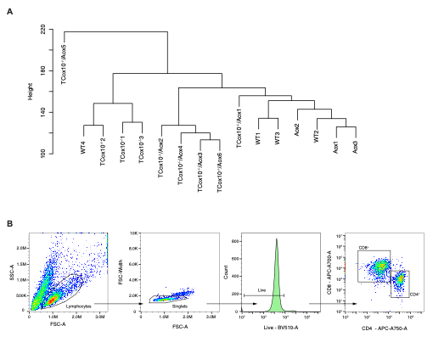Extended Data Fig. 4. Sample handling strategies. (A) Hierarchical clustering revealed RNAseq sample TCox10^{-/-}/Aox 5 partitioned separately from others; this sample was excluded from our analysis. (B) Representative gating strategy for CD8⁺ and CD4⁺ T cells in this manuscript.

