Supplemental materials

Altered brain dynamic functional network connectivity in heavy smokers

Data acquisition
The rs-fMRI data was acquired on a Siemens Trio 3T scanner using echo-planar imaging， with the following parameters: repetition time = 2,000 ms; echo time = 30 ms; field of view = 220×220 mm²; acquisition matrix = 64×64; flip angle = 90º; slice thickness = 4 mm with a 0.5 mm gap; 30 axial slices. The scan lasted for 420 seconds and 210 volumes were obtained for each subject. During the scan, all participants were instructed to keep eyes closed and remain awake. All images were visually evaluated by two neuroradiologists to rule out possible pathological results.

Data preprocessing
The rs-fMRI data preprocessing was performed using statistical parametric mapping software (SPM12). The first 10 volumes were discarded and the remaining 200 volumes were corrected for slice-timing and head motion. Subjects with a maximum displacement greater than 1.5 mm, or a head rotation greater than 1.5º, or mean framewise displacement larger than 0.2 mm were excluded. The data were warped to the Montreal Neurological Institute space and resampled to a 3mm isotropic voxel and smoothed using a 6 mm full width at half maximum isotropic Gaussian kernel. Voxel time series were variance normalized to minimize possible bias in subsequent analysis.

Alterations of dFNC strengths
There was no connected sub-network showing significant between-group differences in sFNC or dFNC in state 4. However, NBS found impaired connected sub-networks in dFNC in states 1-3 (Figures 3A&B). As for state 1, two hyper-connectivity sub-networks and one hypo-connectivity sub-networks were found in heavy smokers. The hyper-connectivity sub-networks consisted of 3 connections between the VS (the middle occipital gyrus and cuneus) and posterior DM (the posterior cingulate and precuneus) networks, and 2 connections between CC (the middle frontal gyrus) and SM (the postcentral gyrus) as well as DM (the medial superior frontal gyrus) networks. Meanwhile, the hypo-connectivity sub-network involved in 2 connections between the CB (the culmen) and CC (the parahippocampal gyrus and anterior insula) networks. As for state 2, two hyper-connectivity sub-networks and three hypo-connectivity sub-networks were found in heavy smokers. The hyper-connectivity sub-networks consisted of 2 connections between the AUD (the superior temporal gyrus) and VS (the lingual gyrus) regions as well as between the CC (the middle frontal gyrus) and CB (the culmen) regions. One hypo-connectivity sub-network involved 2connections between the SM (the paracentral lobule) and CC (the parahippocampal gyrus) as well as VS (the fusiform gyrus) regions. Another hypo-connectivity sub-network centered on the CB (the culmen), radiates to AUD (the superior temporal gyrus), CC (the anterior insula), DM (the anterior cingulate cortex), and SC (the putamen) regions. As for state 3, one hypo-connectivity sub-network was found in heavy smokers, which centered on precentral gyrus and supplementary motor area, radiates to VS (the fusiform gyrus and middle occipital gyrus), CC (the insula), the superior parietal lobule and AUD (the superior temporal gyrus) domains.

Repeatability and reproducibility analysis
Considering the potential influences of window size on results of k-means clustering, we also performed dFNC analysis with different window sizes of 18 TRs (36s) and 26TRs (52s), respectively. The cluster centroids obtained with different window sizes had similar connectivity patterns and proportional distribution of corresponding patterns (Figures S7&S8). As for the temporal properties of dFNC states, compared to non-smokers, heavy smokers had lower occurrence rate and mean dwell time in state 2, while no significant difference in number of transitions (Figures S9&S11). Correlation analyses demonstrated that both the occurrence rate and the mean dwell time in state 2 in heavy smoker were negatively associated with the duration of smoking (Figures S10&S12).

Table S1. Peak coordinates of the selected 42 intrinsic connectivity network (ICNs).
ICN |  | BA |  |  | k |  | T-value |  |  | Peak coordinate (MNI)
 |  |  |  |  |  |  |  |  |  | X |  |  |  |  | Y |  |  |  | Z
Subcortical domain
IC 29 | R putamen | - |  |  | 742 |  | 42.49 |  |  | 27 |  |  |  | 3 |  |  |  |  | 3
IC 29 | L putamen | - |  |  | 650 |  | 38.19 |  |  | -27 |  |  |  | -3 |  |  |  |  | 0
IC 48 | Bi caudate nucleus | - |  |  | 1589 |  | 39.45 |  |  | 9 |  |  |  | 12 |  |  |  |  | 3
IC 78 | Bi thalamus | - |  |  | 1373 |  | 31.37 |  |  | -9 |  |  |  | -18 |  |  |  |  | 0
Auditory domain
IC40 | R superior temporal gyrus | 13 |  |  | 1271 | 35.25 |  |  |  | -42 |  |  |  |  | -24 |  |  |  |  | 15
IC40 | L superior temporal gyrus | 13 |  |  | 957 | 26.44 |  |  |  | 51 |  |  |  |  | -18 |  |  |  |  | 12
IC46 | R superior temporal gyrus | 22 |  |  | 1238 | 31.90 |  |  |  | 57 |  |  |  |  | -30 |  |  |  |  | 6
IC46 | L superior temporal gyrus | 22 |  |  | 975 | 24.32 |  |  |  | -60 |  |  |  |  | -30 |  |  |  |  | 3
Sensorimotor domain
IC03 | R precentral gyrus | 6 |  |  | 884 | 41.56 |  |  |  | 60 |  |  |  |  | -3 |  |  |  |  |  | 21
IC03 | L precentral gyrus | 6 |  |  | 703 | 40.26 |  |  |  | -57 |  |  |  |  | -6 |  |  |  |  |  | 30
IC06 | Bi paracentral lobule | 6 |  |  | 1830 | 34.96 |  |  |  | 6 |  |  |  |  | -30 |  |  |  |  |  | 66
IC20 | Bi superior parietal lobule | 7 |  |  | 1732 | 32.22 |  |  |  | 21 |  |  |  |  | -51 |  |  |  |  |  | 63
IC24 | L postcentral gyrus | 6 |  |  | 1309 | 32.27 |  |  |  | -36 |  |  |  |  | -15 |  |  |  |  |  | 60
IC27 | R postcentral gyrus | 6 |  |  | 1186 | 35.46 |  |  |  | 39 |  |  |  |  | -24 |  |  |  |  |  | 57
IC32 | R postcentral gyrus | 40 |  |  | 834 | 29.05 |  |  |  | 48 |  |  |  |  | -33 |  |  |  |  |  | 48
IC32 | L postcentral gyrus | 40 |  |  | 873 | 28.93 |  |  |  | -39 |  |  |  |  | -36 |  |  |  |  |  | 42
IC61 | Bi supplementary motor area | 6 |  |  | 1216 | 31.27 |  |  |  | 6 |  |  |  |  | 0 |  |  |  |  |  | 45
Visual domain
IC05 | Bi cuneus | 18 |  |  | 2069 |  | 33.47 |  |  |  | 18 |  |  |  |  | -99 |  |  |  |  |  | 9
IC11 | Bi superior occipital gyrus | 19 |  |  | 2268 |  | 35.34 |  |  |  | 15 |  |  |  |  | -90 |  |  |  |  |  | 30
IC14 | Bi calcarine gyrus | 18 |  |  | 2149 |  | 39.53 |  |  |  | 0 |  |  |  |  | -81 |  |  |  |  |  | 12
IC23 | Bi lingual gyrus | 18 |  |  | 1720 |  | 30.30 |  |  |  | -30 |  |  |  |  | -69 |  |  |  |  |  | -3
IC25 | R middle occipital gyrus | 19 |  |  | 1551 |  | 37.27 |  |  |  | 33 |  |  |  |  | -72 |  |  |  |  |  | 3
IC50 | R fusiform gyrus | 37 |  |  | 757 |  | 28.00 |  |  |  | 30 |  |  |  |  | -36 |  |  |  |  |  | -21
IC50 | L fusiform gyrus | 37 |  |  | 615 |  | 25.95 |  |  |  | -24 |  |  |  |  | -39 |  |  |  |  |  | -18
IC54 | L middle occipital gyrus | 18 |  |  | 1491 |  | 30.19 |  |  |  | -30 |  |  |  |  | -75 |  |  |  |  |  | 9
IC55 | L middle temporal gyrus | 37 |  |  | 846 |  | 28.70 |  |  |  | -45 |  |  |  |  | -57 |  |  |  |  |  | -3
IC55 | R middle temporal gyrus | 37 |  |  | 770 |  | 25.06 |  |  |  | 51 |  |  |  |  | -63 |  |  |  |  |  | 0
Cognitive control domain
IC28 | R anterior insula | 47 |  |  | 715 |  |  | 36.38 |  |  |  | 30 |  |  |  |  | 27 |  |  |  |  |  | -6
IC28 | L anterior insula | 47 |  |  | 520 |  |  | 34.42 |  |  |  | -36 |  |  |  |  | 21 |  |  |  |  |  | 3
IC28 | Bi dorsal anterior cingulate cortex | 32 |  |  | 257 |  |  | 16.38 |  |  |  | 3 |  |  |  |  | 21 |  |  |  |  |  | 48
IC35 | R inferior frontal gyrus | 46 |  |  | 1313 |  |  | 35.46 |  |  |  | 48 |  |  |  |  | 12 |  |  |  |  |  | 21
IC49 | L middle frontal gyrus | 10 |  |  | 1004 |  |  | 31.38 |  |  |  | -33 |  |  |  |  | 51 |  |  |  |  |  | 24
IC49 | R middle frontal gyrus | 10 |  |  | 824 |  |  | 27.18 |  |  |  | 30 |  |  |  |  | 54 |  |  |  |  |  | 24
IC51 | R middle frontal gyrus | 10 |  |  | 761 |  |  | 32.68 |  |  |  | 42 |  |  |  |  | 45 |  |  |  |  |  | 9
IC51 | L middle frontal gyrus | 10 |  |  | 554 |  |  | 27.08 |  |  |  | -39 |  |  |  |  | 39 |  |  |  |  |  | 12
IC52 | R parahippocampal gyrus | 28 |  |  | 796 |  |  | 27.17 |  |  |  | 33 |  |  |  |  | -27 |  |  |  |  |  | -12
IC52 | L parahippocampal gyrus | 28 |  |  | 623 |  |  | 23.34 |  |  |  | -27 |  |  |  |  | -9 |  |  |  |  |  | -21
IC67 | L inferior frontal gryus | 46 |  |  | 1254 |  |  | 31.26 |  |  |  | -51 |  |  |  |  | 18 |  |  |  |  |  | 12
IC68 | R precentral gyrus | 6 |  |  | 567 |  |  | 26.60 |  |  |  | 42 |  |  |  |  | 0 |  |  |  |  |  | 45
IC68 | L precentral gyrus | 6 |  |  | 537 |  |  | 24.06 |  |  |  | -36 |  |  |  |  | 0 |  |  |  |  |  | 48
IC68 | Bi supplementary motor area | 6 |  |  | 156 |  |  | 15.38 |  |  |  | 0 |  |  |  |  | 3 |  |  |  |  |  | 57
IC72 | L middle frontal gyrus | 9 |  |  | 999 |  |  | 32.35 |  |  |  | -42 |  |  |  |  | 24 |  |  |  |  |  | 24
IC72 | R middle frontal gyrus | 9 |  |  | 446 |  |  | 23.28 |  |  |  | 45 |  |  |  |  | 21 |  |  |  |  |  | 30
IC87 | L inferior parietal lobule | 40 |  |  | 583 |  |  | 31.96 |  |  |  | -60 |  |  |  |  | -45 |  |  |  |  |  | 36
IC87 | R inferior parietal lobule | 40 |  |  | 794 |  |  | 30.94 |  |  |  | 60 |  |  |  |  | -45 |  |  |  |  |  | 33
IC88 | R insula | 13 |  |  | 985 |  |  | 27.51 |  |  |  | 42 |  |  |  |  | 15 |  |  |  |  |  | 0
IC88 | L insula | 13 |  |  | 127 |  |  | 15.36 |  |  |  | -36 |  |  |  |  | 9 |  |  |  |  |  | 6
IC99 | Bi supplementary motor area | 8 |  |  | 1282 |  |  | 29.72 |  |  |  | -9 |  |  |  |  | 15 |  |  |  |  |  | 60
Default-mode domain
IC07 | Bi anterior cingulate cortex |  |  | 32 | 1581 |  |  |  | 35.34 |  |  |  | 0 |  |  |  |  | 51 |  |  |  |  |  | 9
IC22 | Bi posterior cingulate |  |  | 31 | 1434 |  |  |  | 34.46 |  |  |  | -9 |  |  |  |  | -54 |  |  |  |  |  | 12
IC26 | Bi precuneus |  |  | 7 | 2133 |  |  |  | 33.70 |  |  |  | -6 |  |  |  |  | -48 |  |  |  |  |  | 30
IC30 | Bi superior medial frontal cortex |  |  | 9 | 1797 |  |  |  | 39.65 |  |  |  | -3 |  |  |  |  | 48 |  |  |  |  |  | 33
IC37 | R angular gyrus |  |  | 40 | 1023 |  |  |  | 32.68 |  |  |  | 48 |  |  |  |  | -51 |  |  |  |  |  | 54
IC37 | R superior frontal gyrus |  |  | 8 | 1129 |  |  |  | 29.77 |  |  |  | 39 |  |  |  |  | 24 |  |  |  |  |  | 48
IC37 | R middle frontal gyrus |  |  | 10 | 289 |  |  |  | 19.26 |  |  |  | 33 |  |  |  |  | 57 |  |  |  |  |  | -3
IC37 | R precuneus |  |  | 31 | 151 |  |  |  | 16.32 |  |  |  | 6 |  |  |  |  | -33 |  |  |  |  |  | 39
IC38 | L angular gyrus |  |  | 40 | 817 |  |  |  | 34.81 |  |  |  | -45 |  |  |  |  | -57 |  |  |  |  |  | 51
IC38 | L middle frontal gyrus |  |  | 10 | 408 |  |  |  | 28.48 |  |  |  | -39 |  |  |  |  | 51 |  |  |  |  |  | 3
IC38 | R angular gyrus |  |  | 40 | 280 |  |  |  | 20.83 |  |  |  | 48 |  |  |  |  | -51 |  |  |  |  |  | 48
IC38 | L middle frontal gyrus |  |  | 8 | 303 |  |  |  | 18.78 |  |  |  | -39 |  |  |  |  | 24 |  |  |  |  |  | 48
IC38 | L precuneus |  |  | 31 | 118 |  |  |  | 18.00 |  |  |  | -3 |  |  |  |  | -33 |  |  |  |  |  | 36
IC69 | Bi posterior cingulate |  |  | 31 | 647 |  |  |  | 29.70 |  |  |  | -6 |  |  |  |  | -54 |  |  |  |  |  | 18
IC69 | L superior frontal gyrus |  |  | 8 | 311 |  |  |  | 25.08 |  |  |  | -21 |  |  |  |  | 30 |  |  |  |  |  | 51
IC69 | L angular gyrus |  |  | 39 | 401 |  |  |  | 23.41 |  |  |  | -45 |  |  |  |  | -69 |  |  |  |  |  | 36
IC69 | R angular gyrus |  |  | 39 | 322 |  |  |  | 21.74 |  |  |  | 51 |  |  |  |  | -63 |  |  |  |  |  | 30
IC69 | R superior frontal gyrus |  |  | 8 | 198 |  |  |  | 17.91 |  |  |  | 27 |  |  |  |  | 30 |  |  |  |  |  | 51
IC69 | Bi medial frontal gyrus |  |  | 11 | 247 |  |  |  | 16.12 |  |  |  | -3 |  |  |  |  | 39 |  |  |  |  |  | -15
IC74 | L superior temporal gyrus |  |  | 21 | 1828 |  |  |  | 31.61 |  |  |  | -57 |  |  |  |  | -36 |  |  |  |  |  | -3
IC74 | L inferior frontal gyrus |  |  | 47 | 145 |  |  |  | 15.71 |  |  |  | -51 |  |  |  |  | 21 |  |  |  |  |  | -3
Cerebellar domain
IC12 | L cerebellum (crus 1,2) |  | - |  | 1094 |  |  |  | 31.65 |  |  |  | -30 |  |  |  |  | -60 |  |  |  |  |  | -45
IC15 | Bi cerebellum (culmen) |  | - |  | 1347 |  |  |  | 44.55 |  |  |  | 0 |  |  |  |  | -54 |  |  |  |  |  | -21
IC44 | R cerebellum (crus 1,2) |  | - |  | 1620 |  |  |  | 38.06 |  |  |  | 30 |  |  |  |  | -69 |  |  |  |  |  | -39
The MNI coordinates are peak coordinates of the one-sample t-test results for each IC spatial maps of all subjects with the threshold of t > 10, k > 100.
IC, independent component; BA, Brodmann area; k, number of voxel in each cluster; R, right; L, left; M, medial; Bi, bilateral.

Subcortical domain | Visual domain | Cognitive control domain | Default-mode domain
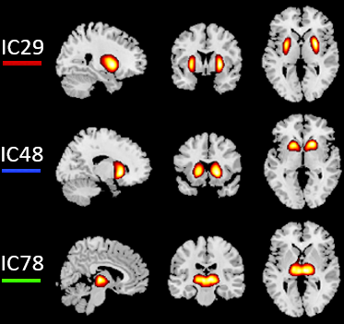 | 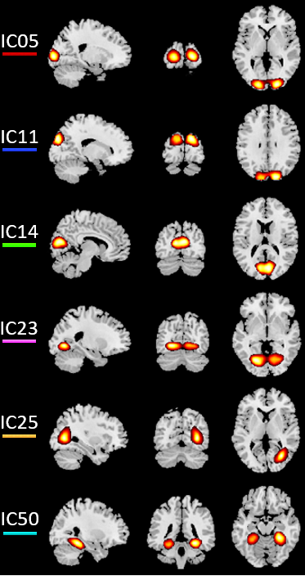  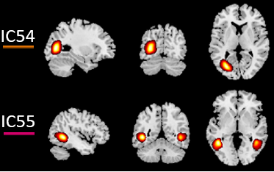 | 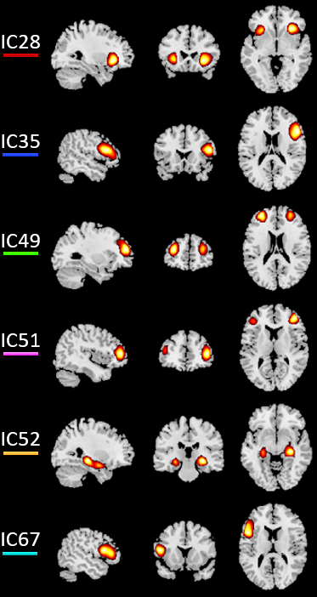  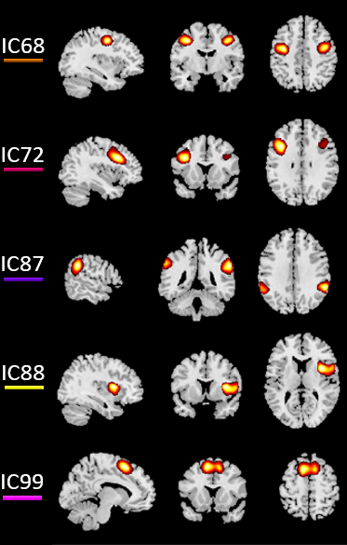 | 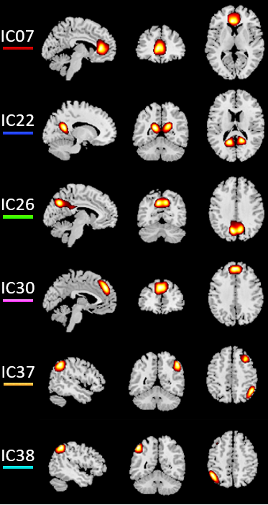  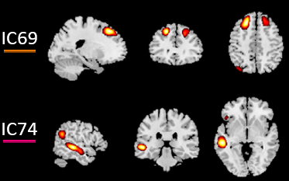
Sensorimotor domain
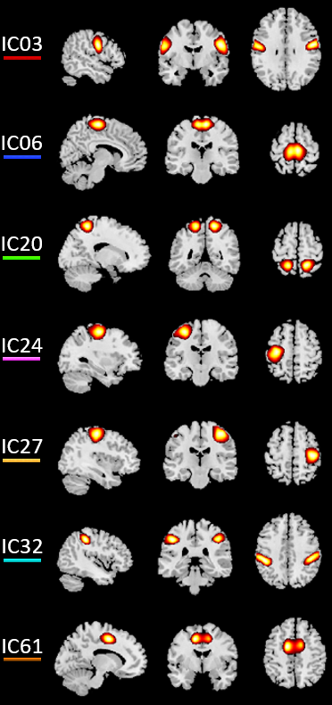
 | Auditory domain |  | Cerebellar domain
 | 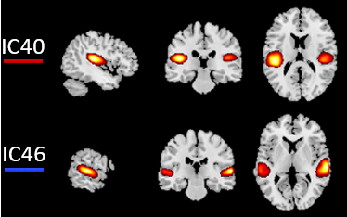 |  | 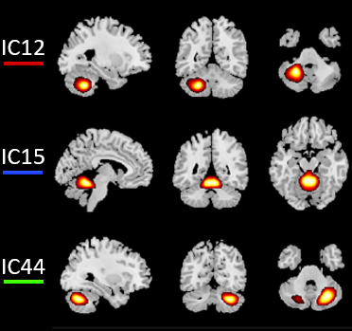
Figure S1. Spatial maps of intrinsic connectivity networks (ICNs). The 42 ICNs are arranged into 7 functional domains [subcortical, auditory, sensorimotor, visual, cognitive control, default-mode, and cerebellar networks]. The one-sample t-test was conducted for each IC with the threshold of t > 10 and voxel size > 100 to generate the spatial map. A color-coded legend next to each ICN matches to the overlaid colors of the spatial maps in Figure 1.

Figure S2. Recurring dynamic functional network connectivity (dFNC) states with different number of clusters (k). (A) The three dFNC states (k=3) were represented in connectivity matrices. State 1 occurs most frequently (54%), characterized by overall weak connectivity within and between functional domains. State 2 occurs 30% of time windows, characterized by negative connectivity between the DM network and the other networks. State 3 occurs 16% of time windows, characterized by strong positive connectivity within the sensory domains (AUD, SM, and VS) and negative connectivity between the sensory domains and the other domains. (B) The four dFNC states (k=4) were represented in connectivity matrices. This is the optimal number of cluster determined by the elbow criterion. (C) The five dFNC states (k=5) represented in connectivity matrices. State 1 occurs most frequently (37%), characterized by overall weak connectivity within and between functional domains. State 2 occurs 23% of time windows, characterized by negative connectivity between the DM network and the other networks. State 3 and 4 occur 8% and 9% of time windows, characterized by strong positive connectivity within the sensory domains (AUD, SM, and VS) and negative connectivity between the sensory domains and the other domains. State 5 occurs 24% of time windows, characterized by overall weak connectivity, positive connectivity within the sensory domains (SM, and VS) and negative connectivity between the DM network and the other networks. Note. The color represent the average connectivity strength between two components, with red-yellow indicating a positive correlation, and blue indicating a negative correlation. SC: subcortical, AUD: auditory, SM: sensorimotor, VS: visual, CC: cognitive control, DM: default-mode, CB: cerebellar.

Figure S3. Temporal properties of dynamic functional network connectivity (dFNC) states between the two groups (k = 3). (A) The mean fractional windows of total subjects spent in each state as measured by percentage, (B) mean dwell time (i.e. number of consecutive windows spent in each state before switching) and (C) number of transitions (i.e. switching between states) is depicted for the heavy smokers (HS) and healthy non-smokers (NS). When compared with non-smokers, heavy smokers had a significantly lower occurrence rate in state 2 while a higher occurrence rate in state 1, significantly decreased mean dwell time in state 2, and no significant difference in number of transitions.

Figure S4. Correlation results between the altered time properties of dynamic functional network connectivity (dFNC) states and smoking-related variables in heavy smokers (k = 3). Both the occurrence rate (A) and the mean dwell time (B) in State 2 were negatively associated with the duration of smoking in heavy smokers.

Figure S5 Temporal properties of dynamic functional connectivity (dFNC) states between the two groups (k = 5). (A) The mean fractional windows of total subjects spent in each state as measured by percentage, (B) mean dwell time (i.e. number of consecutive windows spent in each state before switching) and (C) number of transitions (i.e. switching between states) is depicted for the heavy smokers (HS) and healthy non-smokers (NS). When compared with non-smokers, heavy smokers had a significantly lower occurrence rate in state 2 while a higher occurrence rate in state 1, significantly decreased mean dwell time in state 2, and no significant difference in number of transitions.

Figure S6. Correlation results between altered time properties of dynamic functional network connectivity (dFNC) states and smoking-related variables in heavy smokers (k = 5). Both the occurrence rate (A) and the mean dwell time (B) in State 2 were negatively associated with the duration of smoking in heavy smokers.

Figure S7. Recurring dynamic functional network connectivity (dFNC) states with k = 4 and window size = 18 TRs. (A) The FNC pattern for each state. The four dFNC states represented in connectivity matrices are symmetrically grouped by functional networks. The color represents the average connectivity strength between two components, with red-yellow indicating a positive correlation, and blue indicating a negative correlation. The total number of occurrences and the percentage of total occurrences are listed for each state. State 1 occurs most frequently (56%), characterized by overall weak connectivity within and between functional domains. State 2 occurs 27% of time windows, characterized by negative connectivity between the DM network and the other networks. State 3 and 4 occur 9% and 8% of time windows, characterized by strong positive connectivity within the sensory domains (AUD, SM, and VS) and negative connectivity between the sensory domains and the other domains. Note. SC: subcortical, AUD: auditory, SM: sensorimotor, VS: visual, CC: cognitive control, DM: default-mode, CB: cerebellar.

Figure S8. Recurring dynamic functional network connectivity (dFNC) states with k = 4 and window size = 26 TRs. (A) The FNC pattern for each state. The four dFNC states represented in connectivity matrices are symmetrically grouped by functional networks. The color represents the average connectivity strength between two components, with red-yellow indicating a positive correlation, and blue indicating a negative correlation. The total number of occurrences and the percentage of total occurrences are listed for each state. State 1 occurs most frequently (48%), characterized by overall weak connectivity within and between functional domains. State 2 occurs 32% of time windows, characterized by negative connectivity between the DM network and the other networks. State 3 and 4 occur 10% and 10% of time windows, characterized by strong positive connectivity within the sensory domains (AUD, SM, and VS) and negative connectivity between the sensory domains and the other domains. Note. SC: subcortical, AUD: auditory, SM: sensorimotor, VS: visual, CC: cognitive control, DM: default-mode, CB: cerebellar.

Figure S9. Temporal properties of dynamic functional network connectivity (dFNC) states between the two groups (k = 4 and window size = 18TRs). (A) The mean fractional windows of total subjects spent in each state as measured by percentage, (B) mean dwell time (i.e. number of consecutive windows spent in each state before switching) and (C) number of transitions (i.e. switching between states) is depicted for the heavy smokers (HS) and healthy non-smokers (NS). When compared with non-smokers, the heavy smokers had a significantly lower occurrence rate and mean dwell time in state 2 while no significant difference in number of transitions.

Figure S10. Correlation results between altered time properties of dFNC and smoking-related variables in heavy smokers (k = 4 and window size = 18TRs). Both the occurrence rate (A) and the mean dwell time (B) in State 2 were negatively associated with the duration of smoking in heavy smokers.

Figure S11. Temporal properties of dynamic functional connectivity states between the two groups (k = 4 and window size = 26TRs). (A) The mean fractional windows of total subjects spent in each state as measured by percentage, (B) mean dwell time (i.e. number of consecutive windows spent in each state before switching) and (C) number of transitions (i.e. switching between states) is depicted for the heavy smokers (HS) and healthy non-smokers (NS). When compared with non-smokers, the heavy smokers had a significantly lower occurrence rate in state 2 while a higher occurrence rate in state 1, significantly decreased mean dwell time in state 2, no significant difference in number of transitions.

Figure S12. Correlation results between altered time properties of dFNC and smoking-related variables in heavy smokers (k = 4 and window size = 26TRs). Both the occurrence rate (A) and the mean dwell time (B) in State 2 were negatively associated with the duration of smoking in heavy smokers.

