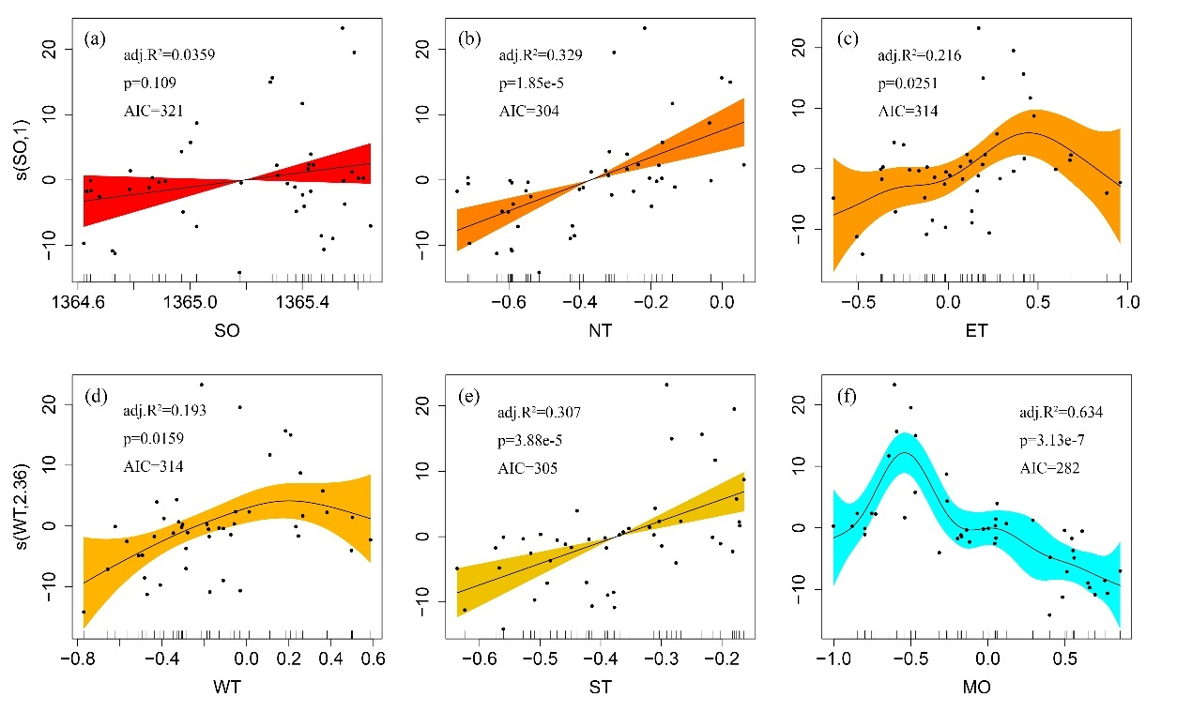
Supplementary Fig. 1 Correlation analysis employing GAMs between NCB and different climate proxies. (a) SO is solar irradiance. (b) NT is the north hemisphere annual temperature anomaly. (c) ET is Central East China annual temperature anomaly. (d) WT is winter time of east China annual temperature anomaly. (e) ST is the summertime of east China annual temperature anomaly and (f) MO is the composite Z-score index of humidity.
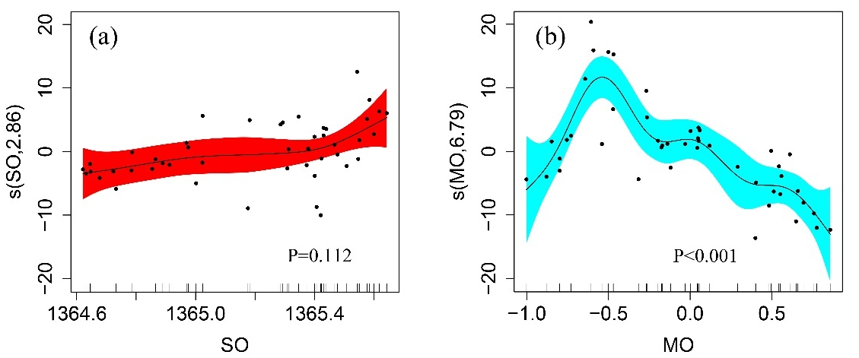
Supplementary Fig. 2 Correlation analysis employing GAMs between NCB and SO, MO. (a) SO is solar irradiance and (b) MO is the composite Z-score index of humidity.
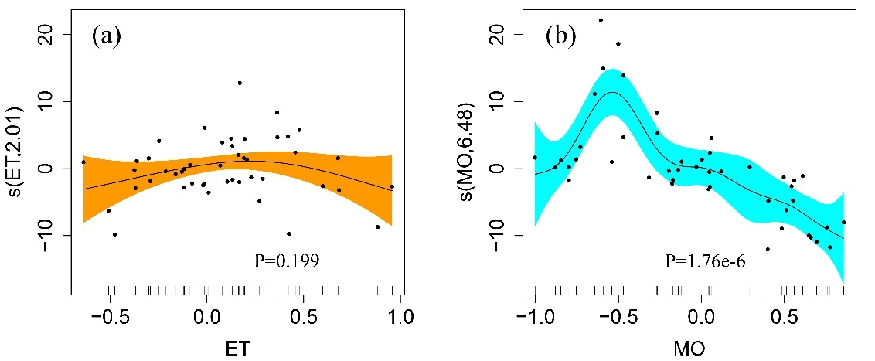
Supplementary Fig. 3 Correlation analysis employing GAMs between NCB and ET, MO. (a) ET is Central East China annual temperature anomaly and (b) MO is the composite Z-score index of humidity.
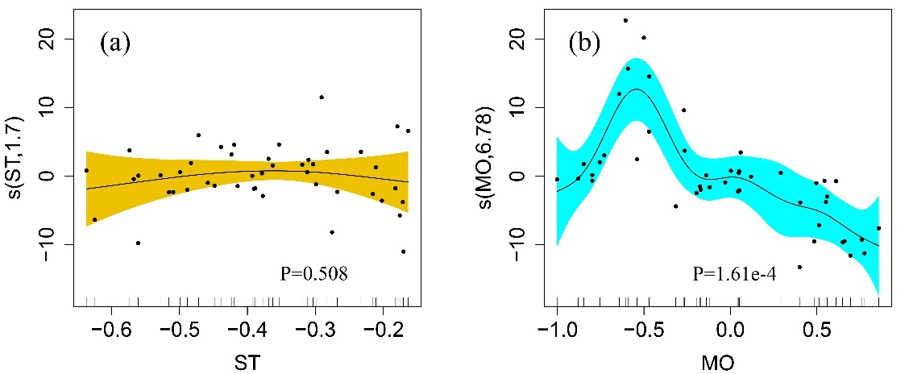
Supplementary Fig. 4 Correlation analysis employing GAMs between NCB and ST, MO. (a) ST is the summertime of east China annual temperature anomaly and (b) MO is the composite Z-score index of humidity.
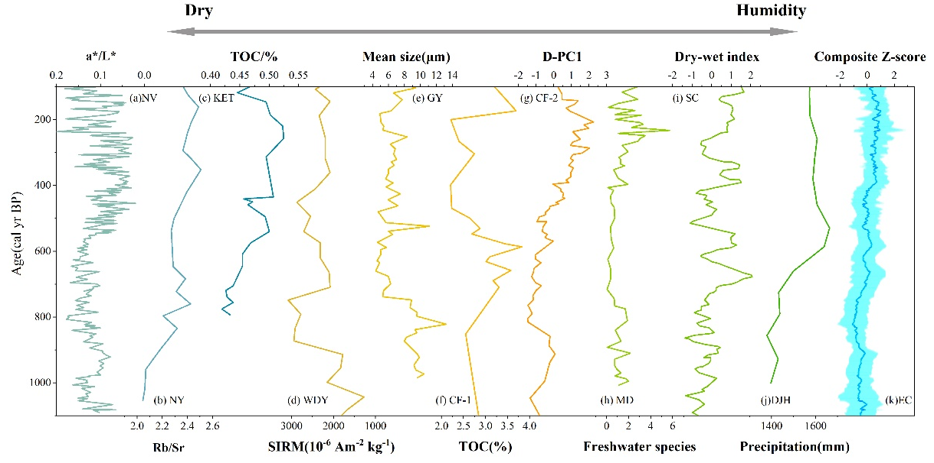
Supplementary Fig. 5 Long-term trends in reconstructed Z-scores of the humidity during the last 1000 cal yr BP. (a) a*/L*from the Nvshan Lake sediment. (b) Rb/Sr from the Nanyi Lake sediment. (c) TOC from the Kuroshio mainstream. (d) SIRM from the Wangdongyang peatland. (e) Mean size from the Gaoyou Lake sediment. (f) TOC from Cuifeng Lake sediment. (g) DPC-1 from Cuifeng Lake sediment. (h) freshwater species from Southern Okinawa. (i) It’s composite index for the dry-humidity based on historical and station records of southern China. (k) the composite Z-score for the different indexes over the 1000 years.

