Parental germline mosaicism in genome-wide phased de novo variants: recurrence risk assessment and implications for precision genetic counselling

Suppplementary Information

Prediction of recurrence risk using Decode Genetics’ De Novo Mutation Recurrence Calculator
With the aim of comparing our detected recurrence risk for paternally phased variants to available predictors, we used Decode’s De Novo Mutation Recurrence Calculator:
https://de-novo-risk.decode.is/.
This software takes as an input a genomic variant and information regarding presence of variants in siblings, parent of origin, parental age at conception, sequencing depth and alt read count in parental genomes. It outputs a mean recurrence risk estimation. We considered the mean paternal age of 30 years at conception in our five probands. Overall, 237 variants were identified with 0 alt reads in a mean of 41x fathers, 5 variants were identified with 1 alt read in a mean of 41x, and 2 reads were identified with 2 alt reads in 38x. These three situations translated to 0.43%, 2.68% and 9.27% recurrence risk, which averaged at 0.55%.

How to assess the risk of recurrence for maternally derived variants?
We define the parental recurrence risks as follows:
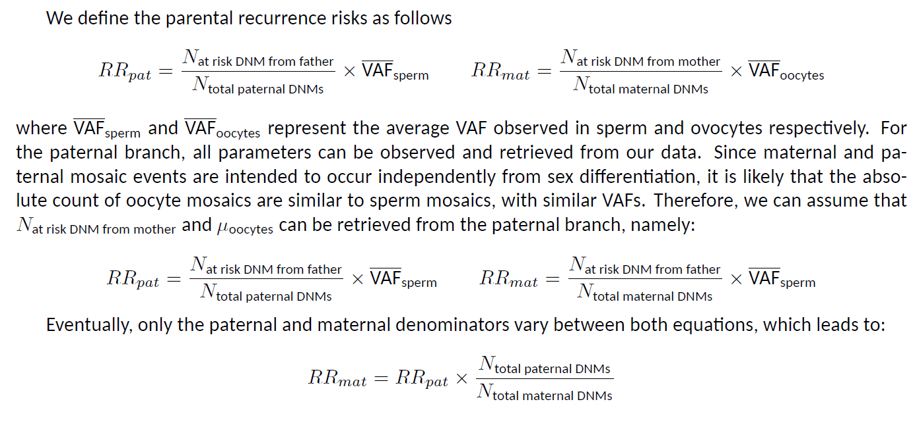
where and represent the average VAF observed in sperm and ovocytes respectively. For the paternal branch, all parameters can be observed and retrieved from our data. Since maternal and paternal mosaic events are intended to occur independently from sex differentiation, it is likely that the absolute count of oocyte mosaics are similar to sperm mosaics, with similar VAFs. Therefore, we can assume that Nat risk DNM from mother and μoocytes can be retrieved from the paternal branch, namely:

Eventually, only the paternal and maternal denominators vary between both equations, which leads to:

