Parental germline mosaicism in genome-wide phased de novo variants: recurrence risk assessment and implications for precision genetic counselling

Suppplementary Figures

Supplementary Figure 1. Literature review: studies exploring parental mosaicisms from de novo mutations 2
Supplementary Figure 2. Parental effect on phased variants 3
Supplementary Figure 3. Single base substitution signatures extraction from the 385 de novo substitutions detected in this study 4
Supplementary Figure 4. Analysis of mutational clusters recapitulate known cluster properties 5
Supplementary Figure 5. Shared mosaicisms in fathers: correlation of VAF in sperm versus blood 6
Supplementary Figure 6 : High evidence for three child embryonic mutations 7
Supplementary Figure 7. Correlation between counts of alt reads in parental WGS and parental mosaicism status 8

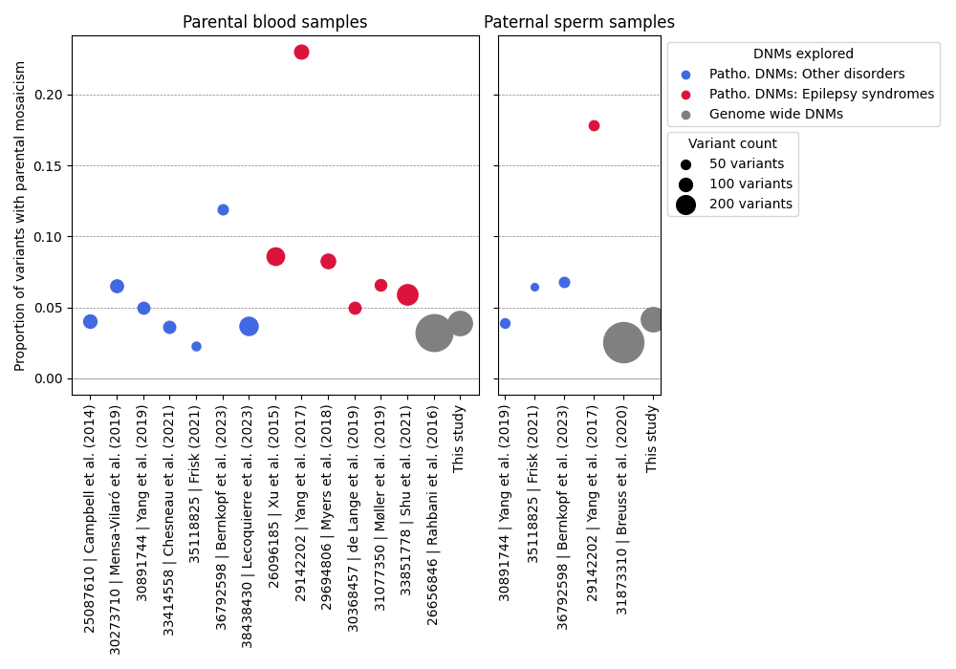
Supplementary Figure 1. Literature review: studies exploring parental mosaicisms from de novo mutations
This plot displays the proportion of the total count of DNMs which is detected to result from parental mosaicism in blood or paternal sperm. Inclusion criteria were: (i) at least 30 variants investigated, and (ii) a sensitive technique specifically applied to detect parental mosaicism, such as deep NGS or ddPCR. Several studies focused on pathogenic DNMs, including many studies on epileptic syndromes notably caused by DNMs in SCN1A, which often display higher rates of parental mosaicism. Few studies assessed the parental mosaicism rate for genome-wide DNMs with sensitive techniques. Of note, the genome-wide study conducted on paternal sperm cells [1] used 200x WGS, which did not allow the detection of low VAF mosaicism explaining the relatively low proportion of sperm mosaicism. References: [1–15]
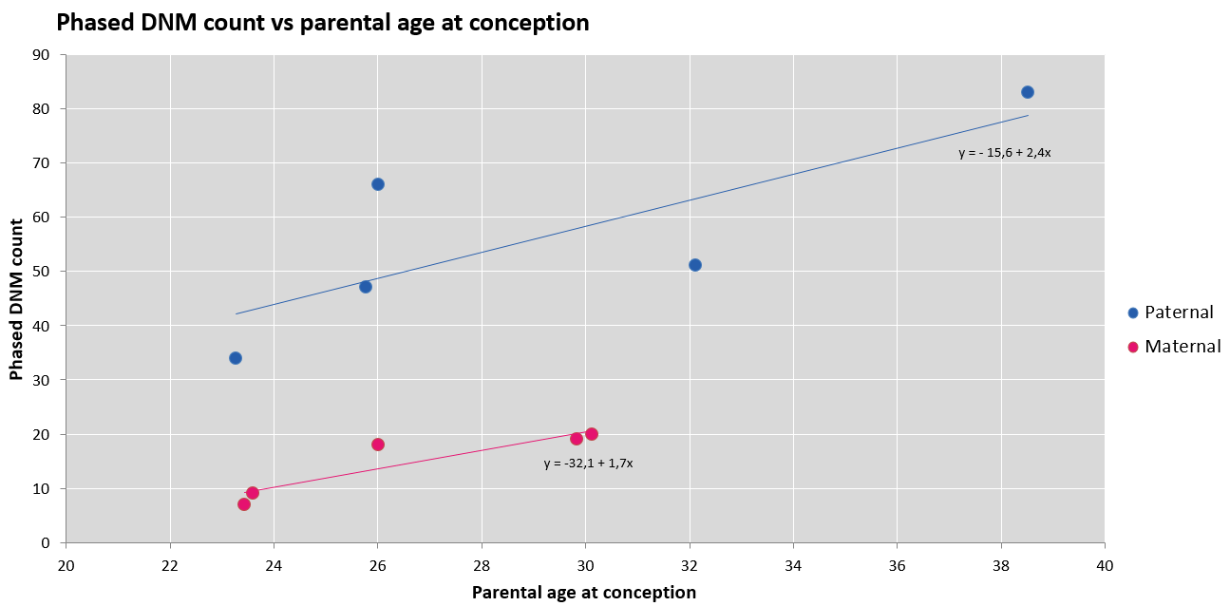
Supplementary Figure 2. Parental effect on phased variants
Phased SNV + indel counts are plotted against parental age at conception. Linear regressions show stronger parental age effect than usually reported, likely due to small sample size.

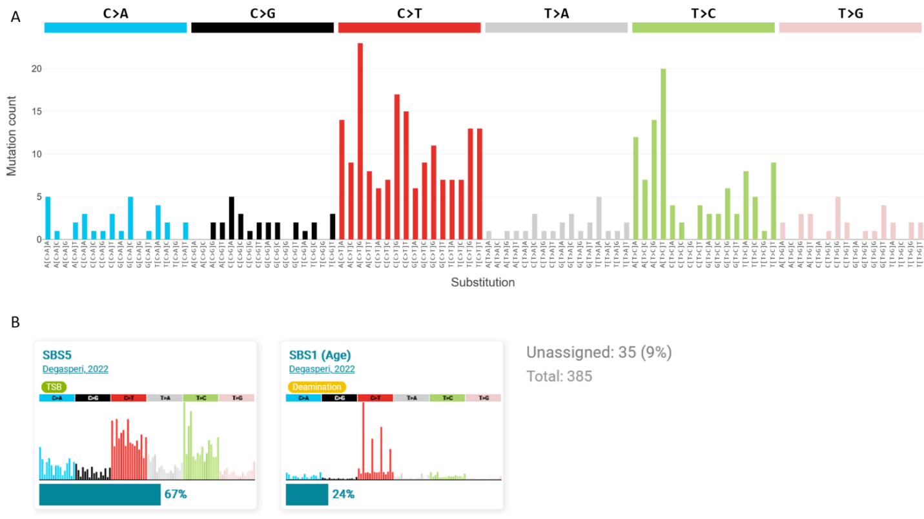
Supplementary Figure 3. Single base substitution signatures extraction from the 385 de novo substitutions detected in this study
A. Proportion of trimer substitutions
B. Signatures extracted by the Signal interface. The SBS5 and SBS1 signatures are detected

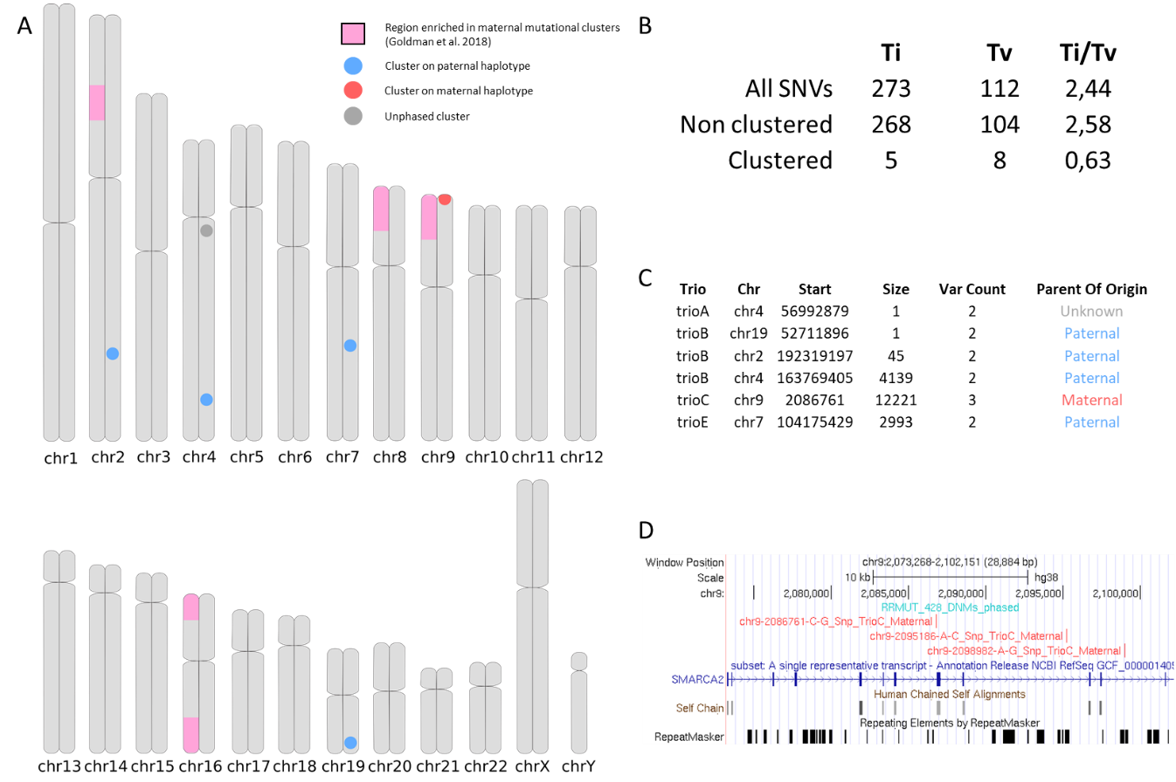

Supplementary Figure 4. Analysis of mutational clusters recapitulate known cluster properties
Clusters were defined as variations separated by a maximum of 20kb and called by https://github.com/francois-lecoquierre/de_novo_tools/blob/main/DNM_cluster_by_sample.py
A. Genomic distribution of clusters. Regions enriched in maternal mutational clusters identified in the literature are shown in pink (source: ref [16]). Note that the only maternal cluster is present in one of these regions. It is also the largest cluster and contains the most variants (n=3, see C and D). Generated using Tagore software (https://github.com/jordanlab/tagore).
B. Types of substitutions of clustered (n=13) versus non-clustered (n=372) variations. The drastic difference in Ti/Tv ratio between clustered and non-clustered variations recapitulates observations on larger trio studies [17].
C. Characteristics of the 6 clusters detected. Note the higher prevalence of paternal clusters, in contrast to literature data in which the number of paternal clusters is equivalent to the number of maternal clusters. This difference is likely due to the small sample size. Of note, the phases of individual SNVs were concordant and have been merged in the “Parent Of Origin” column.
D. Representation of the maternal cluster composed of 3 SNVs within the SMARCA2 gene in the hypermutable 9p region. UCSC euro session: https://genome-euro.ucsc.edu/s/francois.leco/RRMUT_maternal_cluster

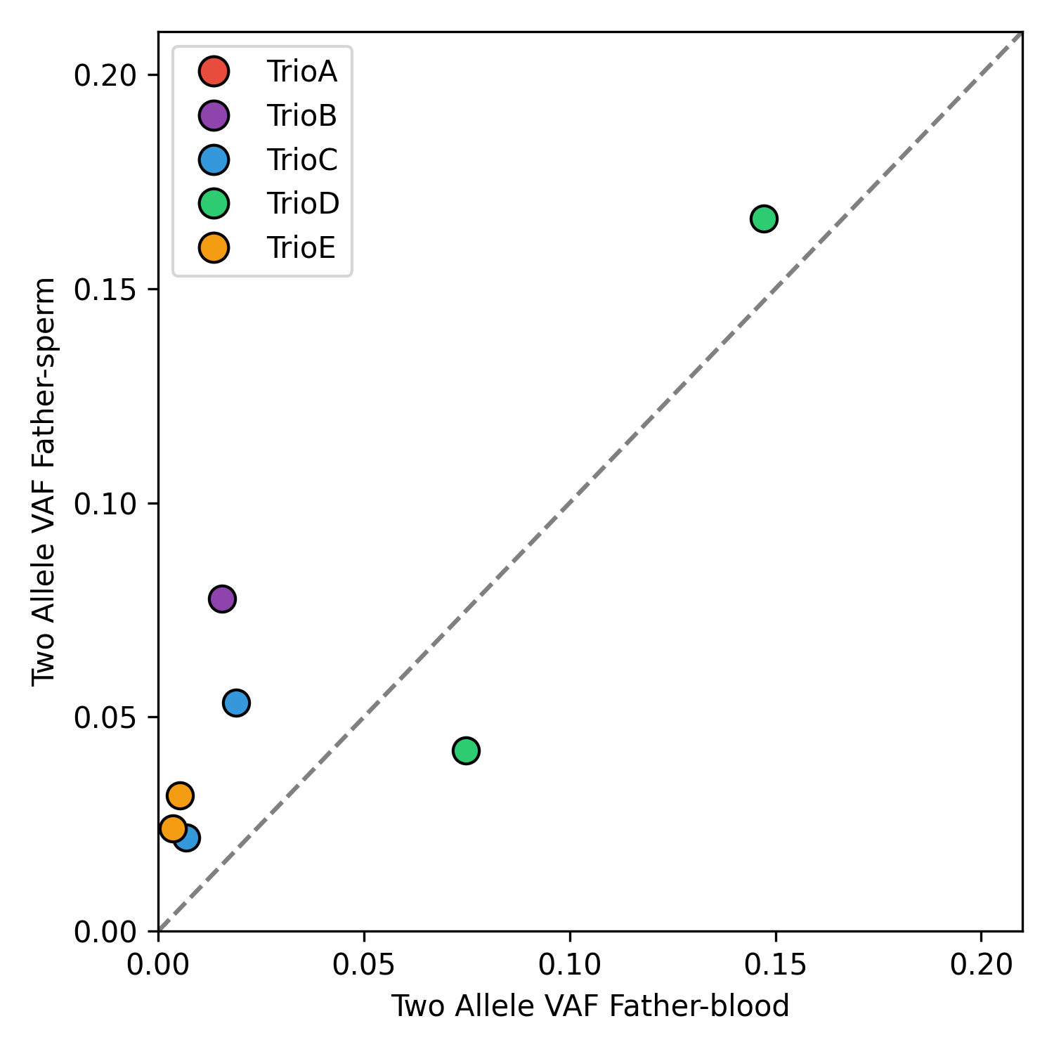
Supplementary Figure 5. Shared mosaicisms in fathers: correlation of VAF in sperm versus blood
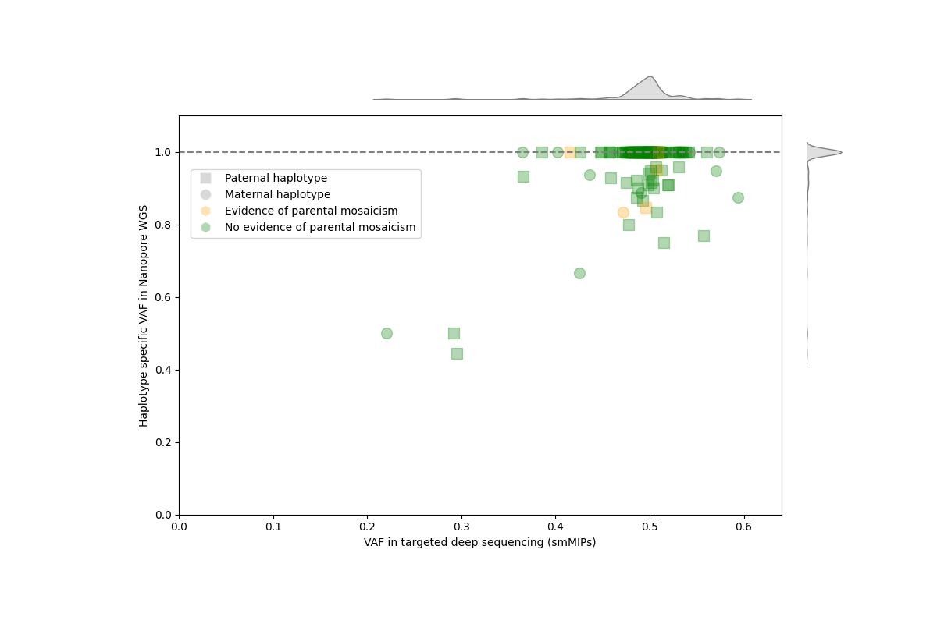
Supplementary Figure 6 : High evidence for three child embryonic mutations
From all de novo variants detected in this study, we extracted a subset of 163 variants with high quality genotypes in child’s sequencing data, both in Nanopore long-read genome data and high depth smMIP sequencing. More specifically, the filters included: (i) SNVs only, (ii) variants with a parental phase determined in long-read data, with a depth of at least 4x on the haplotype bearing the variant, and (iii) variants for which both the extension and ligation arms of the associated smMIP did not lie within a unique repeated element in “RepeatMasker” or “Human Self Chain Alignments” tracks from UCSC, since highly repeated elements were occasionally observed to slightly bias the smMIP-defined VAF by incomplete specificity. The smMIP VAF is centred on 0.5 for heterozygous de novo variants, as expected. The haplotype-specific VAF corresponds to the proportion of alt reads over (ref + alt) reads, only on the mutated haplotype defined by WhatsHap Haplotag. Therefore, it is expected to be of 100% in samples without post-zygotic mosaicism. Since both smMIP and Nanopore sequencing exhibit noise in the definition of the VAF, we considered high evidence mosaicisms as the variants with low VAF in both approaches (three variants). De novo variants with evidence for parental mosaicism are indicated in yellow and serve as negative controls since they are necessarily pre-zygotic.

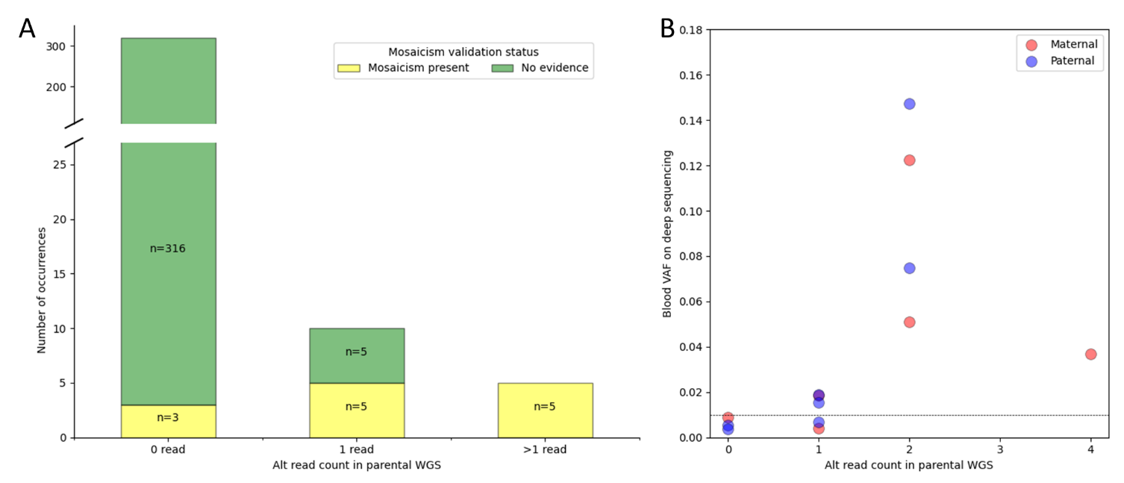
Supplementary Figure 7. Correlation between counts of alt reads in parental WGS and parental mosaicism status
Samtools Mpileup was used to quantify the alt read count in parental WGS for the de novo variants included in this study and to compare it to the presence of a mosaicism as detected by deep sequencing.
- Counts of alt reads in parental genomes and mosaicism status. As expected, the presence of ≥ 2 reads in parental genomes appears highly predictive for parental embryonic mosaicism.
- Parental blood mosaicism: true blood VAF against alternate read count in 40x WGS. The 13 mosaicisms confirmed to be present in parental blood are plotted. Alternate read count from parental 40x WGS appears predictive of blood VAF detected by deep sequencing.

Supplementary references

1. Breuss MW, Antaki D, George RD, Kleiber M, James KN, Ball LL, et al. Autism risk in offspring can be assessed through quantification of male sperm mosaicism. Nat Med. 2020;26:143–50.
2. Campbell IM, Yuan B, Robberecht C, Pfundt R, Szafranski P, McEntagart ME, et al. Parental somatic mosaicism is underrecognized and influences recurrence risk of genomic disorders. Am J Hum Genet. 2014;95:173–82.
3. Mensa-Vilaró A, Bravo García-Morato M, de la Calle-Martin O, Franco-Jarava C, Martínez-Saavedra MT, González-Granado LI, et al. Unexpected relevant role of gene mosaicism in patients with primary immunodeficiency diseases. J Allergy Clin Immunol. 2019;143:359–68.
4. Yang X, Yang X, Chen J, Li S, Zeng Q, Huang AY, et al. ATP1A3 mosaicism in families with alternating hemiplegia of childhood. Clin Genet. 2019;96:43–52.
5. Chesneau B, Plancke A, Rolland G, Chassaing N, Coubes C, Brischoux-Boucher E, et al. Parental mosaicism in Marfan and Ehlers-Danlos syndromes and related disorders. Eur J Hum Genet. 2021;29:771–9.
6. Frisk S, Wachtmeister A, Laurell T, Lindstrand A, Jäntti N, Malmgren H, et al. Detection of germline mosaicism in fathers of children with intellectual disability syndromes caused by de novo variants. Mol Genet Genomic Med. 2022;10:e1880.
7. Bernkopf M, Abdullah UB, Bush SJ, Wood KA, Ghaffari S, Giannoulatou E, et al. Personalized recurrence risk assessment following the birth of a child with a pathogenic de novo mutation. Nat Commun. 2023;14:853.
8. Lecoquierre F, Cassinari K, Drouot N, May A, Fourneaux S, Charbonnier F, et al. Assessment of parental mosaicism rates in neurodevelopmental disorders caused by apparent de novo pathogenic variants using deep sequencing. Sci Rep. 2024;14:5289.
9. Xu X, Yang X, Wu Q, Liu A, Yang X, Ye AY, et al. Amplicon Resequencing Identified Parental Mosaicism for Approximately 10% of “de novo” SCN1A Mutations in Children with Dravet Syndrome. Hum Mutat. 2015;36:861–72.
10. Yang X, Liu A, Xu X, Yang X, Zeng Q, Ye AY, et al. Genomic mosaicism in paternal sperm and multiple parental tissues in a Dravet syndrome cohort. Sci Rep. 2017;7:15677.
11. Myers CT, Hollingsworth G, Muir AM, Schneider AL, Thuesmunn Z, Knupp A, et al. Parental Mosaicism in “De Novo” Epileptic Encephalopathies. N Engl J Med. 2018;378:1646–8.
12. de Lange IM, Koudijs MJ, van ’t Slot R, Sonsma ACM, Mulder F, Carbo EC, et al. Assessment of parental mosaicism in SCN1A-related epilepsy by single-molecule molecular inversion probes and next-generation sequencing. J Med Genet. 2019;56:75–80.
13. Møller RS, Liebmann N, Larsen LHG, Stiller M, Hentschel J, Kako N, et al. Parental mosaicism in epilepsies due to alleged de novo variants. Epilepsia. 2019;60:e63–6.
14. Shu L, Zhang Q, Tian Q, Yang S, Peng X, Mao X, et al. Parental mosaicism in de novo neurodevelopmental diseases. Am J Med Genet A. 2021;185:2119–25.
15. Rahbari R, Wuster A, Lindsay SJ, Hardwick RJ, Alexandrov LB, Turki SA, et al. Timing, rates and spectra of human germline mutation. Nat Genet. 2016;48:126–33.
16. Goldmann JM, Seplyarskiy VB, Wong WSW, Vilboux T, Neerincx PB, Bodian DL, et al. Germline de novo mutation clusters arise during oocyte aging in genomic regions with high double-strand-break incidence. Nat Genet. 2018;50:487–92.
17. Goldmann JM, Wong WSW, Pinelli M, Farrah T, Bodian D, Stittrich AB, et al. Parent-of-origin-specific signatures of de novo mutations. Nat Genet. 2016;48:935–9.

