Table. S1. MR imaging sequences and parameters from four scanners
 | T2WI-FS | T1W IP-OP | T1W-FS tra | T1W-FS cor | DWI
3.0-T UIHMR770 MR
Repetition time (msec) | 2000 | 4.27 | 3.3 | 3.3 | 4165
Echo time (msec) | 106.2 | 2.5 and 1.21 | 1.5 | 1.5 | 66.3
Matrix size | 256 × 256 | 288 × 168 | 320 × 216 | 288 × 208 | 128 × 101
Field of view (mm2) | 346 × 346 | 300 × 300 | 270 × 270 | 340 × 340 | 300 × 300
Slice thickness (mm) | 6–7 | 3–4 | 3 | 3–4 | 6–7
Slice gap (mm) | 1.8–2.1 | 0 | 0 | 0 | 1.8–2.1
Average | 1 | 1 | 1 | 1 | 5
3.0-T GE750 MR
Repetition time (msec) | 4500 | 3.6 | 3.54 | 3.95 | 5454
Echo time (msec) | 88 | 2.23 and 1.12 | 1.67 | 1.84 | 49
Matrix size | 448 × 448 | 256 × 192 | 256 × 192 | 384 × 170 | 130 × 96
Field of view (mm2) | 400 × 400 | 400 × 400 | 400 × 400 | 440 × 440 | 400 × 280
Slice thickness (mm) | 6.5 | 5 | 5 | 4 | 6.5
Slice gap (mm) | 1 | 1.1 | 0 | 0 | 1
Average | 2 | 0.7 | 1.33 | 0.7 | 1
3.0-T Siemens Verio MR
Repetition time (msec) | 2500 | 2.07 | 4.17 | 4.07 | 3400
Echo time (msec) | 83 | 2.31 and 3.69 | 1.43 | 1.46 | 70
Matrix size | 320 × 165 | 256 × 141 | 352 × 200 | 384 × 269 | 128 × 80
Field of view (mm2) | 330 × 380 | 330 × 380 | 330 × 380 | 380 × 380 | 330 × 380
Slice thickness (mm) | 5.5 | 5.5 | 3 | 3 | 6
Slice gap (mm) | 1.1 | 1.1 | 0 | 0 | 1.8
Average | 1 | 1 | 1 | 1 | 4
1.5-T Siemens Area MR
Repetition time (msec) | 2400 | 2.38 | 3.57 | 3.57 | 5100
Echo time (msec) | 94 | 6.87 and 4.76 | 1.41 | 1.41 | 55
Matrix size | 204 × 384 | 188 × 320 | 320 × 195 | 320 × 195 | 124 × 84
Field of view (mm2) | 308 × 380 | 308 × 380 | 308 × 380 | 308 × 380 | 308 × 380
Slice thickness (mm) | 5.5 | 3 | 3 | 3 | 6
Slice gap (mm) | 1.1 | 1 | 0 | 0 | 1.8
Average | 1 | 1 | 1 | 1 | 4

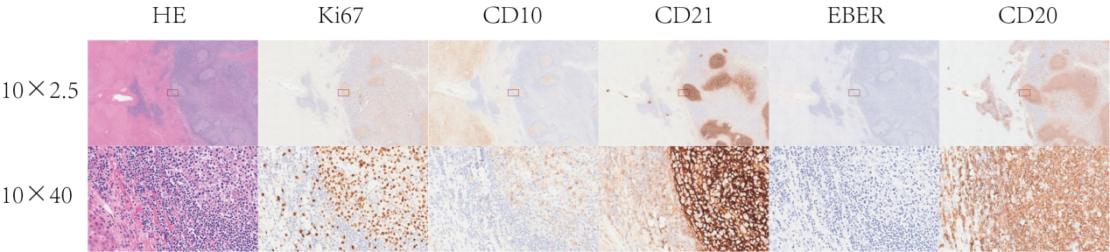
Figure. S1. HPL of 36-year-old woman. HE staining showed that the mass was a well-circumscribed nodule, composed of hyperplastic lymphoid tissue with several enlarged, irregularly shaped, well-demarcated follicles with formation of germinal centers. Ki67 staining showed high positivity in the germinal center, but low positivity in the follicular area. Immunohistochemical stain showed that the germinal centers were composed of lymphocytes positive for CD10, CD20 and CD21 antibody. EBER staining was negative.

Type I | Type II | Type III | Type IV | Type V | Type VI
 |  |  |  |  | 
Figure. S2. Six "ring sign" patterns on dynamic contrast-enhanced MRI of HPL
Type I: Single ring - low signal bull 's-eye with high signal ring
Type II: Single ring - equal signal bull 's-eye with high signal ring
Type III: Single ring - high signal bull 's-eye with equal signal ring
Type IV: Single ring - low signal bull 's-eye with equal signal ring
Type V: Double ring - low signal bull 's-eye with equal signal inner ring and high signal outer ring
Type VI: Double ring - high signal bull 's-eye with low signal inner ring and high signal outer ring
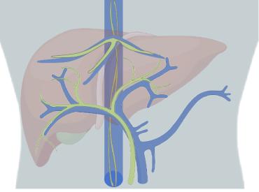
Figure. S3. Liver lymph was mainly delivered travel along the portal or hepatic veins toward to liver hilum or inferior vena cava.

