Climate Dynamics
Supplementary Information (SI)
for
Asymmetric Response of Sri Lanka Northeast monsoon Rainfall to El Niño/La Niña
Pathmarasa Kajakokulan^{1*}, Agus Santoso^{2,3}, Sen Zhao⁴
¹Department of Oceanography and Marine Geology, Faculty of Fisheries and Marine Sciences & Technology, University of Ruhuna, Matara, Sri Lanka.
²Climate Change Research Centre and Australian Research Council Centre of Excellence for Climate Extremes, University of New South Wales, Sydney, NSW, Australia
³International CLIVAR Project Office, Ocean University of China, Qingdao, China
⁴Department of Atmospheric Sciences, University of Hawai'i at Mānoa, Honolulu, HI, USA

*Corresponding author
Email: kajakokulan45@gmail.com
Department of Oceanography and Marine Geology, Faculty of Fisheries and Marine Sciences & Technology, University of Ruhuna, Matara, Sri Lanka.

ORCID
Pathmarasa Kajakokulan - 0009-0007-7361-9620
Agus Santoso - 0000-0001-7749-8124
Sen Zhao - 0000-0002-5597-1109

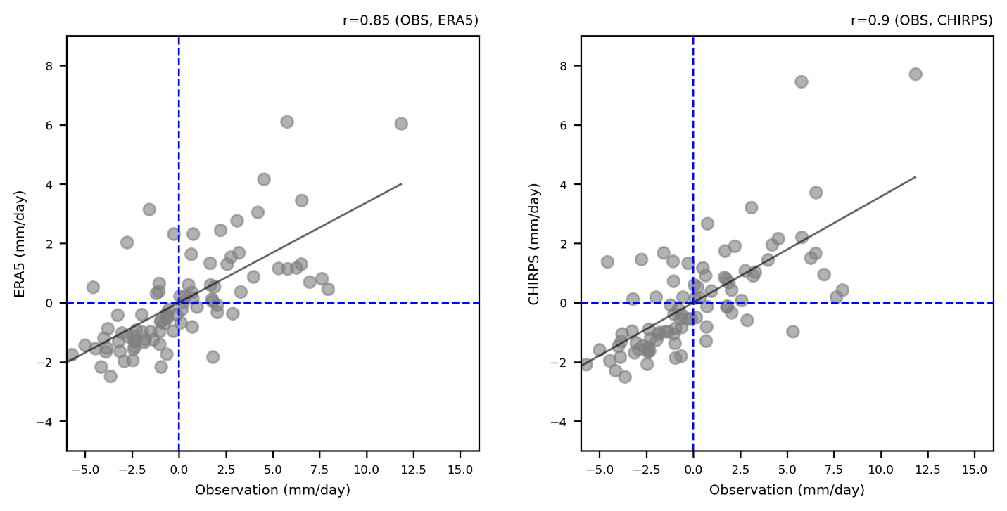

Fig. S1 The correlation between the observations of the precipitation data and a) the ERA5 precipitation and b) the CHIRPS precipitation.

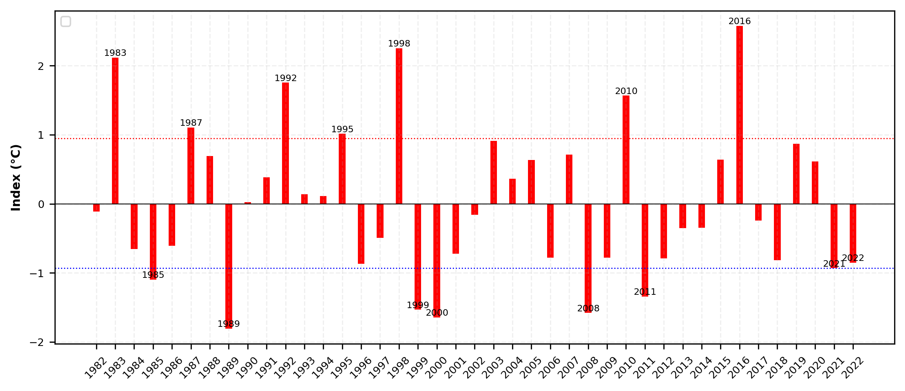
Fig. S2 Time-series of December–February Niño3 index from 1981 to 2022 (Source: ERSSTV5). The horizontal dashed blue (red) line denotes La Niña (El Niño) that Niño3.4 exceeds the $±$1 STD of the Niño3.4 index.

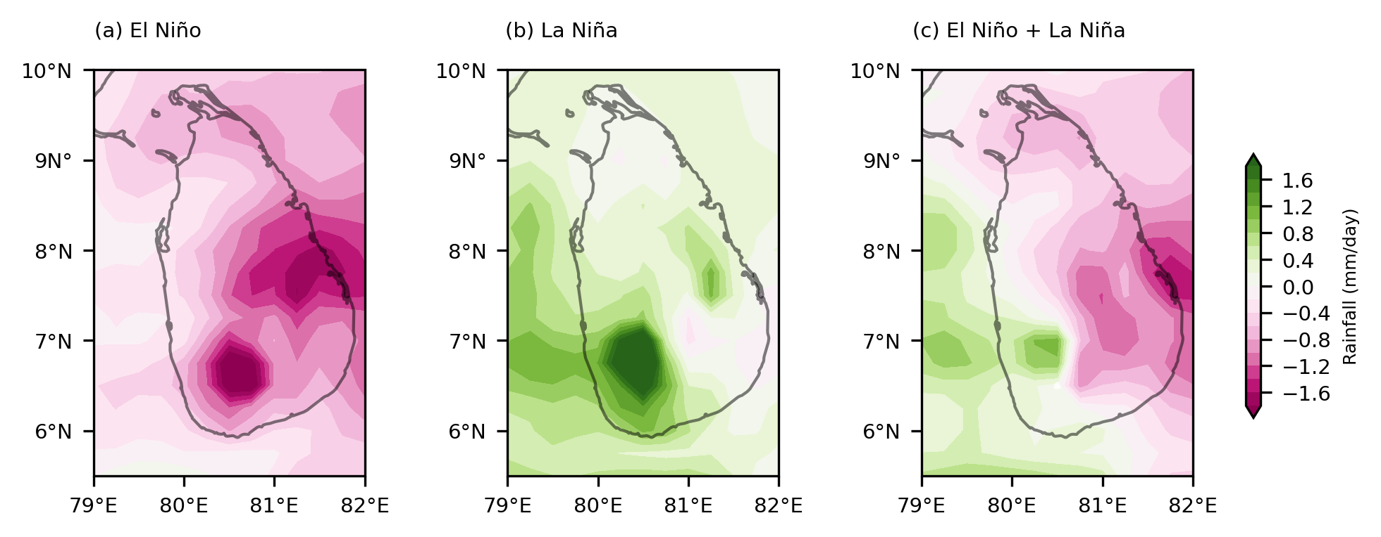
Fig. S3 Composite of rainfall anomalies for the period of 1981 to 2021 (El Niño peak winter) for a) El Niño events of 1982/83, 1986/87, 1991/92, 1994/95, 1997/98, 2009/10, and 2015/16 and b) La Niña events of 1984/85, 1988/89, 1998/99, 1999/00, 2007/08, and 2010/11, 2020/21, and 2021/22, c) asymmetric part was calculated by summation of El Niño and La Niña from ERA5 data.

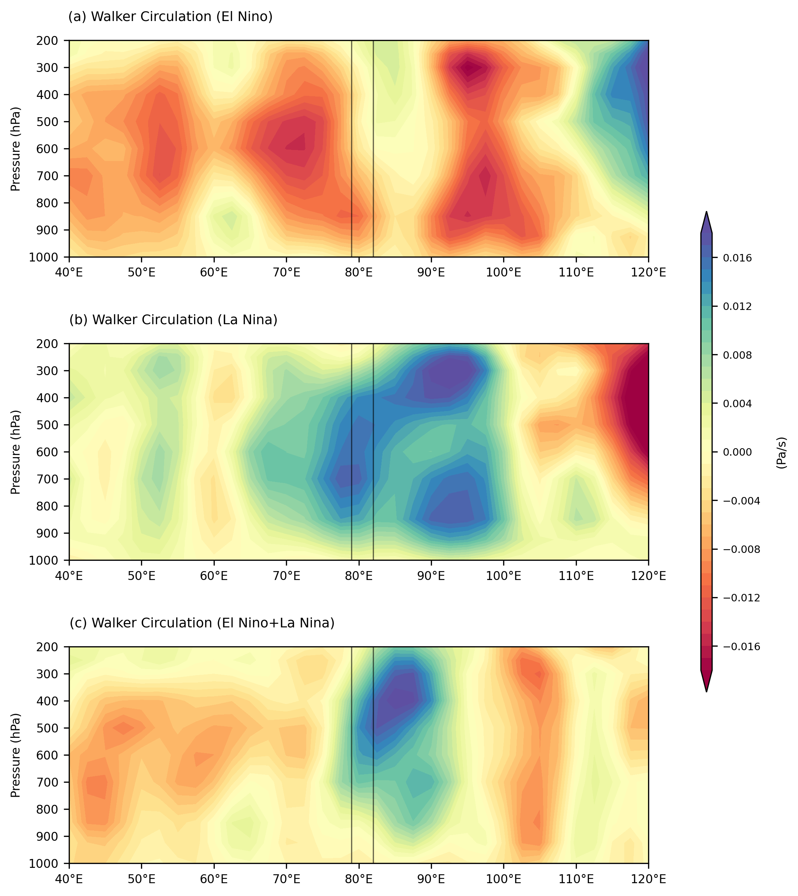
Fig. S4 a) Composite of walker circulation (averaged over 10º S - 10º N) anomalies for the period of 1981 to 2021 (El Niño peak winter) for a) El Niño events of 1982/83, 1986/87, 1991/92, 1994/95, 1997/98, 2009/10, and 2015/16 and b) La Niña events of 1984/85, 1988/89, 1998/99, 1999/00, 2007/08, and 2010/11, 2020/21, and 2021/22, c) asymmetric part was calculated by summation of El Niño and La Niña. In addition, thick black boxes represent the Sri Lanka domain.

