Plant functional traits of Dasiphora fruticosa shrub have a stronger response to soil properties in Qinghai-Tibet Plateau, China
Alpine Botany
Yiyao Liu^{1,2}, Jingyao Suo^{1,2}, Xiang Xiang^{1,2}, Kuan Chen^{1,2}, Yinduo Zhang^{1,2}, Jie Zhang^{1,2} & Yongmei Huang^{1,2✉}
¹ Beijing Key Laboratory of Traditional Chinese Medicine Protection and Utilization, Faculty of Geographical Science, Beijing Normal University, Beijing 100875, China.
² School of Natural Resources, Faculty of Geographical Science, Beijing Normal University, Beijing 100875, China.
✉email: ymhuang@bnu.edu.cn
Supplementary Information

Table S1. Location and altitude information of sampling points (sorted by sampling time).
Points | Altitude (m) | Altitude gradient (m) | Latitude (°N) | Longitude (°E)
1 | 2563 | 2550 | 38.5728 | 100.2891
2 | 2768 | 2750 | 38.5508 | 100.2941
3 | 2914 | 2900 | 38.1854 | 100.9362
4 | 3112 | 3100 | 38.1320 | 100.9207
5 | 3158 | 3150 | 38.0985 | 100.9235
6 | 3277 | 3300 | 37.6680 | 100.0910
7 | 3796 | 3800 | 37.7081 | 100.9315
8 | 3677 | 3700 | 37.5884 | 100.4631
9 | 3550 | 3550 | 37.5545 | 100.4353
10 | 3548 | 3550 | 37.4332 | 100.2594
11 | 4222 | 4200 | 38.2988 | 98.2701
12 | 3973 | 3950 | 37.8867 | 98.4080
13 | 3503 | 3500 | 37.5207 | 100.1018
14 | 3981 | 4000 | 37.6778 | 98.7515
15 | 4591 | 4600 | 34.0006 | 97.4645
16 | 4350 | 4350 | 32.8936 | 96.7190
17 | 4300 | 4300 | 31.6681 | 94.8415
18 | 5000 | 5000 | 31.9836 | 85.6892
19 | 5100 | 5100 | 32.5558 | 91.8334
20 | 4247 | 4250 | 29.2009 | 87.3619
21 | 4508 | 4500 | 29.3304 | 86.9657
22 | 4889 | 4900 | 29.4693 | 85.9733
23 | 5145 | 5150 | 31.3674 | 85.1996
24 | 5188 | 5200 | 30.0359 | 85.6563

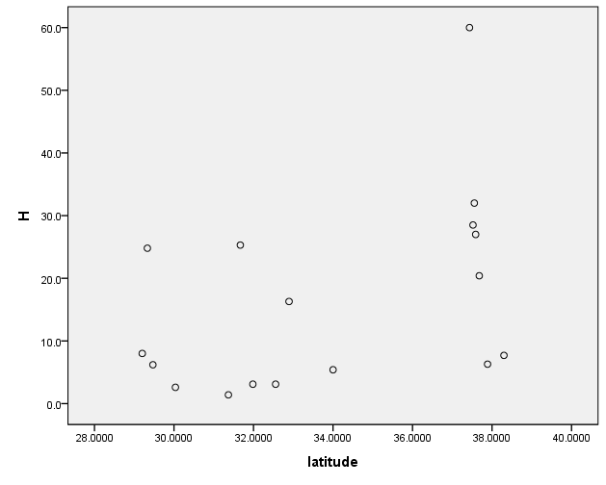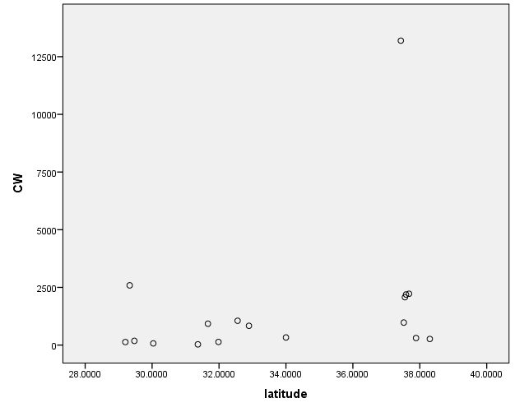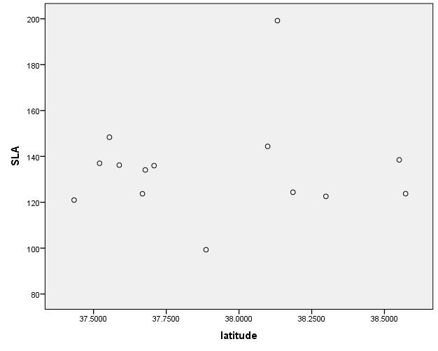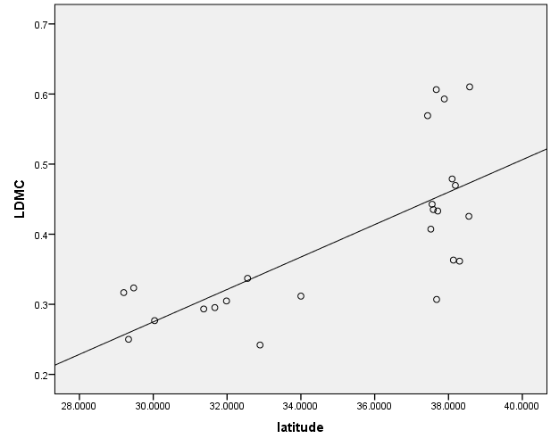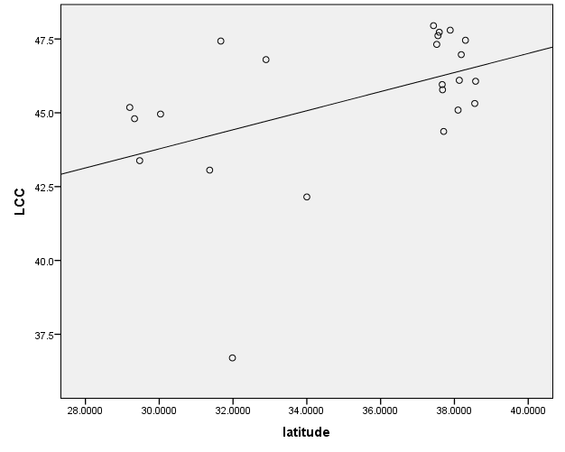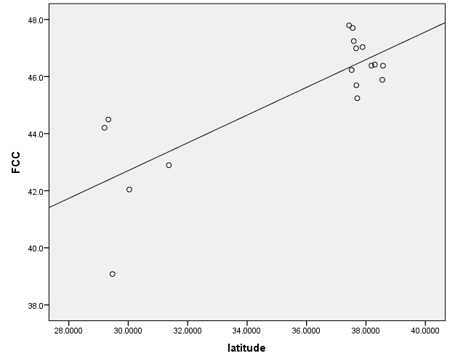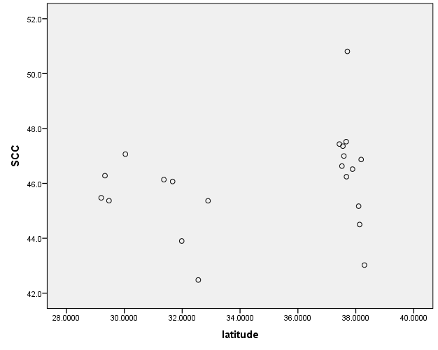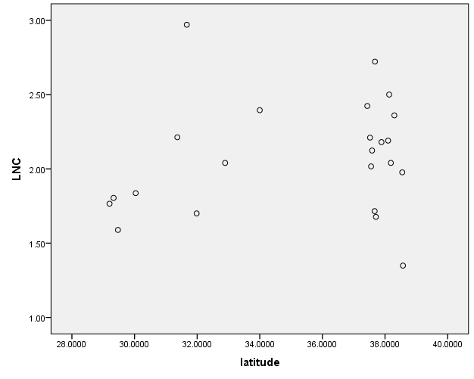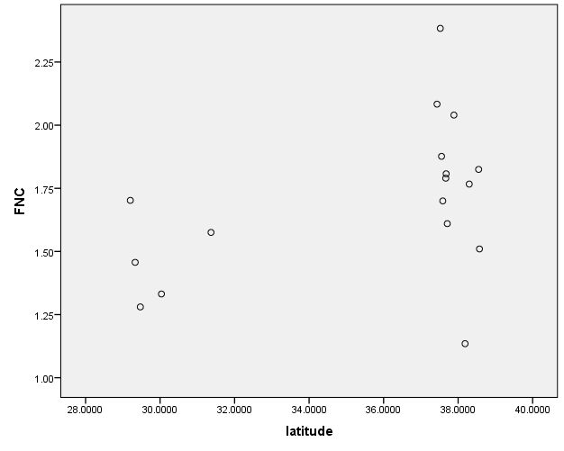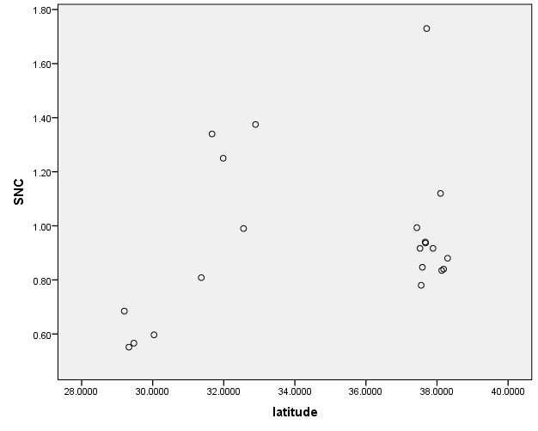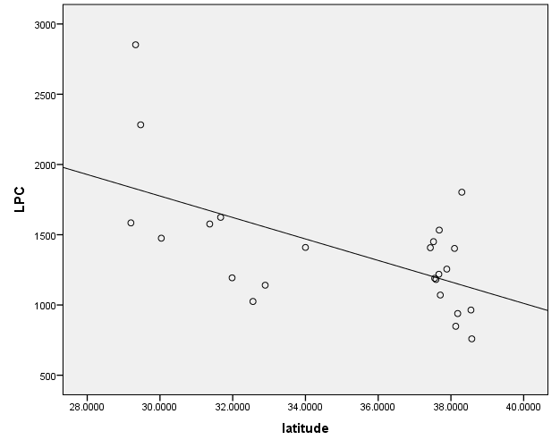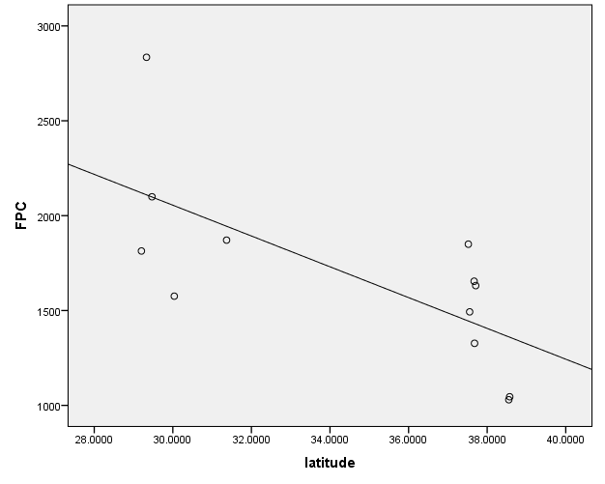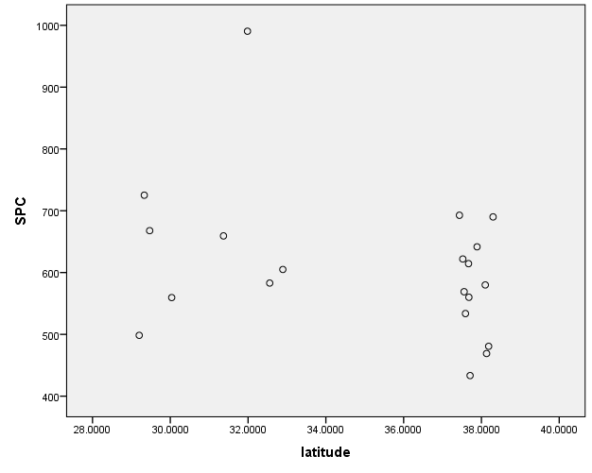
Figure S1. Variation in traits of Dasiphora fruticosa with latitude

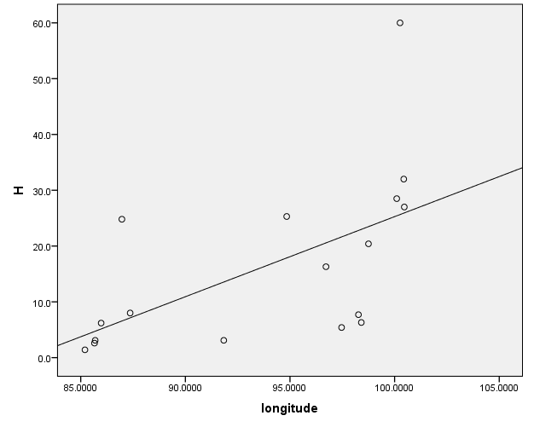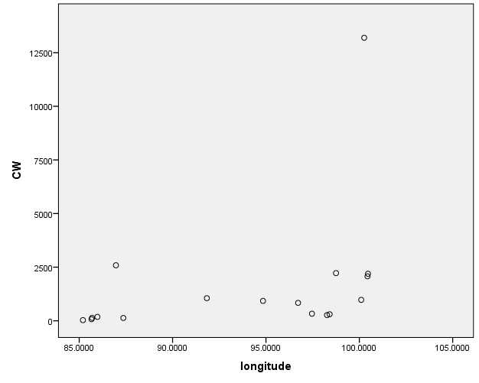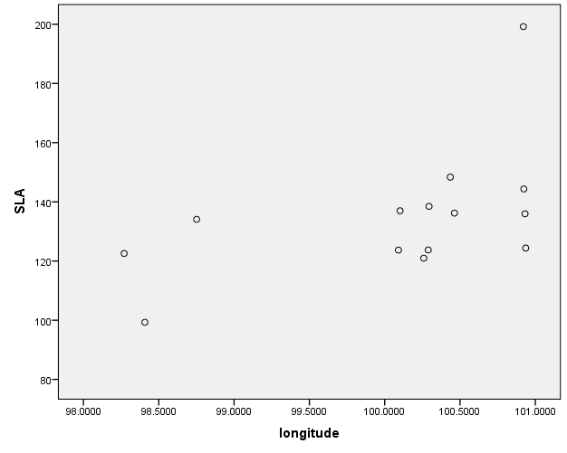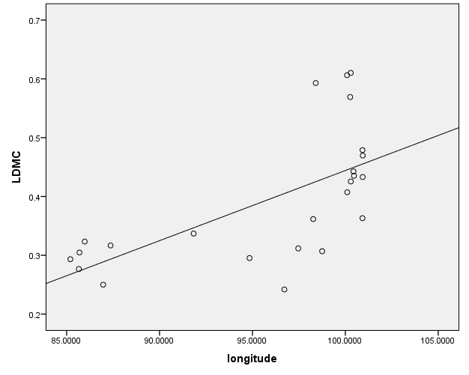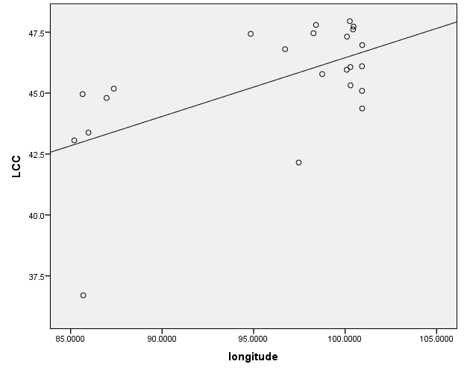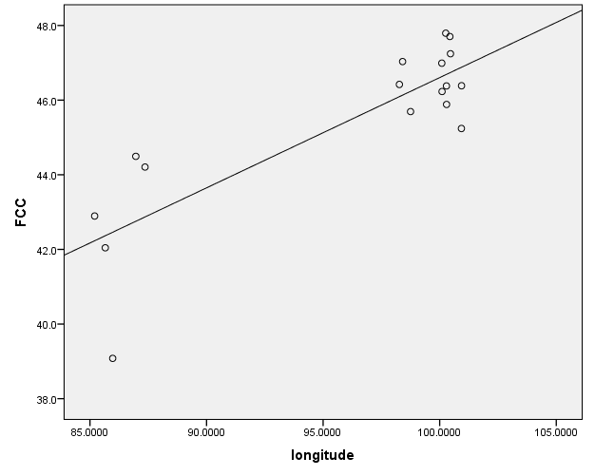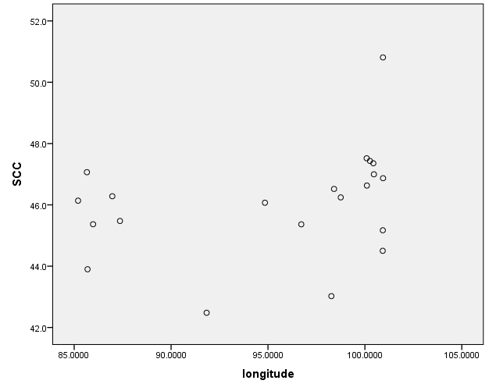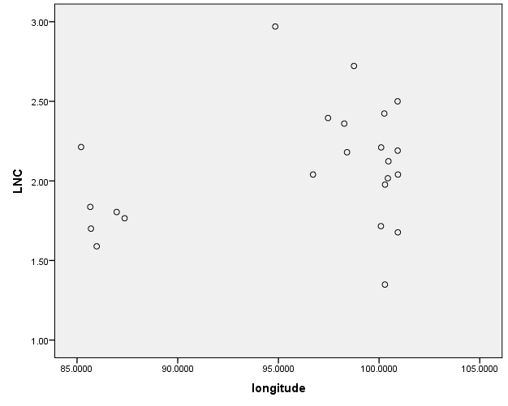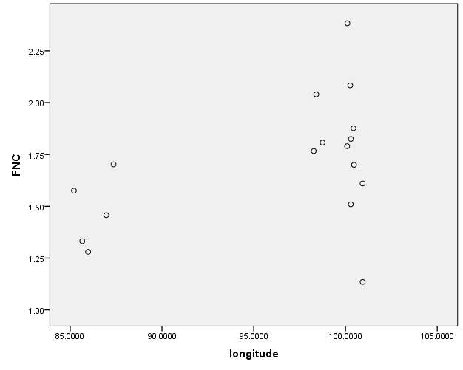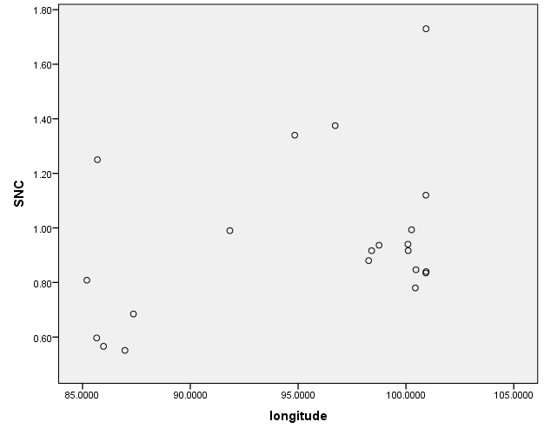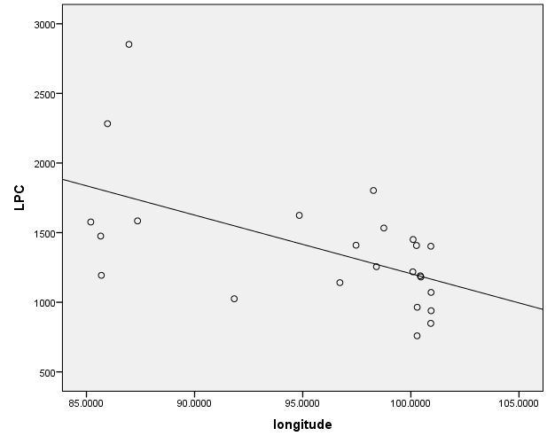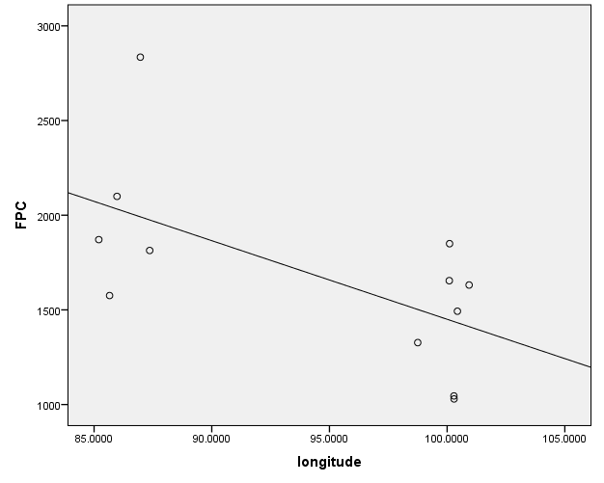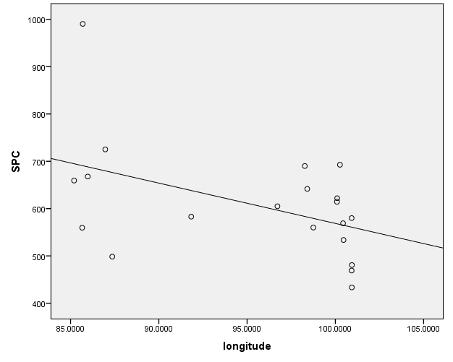
Figure S2. Variation in traits of Dasiphora fruticosa with longitude

Table S2. Spearman's correlations between altitude and other environmental factors.
Environmental factors | Correlation coefficient with altitude | P
MAP | -0.106 | 0.622
MAT | 0.085 | 0.692
pH | -0.140 | 0.514
SOC | -0.401 | 0.052
TN | -0.454* | 0.026
TP | -0.629** | 0.001
TK | -0.543** | 0.006
CEC | -0.550** | 0.005
CF | 0.295 | 0.162
Sand | 0.850** | 0.000
Silt | -0.875** | 0.000
Clay | -0.166 | 0.439
BD | 0.527** | 0.008
Thick | -0.517** | 0.010
* P < 0.05, ** P < 0.01, *** P < 0.001.

Figure S3. Principal component analysis of soil properties

Table S3. Component score coefficient of soil properties in PCA.
Soil properties | PC1 | PC2 | PC3
pH | -0.553 | -0.549 | 0.542
SOC | 0.938 | 0.079 | -0.254
TN | 0.949 | 0.076 | -0.163
TP | 0.938 | 0.017 | 0.013
TK | 0.374 | 0.516 | 0.711
CEC | 0.884 | 0.309 | 0.131
CF | -0.302 | 0.829 | 0.058
Sand | -0.926 | 0.196 | -0.260
Silt | 0.897 | -0.191 | 0.359
Clay | 0.767 | -0.163 | -0.331
BD | -0.893 | -0.156 | 0.031
Thick | 0.465 | -0.739 | 0.075

Figure S4. Principal component analysis of plant functional traits of Dasiphora fruticosa

Table S4. Component score coefficient of plant functional traits in PCA.
Traits | PC1 | PC2 | PC3
LDMC | 0.731 | -0.256 | 0.388
SLA | 0.465 | 0.211 | -0.497
H | 0.852 | -0.003 | 0.240
CW | 0.679 | 0.034 | 0.413
LCC | 0.661 | 0.398 | 0.155
LNC | 0.186 | 0.780 | -0.352
LPC | -0.592 | 0.434 | 0.510
FCC | 0.845 | 0.261 | 0.053
FNC | 0.502 | 0.578 | 0.065
FPC | -0.771 | 0.269 | 0.307
SCC | 0.512 | -0.356 | 0.316
SNC | 0.279 | -0.248 | -0.364
SPC | -0.581 | .0232 | 0.300

