Supplementary material

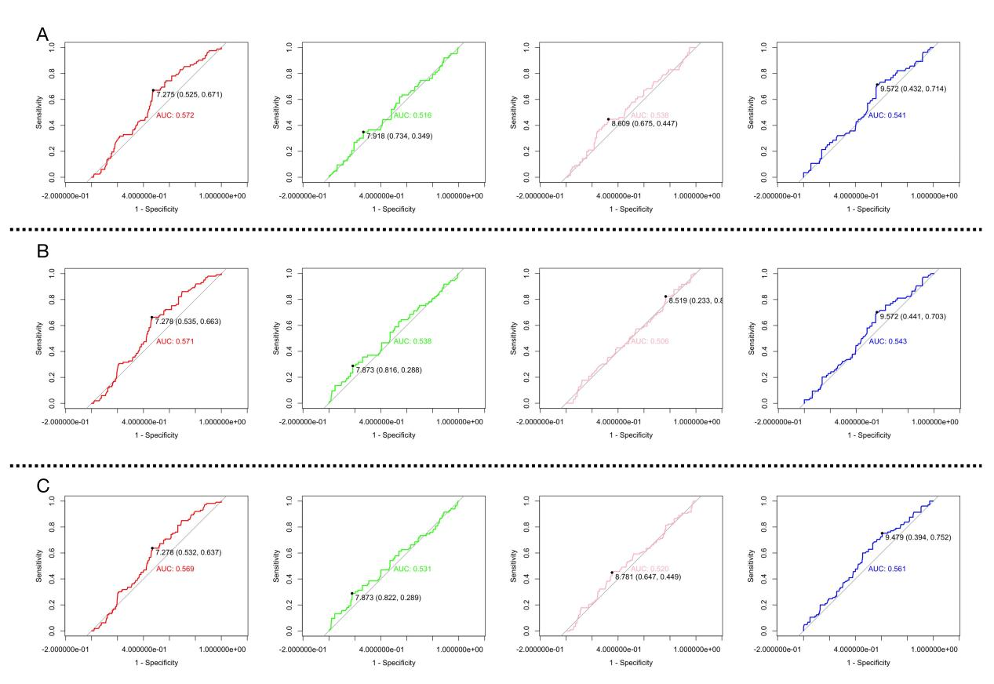
Fig.S1. Receiver operating characteristic (ROC) curve of TabCI in patients with severe ischemic stroke
- 90 days. B. 180 days. C. 1 year

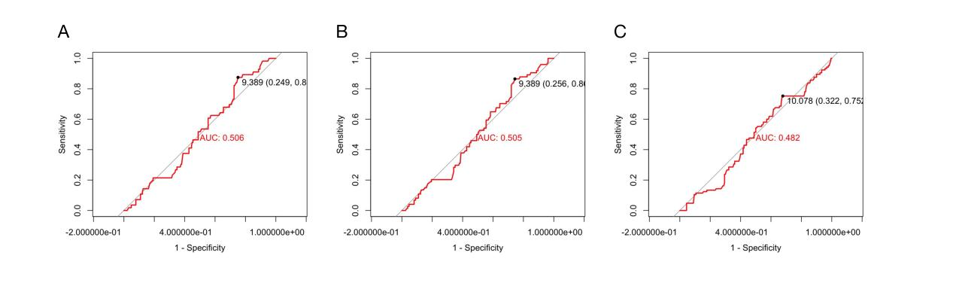
Fig.S2. Receiver operating characteristic (ROC) curve of TyG in patients with severe ischemic stroke
- 90 days. B. 180 days. C. 1 year

