Appl.² | SEEDLING CHARACTERS
Appl.² | SL  (mm) | RL  (mm) | FSW  (g) | NL  (pcs) | FRW  (g) | DSW  (g) | DRW  (g) | LW  (mm) | LL  (mm)
1 | 23.83±2.16^{AB1} | 11.82±1.13^{AB} | 1.3253±0.05^{B} | 5.90±0.20^{AB} | 0.18226±0.02^{B-E} | 0.10506±0.01^{BC} | 0.01819±0.003^{CD} | 9.244±1.211^{C} | 24.769±2.696^{C}
2 | 22.71±1.21^{A-C} | 11.10±1.04^{A-D} | 1.39179±0.19^{B} | 6.00±0.00^{A} | 0.20138±0.078^{A-C} | 0.10523±0.01^{BC} | 0.02139±0.006^{BC} | 12.975±1.671^{A} | 31.159±1.650^{AB}
3 | 24.81±1.38^{A} | 12.40±0.47^{A} | 1.66033±0.18^{A} | 6.00±0.00^{A} | 0.30879±0.015^{A} | 0.12750±0.01^{A} | 0.03887±0.014^{A} | 13.582±2.163^{A} | 33.435±5.769^{A}
4 | 19.79±0.89^{C-E} | 9.69±0.73^{E-G} | 0.85627±0.22^{C} | 5.20±0.57^{BC} | 0.07555±0.023^{EF} | 0.06461±0.01^{D} | 0.00801±0.002^{EF} | 12.778±1.623^{A} | 31.271±2.333^{AB}
5 | 17.40±0.75^{EF} | 9.58±0.78^{FG} | 0.65802±0.07^{CD} | 4.55±0.44^{C} | 0.08376±0.023^{D-F} | 0.05108±0.01^{D} | 0.00973±0.003^{D-F} | 8.792±1.277^{CD} | 19.740±1.841^{D}
6 | 23.97±2.17^{AB} | 11.31±1.79^{A-C} | 1.3578±0.22^{B} | 5.80±0.40^{AB} | 0.19387±0.06^{B-D} | 0.11169±0.02^{A-C} | 0.02187±0.007^{BC} | 11.964±1.644^{AB} | 26.913±3.490^{BC}
7 | 22.87±0.55^{BC} | 10.99±0.51^{B-E} | 1.49496±0.06^{AB} | 6.00±0.00^{A} | 0.24158±0.03^{A-C} | 0.12090±0.01^{AB} | 0.02924±0.004^{AB} | 12.368±3.002^{AB} | 27.680±4.145^{BC}
8 | 18.17±1.61DE | 8.16±1.25^{H} | 0.80695±0.21^{C} | 4.55±1.24^{C} | 0.07375±0.02^{EF} | 0.05869±0.01^{D} | 0.00745±0.002^{EF} | 12.294±2.551^{AB} | 28.527±2.771^{BC}
9 | 14.78±1.62^{F} | 8.48±1.18^{GH} | 0.40921±0.12^{D} | 3.15±0.87^{D} | 0.05309±0.01^{F} | 0.03165±0.01E | 0.00586±0.001^{F} | 6.479±1.851^{D} | 15.442±1.992^{D}
10 | 22.58±0.31^{BC} | 11.65±0.50^{A-C} | 1.32194±0.19^{B} | 6.00±0.00^{A} | 0.1784±0.04^{B-E} | 0.10567±0.01^{BC} | 0.01980±0.008^{BC} | 9.975±1.531^{BC} | 24.613±4.799^{C}
11 | 20.90±0.30^{CD} | 9.81±0.22^{D-G} | 1.28249±0.14^{B} | 5.80±0.40^{AB} | 0.14749±0.05^{C-F} | 0.09798±0.01^{C} | 0.01623±0.008^{C-E} | 12.028±2.257^{AB} | 30.778±3.117^{AB}
12 | 21.53±1.25^{BC} | 10.35±0.60^{C-F} | 1.43051±0.37^{A} | 6.00±0.00^{A} | 0.21715±0.01^{A-C} | 0.12062±0.02^{AB} | 0.02472±0.008^{BC} | 12.293±1.094^{AB} | 29.960±5.700^{AB}
13 | 23.23±1.69^{B} | 11.59±1.81^{A-C} | 1.31466±0.15^{B} | 6.00±0.00^{A} | 0.28388±0.23^{AB} | 0.09959±0.01^{C} | 0.01898±0.008^{CD} | 13.670±1.172^{A} | 28.308±2.269^{BC}
^{LSD}_{(0.05)} | 1.9152 | 0.6882 | 0.1294 | 0.2624 | 0.1229 | 0.0202 | 0.0105 | 2.6329 | 5.2296
Table 3. Average values and difference grouping of the investigated characters.

¹The difference between means indicated by the same letter is statistically insignificant.
²1-Control, 2-0.25% EMS-6hr, 3-0.25% EMS-12hr, 4-0.25% EMS-24hr, 5-0.25% EMS-48hr, 6-0.50% EMS-6hr, 7-0.50% EMS-12hr, 8-0.50% EMS-24hr, 9-0.50% EMS-48hr, 10-0.75% EMS-6hr, 11-0.75% EMS-12hr, 12-1.00% EMS-6hr, 13-1.00% EMS-12hr

Table 4.The observed correlation coefficients among the characters examined in control group plants¹
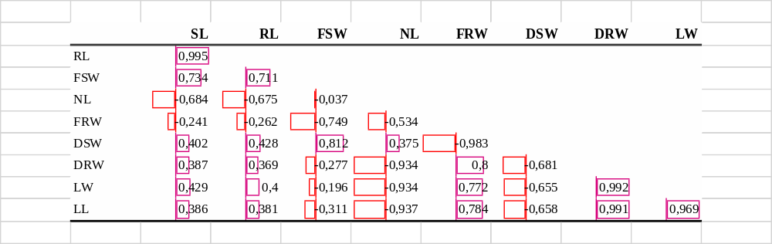
¹Correlation Coefficient: 0.00-0.10 negligible correlation, 0.10-0.39 weak correlation, 0.40-0.69 moderate correlation, 0.70-0.89 strong correlation, 0.90-1.00 very strong correlation (Schober et al. 2018).

Table 5. The observed correlation coefficients among the characters examined in plants treated with EMS¹
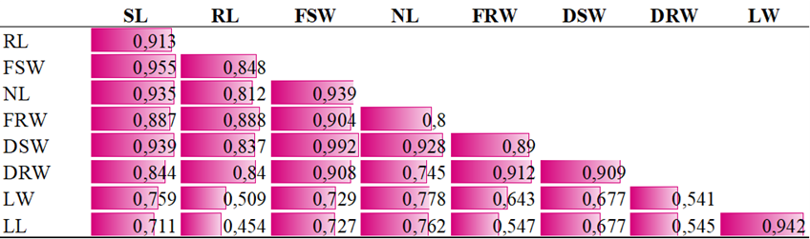
¹Correlation Coefficient: 0.00-0.10 negligible correlation, 0.10-0.39 weak correlation, 0.40-0.69 moderate correlation, 0.70-0.89 strong correlation, 0.90-1.00 very strong correlation (Schober et al. 2018).

