Supplementary Material
"Guanidine Hydrochloride Assisted One-pot Synthesis of 2-Amino-4,6-disubstituted-3-Cyanopyridine Derivatives: A Sustainable and Greener Strategy with Catalyst Recyclability"
Pradeep U. Yadav, Vivek D. Zade, Yatin U. Gadkari*
Institute of Chemical Technology, Mumbai, IndianOil Odisha Campus Bhubaneswar- 751013
*Corresponding author. E-mail: yu.gadkari@iocb.ictmumbai.edu.in

Table of Contents

Sr. No | Content | Page No.
1 | Materials and methods | 2
2 | General procedure for the 2-Amino-4,6-(disubstituted)nicotinonitriles | 2
3 | Spectral data of synthesized compounds | 3-4
4 | NMR spectra of synthesized compounds | 5-21
5 | Eco scale calculations | 22
6 | References | 23

- Experimental:

1.1. Materials and methods:
All solvents and chemicals utilized in this study were procured from reliable vendors, such as Spectrochem, Avra, Eurisotop, Sigma Aldrich, and SD Fine Chemicals, and used as received, without any further purification. The purity of the starting materials and progress of the reaction was determined by using Merk silica gel G254 0.22mm plates, and visualized under UV light at a wavelength of 254nm. H1 and C 13 NMR spectra were recorded on a 400 MHz NMR spectrometer from Bruker NMR instrument Technologies, utilizing tetramethylsilane (TMS) as an internal standard and either CDCl3 or DMSO-d6 as a deuterated solvent. The melting point (MP) of compounds were analyzed using the Analab ThermoCal melting point apparatus, employing one-end open capillary tubes.
2 General procedure for the synthesis of 2-amino-3,4-diphenyl-3-cyanopyridines
A mixture of aldehyde (2 mmol), aryl ketone (2 mmol), malononitrile (2 mmol), ammonium acetate (3 mmol), and Guanidine hydrochloride (10 mole %) in solvent-free conditions was added in a round bottom flask (RBF) and stirred using a magnetic stirrer at 80⁰C for 30 -45 min. The progress of the reaction was monitored every 15 minutes by TLC (n-Hexane: Ethyl acetate 8:2). After completion of the reaction, the reaction mixture was cooled at room temperature followed by a water wash and filtered. The residue was dried under a vacuum and was recrystallized from ethanol to afford the desired pure product. Also, the filtrate was dried under vacuum till complete evacuation of water, and crystals of Guanidine HCl were recovered and reused.

3. Spectral data of synthesized compounds
2-Amino-4,6-diphenyl-nicotinonitrile (5a)
White Solid; M.P. 184-186 ⁰C (Lit [1] 183-185 ⁰C) ¹H NMR (400 MHz, CDCl₃) δ 7.94 (d, J = 2.8 Hz, 2H), 7.57 (d, J = 5.6 Hz, 2H), 7.42 (d, J = 19.2 Hz, 6H), 7.14 (s, 1H), 5.29 (s, 2H) ; ¹³C NMR (101 MHz, CDCl₃) δ 160.40, 159.97, 155.27, 138.08, 137.06, 130.33, 129.95, 129.06, 128.93, 128.30, 127.46, 117.26, 111.40, 88.43.
2-Amino-4-(4-Chlorophenyl)-6-phenylnicotinonitrile (5b)
White solid; M.P. 190-192 ⁰C (Lit [2] 188-190 ⁰C) ¹H NMR (400 MHz, CDCl₃) δ 7.96 – 7.88 (m, 2H), 7.50 (d, J = 2.1 Hz, 1H), 7.44 (s, 1H), 7.43 – 7.36 (m, 4H), 7.19 (s, 1H), 7.10 (s, 1H), 5.32 (s, 2H).
2-amino-4-(3-chlorophenyl)-6-phenylnicotinonitrile (5c)
Yellow Solid; M.P. 170-172 ⁰C (Lit[3] 168-170 ⁰C) ¹H NMR (400 MHz, CDCl₃) δ 8.04 – 7.97 (m, 2H), 7.59 (s, 1H), 7.54 (d, J = 6.8 Hz, 1H), 7.50 – 7.45 (m, 4H), 7.26 (s, 1H), 7.18 (s, 1H), 5.38 (s, 2H).
2-amino-4-(2-chlorophenyl)-6-phenylnicotinonitrile (5d)
White Solid; M.P. 194-196 ⁰C (Lit[3] 193-196 ⁰C) ¹H NMR (400 MHz, CDCl₃) δ 7.83 (d, J = 48.8 Hz, 2H), 7.61 – 7.17 (m, 7H), 7.07 (s, 1H), 5.48 (s, 2H).
2-amino-6-(4-methoxyphenyl)-4-phenylnicotinonitrile (5e)
White Solid; M.P. 170-172 ⁰C (Lit[4] 170 ⁰C) ¹H NMR (400 MHz, CDCl₃) δ 7.91 (d, J = 8.9 Hz, 2H), 7.56 (d, J = 9.6 Hz, 2H), 7.49 – 7.40 (m, 3H), 7.08 (s, 1H), 6.92 (d, J = 8.9 Hz, 2H), 5.26 (s, 2H), 3.80 (s, 3H).
2-amino-4-(3-methoxyphenyl)-6-phenylnicotinonitrile (5f)
Yellow Solid; M.P. 146-148 ⁰C (Lit[5] 145-147 ⁰C) ¹H NMR (400 MHz, CDCl₃) δ 8.00 (d, J = 7.9 Hz, 2H), 7.49 – 7.41 (m, 3H), 7.29 – 7.14 (m, 4H), 7.04 (dd, J = 8.3, 2.5 Hz, 1H), 5.36 (s, 2H), 3.89 (s, 3H); ¹³C NMR (101 MHz, CDCl₃) δ 160.37, 159.96, 155.12, 138.34, 138.05, 130.34, 130.18, 128.94, 127.46, 120.63, 117.22, 115.69, 113.78, 111.34, 88.44, 55.59.
2-amino-4-(3,4-dimethoxyphenyl)-6-phenylnicotinonitrile (5g)
Brown Solid; M.P. 240-242 ⁰C (Lit [6] 249-251⁰C) ¹H NMR (400 MHz, CDCl₃) δ 8.00 (d, J = 9.6 Hz, 2H), 7.54 – 7.42 (m, 3H), 7.28 – 7.22 (m, 1H), 7.21 – 7.16 (m, 2H), 7.00 (d, J = 8.3 Hz, 1H), 5.37 (s, 2H), 3.96 (d, J = 5.6 Hz, 6H).
2-amino-4-(4-methoxyphenyl)-6-phenylnicotinonitrile (5h)
White Solid; M.P. 180-182 ⁰C (Lit[5] 178-180 ⁰C) ¹H NMR (400 MHz, CDCl₃) δ 7.92 (d, J = 8.0 Hz, 2H), 7.54 (d, J = 8.9 Hz, 2H), 7.40 (d, J = 7.3 Hz, 3H), 7.12 (s, 1H), 6.97 (d, J = 8.9 Hz, 2H), 5.28 (s, 2H), 3.81 (s, 3H).
2-amino-6-phenyl-4-(thiophen-3-yl)-nicotinonitrile (5i)
White Solid; M.P. 211-213 ⁰C (Lit[5] 212-215 ⁰C) ¹H NMR (400 MHz, CDCl₃) δ 8.06 – 7.80 (m, 3H), 7.57 – 7.39 (m, 4H), 7.28 (d, J = 17.2 Hz, 1H), 7.24 – 7.16 (m, 1H), 5.37 (s, 2H).
2-amino-6-phenyl-4-(p-tolyl)nicotinonitrile (5j)
White Solid; M.P. 220-222 ⁰C (Lit[5] 216-219 ⁰C) ¹H NMR (400 MHz, CDCl₃) δ 7.99 (d, J = 7.9 Hz, 2H), 7.54 (d, J = 8.1 Hz, 2H), 7.47 (dd, J = 5.1, 2.2 Hz, 3H), 7.33 (d, J = 7.9 Hz, 2H), 7.20 (s, 1H), 5.35 (s, 2H), 2.44 (s, 3H); ¹³C NMR (101 MHz, CDCl₃) δ 160.43, 159.86, 155.28, 140.20, 138.14, 134.15, 130.25, 129.75, 128.90, 128.18, 127.44, 117.43, 111.28, 88.33, 21.48.
2-amino-6-(4-chlorophenyl)-4-phenylnicotinonitrile (5k)
Yellow Solid; M.P. 240-242 ⁰C (Lit [7] 248-250 ⁰C) ¹H NMR (400 MHz, CDCl₃) δ 7.89 (d, J = 8.7 Hz, 2H), 7.57 – 7.54 (m, 2H), 7.45 (dd, J = 5.1, 1.9 Hz, 3H), 7.38 (d, J = 8.7 Hz, 2H), 7.11 (s, 1H), 5.30 (s, 2H).
2-amino-6-(4-hydroxyphenyl)-4-phenylnicotinonitrile (5l)
Yellow Solid; M.P. 230-232 ⁰C (Lit [7] 231-233 ⁰C) ¹H NMR (400 MHz, DMSO-d₆) δ 9.97 (s, 1H), 8.01 (d, J = 8.8 Hz, 2H), 7.66 (d, J = 9.5 Hz, 2H), 7.56 – 7.52 (m, 4H), 6.90 – 6.84 (m, 4H).
2-amino-6-(4-bromophenyl)-4-(p-tolyl)nicotinonitrile (5m)
Yellow Solid; M.P. 220-222°C (Lit: [7] 219-221⁰C) ¹H NMR (400 MHz, CDCl₃): δ 8.1 (m, 2H), 7.86-7.59 (m, 4H), 7.36-7.28 (m, 2H), 7.16 (s, 1H), 5.97 (s, 2H), 2.49 (s, 3H).
2-amino-4-(4-nitrophenyl)-6-phenylnicotinonitrile (5n)
White Solid; M.P. 220-222°C (Lit:[8] 219-221⁰C) ¹H NMR (400 MHz, CDCl₃): δ 8.24-8.18 (d, 2 H), 7.96-7.93(s, 2 H), 7.72-7.78 (d, J = 8.6 Hz 3 H), 7.56 (m, 2 H), 7.04 (s 1H), 5.6 (s, 2H)
2-Amino-4-(4-Fluorophenyl)-6-phenylnicotinonitrile (5o)
Yellow Solid; M.P. 218-220°C (Lit:[8] 219-221⁰C) ¹H NMR (400 MHz, DMSO-d₆) δ 8.10-8.14 (m, 2 H), 7.88 (m, 2 H), 7.72-7.76 (d, J = 6.2 Hz, 3 H), 7.54-7.65 (d, J = 8.4 Hz, 2 H), δ7.34(s 1H), 7.02 (s, 2H)
2-amino-6-(p-tolyl)-4-phenyl-nicotinonitrile (5p)
White Solid; M.P. 178-180°C (Lit: [9] 182-183⁰C) ¹H NMR (400 MHz, CDCl₃): δ 7.99 (s, 2H), 7.58 – 7.50 (m, 2H), 7.45 (s, 3H), 7.31 (s, 2H), 7.18 (s, 1H), 5.41 (s, 2H), 2.43 (s, 3H).

4. NMR spectra of synthesized compounds

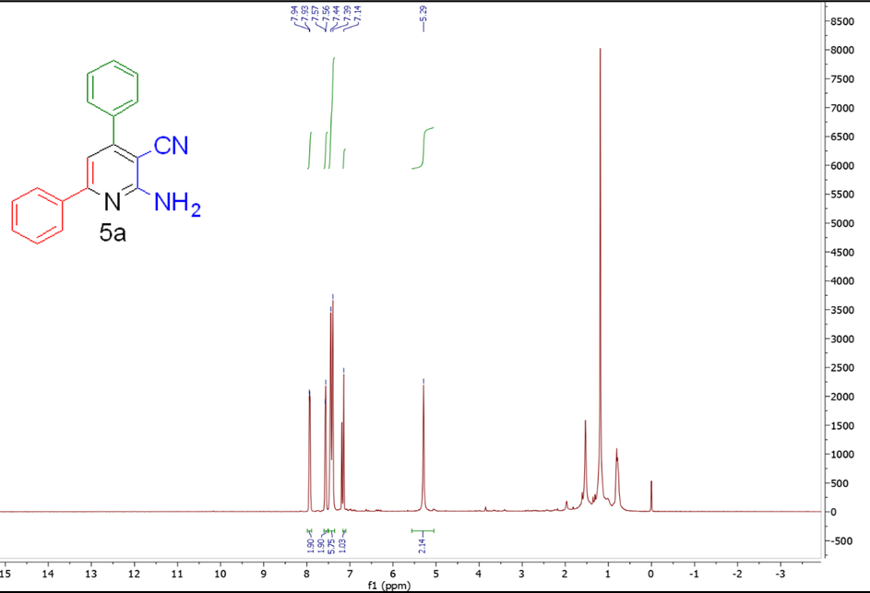

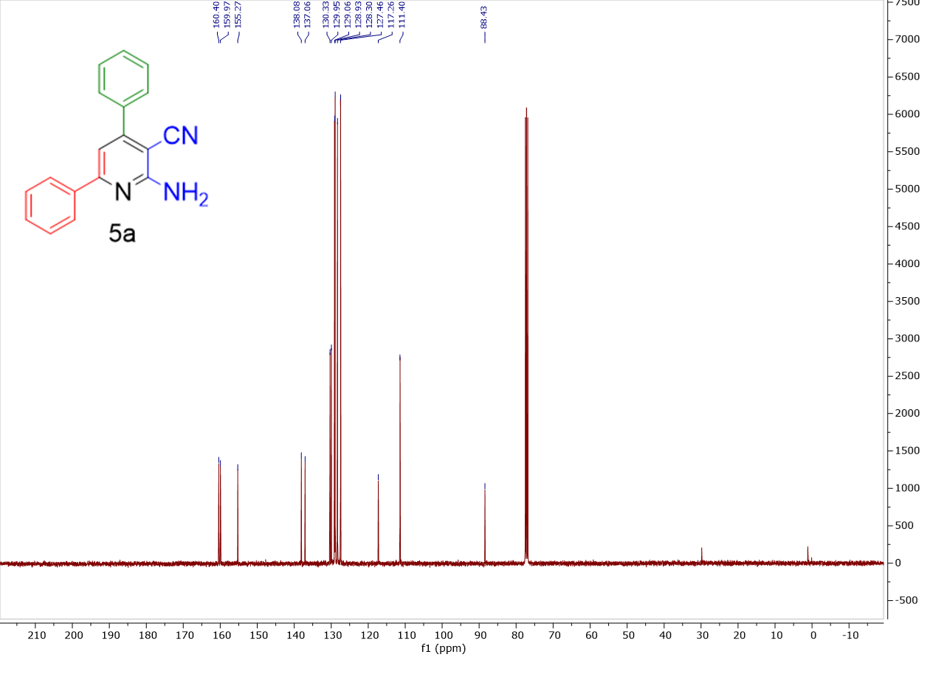

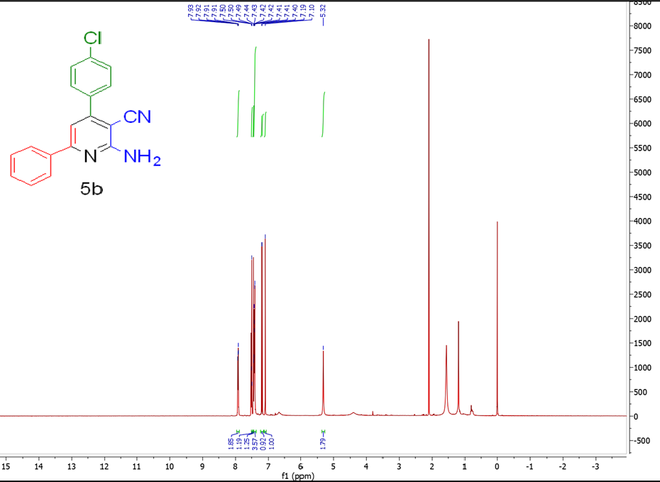

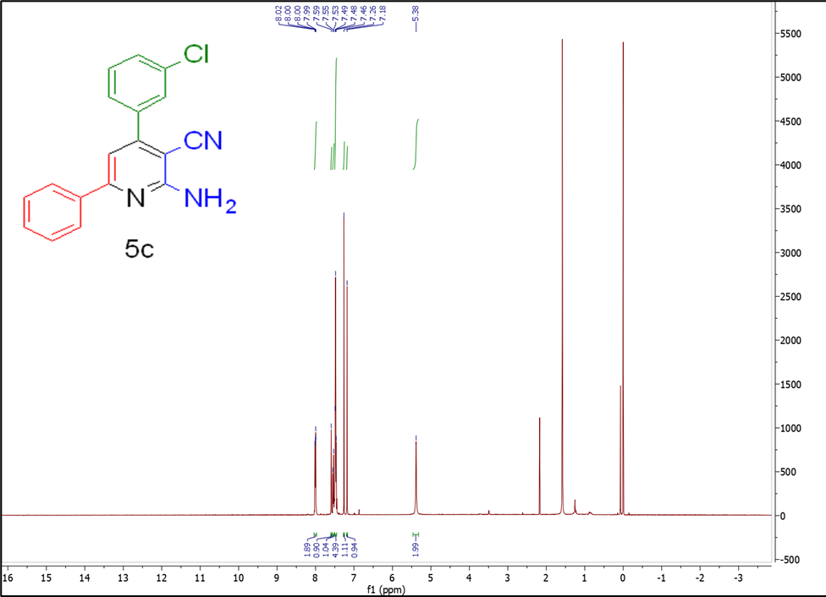

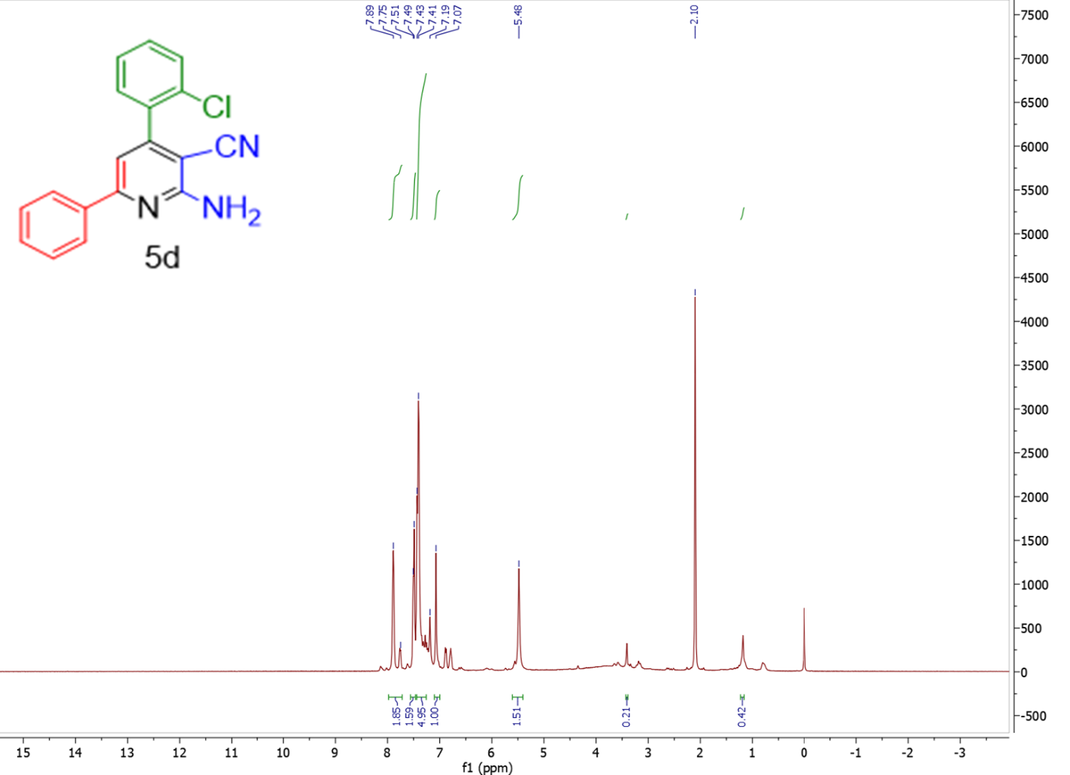

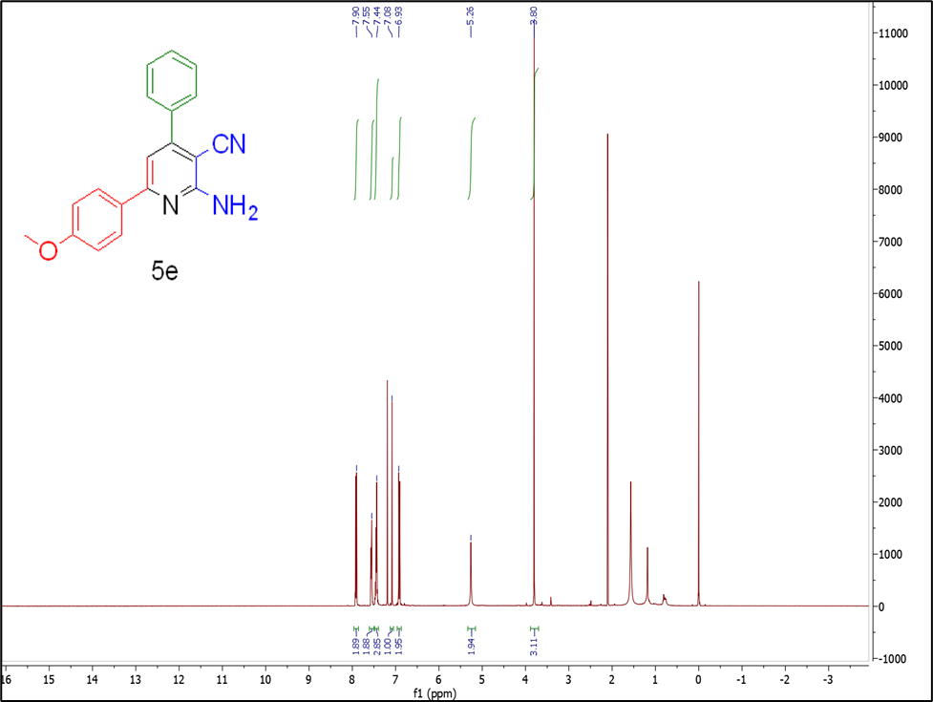

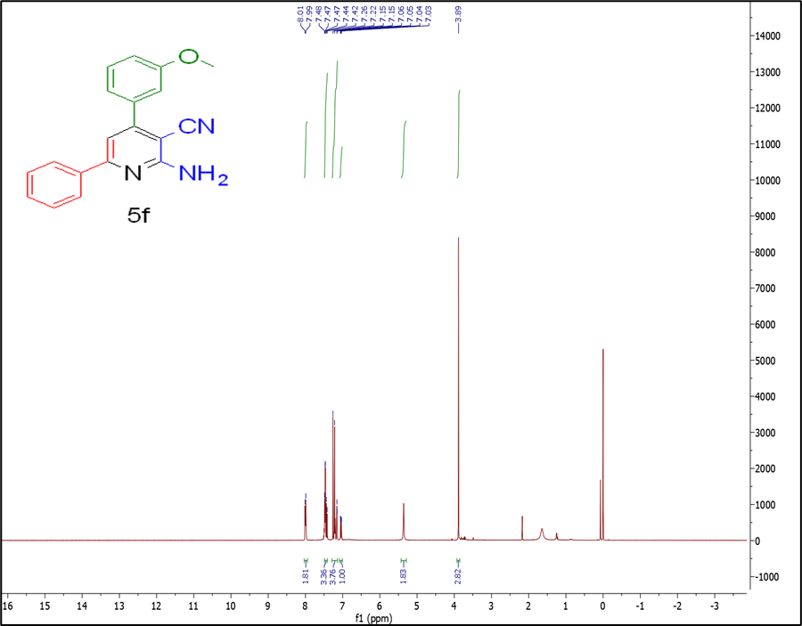

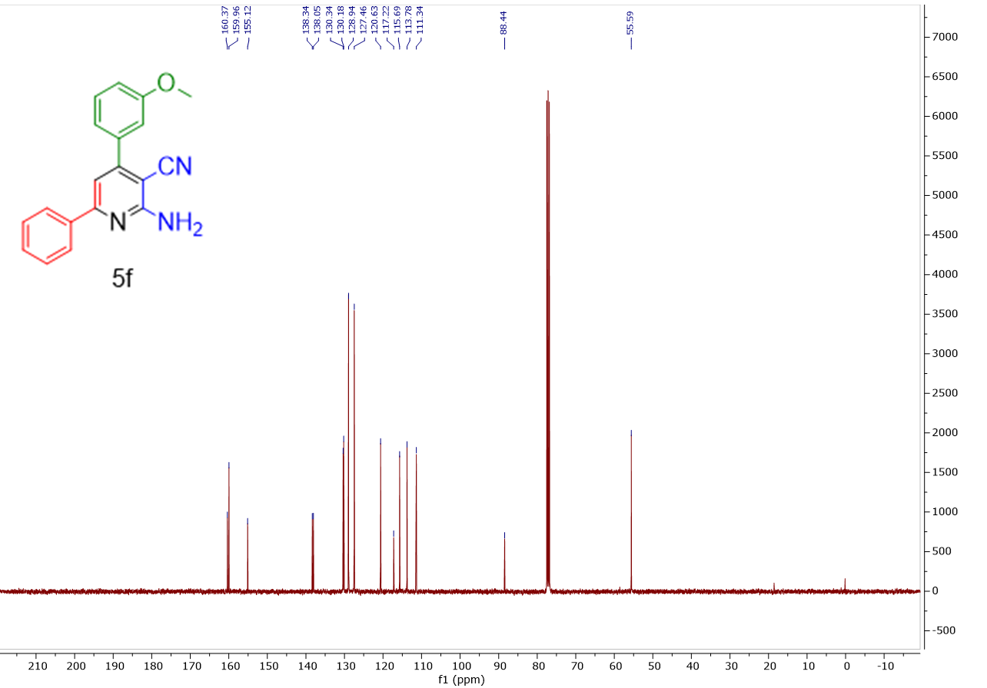

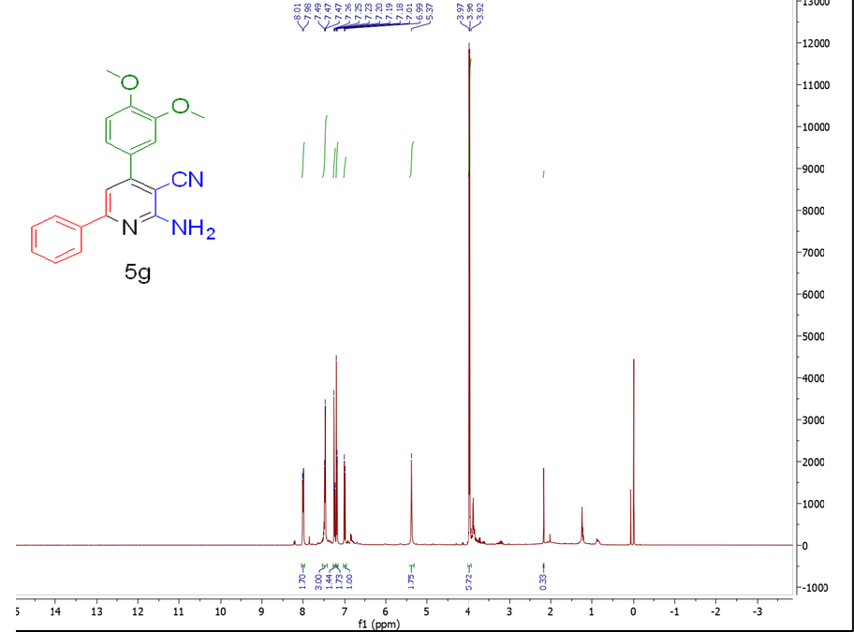

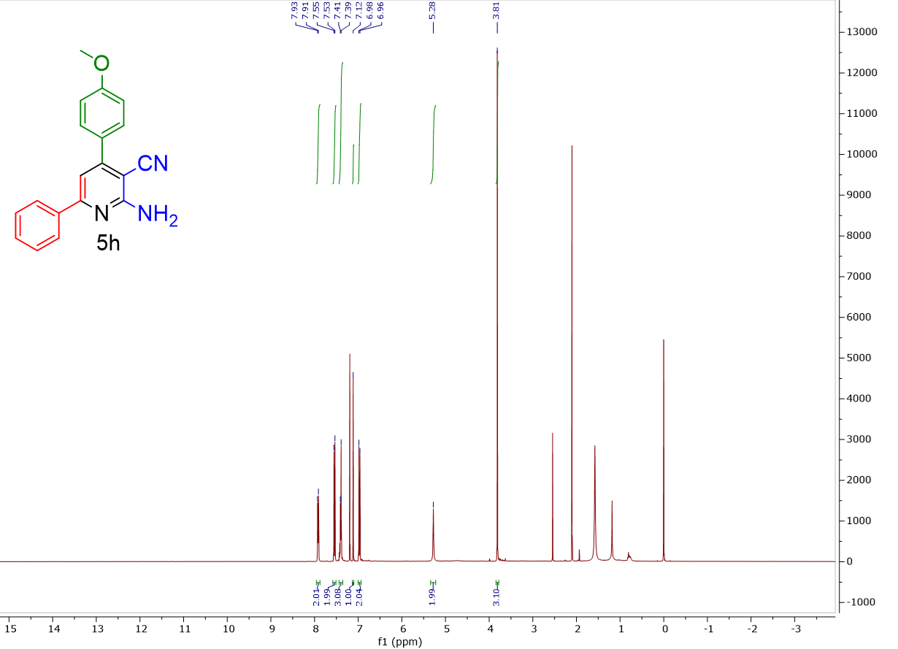

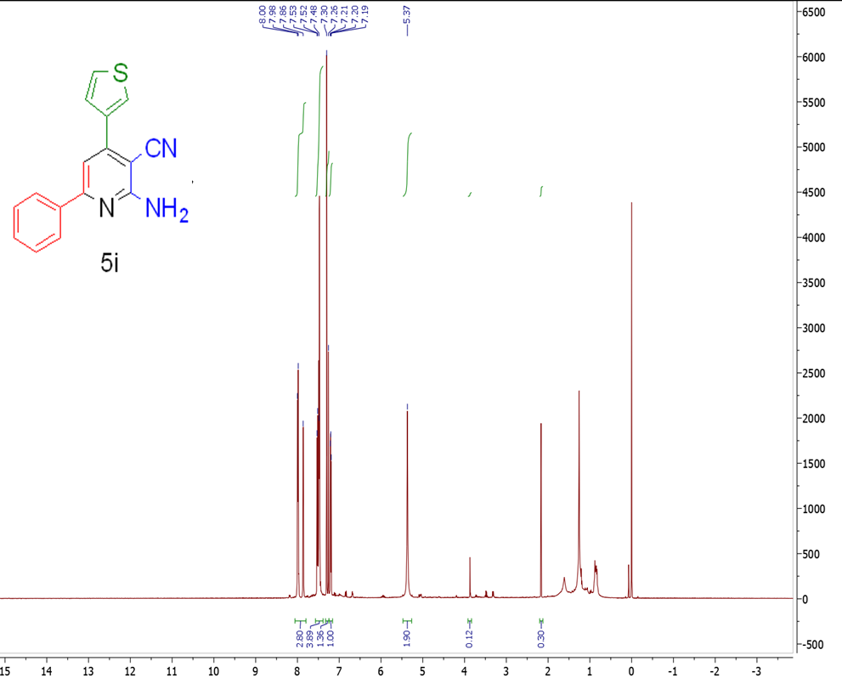

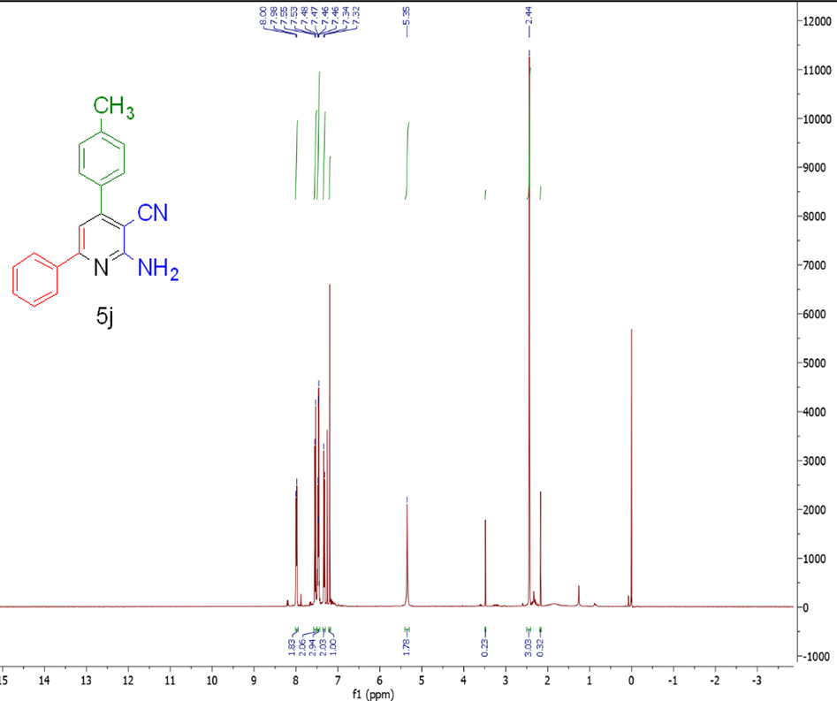

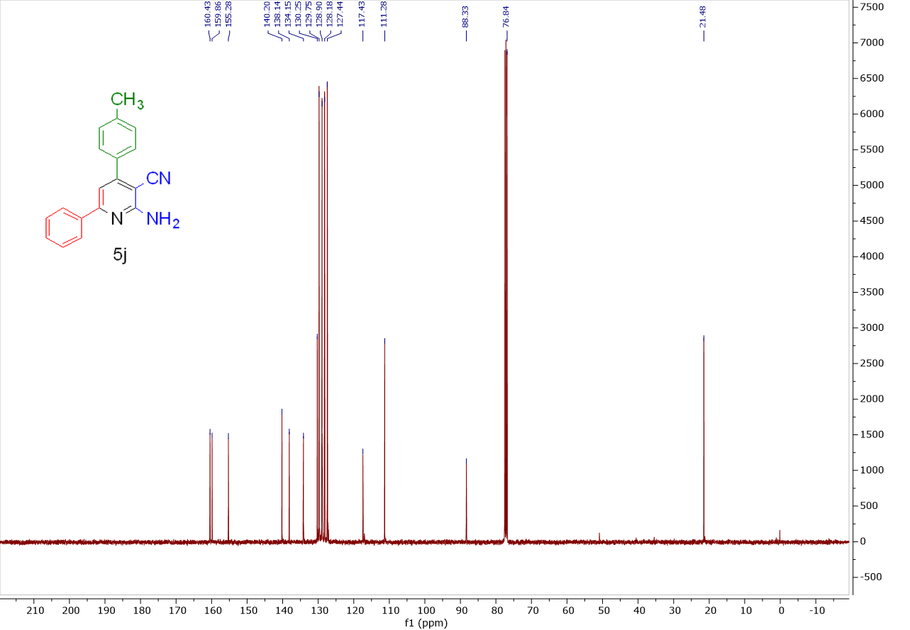

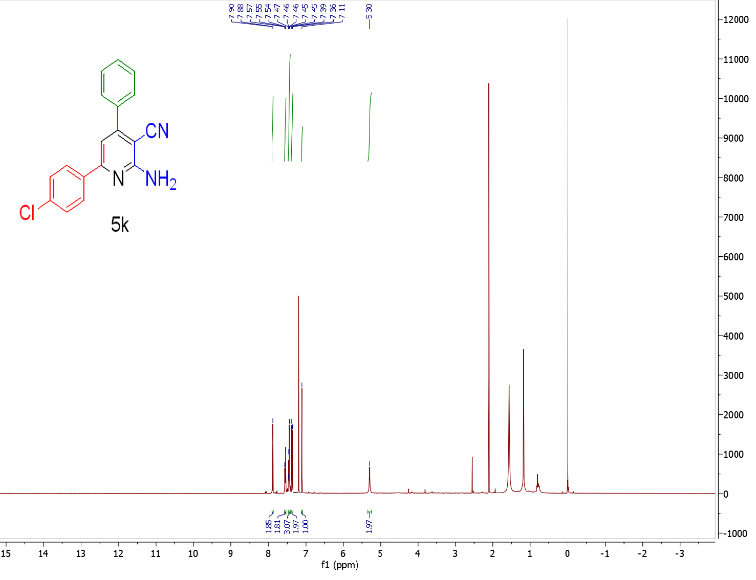

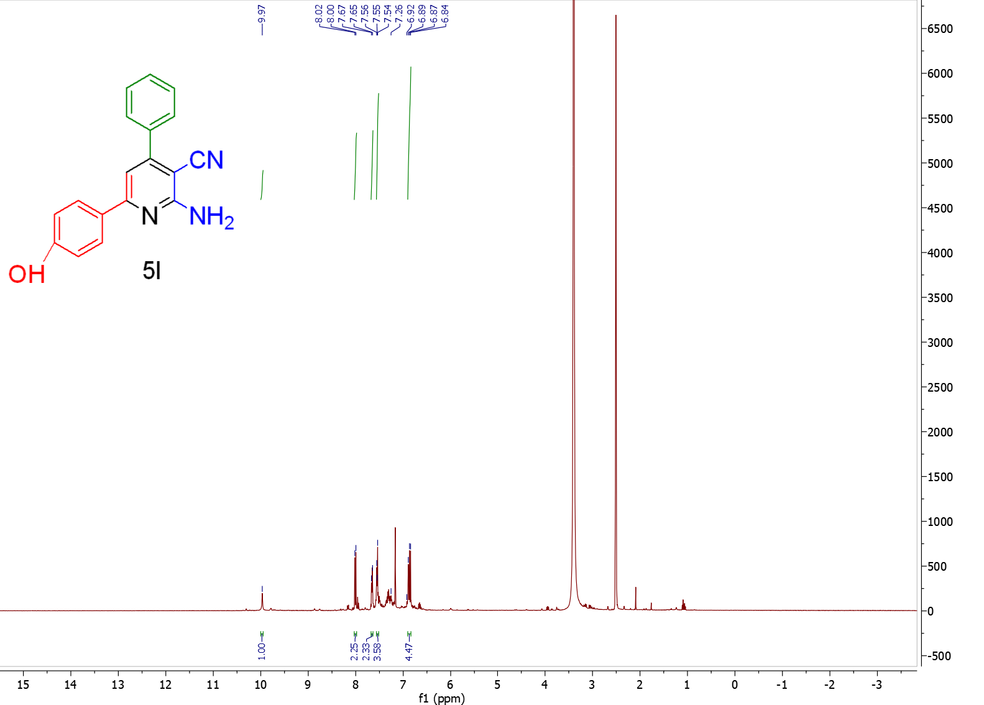

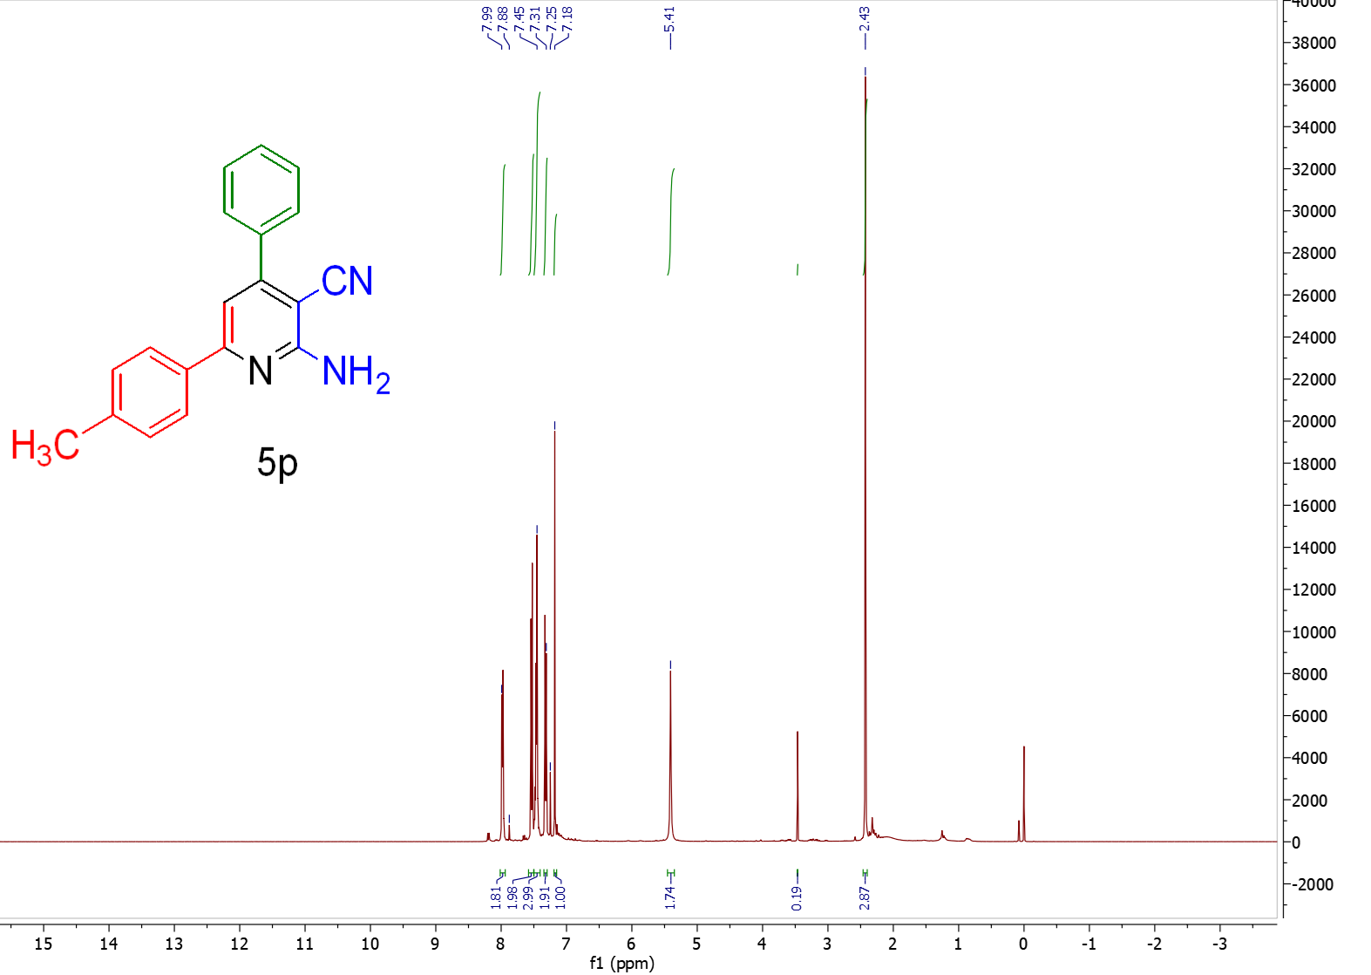

5. Eco-scale calculations

Parameter | Current work |  | Previous work [10]
Parameter | Details | Penalty points | Details | Penalty points
1. Yield | 96% | 2 | 73% | 13.5
2. Cost of reactants to obtain 10 mmol product | Benzaldehyde  Acetophenone  Malononitrile  Ammonium Acetate | 0  0  0  0 | Benzaldehyde  Acetophenone  Malononitrile  Ammonium Acetate | 0  0  0  0
3. Safety | N/A | 0 | N/A | 0
Technical setup | Common setup, stirring | 0 | Common setup, stirring | 0
Temperature/time | 80⁰ C / 30 min | 2 | 100⁰ C/ 20 min | 2
Workup and purification | Simple filtration and crystallization | 1 | Column Chromatography | 10
Eco-scale score= (100 – sum of penalties) |  | 95 |  | 74.5

References
- D. S. Rekunge, A. S. Mali, and G. U. Chaturbhuj, Org. Prep. Proced. Int. 53, 112 (2021).
- H. Goudarziafshar, A. R. Moosavi-Zare, N. Rezaei Dehghanzadeh, and Z. Jalilian, Res. Chem. Intermed. 49, 4771 (2023).
- Z. Hosseinzadeh, A. Ramazani, N. Razzaghi-Asl, K. Slepokura, and T. Lis, Turk. J. Chem. 43, 464 (2019).
- L. Prakash, S. S. Verma, Shaihla, E. Tyagi, and R. L. Mital, J. Fluor. Chem. 41, 303 (1988).
- A. Yahyazadeh, E. Abbaspour-Gilandeh, and M. Aghaei-Hashjin, Catal. Lett. 148, 1254 (2018).
- M. Zadpour and F. K. Behbahani, Monatshefte Für Chem. - Chem. Mon. 146, 1865 (2015).
- D. S. Rekunge, A. S. Mali, and G. U. Chaturbhuj, Org. Prep. Proced. Int. 53, 112 (2021).
- P. K. Bhadke, Y. U. Gadkari, S. S. Salim, L. B. Masram, and V. N. Telvekar, J. Chem. Sci. 135, 68 (2023).
- F. Tamaddon, S. Ghazi, and M. R. Noorbala, J. Mol. Catal. B Enzym. 127, 89 (2016).
- M. Abdollahi-Alibeik, N. Sadeghi-Vasafi, A. Moaddeli, and A. Rezaeipoor-Anari, Res. Chem. Intermed. 42, 2867 (2016)

