Supplementary
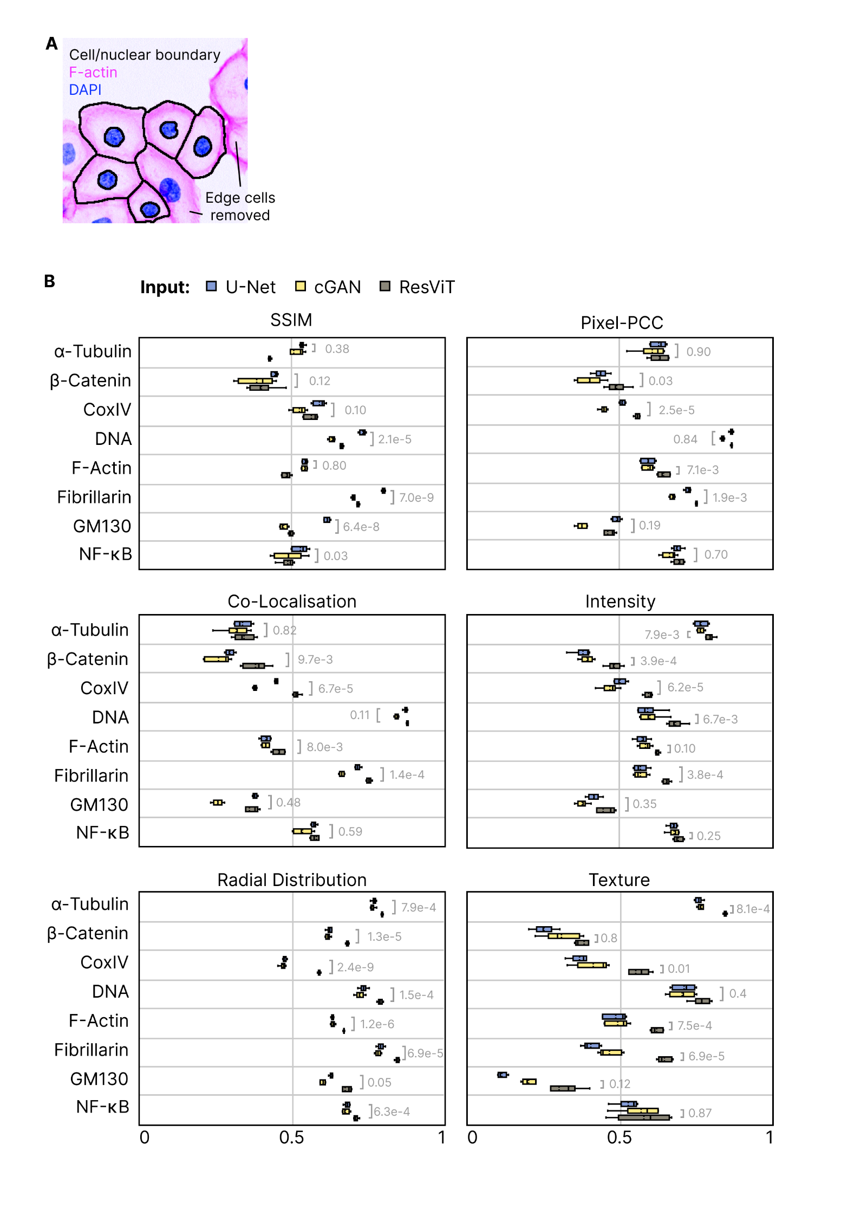
Supplementary Figure 1. (A) Representative cell segmentation example with cell and nuclear boundary (black) overlaying F-actin (phalloidin, pink) and DNA (DAPI, blue). Partial cells touching image edges are removed. (B) 5-fold cross-validated image-level SSIM (structured similarity index) and PCC (Pearson’s correlation coefficient) metric scores comparing virtual labelling performance for U-Net (blue), cGAN (yellow) and ResViT (grey) models, per target marker. All box plots depict data distributions as follows: dashed center line, median; solid center line, mean; box limits, upper and lower quartiles; whiskers, 1.5x interquartile range.
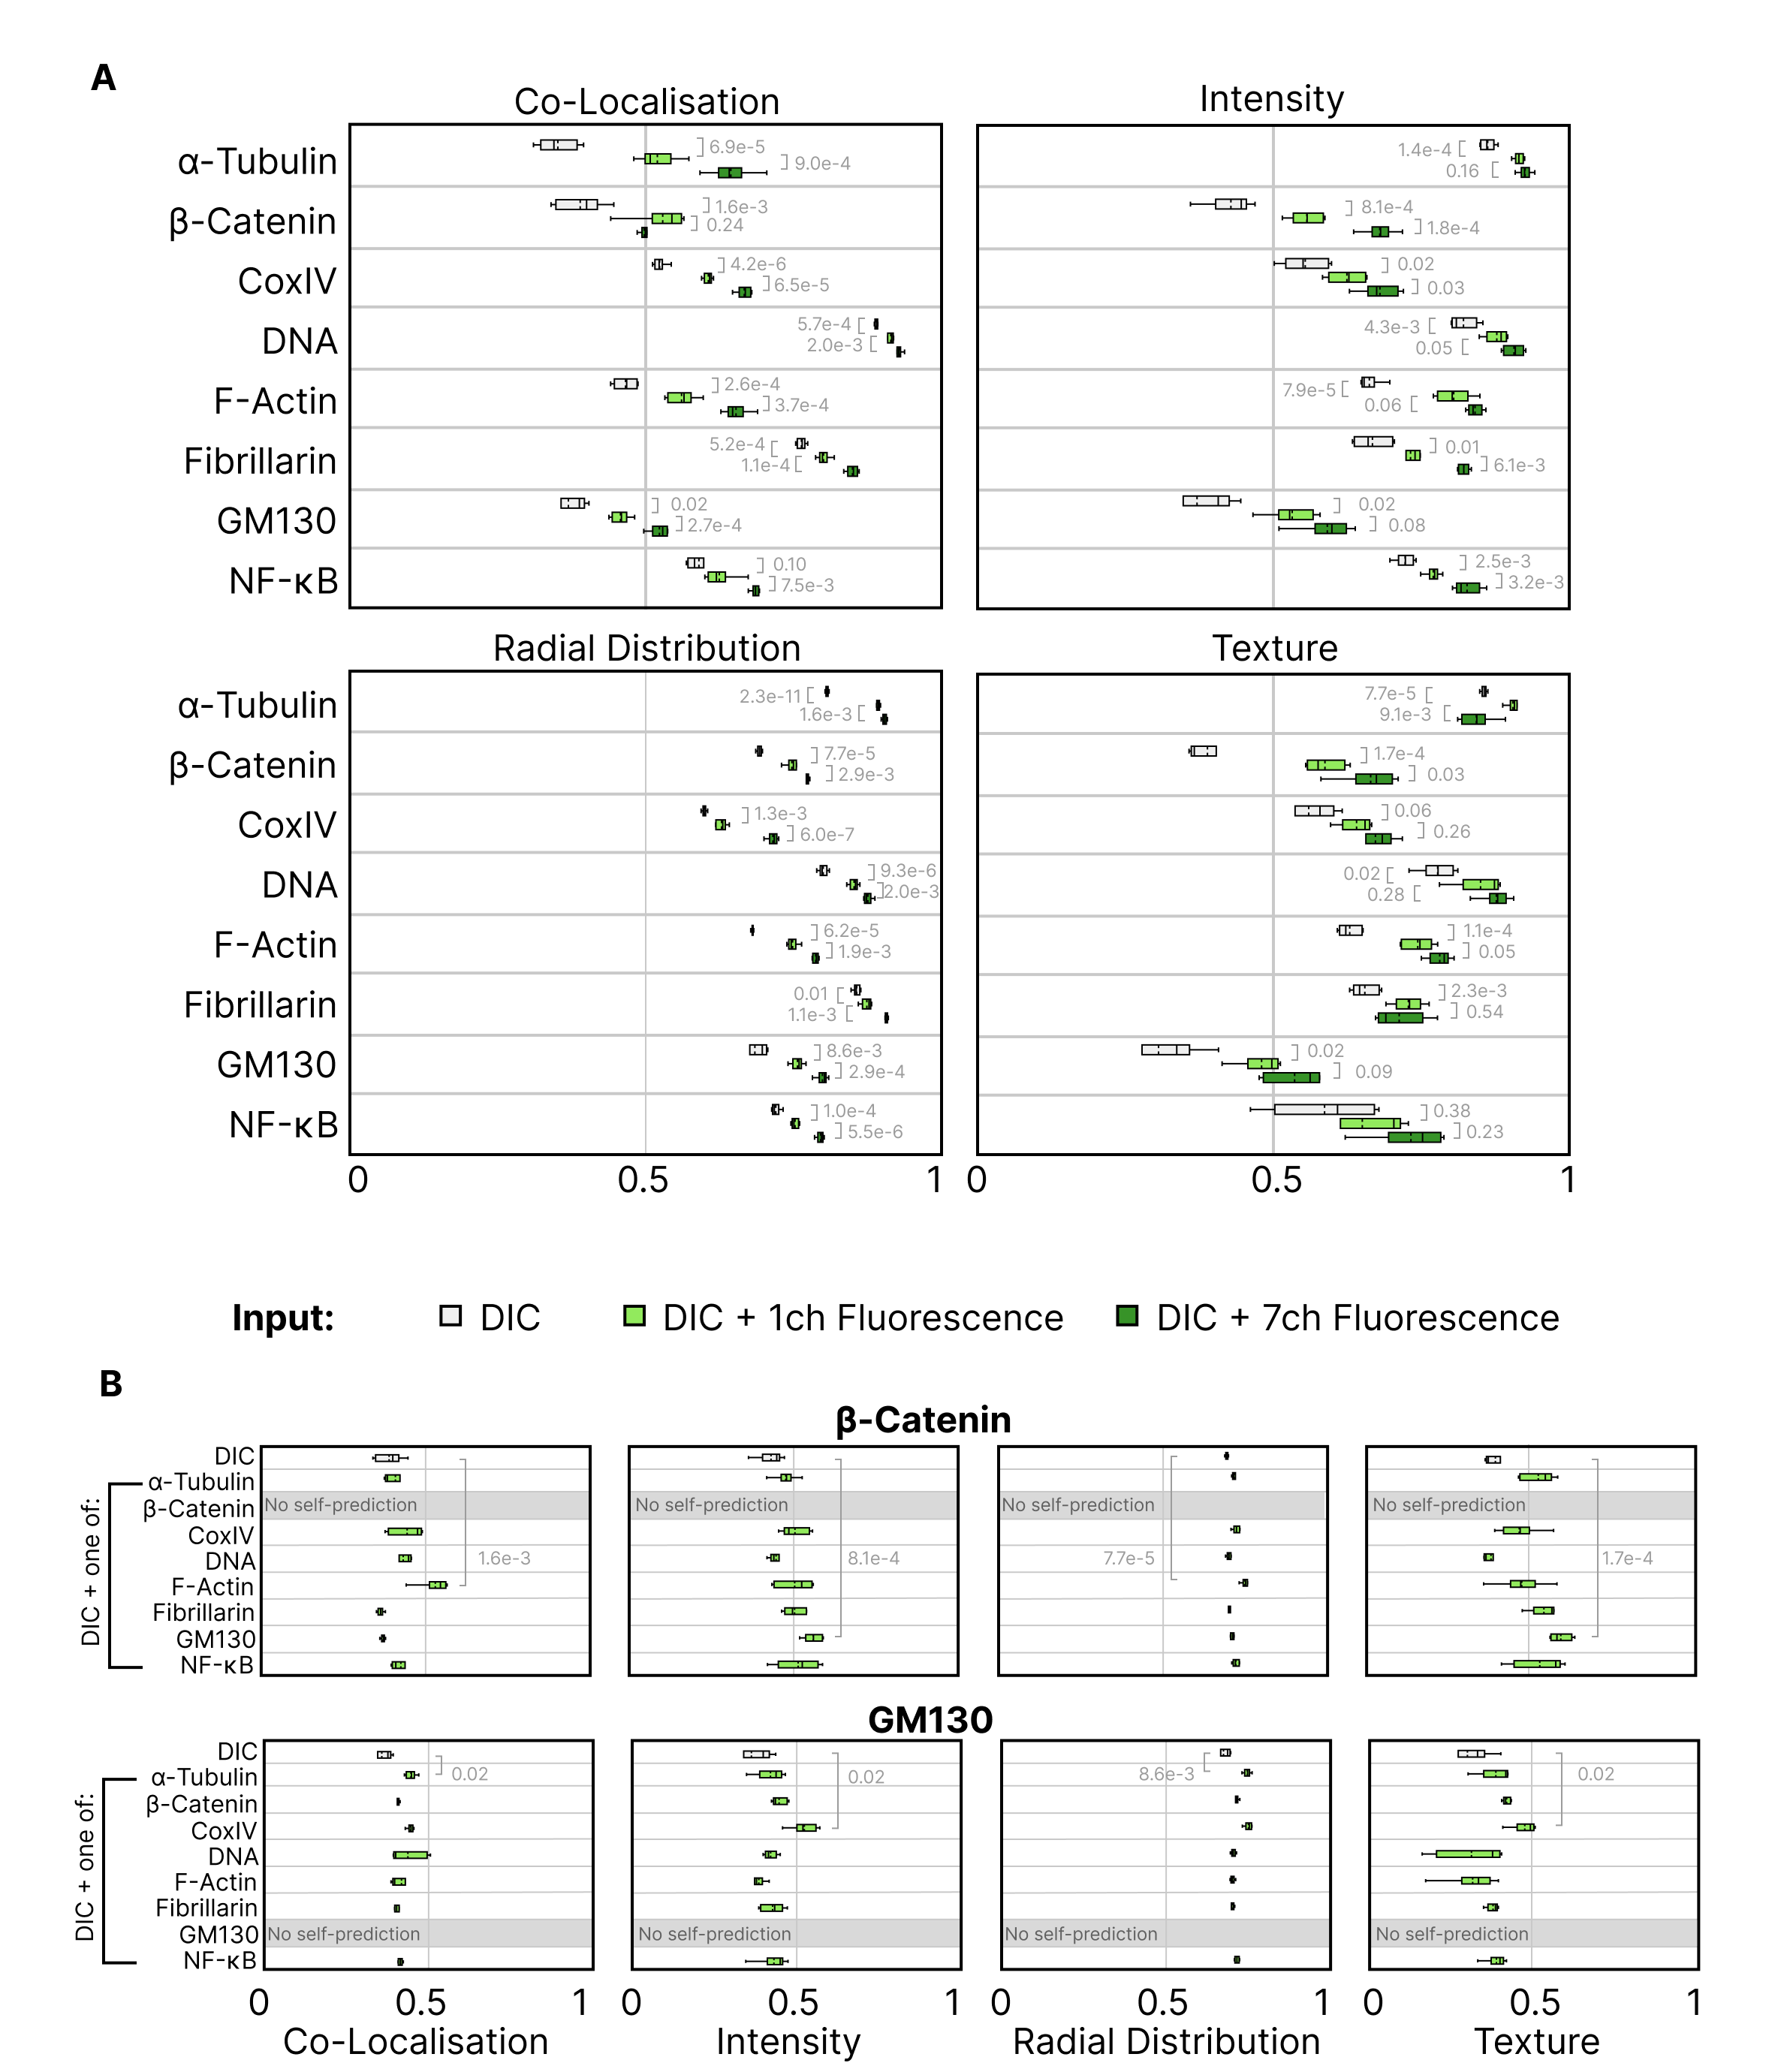
Supplementary Figure 2. (A) 5-fold cross-validated single-cell feature-level metric scores (PCC) for given feature categories per marker comparing ResViT models with DIC only input (grey), DIC plus 1 fluorescence channel (light green; only the channel maximally improving above DIC-only performance is shown), or DIC plus seven fluorescence channels (dark green). (B) 5-fold cross-validated single-cell feature-level metric scores (PCC) for given categories for β-Catenin (top) or GM130 (bottom), comparing ResViT models with DIC only input (grey) or DIC plus 1 fluorescence channel (light green; additional fluorescence channel denoted on left axis). Self-prediction (where fluorescence inputs and targets are identical) was avoided. All box plots depict data distributions as follows: dashed center line, median; solid center line, mean; box limits, upper and lower quartiles; whiskers, 1.5x interquartile range. Significance testing reflects Welsh’s two-sided t-test. In total, 45,780 experimentally multiplexed DU145 cells were quantitatively assessed.

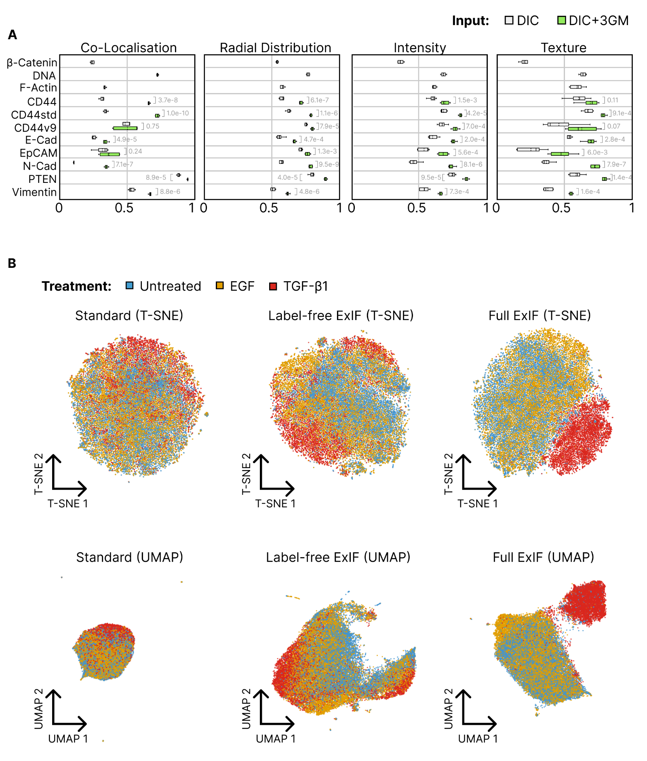
Supplementary Figure 3. (A) 5-fold cross-validated single-cell feature-level PCC (Pearson’s correlation coefficient) scores per feature category, per marker; comparing virtual labelling with ResViT models receiving DIC-only input (grey) versus DIC plus the 3 general markers as concurrent model inputs (light green). Significance reflects Welsh’s two-sided t-testing. (B) ‘Standard’ phenotypic manifold constructed using features extracted from the 3 real general markers only (Left). ‘Label-free ExIF’ phenotypic manifold constructed using features extracted from 11 virtual labels (3 common plus 8 EM markers) predicted by ResViT using only label-free (DIC) inputs (center). ‘Full-ExIF’ phenotypic manifold constructed using features extracted from the three real general markers and eight virtual EM markers predicted by ResViT using the three general markers and DIC as input (right). A total of 33,572 cells were analysed (12,103 control, blue; 14,350 EGF-treated, yellow; 7,119 TGF-β1-treated, red) and embedded using T-SNE (top row) or UMAP (bottom row).
Supplementary Table 1. List of per cell features and feature categories measured via CellProfiler.

Intensity Features | Radial Distribution Features | Texture Features
1. Intensity_IntegratedIntensityEdge  2. Intensity_IntegratedIntensity  3. Intensity_LowerQuartileIntensity  4. Intensity_MADIntensity  5. Intensity_MassDisplacement  6. Intensity_MaxIntensityEdge  7. Intensity_MaxIntensity  8. Intensity_MeanIntensityEdge  9. Intensity_MeanIntensity  10. Intensity_MedianIntensity  11. Intensity_MinIntensityEdge  12. Intensity_MinIntensity  13. Intensity_StdIntensityEdge  14. Intensity_StdIntensity  15. Intensity_UpperQuartileIntensity | 1. RadialDistribution_FracAtD_1of5  2. RadialDistribution_FracAtD_2of5  3. RadialDistribution_FracAtD_3of5  4. RadialDistribution_FracAtD_4of5  5. RadialDistribution_FracAtD_5of5  6. RadialDistribution_MeanFrac_1of5  7. RadialDistribution_MeanFrac_2of5  8. RadialDistribution_MeanFrac_3of5  9. RadialDistribution_MeanFrac_4of5  10. RadialDistribution_MeanFrac_5of5  11. RadialDistribution_RadialCV_1of5  12. RadialDistribution_RadialCV_2of5  13. RadialDistribution_RadialCV_3of5  14. RadialDistribution_RadialCV_4of5  15. RadialDistribution_RadialCV_5of5  16. RadialDistribution_ZernikeMagnitude_0_0  17. RadialDistribution_ZernikeMagnitude_1_1  18. RadialDistribution_ZernikeMagnitude_2_0  19. RadialDistribution_ZernikeMagnitude_2_2  20. RadialDistribution_ZernikeMagnitude_3_1  21. RadialDistribution_ZernikeMagnitude_3_3  22. RadialDistribution_ZernikeMagnitude_4_0  23. RadialDistribution_ZernikeMagnitude_4_2  24. RadialDistribution_ZernikeMagnitude_4_4  25. RadialDistribution_ZernikeMagnitude_5_1  26. RadialDistribution_ZernikeMagnitude_5_3  27. RadialDistribution_ZernikeMagnitude_5_5  28. RadialDistribution_ZernikeMagnitude_6_0  29. RadialDistribution_ZernikeMagnitude_6_2  30. RadialDistribution_ZernikeMagnitude_6_4  31. RadialDistribution_ZernikeMagnitude_6_6  32. RadialDistribution_ZernikeMagnitude_7_1  33. RadialDistribution_ZernikeMagnitude_7_3  34. RadialDistribution_ZernikeMagnitude_7_5  35. RadialDistribution_ZernikeMagnitude_7_7  36. RadialDistribution_ZernikeMagnitude_8_0  37. RadialDistribution_ZernikeMagnitude_8_2  38. RadialDistribution_ZernikeMagnitude_8_4  39. RadialDistribution_ZernikeMagnitude_8_6  40. RadialDistribution_ZernikeMagnitude_8_8  41. RadialDistribution_ZernikeMagnitude_9_1  42. RadialDistribution_ZernikeMagnitude_9_3  43. RadialDistribution_ZernikeMagnitude_9_5  44. RadialDistribution_ZernikeMagnitude_9_7  45. RadialDistribution_ZernikeMagnitude_9_9  46. RadialDistribution_ZernikePhase_0_0  47. RadialDistribution_ZernikePhase_1_1  48. RadialDistribution_ZernikePhase_2_0  49. RadialDistribution_ZernikePhase_2_2  50. RadialDistribution_ZernikePhase_3_1  51. RadialDistribution_ZernikePhase_3_3  52. RadialDistribution_ZernikePhase_4_0  53. RadialDistribution_ZernikePhase_4_2  54. RadialDistribution_ZernikePhase_4_4  55. RadialDistribution_ZernikePhase_5_1  56. RadialDistribution_ZernikePhase_5_3  57. RadialDistribution_ZernikePhase_5_5  58. RadialDistribution_ZernikePhase_6_0  59. RadialDistribution_ZernikePhase_6_2  60. RadialDistribution_ZernikePhase_6_4  61. RadialDistribution_ZernikePhase_6_6  62. RadialDistribution_ZernikePhase_7_1  63. RadialDistribution_ZernikePhase_7_3  64. RadialDistribution_ZernikePhase_7_5  65. RadialDistribution_ZernikePhase_7_7  66. RadialDistribution_ZernikePhase_8_0  67. RadialDistribution_ZernikePhase_8_2  68. RadialDistribution_ZernikePhase_8_4  69. RadialDistribution_ZernikePhase_8_6  70. RadialDistribution_ZernikePhase_8_8  71. RadialDistribution_ZernikePhase_9_1  72. RadialDistribution_ZernikePhase_9_3  73. RadialDistribution_ZernikePhase_9_5  74. RadialDistribution_ZernikePhase_9_7  75. RadialDistribution_ZernikePhase_9_9 | 1. Texture_AngularSecondMoment_3_00_256  2. Texture_AngularSecondMoment_3_01_256  3. Texture_AngularSecondMoment_3_02_256  4. Texture_AngularSecondMoment_3_03_256  5. Texture_Contrast_3_00_256  6. Texture_Contrast_3_01_256  7. Texture_Contrast_3_02_256  8. Texture_Contrast_3_03_256  9. Texture_Correlation_3_00_256  10. Texture_Correlation_3_01_256  11. Texture_Correlation_3_02_256  12. Texture_Correlation_3_03_256  13. Texture_DifferenceEntropy_3_00_256  14. Texture_DifferenceEntropy_3_01_256  15. Texture_DifferenceEntropy_3_02_256  16. Texture_DifferenceEntropy_3_03_256  17. Texture_DifferenceVariance_3_00_256  18. Texture_DifferenceVariance_3_01_256  19. Texture_DifferenceVariance_3_02_256  20. Texture_DifferenceVariance_3_03_256  21. Texture_Entropy_3_00_256  22. Texture_Entropy_3_01_256  23. Texture_Entropy_3_02_256  24. Texture_Entropy_3_03_256  25. Texture_InfoMeas1_3_00_256  26. Texture_InfoMeas1_3_01_256  27. Texture_InfoMeas1_3_02_256  28. Texture_InfoMeas1_3_03_256  29. Texture_InfoMeas2_3_00_256  30. Texture_InfoMeas2_3_01_256  31. Texture_InfoMeas2_3_02_256  32. Texture_InfoMeas2_3_03_256  33. Texture_InverseDifferenceMoment_3_00_256  34. Texture_InverseDifferenceMoment_3_01_256  35. Texture_InverseDifferenceMoment_3_02_256  36. Texture_InverseDifferenceMoment_3_03_256  37. Texture_SumAverage_3_00_256  38. Texture_SumAverage_3_01_256  39. Texture_SumAverage_3_02_256  40. Texture_SumAverage_3_03_256  41. Texture_SumEntropy_3_00_256  42. Texture_SumEntropy_3_01_256  43. Texture_SumEntropy_3_02_256  44. Texture_SumEntropy_3_03_256  45. Texture_SumVariance_3_00_256  46. Texture_SumVariance_3_01_256  47. Texture_SumVariance_3_02_256  48. Texture_SumVariance_3_03_256  49. Texture_Variance_3_00_256  50. Texture_Variance_3_01_256  51. Texture_Variance_3_02_256  52. Texture_Variance_3_03_256

Supplementary Table 2. List of antibodies and cell labelling reagents used.
 | Species | Dilution | Supplier | Catalogue number
Primary antibodies
CD44 | Mouse | 1:500 | Cell Signaling Technology | 3570S
CD44std | Mouse | 1:500 | Thermo-Fischer Scientific | BMS113
CD44v9 | Mouse | 1:500 | Novus Biologicals | NBP2-53204
COX IV | Mouse | 1:500 | Abcam | ab33985
E-Cadherin | Mouse | 1:500 | BD Biosciences | 610181
EpCAM | Mouse | 1:500 | Cell Signaling Technology | 2929S
Fibrillarin | Rabbit | 1:500 | Abcam | ab5821
GM130 | Mouse | 1:500 | BD Biosciences | 610823
N-Cadherin | Mouse | 1:200 | Cell Signaling Technology | 14215S
NF-kB p65 | Rabbit | 1:500 | Cell Signaling Technology | 8242S
PTEN | Mouse | 1:500 | Thermo-Fischer Scientific | 32-5800
Vimentin | Mouse | 1:500 | Abcam | ab8978
α-Tubulin | Mouse | 1:500 | Abcam | ab7291
β-catenin | Rabbit | 1:500 | Thermo-Fischer Scientific | 71-2700
Fluorescent Labels
4’, 6-diamidino-2-phenylindole (DAPI) | N/A | 1:2000 | Sigma-Aldrich Pty Ltd | D9532
Atto-647 Phalloidin | N/A | 1:2000 | Atto-Tec GmbH | AD647-81
Secondary antibodies
Anti-mouse IgG (H+L), F(ab’)2 Fragment (Alexa Fluor 488 Conjugate) | Goat | 1:1000 | Cell Signalling Technology | 448S
Anti-rabbit IgG (H+L), F(ab’)2 Fragment (Alexa Fluor 555 Conjugate | Goat | 1:1000 | Cell Signalling Technology | 4413S

