Supporting Information for

Monolithic poly(methylsilsesquioxane) aerogels with glasslike transparency: From sol-gel synthesis to ambient pressure drying

Riichi Miyamoto,¹ Ryota Ueoka,^{1,2} Koichiro Tachibana,² Ayaka Maeno,³
Hironori Kaji,³ and Kazuyoshi Kanamori^{1*}

¹Department of Chemistry, Graduate School of Science, Kyoto University, Kitashirakawa, Sakyo-ku, Kyoto 606-8502, Japan.

²tiem factory Inc., Higashi-ibaraki, Ibaraki 311-3108, Japan.

³Institute for Chemical Research, Kyoto University, Uji, Kyoto 611-0011, Japan.

*Corresponding author: kanamori@kuchem.kyoto-u.ac.jp

Fig. S1 Obtained wet gels after gelation in a polystyrene container with different mixing times. Prepared in the standard procedure (left), cooled in ice bath for 5 d before adding TMAOH (center), and the same condition with the center with sonication after adding TMAOH (right).

Fig. S2 Density fluctuation in the obtained wet gel on the side view. Air bubbles were also found on the top of the wet gel.

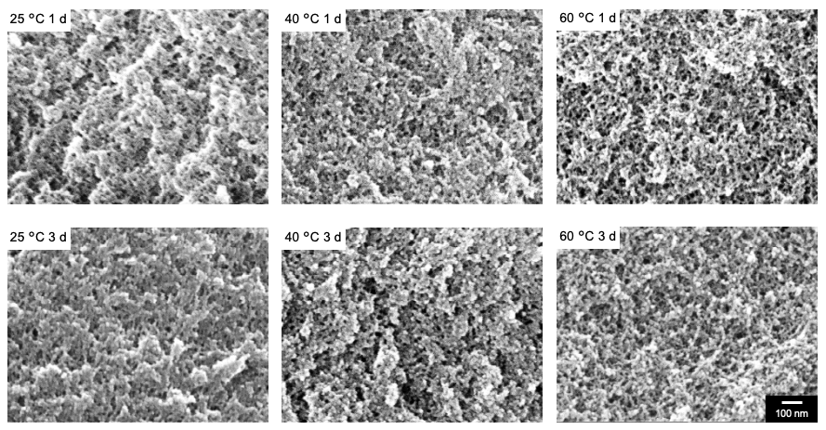
Fig. S3 FESEM images of SCD aerogels prepared in different aging conditions.

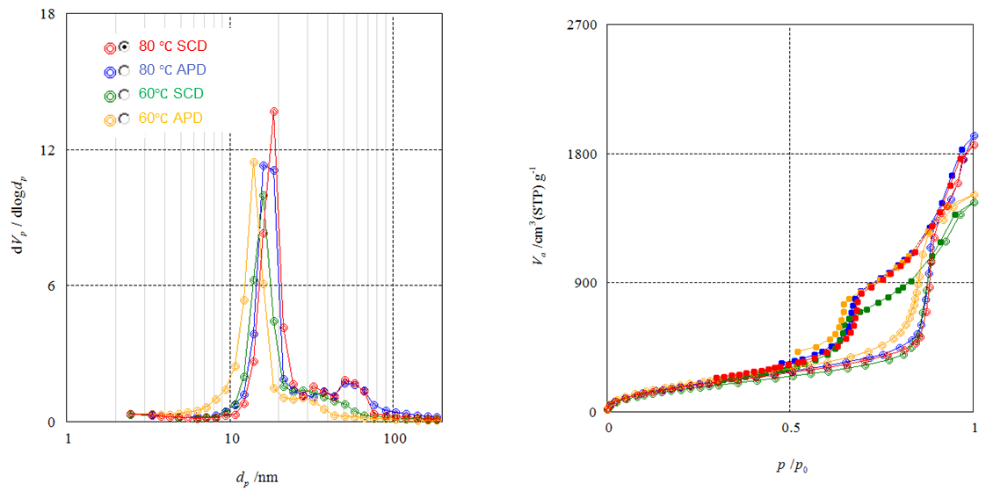
Fig. S4 BJH pore size distributions and the adsorption-desorption isotherms of SCD and APD aerogels prepared in different aging conditions analyzed by nitrogen adsorption-desorption method.

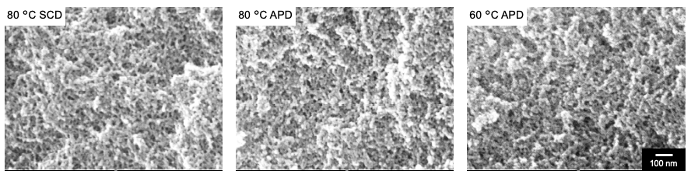
Fig. S5 FESEM images of SCD and APD aerogels prepared in different aging conditions.

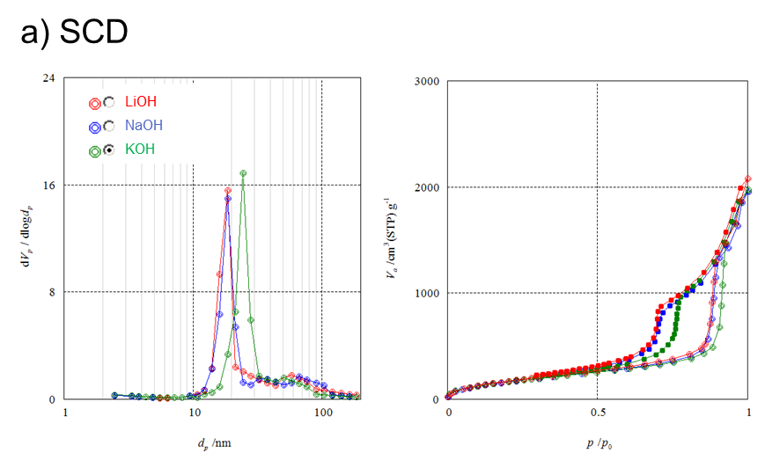
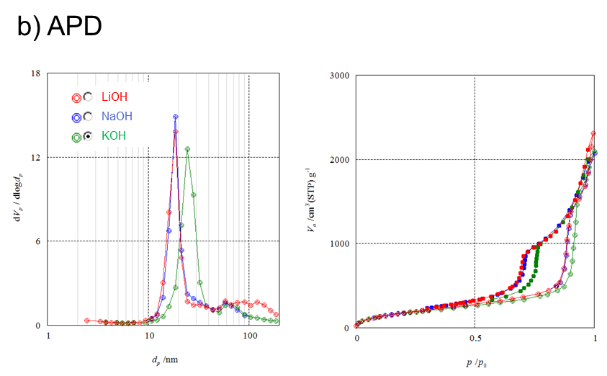
Fig. S6 BJH pore size distributions and the adsorption-desorption isotherms of SCD and APD aerogels prepared using different alkali hydroxide bases analyzed by nitrogen adsorption-desorption method.

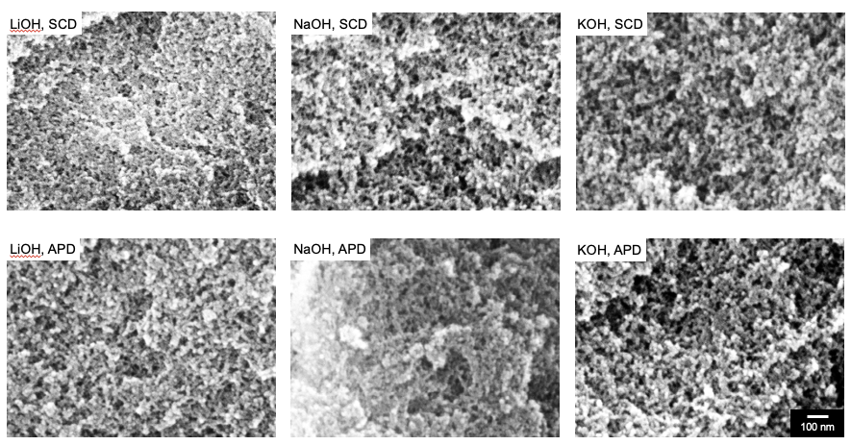
Fig. S7 FESEM images of SCD and APD aerogels prepared using different alkali hydroxide bases.

