Supporting information
Free radical scavenging polylactic acid fibers: A study of melt spinning preparation, characterization, and properties
Chenghui Zheng,¹ Huanling Wu,¹ Qingqing Zhou,¹ Lingfang Wang,² Jingchun Lv¹ and Haiyan Mao ¹ *
¹ Department of Light-Chemical Engineering, College of Textiles and Clothing, Yancheng Institute of Technology, Yancheng, 224051, China
² Department of Polymer and Composite Materials, College of Materials Science and Engineering, Yancheng Institute of Technology, Yancheng, 224051, China

*Corresponding author:
Email: mao-hai-yan@hotmail.com
Number of Tables: 3
Number of Figures: 5

TABLE S1. Tensile characteristic values of PLA/PEO/CUR fibers
Code | Material | Tenacity  /cN dtex⁻¹ | Elongation at  break /% | Initial modulus  /cN dtex⁻¹
M₀ | PLA100 | 2.24 ± 0.22 | 12.1 ± 0.7 | 1.09 ± 0.08
M₁ | PLA/PEO-8/CUR-5 | 2.65 ± 0.14 | 41.3 ± 6.5 | 0.88 ± 0.03
M₂ | PLA/PEO-8/CUR-10 | 2.82 ± 0.13 | 35.2 ± 5.4 | 0.98 ± 0.02
M₃ | PLA/PEO-12/CUR-5 | 2.94 ± 0.16 | 58.6 ± 9.7 | 0.83 ± 0.03
M₄ | PLA/PEO-12/CUR-10 | 3.14 ± 0.02 | 47.6 ± 11.8 | 0.89 ± 0.02
M₅ | PLA/PEO-8 | 2.48 ± 0.12 | 53.9 ± 7.1 | 0.79 ± 0.02
M₆ | PLA/PEO-12 | 2.75 ± 0.13 | 83.5 ± 12.3 | 0.72 ± 0.02

TABLE S2. Crystallinity and crystallite size of PLA/PEO/CUR fibers
Code | Material | 2θ of main crystalline peak/ º | Crystallinity  /% | Crystallite size  /nm
M₀ | PLA100 | 16.0 | 13.5 | 1.4
M₁ | PLA/PEO-8/CUR-5 | 16.2 | 22.0 | 2.9
M₂ | PLA/PEO-8/CUR-10 | 16.5 | 23.5 | 4.2
M₃ | PLA/PEO-12/CUR-5 | 16.5 | 26.6 | 6.5
M₄ | PLA/PEO-12/CUR-10 | 16.4 | 28.2 | 8.1

TABLE S3. Characteristic points of TG-DTA curves of PLA/PEO/CUR fibers
Code* | T_{g}  /℃ | T_{c}  /℃ | T_{m}  /℃ | T_{onset}  /℃ | T_{max}  /℃ | T_{decom.}  /℃ | T_{final}  /℃ | Residuals  /%
M₀ | 60.4 | 103.6 | 180.8 | 349.5 | 367.2 | 372.2 | 380.0 | 0.72
M₁ | 58.7 | 102.0 | 169.0 | 337.0 | 362.2 | 367.8 | 378.1 | 1.49
M₂ | 57.0 | 100.1 | 169.5 | 337.8 | 360.3 | 365.3 | 377.6 | 1.52
M₃ | 55.7 | 101.7 | 168.5 | 336.2 | 364.1 | 368.9 | 378.0 | 1.43
M₄ | 55.1 | 101.0 | 169.0 | 336.7 | 361.2 | 367.8 | 377.2 | 1.78
* M₀, PLA100; M₁, PLA/PEO-8/CUR-5; M₂, PLA/PEO-8/CUR-10; M₃, PLA/PEO-12/CUR-5; M₄, PLA/PEO-12/CUR-10.
Characteristic points were obtained based on references. ^{[1], [2]}

FIGURE S1. XRD patterns of PLA/PEO/CUR fibers. Intensity was normalized for visible convenience. The main broad peak in M₀ indicated quite low crystallinity because of mostly amorphous phase of PLA.

FIGURE S2. Broad XPS spectra of PLA/PEO/CUR fibers. a, PLA100; b, PLA/PEO-12; c, PLA/PEO-12/CUR-10.

FIGURE S3. TG-DTA curves of the composited fibers. (a) TG curves. The embedded figure depicted detailed inflection from 310 ℃ to 355 ℃. (b) DTA curves. T_{onset}, T_{g} , and T_{m} were obtained by determining intersections of two tangent lines from each curve.

Code* | 14 days | 45 days -1 | 45 days-2
M₀ | 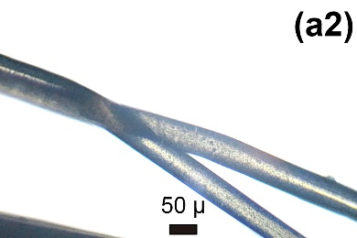 | 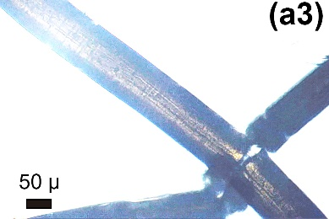 | 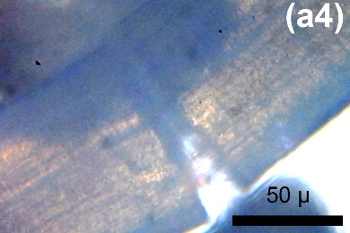
M₁ | 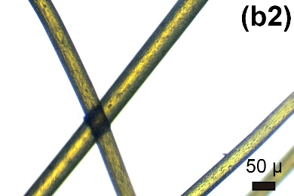 | 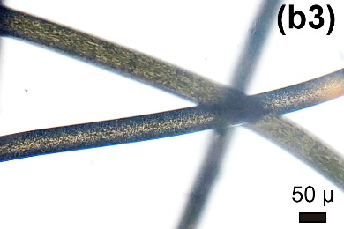 | 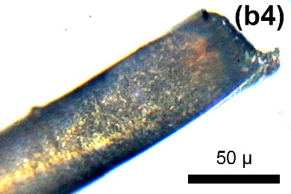
M₂ | 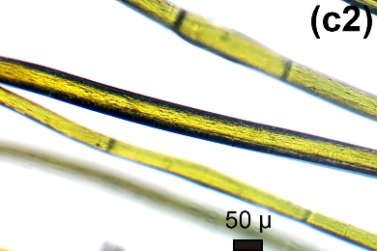 | 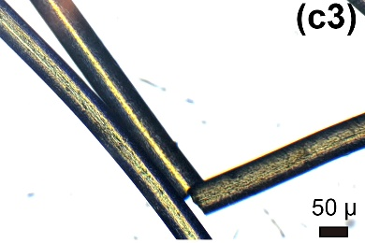 | 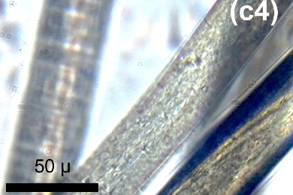
M₃ | 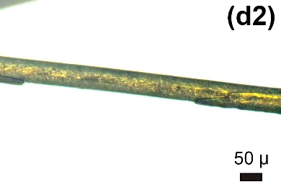 | 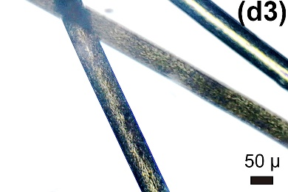 | 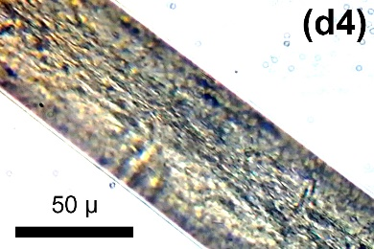
M₄ | 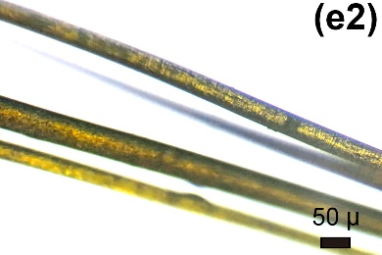 | 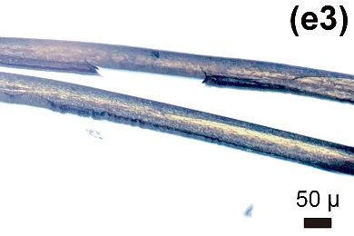 | 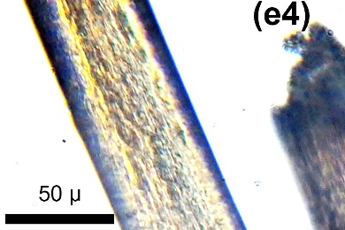
* M₀, PLA100; M₁, PLA/PEO-8/CUR-5; M₂, PLA/PEO-8/CUR-10; M₃, PLA/PEO-12/CUR-5; M₄, PLA/PEO-12/CUR-10.
FIGURE S4. Microscopic images of PLA/PEO/CUR fiber surfaces after 14, 45 days (different magnification for 45 days) in soil at 50 ℃, 55% R.H. Fiber surfaces before buried in soil (0 days) were pictured in Figure 3, a ~ b.
Code* | 0 days | 14 days | 45 days
M₀ | 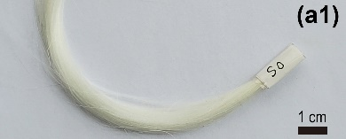 | 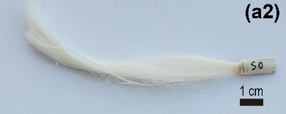 | 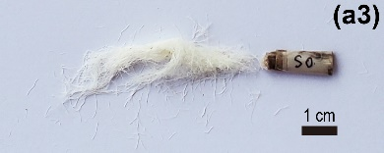
M₁ | 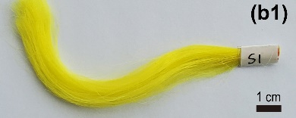 | 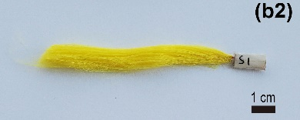 | 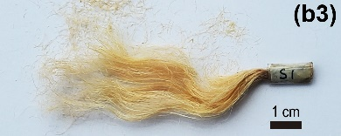
M₂ | 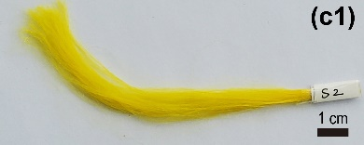 | 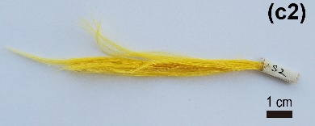 | 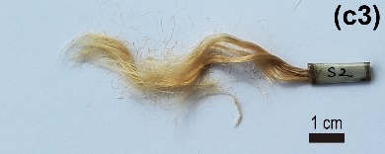
M₃ | 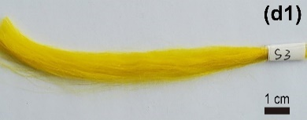 | 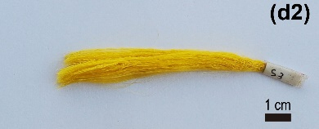 | 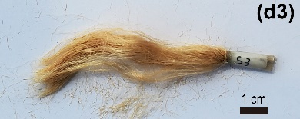
M₄ | 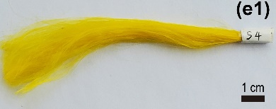 | 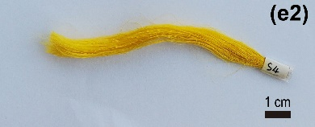 | 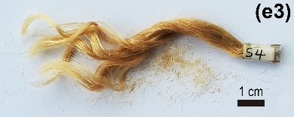
* M₀, PLA100; M₁, PLA/PEO-8/CUR-5; M₂, PLA/PEO-8/CUR-10; M₃, PLA/PEO-12/CUR-5; M₄, PLA/PEO-12/CUR-10.
FIGURE S5. Photos of PLA/PEO/CUR fibers before (0 days) and after 14, 45 days in soil at 50 ℃, 55 % R.H.
REFERENCES
[1] Zhou H, Green TB, Joo YL (2006) The thermal effects on electrospinning of polylactic acid melts Polymer 47: 7497. https://doi.org/10.1016/j.polymer.2006.08.042
[2] Hutchinson JM (2009) Determination of the glass transition temperature Journal of Thermal Analysis and Calorimetry 98: 579. https://doi.org/10.1007/s10973-009-0268-0

