Supplementary Information
Enantioselective Heck/Tsuji−Trost Reaction of Flexible Vinylic Halides with 1,3-Dienes
Li-Zhi Zhang,^{+[a]} Pei-Chao Zhang,^{+[b]} Qian Wang,^{c} Min Zhou*ª and Junliang Zhang*^{c,d}

ªSchool of Ethnic Medicine, Yunnan Minzu University, Kunming 650031, P.R. China
^{b}Department of Organic Chemistry, School of Pharmacy, Second Military Medical University, Shanghai 200433, P. R. China
^{c}College of Chemistry and Life Science, Advanced Institute of Materials Science, Changchun University of Technology, Changchun 130012, P. R. China
^{d}Department of Chemistry, Fudan University, 2005 Songhu Road, Shanghai 200438, P. R. China

Contents
1. General information. 2
2. Optimization of the reaction conditions. 3
3. X-ray of the product 3aa. 6
4. Non-linear effect. 6
5. Synthesis of the Xu-Phos and starting materials 7
6. General procedure for asymmetric tandem Heck/Tsuji−Trost reaction of flexible vinylic halides with 1,3-dienes. 9
7. Gram-scale synthesis. 40
8. Synthetic applications of the products 41
9. NMR Spectra. 46
10. References. 113

General information
Unless otherwise noted, all reactions were carried out in standard Schlenk techniques with magnetic stirring bar under air. Materials obtained from commercial suppliers were used directly without further purification. ¹H NMR spectra were recorded in CDCl₃ with Bruker spectrometers at 400 (100 MHz) or 500 (125 MHz). Chemical shifts are reported in ppm with tetramethylsilane (TMS: 0 ppm) with the solvent resonance as the internal standard. Data are reported as follows: chemical shift, multiplicity (s = singlet, d = doublet, t = triplet, q = quartet, m = multiplet), coupling constants (Hz), and integration. ¹³C NMR spectra were recorded on Bruker 400 (100 MHz) and 500 (125 MHz) spectrometers in CDCl₃ with complete proton decoupling. Chemical shifts are reported in ppm with the deuterium solvent as the internal standard (CDCl₃: 77.0 ppm). The [α]^{D} were measured on a PolAAr 3005 High Accuracy Polarimeter. The ee was recorded using LC-2030C 3D from Shimadzu Company. Flash column chromatography was performed over silica gel (10-40 mesh).
The starting materials Xu-Phos¹, vinylic halides 1² and cyclic 1,3-dienes 2³ were synthesized according to published procedures. The spectral data of the substrates were consisted with that reported in the literature. The enantionmeric excesses of the products were determined by chiral stationary phase HPLC using Chiralpak IA, IC, ID, IE and IF columns.
Note: The prepared cyclic 1,3-dienes should be stored at low temperature and protected from light, and used as soon as possible. If the storage time of cyclic 1,3-diene is too long, it should be purified by flash column chromatography on silica gel to remove excess water and impurities before use.

Optimization of the reaction conditions.

Optimization of Sadphos
Figure S1. Unless otherwise noted, all reactions were carried out with 1a (0.1 mmol), 0.4 mmol of 2a (0.4 mmol), Pd(OAc)₂ (10 mol%), Xu-Phos (20 mol%) and Ag₂SO₄ (0.05 mmol), in 0.5 mL DMF at 80 ℃ for 24 h; yield and conversion were determined by GC analysis using anisole as a standard, e.e. were determined by HPLC analysis. Trip: 2-triptycene.

2.2 Optimization of solvent
Entry | Solvent | Yield% | Ee%
1 | DMF | 21 | 98
2 | DMAc | 28 | 95
3 | NMP | 19 | 94
4 | DMSO | 36 | 35
5 | Et₂O | 31 | 36
6 | CF₃Ph | 24 | 35
7 | DCE | trace | -
8 | THF | 43 | 27
9 | DME | 38 | 28
Figure S2. Unless otherwise noted, all reactions were carried out with 1a (0.1 mmol), 0.4 mmol of 2a (0.4 mmol), Pd(OAc)₂ (10 mol%), Xu8 (20 mol%) and Ag₂SO₄ (0.05 mmol), in 0.5 mL solvent at 80 ℃ for 24 h; yield and conversion were determined by GC analysis using anisole as a standard, e.e. were determined by HPLC analysis. DMAc: Dimethylacetamide; NMP: N-methyl pyrrolidone.

2.3 Optimization of silver salt
Entry | Silver salt | Yield% | Ee%
1 | Ag₂SO₄ | 29 | 96
2 | Ag₂CO₃ | Trace | 96
3 | AgF | 24 | 94
4 | Ag₂O | 19 | 96
5 | AgN(CF₃SO₂)₂ | 36 | 55
6 | AgOTs | 35 | 51
7 | AgPF₆ | 34 | 48
8 | CF₃CO₂Ag | 41 | 53
9 | CH₃CO₂Ag | NR | --
10 | CH₃SO₃Ag | 23 | 52
Figure S3. Unless otherwise noted, all reactions were carried out with 1a (0.1 mmol), 0.4 mmol of 2a (0.4 mmol), Pd(OAc)₂ (10 mol%), Xu8 (20 mol%) and silver salt (0.05 mmol), in 0.5 mL DMAc at 80 ℃ for 24 h; yield and conversion were determined by GC analysis using anisole as a standard, e.e. were determined by HPLC analysis.

Optimization of temperature
Entry | T/⁰C | Yield% | Ee%
1 | 50 | NR | --
2 | 60 | 30 | 99
3 | 70 | 32 | 97
4 | 80 | 28 | 96
5 | 90 | 21 | 90
6 | 100 | 18 | 87
7 | 110 | 17 | 84
8 | 120 | 13 | 68
Figure S4. Unless otherwise noted, all reactions were carried out with 1a (0.1 mmol), 0.4 mmol of 2a (0.4 mmol), Pd(OAc)₂ (10 mol%), Xu8 (20 mol%) and Ag₂SO₄ (0.05 mmol), in 0.5 mL DMAc at 50-120 ℃ for 24 h; yield and conversion were determined by GC analysis using anisole as a standard, e.e. were determined by HPLC analysis.

Optimization of Pd presursors
Entry | [Pd] | Yield% | Ee%
1 | Pd(PPh₃)₄ | NR | --
2 | Pd₂(dba)₃ | 33 | 95
3 | Pd₂(dba)₃·CHCl₃ | 35 | 97
4 | Pd (dba)₂ | 29 | 95
5 | Pd (TFA)₂ | 41 | 98
6 | [Pd(allyl)Cl]₂ | 30 | 95
7 | PdCl₂(PPh₃)₂ | 20 | 95
8 | Pd(PhCN)₂Cl₂ | 31 | 96
9 | PdBF₄(CH₃CN)₄ | 48 | 98
10 | Pd(CO₂^{t}Bu)₂ | 62 | 99
Figure S5. Unless otherwise noted, all reactions were carried out with 1a (0.1 mmol), 0.4 mmol of 2a (0.4 mmol), [Pd] (10 mol%), Xu8 (20 mol%) and Ag₂SO₄ (0.05 mmol), in 0.5 mL DMAc at 70 ℃ for 24 h; yield and conversion were determined by GC analysis using anisole as a standard, e.e. were determined by HPLC analysis.

Screening of chiral ligands
Figure S6. Unless otherwise noted, all reactions were carried out with 1a (0.1 mmol), 0.4 mmol of 2a (0.4 mmol), Pd(CO₂^{t}Bu)₂ (10 mol%), Xu8 (20 mol%) and Ag₂SO₄ (0.06 mmol), in 0.5 mL DMAc at 70 ℃ for 48 h; yield and conversion were determined by GC analysis using anisole as a standard, e.e. were determined by HPLC analysis.

X-ray of the product 3aa.

Non-linear effect
The linear relationship between the ee of the Xu3 and those of product 3aa, which reveal that the enantioselectivity determining step might involve a single chiral sulfinamide phosphine ligand and one palladium species.

Synthesis of the Xu-Phos and starting materials.

Sythesis of the Xu-Phos.¹
To a stirred solution of dicyclohexylphosphine borane (Cy₂PH•BH₃, 1.0 equiv, 8 mmol, CAS: 108756-88-3) in anhydrous Tol (16 mL) and THF (8 mL) under N₂ atmosphere was added n-BuLi (1.0 equiv, 8 mmol, 1.6 M in hexane, 5 mL) dropwise at -78 °C. The mixture maintained this temperature for 1 h. Then, the mixed solvents Tol : THF (6 mL : 3 mL) dissolving the dibromobenzene (8 mmol, CAS: 25812-80-0) was added dropwise followed by n-BuLi (1.0 equiv, 8 mmol, 1.6 M, 5 mL) . After 10 minutes at -78 °C, (E, Rs)-sulfinyl imine (1.2 equiv, 9.6 mmol, CAS: 2241598-36-5) was added and the reaction mixture was slowly warmed to room temperature for 10 h. After reaction was completed, the reaction mixture was quenched by the addition of saturated aqueous NH₄Cl solution (10 mL) and extracted by EA (20 mL×3). The combined organic layers were washed by brine, dried over Na₂SO₄ and concentrated to dryness.
The crude product was dealed with HNEt₂ (20 mL) under N₂ atmosphere and the resulting solution was stirred at 50 °C for more 8 h. After the reaction was complete (monitored by TLC), solvent was removed under reduced pressure. The residue was purified by flash column chromatography on silica gel (PE: EA = 6:1) to afford the desired product Xu3 (2.95g, 54% yield) as a white solid.
(R)-N-((S)-(3,5-di-tert-butyl-4-methoxyphenyl)(7-(dicyclohexylphosphaneyl)-2,3-dihydrobenzo[b][1,4]dioxin-6-yl)methyl)-2-methylpropane-2-sulfinamide (Xu3)
¹H NMR (400 MHz, CDCl₃) δ 7.26 (s, 2H), 7.14 (d, J = 3.3 Hz, 1H), 6.96 (s, 1H), 6.63 (d, J = 8.6 Hz, 1H), 4.32 (s, 4H), 3.68 (br s, 1H), 3.65 (s, 3H), 1.94 (m, 1H), 1.85 – 1.60 (overlapped, 10H), 1.58 – 1.42 (m, 4H), 1.42 – 1.35 (overlapped, 16H), 1.31 – 1.24 (overlapped, 10H), 1.23 – 1.13 (overlapped, 4H), 1.11 – 0.93 (overlapped, 3H), 0.57 (m, 1H);
¹³C NMR (100 MHz, CDCl₃) δ 158.6, 144.1, 143.2, 142.6 (d, J = 23.7 Hz), 142.1, 136.9, 127.3 (d, J = 21.5 Hz), 126.9, 126.0, 121.1, 116.5 (d, J = 6.2 Hz), 64.5, 64.4, 64.1, 59.0 (d, J = 29.2 Hz), 55.8, 35.8, 35.7 (d, J = 13.1 Hz), 35.1 (d, J = 13.3 Hz), 32.1, 30.7 (dd, J = 18.0, 12.2 Hz), 29.2 (t, J = 9.2 Hz), 27.2 (m), 26.4 (d, J = 7.2 Hz), 22.8;
³¹P NMR (130 MHz, CDCl₃) δ -18.4;
HRESIMS (positive ion mode) m/z 684.4214 [M + H]⁺ (calcd. for C₄₀H₆₃NO₄PS, 684.4210);
[α]_{D}²⁰ = 0.9 (c = 0.14, acetone).

Sythesis of the Vinylic Halides.²
General procedure:
The vinylic halides 1 were prepared as described in the literature.² To a stirred solution of propargyl alcohol (50 mmol, CAS: 107-19-7) in anhydrous THF (100 mL) under N₂ atmosphere was added CuI (10 mol%, 5 mmol, CAS: 7681-65-4) and the mixture was cooled to -78 °C. Freshly prepared Grignard reagents (2.5 eq, 125 mmol) in THF (100 mL) was added using constant pressure funnel maintain the temperature below -60 °C for 1h. Then, the mixture was allowed to warm up to room temperture and vigorously stirred overnight. The reaction was cooled again to -78 °C and treated with I₂ (55 mmol, 1.1 equiv.) in anhydrous THF (100 mL). After warming up to room temperature and stirring at rt for additional 1h, the reaction mixture was kept in refrigerator at about 0-3 °C over 3 hours. The mixture was cooled to 0 °C and was quenched with saturated aqueous NH₄Cl (50 mL). The two phase mixture was poured through a separatory funnel and cambined organic layers were washed extracted with saturated aqueous Na₂S₂O₃ (2 × 50 mL) and saturated aqueous NaCl (100 mL), and dried over Na₂SO₄. It was purified by column chromatography to give 1 (42-85 % yield).

Sythesis of the cyclic 1,3-dienes.³
General procedure:
The cyclic 1,3-dienes 2 were prepared as described in the literature.³ To a solution of 2-cyclohexen-1-one (10 mmol, 0.97 mL, CAS: 930-68-7, Bide) in 20 mL dry Et₂O at -78 °C for 10 min under N₂, was added lithium reagent (15 mmol, 1.5 eq, 1 M in Et₂O), the mixture was stirred at - 78 °C for 10 min, and allowed to warm to room temperature for another 30 min. When completed, the reaction mixture was quenched by the addition of saturated NH₄Cl solution and diluted with EtOAc. The organic layer was separated, and the aqueous layer was extracted twice with EA. The combined organic layers were dried over Na₂SO₄, filtered, concentrated, and purified by flash chromatography (PE: EA = 3:1) to isolated allyl alcohols as liquid (77-93 % yield).
To a solution of allyl alcohols (5 mmol) and Et₃N (10.0 mmol, 2.0 eq) in 20 mL dry DCM at 0 °C for 10 min under N₂, to the mixture was added 2-BSC (5.5 mmol, 1.1 eq, 2-nitrobenzenesulfenyl chloride, CAS: 7669-54-7, Bide) (When R= alkyl, allyl, vinyl; 2,4-NBSC instead of 2-BSC, 2,4-dinitrobenzenesulfenyl chloride, CAS: 528-76-7, TCI) at 0 °C for 10 min, and allowed to warm to room temperature for another 2 h. When completed, n-Hexane was added to the reaction mixture. The precipitate was filtered out (celite), and the solution was washed with H₂O and brine and dried over Na₂SO₄, filtered, concentrated, and purified by flash chromatography (n-Hexane) to isolated cyclic 1,3-dienes 2 as liquid or solid (57-83 % yield). (Note: The prepared 1,3-diene should be stored at low temperature and protected from light.)

General procedure for Pd-catalyzed cycloaddition reactions of iodide alcohols and cyclic 1,3-dienes.
General procedure:
To a sealed tube was added Palladium pivalate (10 mol%, 15.5 mg, CAS: 106224-36-6, Bide) and Xu3 (20 mol%, 68.4 mg,) in 2.5 mL dry DMAc and stirred at room temperature for 1 h under nitrogen atmosphere. Then, 1 (0.5 mmol, 1.0 eq), 2 (2.0 mmol, 4.0 eq) and Ag₂SO₄ (93.5 mg, 0.6 equiv) were added to the tube under nitrogen atmosphere, and stirred at 70 °C for 48 h. After the reaction was complete (monitored by TLC), dilute with saturated salt water and EA, then extracted with EA (twice), dried over anhydrous Na₂SO₄, the solvent was removed under reduced pressure. The crude product was purified by column chromatography (n-Hexane/EA, 50:1 to 30:1) to give 3 as a white solid or colourless liquid (42-94 % yield).
5.1 (4aR,8aS)-3,7-diphenyl-4a,5,6,8a-tetrahydro-2H-chromene (3aa)
Isolated 3aa in 83% yield, as white solid (m.p.: 157.9 °C).
¹H NMR (400 MHz, CDCl₃) δ 7.47 (d, J = 7.6 Hz, 2H), 7.41 – 7.26 (overlapped, 8H), 7.25 – 7.22 (overlapped, 2H), 4.62 (m, 2H), 4.25 (t, J = 4.5 Hz, 1H), 2.60 (dt, J = 17.4, 4.2 Hz, 1H), 2.54 – 2.42 (m, 1H), 2.35 (m, 1H), 1.96 (m, 1H), 1.80 (qd, J = 11.7, 4.9 Hz, 1H);
¹³C NMR (100 MHz, CDCl₃) δ 142.6, 141.4, 138.1, 136.1, 128.5 (2C), 128.3 (2C), 127.5, 127.4, 125.5 (2C), 125.4, 124.9 (2C), 122.7, 69.6, 66.7, 34.3, 27.8, 25.2;
HRESIMS (positive ion mode) m/z 311.1401 [M + Na]⁺ (calcd. for C₂₁H₂₀ONa, 311.1406);
[α]_{D}²⁵ = -97.5 (c = 0.12 g/100mL, acetone);
HPLC conditions: Chiralpak IC column (n-Hexane:2-Propanol = 90:10, 0.5 ml/min, 254nm); tr (minor) = 18.5 min, tr (major) = 16.8 min; 99% ee.
5.2 (4aR,8aS)-3-(4-chlorophenyl)-7-phenyl-4a,5,6,8a-tetrahydro-2H-chromene (3ab)
Isolated 3ab in 88% yield, as white solid (m.p.: 179.2 °C).
¹H NMR (400 MHz, CDCl₃) δ 7.51 – 7.43 (overlapped, 2H), 7.41 – 7.26 (overlapped, 7H), 6.23 (overlapped, 2H), 4.58 (m, 2H), 4.25 (m, 1H), 2.60 (m, 1H), 2.50 (m, 1H), 2.36 (m, 1H), 1.95 (m, 1H), 1.80 (m, 1H);
¹³C NMR (100 MHz, CDCl₃) δ 142.8, 141.4, 136.6, 135.2, 133.3, 128.7 (2C), 128.3 (2C), 127.6, 126.2 (2C), 126.1, 125.6 (2C), 122.6, 69.6, 66.6, 34.3, 27.8, 25.1;
HRESIMS (positive ion mode) m/z 345.1016 [M + Na]⁺ (calcd. for C₂₁H₁₉ClONa, 345.1017);
[α]_{D}²⁵ = -85.2 (c = 0.11 g/100mL, acetone);
HPLC conditions: Chiralpak IE column (n-Hexane:2-Propanol = 90:10, 0.5 ml/min, 254nm); tr (minor) = 13.7 min, tr (major) = 14.3 min; 92% ee.

5.3 (4aR,8aS)-3-(4-fluorophenyl)-7-phenyl-4a,5,6,8a-tetrahydro-2H-chromene (3ac)
Isolated 3ac in 93% yield, as white solid (m.p.: 140.8 °C).
¹H NMR (400 MHz, CDCl₃) δ 7.46 (m, 2H), 7.40 – 7.26 (overlapped, 5H), 7.03 (t, J = 8.7 Hz, 2H), 6.22 (d, J = 3.1 Hz, 1H), 6.15 (d, J = 4.4 Hz, 1H), 4.57 (m, 2H), 4.23 (t, J = 4.5 Hz, 1H), 2.59 (dt, J = 17.4, 4.3 Hz, 1H), 2.48 (m, 1H), 2.34 (m, 1H), 1.94 (m, 1H), 1.78 (dtd, J = 12.9, 11.0, 5.0 Hz, 1H);
¹³C NMR (100 MHz, CDCl₃) δ 162.3 (d, J = 246.7 Hz), 142.7, 141.4, 135.3, 134.3 (d, J = 3.4 Hz), 128.3 (2C), 127.6, 126.6 (d, J = 7.9 Hz, 2C), 125.6 (2C), 125.5 (d, J = 1.5 Hz), 122.7, 115.39 (d, J = 21.4 Hz, 2C), 69.61, 66.8, 34.3, 27.8, 25.2;
¹⁹F NMR (376 MHz, CDCl₃) δ -114.8;
HRESIMS (positive ion mode) m/z 329.1310 [M + Na]⁺ (calcd. for C₂₁H₁₉FONa, 329.1312);
[α]_{D}²⁵ = -51.2 (c = 0.08 g/100mL, MeOH);
HPLC conditions: Chiralpak IF column (n-Hexane:2-Propanol = 90:10, 0.5 ml/min, 254nm); tr (minor) = 13.6 min, tr (major) = 15.9 min; 97% ee.

5.4 (4aR,8aS)-3-(4-(tert-butyl)phenyl)-7-phenyl-4a,5,6,8a-tetrahydro-2H-chromene (3ad)
Isolated 3ad in 88% yield, as white solid (m.p.: 186.6 °C).
¹H NMR (400 MHz, CDCl₃) δ 7.49 (d, J = 7.4 Hz, 2H), 7.44 – 7.30 (overlapped, 7H), 6.25 (d, J = 4.4 Hz, 1H), 6.22 (d, J = 4.8 Hz, 1H), 4.62 (m, 2H), 4.27 (t, J = 4.5 Hz, 1H), 2.61 (dt, J = 17.4, 4.3 Hz, 1H), 2.49 (m, 1H), 2.37 (m, 1H), 1.97 (m, 1H), 1.81 (m, 1H), 1.36 (s, 9H);
¹³C NMR (100 MHz, CDCl₃) δ 150.6, 142.7, 141.5, 135.9, 135.3, 128.3 (2C), 127.6, 125.6 (2C), 125.5 (2C), 124.8, 124.6 (2C), 122.9, 69.6, 66.8, 34.5, 34.3, 31.3 (3C), 27.8, 25.3;
HRESIMS (positive ion mode) m/z 367.2031 [M + Na]⁺ (calcd. for C₂₅H₂₈ONa, 367.2032);
[α]_{D}²⁵ = -41.1 (c = 0.16 g/100mL, acetone);
HPLC conditions: Chiralpak IF column (n-Hexane:2-Propanol = 90:10, 0.5 ml/min, 254nm); tr (minor) = 11.6 min, tr (major) = 16.0 min; 90% ee.

5.5 (4aR,8aS)-3-(m-tolyl)-7-phenyl-4a,5,6,8a-tetrahydro-2H-chromene (3ae)
Isolated 3ae in 94% yield, as white solid (m.p.: 114.7 °C).
¹H NMR (400 MHz, CDCl₃) δ 7.50 (m, 2H), 7.39 (m, 2H), 7.33 (m, 1H), 7.29 (m, 1H), 7.22 – 7.12 (overlapped, 3H), 6.27 (d, J = 3.4 Hz, 1H), 6.23 (d, J = 4.8 Hz, 1H), 4.63 (m, 2H), 4.27 (t, J = 4.5 Hz, 1H), 2.62 (m, 1H), 2.52 (m, 1H), 2.41 (s, 3H), 2.38 (overlapped, 1H), 1.98 (m, 1H), 1.82 (m, 1H);
¹³C NMR (100 MHz, CDCl₃) δ 142.8, 141.6, 138.3, 138.2, 136.4, 128.5, 128.41 (2C), 128.38, 127.7, 125.8, 125.7 (2C), 125.4, 122.9, 122.2, 77.5, 67.0, 34.5, 27.9, 25.4, 21.6;
HRESIMS (positive ion mode) m/z 325.1561 [M + Na]⁺ (calcd. for C₂₂H₂₂ONa, 325.1563);
[α]_{D}²⁵ = -76.9 (c = 0.12 g/100mL, acetone);
HPLC conditions: Chiralpak IE column (n-Hexane:2-Propanol = 90:10, 0.5 ml/min, 254nm); tr (minor) = 12.3 min, tr (major) = 13.4 min; 99% ee.

5.6 (4aR,8aS)-3-(4-fluoro-3-methylphenyl)-7-phenyl-4a,5,6,8a-tetrahydro-2H-chromene (3af)
Isolated 3af in 87% yield, as white solid (m.p.: 111.0 °C).
¹H NMR (400 MHz, CDCl₃) δ 7.46 (d, J = 7.6 Hz, 2H), 7.34 (overlapped, 2H), 7.29 (overlapped, 1H), 7.19 – 7.09 (overlapped, 2H), 6.97 (t, J = 8.9 Hz, 1H), 6.22 (d, J = 3.2 Hz, 1H), 6.12 (d, J = 4.9 Hz, 1H), 4.54 (m, 2H), 4.21 (br s, 1H), 2.58 (dt, J = 17.5, 4.3 Hz, 1H), 2.46 (m, 1H), 2.32 (m, 1H), 2.29 (s, 3H), 1.93 (m, 1H), 1.77 (m, 1H);
¹³C NMR (100 MHz, CDCl₃) δ 160.9 (d, J = 245.3 Hz), 142.7, 141.4, 135.5, 134.1 (d, J = 3.5 Hz), 128.3 (2C), 128.1 (d, J = 5.1 Hz), 127.6, 125.6 (2C), 125.2 (d, J = 1.7 Hz), 124.8 (d, J = 17.4 Hz), 123.9 (d, J = 7.9 Hz), 122.7, 115.0 (d, J = 22.3 Hz), 69.6, 66.8, 34.3, 27.8, 25.2, 14.7 (d, J = 3.5 Hz);
¹⁹F NMR (376 MHz, CDCl₃) δ -119.1;
HRESIMS (positive ion mode) m/z 343.1468 [M + Na]⁺ (calcd. for C₂₂H₂₁FONa, 343.1469);
[α]_{D}²⁴ = -54.3 (c = 0.15 g/100mL, acetone);
HPLC conditions: Chiralpak IC column (n-Hexane:2-Propanol = 90:10, 0.5 ml/min, 254nm); tr (minor) = 16.9 min, tr (major) = 13.6 min; 97% ee.

5.7 (4aR,8aS)-3-(3-methoxyphenyl)-7-phenyl-4a,5,6,8a-tetrahydro-2H-chromene (3ag)
Isolated 3ag in 61% yield, as white solid (m.p.: 118.6 °C).
¹H NMR (400 MHz, CDCl₃) δ 7.49 (d, J = 7.6 Hz, 2H), 7.38 (t, J = 7.5 Hz, 2H), 7.31 (overlapped, 2H), 6.98 (d, J = 7.7 Hz, 1H), 6.93 (s, 1H), 6.87 (d, J = 7.9 Hz, 1H), 6.26 (overlapped, 2H), 4.62 (q, J = 15.6 Hz, 2H), 4.27 (br s, 1H), 3.86 (s, 3H), 2.62 (dt, J = 17.5, 4.2 Hz, 1H), 2.49 (m, 1H), 2.37 (m, 1H), 1.97 (m, 1H), 1.83 (td, J = 12.3, 11.8, 5.0 Hz, 1H);
¹³C NMR (100 MHz, CDCl₃) δ 159.8, 142.7, 141.4, 139.7, 136.1, 129.5, 128.3 (2C), 127.6, 125.8, 125.6 (2C), 122.8, 117.5, 112.7, 111.0, 69.6, 66.8, 55.3, 34.4, 27.8, 25.2;
HRESIMS (positive ion mode) m/z 341.1515 [M + Na]⁺ (calcd. for C₂₂H₂₂O₂Na, 341.1512);
[α]_{D}²³ = -92.4 (c = 0.11 g/100mL, acetone);
HPLC conditions: Chiralpak IE column (n-Hexane:2-Propanol = 90:10, 0.5 ml/min, 254nm); tr (minor) = 24.0 min, tr (major) = 23.0 min; 84% ee.

5.8 (4aR,8aS)-3-(naphthalen-2-yl)-7-phenyl-4a,5,6,8a-tetrahydro-2H-chromene (3ah)
Isolated 3ah in 72% yield, as white solid (m.p.: 193.9 °C).
¹H NMR (400 MHz, CDCl₃) δ 7.83 – 7.81 (overlapped, 3H), 7.69 (br s, 1H), 7.58 (d, J = 8.5 Hz, 1H), 7.48 – 7.43 (overlapped, 4H), 7.41 – 7.28 (overlapped, 3H), 6.38 (d, J = 5.0 Hz, 1H), 6.26 (d, J = 4.8 Hz, 1H), 4.76 (m, 2H), 4.28 (br d, 1H), 2.65 – 2.37 (overlapped, 3H), 1.97 (m, 1H), 1.84 (m, 1H);
¹³C NMR (100 MHz, CDCl₃) δ 142.8, 141.4, 135.9, 135.3, 133.4, 132.8, 128.3 (2C), 128.1, 128.1, 127.6 (2C), 126.3, 126.2, 125.9, 125.6 (2C), 123.4, 123.2, 122.8, 69.7, 66.8, 34.5, 27.9, 25.3;
HRESIMS (positive ion mode) m/z 361.1557 [M + Na]⁺ (calcd. for C₂₅H₂₂ONa, 361.1563);
[α]_{D}²⁶ = -46.4 (c = 0.15 g/100mL, acetone);
HPLC conditions: Chiralpak IC column (n-Hexane:2-Propanol = 90:10, 0.5 ml/min, 254nm); tr (minor) = 25.7 min, tr (major) = 18.5 min; 94% ee.

5.9 (4aR,8aS)-3-(prop-1-en-2-yl)-7-phenyl-4a,5,6,8a-tetrahydro-2H-chromene (3ai)
Isolated 3ai in 68% yield, as white solid (m.p.: 96.3°C).
¹H NMR (400 MHz, CDCl₃) δ 7.45 (m, 2H), 7.34 (m, 2H), 7.28 (m, 1H), 6.20 (d, J = 5.0, 1H), 5.96 (d, J = 5.0 Hz, 1H), 4.90 (br s, 1H), 4.81 (br s, 1H), 4.45 (m, 2H), 4.13 (t, J = 4.6 Hz, 1H), 2.56 (m, 1H), 2.44 (m, 1H), 2.26 (dt, J = 11.7, 4.0 Hz, 1H), 1.94 (s, 3H), 1.90 (m, 1H), 1.75 (m, 1H);
¹³C NMR (100 MHz, CDCl₃) δ 142.5, 141.4, 140.2, 135.9, 128.3 (2C), 127.5, 125.8, 125.6 (2C), 122.8, 110.2, 69.4, 66.0, 34.3, 27.9, 25.1, 20.4;
HRESIMS (positive ion mode) m/z 275.1405 [M + Na]⁺ (calcd. for C₁₈H₂₀ONa, 275.1406);
[α]_{D}²⁶ = -154.8 (c = 0.09 g/100mL, MeOH);
HPLC conditions: Chiralpak IE column (n-Hexane:2-Propanol = 90:10, 0.5 ml/min, 254nm); tr (minor) = 11.9 min, tr (major) = 12.9 min; 96% ee.

5.10 (4aR,8aS)-3-(but-3-en-1-yl)-7-phenyl-4a,5,6,8a-tetrahydro-2H-chromene (3aj)
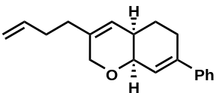
Isolated 3aj in 77% yield, as colorless oil.
¹H NMR (400 MHz, CDCl₃) δ 7.45 (m, 2H), 7.35 (m, 2H), 7.28 (m, 1H), 6.18 (d, J = 3.7 Hz, 1H), 5.84 (ddt, J = 16.9, 10.2, 6.5 Hz, 1H), 5.57 (d, J = 3.3 Hz, 1H), 5.06 (dq, J = 17.1, 1.7 Hz, 1H), 4.99 (ddt, J = 10.2, 2.1, 1.2 Hz, 1H), 4.22 – 4.04 (overlapped, 3H), 2.55 (m, 1H), 2.41 (m, 1H), 2.26 – 2.12 (overlapped, 3H), 2.06 (t, J = 3.3 Hz, 2H), 1.84 (m, 1H), 1.69 (m, 1H);
¹³C NMR (100 MHz, CDCl₃) δ 142.4, 141.5, 138.0, 136.5, 128.2 (2C), 127.4, 125.5 (2C), 123.0, 122.7, 114.8, 69.7, 67.7, 33.9, 32.4, 31.8, 27.7, 25.3;
HRESIMS (positive ion mode) m/z 289.1558 [M + Na]⁺ (calcd. for C₁₉H₂₂ONa, 289.1563);
[α]_{D}²³ = -44.0 (c = 0.19 g/100mL, acetone);
HPLC conditions: Chiralpak IA column (n-Hexane:2-Propanol = 90:10, 0.5 ml/min, 254nm); tr(minor) = 10.4 min, tr (major) = 11.0 min; 93% ee.

5.11 (4aR,8aS)-3-(pent-4-en-1-yl)-7-phenyl-4a,5,6,8a-tetrahydro-2H-chromene (3ak)
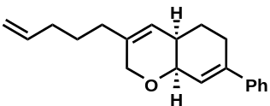
Isolated 3ak in 76% yield, as colorless oil.
¹H NMR (400 MHz, CDCl₃) δ 7.45 (t, J = 7.9 Hz, 2H), 7.33 (overlapped, 3H), 6.19 (d, J = 6.8 Hz, 1H), 5.84 (dq, J = 17.2, 9.2, 8.7 Hz, 1H), 5.56 (m, 1H), 5.02 (dt, J = 18.7, 9.0 Hz, 2H), 4.14 (overlapped, 3H), 2.55 (m, 1H), 2.42 (m, 1H), 2.27 – 2.06 (overlapped, 3H), 1.99 (m, 2H), 1.83 (m, 1H), 1.74 – 1.49 (overlapped, 3H);
¹³C NMR (100 MHz, CDCl₃) δ 142.5, 141.6, 138.5, 137.0, 128.3 (2C), 127.5, 125.6 (2C), 123.1, 122.6, 114.8, 69.8, 67.7, 33.9, 33.3, 32.5, 27.7, 26.9, 25.4;
HRESIMS (positive ion mode) m/z 303.1715 [M + Na]⁺ (calcd. for C₂₀H₂₄ONa, 303.1719);
[α]_{D}²⁴ = -118.7 (c = 0.07 g/100mL, acetone);
HPLC conditions: Chiralpak IC column (n-Hexane:2-Propanol = 90:10, 0.5 ml/min, 254nm); tr (minor) = 16.8 min, tr (major) = 11.2 min; 97% ee.

5.12 (4aR,8aS)-3-methyl-7-phenyl-4a,5,6,8a-tetrahydro-2H-chromene (3al)
Isolated 3al in 72% yield, as white solid (m.p.: 37.9 °C).
¹H NMR (400 MHz, CDCl₃) δ 7.46 (m, 2H), 7.35 (m, 2H), 7.28 (m, 1H), 6.18 (d, J = 2.9 Hz, 1H), 5.56 (br s, 1H), 4.18 – 4.01 (overlapped, 3H), 2.55 (dt, J = 17.3, 4.2 Hz, 1H), 2.42 (m, 1H), 2.12 (m, 1H), 1.83 (m, 1H), 1.69 (m, 1H), 1.67 (s, 3H);
¹³C NMR (100 MHz, CDCl₃) δ 142.3, 141.5, 133.2, 128.2 (2C), 127.4, 125.5 (2C), 123.0, 122.9, 69.5, 68.7, 34.0, 27.8, 25.2, 18.7;
HRESIMS (positive ion mode) m/z 249.1249 [M + Na]⁺ (calcd. for C₁₆H₁₈ONa, 249.1250);
[α]_{D}²⁶ = -92.4 (c = 0.14 g/100mL, MeOH);
HPLC conditions: Chiralpak IE column (n-Hexane:2-Propanol = 90:10, 0.5 ml/min, 254nm); tr (minor) = 11.2 min, tr (major) = 13.2 min; 97% ee.

5.13 (4aR,8aS)-3-ethyl-7-phenyl-4a,5,6,8a-tetrahydro-2H-chromene (3am)
Isolated 3am in 90% yield, as colorless oil.
¹H NMR (400 MHz, CDCl₃) δ 7.46 (d, J = 7.7 Hz, 2H), 7.35 (t, J = 7.5 Hz, 2H), 7.30 (m, 1H), 6.20 (d, J = 4.7 Hz, 1H), 5.55 (d, J = 4.6 Hz, 1H), 4.20 – 4.05 (overlapped, 3H), 2.55 (m, 1H), 2.44 (m, 1H), 2.15 (m, 1H), 1.99 (q, J = 7.8 Hz, 2H), 1.85 (m, 1H), 1.69 (qd, J = 12.0, 4.8 Hz, 1H), 1.07 (t, J = 7.6 Hz, 3H);
¹³C NMR (100 MHz, CDCl₃) δ 142.4, 141.6, 138.7, 128.3 (2C), 127.5, 125.6 (2C), 123.1, 121.1, 69.8, 67.9, 34.0, 27.9, 25.7, 25.4, 12.1;
HRESIMS (positive ion mode) m/z 263.1404 [M + Na]⁺ (calcd. for C₁₇H₂₀ONa, 263.1406);
[α]_{D}²⁵ = -86.4 (c = 0.09 g/100mL, acetone);
HPLC conditions: Chiralpak IE column (n-Hexane:2-Propanol = 90:10, 0.5 ml/min, 254nm); tr (minor) = 10.6 min, tr (major) = 11.3 min; 92% ee.

5.14 (4aR,8aS)-3-propyl-7-phenyl-4a,5,6,8a-tetrahydro-2H-chromene (3an)
Isolated 3an in 82% yield, as colorless oil.
¹H NMR (400 MHz, CDCl₃) δ 7.49 – 7.43 (m, 2H), 7.38 – 7.32 (m, 2H), 7.32 – 7.27 (m, 1H), 6.18 (d, J = 3.5 Hz, 1H), 5.55 (d, J = 4.9 Hz, 1H), 4.18 – 4.06 (overlapped, 3H), 2.60 – 2.51 (m, 1H), 2.42 (m, 1H), 2.16 (m, 1H), 1.95 (d, J = 7.6 Hz, 2H), 1.84 (m, 1H), 1.70 (m, 1H), 1.47 (m, 2H), 0.94 (t, J = 7.3 Hz, 3H);
¹³C NMR (100 MHz, CDCl₃) δ 142.5, 141.6, 137.1, 128.3 (2C), 127.4, 125.6 (2C), 123.2, 122.4, 69.8, 67.7, 35.3, 33.9, 27.8, 25.4, 20.8, 13.8;
HRESIMS (positive ion mode) m/z 277.1560 [M + Na]⁺ (calcd. for C₁₈H₂₂ONa, 277.1563);
[α]_{D}²³ = -54.3 (c = 0.11 g/100mL, acetone);
HPLC conditions: Chiralpak IE column (n-Hexane:2-Propanol = 90:10, 0.5 ml/min, 254nm); tr (minor) = 11.0 min, tr (major) = 11.4 min; 98% ee.

5.15 (4aR,8aS)-3-butyl-7-phenyl-4a,5,6,8a-tetrahydro-2H-chromene (3ao)
Isolated 3ao in 91% yield, as white solid (m.p.: 42.0 °C)..
¹H NMR (400 MHz, CDCl₃) δ 7.45 (d, J = 7.3 Hz, 2H), 7.35 (t, J = 7.4 Hz, 2H), 7.29 (t, J = 7.1 Hz, 1H), 6.18 (d, J = 3.2 Hz, 1H), 5.55 (d, J = 3.8 Hz, 1H), 4.21 – 4.04 (overlapped, 3H), 2.55 (m, 1H), 2.42 (m, 1H), 2.16 (m, 1H), 1.98 (t, J = 7.3 Hz, 2H), 1.84 (m, 1H), 1.69 (ddt, J = 16.3, 12.9, 5.0 Hz, 2H), 1.44 – 1.35 (overlapped, 4H), 0.93 (t, J = 7.1 Hz, 3H);
¹³C NMR (100 MHz, CDCl₃) δ 142.5, 141.6, 137.3, 128.3 (2C), 127.4, 125.6 (2C), 123.2, 122.2, 69.8, 67.7, 33.9, 32.9, 29.8, 27.8, 25.4, 22.4, 13.9;
HRESIMS (positive ion mode) m/z 291.1720 [M + Na]⁺ (calcd. for C₁₉H₂₄ONa, 291.1719);
[α]_{D}²⁴ = -43.9 (c = 0.16 g/100mL, acetone);
HPLC conditions: Chiralpak IE column (n-Hexane:2-Propanol = 90:10, 0.5 ml/min, 254nm); tr (minor) = 9.8 min, tr (major) = 10.2 min; 91% ee.

5.16 (4aR,8aS)-3-isopentyl-7-phenyl-4a,5,6,8a-tetrahydro-2H-chromene (3ap)
Isolated 3ap in 64% yield, as colorless oil.
¹H NMR (400 MHz, CDCl₃) δ 7.45 (m, 2H), 7.34 (m, 2H), 7.28 (m, 1H), 6.17 (d, J = 3.5 Hz, 1H), 5.54 (d, J = 4.6 Hz, 1H), 4.19 – 4.07 (overlapped, 3H), 2.54 (m, 1H), 2.41 (m, 1H), 2.14 (m, 1H), 1.97 (t, J = 8.0 Hz, 2H), 1.83 (m, 1H), 1.68 (overlapped, 1H), 1.57 (m, 1H), 1.37 – 1.27 (overlapped, 2H), 0.92 (d, J = 6.8 Hz, 3H), 0.91 (d, J = 6.8 Hz, 3H);
¹³C NMR (100 MHz, CDCl₃) δ 142.5, 141.6, 137.5, 128.3 (2C), 127.4, 125.6 (2C), 123.1, 122.0, 69.8, 67.8, 36.8, 34.0, 31.0, 27.8, 27.7, 25.4, 22.6, 22.5;
HRESIMS (positive ion mode) m/z 305.1874 [M + Na]⁺ (calcd. for C₂₀H₂₆ONa, 305.1876);
[α]_{D}²⁵ = -64.5 (c = 0.12 g/100mL, acetone);
HPLC conditions: Chiralpak IC column (n-Hexane:2-Propanol = 90:10, 0.5 ml/min, 254nm); tr (minor) = 15.3 min, tr (major) = 10.4 min; 95% ee.

5.17 (4aR,8aS)-3-phenethyl-7-phenyl-4a,5,6,8a-tetrahydro-2H-chromene (3aq)
Isolated 3aq in 78% yield, as white solid (m.p.: 61.0 °C).
¹H NMR (400 MHz, CDCl₃) δ 7.41 (d, J = 7.3 Hz, 2H), 7.31 (t, J = 7.4 Hz, 2H), 7.27 – 7.21 (overlapped, 3H), 7.21 – 7.11 (m, 3H), 6.14 (d, J = 4.7 Hz, 1H), 5.51 (d, J = 4.7 Hz, 1H), 4.17 – 4.04 (overlapped, 3H), 2.73 (h, J = 6.0 Hz, 2H), 2.48 (m, 1H), 2.38 (m, 1H), 2.23 (t, J = 7.9 Hz, 2H), 2.10 (m, 1H), 1.77 (m, 1H), 1.65 (m, 1H);
¹³C NMR (100 MHz, CDCl₃) δ 142.5, 141.8, 141.5, 136.5, 128.4 (2C), 128.3 (2C), 128.3 (2C), 127.5, 125.9, 125.6 (2C), 123.1, 123.0, 69.8, 67.8, 34.9, 34.3, 34.0, 27.7, 25.3;
HRESIMS (positive ion mode) m/z 339.1717 [M + Na]⁺ (calcd. for C₂₃H₂₄ONa, 339.1719);
[α]_{D}²⁶ = -59.4 (c = 0.10 g/100mL, MeOH);
HPLC conditions: Chiralpak IC column (n-Hexane:2-Propanol = 90:10, 0.5 ml/min, 254nm); tr (minor) = 19.9 min, tr (major) = 13.4 min; 96% ee.

5.18 (4aR,8aS)-3-cyclopentyl-7-phenyl-4a,5,6,8a-tetrahydro-2H-chromene (3ar)
Isolated 3ar in 51% yield, as white solid (m.p.: 74.6 °C).
¹H NMR (400 MHz, CDCl₃) δ 7.46 (d, J = 7.6 Hz, 2H), 7.35 (t, J = 7.5 Hz, 2H), 7.30 (d, J = 7.7 Hz, 1H), 6.19 (d, J = 4.8 Hz, 1H), 5.57 (d, J = 4.7 Hz, 1H), 4.28 – 4.09 (overlapped, 3H), 2.54 (m, 1H), 2.45 (m, 1H), 2.33 (m, 1H), 2.15 (m, 1H), 1.87 – 1.79 (overlapped, 4H), 1.74 – 1.50 (overlapped, 6H);
¹³C NMR (100 MHz, CDCl₃) δ 142.5, 141.6, 140.4, 128.3 (2C), 127.4, 125.6 (2C), 123.2, 120.1, 69.9, 67.4, 43.4, 33.9, 31.0, 30.9, 27.9, 25.5, 25.0, 24.9;
HRESIMS (positive ion mode) m/z 303.1715 [M + Na]⁺ (calcd. for C₂₀H₂₄ONa, 303.1719);
[α]_{D}²⁵ = -17.1 (c = 0.08 g/100mL, acetone);
HPLC conditions: Chiralpak IC column (n-Hexane:2-Propanol = 90:10, 0.5 ml/min, 254nm); tr (minor) = 19.1 min, tr (major) = 11.2 min; 85% ee.

5.19 (4aR,8aS)-3-cyclohexyl-7-phenyl-4a,5,6,8a-tetrahydro-2H-chromene (3as)
Isolated 3as in 47% yield, as white solid (m.p.: 67.6 °C).
¹H NMR (400 MHz, CDCl₃) δ 7.45 (dd, J = 7.4, 1.8 Hz, 2H), 7.35 (t, J = 7.5 Hz, 2H), 7.29 (m, 1H), 6.17 (d, J = 4.5 Hz, 1H), 5.52 (d, J = 4.7 Hz, 1H), 4.23 – 4.09 (overlapped, 3H), 2.54 (dt, J = 17.4, 4.3 Hz, 1H), 2.42 (m, 1H), 2.15 (m, 1H), 1.86 – 1.73 (overlapped, 6H), 1.72 – 1.58 (overlapped, 3H), 1.28 – 1.15 (overlapped, 4H);
¹³C NMR (100 MHz, CDCl₃) δ 142.5, 142.3, 141.7, 128.3 (2C), 127.4, 125.6 (2C), 123.2, 120.4, 69.9, 66.9, 41.9, 33.8, 32.1, 31.9, 27.8, 26.7 (2C), 26.3, 25.5;
HRESIMS (positive ion mode) m/z 317.1874 [M + Na]⁺ (calcd. for C₂₁H₂₆ONa, 317.1876);
[α]_{D}²⁴ = -85.9 (c = 0.09 g/100mL, acetone);
HPLC conditions: Chiralpak IC column (n-Hexane:2-Propanol = 90:10, 0.5 ml/min, 254nm); tr (minor) = 19.3 min, tr (major) = 11.0 min; 91% ee.

5.20 (4aR,8aS)-3-pentyl-7-phenyl-4a,5,6,8a-tetrahydro-2H-chromene (3at)
Isolated 3at in 79% yield, as colorless oil.
¹H NMR (400 MHz, CDCl₃) δ 7.43 (m, 2H), 7.33 (m, 2H), 7.26 (m, 1H), 6.16 (d, J = 4.1 Hz, 1H), 5.52 (d, J = 4.6 Hz, 1H), 4.19 – 4.03 (overlapped, 3H), 2.52 (dt, J = 17.3, 4.0 Hz, 1H), 2.42 (m, 1H), 2.20 – 2.09 (m, 1H), 1.94 (t, J = 7.6 Hz, 2H), 1.82 (m, 1H), 1.67 (dtd, J = 12.9, 10.8, 5.0 Hz, 1H), 1.42 (m, 2H), 1.33 – 1.25 (overlapped, 4H), 0.89 (t, J = 6.9 Hz, 3H);
¹³C NMR (100 MHz, CDCl₃) δ 142.4, 141.6, 137.3, 128.2 (2C), 127.4, 125.5 (2C), 123.1, 122.1, 69.7, 67.7, 33.9, 33.1, 31.5, 27.7, 27.3, 25.4, 22.5, 14.0;
HRESIMS (positive ion mode) m/z 305.1873 [M + Na]⁺ (calcd. for C₂₀H₂₆ONa, 305.1876);
[α]_{D}²³ = -47.5 (c = 0.17 g/100mL, acetone);
HPLC conditions: Chiralpak IA column (n-Hexane:2-Propanol = 90:10, 0.5 ml/min, 254nm); tr (minor) = 9.9 min, tr (major) = 9.2 min; 93% ee.

5.21 (4aR,8aS)-3-hexyl-7-phenyl-4a,5,6,8a-tetrahydro-2H-chromene (3au)
Isolated 3au in 81% yield, as colorless oil.
¹H NMR (400 MHz, CDCl₃) δ 7.45 (m, 2H), 7.34 (m, 2H), 7.28 (m, 1H), 6.18 (d, J = 4.3 Hz, 1H), 5.54 (d, J = 4.6 Hz, 1H), 4.22 – 4.03 (overlapped, 3H), 2.54 (m, 1H), 2.41 (m, 1H), 2.15 (m, 1H), 1.96 (t, J = 7.6 Hz, 2H), 1.84 (m, 1H), 1.68 (dtd, J = 12.8, 10.8, 5.0 Hz, 1H), 1.47 – 1.48 (overlapped, 2H), 1.33 – 1.24 (overlapped, 6H), 0.91 (t, J = 6.9 Hz, 3H);
¹³C NMR (100 MHz, CDCl₃) δ 142.4, 141.6, 137.3, 128.2 (2C), 127.4, 125.5 (2C), 123.1, 122.1, 69.7, 67.7, 33.9, 33.2, 31.7, 28.9, 27.7, 27.6, 25.4, 22.6, 14.1;
HRESIMS (positive ion mode) m/z 319.2029 [M + Na]⁺ (calcd. for C₂₁H₂₈ONa, 319.2032);
[α]_{D}²³ = -46.4 (c = 0.13 g/100mL, acetone);
HPLC conditions: Chiralpak IA column (n-Hexane:2-Propanol = 90:10, 0.5 ml/min, 254nm); tr (minor) = 9.7 min, tr (major) = 9.0 min;92% ee.

5.22 (4aR,8aS)-3-heptyl-7-phenyl-4a,5,6,8a-tetrahydro-2H-chromene (3av)
Isolated 3av in 79% yield, as white solid(m.p.: 34.6 °C).
¹H NMR (400 MHz, CDCl₃) δ 7.45 (m, 2H), 7.35 (m, 2H), 7.28 (m, 1H), 6.18 (d, J = 4.2 Hz, 1H), 5.54 (d, J = 4.6 Hz, 1H). 4.20 – 4.06 (overlapped, 3H), 2.55 (dt, J = 17.4, 4.3 Hz, 1H), 2.42 (m, 1H), 2.16 (m, 1H), 1.97 (t, J = 7.6 Hz, 2H), 1.84 (m, 1H), 1.69 (m, 1H), 1.43 (m, 2H), 1.34 – 1.26 (overlapped, 8H), 0.91 (t, J = 6.8 Hz, 3H);
¹³C NMR (100 MHz, CDCl₃) δ 142.4, 141.5, 137.3, 128.2 (2C), 127.4, 125.5 (2C), 123.1, 122.1, 69.7, 67.7, 33.9, 33.2, 31.8, 29.2, 29.1, 27.7, 27.6, 25.4, 22.6, 14.1;
HRESIMS (positive ion mode) m/z 333.2189 [M + Na]⁺ (calcd. for C₂₂H₃₀ONa, 333.2189);
[α]_{D}²⁵ = -75.4 (c = 0.16 g/100mL, acetone);
HPLC conditions: Chiralpak IA column (n-Hexane:2-Propanol = 90:10, 0.5 ml/min, 254nm); tr (minor) = 9.5 min, tr (major) = 8.8 min; 92% ee.

5.23 (4aR,8aS)-3-decyl-7-phenyl-4a,5,6,8a-tetrahydro-2H-chromene (3aw)
Isolated 3aw in 86% yield, as white solid (m.p.: 38.0 °C).
¹H NMR (400 MHz, CDCl₃) δ 7.45 (m, 2H), 7.34 (m, 2H), 7.28 (m, 1H), 6.18 (d, J = 4.3 Hz, 1H), 5.54 (d, J = 4.6 Hz, 1H), 4.23 – 4.08 (overlapped, 3H), 2.54 (m, 1H), 2.42 (m, 1H), 2.16 (m, 1H), 1.96 (t, J = 7.6 Hz, 2H), 1.83 (m, 1H), 1.68 (m, 1H), 1.42 (m, 2H), 1.37 – 1.23 (m, 14H), 0.91 (t, J = 6.7 Hz, 3H);
¹³C NMR (100 MHz, CDCl₃) δ 142.4, 141.6, 137.4, 128.3 (2C), 127.4, 125.6 (2C), 123.2, 122.2, 69.8, 67.7, 33.9, 33.2, 31.9, 29.7 (2C), 29.6, 29.5, 29.4, 27.7 (2C), 25.4, 22.7, 14.1;
HRESIMS (positive ion mode) m/z 375.2657 [M + Na]⁺ (calcd. for C₂₅H₃₆ONa, 375.2658);
[α]_{D}²³ = -83.3 (c = 0.12 g/100mL, acetone);
HPLC conditions: Chiralpak IC column (n-Hexane:2-Propanol = 90:10, 0.5 ml/min, 254nm); tr (minor) = 15.3 min, tr (major) = 9.7 min; 94% ee.

5.24 (4aR,8aS)-3-tetradecyl-7-phenyl-4a,5,6,8a-tetrahydro-2H-chromene (3ax)
Isolated 3ax in 83% yield, as white solid (m.p.: 49.1 °C).
¹H NMR (400 MHz, CDCl₃) δ 7.45 (dd, J = 7.3, 1.8 Hz, 2H), 7.34 (t, J = 7.4 Hz, 2H), 7.28 (m, 1H), 6.18 (d, J = 4.4 Hz, 1H), 5.54 (d, J = 4.7 Hz, 1H), 4.13 (overlapped, 3H), 2.54 (dt, J = 17.3, 4.3 Hz, 1H), 2.42 (m, 1H), 2.16 (m, 1H), 1.96 (t, J = 7.5 Hz, 2H), 1.84 (m, 1H), 1.77 – 1.60 (m, 2H), 1.42 (m, 2H), 1.29 (overlapped, 21H), 0.91 (t, J = 6.7 Hz, 3H);
¹³C NMR (100 MHz, CDCl₃) δ 142.4, 141.6, 137.4, 128.3 (2C), 127.4, 125.6 (2C), 123.2, 122.2, 69.8, 67.7, 33.9, 33.2, 32.0, 29.7 (5C), 29.6, 29.5, 29.4, 29.3, 27.7 (2C), 25.4, 22.7, 14.1;
HRESIMS (positive ion mode) m/z 431.3288 [M + Na]⁺ (calcd. for C₂₉H₄₄ONa, 431.3284);
[α]_{D}²⁴ = -81.7 (c = 0.08 g/100mL, acetone);
HPLC conditions: Chiralpak IC column (n-Hexane:2-Propanol = 90:10, 0.5 ml/min, 254nm); tr (minor) = 12.2 min, tr (major) = 8.9 min; 95% ee.

5.25 (4aR,8aS)-3-phenyl-7-(4-fluorophenyl)-4a,5,6,8a-tetrahydro-2H-chromene (3ba)
Isolated 3ba in 87% yield, as white solid (m.p.: 122.0 °C).
¹H NMR (400 MHz, CDCl₃) δ 7.41 (m, 2H), 7.35 (overlapped, 4H), 7.28 (m, 1H), 7.02 (m, 2H), 6.21 (d, J = 4.8 Hz, 1H), 6.17 (d, J = 4.8 Hz, 1H), 4.60 (m, 2H), 4.22 (t, J = 4.6 Hz, 1H), 2.54 (m, 1H), 2.44 (m, 1H), 2.33 (m, 1H), 1.94 (m, 1H), 1.78 (m, 1H);
¹³C NMR (100 MHz, CDCl₃) δ 162.4 (d, J = 246.4 Hz), 141.7, 138.1, 137.4 (d, J = 3.3 Hz), 136.1, 128.5 (2C), 127.5, 127.1 (d, J = 8.0 Hz, 2C), 125.4, 124.9 (2C), 122.6 (d, J = 1.4 Hz), 115.1 (d, J = 21.2 Hz, 2C), 69.5, 66.8, 34.2, 27.9, 25.1;
¹⁹F NMR (376 MHz, CDCl₃) δ -115.0;
HRESIMS (positive ion mode) m/z 329.1309 [M + Na]⁺ (calcd. for C₂₁H₁₉FONa, 329.1312);
[α]_{D}²⁵ = -37.4 (c = 0.12 g/100mL, MeOH);
HPLC conditions: Chiralpak ID column (n-Hexane:2-Propanol = 90:10, 0.5 ml/min, 254nm); tr (minor) = 12.9 min, tr (major) = 16.4 min; 98% ee.

5.26 (4aR,8aS)-3-phenyl-7-(4-chlorophenyl)-4a,5,6,8a-tetrahydro-2H-chromene (3bb)
Isolated 3bb in 76% yield, as white solid (m.p.: 174.0 °C).
¹H NMR (400 MHz, CDCl₃) δ 7.41 – 7.28 (overlapped, 9H), 6.21 (overlapped, 2H), 4.60 (overlapped, 2H), 4.22 (t, J = 4.6 Hz, 1H), 2.54 (dt, J = 17.2, 4.2 Hz, 1H), 2.41 (m, 1H), 2.33 (m, 1H), 1.94 (m, 1H), 1.77 (dtd, J = 12.9, 11.1, 5.0 Hz, 1H);
¹³C NMR (100 MHz, CDCl₃) δ 141.6, 139.8, 138.1, 136.2, 133.4, 128.6 (2C), 128.5 (2C), 127.6, 126.9 (2C), 125.3, 124.9 (2C), 123.3, 69.5, 66.9, 34.3, 27.8, 25.1;
HRESIMS (positive ion mode) m/z 345.1014 [M + Na]⁺ (calcd. for C₂₁H₁₉ClONa, 345.1017);
[α]_{D}²⁴ = -48.9 (c = 0.11 g/100mL, acetone);
HPLC conditions: Chiralpak IE column (n-Hexane:2-Propanol = 90:10, 0.5 ml/min, 254nm); tr (minor) = 13.1 min, tr (major) = 16.4 min; 99% ee.

5.27 (4aR,8aS)-3-phenyl-7-(p-tolyl)-4a,5,6,8a-tetrahydro-2H-chromene (3bc)
Isolated 3bc in 91% yield, as white solid (m.p.: 166.0 °C).
¹H NMR (400 MHz, CDCl₃) δ 7.38 – 7.34 (overlapped, 6H), 7.29 (m, 1H), 7.16 (d, J = 7.9 Hz, 2H), 6.22 – 6.20 (overlapped, 2H), 4.62 (m, 2H), 4.24 (d, J = 4.6 Hz, 1H), 2.58 (dt, J = 17.3, 4.3 Hz, 1H), 2.45 (m, 1H), 2.36 (s, 3H), 2.33 (m, 1H), 1.94 (m, 1H), 1.79 (dtd, J = 12.9, 11.0, 5.0 Hz, 1H);
¹³C NMR (100 MHz, CDCl₃) δ 142.5, 138.6, 138.3, 137.3, 136.1, 129.0 (2C), 128.5 (2C), 127.5, 125.6, 125.5 (2C), 125.0 (2C), 121.9, 69.7, 66.8, 34.4, 27.8, 25.3, 21.1;
HRESIMS (positive ion mode) m/z 303.1742 [M + H]⁺ (calcd. for C₂₂H₂₃O, 303.1743);
[α]_{D}²⁵ = -38.1 (c = 0.09 g/100mL, acetone);
HPLC conditions: Chiralpak ID column (n-Hexane:2-Propanol = 90:10, 0.5 ml/min, 254nm); tr (minor) = 12.9 min, tr (major) = 16.3 min; 93% ee.

5.28 (4aR,8aS)-3-phenyl-7-(4-(trifluoromethoxy)phenyl)-4a,5,6,8a-tetrahydro-2H-chromene (3bd)
Isolated 3bd in 73% yield, as white solid (m.p.: 159.0 °C).
¹H NMR (400 MHz, CDCl₃) δ 7.46 (d, J = 8.7 Hz, 2H), 7.37 – 7.32 (overlapped, 4H), 7.29 (m, 1H), 7.18 (d, J = 8.4 Hz, 2H), 6.21 (overlapped, 2H), 4.61 (m, 2H), 4.23 (t, J = 4.5 Hz, 1H), 2.55 (dt, J = 17.3, 4.3 Hz, 1H), 2.44 (m, 1H), 2.34 (m, 1H), 1.95 (m, 1H), 1.78 (dtd, J = 12.9, 11.0, 5.1 Hz, 1H);
¹³C NMR (100 MHz, CDCl₃) δ 148.6, 141.5, 140.1, 138.1, 136.2, 128.6 (2C), 127.6, 126.9 (2C), 125.3, 124.9 (2C), 123.6, 120.7 (2C), 69.4, 66.9, 34.2, 27.8, 25.1;
¹⁹F NMR (376 MHz, CDCl₃) δ -57.8 (3F);
HRESIMS (positive ion mode) m/z 395.1222 [M + Na]⁺ (calcd. for C₂₂H₁₉F₃O₂Na, 395.1229);
[α]_{D}²⁴ = -87.4 (c = 0.12 g/100mL, acetone);
HPLC conditions: Chiralpak IE column (n-Hexane:2-Propanol = 90:10, 0.5 ml/min, 254nm); tr (minor) = 12.2 min, tr (major) = 12.6 min; 98% ee.

5.29 (4aR,8aS)-3-phenyl-7-(4-(trifluoromethyl)phenyl)-4a,5,6,8a-tetrahydro-2H-chromene (3be)
Isolated 3be in 86% yield, as white solid (m.p.: 168.0 °C).
¹H NMR (400 MHz, CDCl₃) δ 7.67 – 7.54 (overlapped, 4H), 7.40 – 7.35 (overlapped, 4H), 7.31 (m, 1H), 6.32 (d, J = 3.8 Hz, 1H), 6.24 (d, J = 5.0 Hz, 1H), 4.64 (m, 2H), 4.27 (t, J = 4.6 Hz, 1H), 2.60 (dt, J = 17.4, 4.3 Hz, 1H), 2.50 (m, 1H), 2.38 (m, 1H), 1.99 (m, 1H), 1.82 (m, 1H);
¹³C NMR (100 MHz, CDCl₃) δ 144.9, 141.6, 138.1, 136.3, 128.6 (2C), 127.6, 125.9 (2C), 125.4, 125.3 (q, J = 3.8 Hz, 2C), 124.9 (2C), 124.8, 69.4, 66.9, 34.2, 27.8, 25.1;
¹⁹F NMR (376 MHz, CDCl₃) δ -62.5 (3F);
HRESIMS (positive ion mode) m/z 357.1460 [M + H]⁺ (calcd. for C₂₂H₂₀F₃O, 357.1461);
[α]_{D}²⁵ = -68.8 (c = 0.06 g/100mL, MeOH:CHCl₃ = 2:1);
HPLC conditions: Chiralpak ID column (n-Hexane:2-Propanol = 90:10, 0.5 ml/min, 254nm); tr (minor) = 10.7 min, tr (major) = 13.3 min; 97% ee.

5.30 trimethyl(4-((4aR,8aS)-3-phenyl-4a,5,6,8a-tetrahydro-2H-chromen-7-yl)phenyl)silane (3bf)
Isolated 3bf in 88% yield, as white solid (m.p.: 177.0 °C).
¹H NMR (400 MHz, CDCl₃) δ 7.53 (d, J = 7.7 Hz, 2H), 7.46 (d, J = 7.7 Hz, 2H), 7.36 (overlapped, 4H), 7.30 (m, 1H), 6.26 (d, J = 3.8 Hz, 1H), 6.22 (d, J = 4.9 Hz, 1H), 4.62 (m, 2H), 4.26 (t, J = 4.4 Hz, 1H), 2.59 (m, 1H), 2.49 (m, 1H), 2.36 (m, 1H), 1.96 (m, 1H), 1.81 (m, 1H), 0.30 (s, 9H);
¹³C NMR (100 MHz, CDCl₃) δ 142.7, 141.8, 139.8, 138.2, 136.2, 133.4 (2C), 128.6 (2C), 127.5, 125.5, 125.0 (2C), 124.9 (2C), 122.9, 69.7, 66.8, 34.4, 27.7, 25.3, -1.08 (3C);
HRESIMS (positive ion mode) m/z 383.1799 [M + Na]⁺ (calcd. for C₂₄H₂₈OSiNa, 383.1802);
[α]_{D}²⁵ = -71.0 (c = 0.13 g/100mL, acetone);
HPLC conditions: Chiralpak IC column (n-Hexane:2-Propanol = 90:10, 0.5 ml/min, 254nm); tr (minor) = 13.1 min, tr (major) = 21.0 min; 90% ee.

5.31 (4aR,8aS)-3-phenyl-7-(3-fluorophenyl)-4a,5,6,8a-tetrahydro-2H-chromene (3bg)
Isolated 3bg in 74% yield, as white solid (m.p.: 118.3 °C).
¹H NMR (400 MHz, CDCl₃) δ 7.37 – 7.34 (overlapped, 4H), 7.33 – 7.28 (overlapped, 2H), 7.24 (m, 1H), 7.15 (dt, J = 10.4, 2.1 Hz, 1H), 6.98 (m, 1H), 6.26 (d, J = 4.9 Hz, 1H), 6.21 (d, J = 4.7 Hz, 1H), 4.61 (tdd, J = 15.7, 14.5, 1.9 Hz, 2H), 4.24 (t, J = 4.6 Hz, 1H), 2.55 (dt, J = 17.3, 4.2 Hz, 1H), 2.43 (m, 1H), 2.34 (m, 1H), 1.95 (m, 1H), 1.79 (dtd, J = 12.9, 11.0, 5.0 Hz, 1H);
¹³C NMR (100 MHz, CDCl₃) δ 162.9 (d, J = 245.1 Hz), 143.7 (d, J = 7.3 Hz), 141.6 (d, J = 2.2 Hz), 138.1, 136.2, 129.7 (d, J = 8.4 Hz), 128.6 (2C), 127.6, 125.3, 125.0 (2C), 123.8, 121.2 (d, J = 2.8 Hz), 114.33 (d, J = 21.2 Hz), 112.6 (d, J = 22.1 Hz), 69.5, 66.9, 34.3, 27.7, 25.1;
¹⁹F NMR (376 MHz, CDCl₃) δ -113.4;
HRESIMS (positive ion mode) m/z 329.1309 [M + Na]⁺ (calcd. for C₂₁H₁₉FONa, 329.1312);
[α]_{D}²⁵ = -67.3 (c = 0.12 g/100mL, MeOH);
HPLC conditions: Chiralpak IE column (n-Hexane:2-Propanol = 90:10, 0.5 ml/min, 254nm); tr (minor) = 12.6 min, tr (major) = 15.9 min; 98% ee.

5.32 (4aR,8aS)-3-phenyl-7-(m-tolyl)-4a,5,6,8a-tetrahydro-2H-chromene (3bh)
Isolated 3bh in 93% yield, as white solid (m.p.: 106.3 °C).
¹H NMR (400 MHz, CDCl₃) δ 7.43 – 7.35 (overlapped, 4H), 7.34 – 7.25 (overlapped, 4H), 7.14 (d, J = 6.3 Hz, 1H), 6.25 – 6.23 (overlapped, 2H), 4.64 (m, 2H), 4.26 (t, J = 4.6 Hz, 1H), 2.60 (m, 1H), 2.48 (m, 1H), 2.40 (s, 3H), 2.36 (m, 1H), 1.97 (m, 1H), 1.81 (dtd, J = 12.9, 10.9, 5.0 Hz, 1H);
¹³C NMR (100 MHz, CDCl₃) δ 142.9, 141.5, 138.2, 137.8, 136.2, 128.5 (2C), 128.3, 128.2, 127.5, 126.5, 125.6, 125.0 (2C), 122.7, 122.6, 69.7, 66.8, 34.4, 27.9, 25.3, 21.5;
HRESIMS (positive ion mode) m/z 303.1741 [M + H]⁺ (calcd. for C₂₂H₂₃O, 303.1743);
[α]_{D}²⁵ = -112,9 (c = 0.10 g/100mL, acetone);
HPLC conditions: Chiralpak IC column (n-Hexane:2-Propanol = 90:10, 0.5 ml/min, 254nm); tr (minor) = 11.9 min, tr (major) = 14.7 min; 98% ee.

5.33 (4aR,8aS)-3-phenyl-7-(3-methoxyphenyl)-4a,5,6,8a-tetrahydro-2H-chromene (3bi)
Isolated 3bi in 88% yield, as white solid (m.p.: 124.0°C).
¹H NMR (400 MHz, CDCl₃) δ 7.38 – 7.34 (overlapped, 4H), 7.34 – 7.26 (m, 2H), 7.10 – 7.01 (m, 2H), 6.86 (dd, J = 8.2, 2.6 Hz, 1H), 6.28 – 6.20 (m, 2H), 4.63 (m, 2H), 4.25 (t, J = 4.5 Hz, 1H), 3.84 (s, 3H), 2.59 (m, 1H), 2.46 (m, 1H), 2.35 (dt, J = 12.0, 3.8 Hz, 1H), 1.95 (m, 1H), 1.80 (dtd, J = 13.0, 11.0, 5.1 Hz, 1H);
¹³C NMR (100 MHz, CDCl₃) δ 159.6, 143.0, 142.7, 138.2, 136.2, 129.3, 128.6 (2C), 127.5, 125.5, 125.0 (2C), 123.0, 118.2, 113.1, 111.4, 69.6, 66.9, 55.3, 34.4, 28.0, 25.2;
HRESIMS (positive ion mode) m/z 341.1507 [M + Na]⁺ (calcd. for C₂₂H₂₂O₂Na, 341.1512);
[α]_{D}²⁵ = -28.2 (c = 0.12 g/100mL, MeOH);
HPLC conditions: Chiralpak IE column (n-Hexane:2-Propanol = 90:10, 0.5 ml/min, 254nm); tr (minor) = 20.8 min, tr (major) = 27.1 min; 98% ee.

5.34 (4aR,8aS)-3-phenyl-7-(2-methoxyphenyl)-4a,5,6,8a-tetrahydro-2H-chromene (3bj)
Isolated 3bj in 57% yield, as white solid (m.p.: 119.0 °C).
¹H NMR (400 MHz, CDCl₃) δ 7.41 – 7.34 (overlapped, 4H), 7.33 – 7.22 (overlapped, 3H), 6.96 (t, J = 7.4 Hz, 1H), 6.91 (d, J = 8.2 Hz, 1H), 6.23 (d, J = 4.9 Hz, 1H), 5.96 (br s, 1H), 4.63 (m, 2H), 4.23 (t, J = 4.7 Hz, 1H), 3.83 (s, 3H), 2.51 (m, 1H), 2.41 (m, 1H), 1.90 (m, 1H), 1.85 – 1.68 (overlapped, 2H);
¹³C NMR (100 MHz, CDCl₃) δ 156.7, 143.6, 138.4, 136.1, 132.4, 129.5, 128.52 (2C), 128.47, 127.5, 125.9, 125.0 (2C), 124.6, 120.6, 110.9, 69.6, 66.7, 55.4, 34.5, 29.2, 25.4;
HRESIMS (positive ion mode) m/z 341.1510 [M + Na]⁺ (calcd. for C₂₂H₂₂O₂Na, 341.1512);
[α]_{D}²⁵ = -108.8 (c = 0.13 g/100mL, acetone);
HPLC conditions: Chiralpak ID column (n-Hexane:2-Propanol = 90:10, 0.5 ml/min, 254nm); tr (minor) = 13.2 min, tr (major) = 14.6 min; 90% ee.

5.35 (4aR,8aS)-3-phenyl-7-(naphthalen-1-yl)-4a,5,6,8a-tetrahydro-2H-chromene (3bk)
Isolated 3bk in 52% yield, as white solid (m.p.: 82.1 °C).
¹H NMR (400 MHz, CDCl₃) δ 7.98 (d, J = 7.6 Hz, 1H), 7.87 (d, J = 8.0 Hz, 1H), 7.80 (d, J = 8.1 Hz, 1H), 7.51 – 7.38 (overlapped, 7H), 7.35 – 7.31 (overlapped, 2H), 6.27 (br s, 1H), 5.98 (br s, 1H), 4.67 (m, 2H), 4.37 (t, J = 4.4 Hz, 1H), 2.59 – 2.43 (overlapped, 3H), 2.04 – 1.91 (overlapped, 2H);
¹³C NMR (100 MHz, CDCl₃) δ 143.8, 141.5, 138.3, 136.4, 133.7, 131.0, 128.6 (2C), 128.3, 127.6, 127.3, 126.1, 125.9, 125.7, 125.62, 125.60, 125.4, 125.0 (2C), 124.7, 69.6, 66.5, 34.3, 31.1, 25.5;
HRESIMS (positive ion mode) m/z 361.1564 [M + Na]⁺ (calcd. for C₂₅H₂₂ONa, 361.1563);
[α]_{D}²⁵ = -44.9 (c = 0.15 g/100mL, MeOH);
HPLC conditions: Chiralpak IC column (n-Hexane:2-Propanol = 90:10, 0.5 ml/min, 254nm); tr (minor) = 12.4 min, tr (major) = 13.2 min; 84% ee.

5.36 (4aR,8aS)-3-phenyl-7-(naphthalen-2-yl)-4a,5,6,8a-tetrahydro-2H-chromene (3bl)
Isolated 3bl in 71% yield, as white solid (m.p.: 171.0 °C).
¹H NMR (400 MHz, CDCl₃) δ 7.89 – 7.79 (overlapped, 4H), 7.65 (d, J = 8.7 Hz, 1H), 7.54 – 7.26 (overlapped, 7H), 6.39 (br s, 1H), 6.24 (br s, 1H), 4.63 (q, J = 15.6 Hz, 2H), 4.29 (br s, 1H), 2.73 (m, 1H), 2.60 (m, 1H), 2.39 (m, 1H), 2.00 (m 1H), 1.85 (m, 1H);
¹³C NMR (100 MHz, CDCl₃) δ 142.5, 138.6, 138.2, 136.2, 133.4, 132.9, 128.6 (2C), 128.2, 127.8, 127.6, 127.5, 126.2, 125.9, 125.5, 125.0 (2C), 124.4, 124.0, 123.3, 69.7, 66.9, 34.4, 27.9, 25.3;
HRESIMS (positive ion mode) m/z 361.1559 [M + Na]⁺ (calcd. for C₂₅H₂₂ONa, 361.1563);
[α]_{D}²⁵ = -89.4 (c = 0.10 g/100mL, acetone);
HPLC conditions: Chiralpak IC column (n-Hexane:2-Propanol = 90:10, 0.5 ml/min, 254nm); tr (minor) = 16.7 min, tr (major) = 24.9 min; 96% ee.

5.37 (4aR,8aS)-3-phenyl-7-(benzo[d][1,3]dioxol-5-yl)-4a,5,6,8a-tetrahydro-2H-chromene (3bm)
Isolated 3bm in 94% yield, as white solid (m.p.: 135.0 °C).
¹H NMR (400 MHz, CDCl₃) δ 7.33 (overlapped, 4H), 7.25 (m, 1H), 6.93 (overlapped, 2H), 6.77 (d, J = 8.1 Hz, 1H), 6.19 (d, J = 4.7 Hz, 1H), 6.11 (d, J = 3.0 Hz, 1H), 5.95 (s, 2H), 4.58 (qt, J = 15.6, 1.9 Hz, 2H), 4.20 (t, J = 4.6 Hz, 1H), 2.51 (dt, J = 17.3, 4.2 Hz, 1H), 2.40 (m, 1H), 2.30 (m, 1H), 1.91 (m, 1H), 1.75 (m, 1H);
¹³C NMR (100 MHz, CDCl₃) δ 147.7, 147.1, 142.1, 138.2, 136.1, 135.8, 128.5 (2C), 127.5, 125.4, 124.9 (2C), 121.7, 119.1, 108.0, 106.1, 101.0, 69.6, 66.8, 34.3, 28.0, 25.2;
HRESIMS (positive ion mode) m/z 355.1304 [M + Na]⁺ (calcd. for C₂₂H₂₀O₃Na, 355.1305);
[α]_{D}²⁵ = -42.3 (c = 0.10 g/100mL, MeOH);
HPLC conditions: Chiralpak IE column (n-Hexane:2-Propanol = 85:15, 0.5 ml/min, 254nm); tr (minor) = 25.6 min, tr (major) = 26.7 min; 91% ee.

5.38 (4aR,8aS)-7-(benzo[b]thiophen-6-yl)-3-phenyl-4a,5,6,8a-tetrahydro-2H-chromene (3bn)
Isolated 3bn in 76% yield, as white solid (m.p.: 173.4 °C).
¹H NMR (400 MHz, CDCl₃) δ 7.88 (d, J = 1.7 Hz, 1H), 7.83 (d, J = 8.4 Hz, 1H), 7.47 (dd, J = 8.5, 1.9 Hz, 1H), 7.44 (d, J = 5.5 Hz, 1H), 7.38 – 7.30 (overlapped, 5H), 7.29 (m, 1H), 6.28 (d, J = 3.5 Hz, 1H), 6.22 (d, J = 5.0 Hz, 1H), 4.62 (m, 2H), 4.25 (d, J = 4.7 Hz, 1H), 2.66 (m, 1H), 2.53 (m, 1H), 2.37 (m, 1H), 1.97 (m, 1H), 1.81 (m, 1H);
¹³C NMR (100 MHz, CDCl₃) δ 142.8, 139.8, 138.9, 138.2, 137.9, 136.2, 128.5 (2C), 127.5, 126.8, 125.5 (2C), 125.0, 124.1, 122.8, 122.4, 122.2, 120.5, 69.7, 66.9, 34.4, 28.2, 25.3;
HRESIMS (positive ion mode) m/z 367.1123 [M + Na]⁺ (calcd. for C₂₃H₂₀OSNa, 367.1127);
[α]_{D}²³ = -71.1 (c = 0.09 g/100mL, acetone);
HPLC conditions: Chiralpak IC column (n-Hexane:2-Propanol = 90:10, 0.5 ml/min, 254nm); tr (minor) = 19.3 min, tr (major) = 26.4 min; 97% ee.

5.39 (4aR,8aS)-3-phenyl-7-(thiophen-3-yl)-4a,5,6,8a-tetrahydro-2H-chromene (3bo)
Isolated 3bo in 66% yield, as white solid (m.p.: 47.2 °C).
¹H NMR (400 MHz, CDCl₃) δ 7.37 – 7.26 (m, 8H), 6.30 (d, J = 4.9 Hz, 1H), 6.22 (d, J = 5.0 Hz, 1H), 4.62 (q, J = 15.6 Hz, 2H), 4.26 (d, J = 4.6 Hz, 1H), 2.62 (m, 1H), 2.45 (m, 1H), 2.35 (m, 1H), 1.94 (m, 1H), 1.81 (m, 1H);
¹³C NMR (100 MHz, CDCl₃) δ 142.9, 138.3, 137.5, 136.2, 128.7 (2C), 127.6, 125.7, 125.6, 125.2, 125.1 (2C), 121.7, 120.4, 69.8, 66.9, 34.5, 27.7, 25.1;
HRESIMS (negative ion mode) m/z 293.1000 [M - H]⁻ (calcd. for C₁₉H₁₇OS, 293.1006);
[α]_{D}²⁰ = -43.4 (c = 0.10 g/100mL, acetone);
HPLC conditions: Chiralpak IC column (n-Hexane:2-Propanol = 90:10, 0.5 ml/min, 254nm); tr (minor) = 17.7 min, tr (major) = 19.5 min; 83% ee.

5.40 (4aR,8aS)-3-phenyl-7-vinyl-4a,5,6,8a-tetrahydro-2H-chromene (3bp)
Isolated 3bp in 76% yield, as white solid (m.p.: 71.0 °C).
¹H NMR (400 MHz, CDCl₃) δ 7.43 – 7.27 (m, 5H), 6.46 (dd, J = 17.5, 10.8 Hz, 1H), 6.20 (d, J = 5.0 Hz, 1H), 5.89 (d, J = 4.8 Hz, 1H), 5.30 (d, J = 17.5 Hz, 1H), 5.12 (d, J = 10.7 Hz, 1H), 4.59 (m, 2H), 4.17 (t, J = 4.5 Hz, 1H), 2.42 (dt, J = 17.1, 4.2 Hz, 1H), 2.31 (m, 1H), 2.13 (m, 1H), 1.88 (m, 1H), 1.70 (m, 1H);
¹³C NMR (100 MHz, CDCl₃) δ 141.0, 139.2, 138.2, 136.1, 128.5 (2C), 127.5, 126.7, 125.5, 124.9 (2C), 113.5, 69.6, 66.8, 34.7, 24.6, 23.9;
HRESIMS (positive ion mode) m/z 261.1246 [M + Na]⁺ (calcd. for C₁₇H₁₈ONa, 261.1250);
[α]_{D}²⁶ = -156.0 (c = 0.11 g/100mL, MeOH);
HPLC conditions: Chiralpak IE column (n-Hexane:2-Propanol = 90:10, 0.5 ml/min, 254nm); tr (minor) = 11.2 min, tr (major) = 12.0 min; 91% ee.

5.41 (4aR,8aS)-3-phenyl-7-(phenylethynyl)-4a,5,6,8a-tetrahydro-2H-chromene (3bq)
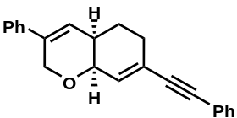
Isolated 3bq in 55% yield, as white solid (m.p.: 126.0 °C).
¹H NMR (400 MHz, CDCl₃) δ 7.52 – 7.45 (overlapped, 2H), 7.40 – 7.30 (overlapped, 8H), 6.30 (d, J = 4.8 Hz, 1H), 6.17 (d, J = 4.7 Hz, 1H), 4.66 – 4.52 (m, 2H), 4.19 (t, J = 4.7 Hz, 1H), 2.41 (m, 1H), 2.36 – 2.26 (m, 2H), 1.86 (m, 1H), 1.73 (m, 1H);
¹³C NMR (100 MHz, CDCl₃) δ 138.1, 136.3, 131.9, 131.6 (2C), 128.5 (2C), 128.3 (2C), 128.2, 127.6, 126.5, 125.1, 124.9 (2C), 123.2, 89.9, 89.5, 68.9, 66.6, 33.9, 29.5, 24.7;
HRESIMS (positive ion mode) m/z 313.1589 [M + H]⁺ (calcd. for C₂₃H₂₁O, 313.1587);
[α]_{D}²⁵ = -93.1 (c = 0.14 g/100mL, acetone);
HPLC conditions: Chiralpak IE column (n-Hexane:2-Propanol = 90:10, 0.5 ml/min, 254nm); tr (minor) = 12.1 min, tr (major) = 14.8 min; 84% ee.
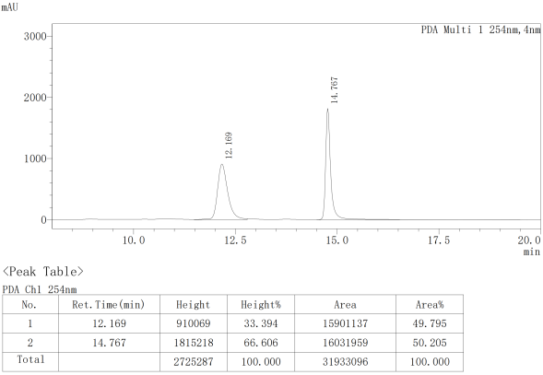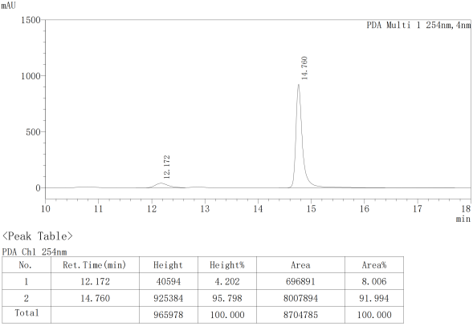

5.42 (4aR,8aS)-3-phenyl-7-butyl-4a,5,6,8a-tetrahydro-2H-chromene (3br)
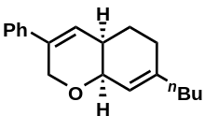
Isolated 3br in 67% yield, as colorless oil.
¹H NMR (400 MHz, CDCl₃) δ 7.35 (overlapped, 4H), 7.32 – 7.28 (m, 1H), 6.18 (d, J = 5.1 Hz, 1H), 5.63 (d, J = 4.8 Hz, 1H), 4.57 (m, 2H), 4.03 (t, J = 4.4 Hz, 1H), 2.21 (m, 1H), 2.12 – 2.02 (overlapped, 4H), 1.79 (m, 1H), 1.64 (m, 1H), 1.45 (m, 2H), 1.34 (m, 2H), 0.93 (t, J = 7.2 Hz, 3H);
¹³C NMR (100 MHz, CDCl₃) δ 145.1, 138.3, 135.9, 128.5 (2C), 127.4, 126.0, 124.9 (2C), 119.8, 69.6, 66.8, 37.4, 34.6, 29.7, 28.8, 25.1, 22.5, 14.0;
HRESIMS (positive ion mode) m/z 291.1714 [M + Na]⁺ (calcd. for C₁₉H₂₄ONa, 291.1719);
[α]_{D}²⁵ = -66.3 (c = 0.10 g/100mL, acetone);
HPLC conditions: Chiralpak IE column (n-Hexane:2-Propanol = 90:10, 0.5 ml/min, 254nm); tr (minor) = 9.7 min, tr (major) = 11.3 min; 94% ee.
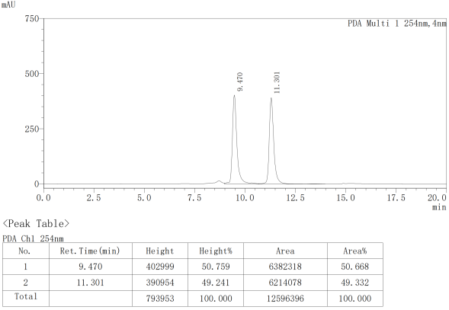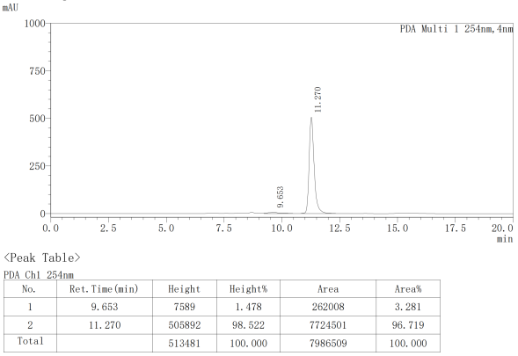

5.43 (4aR,8aS)-3-phenyl-4a,5,6,8a-tetrahydro-2H-chromene (3bs)
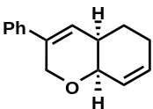
Isolated 3bs in 94% yield, as white solid (m.p.: 44.4 °C).
¹H NMR (400 MHz, CDCl₃) δ 7.36 (overlapped, 4H), 7.30 (m, 1H), 6.19 (d, J = 4.6 Hz, 1H), 6.08 (m, 1H), 5.91 (m, 1H), 4.58 (m, 2H), 4.05 (d, J = 4.5 Hz, 1H), 2.28 (m, 1H), 2.20 (m, 1H), 2.08 (m, 1H), 1.79 (m, 1H), 1.64 (m, 1H);
¹³C NMR (100 MHz, CDCl₃) δ 138.3, 135.9, 133.0, 128.5 (2C), 127.5, 126.0, 125.9, 124.9 (2C), 68.9, 66.8, 34.7, 25.3, 24.6;
HRESIMS (positive ion mode) m/z 235.1095 [M + Na]⁺ (calcd. for C₁₅H₁₆ONa, 235.1093);
[α]_{D}²⁵ = -103.8 (c = 0.17 g/100mL, acetone);
HPLC conditions: Chiralpak IE column (n-Hexane:2-Propanol = 90:10, 0.5 ml/min, 254nm); tr (minor) = 10.3 min, tr (major) = 11.0 min; 94% ee.
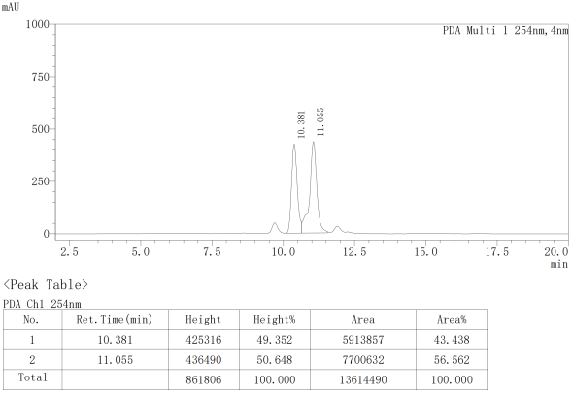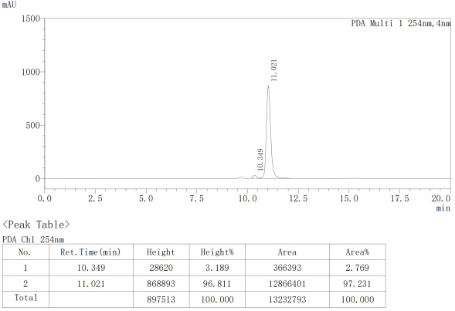

5.44 (4aR,8aS)-7-(4-(((1R,2S,5R)-2-isopropyl-5-methylcyclohexyl)oxy)phenyl)-3-phenyl-4a,5,6,8a-tetrahydro-2H-chromene (3bt)
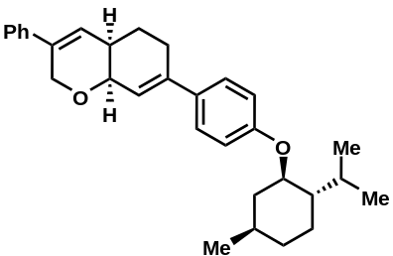
Isolated 3bt in 58% yield, as white solid (m.p.: 153.7 °C).
¹H NMR (400 MHz, CDCl₃) δ 7.52 – 7.23 (overlapped, 7H), 6.89 (d, J = 8.3 Hz, 2H), 6.22 (d, J = 4.9 Hz, 1H), 6.17 (d, J = 4.8 Hz, 1H), 4.62 (q, J = 15.6 Hz, 2H), 4.25 (t, J = 4.5 Hz, 1H), 4.06 (td, J = 10.5, 4.2 Hz, 1H), 2.59 (dt, J = 17.3, 4.2 Hz, 1H), 2.44 (m, 1H), 2.35 (m, 1H), 2.30 – 2.12 (overlapped, 2H), 1.95 (dq, J = 12.7, 3.9 Hz, 1H), 1.86 – 1.70 (overlapped, 3H), 1.59 – 1.42 (overlapped, 2H), 1.20 – 0.88 (overlapped, 9H), 0.81 (d, J = 7.0 Hz, 3H);
¹³C NMR (400 MHz, CDCl₃) δ 158.1, 142.0, 138.3, 136.1, 133.5, 128.5 (2C), 127.5, 126.7 (2C), 125.6, 124.9 (2C), 120.9, 115.5 (2C), 77.5, 69.8, 66.7, 48.1, 40.4, 34.5, 34.4, 31.5, 27.8, 26.1, 25.3, 23.8, 22.2, 20.8, 16.6;
HRESIMS (positive ion mode) m/z 465.2769 [M + Na]⁺ (calcd. for C₃₁H₃₈O₂Na, 465.2764);
[α]_{D}²¹ = -37.8 (c = 0.13 g/100mL, acetone);

5.45 (4aR,8aS)-3-phenyl-7-(4-(((S)-4-(prop-1-en-2-yl)cyclohex-1-en-1-yl)methoxy)phenyl)-4a,5,6, 8a-tetrahydro-2H-chromene (3bu)
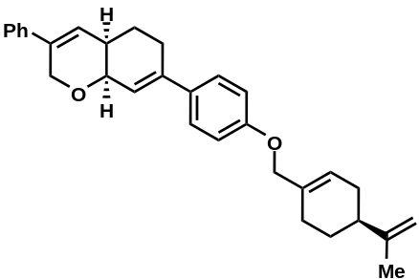
Isolated 3bu in 44% yield, as white solid (m.p.: 167.0 °C).
¹H NMR (400 MHz, CDCl₃) δ 7.47 – 7.28 (overlapped, 7H), 6.92 (d, J = 8.3 Hz, 2H), 6.23 (d, J = 4.9 Hz, 1H), 6.19 (d, J = 4.9 Hz, 1H), 5.88 (s, 1H), 4.77 (d, J = 4.9 Hz, 2H), 4.63 (q, J = 15.6 Hz, 2H), 4.43 (s, 2H), 4.25 (t, J = 4.6 Hz, 1H), 2.60 (m, 1H), 2.45 (m, 1H), 2.35 (m, 1H), 2.23 (overlapped, 4H), 2.05 (m, 1H), 1.94 (overlapped, 2H), 1.79 (overlapped, 4H), 1.57 (m, 1H);
¹³C NMR (100 MHz, CDCl₃) δ 158.7, 149.7, 142.0, 138.2, 136.1, 133.8, 133.5, 128.5 (2C), 127.5, 126.6 (2C), 125.6, 125.2, 124.9 (2C), 121.1, 114.5 (2C), 108.8, 72.4, 69.8, 66.8, 41.0, 34.4, 30.5, 27.8, 27.4, 26.4, 25.3, 20.8;
HRESIMS (positive ion mode) m/z 461.2454 [M + Na]⁺ (calcd. for C₃₁H₃₄O₂Na, 461.2451);
[α]_{D}²² = -42.2 (c = 0.11 g/100mL, acetone).

5.46 (S,E)-5-phenyl-2-styryl-3,6-dihydro-2H-pyran (3aa')
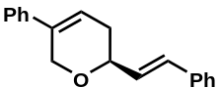
Isolated 3aa' in 93% yield, as white solid (m.p.: 134.0 °C).
¹H NMR (400 MHz, CDCl₃) δ 7.45 (overlapped, 2H), 7.41 – 7.25 (overlapped, 8H), 6.82 – 6.67 (m, 1H), 6.36 (dd, J = 16.0, 5.9 Hz, 1H), 6.25 (m, 1H), 4.80 – 4.59 (m, 2H), 4.38 – 4.23 (m, 1H), 2.53 – 2.33 (m, 2H);
¹³C NMR (100 MHz, CDCl₃) δ 13C NMR (101 MHz, CDCl3) δ 138.2, 136.8, 136.0, 130.9, 129.6, 128.6 (4C), 127.7, 127.5, 126.5 (2C), 124.9 (2C), 120.8, 73.8, 67.1, 31.4;
HRESIMS (positive ion mode) m/z 262.1350 [M]⁺ (calcd. for C₁₉H₁₈O⁺, 262.1352);
[α]_{D}²⁵ = 5.6 (c = 0.18 g/100mL, acetone);
HPLC conditions: Chiralpak IE column (n-Hexane:2-Propanol = 90:10, 0.5 ml/min, 254nm); tr (minor) = 12.4 min, tr (major) = 14.3 min; 6% ee.
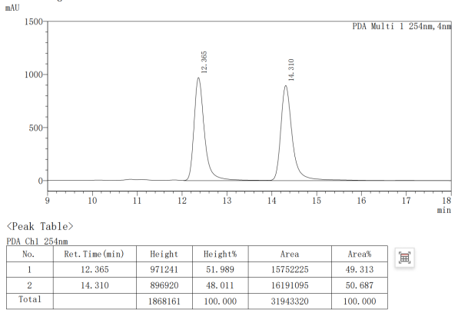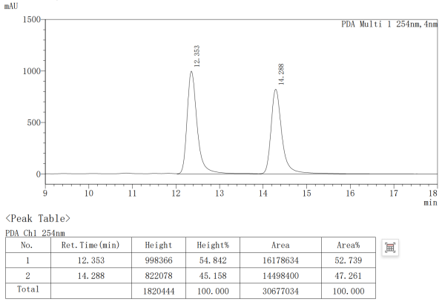

Gram-scale synthesis.
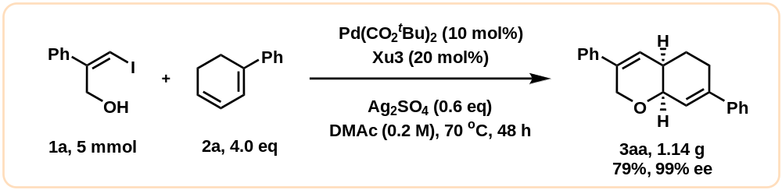
To a sealed tube was added Palladium pivalate (155 mg, 10 mol%, Bide) and Xu3 (684 mg, 20 mol%) in 25 mL dry DMAc and stirred at room temperature for 1 h under nitrogen atmosphere. Then, 1a (5 mmol), 2a (20 mmol, 4.0 equiv) and Ag₂SO₄ (935 mg, 0.6 equiv) were added to the tube under nitrogen atmosphere, and stirred at 70 °C for 48 h. After the reaction was complete (monitored by TLC), dilute with saturated salt water and EtOAc, then extracted with EA (twice), dried over anhydrous Na₂SO₄, the solvent was removed under reduced pressure. The crude product was purified by column chromatography (n-Hexane/EA, 50:1 to 30:1) to give 3aa as a white solid (1.14 g, 79 % yield, 99% ee).
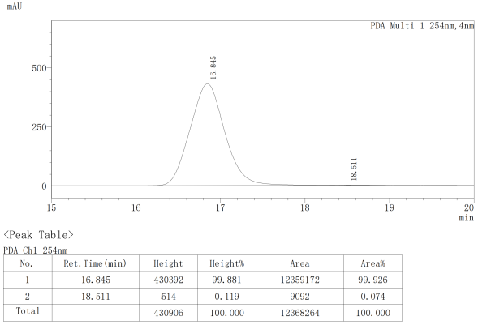
HPLC conditions: Chiralpak ID column (n-Hexane:2-Propanol = 90:10, 1 ml/min, 254nm); tr (minor) = 18.5min, tr (major) = 16.8 min; 99% ee.
- Synthetic applications of the products.
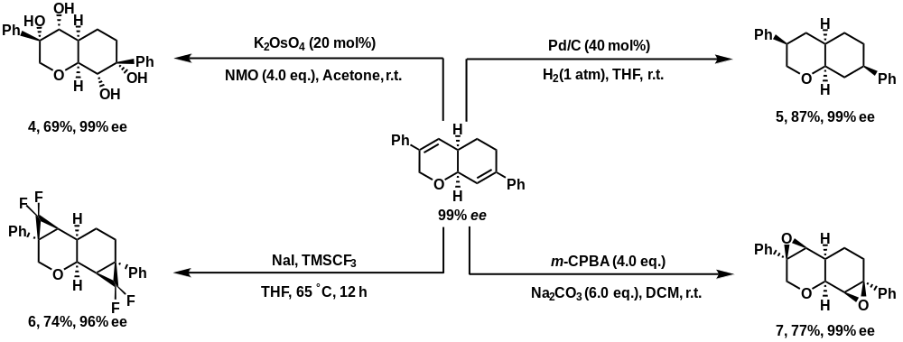
7.1 (3S,4R,4aR,7R,8R,8aS)-3,7-diphenyloctahydro-2H-chromene-3,4,7,8-tetraol (4)
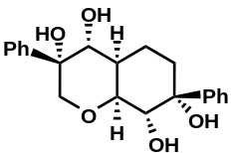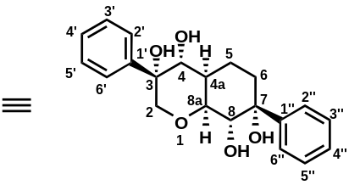
To a solution of 3aa (99% ee, 0.2 mmol, 57.7 mg) and NMO (4.0 equiv., 93.8 mg, cas: 7529-22-8) in acetone (2 mL) was added K₂OsO₄·2H₂O (20 mol%, 12.4 mg, cas: 10022-66-9) at r.t., then the resulting mixture was stirred for 12 h. Upon completion of the reaction, Na₂SO₃ (sat. aq) was added to the mixture. The mixture was extracted with DCM. The combined organics were washed with H₂O and brine, dried with MgSO₄, filtered, and concentrated on a rotary evaporator. The crude product was purified by column chromatography (PE/EA = 1:1) to give 4 (69 % yield, 49.2mg, 99% ee) as a white solid (m.p.: 69.0°C).
¹H NMR (400 MHz, CDCl₃) δ 7.50 – 7.45 (overlapped, 4H, H-2', H-6', H-2'' and H-6''), 7.41 – 7.36 (overlapped, 4H, H-3', H-5', H-3'' and H-5''), 7.34 – 7.27 (overlapped, 2H, H-4' and H-4''), 4.46 (d, J = 10.1 Hz, 1H, H-8), 4.18 (overlapped, 2H, H-4 and H-8a), 3.78 (d, J = 13.0 Hz, 1H, H_{a}-2), 3.52 (d, J = 13.0 Hz, 1H, H_{b}-2), 3.17 (s, 1H, 7-OH), 2.40 (m, 1H, H-4a), 1.82 (td, J = 13.4, 12.2, 5.2 Hz, 1H, H_{a}-6), 1.73 (m, 1H, H_{b}-6);
¹³C NMR (100 MHz, CDCl₃) δ 145.8 (C-1''), 140.8 (C-1'), 128.6 (2C, C-3''/5''), 128.5 (2C, C-3'/5'), 127.9 (C-4'), 127.3 (C-4''), 125.7 (2C, C-2'/6'), 124.9 (2C, C-2''/6''), 77.2 (C-8a), 76.7 (C-7), 74.8 (C-3), 68.9 (C-2), 68.6 (C-4), 67.9 (C-8), 37.6 (C-4a), 33.4 (C-6), 19.3 (C-5);
HRESIMS (positive ion mode) m/z 379.1512 [M + Na]⁺ (calcd. for C₂₁H₂₄O₅Na, 379.1516);
[α]_{D}²² = 29.1 (c = 0.09 g/100mL, acetone);
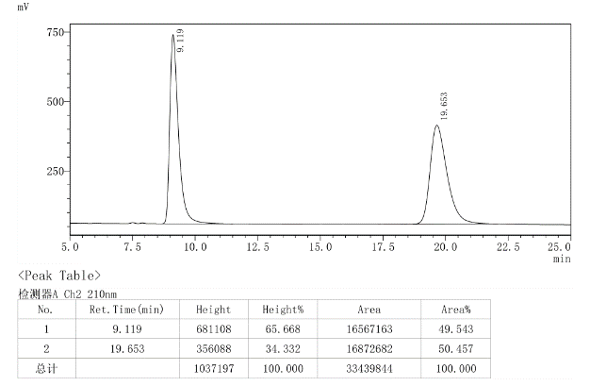
HPLC conditions: Chiralpak IF column (n-Hexane:2-Propanol = 50:50, 0.5 ml/min, 254nm); tr (minor) = 9.2 min, tr (major) =19.4 min; 99% ee.
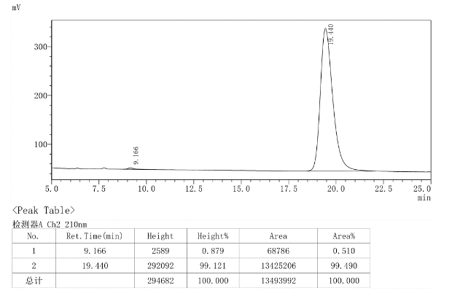
7.2 (3R,4aR,7R,8aR)-3,7-diphenyloctahydro-2H-chromene (5)
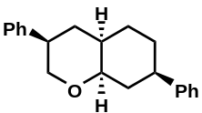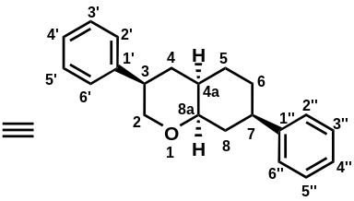
In a 10 mL Schlenk tube, after the solution of Pd/C (40 mol%, 10% on activated carbon, reduced, dry powder, cas: 7440-05-3, j&k chemical) and 3aa (99% ee, 0.2 mmol, 57.7mg) in THF (2 mL) was stirred at room temperature for 8 h. The reaction was determined by TLC analysis, after the 3aa was consumed completely. Solvent was removed in a rotary evaporator, purified by flash column chromatography on silica gel (PE/EA= 10:1) to afford the desired product 5 (87% yield, 99% ee, 50.9 mg) as white solid (m.p.: 72.8°C).
¹H NMR (400 MHz, CDCl₃) δ 7.45 – 7.23 (overlapped, 10H, H-1' – H-6''), 4.12 (dt, J = 12.2, 4.8 Hz, 1H, H-8a), 3.78 (ddd, J = 11.7, 4.8, 1.9 Hz, 1H, H_{a}-2), 3.68 (t, J = 11.5 Hz, 1H, H_{b}-2), 3.00 (tt, J = 11.8, 4.3 Hz, 1H, H-3), 2.67 (tt, J = 12.1, 3.7 Hz, 1H, H-7), 2.35 – 2.25 (overlapped, 2H, H-4a and H_{a}-8), 2.14 (q, J = 12.7 Hz, 1H, H_{a}-4), 1.89 – 1.77 (overlapped, 3H, H_{b}-8, H_{a}-5, and H_{b}-5), 1.77 – 1.64 (overlapped, 3H, H_{b}-4, H_{a}-1, and H_{b}-1);
¹³C NMR (100 MHz, CDCl₃) δ 146.4 (C-1''), 142.6 (C-1'), 128.7 (2C, C-3''/5''), 128.6 (2C, C-3'/5'), 127.4 (2C, C-2'/6'), 126.9 (2C, C-2''/6''), 126.8 (C-5'), 126.4 (C-5''), 74.4 (C-8a), 66.0 (C-2), 43.7 (C-3), 43.3 (C-7), 34.7 (C-4a), 32.0 (C-8), 30.6 (C-5), 30.3 (C-4), 28.2 (C-6);
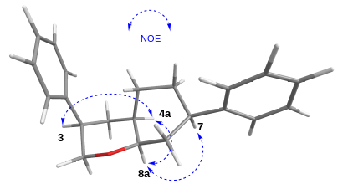
HRESIMS (positive ion mode) m/z 315.1720 [M + Na]⁺ (calcd. for C₂₁H₂₄ONa, 315.1719);
[α]_{D}²² = 35.5 (c = 0.13 g/100mL, acetone);
HPLC conditions: Chiralpak IE column (n-Hexane:2-Propanol = 90:10, 0.5 ml/min, 254nm); tr (minor) = 10.9 min, tr (major) = 12.9 min; 99% ee.
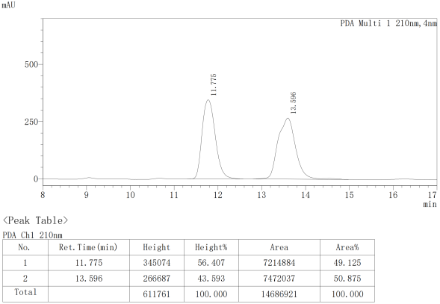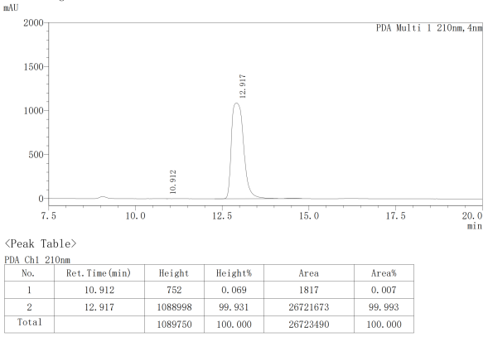

7.3 (1aR,1bS,3aR,4aS,4bR,6aR)-1,1,4,4-tetrafluoro-3a,6a-diphenyldecahydro-1H-dicyclopropa [c,h]chromene (6)
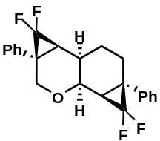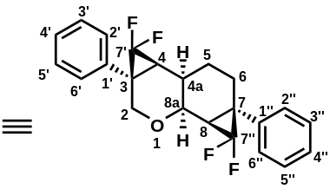
To a dry sealed tube was added material 3aa (99% ee, 0.2 mmol, 57.7mg) and sodium iodide (40 mol%), dried THF (2.0 mL) was added under argon atmosphere, and then TMSCF₃ (14.0 eq) was added to the mixture. The reaction mixture was allowed to stir at 65 °C for 12 hours. The reaction was completed by TLC monitoring, then the reaction mixture was concentrated and purified by silica gel chromatography (n-Hexane /EA = 20:1) to obtain white solid 6 (74% yield, 57.5 mg, 96% ee) (m.p.: 135.7 °C).
¹H NMR (400 MHz, CDCl₃) δ 7.40 – 7.26 (overlapped, 10H, H-1' – H-6''), 4.25 (d, J = 2.9 Hz, 2H, H-2), 3.87 (s, 1H, H-8a), 2.26 (m, 1H, H_{α}-6), 2.12 (m, 1H, H_{β}-6), 2.06 (m, 1H, H-8), 1.99 (m, 1H, H_{β}-5), 1.95 (m, 1H, H-4a), 1.77 (dd, J = 13.8, 3.9 Hz, 1H, H-4), 1.53 (m, 1H, H_{α}-5);
¹³C NMR (100 MHz, CDCl₃) δ 140.6 (C-1''), 139.1 (C-1'), 128.9 (2C, C-3'/5' or C-3''/5''), 128.7 (2C, C-3'/5' or C-3''/5''), 128.4 (d, ³J_{C-F} = 1.9 Hz, 2C, C-2'/6' or C-2''/6''), 128.3 (d, ³J_{C-F} = 1.9 Hz, 2C, C-2'/6' or C-3''/6''), 127.6 (C-4' or C-4''), 127.3 (C-4' or C-4''), 114.1 (m, C-7'), 111.2 (m, C-7''), 68.4 (C-2), 64.9 (d, ³J_{C-F} = 4.6 Hz, C-8a), 31.8 (t, ²J_{C-F} = 9.5 Hz, C-7), 30.9 (t, ²J_{C-F} = 9.3 Hz, C-3), 30.2 (t, ²J_{C-F} = 10.3 Hz, C-4), 29.8 (t, ²J_{C-F} = 10.1 Hz, C-8), 26.3 (C-6), 24.1 (C-4a), 24.0 (C-5);
¹⁹F NMR (376 MHz, CDCl₃) δ -127.3 (dd, J = 153.7, 13.6 Hz, 1F), -129.4 (dd, J = 154.3, 15.9 Hz, 1F), -140.0 (dt, J = 154.0, 4.4 Hz, 1F), -140.8 (dt, J = 154.0, 3.5 Hz, 1F);
HRESIMS (positive ion mode) m/z 411.1336 [M + Na]⁺ (calcd. for C₂₃H₂₀F₄ONa, 411.1342);
[α]_{D}²² = -134.1 (c = 0.11 g/100mL, acetone);
HPLC conditions: Chiralpak IA column (n-Hexane:2-Propanol = 90:10, 0.5 ml/min, 254nm); tr (minor) = 7.4 min, tr (major) = 8.0 min; 96% ee.
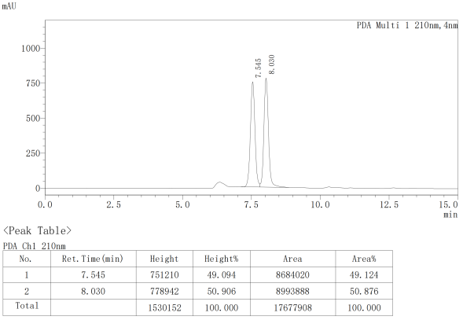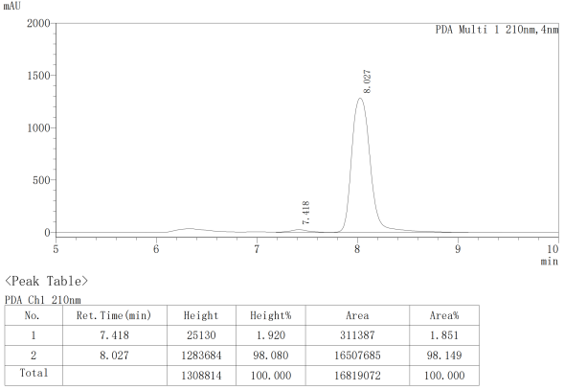

7.4 (1aS,1bS,3aR,4aS,4bS,6aS)-3a,6a-diphenyloctahydro-3H-bis(oxireno)[2,3-c:2',3'-h]chromene (7)
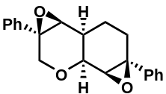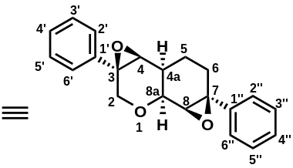
To a solution of 3aa (99% ee, 0.2 mmol,57.7mg) in DCM (4 mL) was sequentially added an aqueous solution of Na₂CO₃ (127 mg, 6.0 eq) and 3-chloroperoxybenzoic acid (m-CPBA, 138 mg, 4.0 eq) at r.t. The reaction mixture was stirred for 2 h and poured into a saturated solution of aqueous sodium bicarbonate. The two layers were separated and the organic layer was washed with a saturated solution of aqueous sodium bicarbonate. This procedure was repeated twice more. The organic layer was dried over MgSO₄, filtered, and concentrated on a rotary evaporator. The crude product was purified by column chromatography (n-Hexane /EA = 20:1) to give 7 (77 % yield, 49.3mg, 99% ee) as a white solid (m.p.: 131.5 °C).
¹H NMR (400 MHz, CDCl₃) δ 7.43 – 7.27 (overlapped, 10H, H-1' – H-6''), 4.48 (d, J = 13.5 Hz, 1H, H_{a}-2), 4.19 (dd, J = 4.4, 1.9 Hz, 1H, H-8a), 4.12 (d, J = 13.5 Hz, 1H, H_{b}-2), 3.18 (s, 1H, H-8), 3.10 (s, 1H, H-4), 2.46 (ddd, J = 15.4, 5.9, 4.7 Hz, 1H, H_{a}-6), 2.36 (m, 1H, H-4a), 2.15 (ddd, J = 15.7, 10.1, 6.0 Hz, 1H, H_{b}-6), 1.82 (m, 1H, H_{a}-5), 1.63 (m, 1H, H_{b}-5);
¹³C NMR (100 MHz, CDCl₃) δ 141.1 (C-1''), 138.4 (C-1'), 128.6 (2C, C-3''/5''), 128.4 (2C, C-3'/5'), 128.0 (C-4'), 127.6 (C-4''), 125.6 (2C, C-2'/6'), 125.4 (2C, C-2''/6''), 68.1 (C-2), 67.2 (C-8a), 63.8 (C-4), 62.5 (C-8), 61.2 (C-7), 59.5 (C-3), 30.0 (C-4a), 27.0 (C-5), 19.3 (C-6);
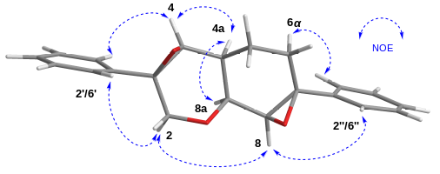
HRESIMS (positive ion mode) m/z 343.1304 [M + Na]⁺ (calcd. for C₂₁H₂₀O₃Na, 343.1305);
[α]_{D}²² = 10.4 (c = 0.10 g/100mL, acetone);
HPLC conditions: Chiralpak ID column (n-Hexane:2-Propanol = 90:10, 0.5 ml/min, 254 nm); tr (minor) = 10.7 min, tr (major) = 14.1 min; 99% ee.
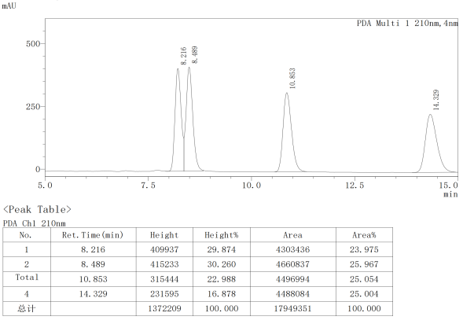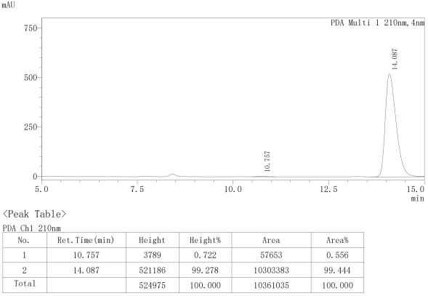

NMR Spectra
¹H NMR of Xu3
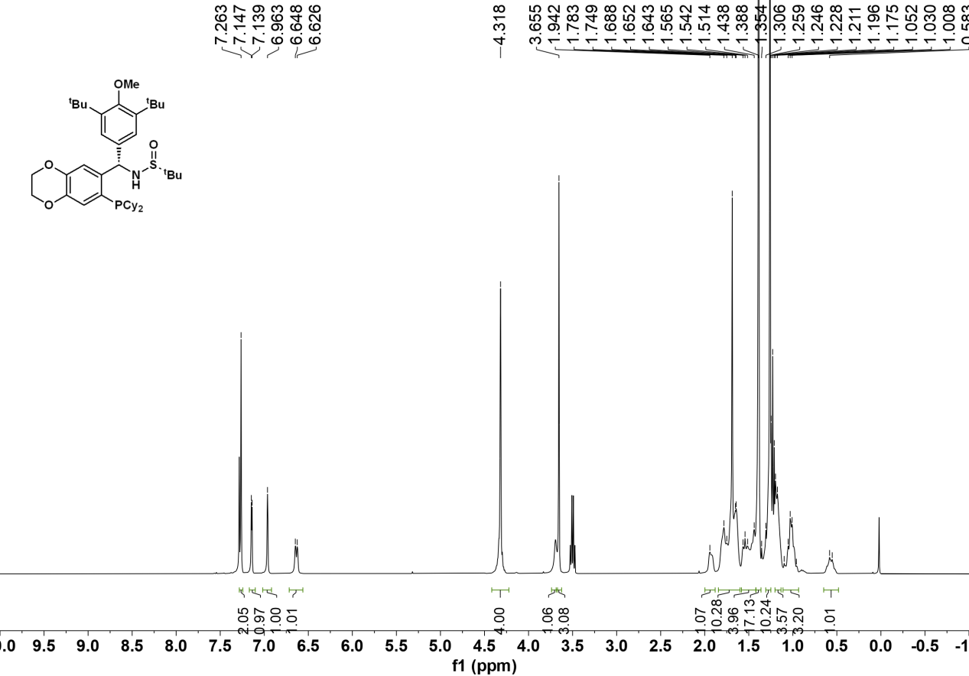

¹³C NMR of Xu3
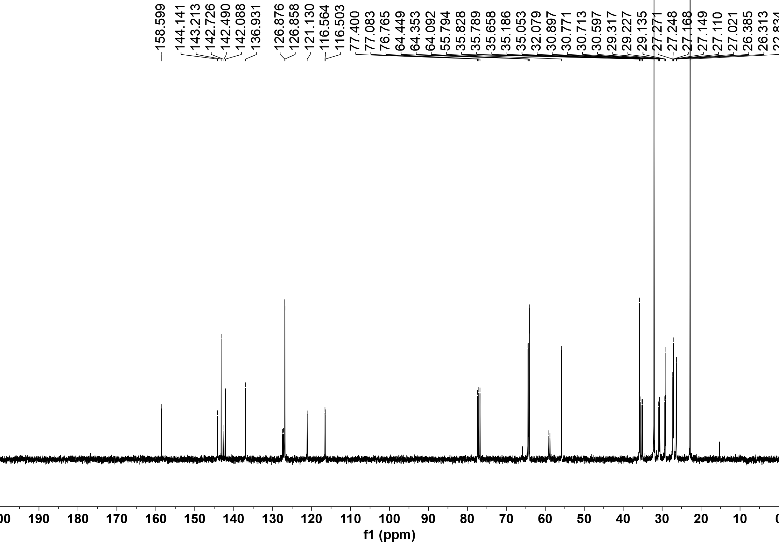

³¹P NMR of Xu3
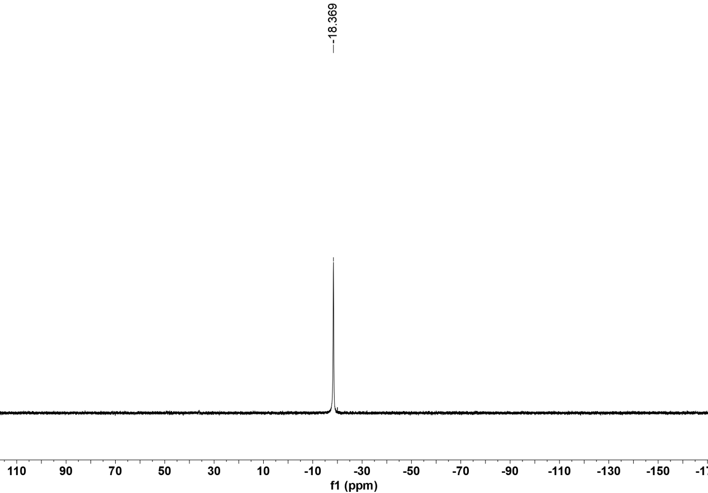

¹H NMR of 3aa
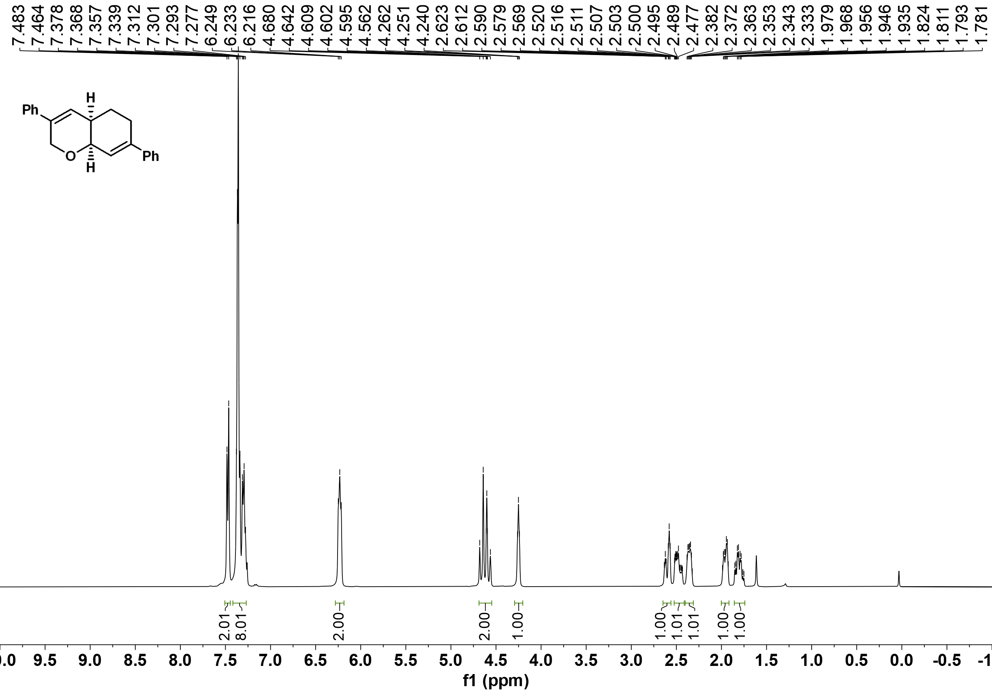
¹³C NMR of 3aa
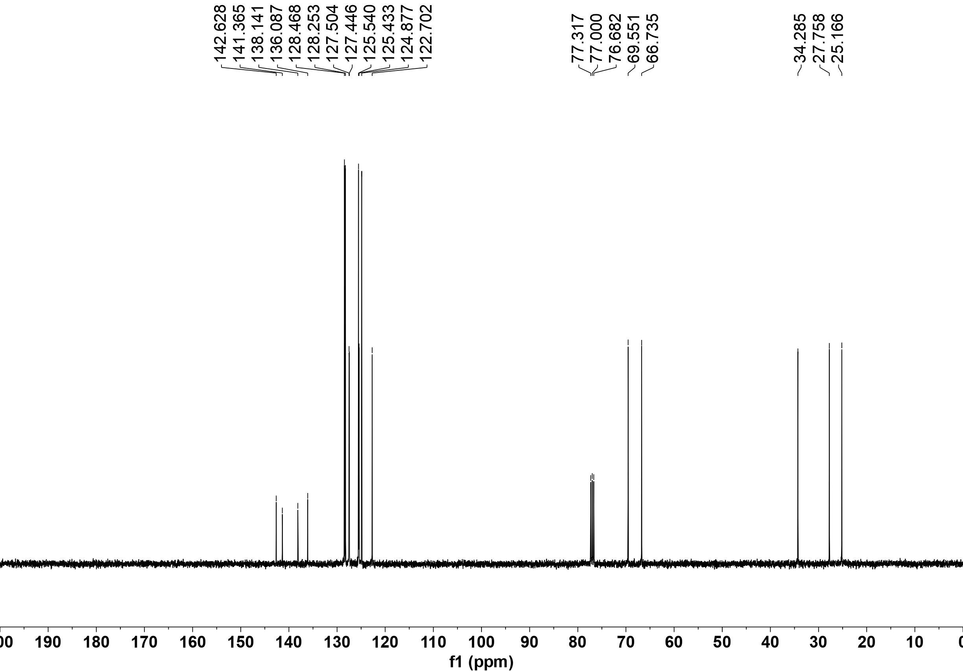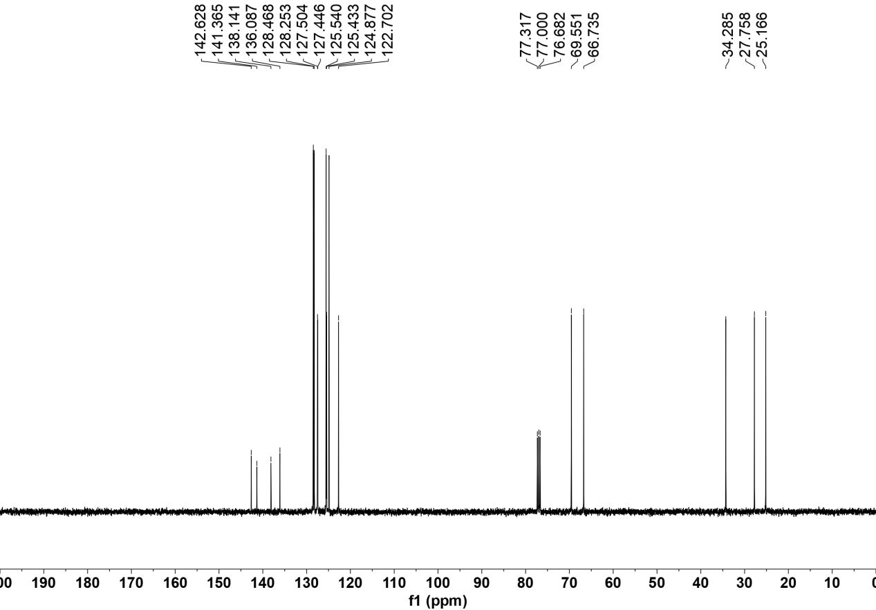

¹H NMR of 3ab
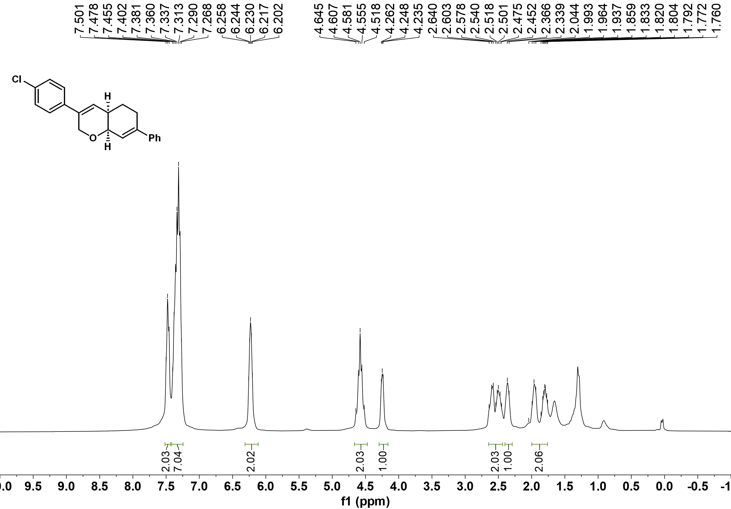

¹³C NMR of 3ab
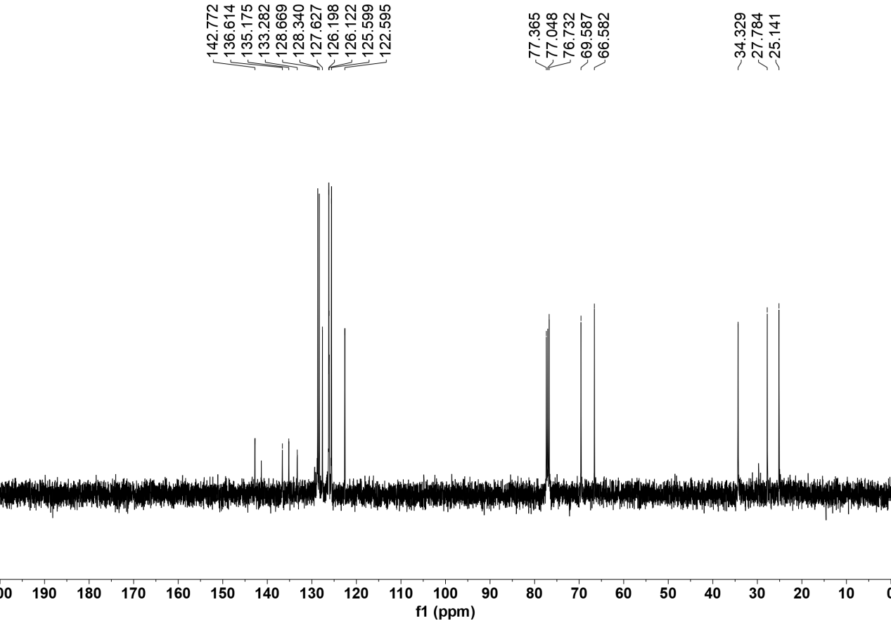

¹H NMR of 3ac
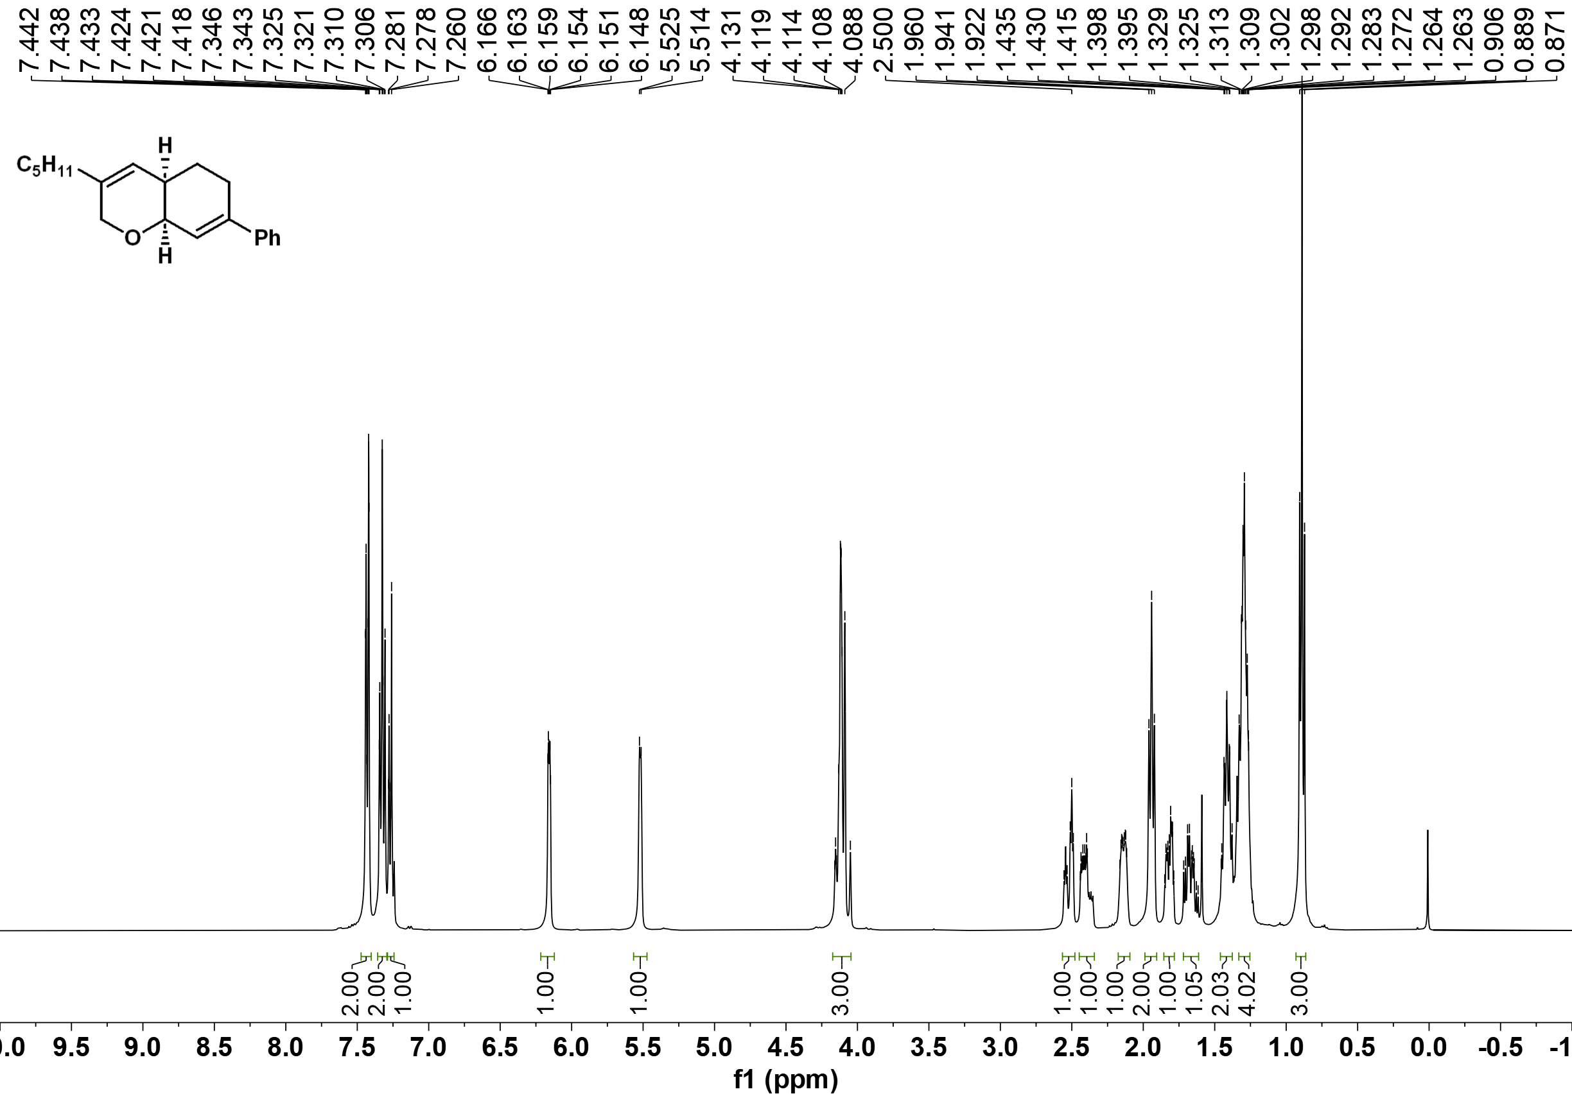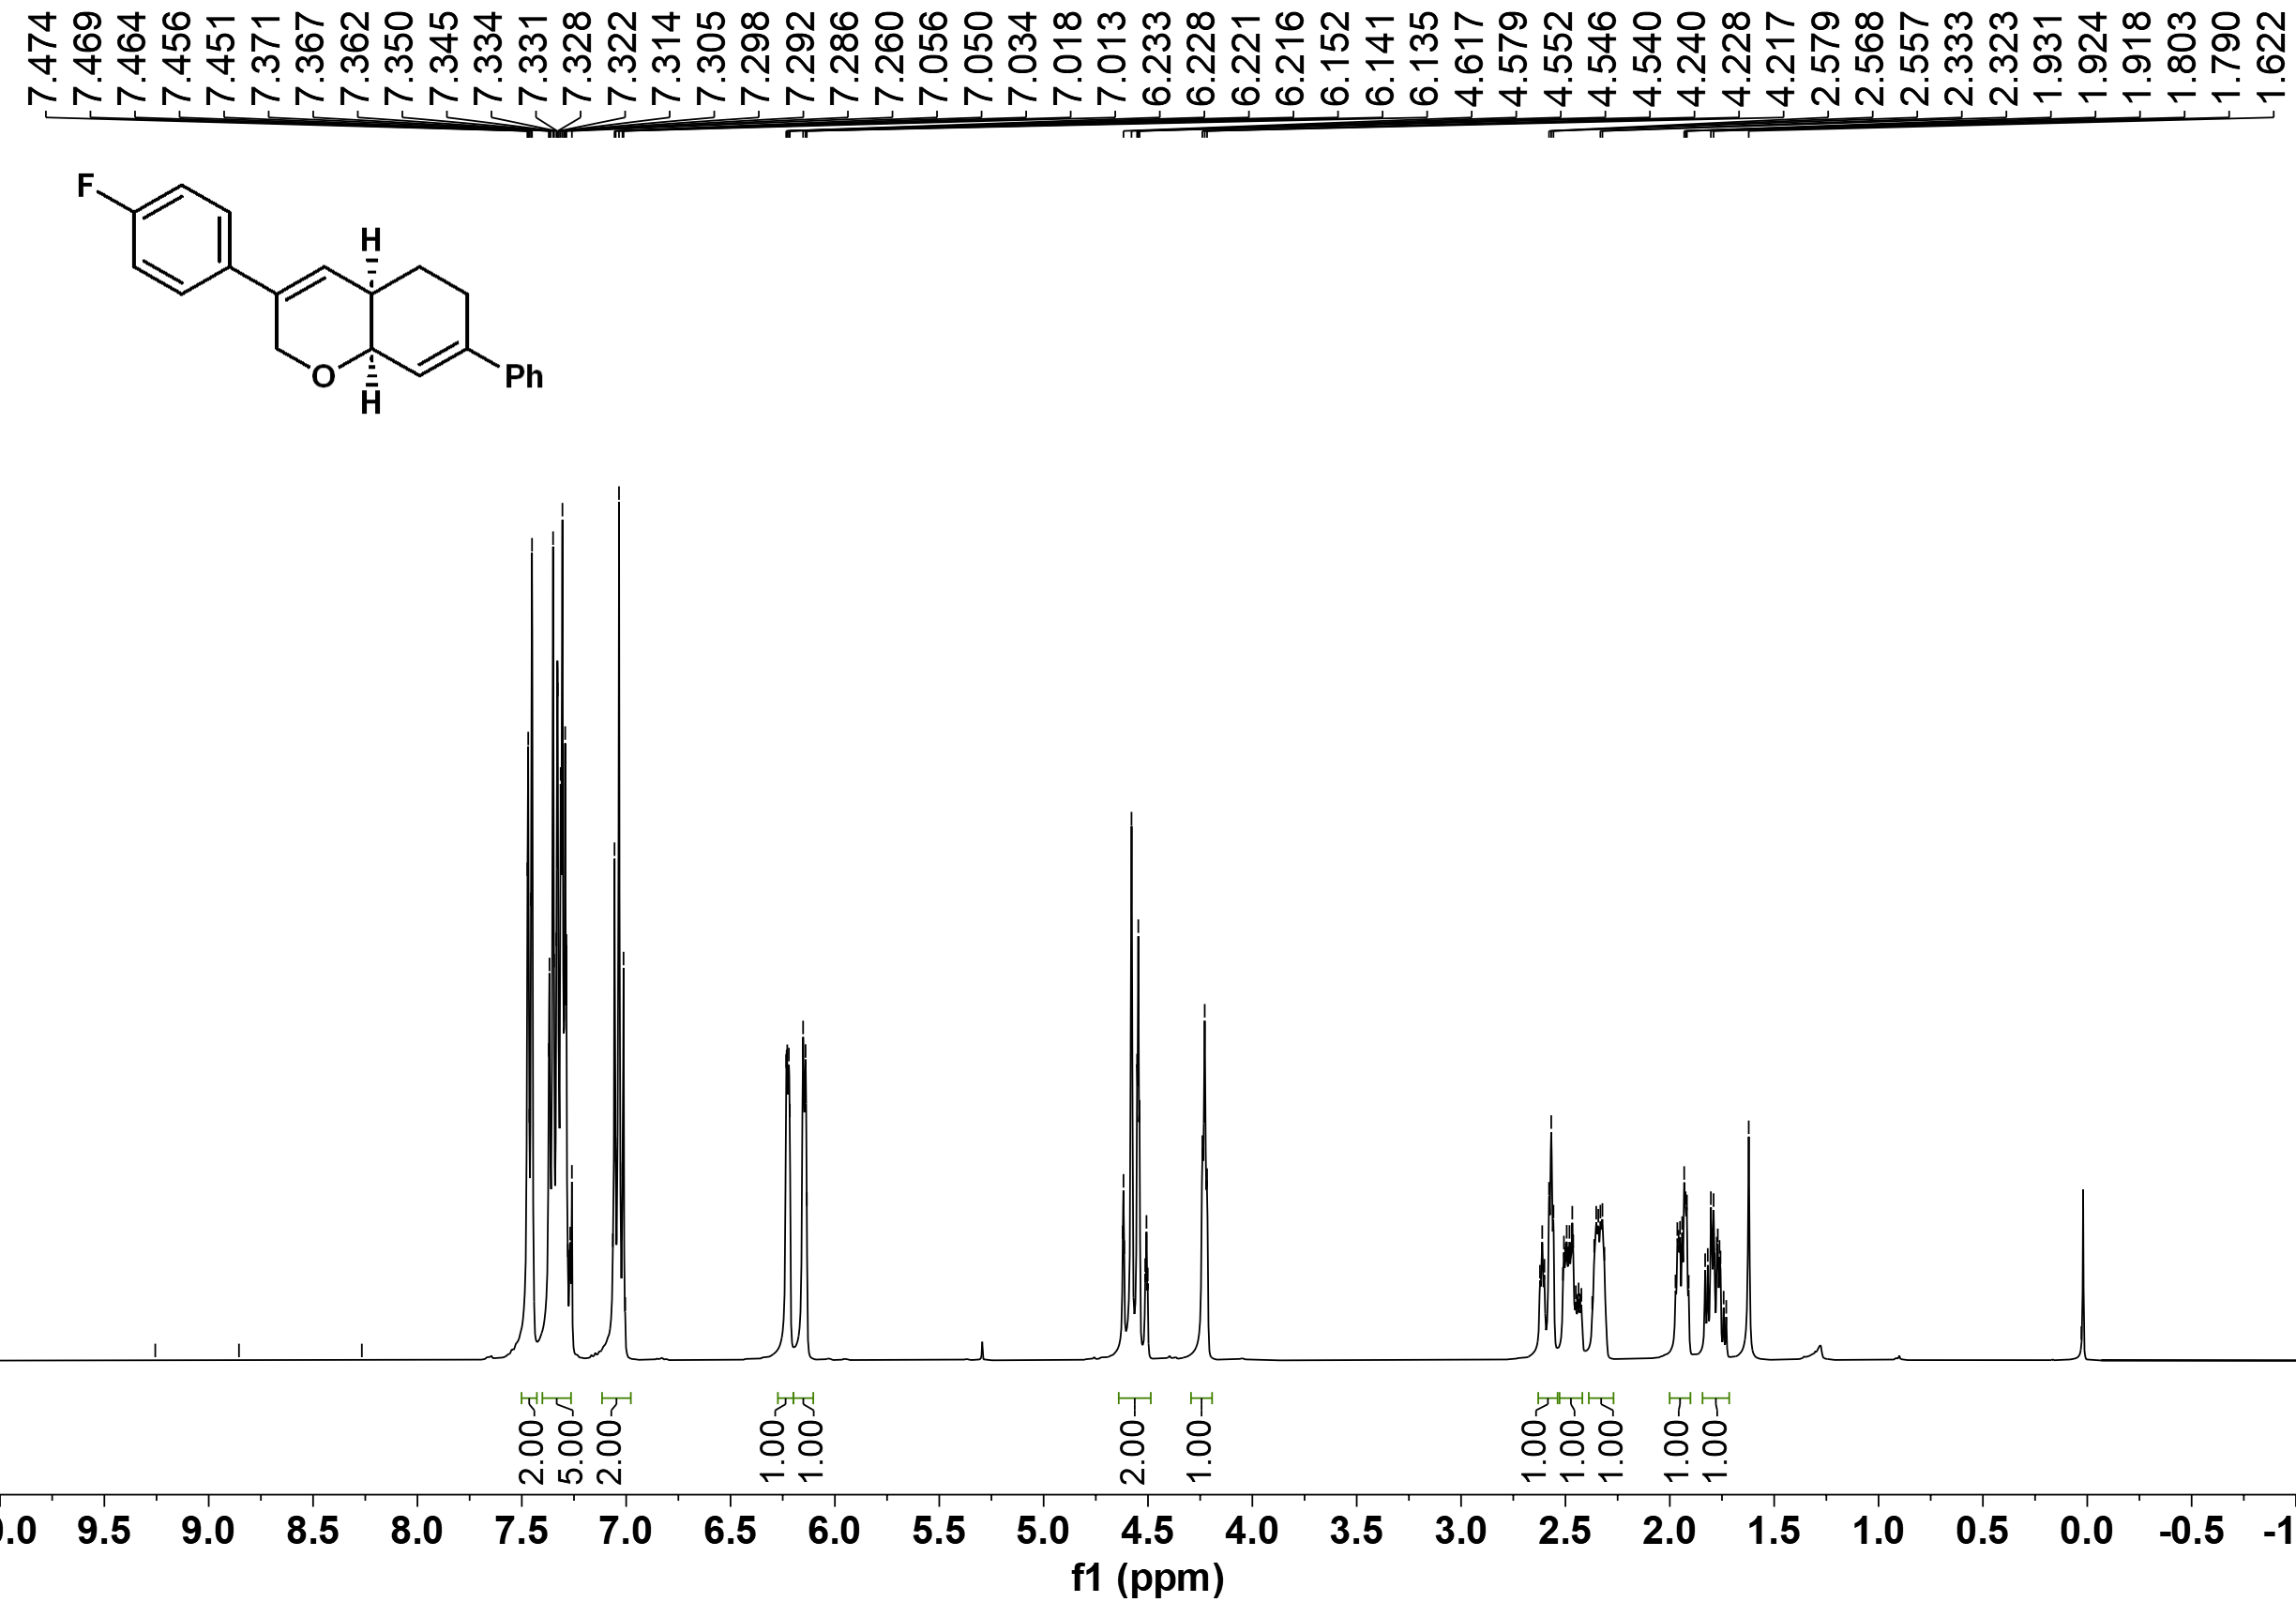

¹³C NMR of 3ac
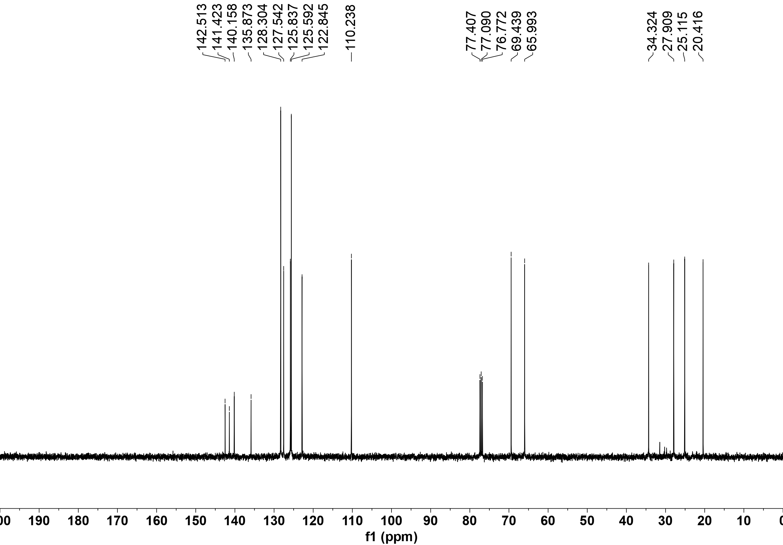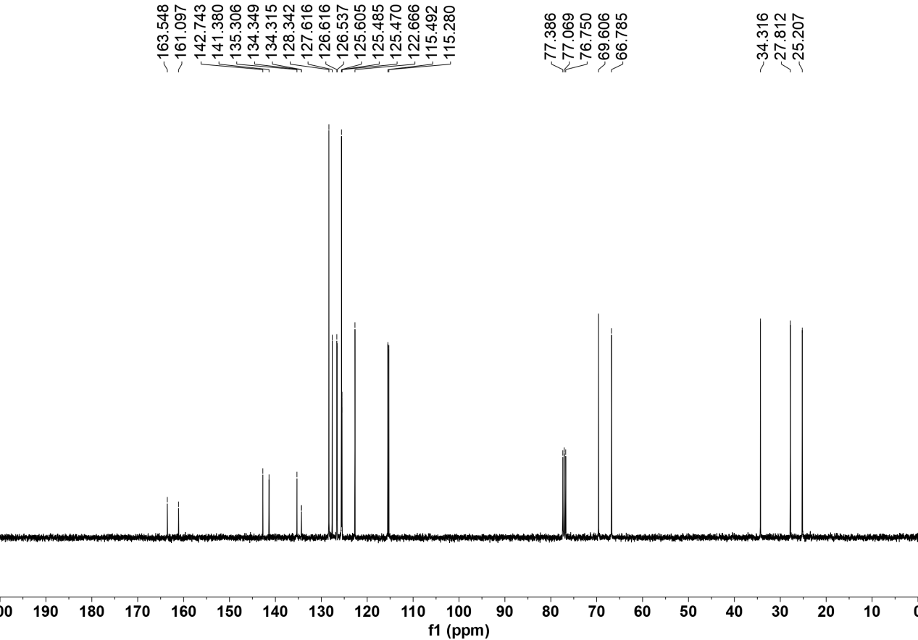

¹⁹F NMR of 3ac
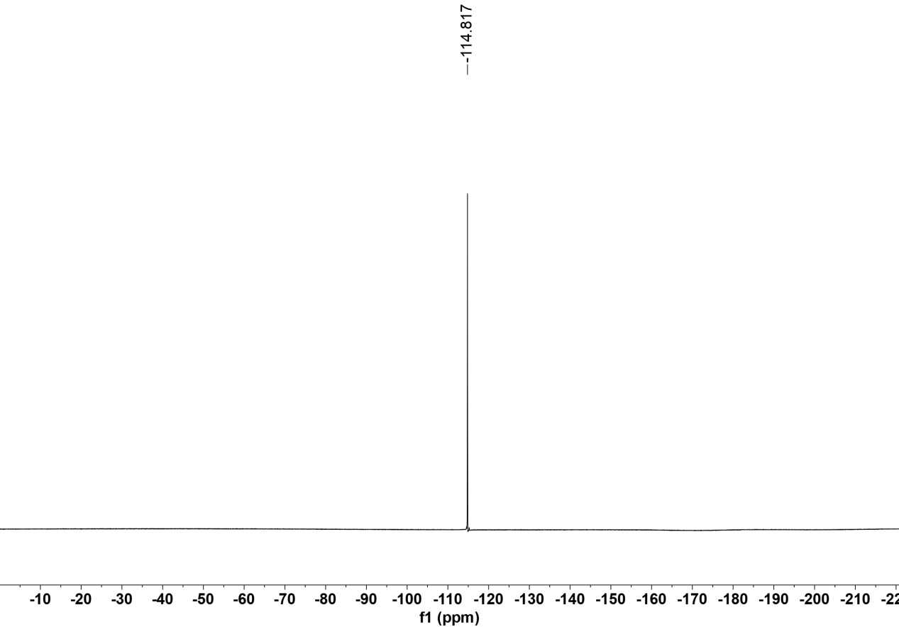

¹H NMR of 3ad
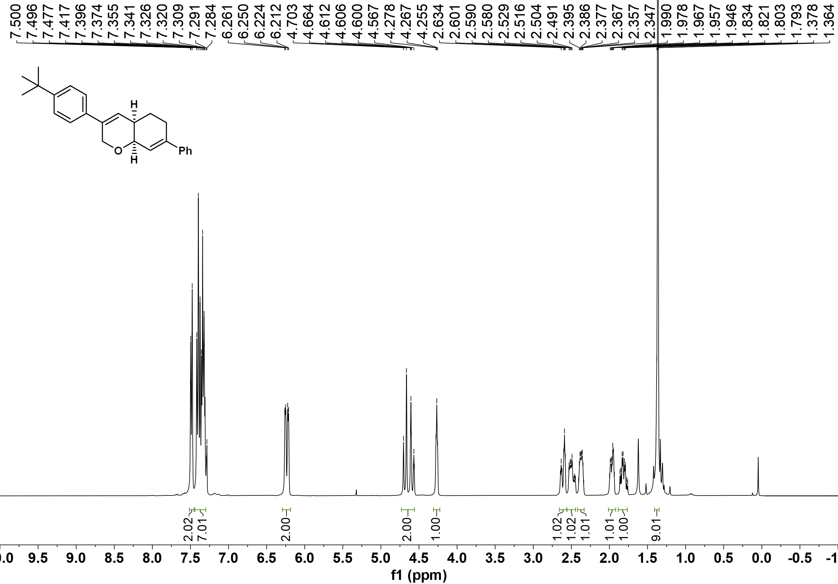

¹³C NMR of 3ad
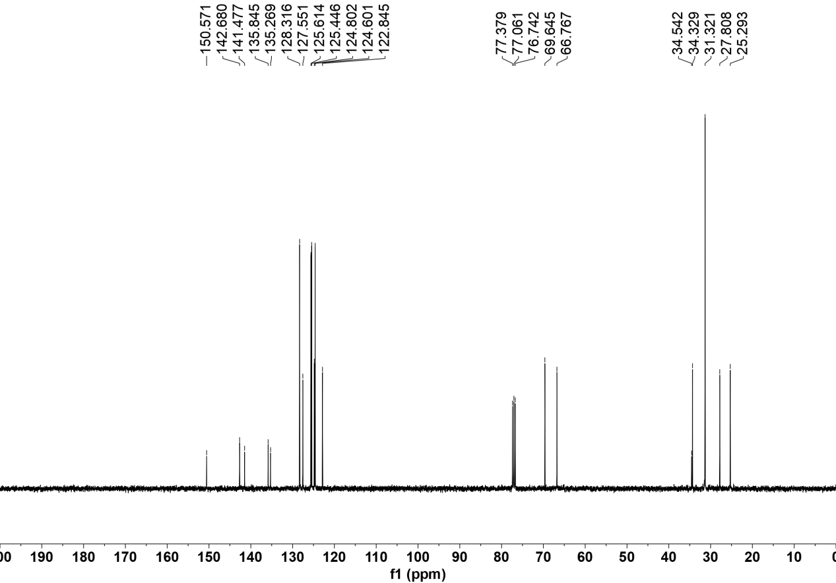

¹H NMR of 3ae
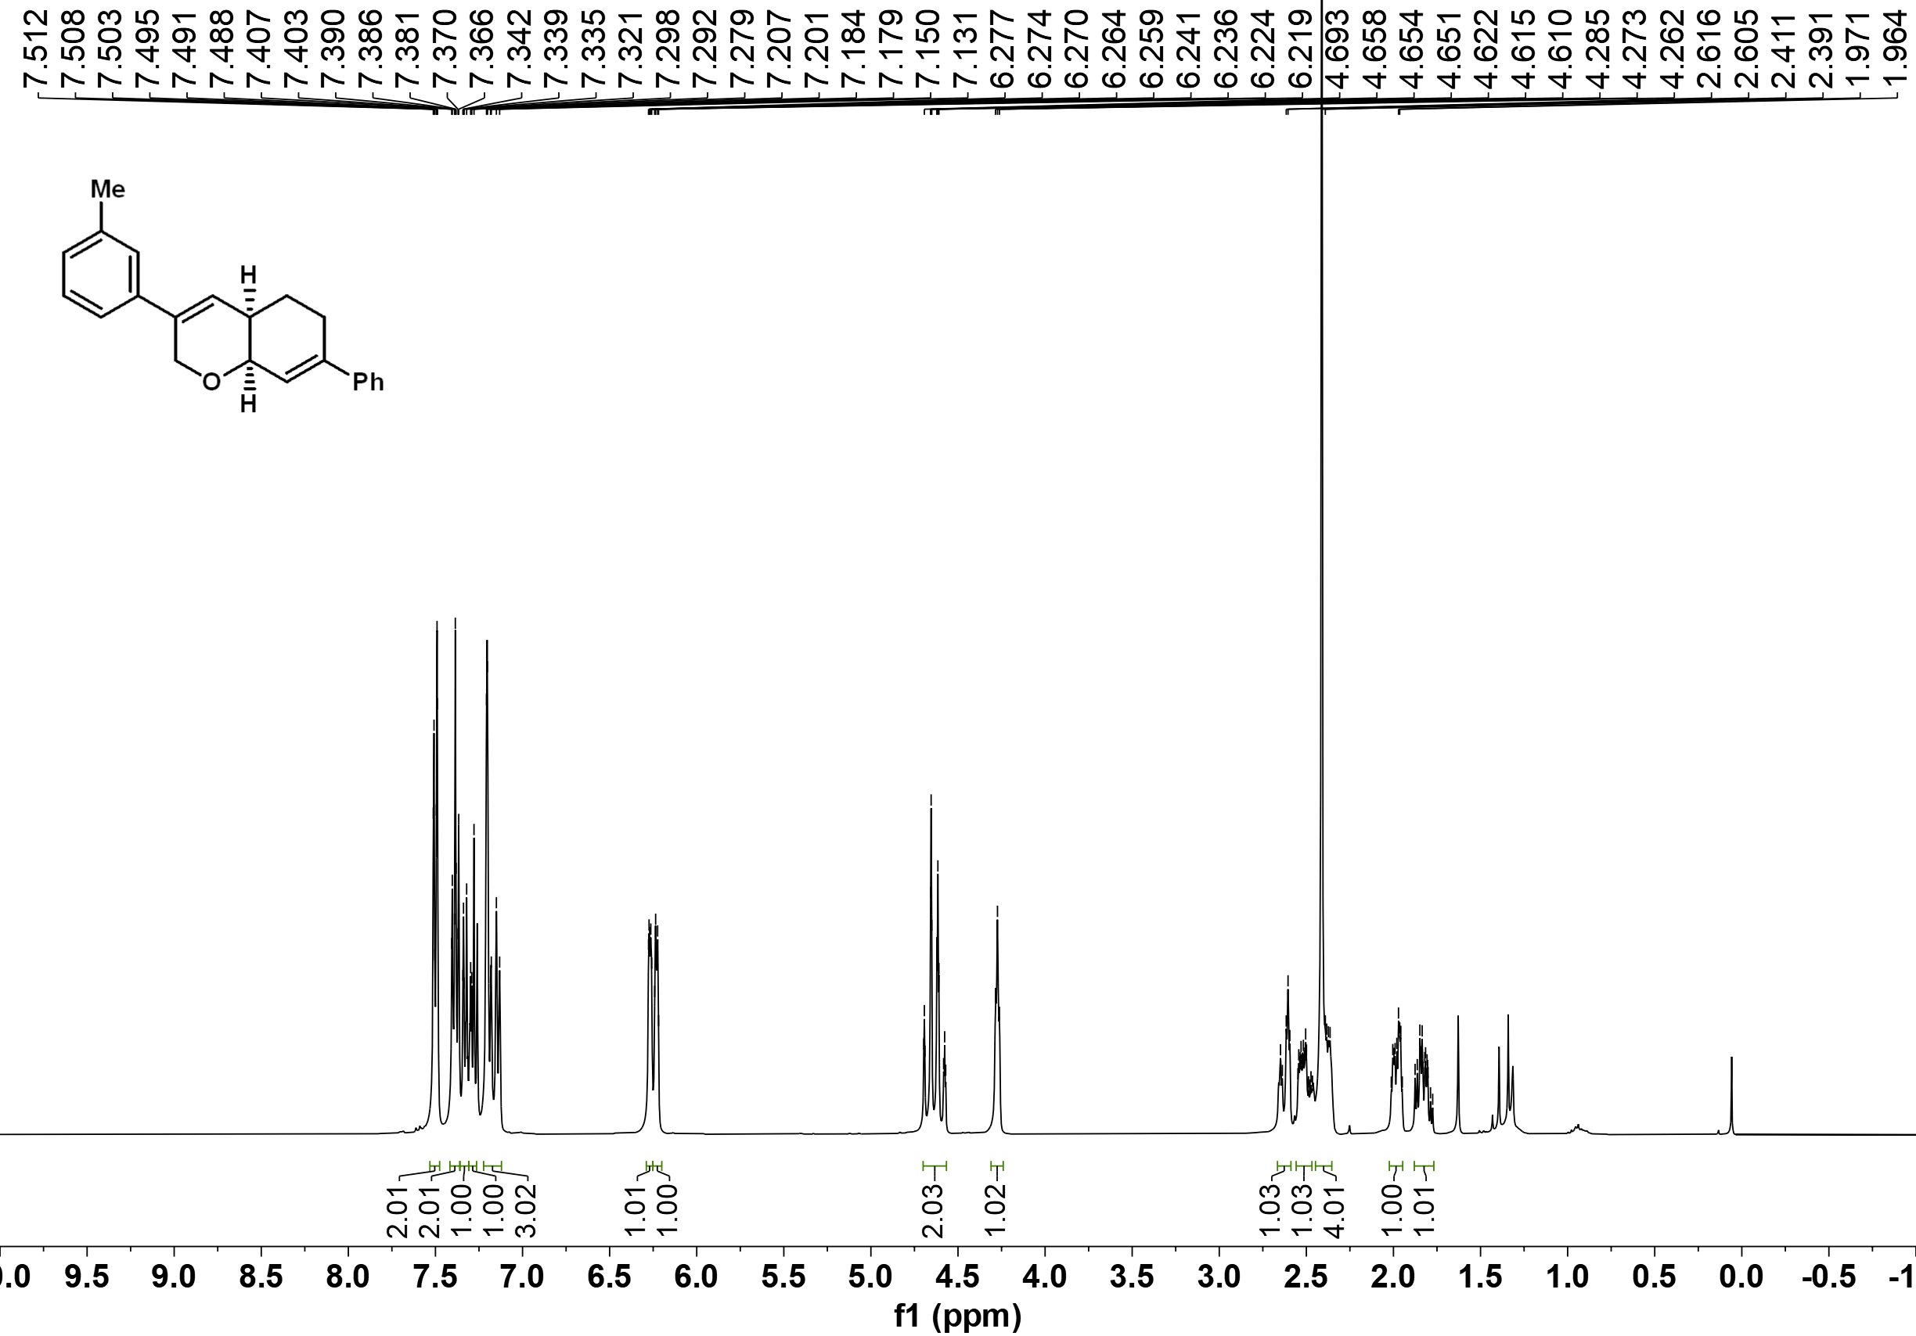

¹³C NMR of 3ae
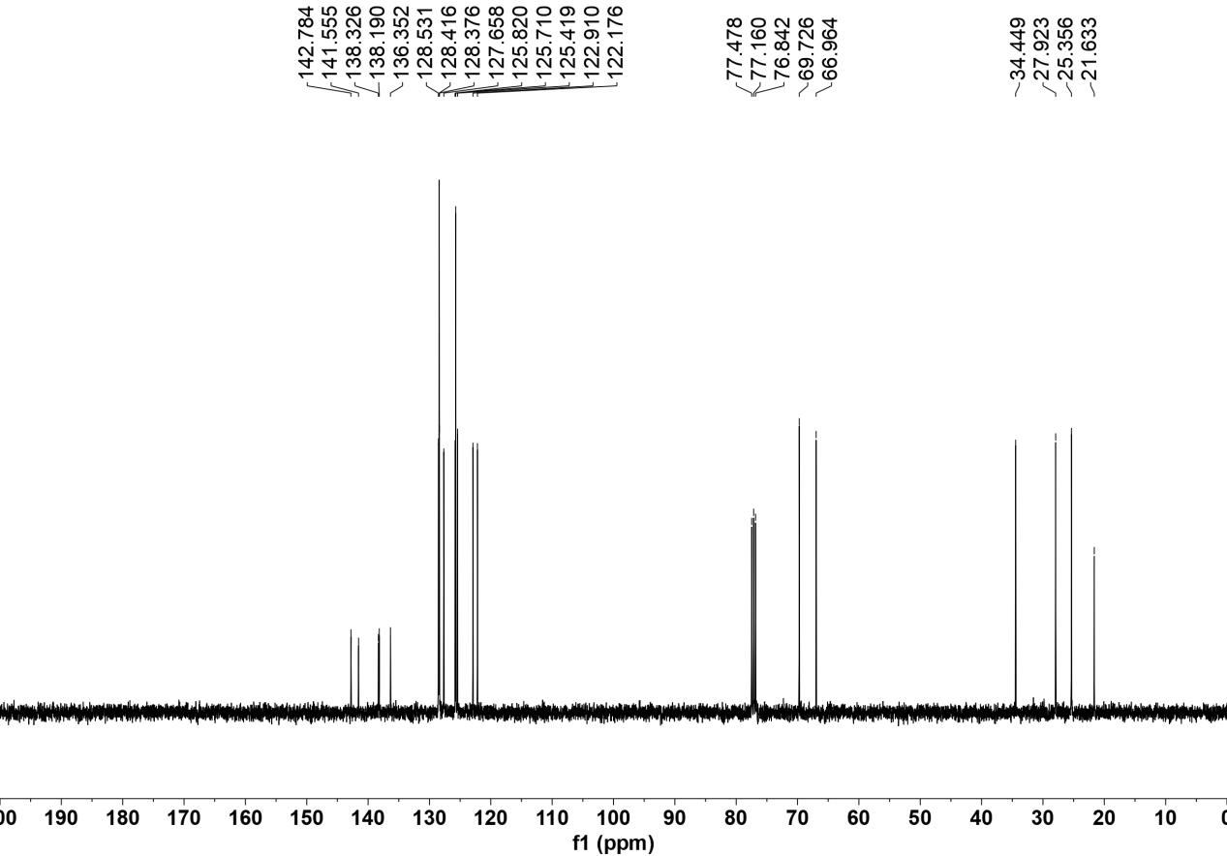

¹H NMR of 3af
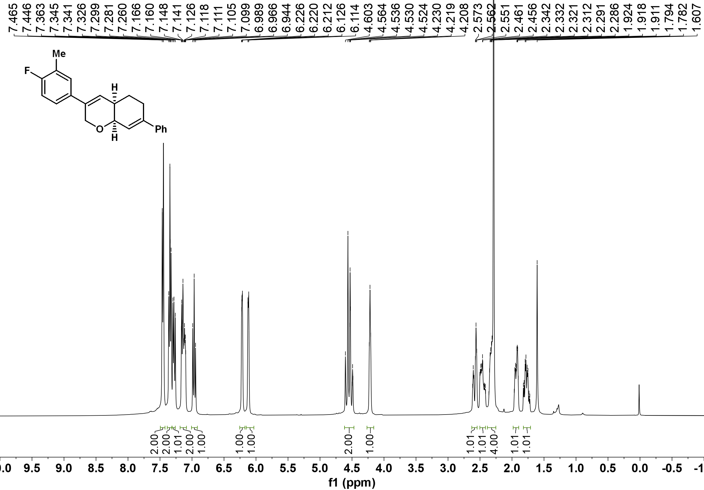

¹³C NMR of 3af
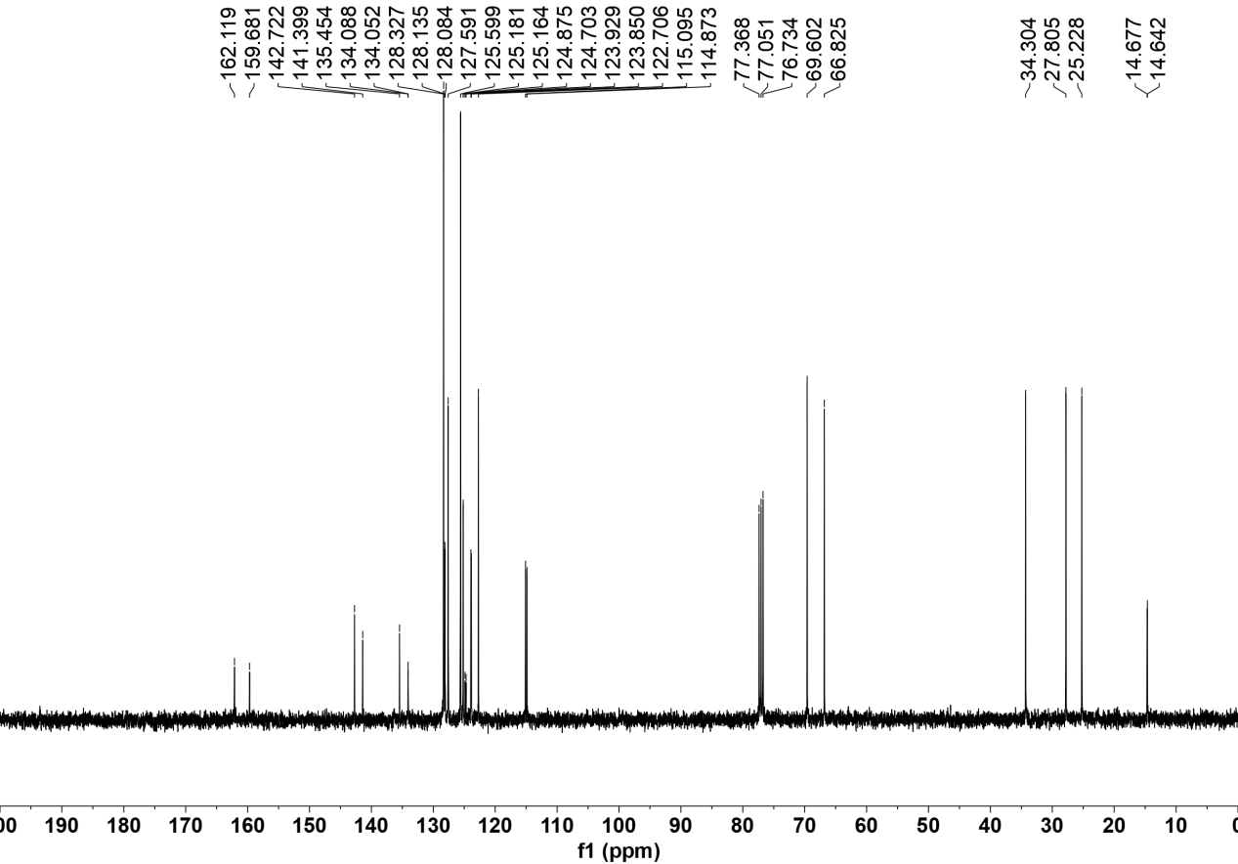

¹⁹F NMR of 3af
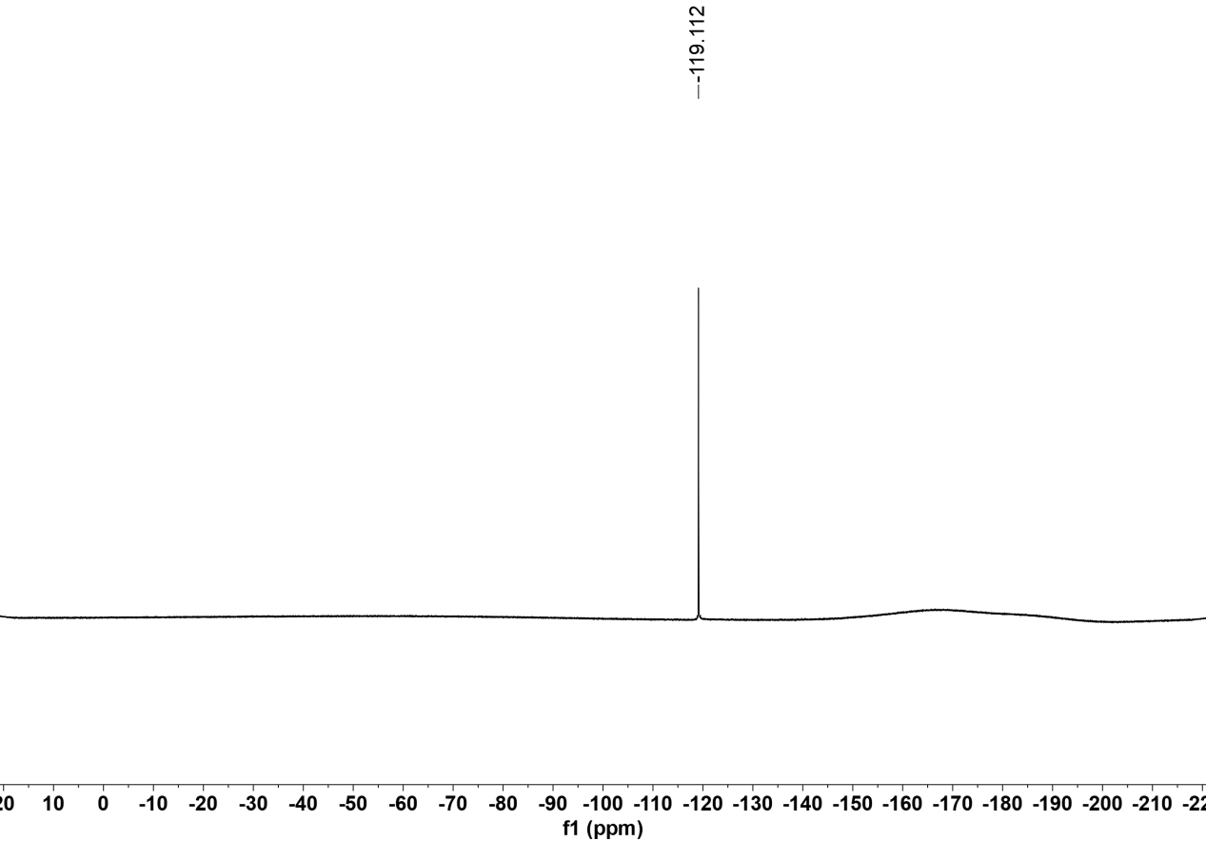

¹H NMR of 3ag
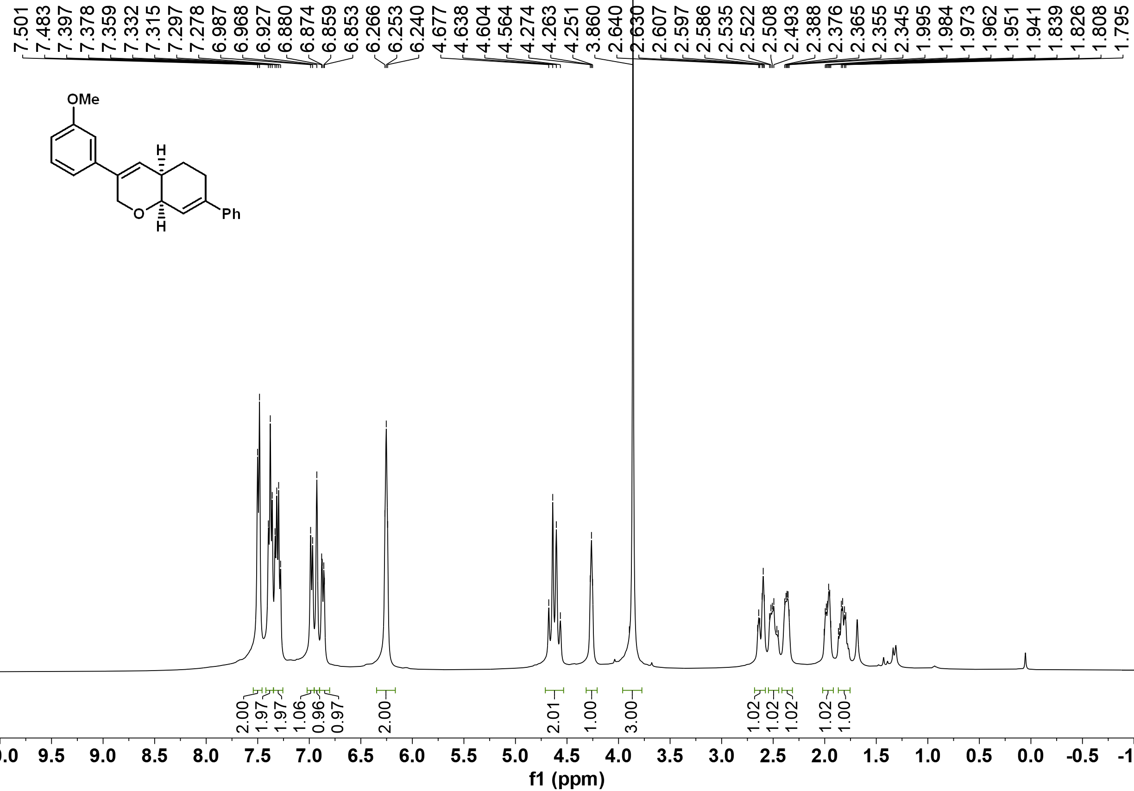

¹³C NMR of 3ag
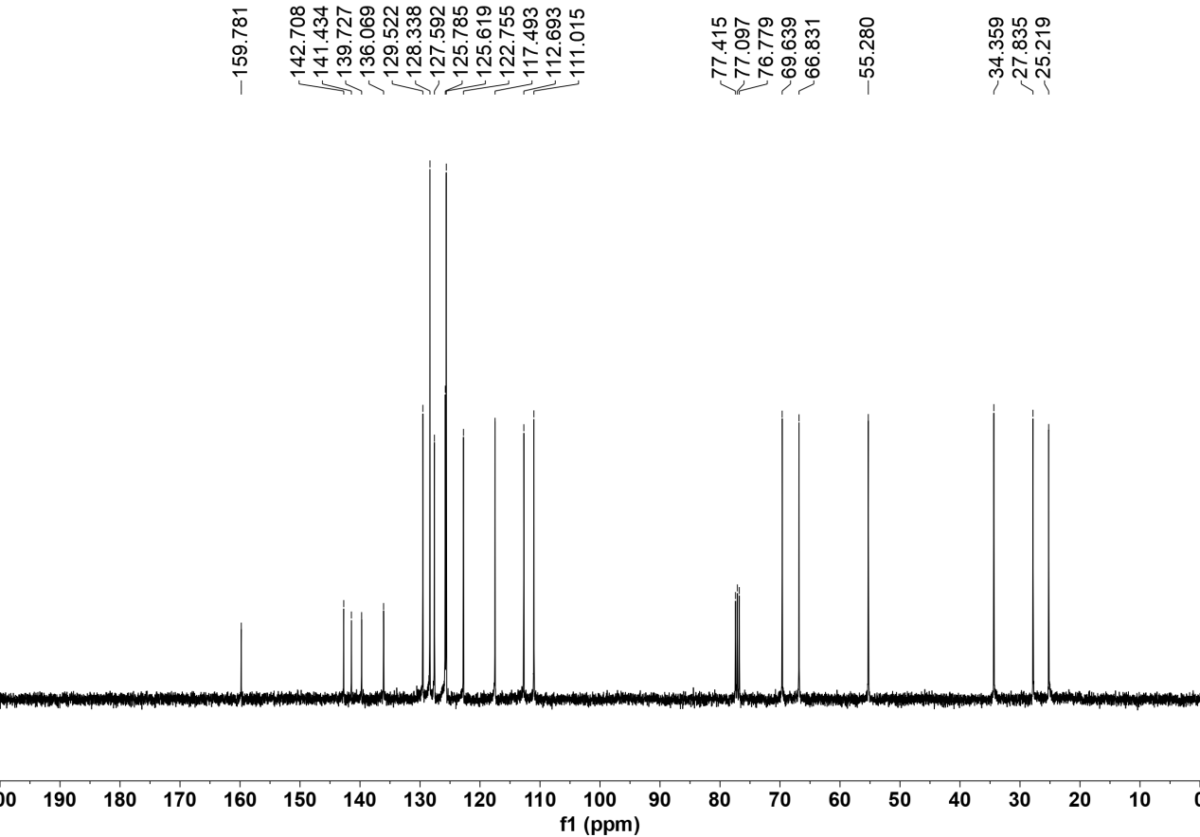

¹H NMR of 3ah
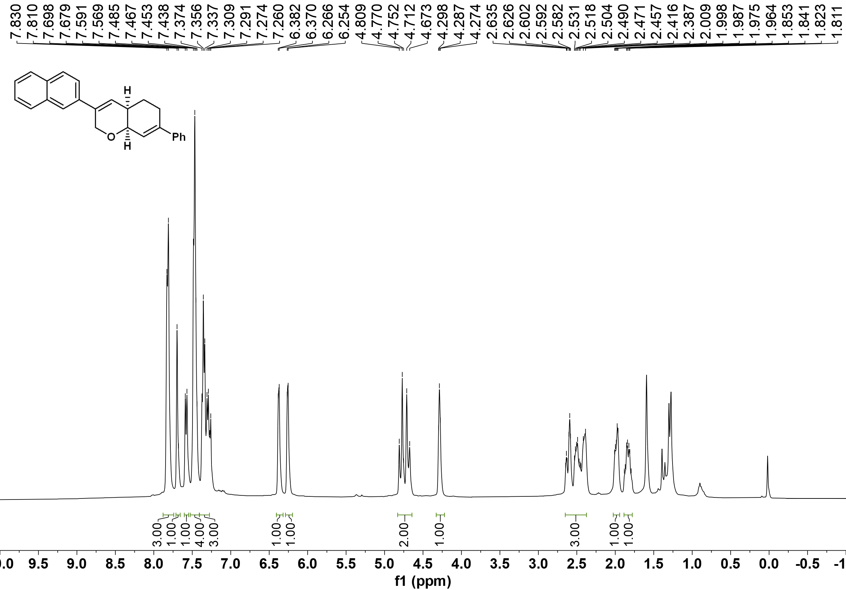

¹³C NMR of 3ah
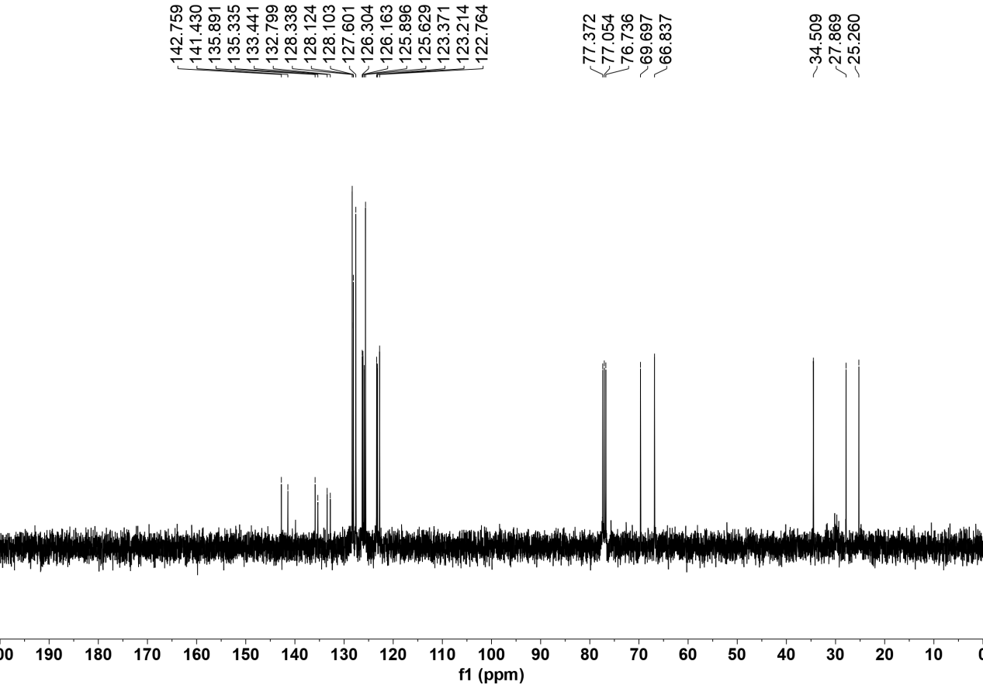

¹H NMR of 3ai
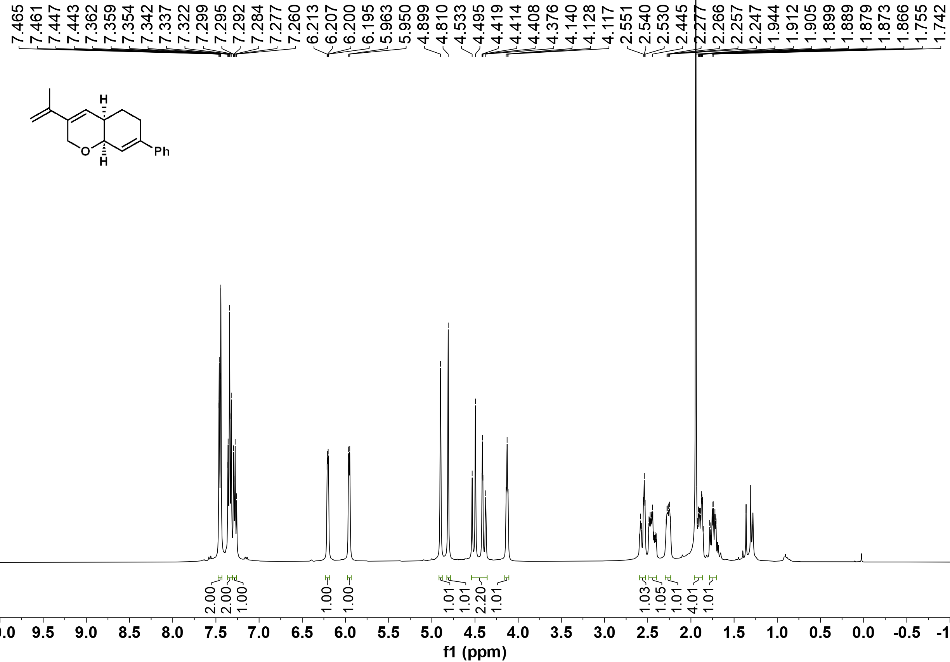

¹³C NMR of 3ai
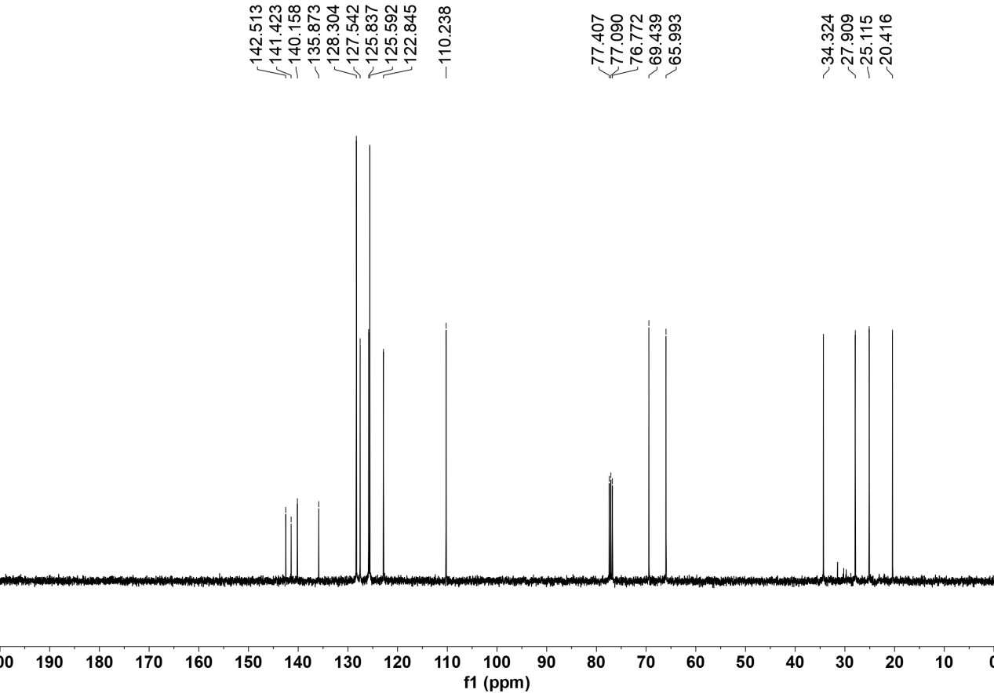

¹H NMR of 3aj
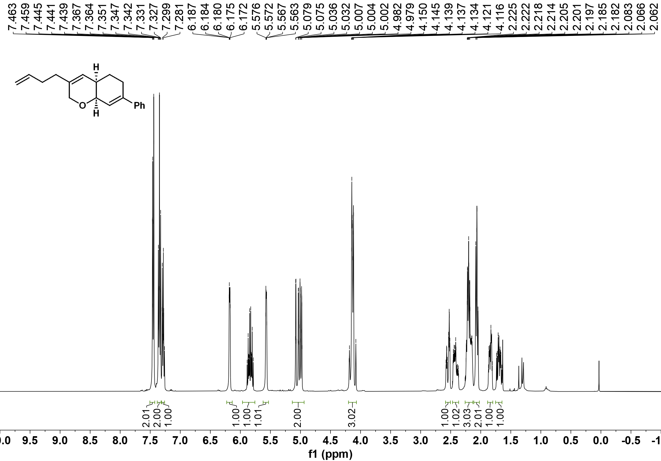

¹³C NMR of 3aj
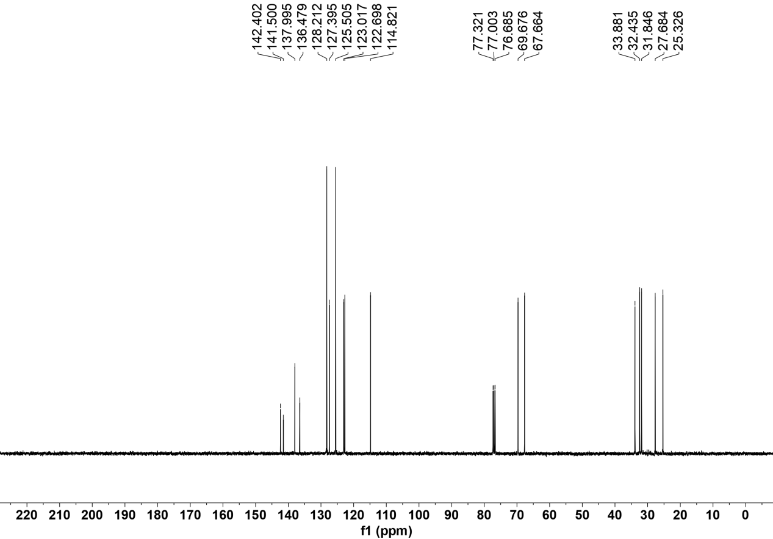

¹H NMR of 3ak
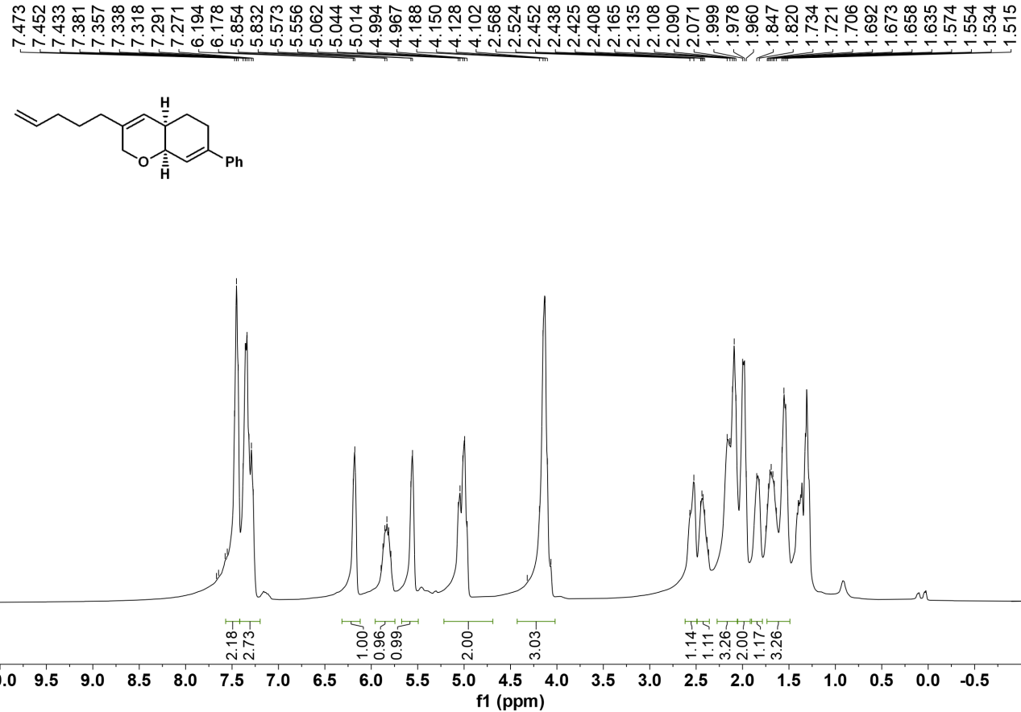

¹³C NMR of 3ak
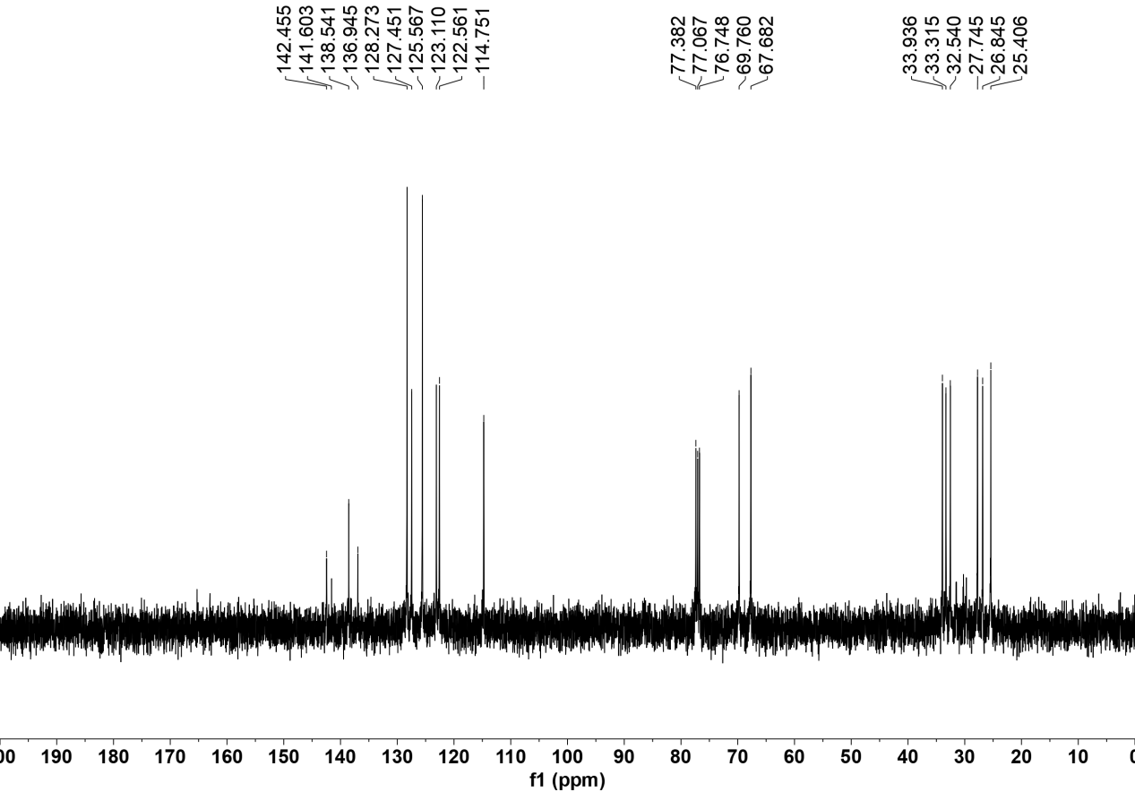

¹H NMR of 3al
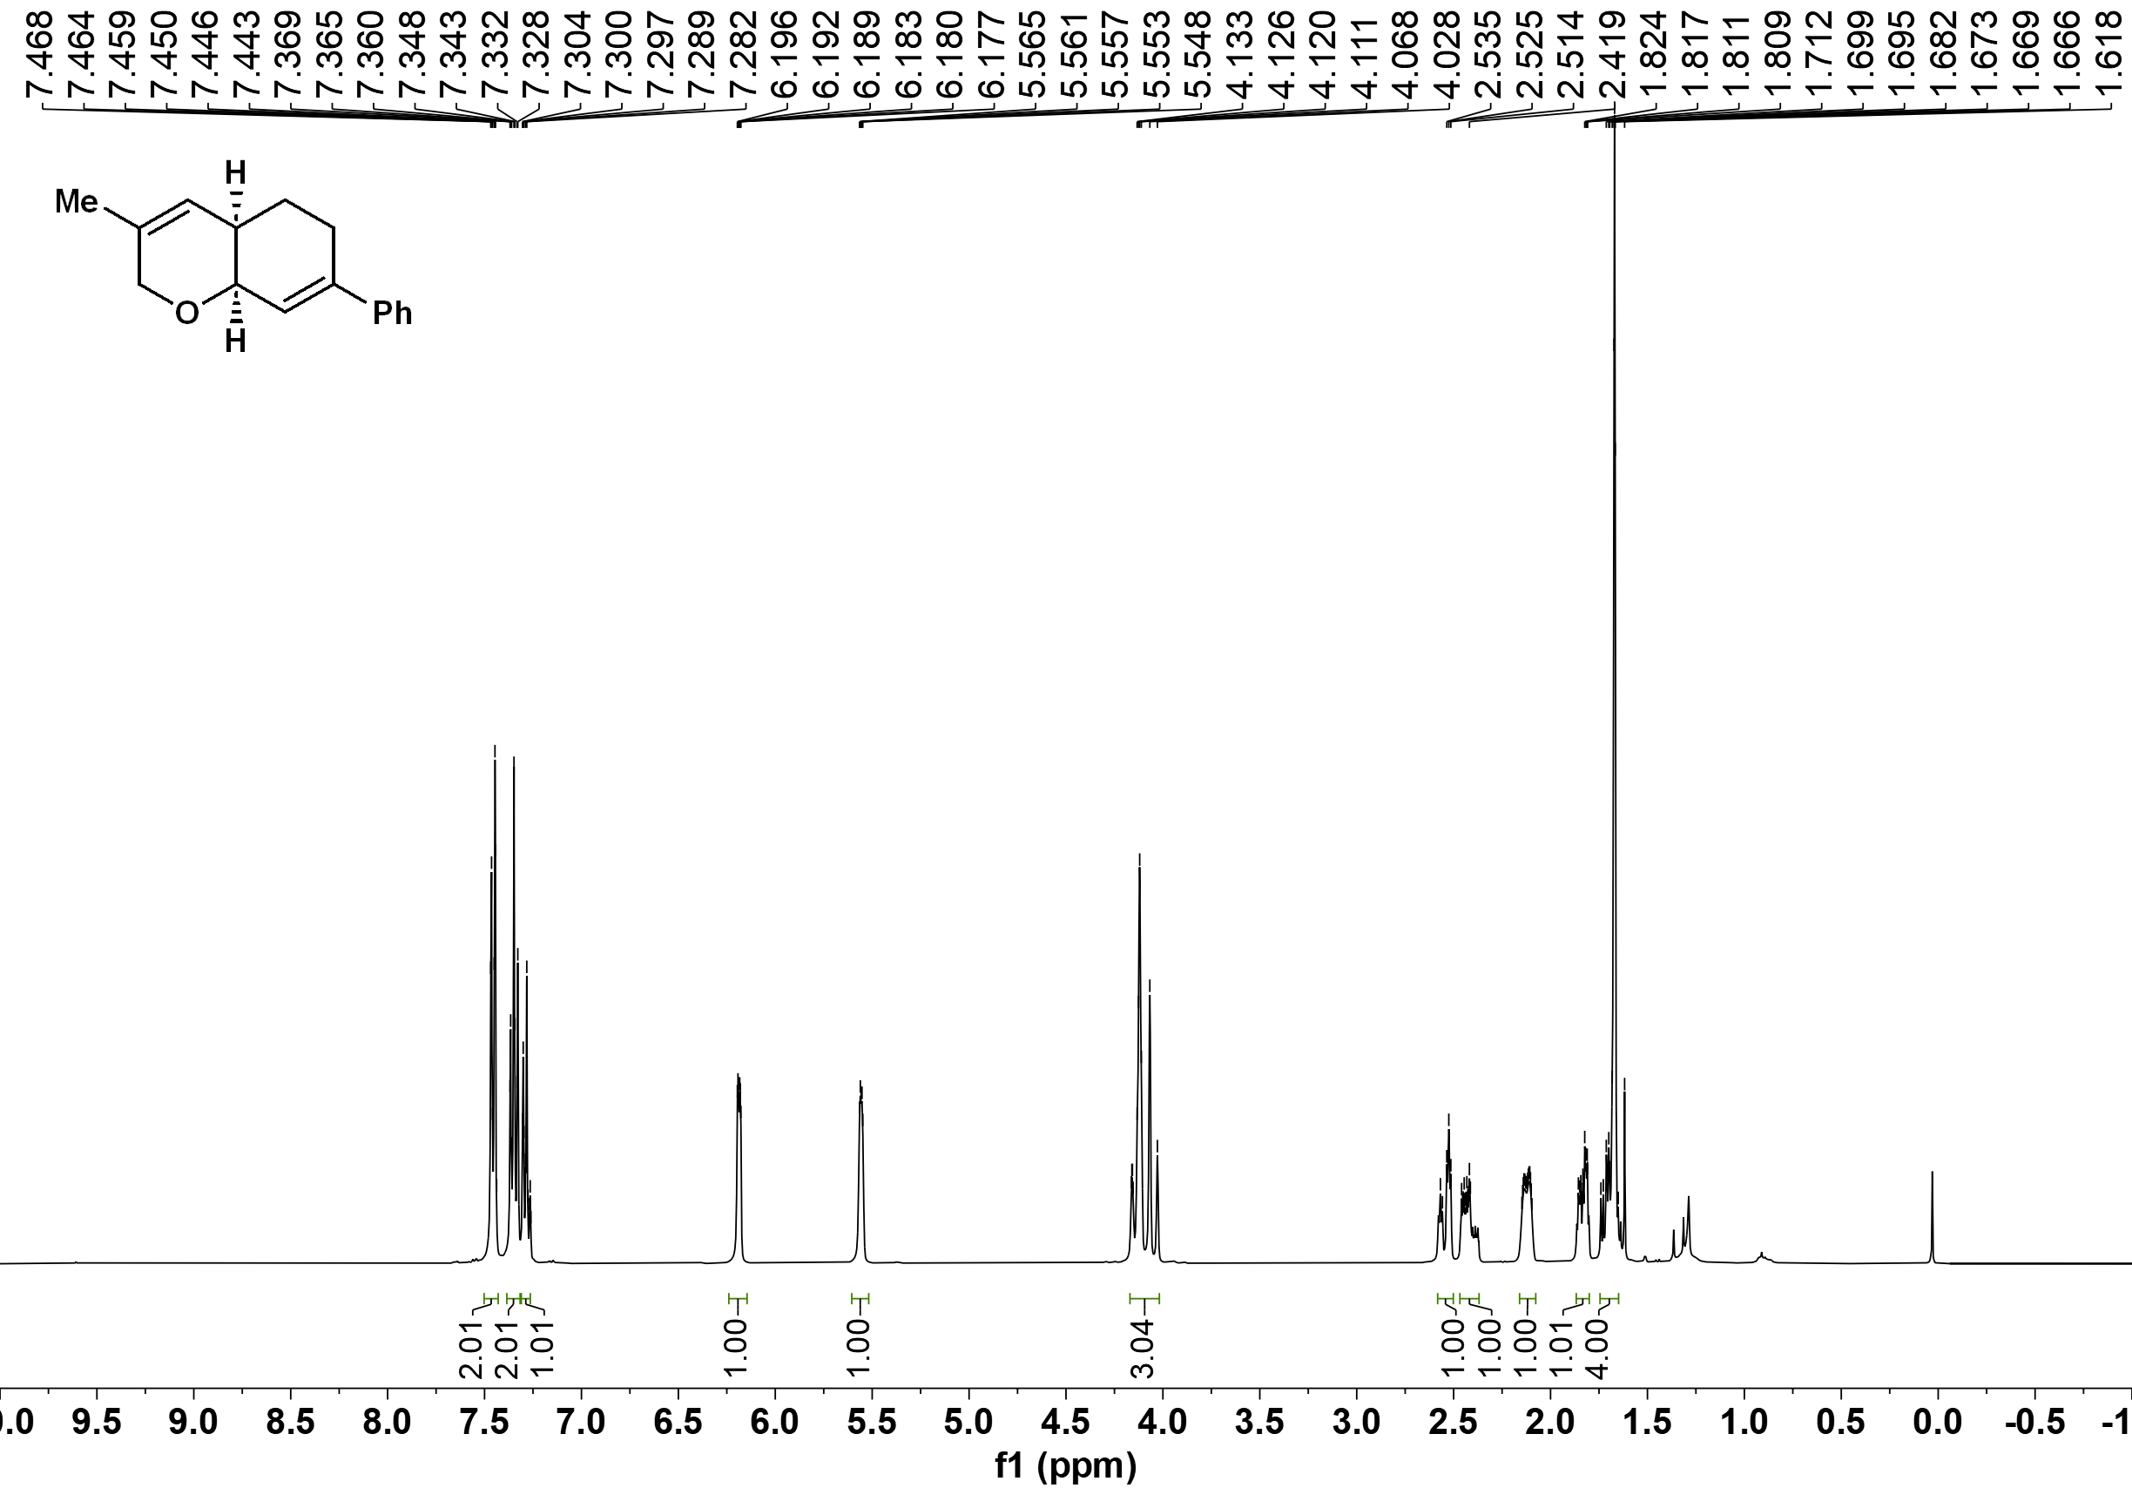

¹³C NMR of 3al
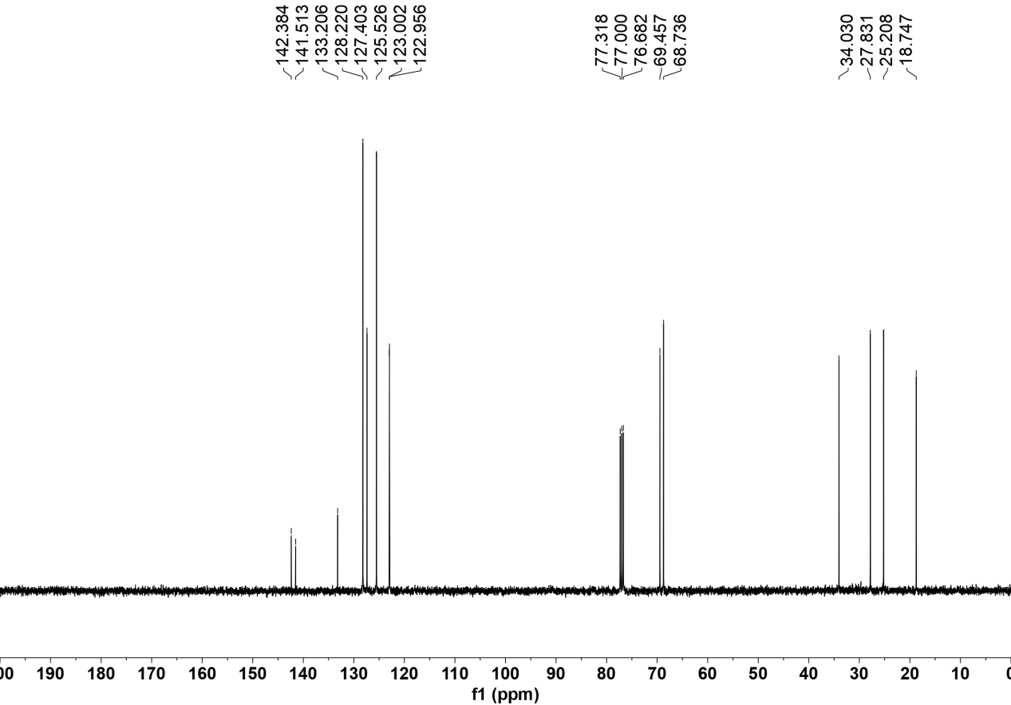

¹H NMR of 3am
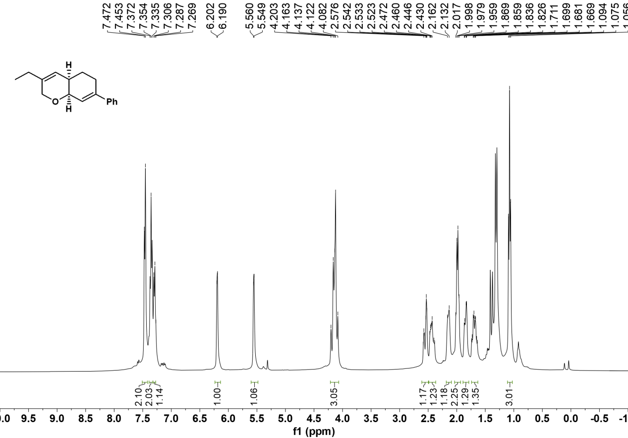

¹³C NMR of 3am
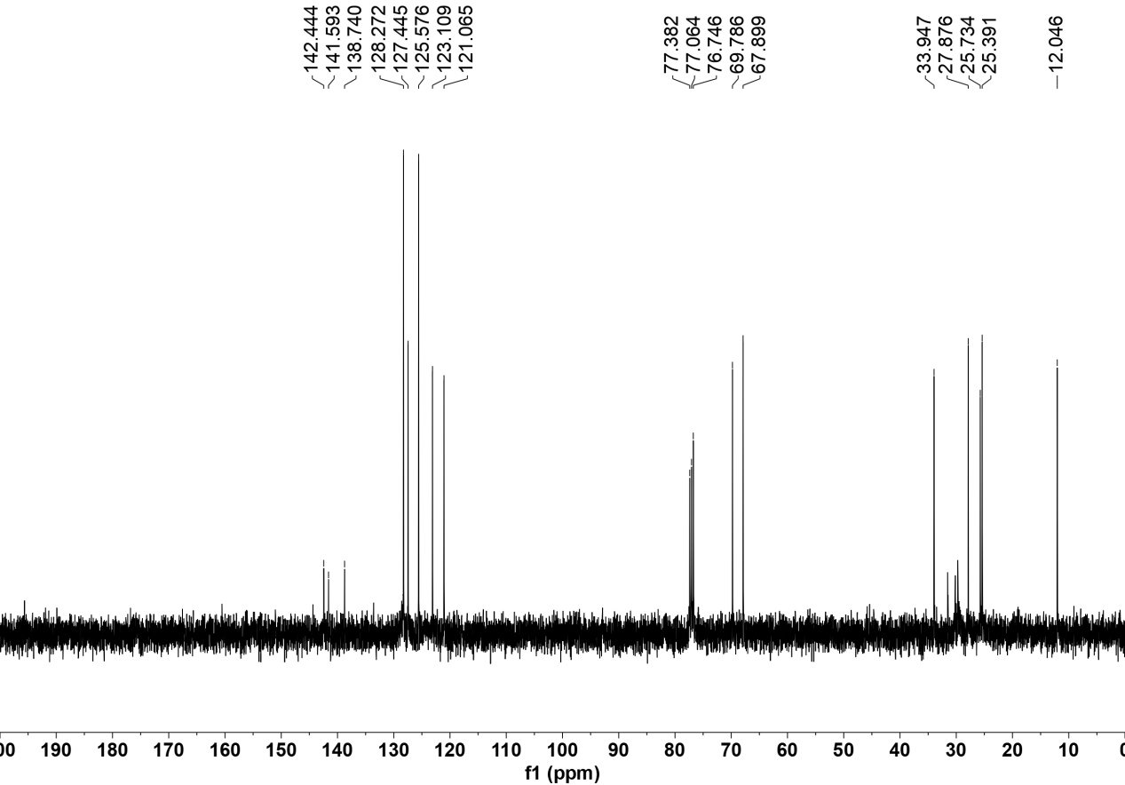

¹H NMR of 3an
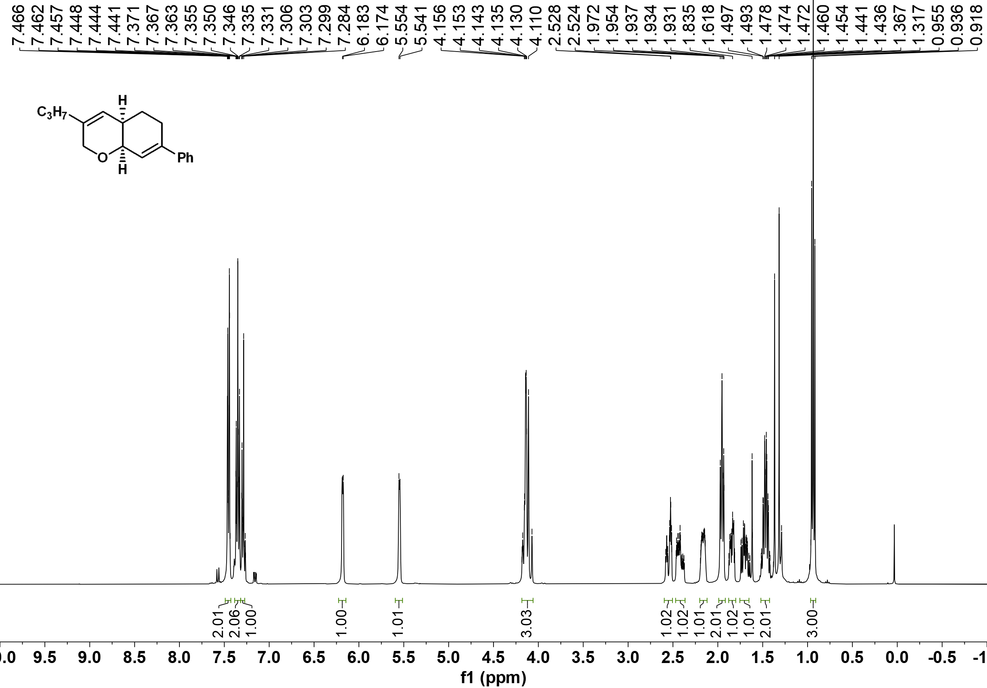

¹³C NMR of 3an
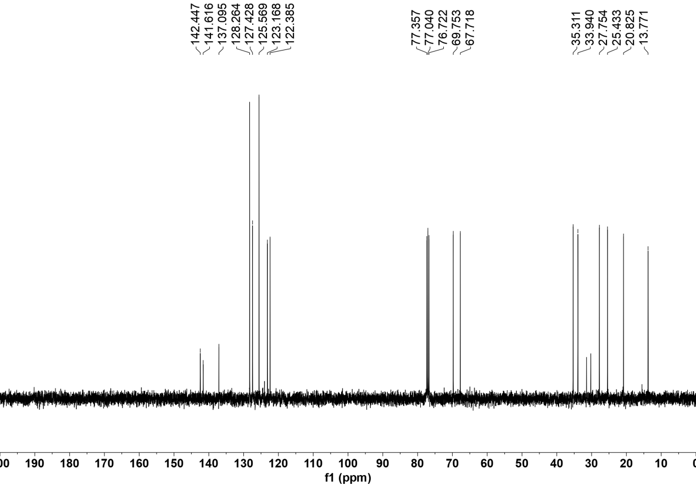

¹H NMR of 3ao
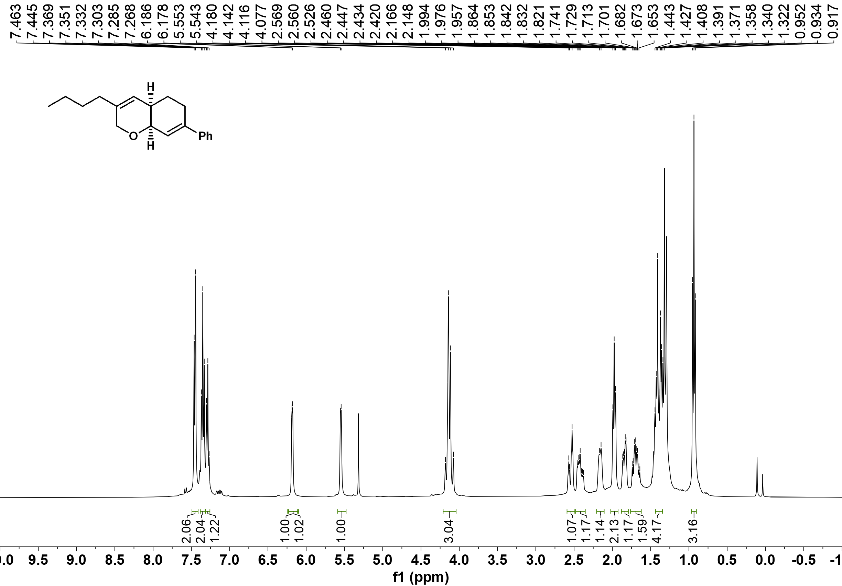

¹³C NMR of 3ao

¹H NMR of 3ap
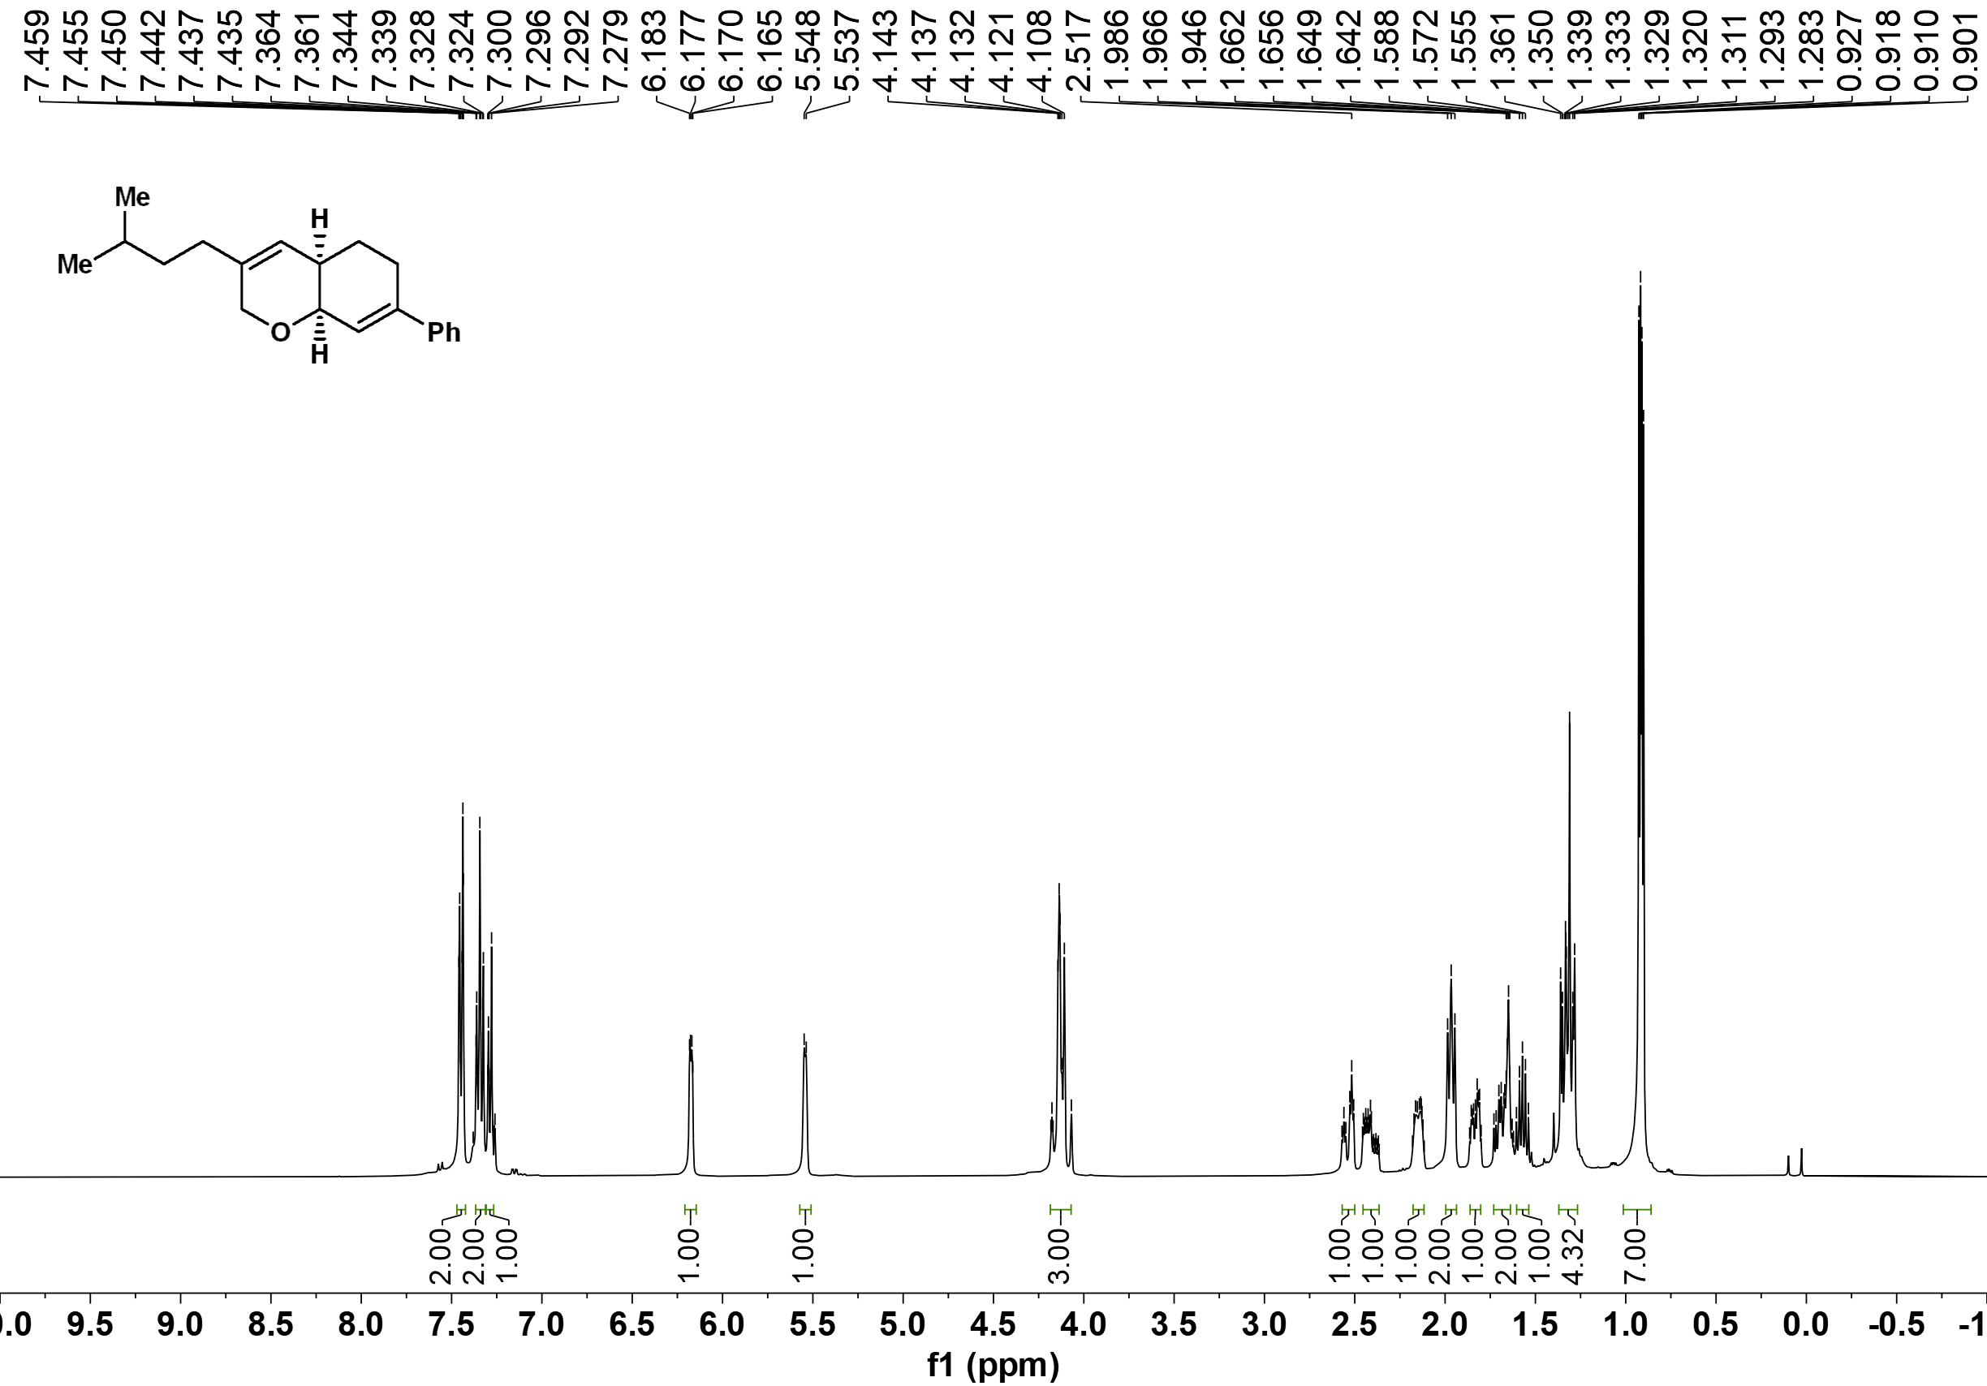

¹³C NMR of 3ap
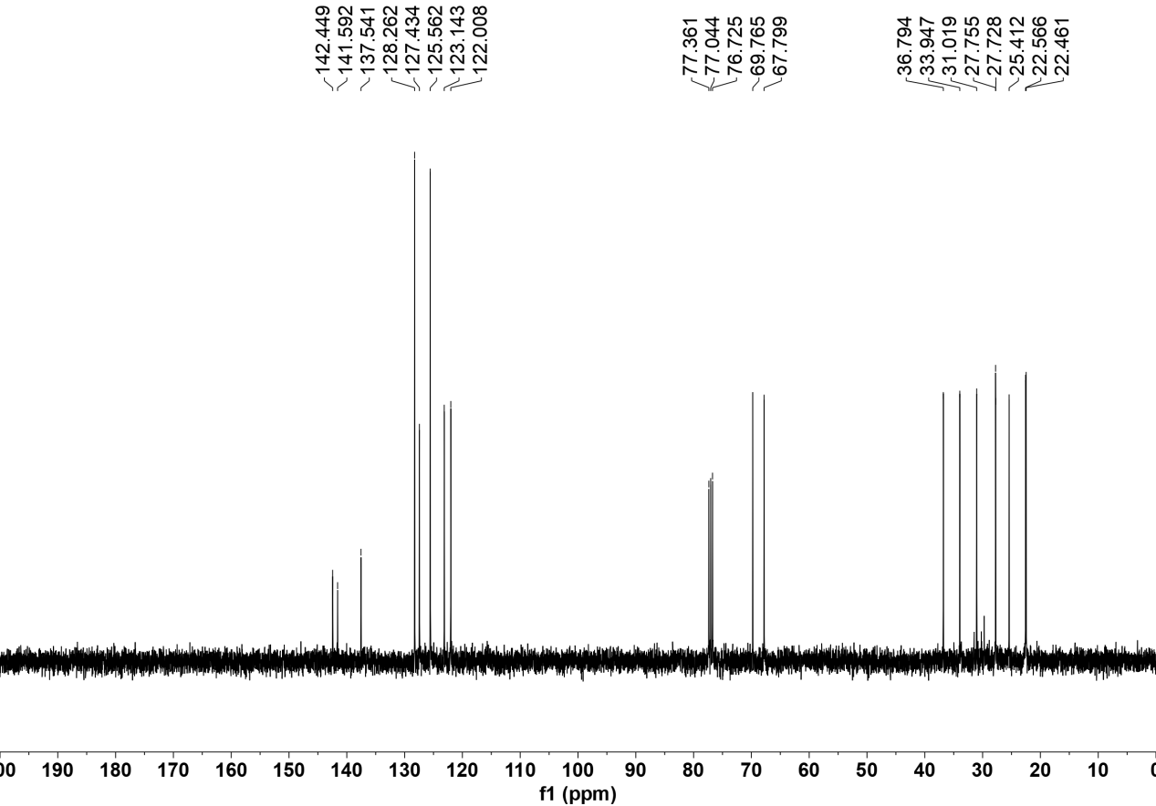

¹H NMR of 3aq
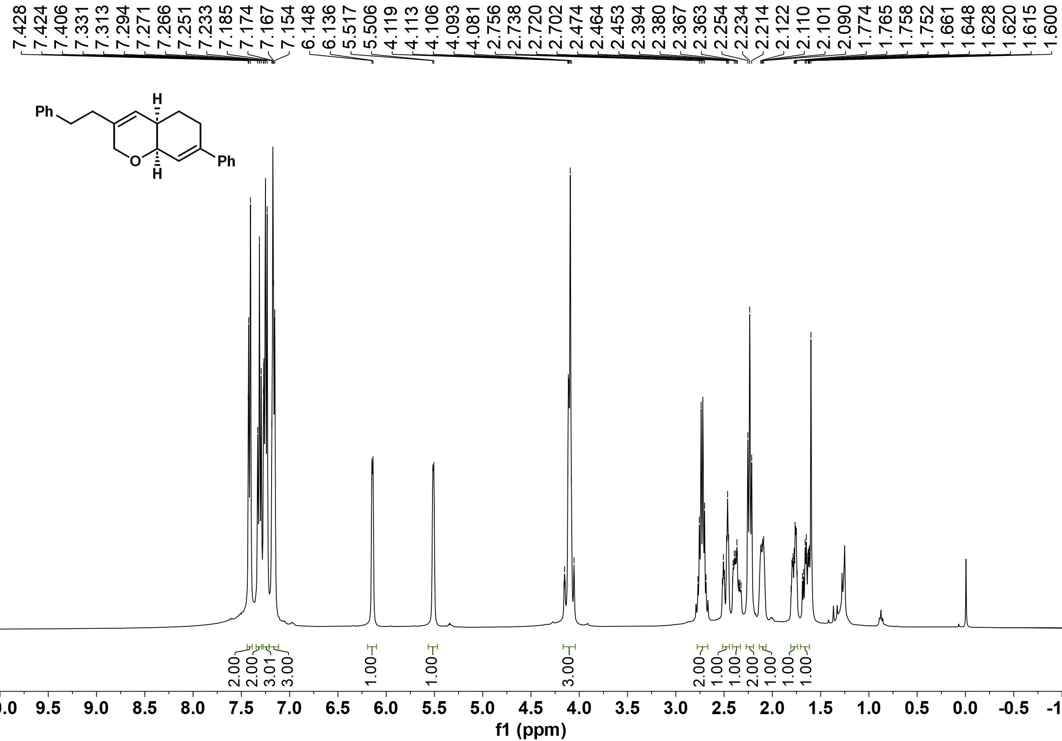

¹³C NMR of 3aq
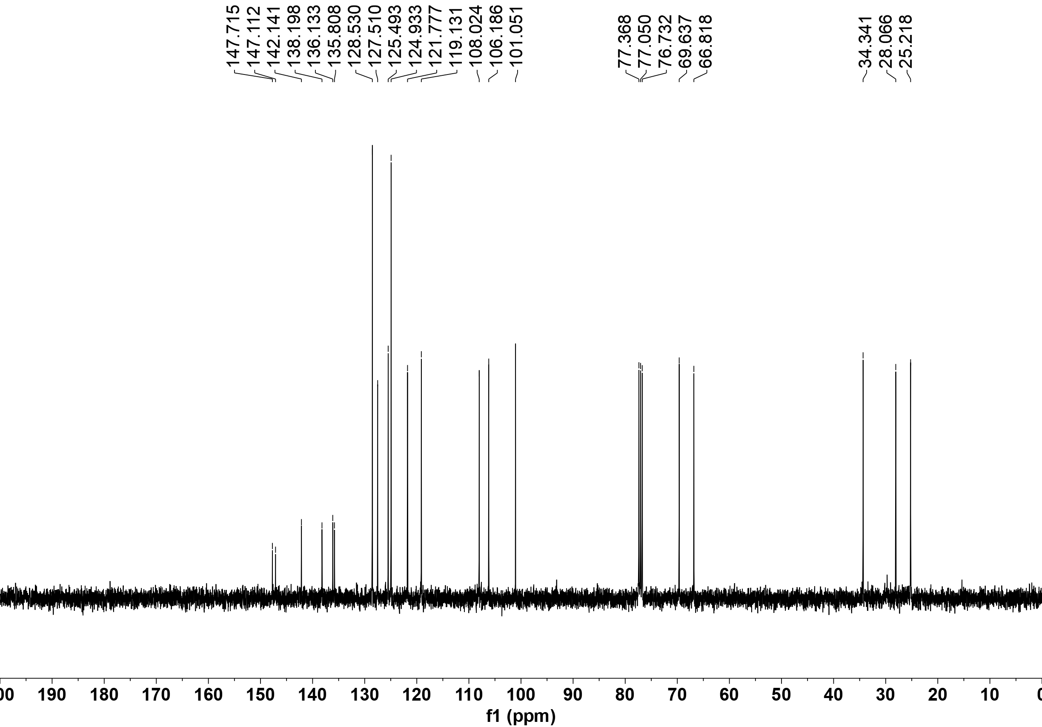

¹H NMR of 3ar
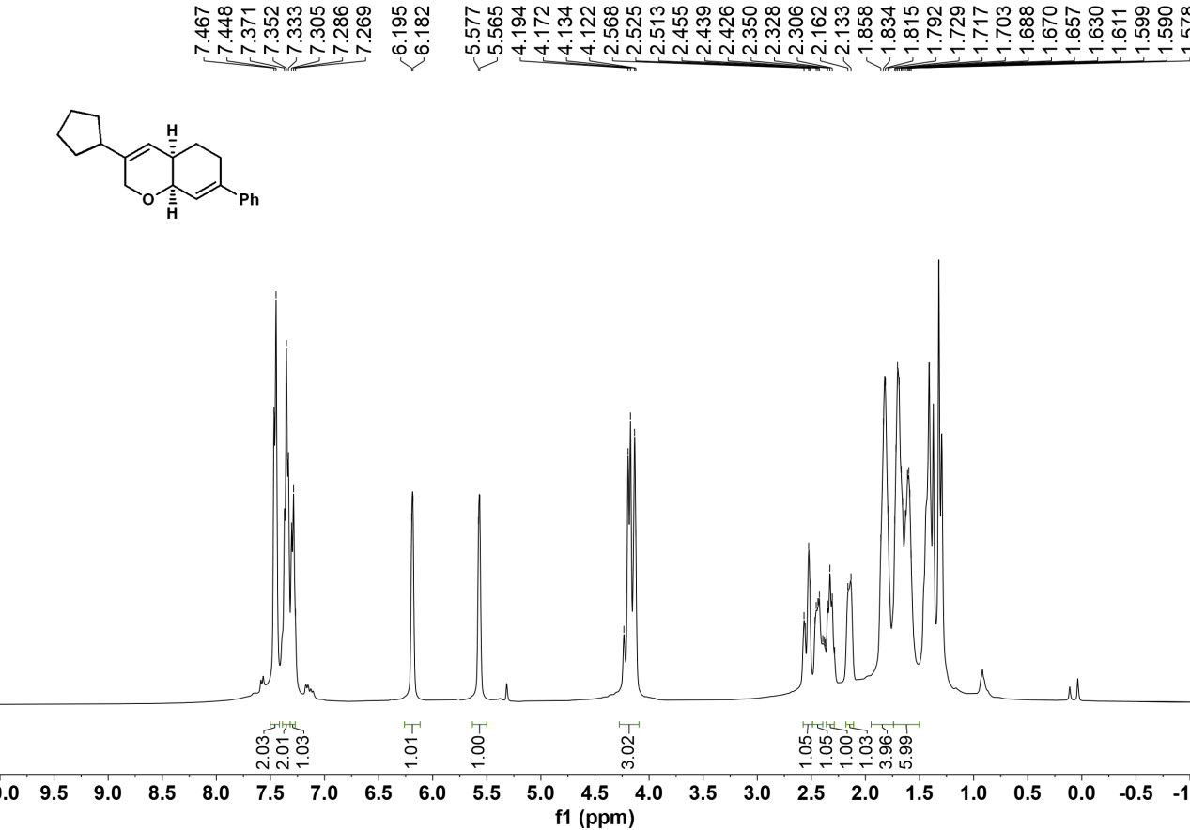

¹³C NMR of 3ar

¹H NMR of 3as
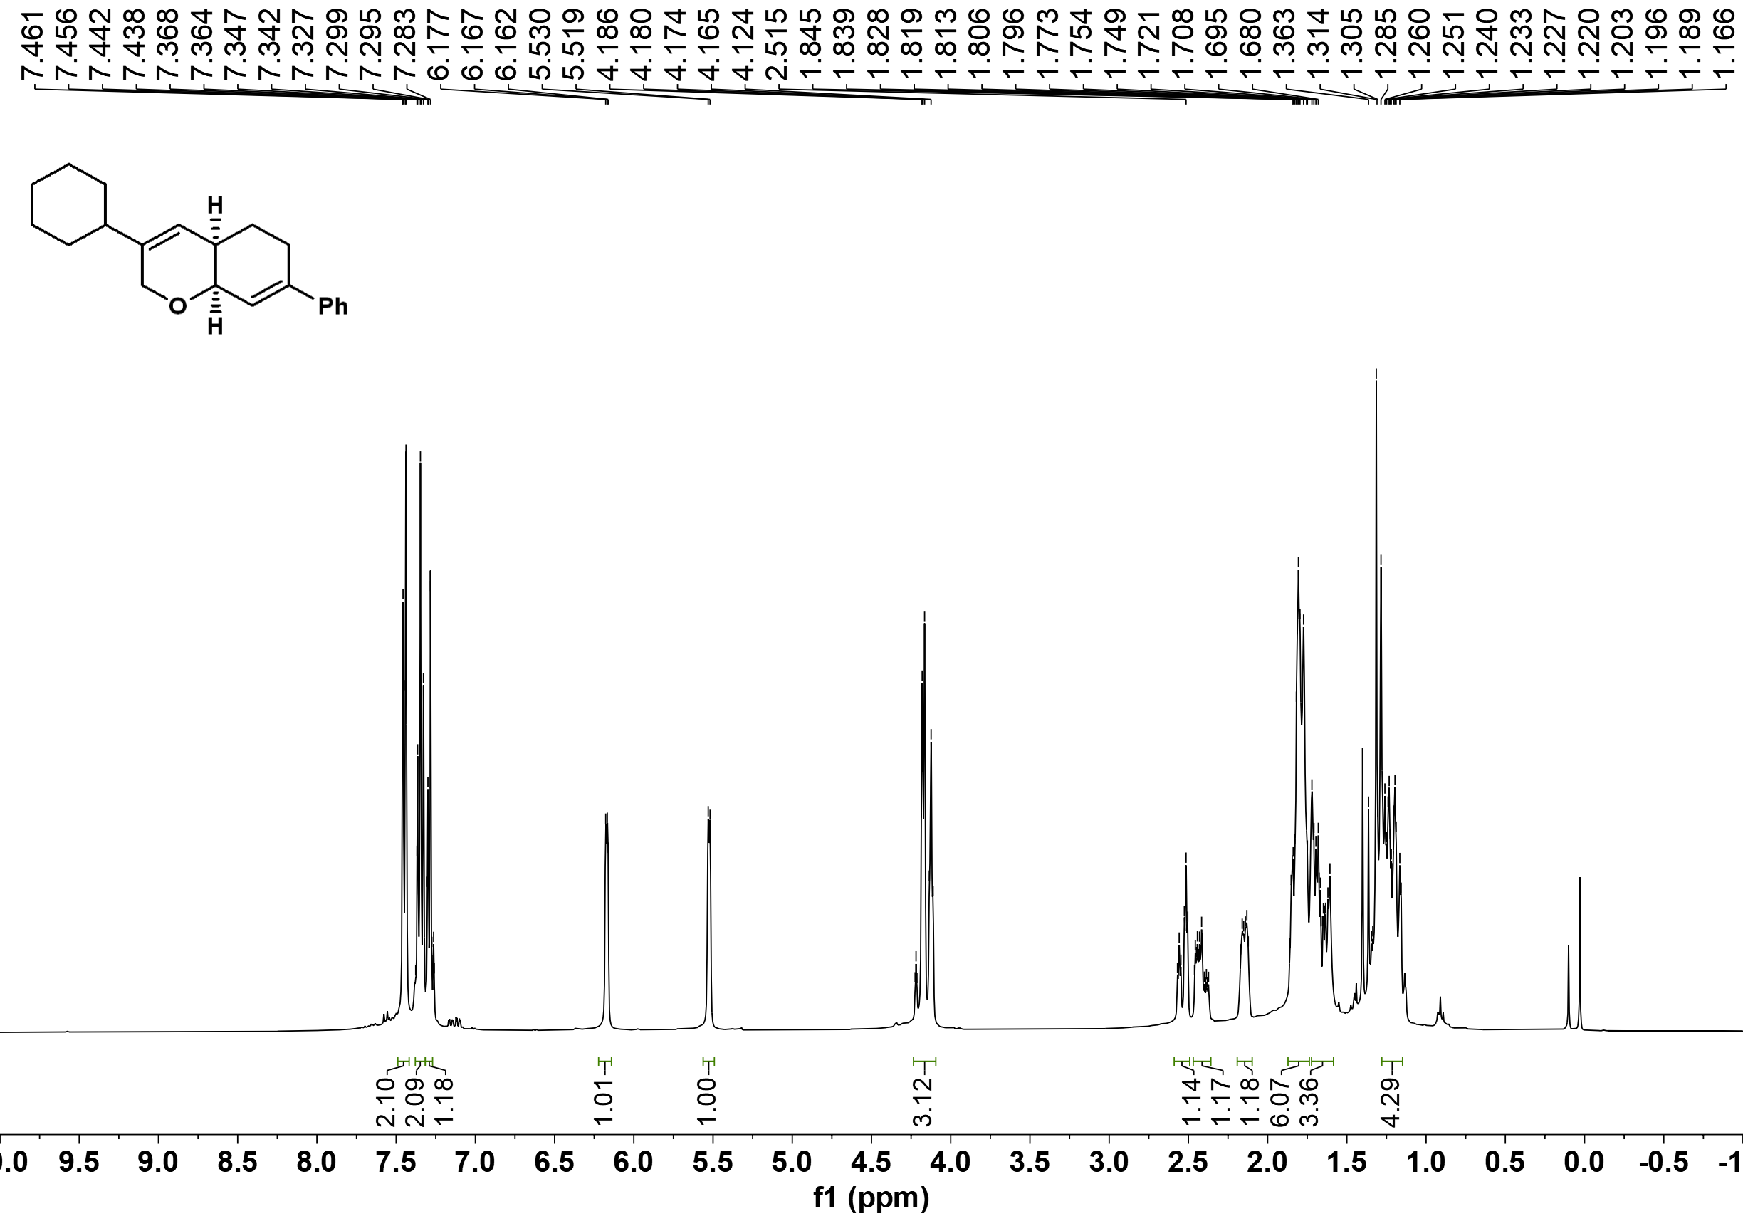

¹³C NMR of 3as
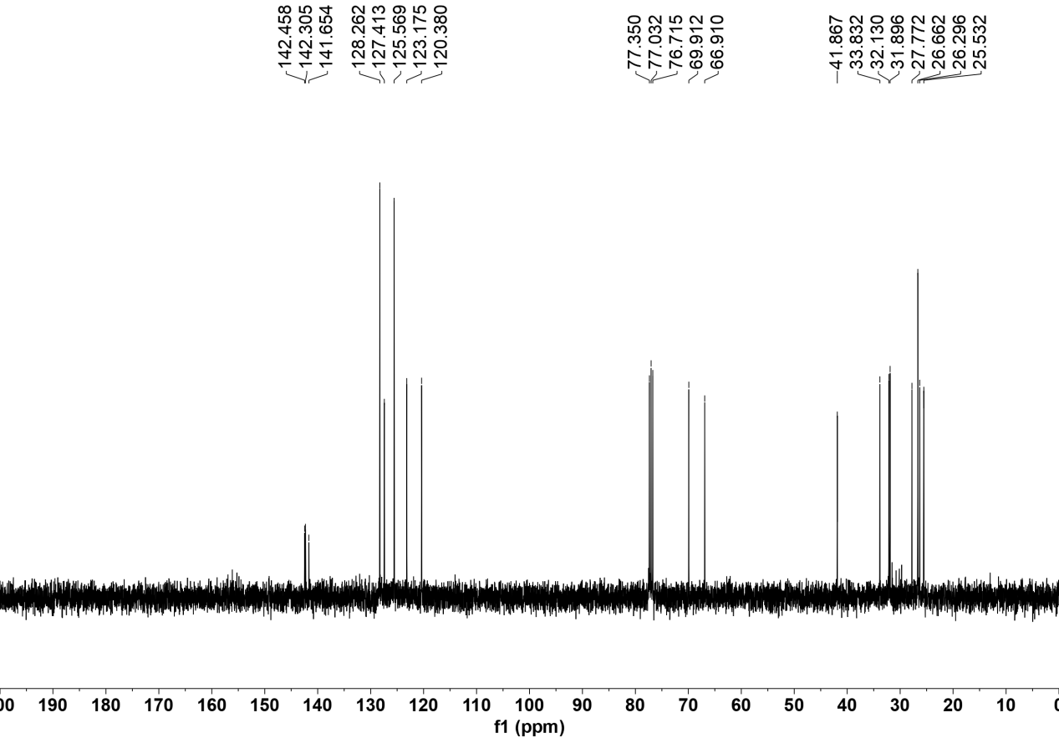

¹H NMR of 3at

¹³C NMR of 3at
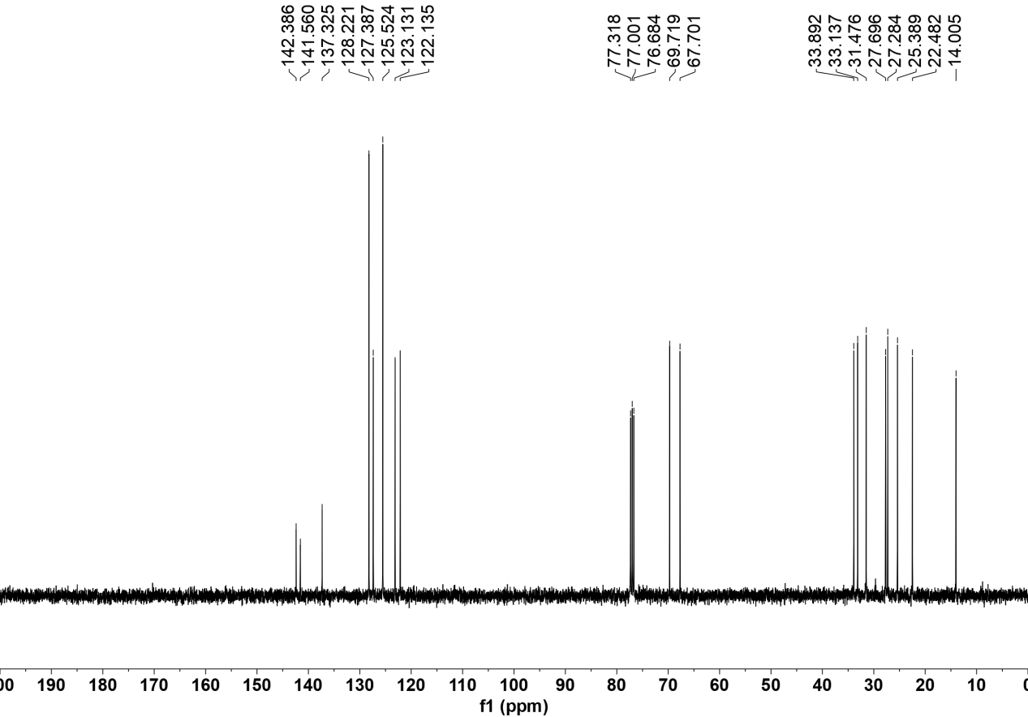

¹H NMR of 3au
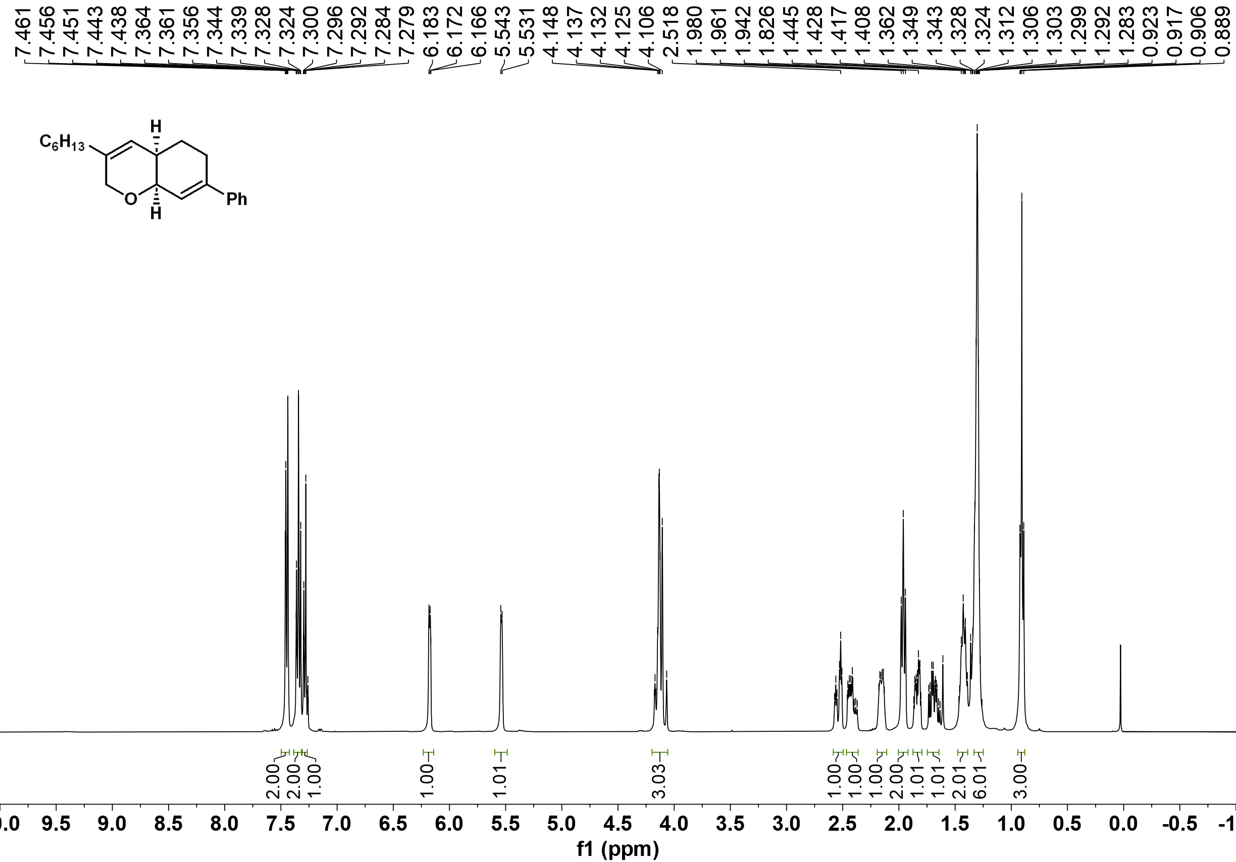

¹³C NMR of 3au
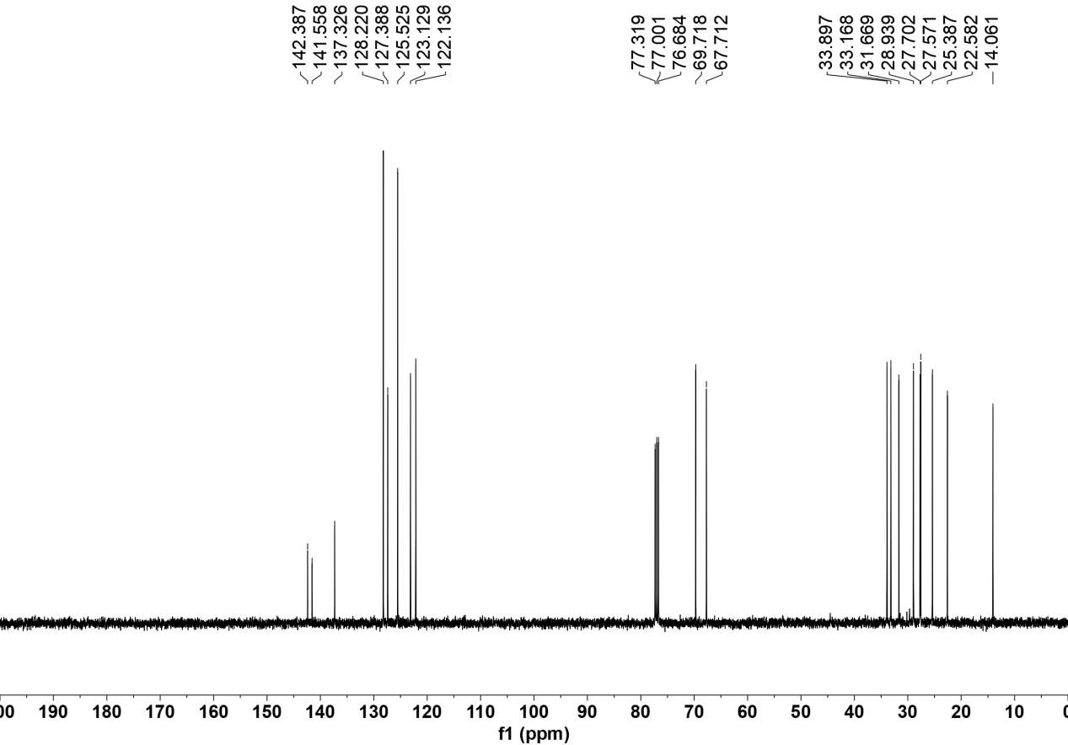

¹H NMR of 3av
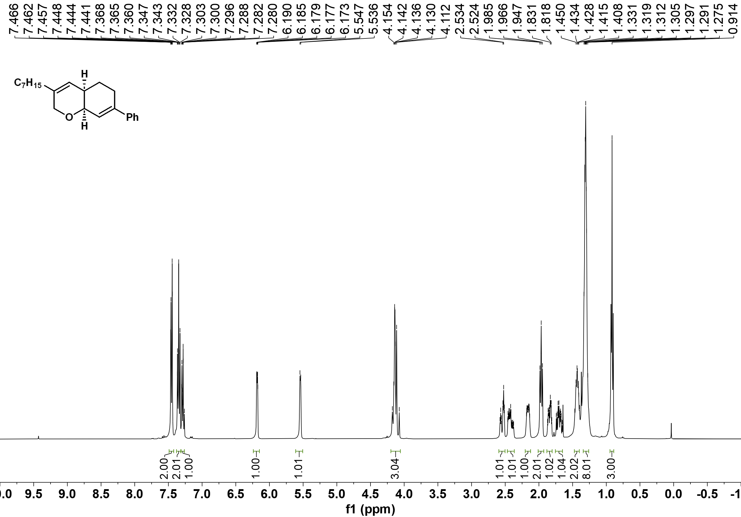

¹³C NMR of 3av
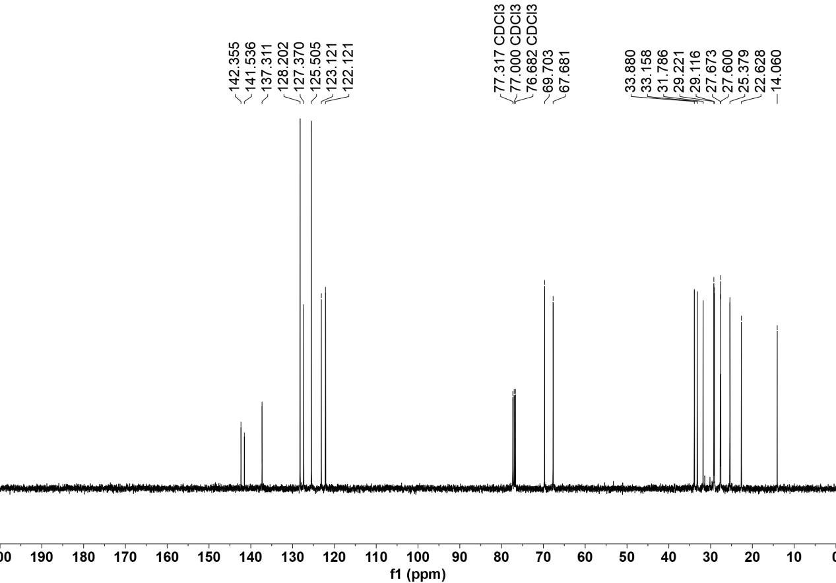

¹H NMR of 3aw
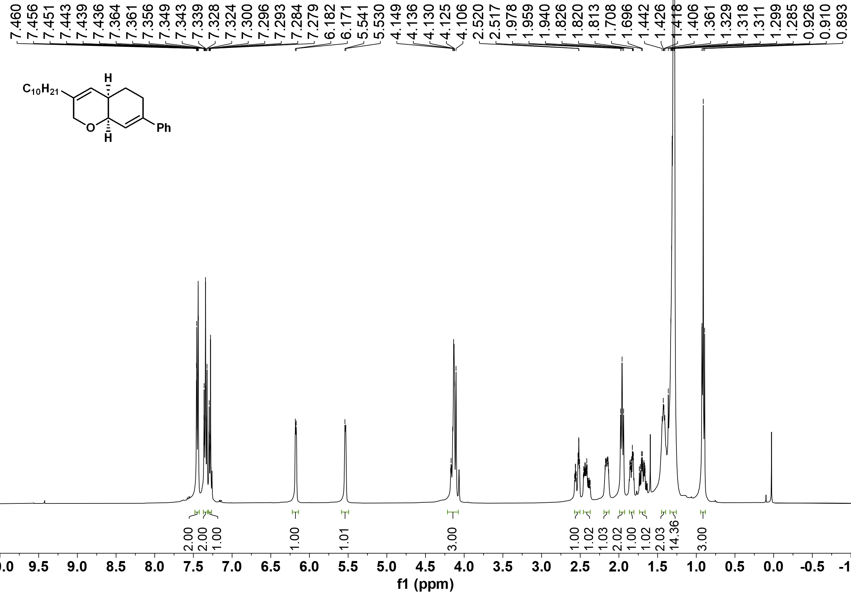

¹³C NMR of 3aw
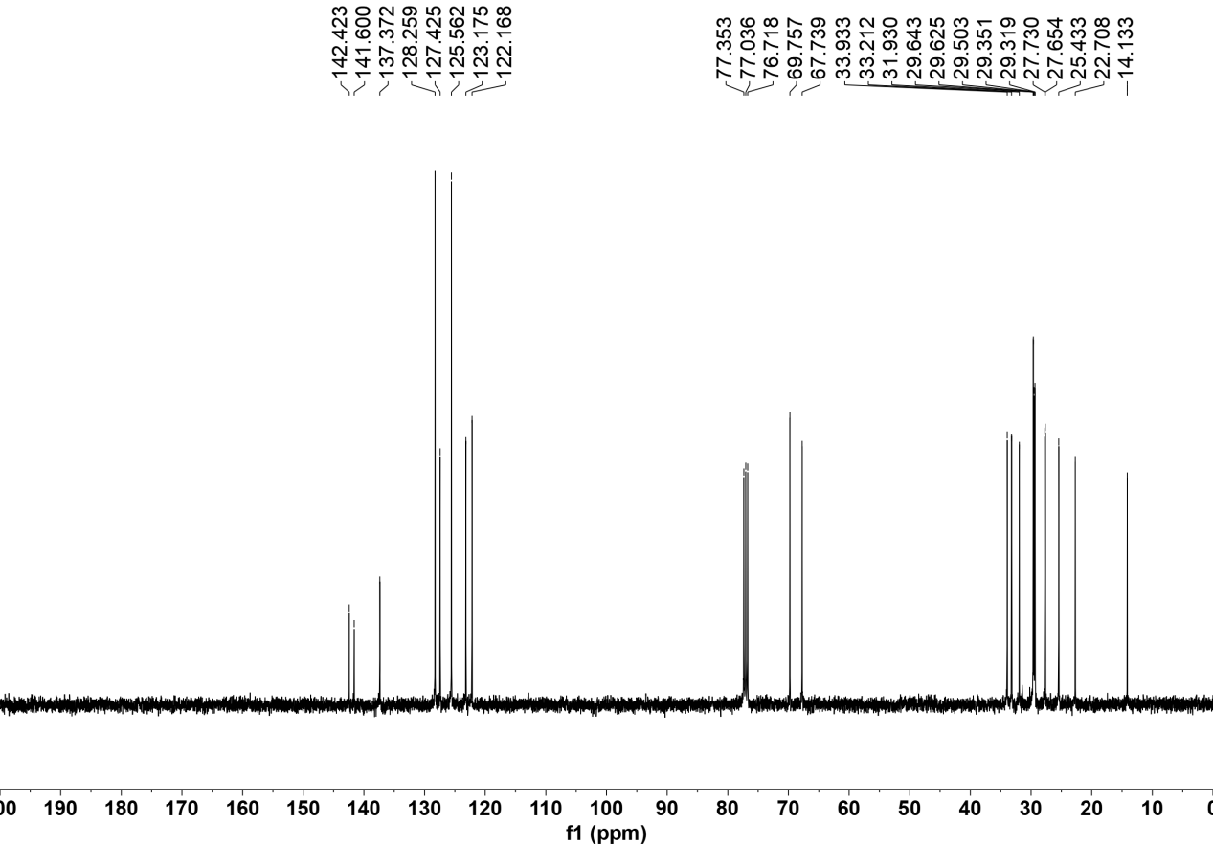

¹H NMR of 3ax
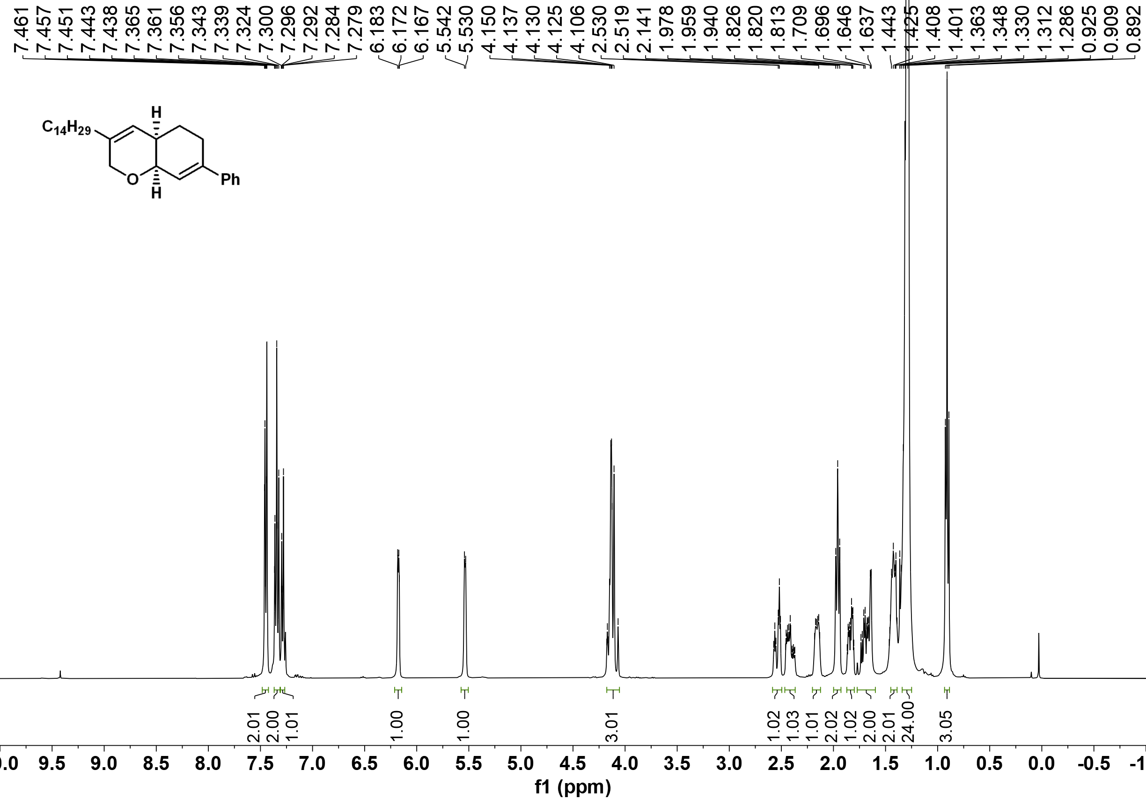

¹³C NMR of 3ax
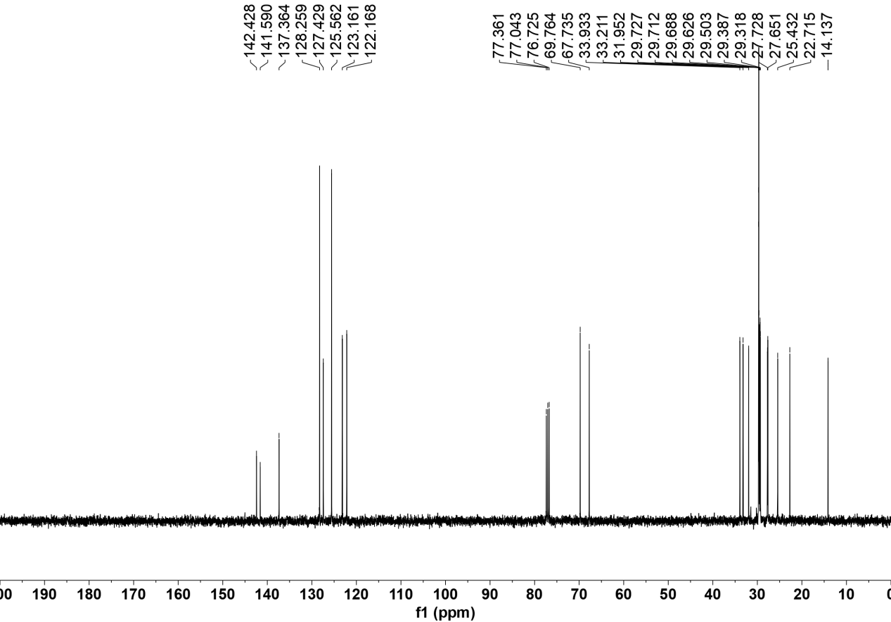

¹H NMR of 3ba
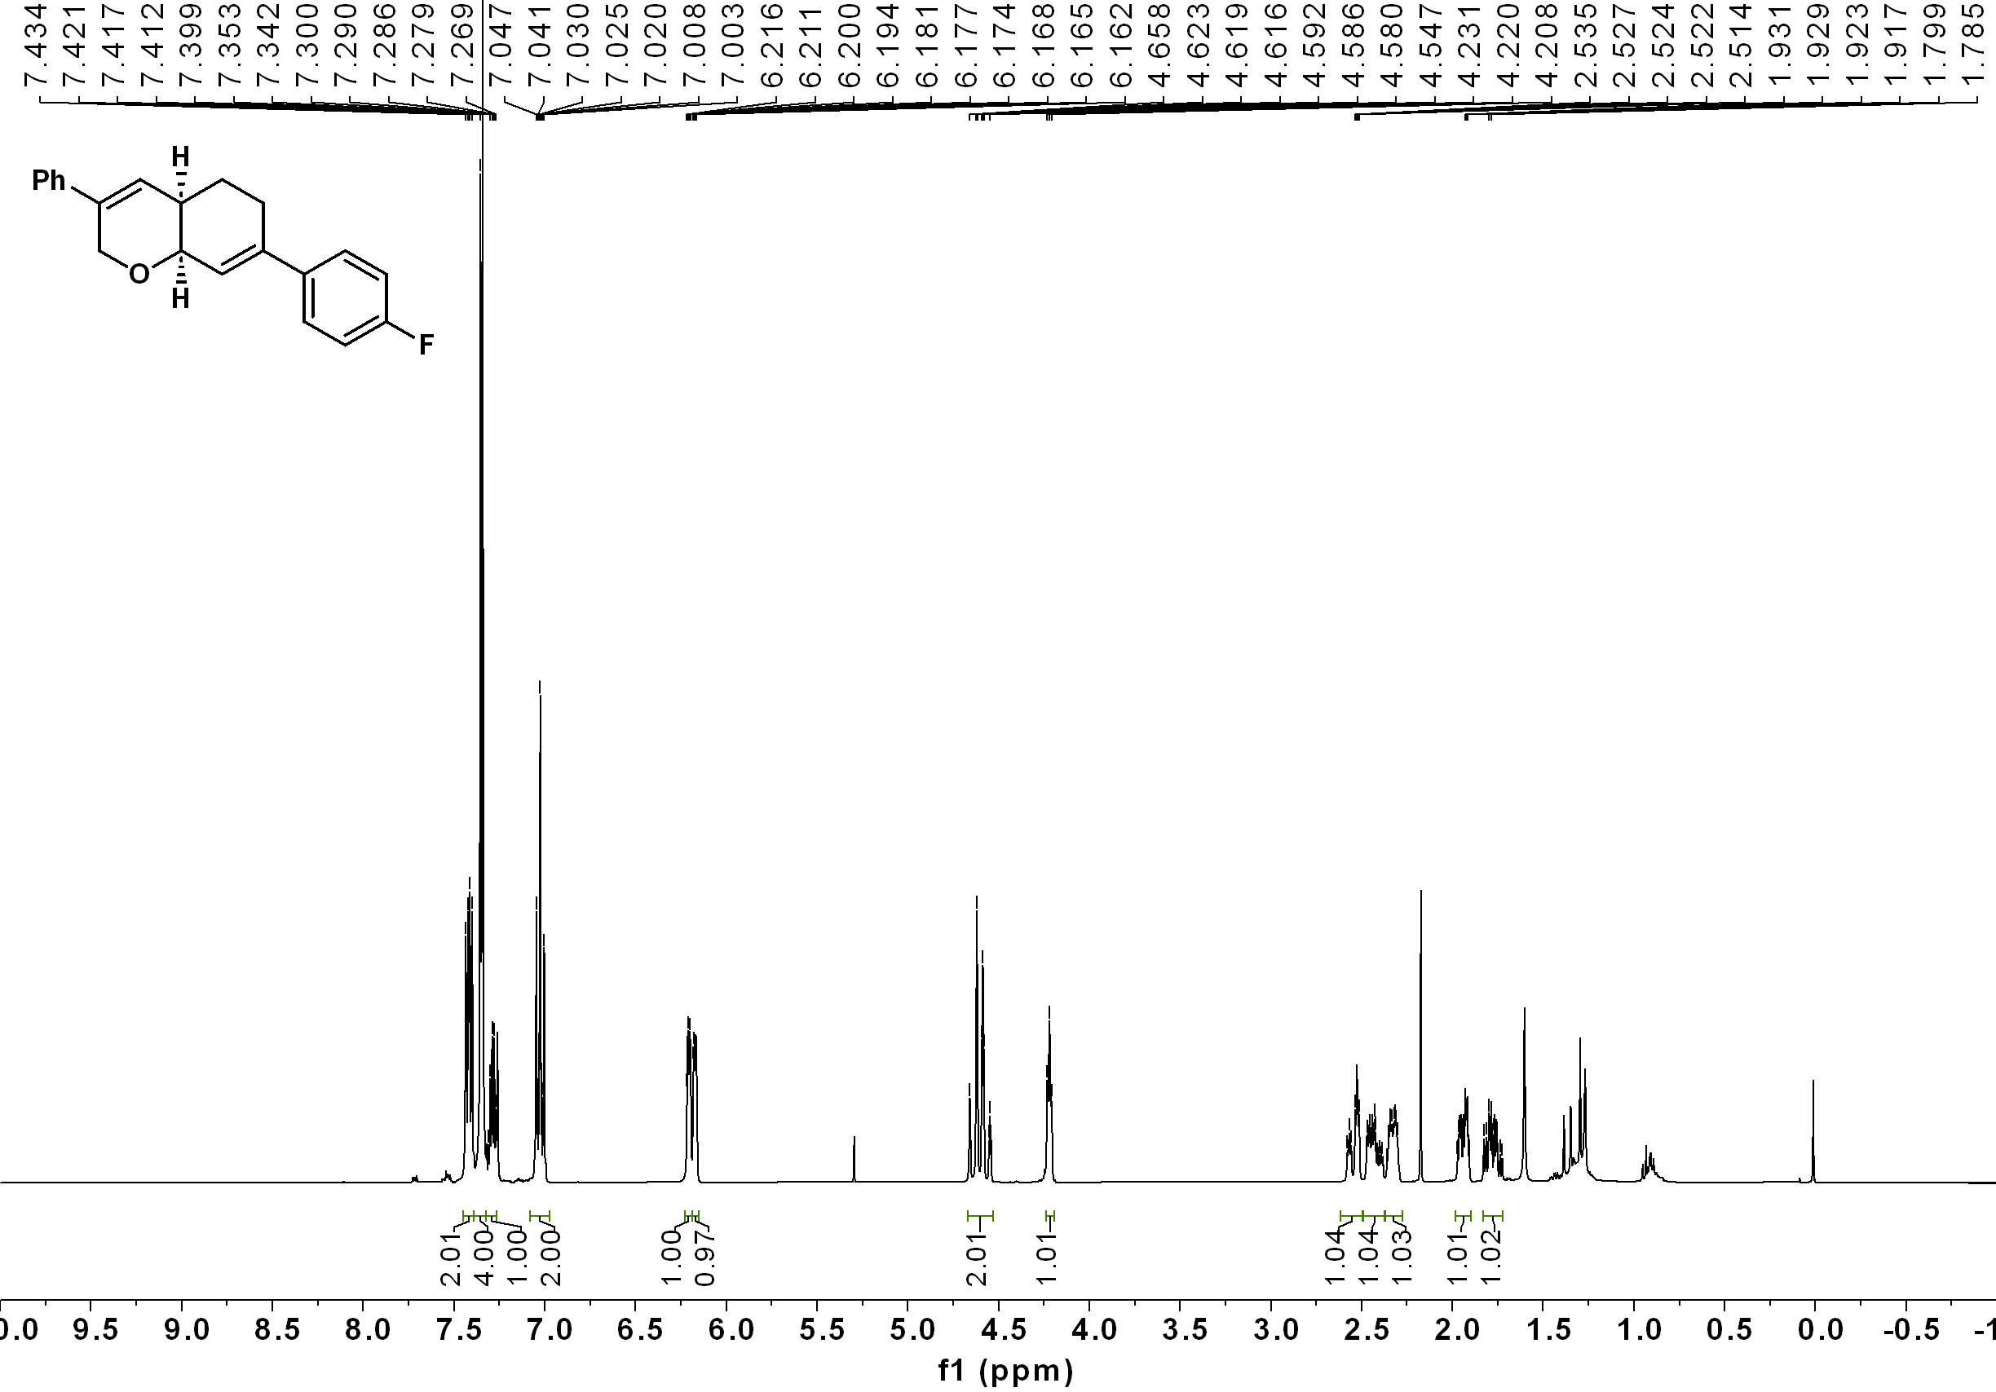

¹³C NMR of 3ba
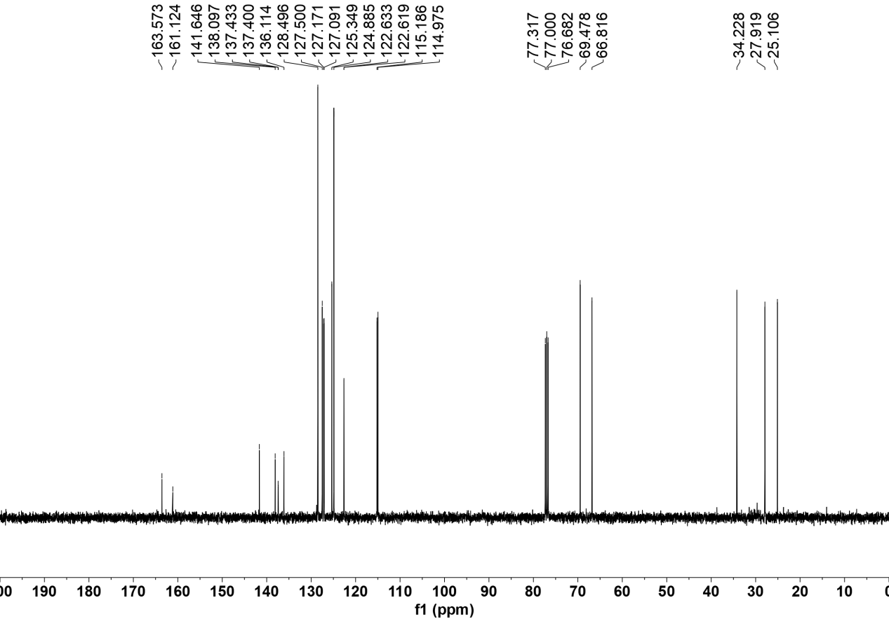

¹⁹F NMR of 3ba
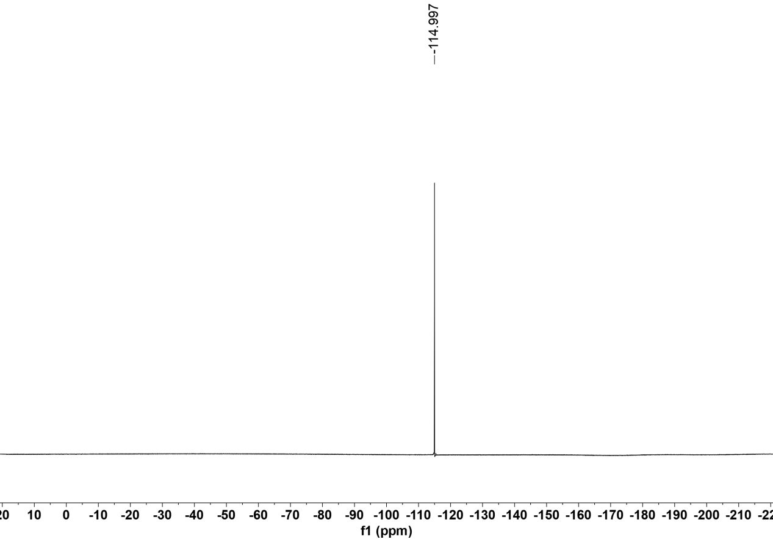

¹H NMR of 3bb

¹³C NMR of 3bb
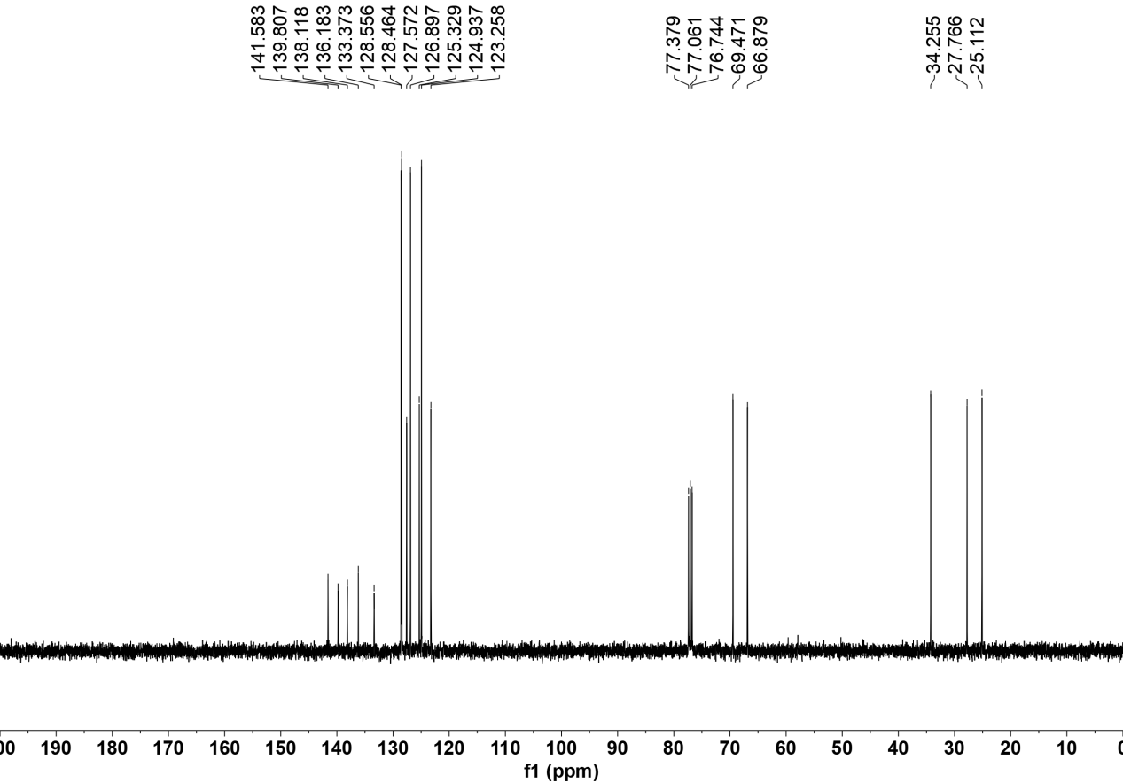

¹H NMR of 3bc

¹³C NMR of 3bc

¹H NMR of 3bd

¹³C NMR of 3bd

¹⁹F NMR of 3bd

¹H NMR of 3be

¹³C NMR of 3be

¹⁹F NMR of 3be

¹H NMR of 3bf

¹³C NMR of 3bf

¹H NMR of 3bg

¹³C NMR of 3bg
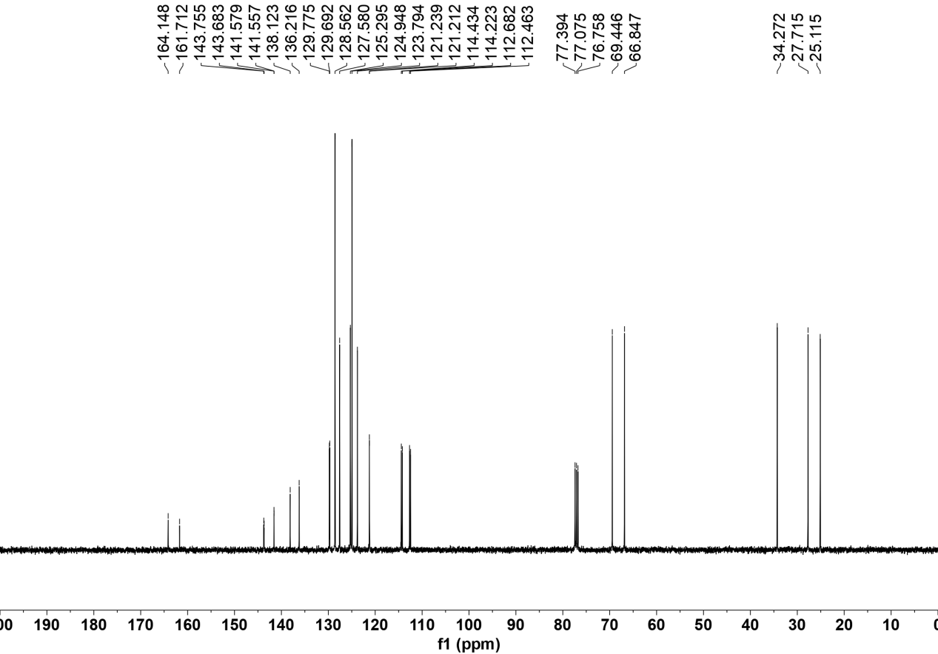

¹⁹F NMR of 3bg

¹H NMR of 3bh

¹³C NMR of 3bh

¹H NMR of 3bi

¹³C NMR of 3bi

¹H NMR of 3bj

¹³C NMR of 3bj

¹H NMR of 3bk

¹³C NMR of 3bk
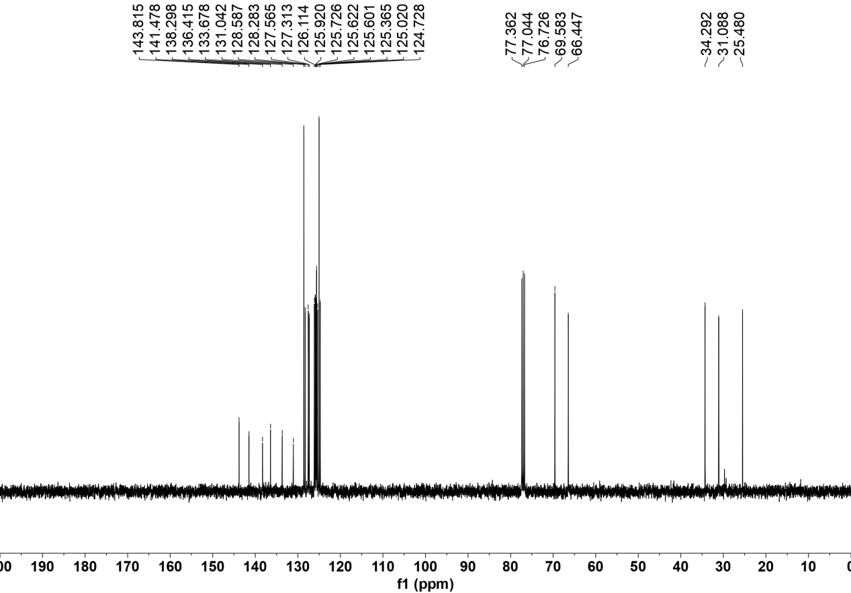

¹H NMR of 3bl
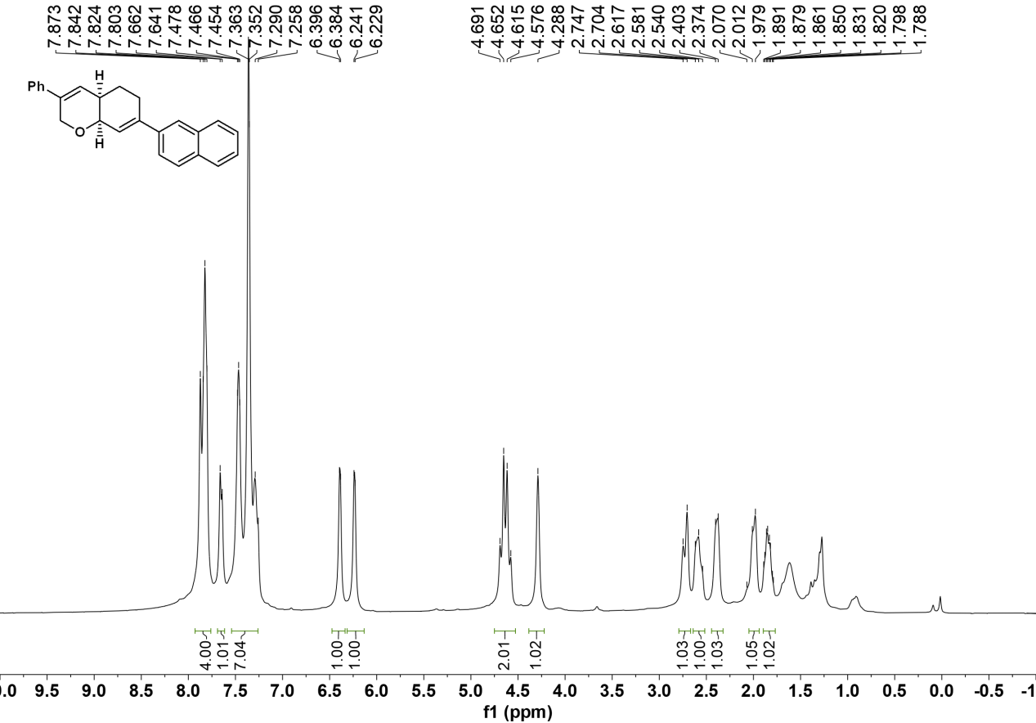

¹³C NMR of 3bl
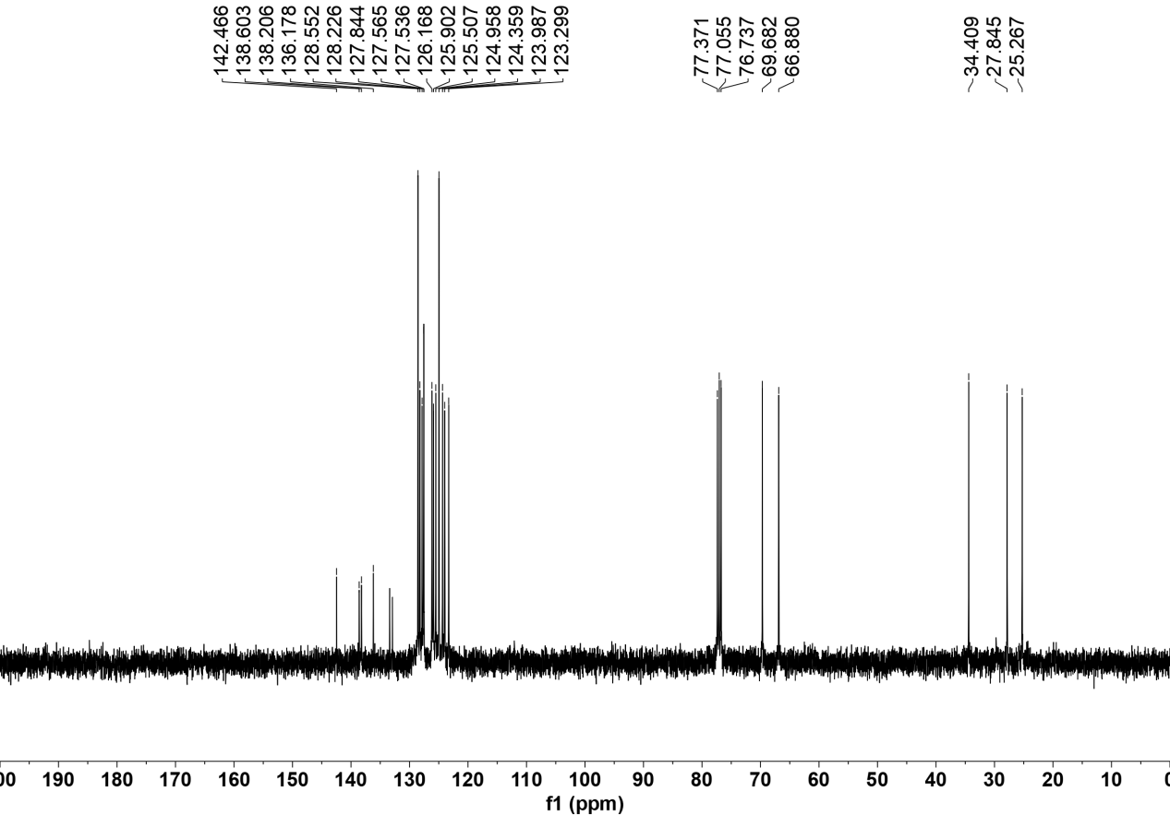

¹H NMR of 3bm
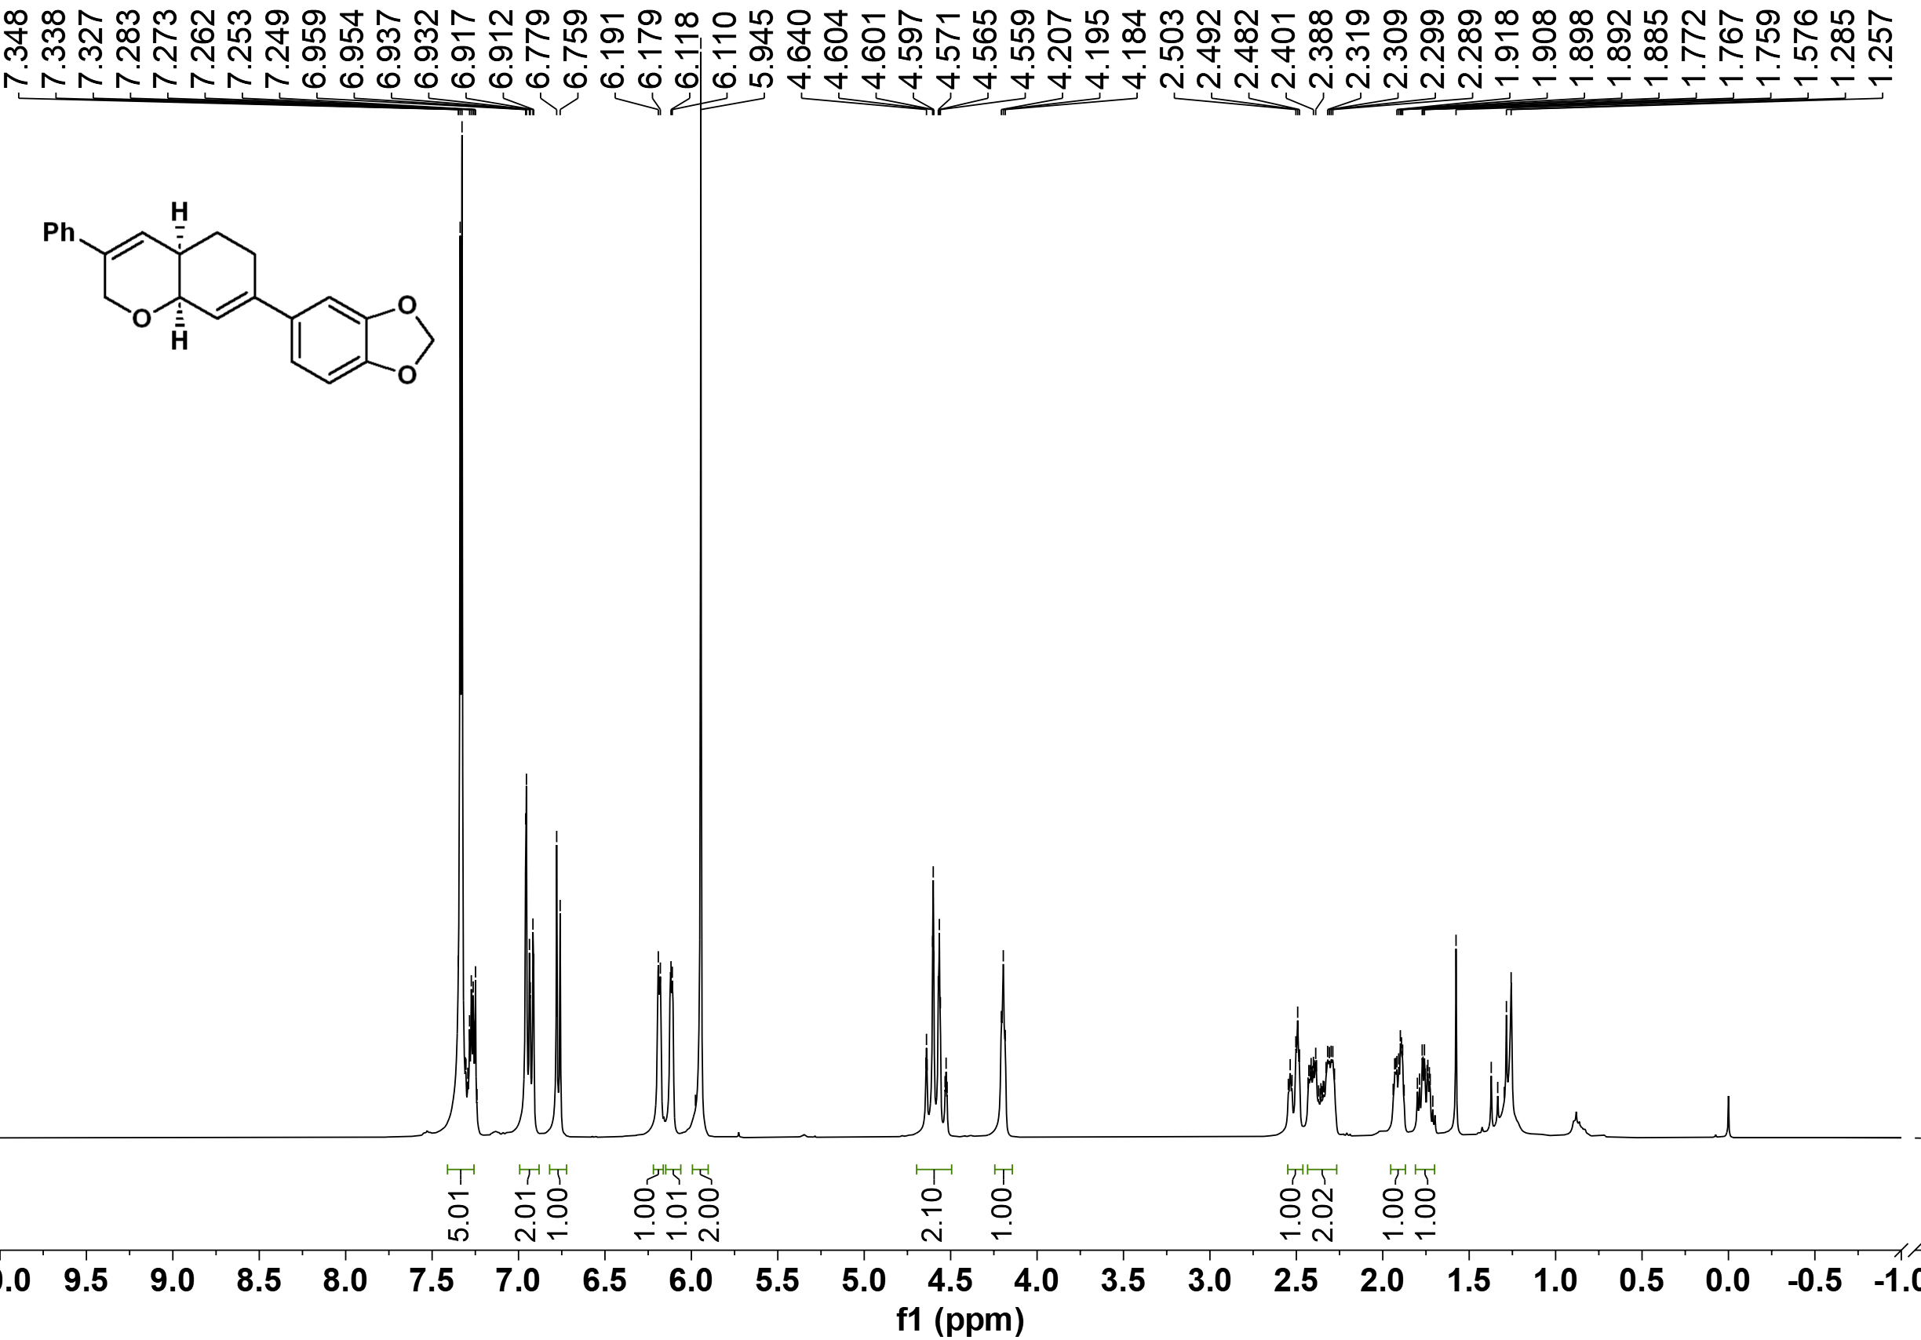

¹³C NMR of 3bm
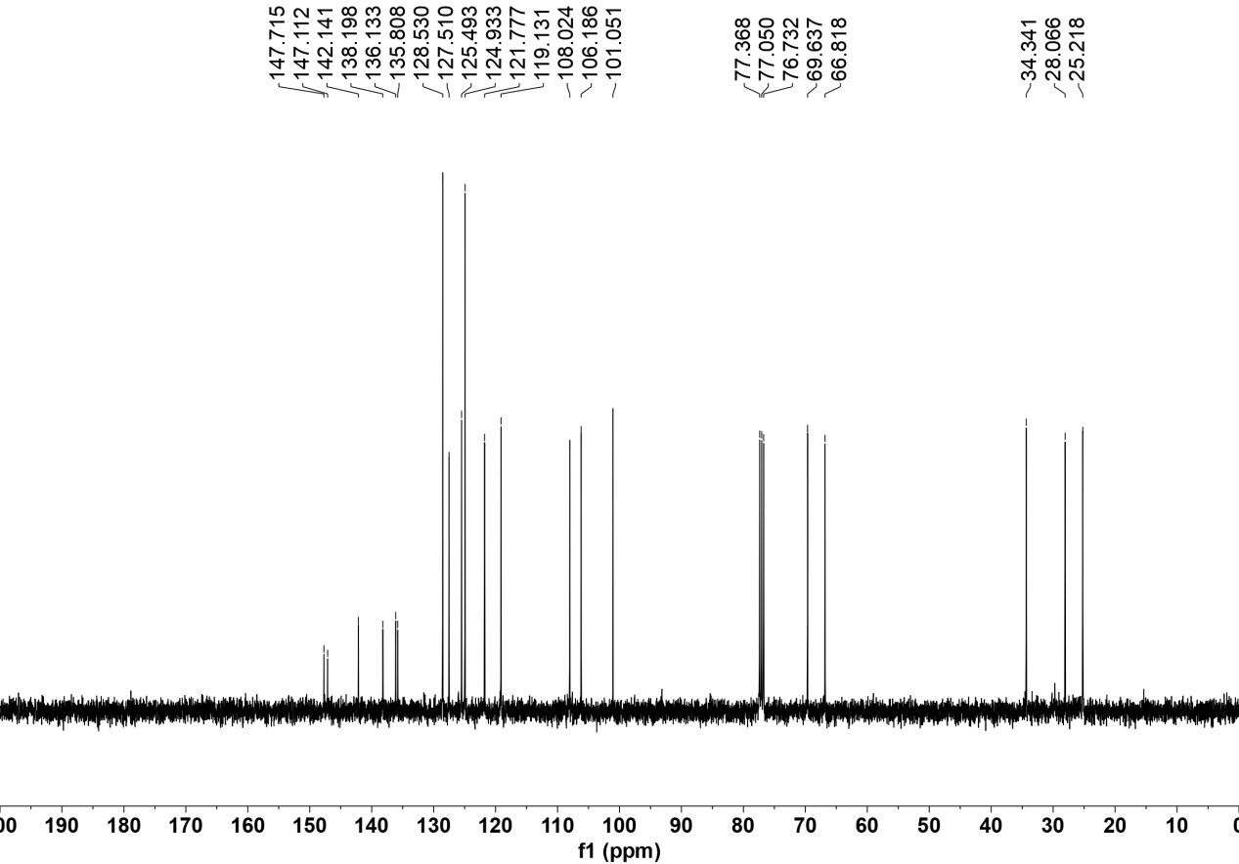

¹H NMR of 3bn
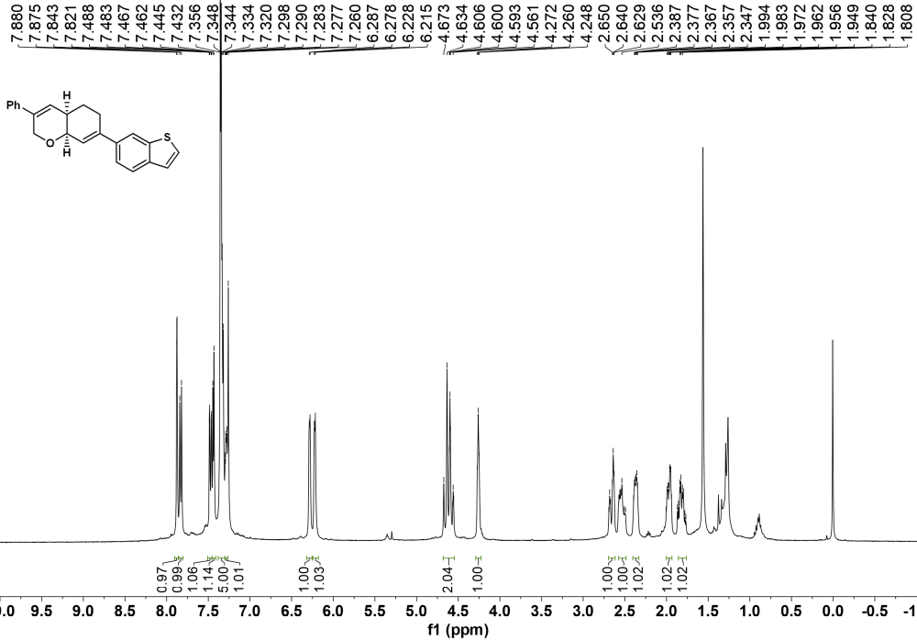

¹³C NMR of 3bn

¹H NMR of 3bo
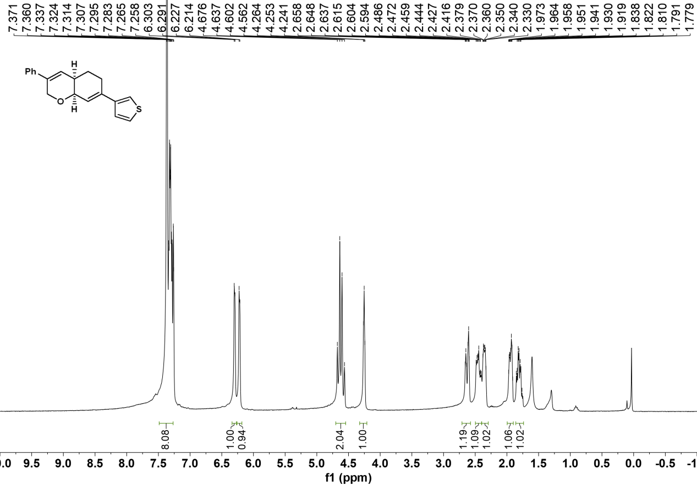

¹³C NMR of 3bo
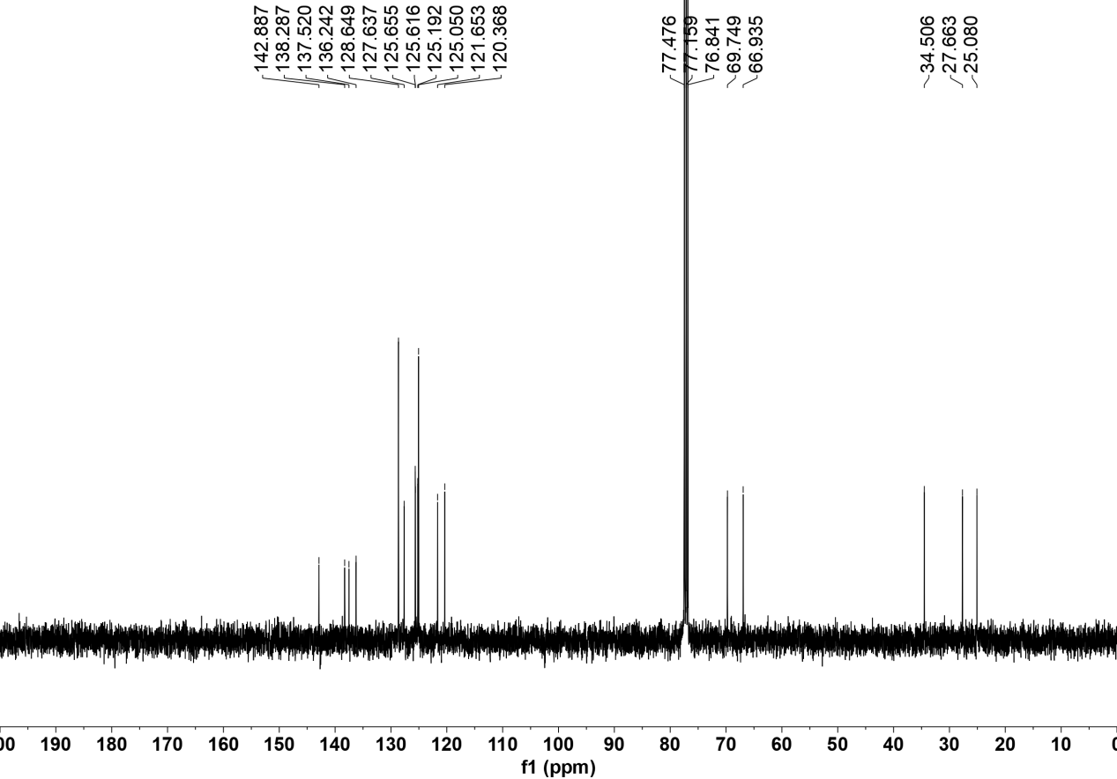

¹H NMR of 3bp
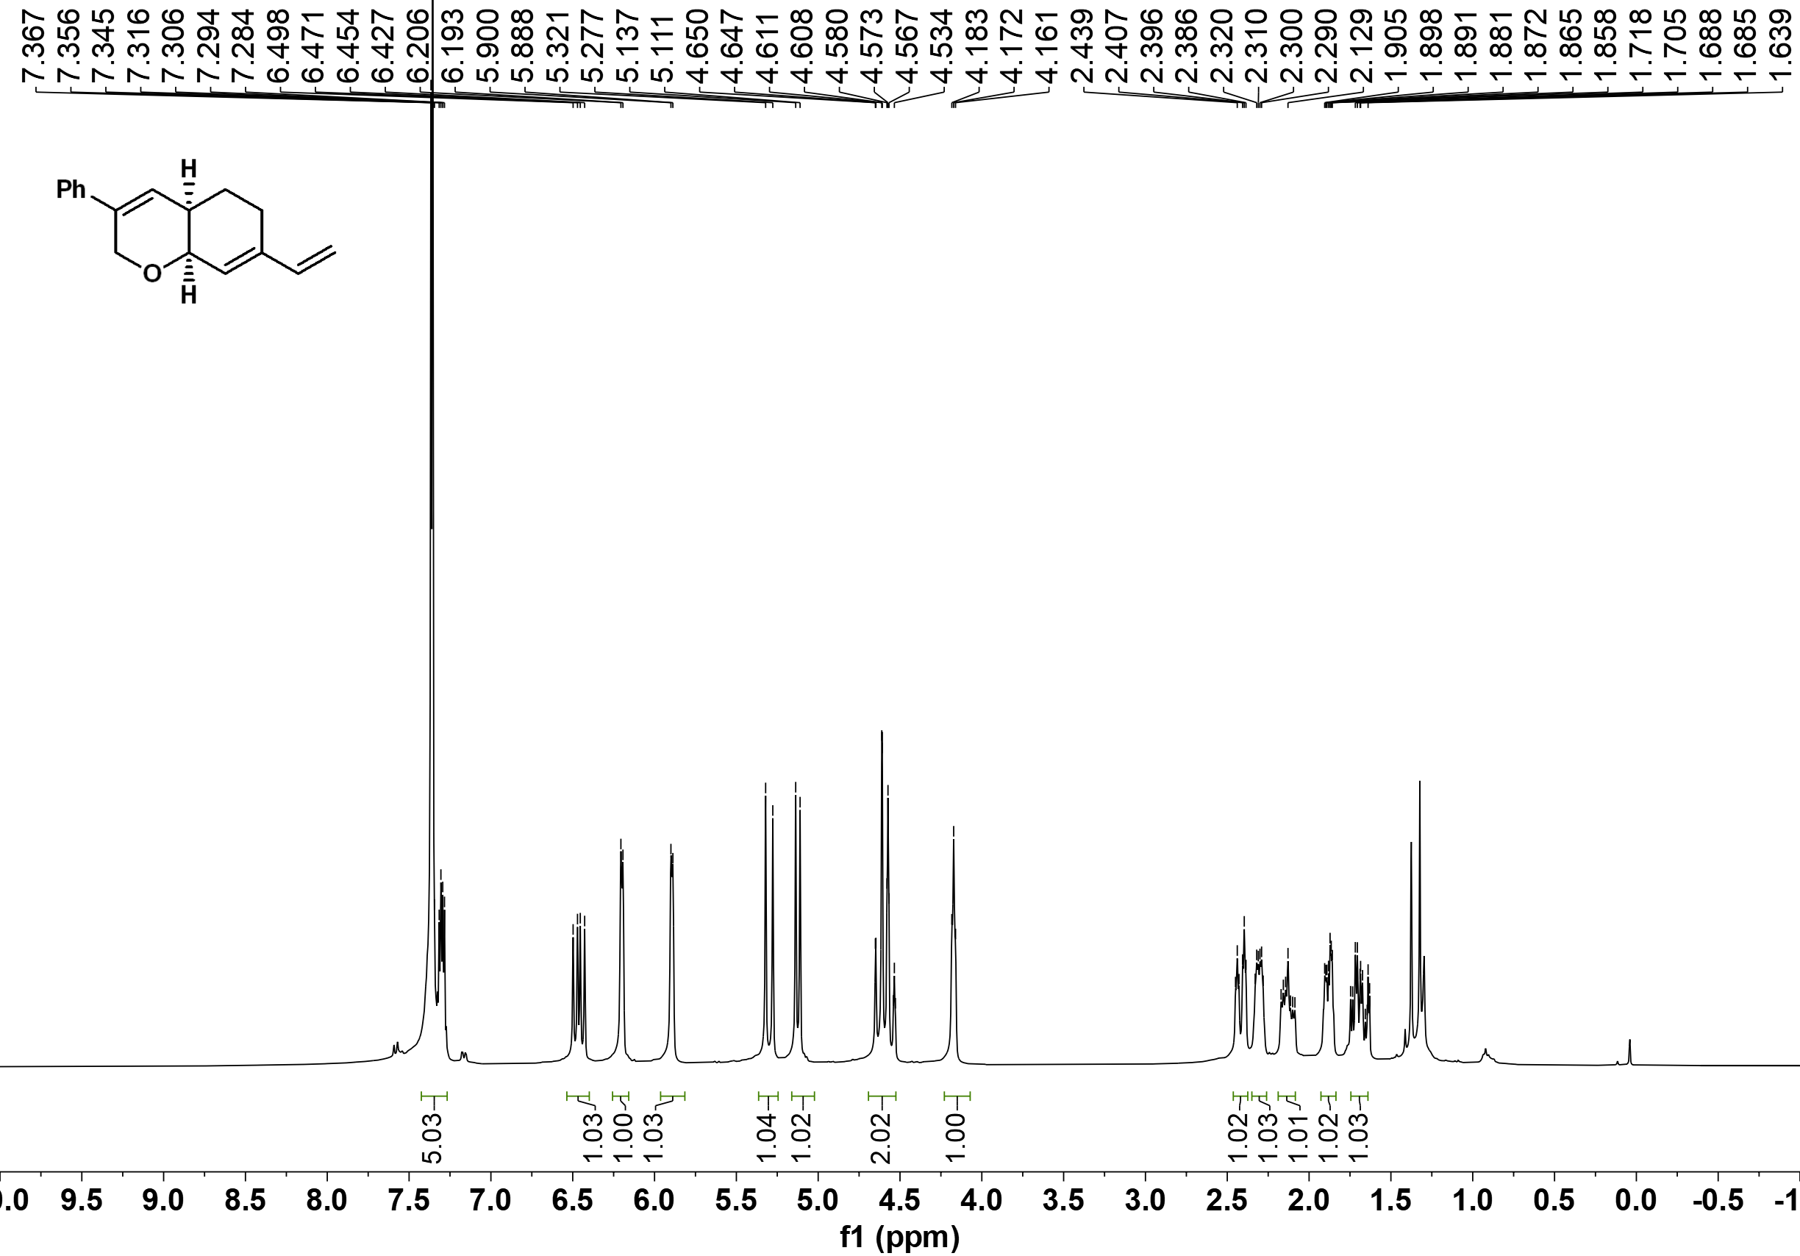

¹³C NMR of 3bp
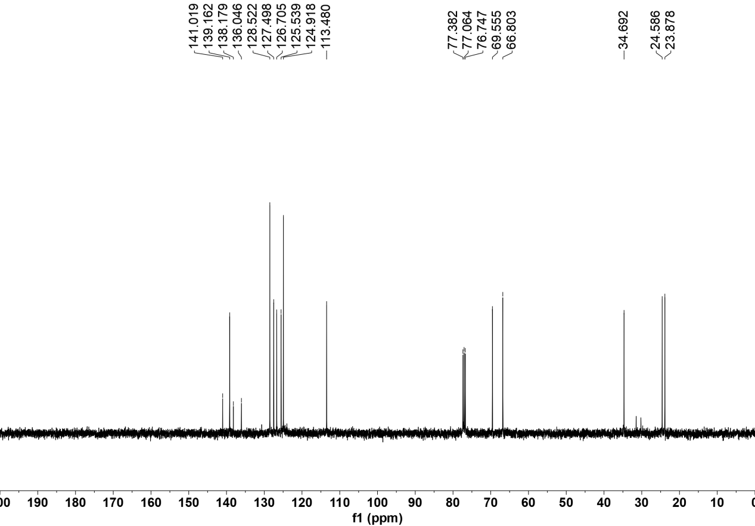

¹H NMR of 3bq
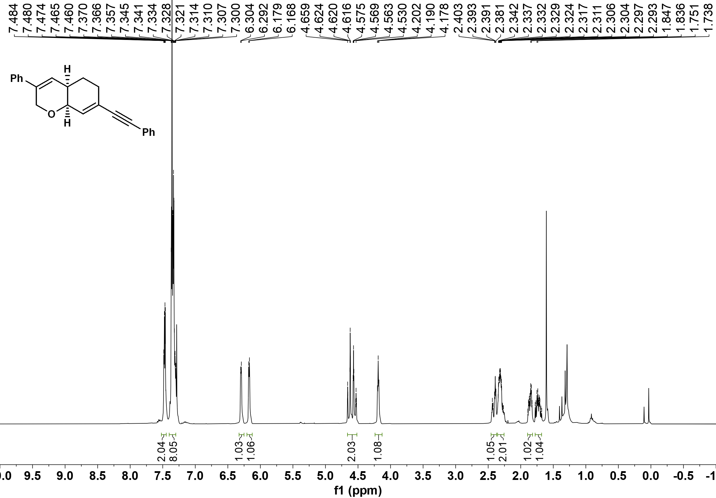

¹³C NMR of 3bq
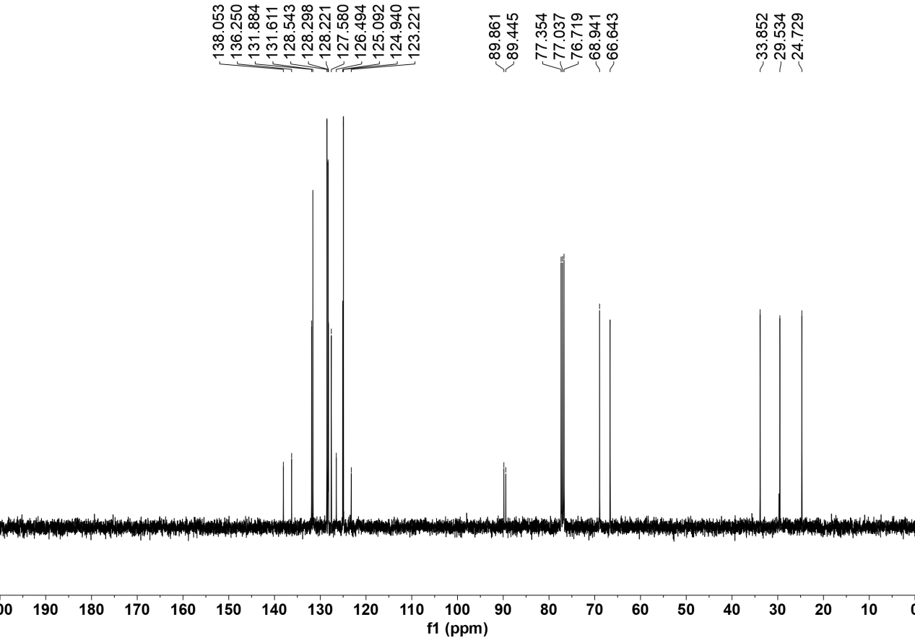

¹H NMR of 3br
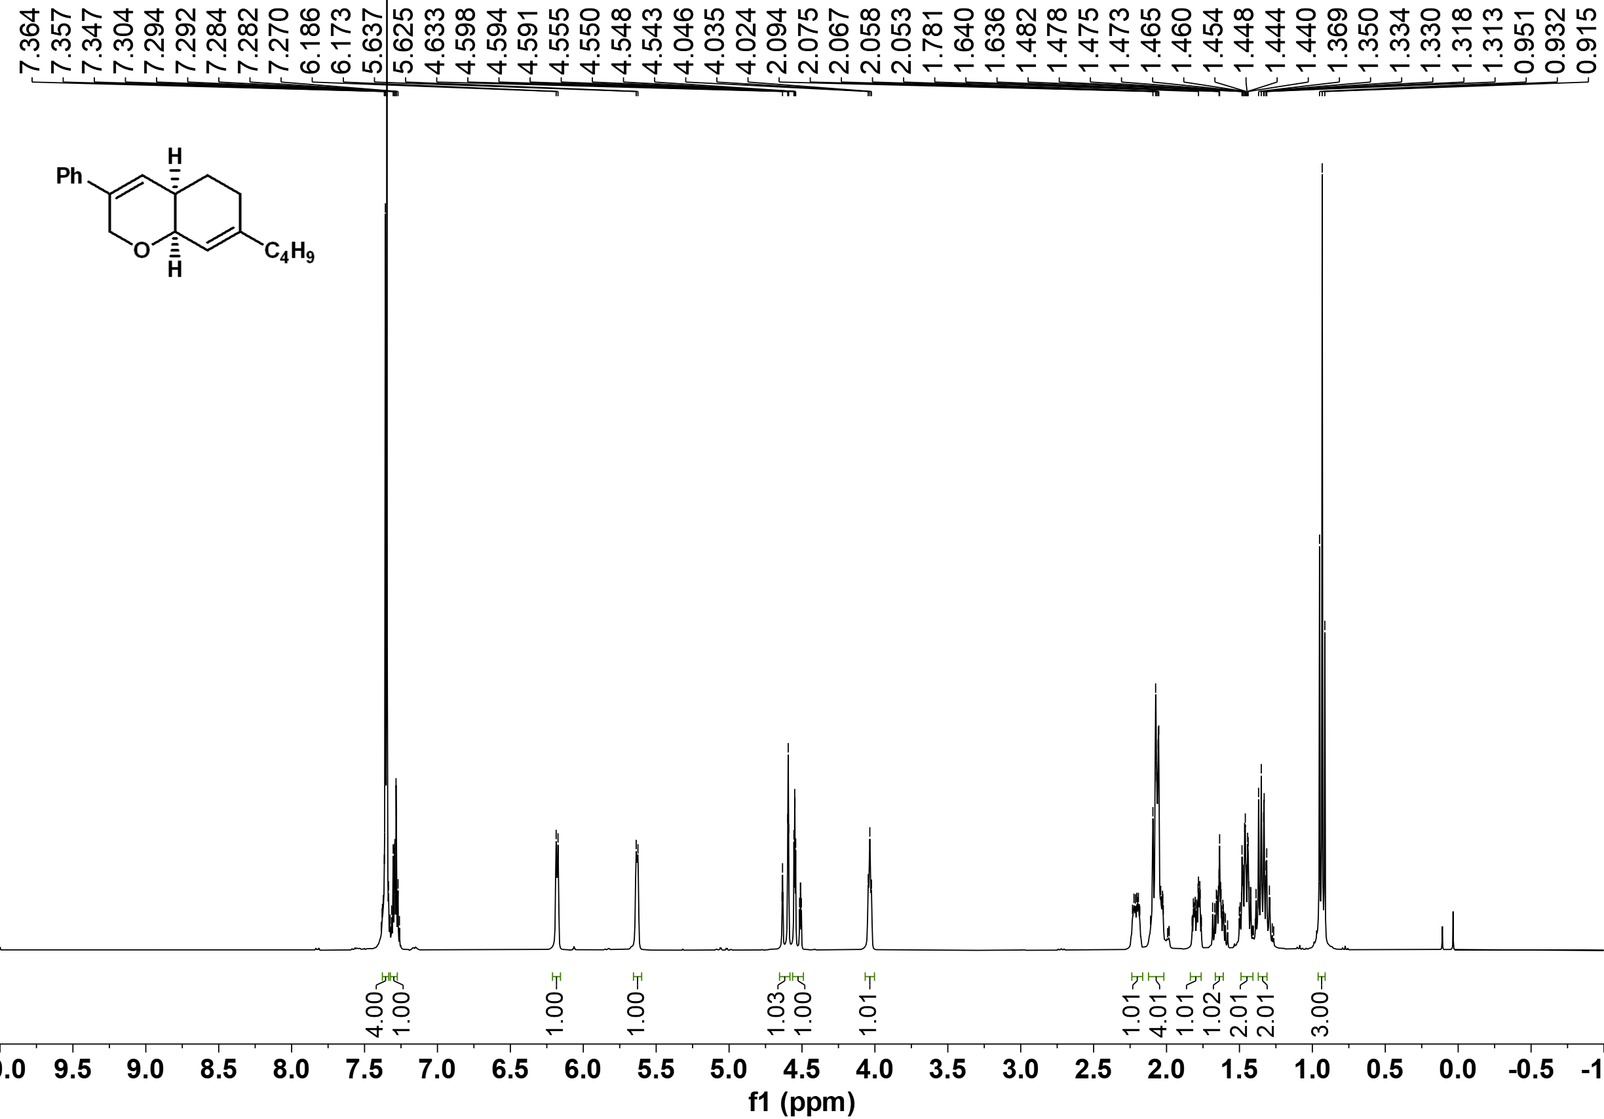

¹³C NMR of 3br
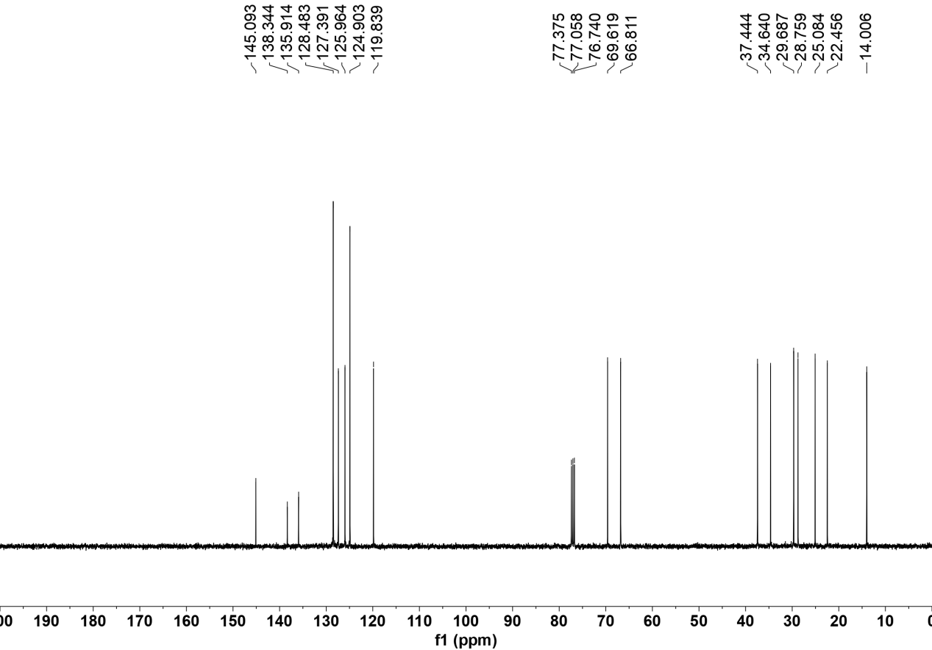

¹H NMR of 3bs
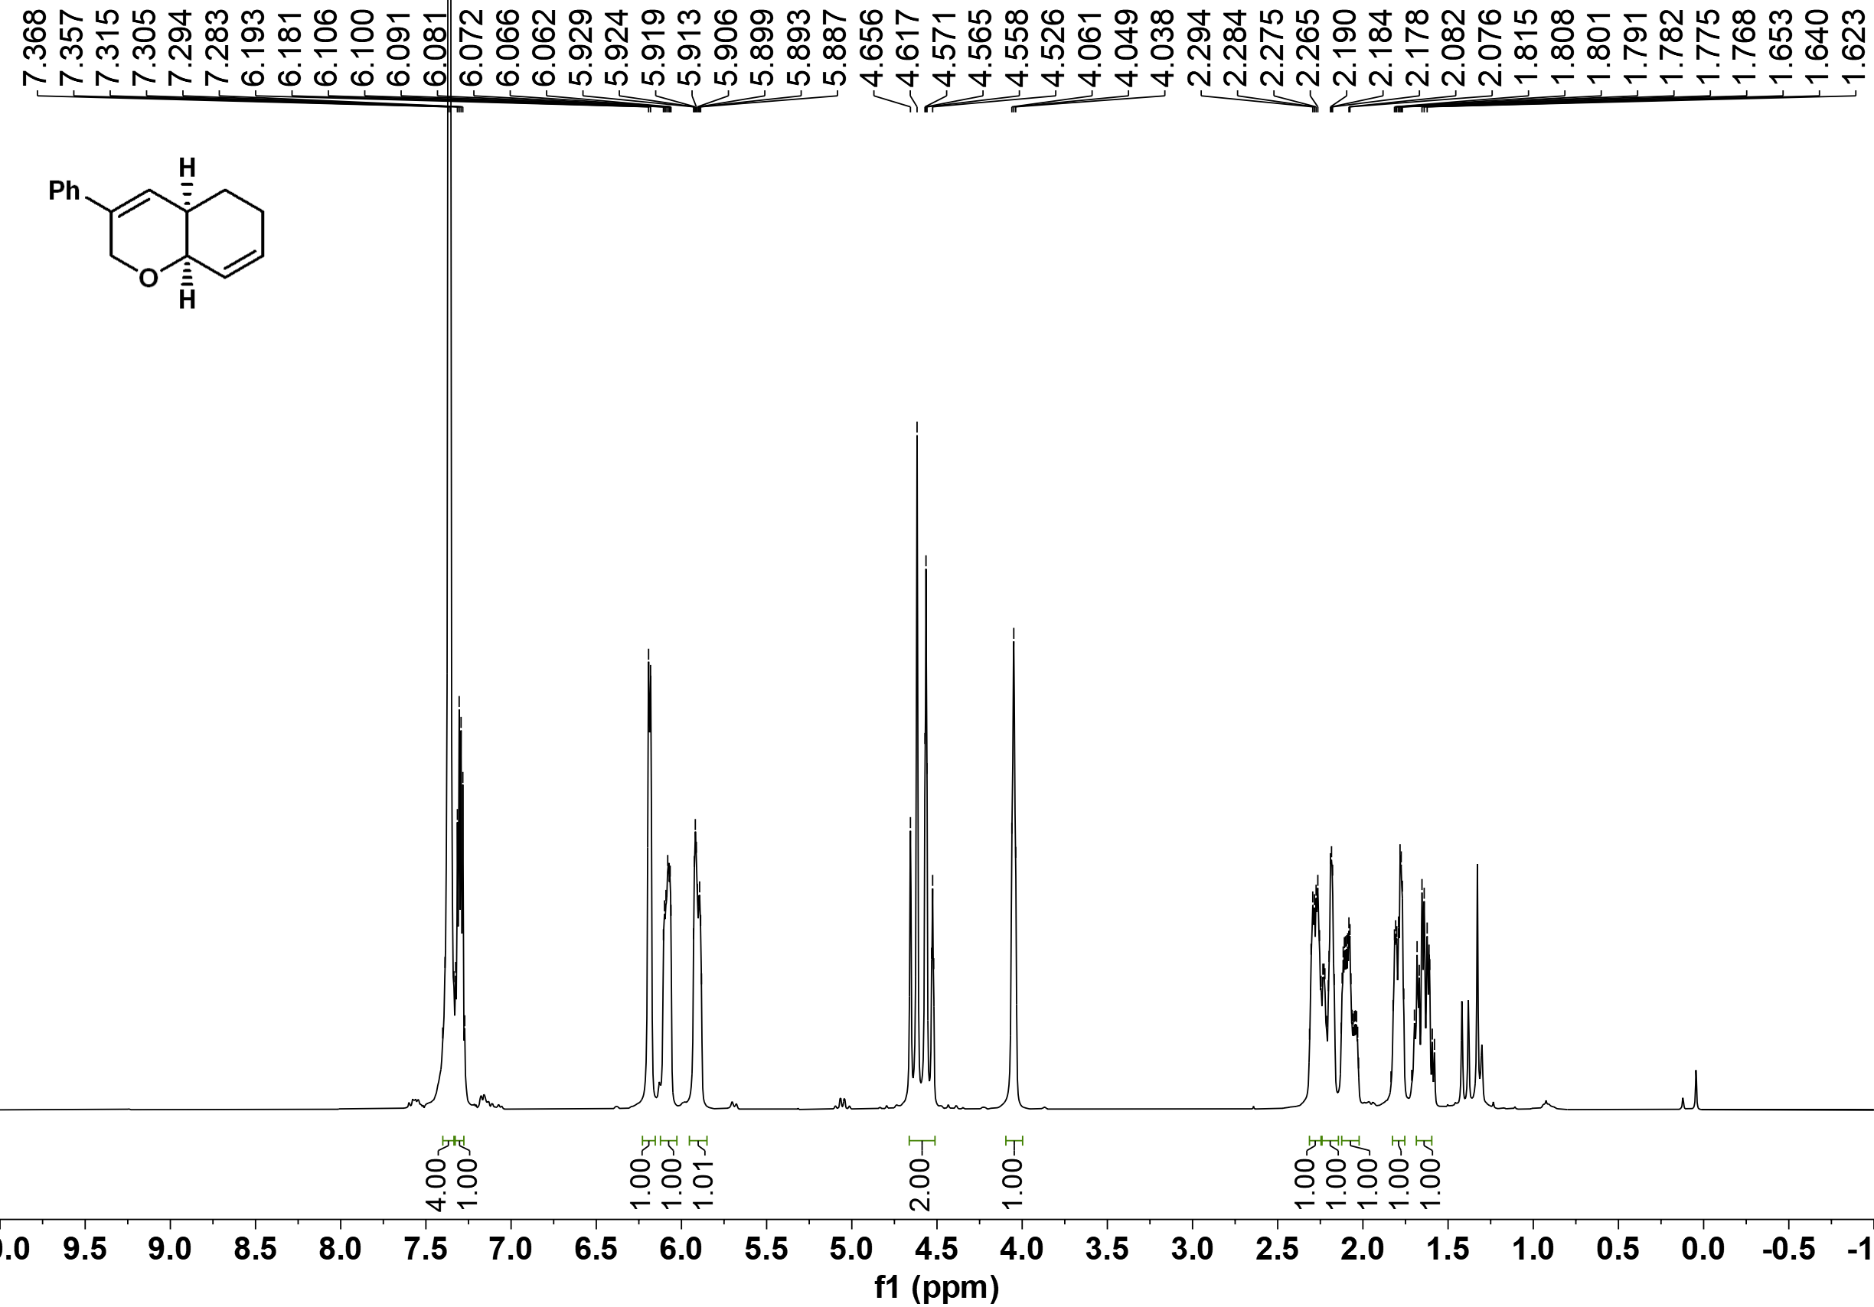

¹³C NMR of 3bs
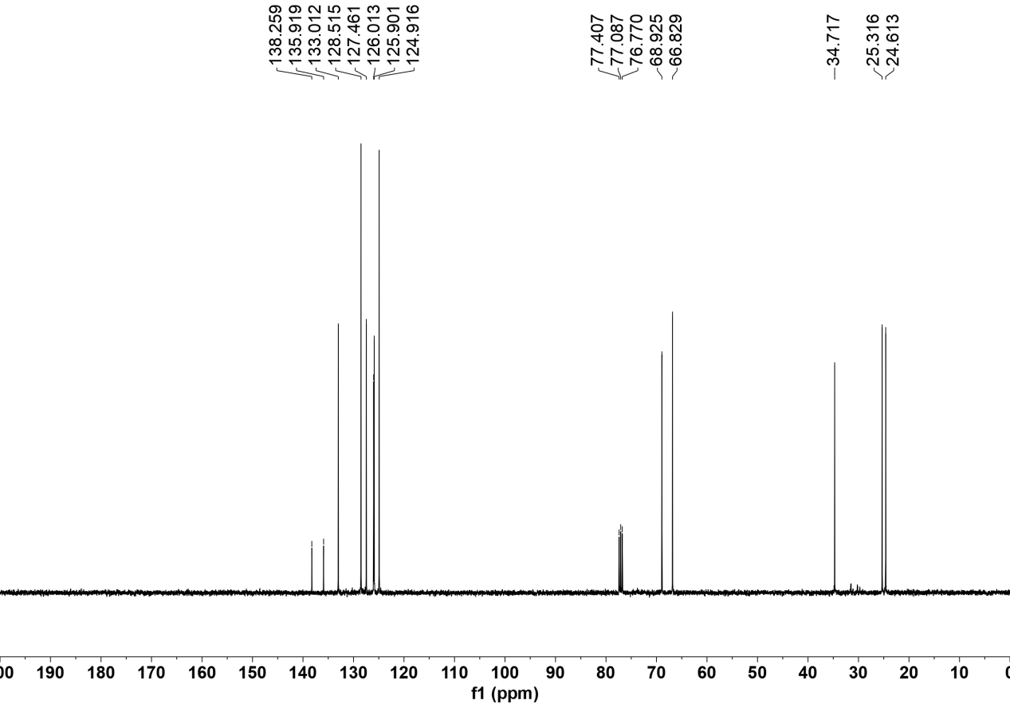

¹H NMR of 3bt
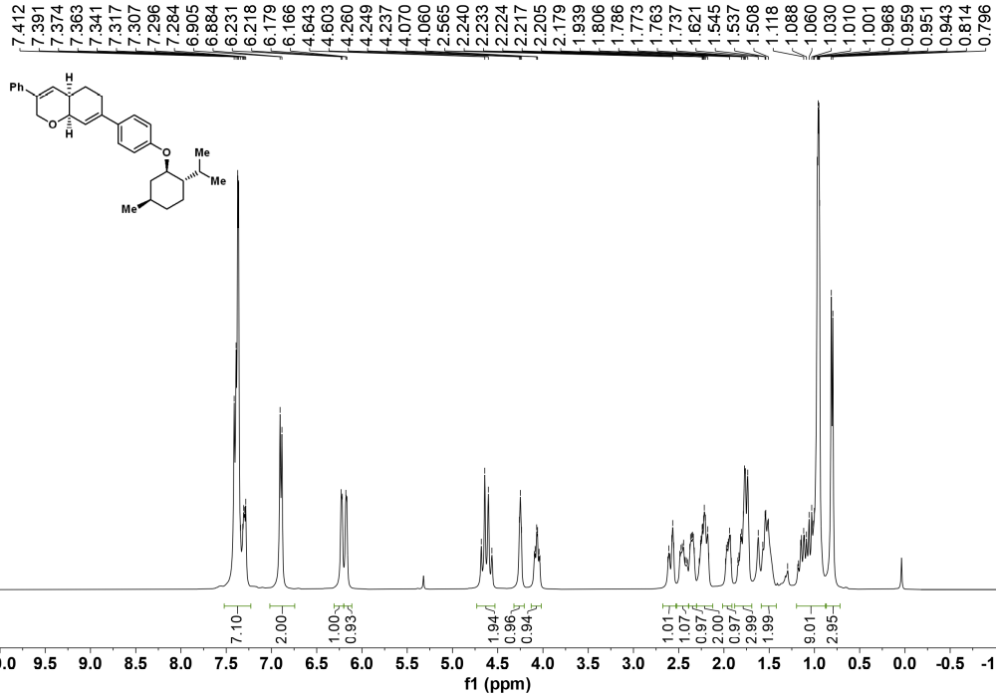

¹³C NMR of 3bt
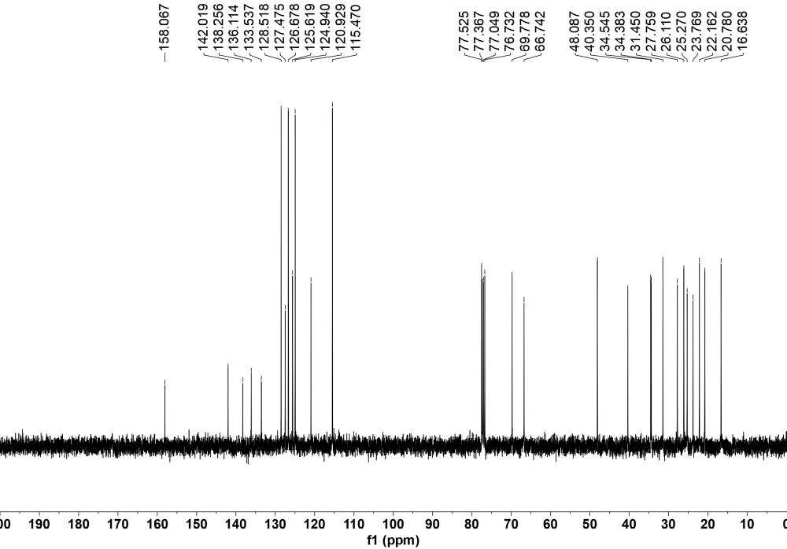

¹H NMR of 3bu
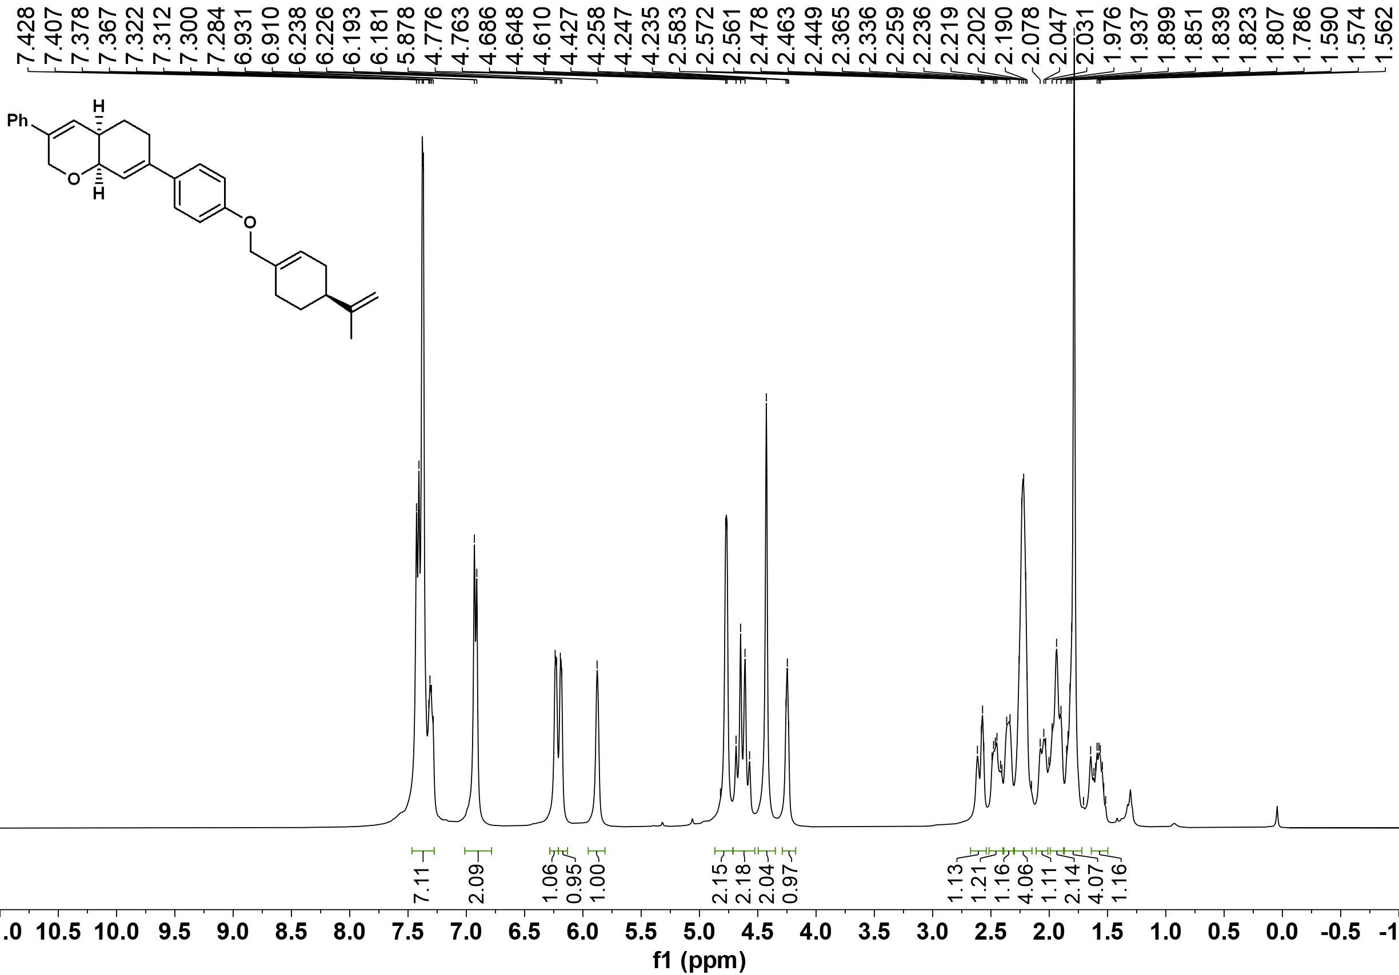

¹³C NMR of 3bu
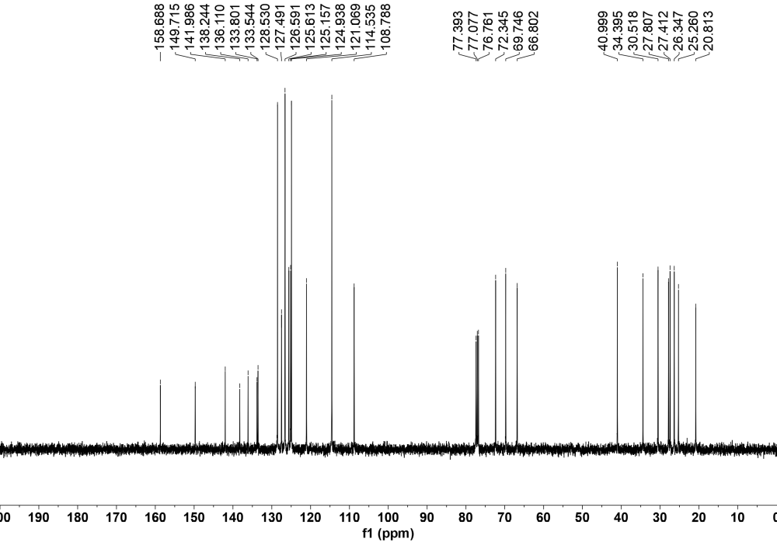

¹H NMR of 3aa'
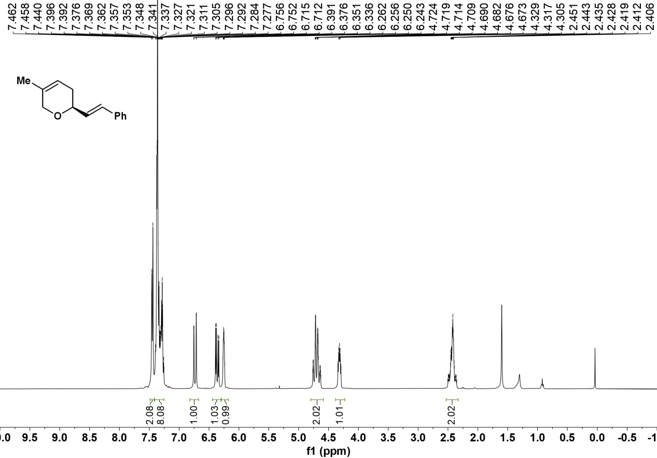

¹³C NMR of 3aa'
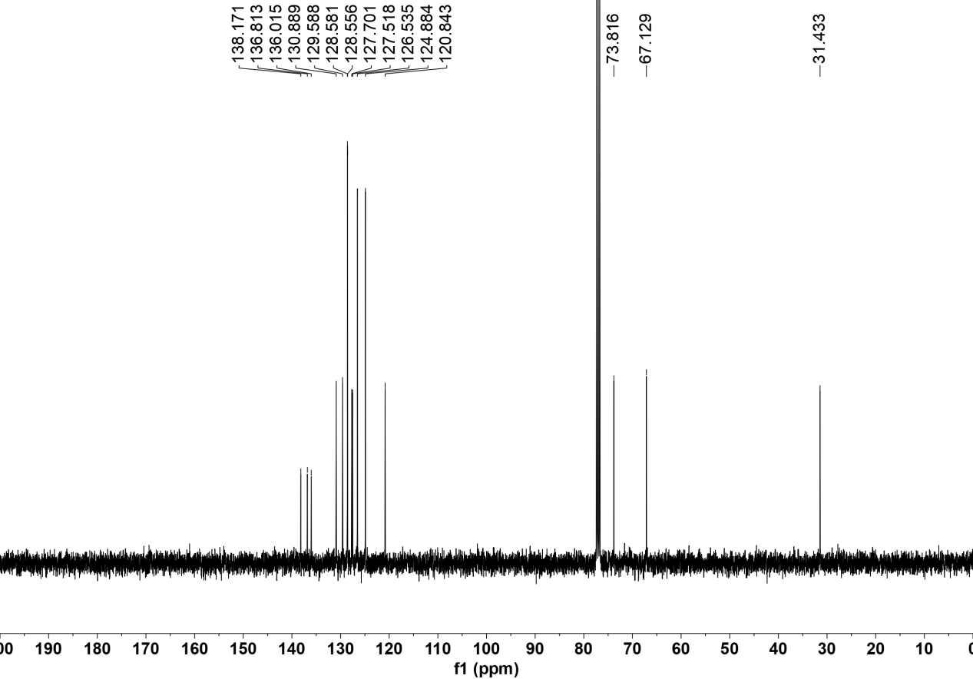

¹H NMR of 4
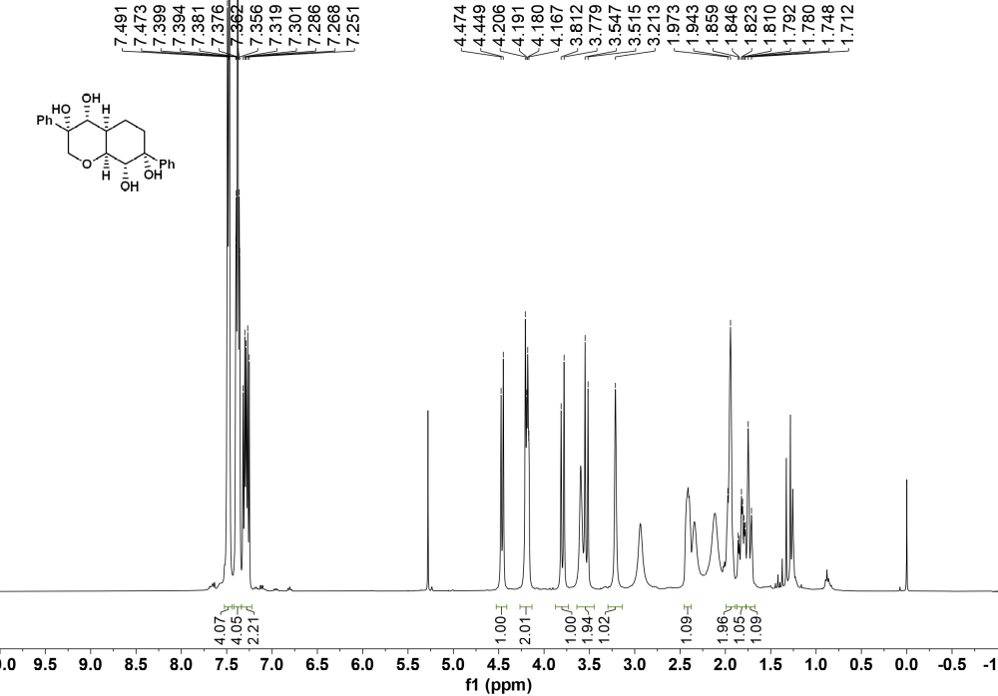

¹³C NMR of 4
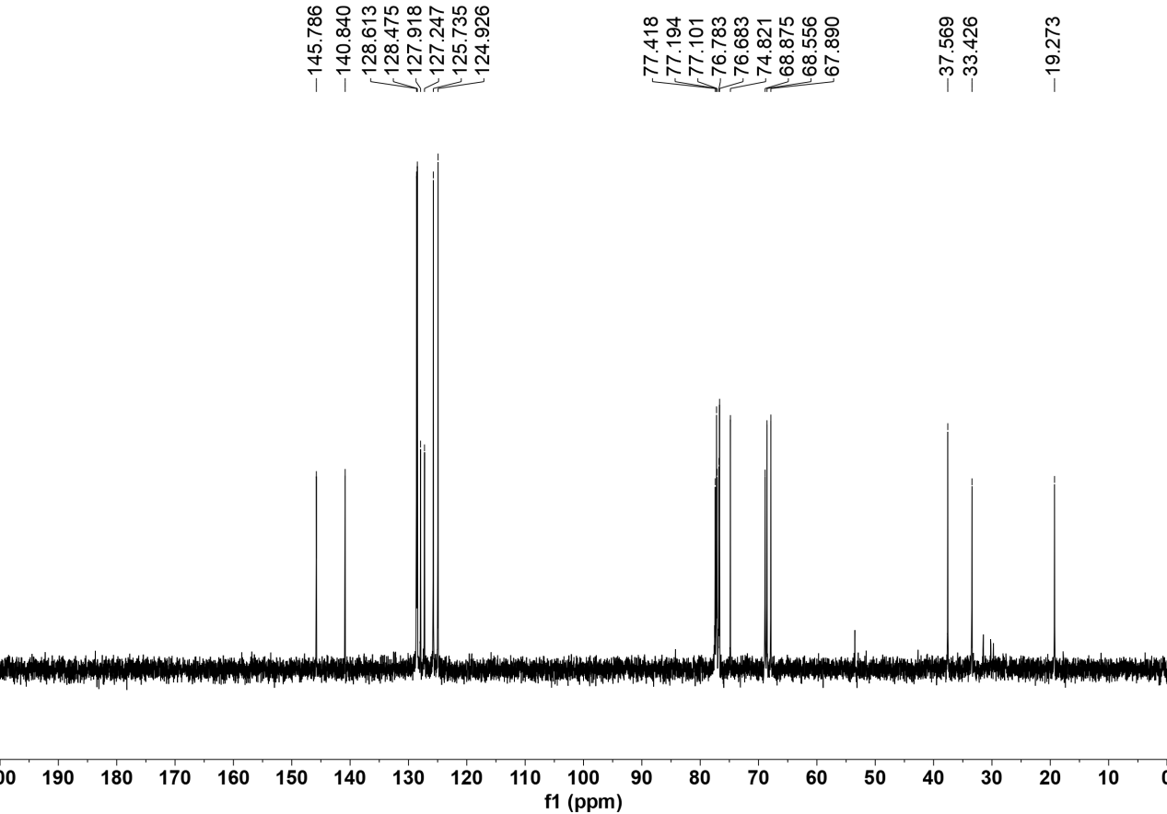

¹H-¹H COSY spectrum of 4
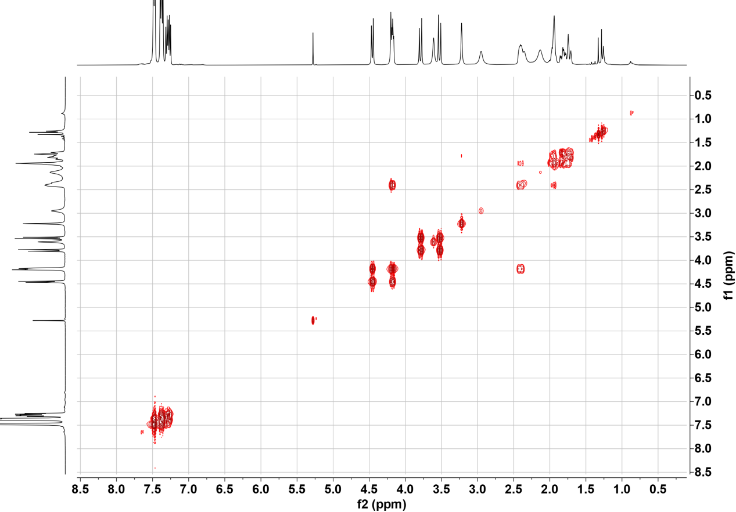

HMQC spectrum of 4

HMBC spectrum of 4
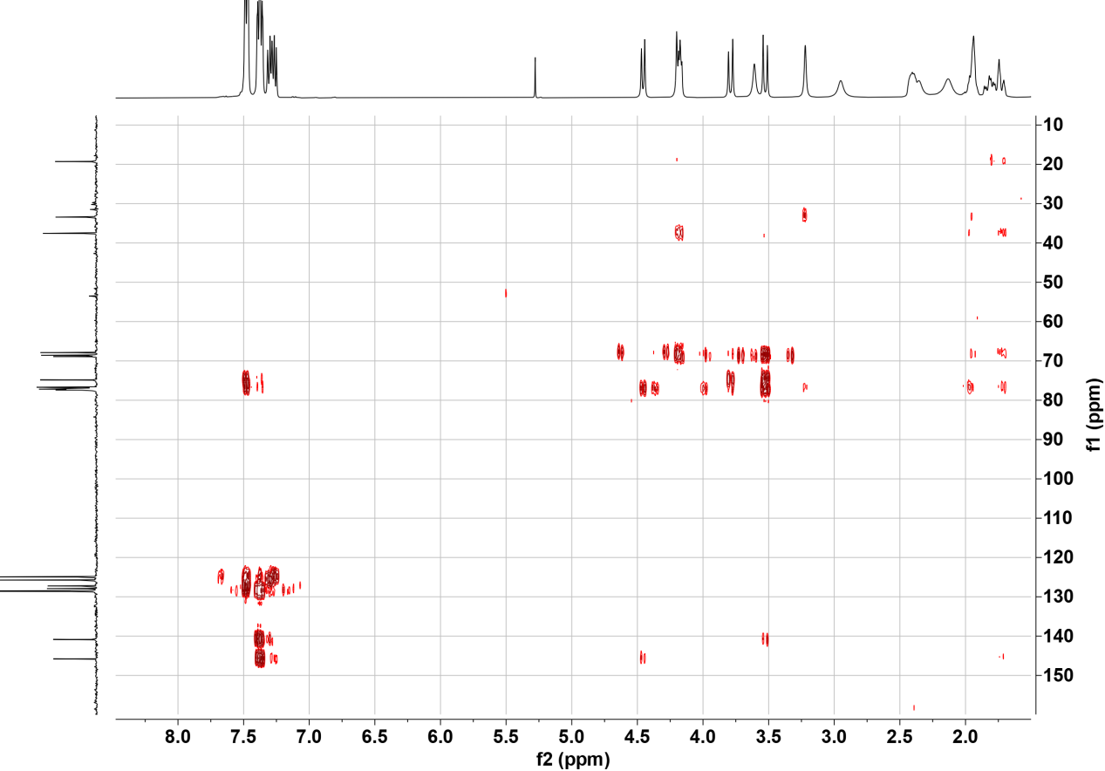

ROESY spectrum of 4
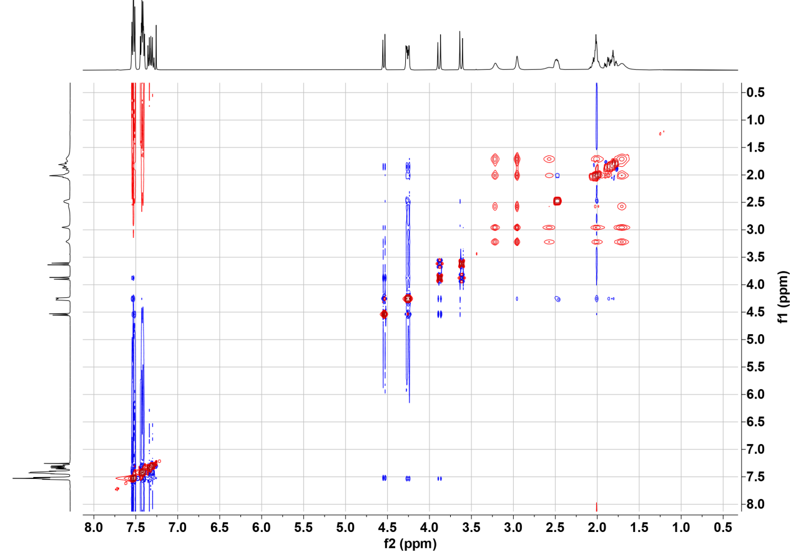

¹H NMR of 5

¹³C NMR of 5

¹H-¹H COSY spectrum of 5
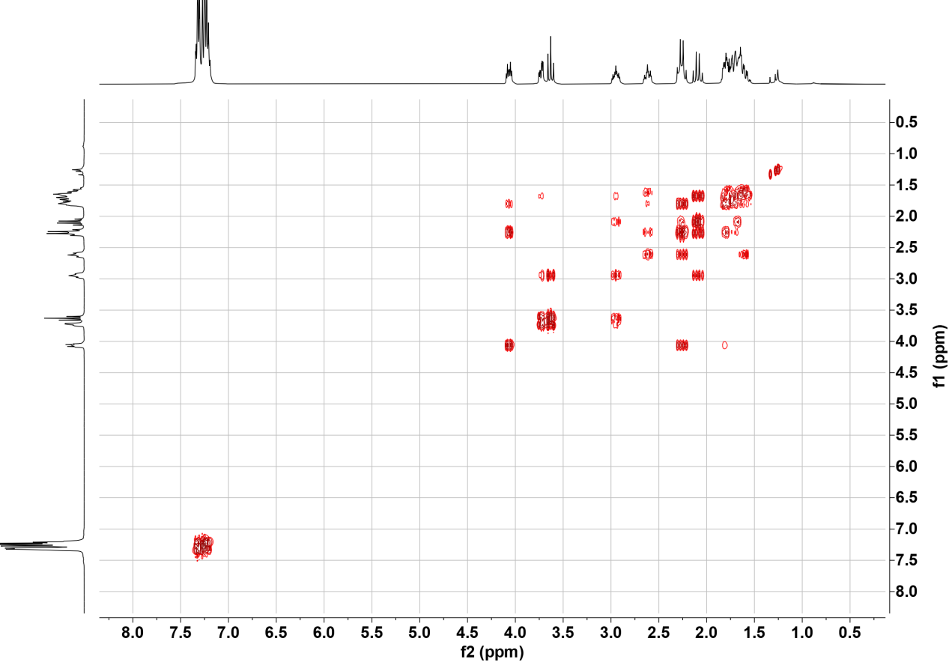

HMQC spectrum of 5

HMBC spectrum of 5

ROESY spectrum of 5

¹H NMR of 6
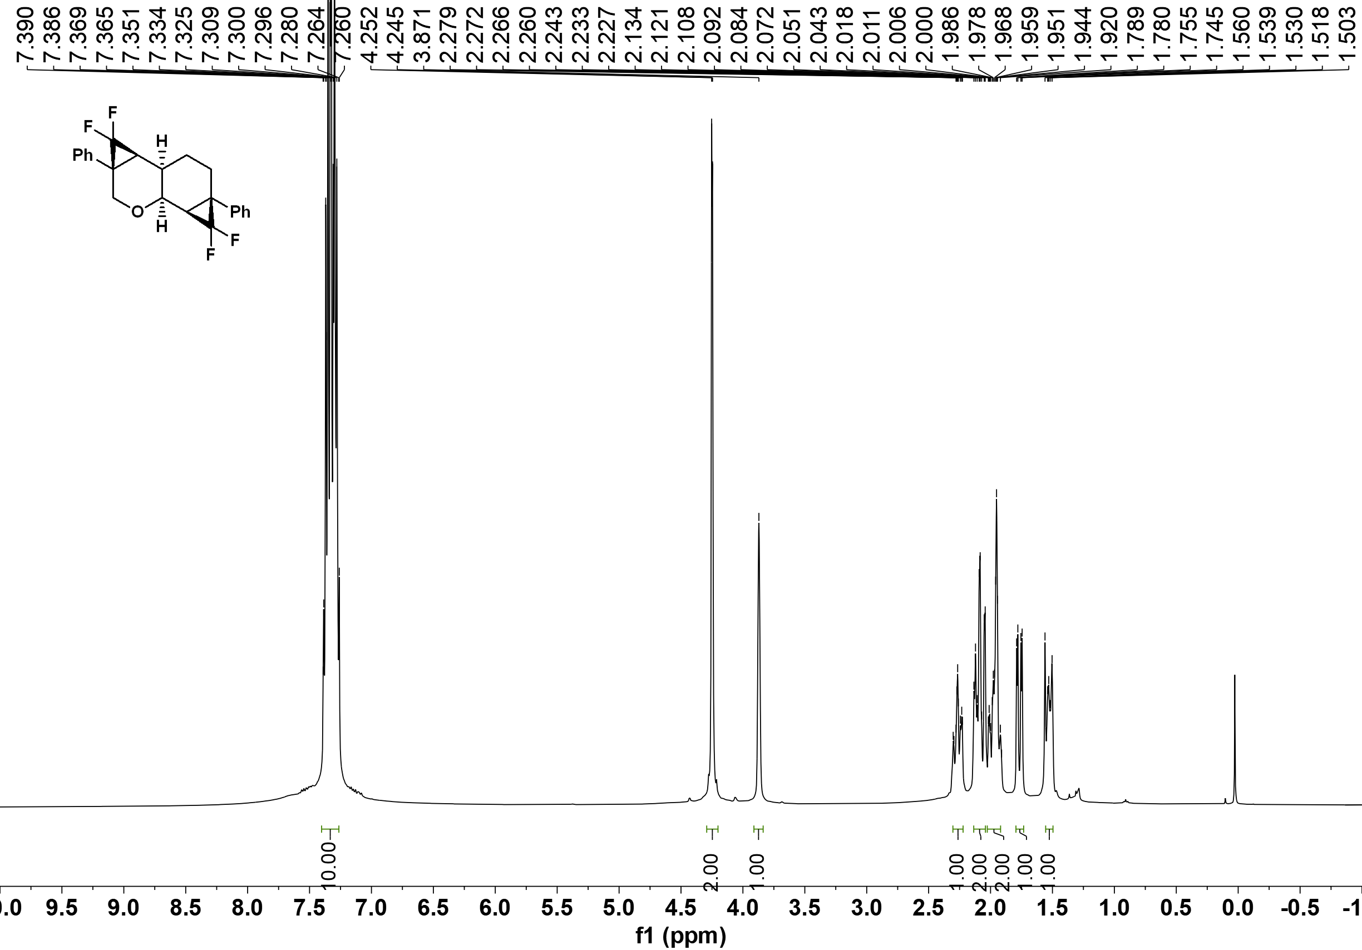

¹³C NMR of 6
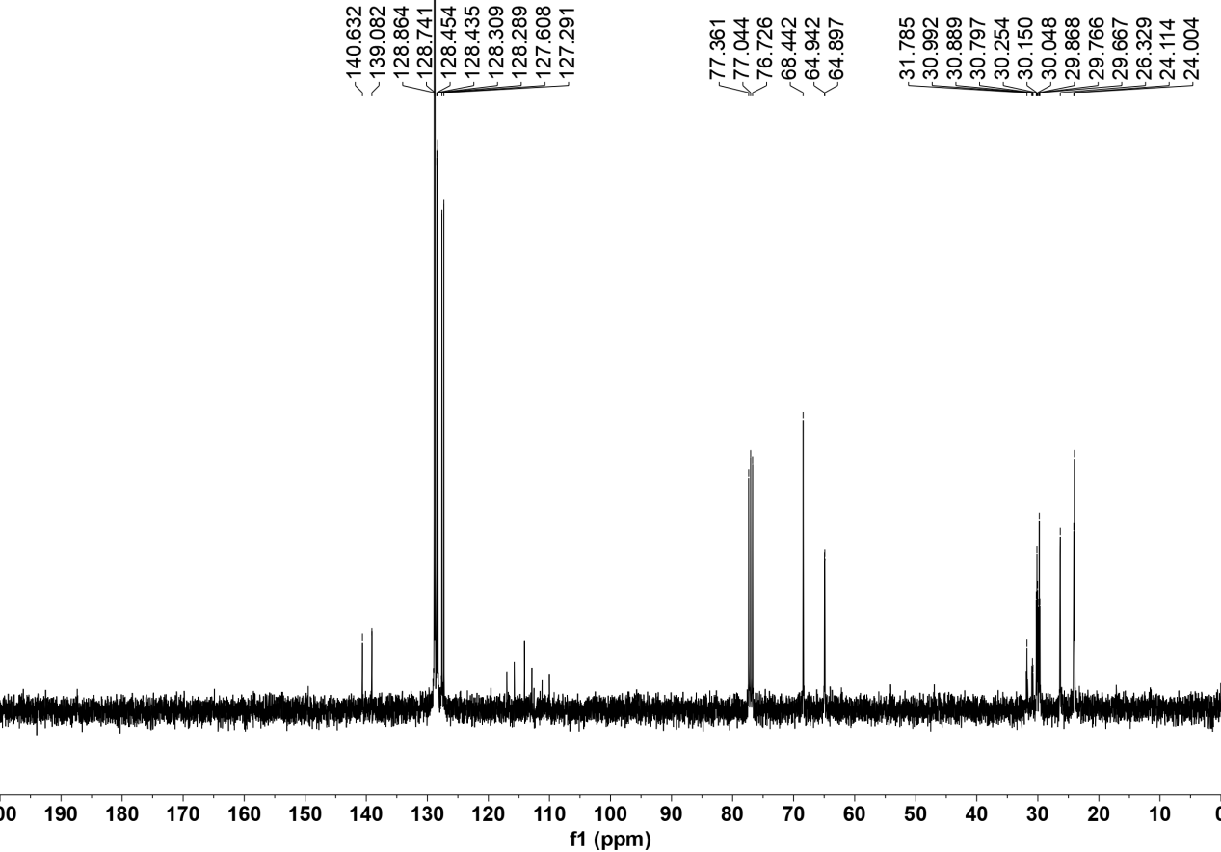

¹⁹F NMR of 6
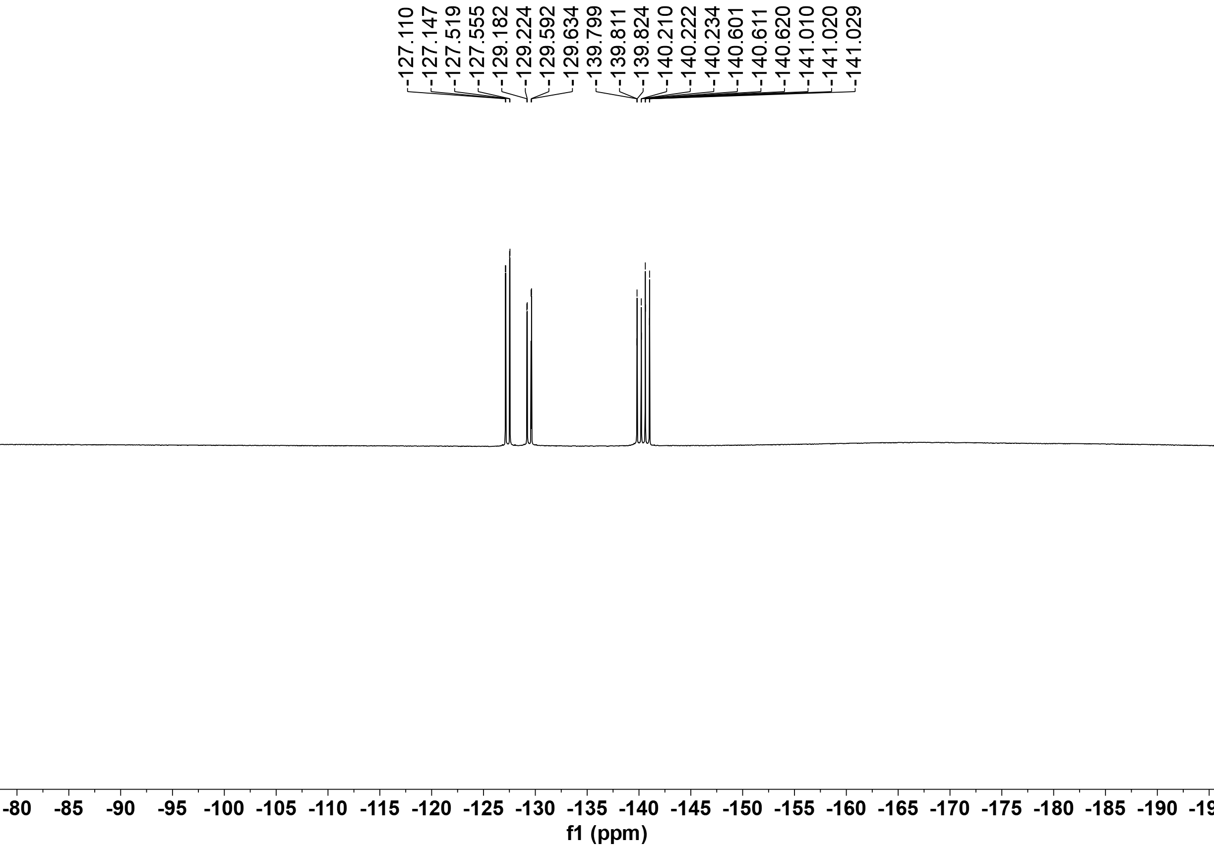

¹H-¹H COSY spectrum of 6
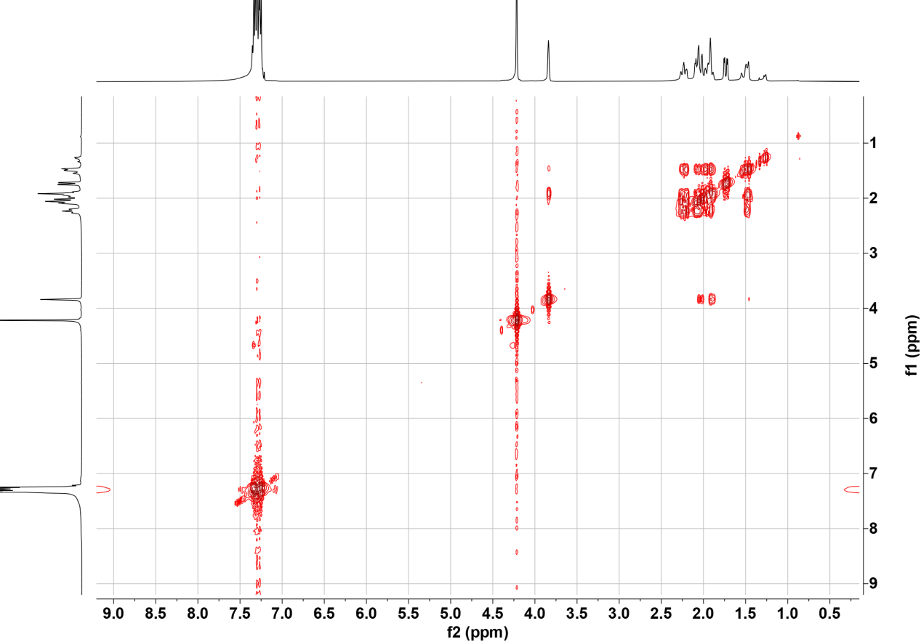

HMQC spectrum of 6
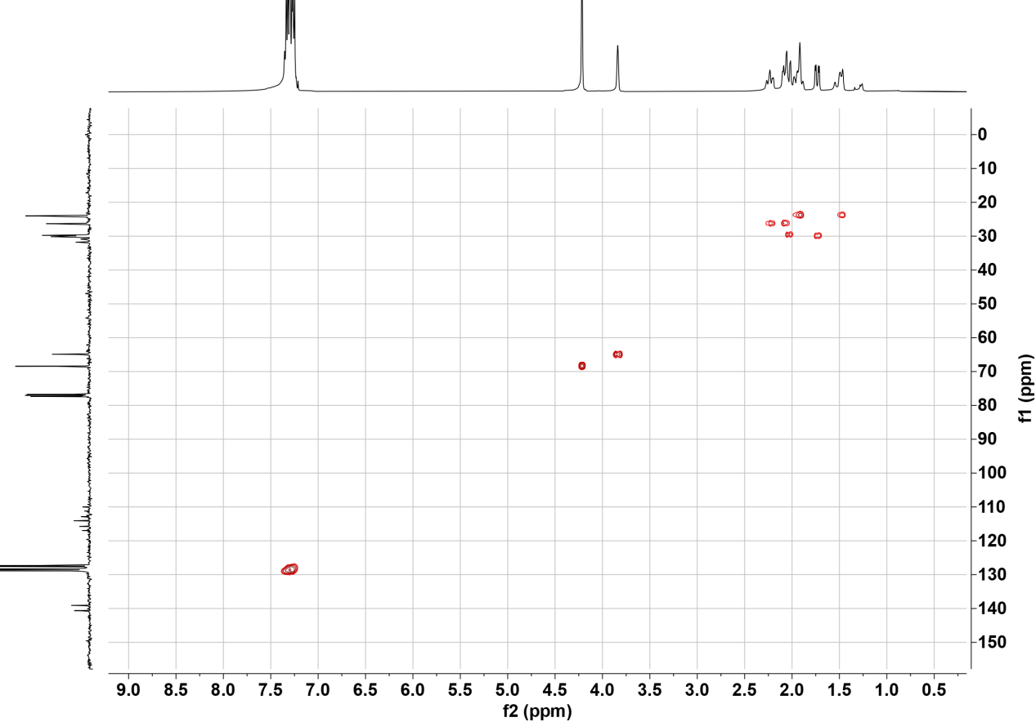

HMBC spectrum of 6
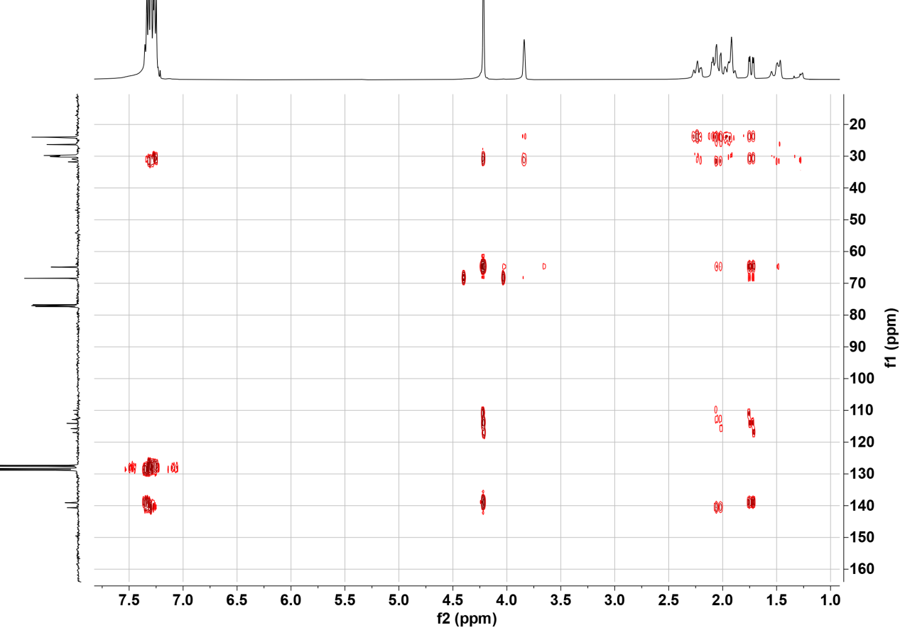

ROESY spectrum of 6
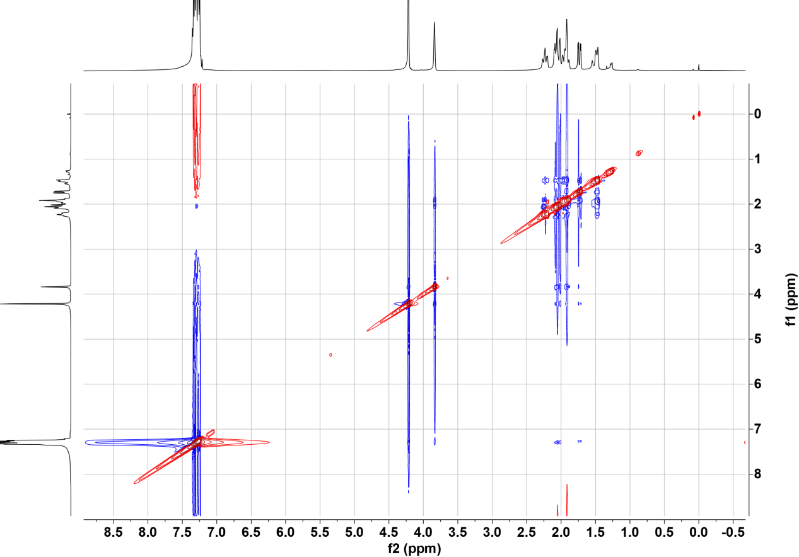

¹H NMR of 7

¹³C NMR of 7

¹H-¹H COSY spectrum of 7
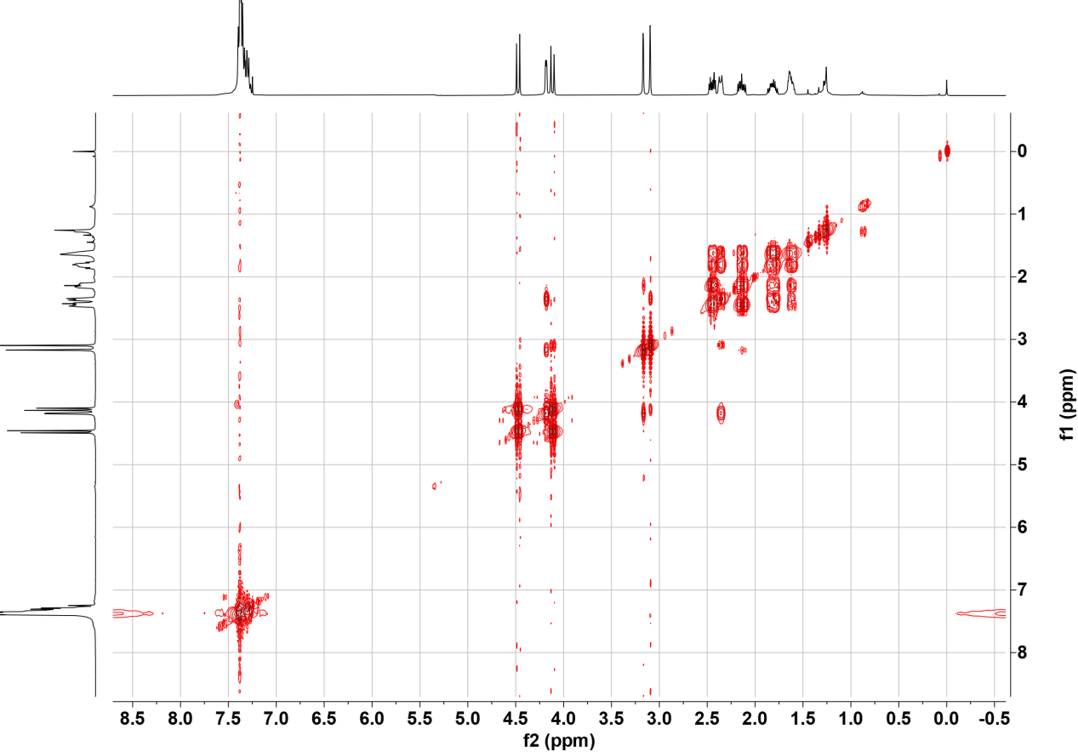

HMQC spectrum of 7

HMBC spectrum of 7

ROESY spectrum of 7

References.
[1] Zhang, Z.-M.; Xu, B.; Qian, Y.; Wu, L.; Wu, Y.; Zhou, L.; Liu, Y.; Zhang, J. Angew. Chem. Int. Ed. 2018, 57, 10373.
[2] Larock, R. C.; Doty, M. J.; Han, X. J. Org. Chem. 1999, 64, 8770.
[3] (a) Trost, B. M.; Huang, Z.; Murhade, G. M. Science 2018, 362, 564. (b) Reich, H. J.; Wollowitz, S. J. Am. Chem. Soc. 1982, 104, 7051.

