Cover crop providing windborne pollen enhances the efficacy of biocontrol of multiple pests by Euseius sojaensis in citrus orchards

Yuta Tsuchida, Shinichi Masui
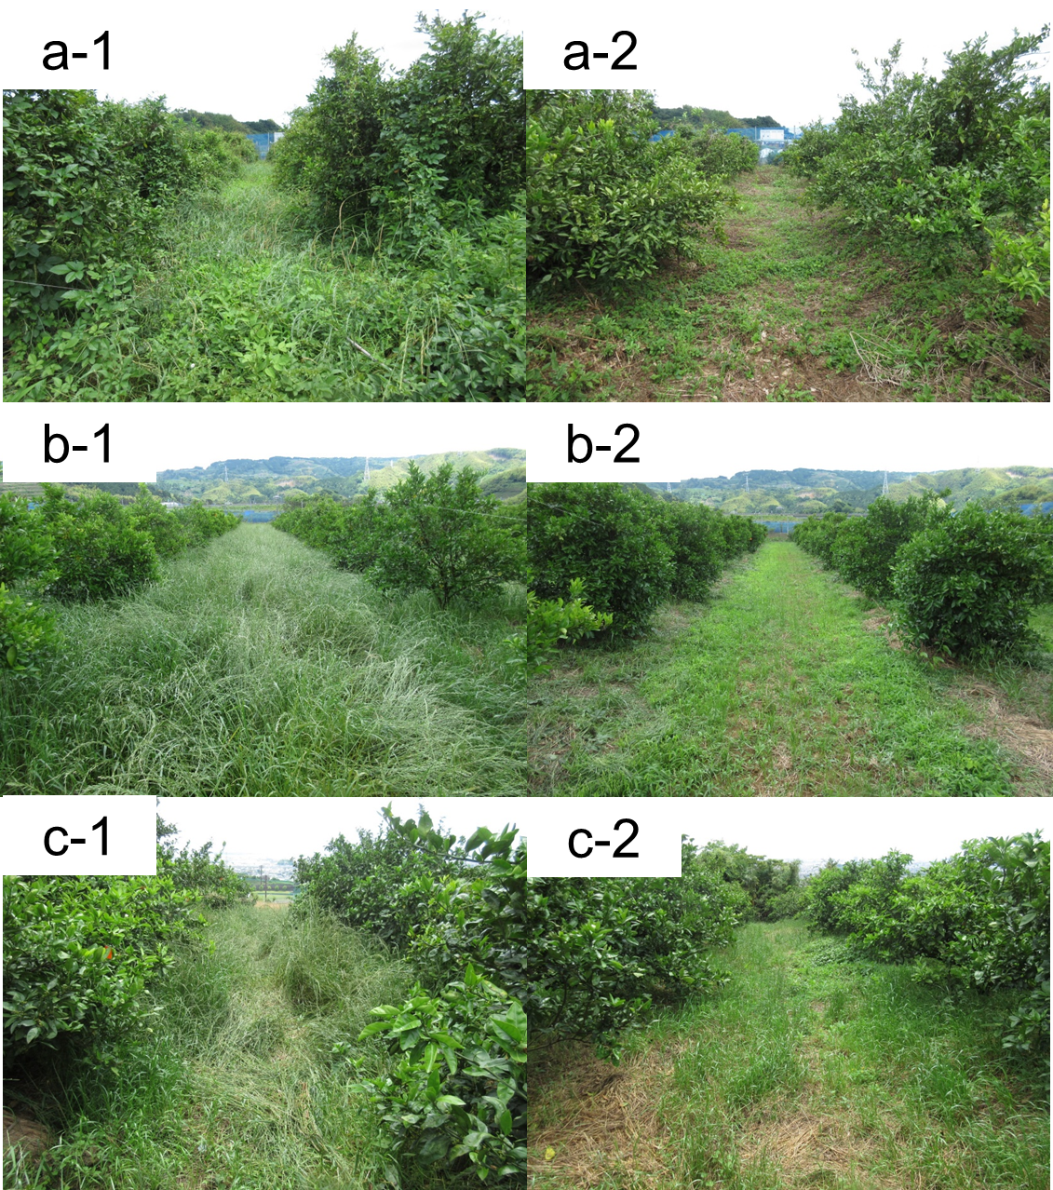
Fig. S1 Experimental orchards in early June at the flowering peak of perennial ryegrass. a-1, b-1, c-1, flowering plots in orchards A, B, and C, respectively. b-1, b-2, b-3, mown plots in orchards A, B, and C, respectively

