Author's Profile

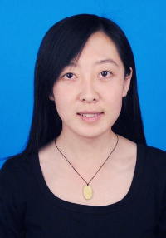 | Siyuan Tang. She was born in Chifeng, Inner Mongolia, China,in 1981. she received M.S. degree in computer application from Inner Mongolia Normal University, Huhhot,China, in 2009. From 2009 to present, she work in Baotou Medical College, Inner Mongolia University of Science and Technology. she is a professor and the associate dean of the school of computer science and technology.Her research interest includes medical image processing, deep learning, etc. she have been engaged in medical image processing research for more than 15 years and have published more than 20 related research papers. she have presided over and participated in more than 20 projects above provincial level.
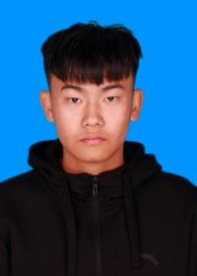 | Qiangqiang Bao. He was born in Hulun Buir, Inner Mongolia, China, in 1999. He received the B.S. degree in Information and Computing Science from Hetao College, Bayannur, China, in 2022. From 2022 to present, pursuing a Master's degree in Computer Technology with research interests in Deep Learning and Medical Image Processing at Inner Mongolia University of Science and Technology, Baotou, China, and published 1 related research paper.
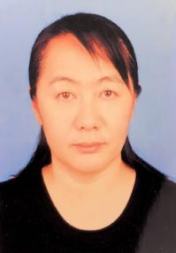 | Siriguleng Wang. She was born in Xilingol, Inner Mongolia, China,in 1970. she received Doctor's degree in computer application from Inner Mongolia University, Huhhot,China, in 2010. From 1993 to present, she works in the College of Computer Science and Technology, Inner Mongolia Normal University. she is a professor. Her research interest includes Natural Language processing, machine translation, deep learning, etc. she have published more than 60 related research papers. she have presided over and participated in more than 20 projects above provincial level.

