Bisindolylmaleimide IX: A novel anti-SARS-CoV2 agent targeting viral main protease 3CLpro demonstrated by virtual screening and in vitro assays

Yash Gupta^{1,2}, Dawid Maciorowski^{1,3}, Samantha E. Zak^{4,5}, Krysten A. Jones⁶, Rahul S. Kathayat⁶, Saara-Anne Azizi⁶, Raman Mathur¹, Catherine M Pearce¹, David J. Ilc^{1,3}, Hamza Husein^{1,3}, Andrew S. Herbert⁴, Ajay Bharti⁷, Brijesh Rathi^{2,8}, Ravi Durvasula^{1,2}, Daniel P. Becker³, Bryan C. Dickinson⁶, John M. Dye^{4,5*} and Prakasha Kempaiah^{1,2*}

1 Loyola University Chicago Stritch School of Medicine, Chicago, IL, 60153, USA; 2 Department of Medicine, Loyola University Medical Center, Chicago, IL, 60153, USA; 3 Loyola University Chicago, Chicago, IL, USA; 4 United States Army Medical Research Institute of Infectious Diseases, Fort Detrick, MD, USA; 5 The Geneva Foundation, 917 Pacific Avenue, Tacoma, WA 98402, USA; 6 Department of Chemistry, The University of Chicago, 5801 South Ellis Avenue, Chicago, Illinois, USA; 7 Division of Infectious Diseases, Department of Medicine, University of California, San Diego, CA, 92093, USA; 8 Laboratory for Translational Chemistry and Drug Discovery, Hansraj College, University of Delhi, India

Supplementary Materials

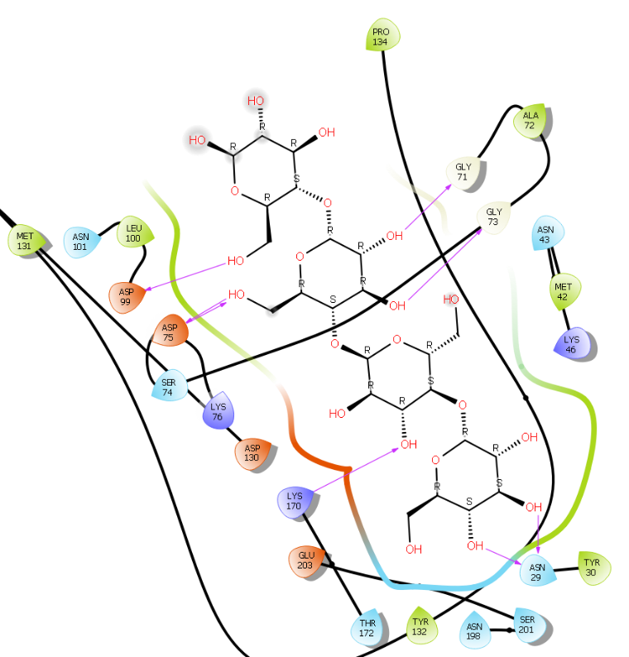
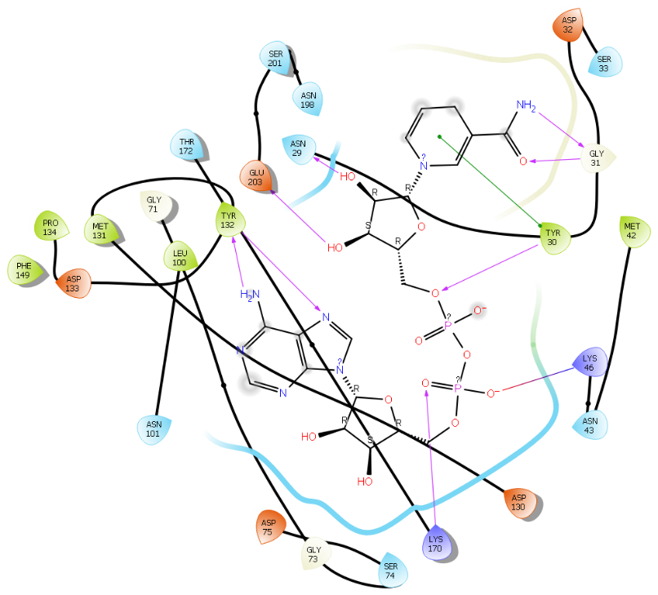
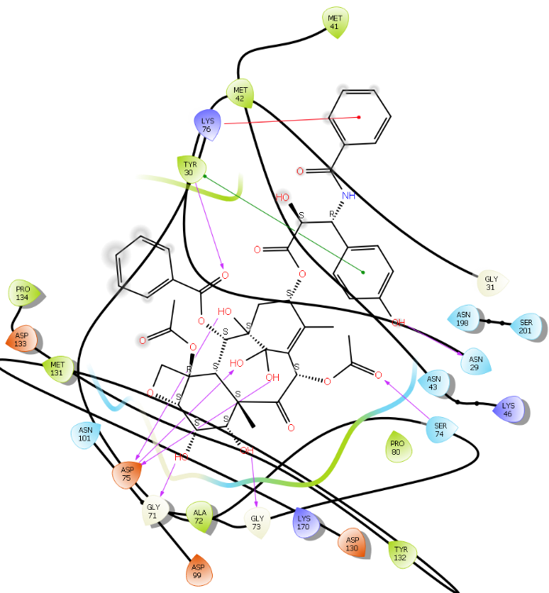
Supplementary fig. 1. 2D Ligand interaction maps of the top 3 hits (Table3) within the 2'-O-methyltransferase (2'-O-MT) binding pocket (Schrödinger LLC_2020-1) depicting amino acid side chain residues colored according to their biochemical nature i.e. red = acidic, violet = basic, green = hydrophilic, and light blue = hydrophobic. The bold lines depict peptide backbone and red arrows depict molecular interactions.

A
B
C
Supplementary fig. 2. Results of a 20 ns MD simulation (A) Root mean square deviations difference between the 2'-O-methyltransferase (2’-O-MT) and the bound ligand iohexol. Graph obtained for RMSF values of ligand (purple line) from the protein back bone (green line). The ligand remained in the bound state throughout the simulation. (B) Schematic 2D representation of bound ligand interactions of iohexol throughout the simulation. (C) Critical protein ligand contacts of amino acid sidechain residues with the interaction properties (D) Root mean square fluctuations between the binding site of target protein and the interacting ligand.
(A)
(B)
(C)
(D)

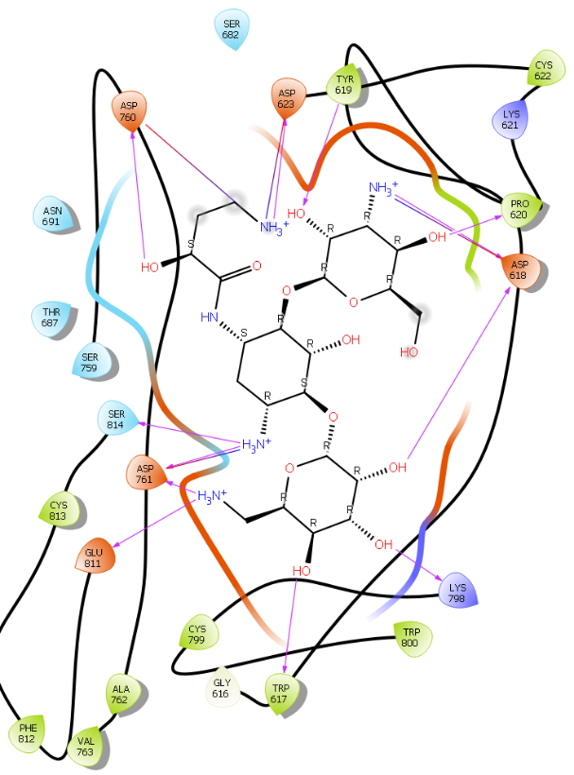
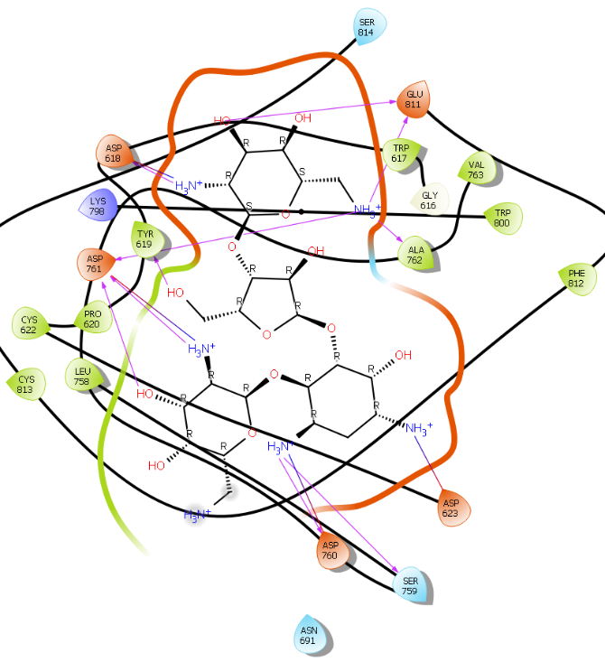
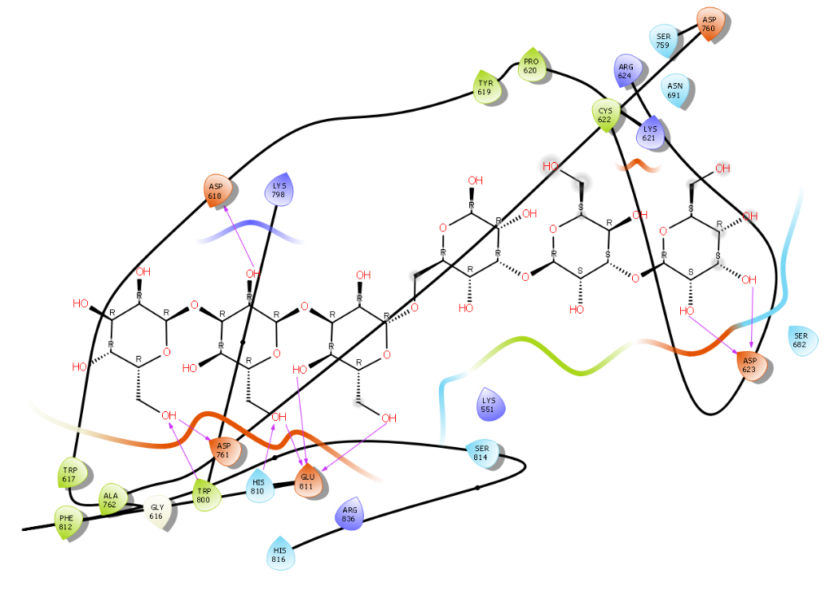
Supplementary fig. 3. 2D Ligand interaction maps of the top 3 hits (Table4) within RdRP (RNA-dependent RNA polymerase) binding pocket (Schrödinger, 2020-1) depicting amino acid side chain residues colored according to their biochemical nature i.e. red = acidic, violet = basic, green = hydrophilic, and light blue = hydrophobic. bold lines depict peptide backbone and red arrows depict molecular interactions.

A
B
C
(A)
(B)
(C)
(D)
Supplementary fig. 4. Results of a 20 ns MD simulation. (A) Root mean square deviations (RMSD) differences between the RNA-directed RNA polymerase (RdRp) and the bound ligand paromomycin, with the graph obtained for the RMSF value of ligand (purple line) from the protein back bone (green line). The entire ligand is involved in a very strong binding, and there was little movement observed for the ligand throughout the simulation period. (B) The acidic amino acid side 2D interaction map of bound paromomycin interactions throughout the simulation. (C) Critical protein-ligand contacts of amino acid side chain residues with the interaction properties by type. (D) Root mean square fluctuations between the binding site of target protein and the interacting paromomycin ligand.

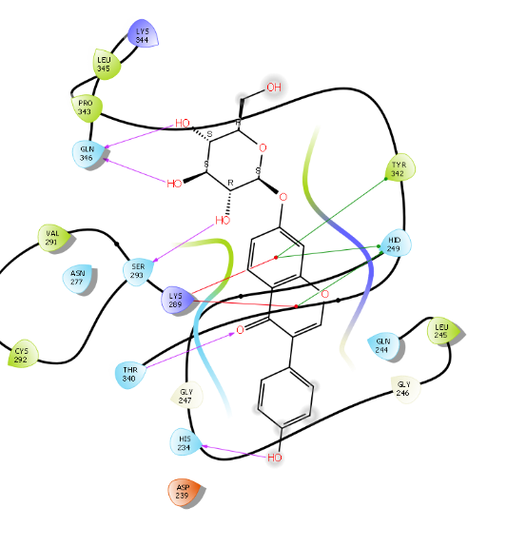
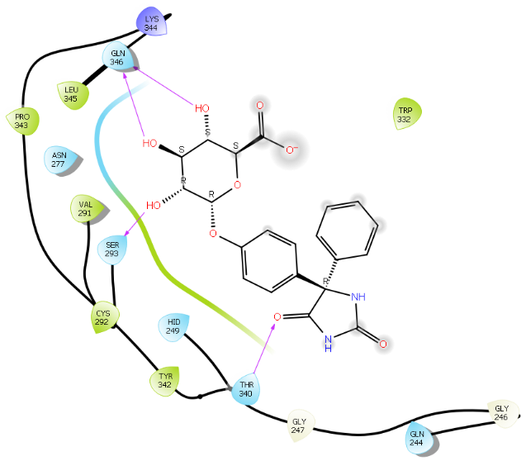
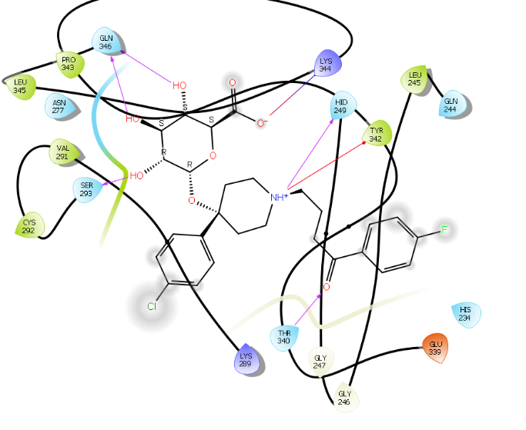

A
B
C
Supplementary fig.5. 2D Ligand interaction maps of the top 3 hits (Table 5): A) daidzin, B) phenytoin glucuronide, and C) haloperidol glucuronide within the Uridylate-specific endoribonuclease (NendoU) binding pocket as determined by (Schrödinger LLC_2020-1) depicting amino acid side chain residues colored according to their biochemical nature i.e. red = acidic, violet = basic, green = hydrophilic, and light blue = hydrophobic. The bold lines depict peptide backbone and red arrows depict molecular interactions. The bold lines depict peptide backbone and red arrows depict molecular interactions.

(A)
(B)
(C)
(D)
Supplementary fig. 6. Results of a 20 ns MD simulation (A) Root mean square deviations (RMDS) differences between the Uridylate-specific endoribonuclease (NandoU) and bound ligand diadzin, with the graph obtained for RMSF value of ligand (purple line) from the protein back bone (green line). The ligand underwent major conformational changes with respect to its interactions with Trp-332 and Glu-339. The complex attained high stability within 12 ns and remained highly stable for the rest of the simulation. (B) The acidic amino acid side 2D interaction map of bound diadzin throughout the simulation. (C) Critical protein ligand contacts of amino acid side chain residues with the interaction properties (D) Root mean square fluctuations between the binding site of target protein and the diadzin ligand.

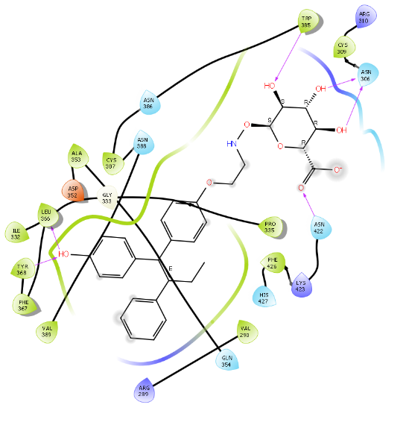
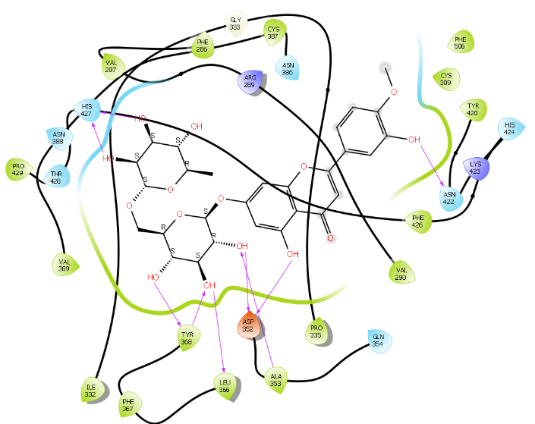
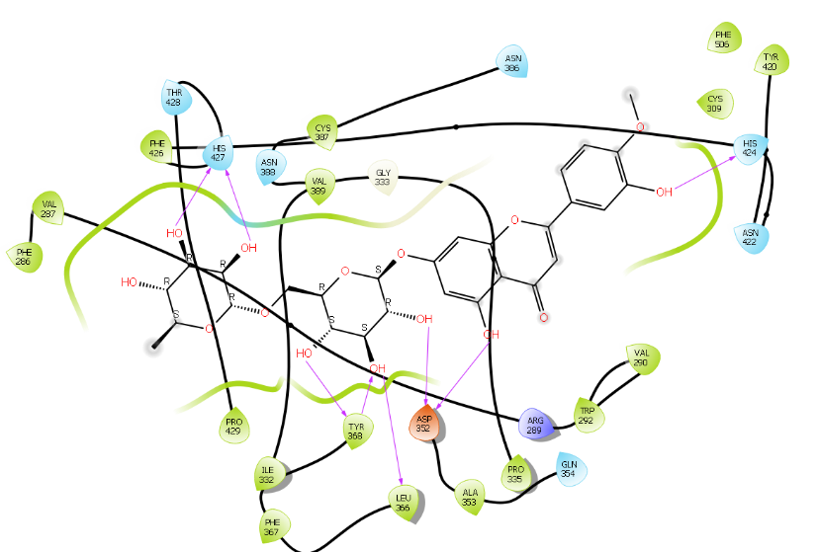
Supplementary fig.7. 2D Ligand interaction maps of the top 3 hits (Table 6) within the Guanine-N7 methyltransferase (ExoN) binding pocket (Schrödinger LLC_2020-1) depicting amino acid side chain residues colored according to their biochemical nature i.e. red = acidic, violet = basic, green = hydrophilic, and light blue = hydrophobic. The bold lines depict peptide backbone and red arrows depict molecular interactions.

A
B
C

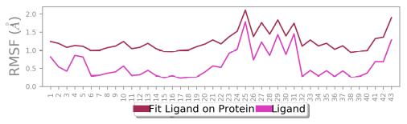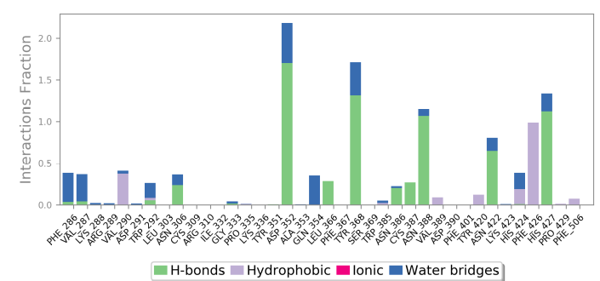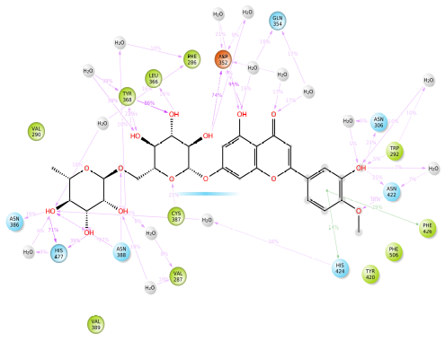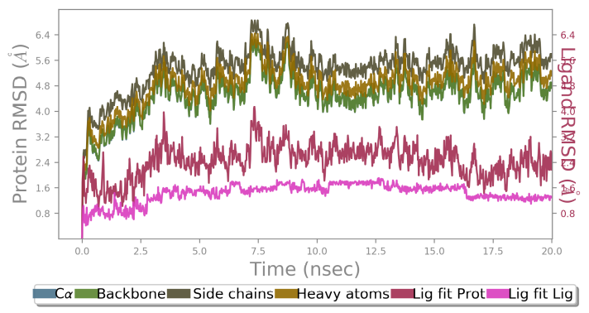
(A)
(B)
(C)
(D)
Supplementary fig. 8. Results of a 20 ns MD simulation (A) Root mean square deviations difference between the guanine-N7 methyltransferase (ExoN) and bound ligand diosmin, with the graph obtained for RMSF value of ligand (purple line) from the protein back bone (green line), revealing that the ligand is very strongly bound to the active site of the target. There was little change in the binding profile of the ligand throughout the simulation. (B) The acidic amino acid side 2D interaction map of bound diosmin throughout the simulation. (C) Critical protein ligand contacts of amino acid side chain residues with the interaction properties (D) Root mean square fluctuation between the binding site of target protein and interacting ligand.

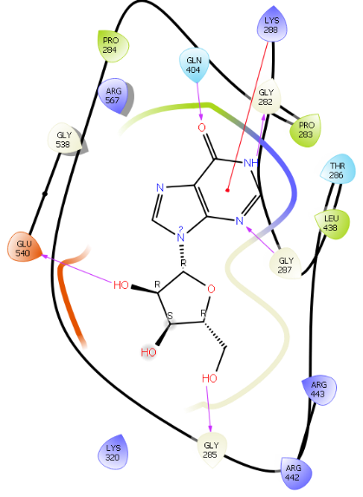
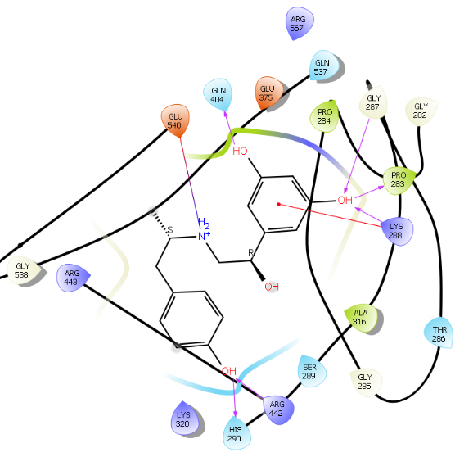
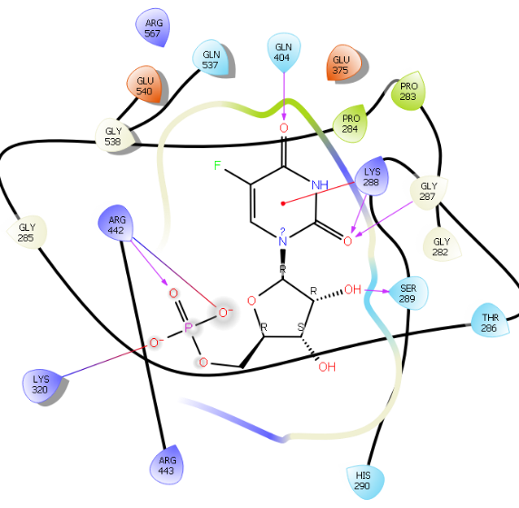
Supplementary fig.9. 2D Ligand interaction maps of the top 3 hits (Table 7) A) inosine, B) name, and C) 5-fluorouridine monophosphate within the Helicase (Hel) binding pocket (Schrödinger LLC_2020-1) depicting amino acid side chain residues colored according to their biochemical nature i.e. red = acidic, violet = basic, green = hydrophilic, and light blue = hydrophobic. The bold lines depict peptide backbone and red arrows depict molecular interactions.

A
B
C
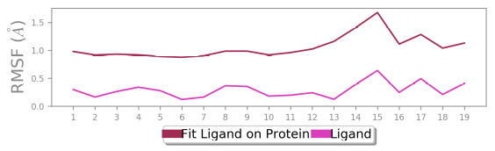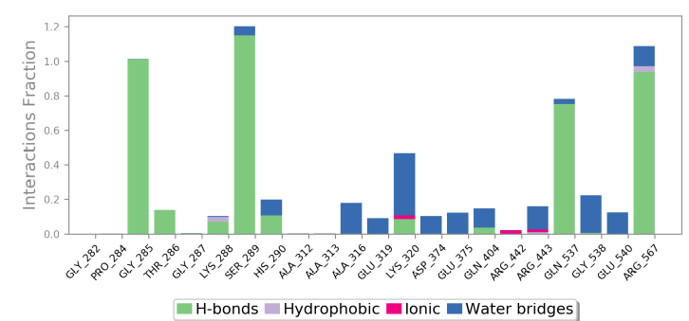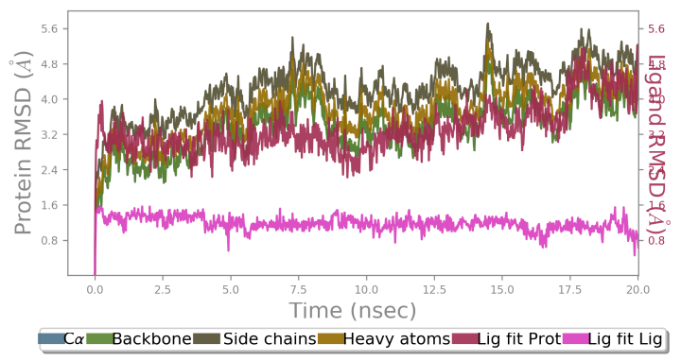
(A)
(B)
(C)
(D)
Supplementary fig. 10. Results of a 20 ns MD simulation (A) Root mean square deviations difference between the Helicase and bound ligand inosine. Graph obtained for RMSF value of ligand (purple line) from the protein back bone (green line). The ligand was tightly bound to the ATP- unpaired nucleoside binding site. (B) The acidic amino acid side 2D interaction map of bound inosine throughout the simulation. (C) Critical protein ligand contacts of amino acid side chain residues with the interaction properties (D) Root mean square fluctuations between the binding site of target protein and interacting ligand.

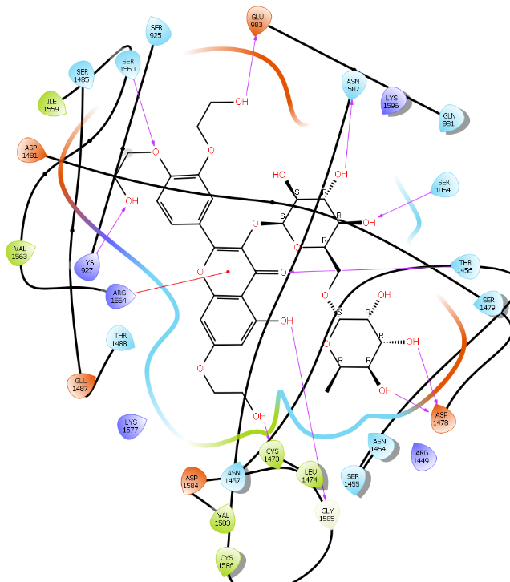
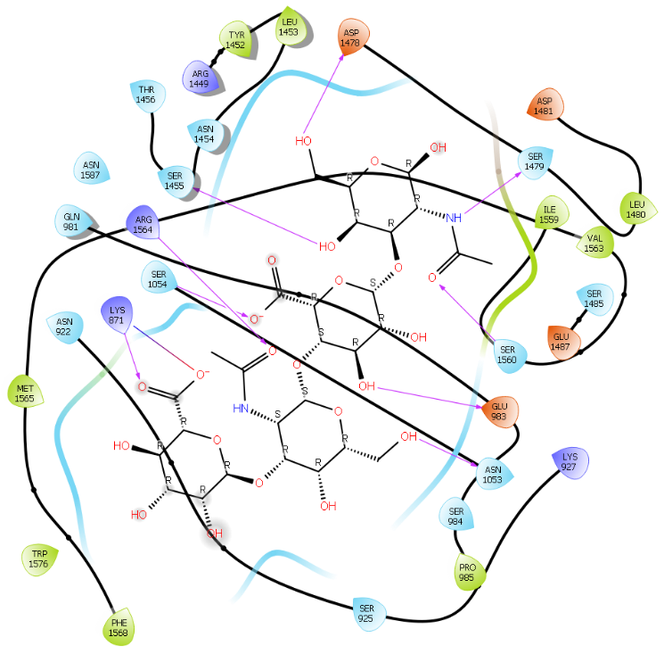
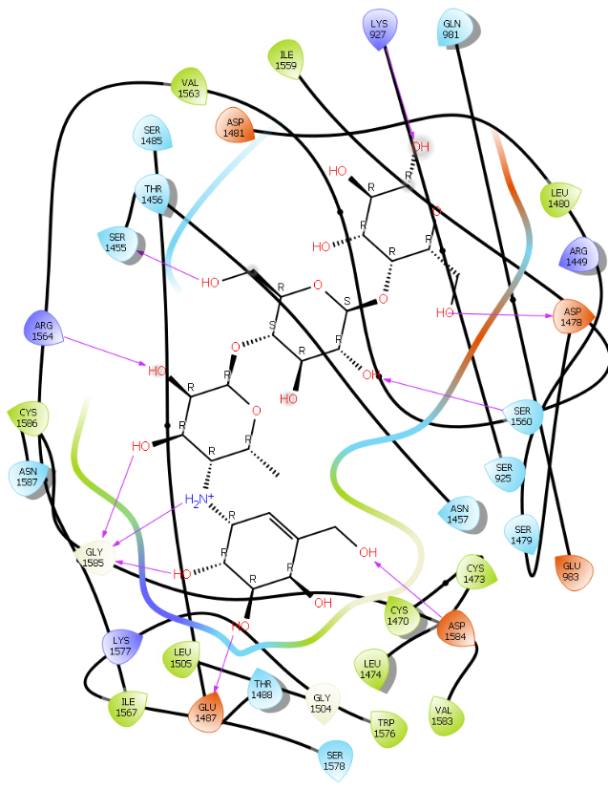
Supplementary fig.11. 2D Ligand interaction maps of the top 3 hits (Table 8) within Papain-like proteinase (PlPro) binding pocket (Schrödinger LLC_2020-1) depicting amino acid side chain residues colored according to their biochemical nature i.e. red = acidic, violet = basic, green = hydrophilic, and light blue = hydrophobic. The bold lines depict peptide backbone and red arrows depict molecular interactions.

A
B
C
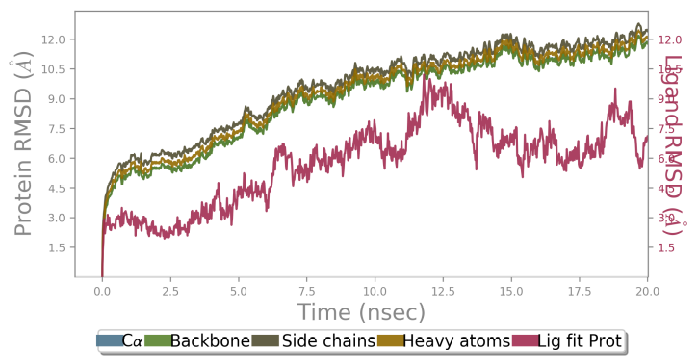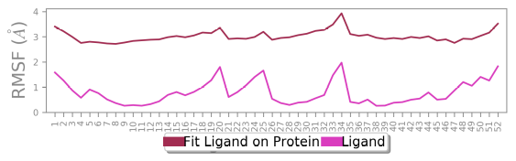
(A)
(B)
(C)
(D)
Supplementary fig. 12. Results of a 20 ns MD simulation (A) Root mean square deviations difference between the Papain like protease (PLpro) and bound ligand troxerutin. The graph obtained for RMSF value of ligand (purple line) relative to the protein backbone (green line). The ligand was tightly bound to the de-ubiquitinylating site. (B) Schematic 2D representation of bound ligand interactions of Troxerutin throughout the simulation. (C) Critical protein-ligand contacts of amino acid sidechain residues with the interaction properties (D) Root mean square fluctuation between the binding site of the target protein and interacting ligand.

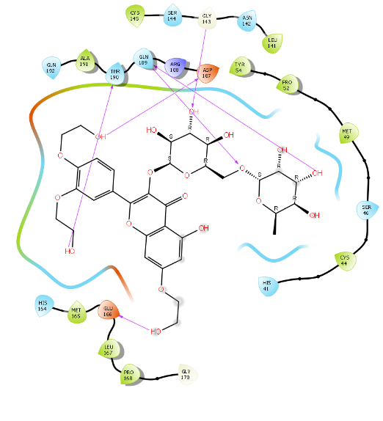
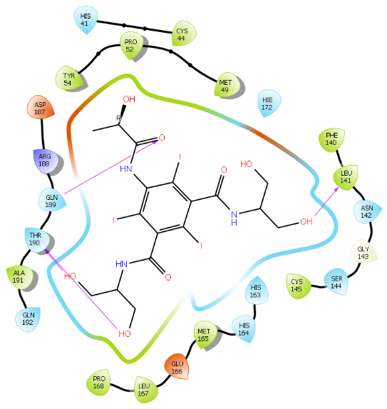
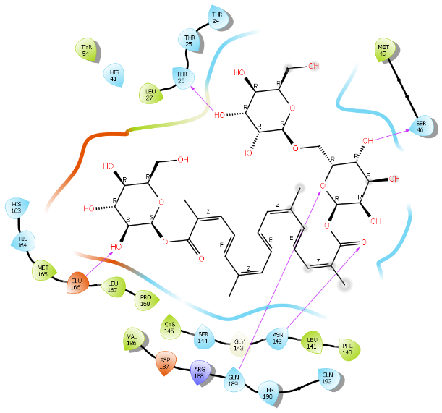
Supplementary fig.13. 2D Ligand interaction maps of the top 3 hits (Table9) within the Main Proteinase (3CL-PRO) binding pocket (Schrödinger LLC_2020-1) depicting amino acid side chain residues colored according to their biochemical nature i.e. red = acidic, violet = basic, green = hydrophilic, and light blue = hydrophobic. The bold lines depict peptide backbone and red arrows depict molecular interactions.

A
B
C
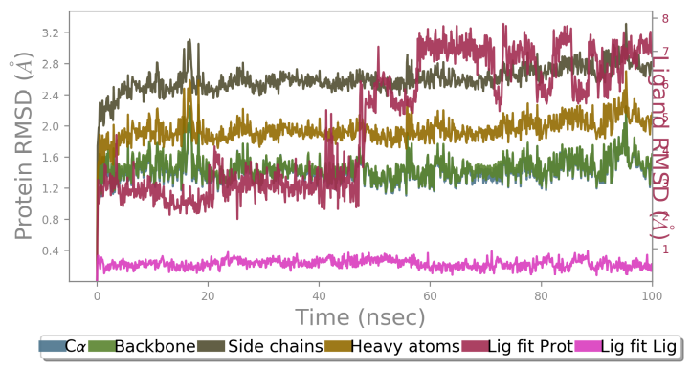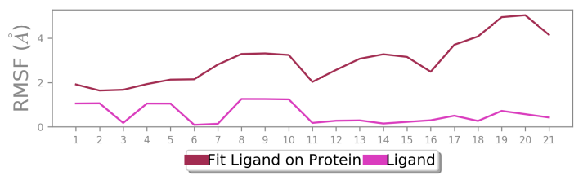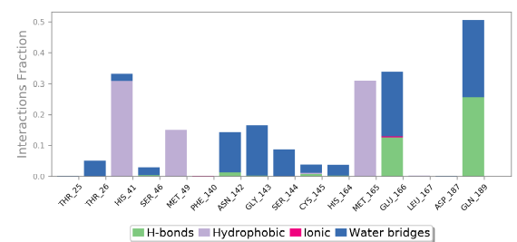 Supplementary fig. 14. Results of a 100 ns MD simulation (A) Root mean square deviations difference between the Main protease (3CLpro) and bound ligand XAV-939. The graph obtained for the RMSF value of ligand (purple line) from the protein backbone (green line). It revealed that there was a major conformational change of the ligand at around 50 ns without loss of the ligand. This suggests two binding conformers of the same ligand within the binding site. (B) Schematic 2D representation of bound ligand interactions of XAV-939 throughout the simulation. (C) Root mean square fluctuation between the binding site of the target protein and interacting ligand. (D) Critical protein-ligand contacts of amino acid side chain residues with the interaction properties.
(A)
(B)
(C)
(D)

