Causal mapping of a midbrain circuit supporting 3-D vision in humans and monkeys
Friedrich, MU. et al.

Supplementary materials

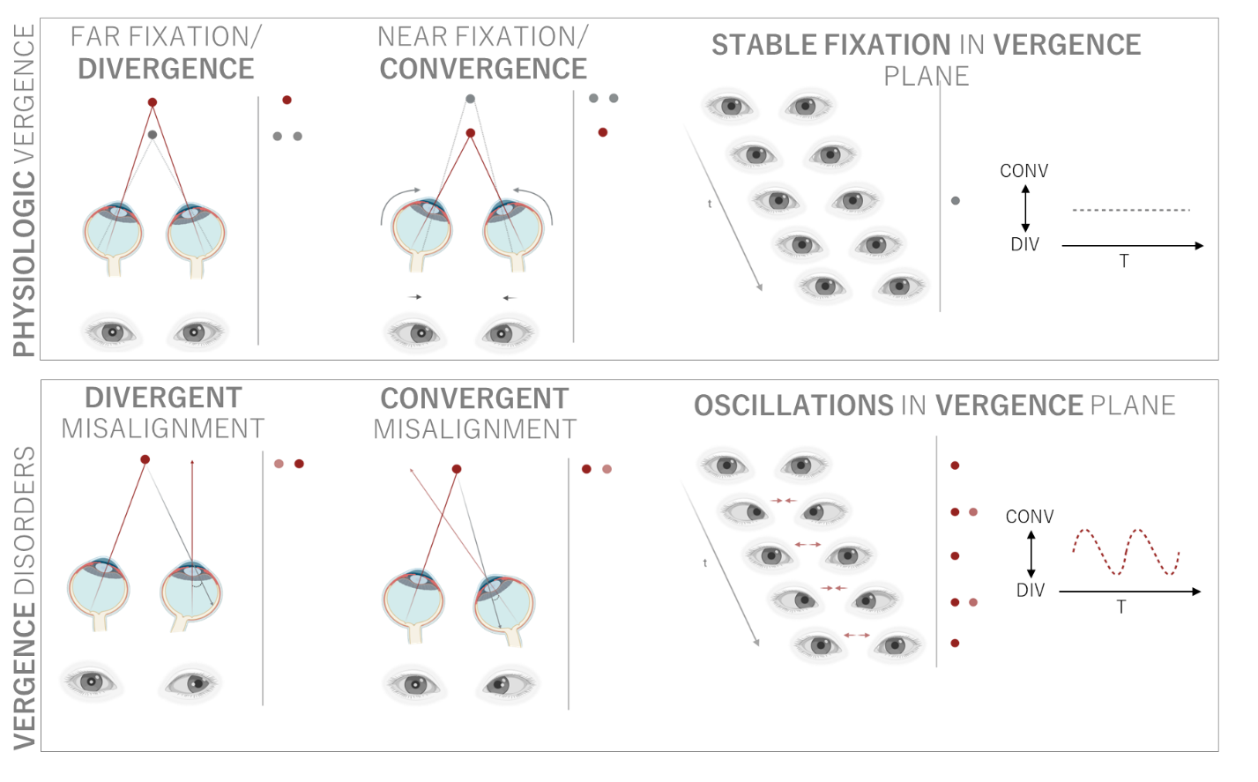
Supplementary Figure 1. Overview of disconjugate gaze in health and disease. Top panel: Divergence and convergence are physiologically disconjugate eye movements that enable binocular fixation of objects lying in different distances, enabling depth perception. In physiologic situations, the eyes remain stable during fixation, i. e. without oscillations. Lower panel: In pathologically disconjugate gaze, vergence angles are inappropriate for object distance, which leads to diplopia and loss of depth perception. In dorsal midbrain syndrome with vergence abnormalities, stable fixation cannot be maintained due to involuntary oscillations in the depth, or vergence plane.

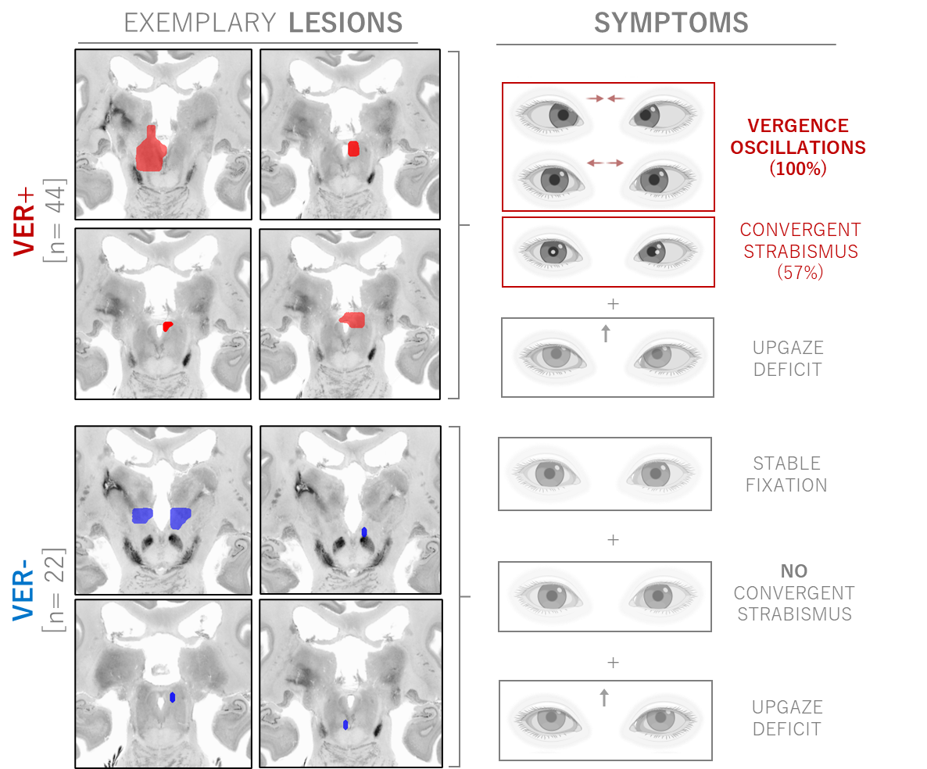
Supplementary Figure 2. Exemplary lesion locations associated with (VER+, red, n= 44) and without vergence deficits (VER-, blue, n= 22). All dorsal midbrain lesions were associated with deficits in conjugate upgaze. The spectrum of additional vergence deficits in VER+ encompasses vergence oscillations (convergence-(retraction) nystagmus) in all cases and static, convergent misalignment in the majority of cases (57%). In contrast, no VER- case displayed vergence oscillations or convergent misalignment.

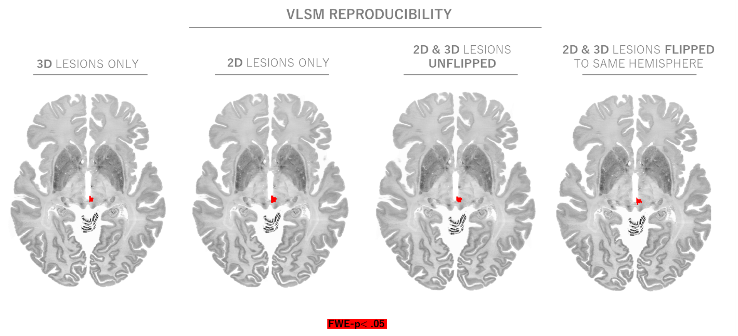
Supplementary Figure 3. Voxel-lesion symptom mapping results are independent of lesion dimensionality (3D vs. 2D lesions), and lesion laterality (flipped, unflipped).

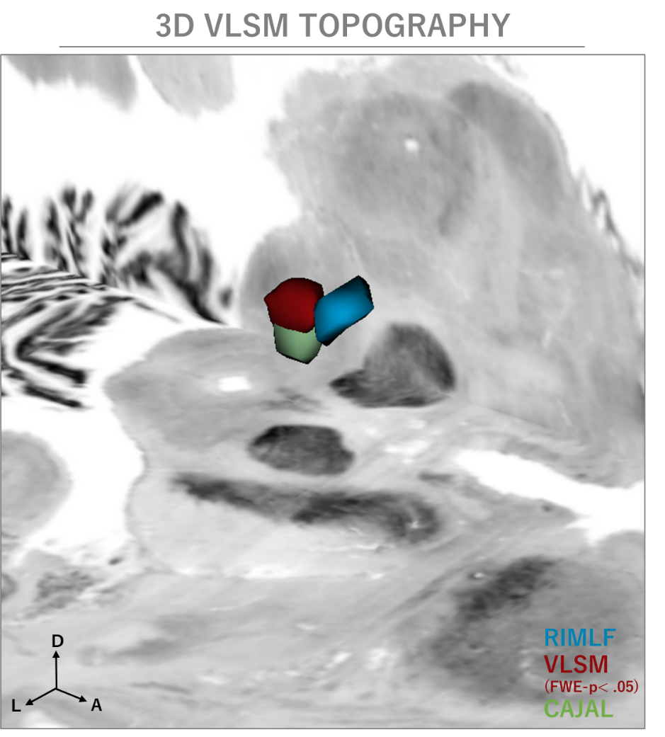
Supplementary Figure 4. 3D visualization of the VLSM finding (FWE-p< .05, red), alongside midbrain regions with known roles in ocular motor control. The rostral interstitial nucleus of the medial longitudinal fasciculus (RIMLF, blue) is involved in vertical saccades¹ and the interstitial nucleus of Cajal is the vertical-torsional eye movement integrator² (green). Notably, the VLSM finding is localized posterior of the RIMLF and dorsal to the INC in the region rostral of the superior colliculus. Atlas segmentations of RIMLF and INC in MNI152 space from^{3,4}.

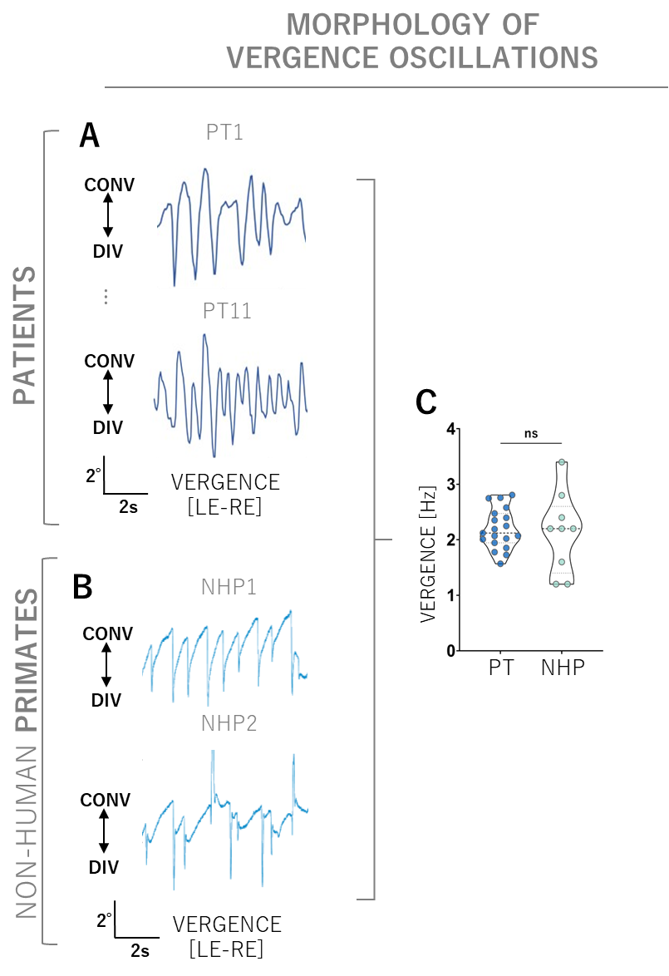
Supplementary Figure 5. Comparative analysis of vergence kinematics in patients and non-human primates. Vergence traces were computed by differentiating the left and right eye’s horizontal traces so that positive deflections indicate convergence and negative deflections indicate divergence. A. Two examples of vergence oscillations in patients (PT) extracted from clinical video material using a computer vision framework for clinical eye movement analysis, ConVNG⁵. B. Two examples of vergence oscillations in non-human primates (NHP), recorded using magnetic search coils⁶. Oscillation waveforms vary considerably within and between species. Of note, lesion-induced vergence oscillations are accompanied by varying degrees of abnormal eye muscle co-contractions leading to globe retraction and presumably causing atypical waveforms. Particularly in monkeys however, waveforms resemble a nystagmus with exponentially decelerating slow phases, suggesting integrator deficit^{7–9}. C. Vergence oscillation frequencies are similar between patients and monkeys (2.18 ± 0.35Hz in patients and 2.13 ± 0.68Hz in monkeys, p= .99).
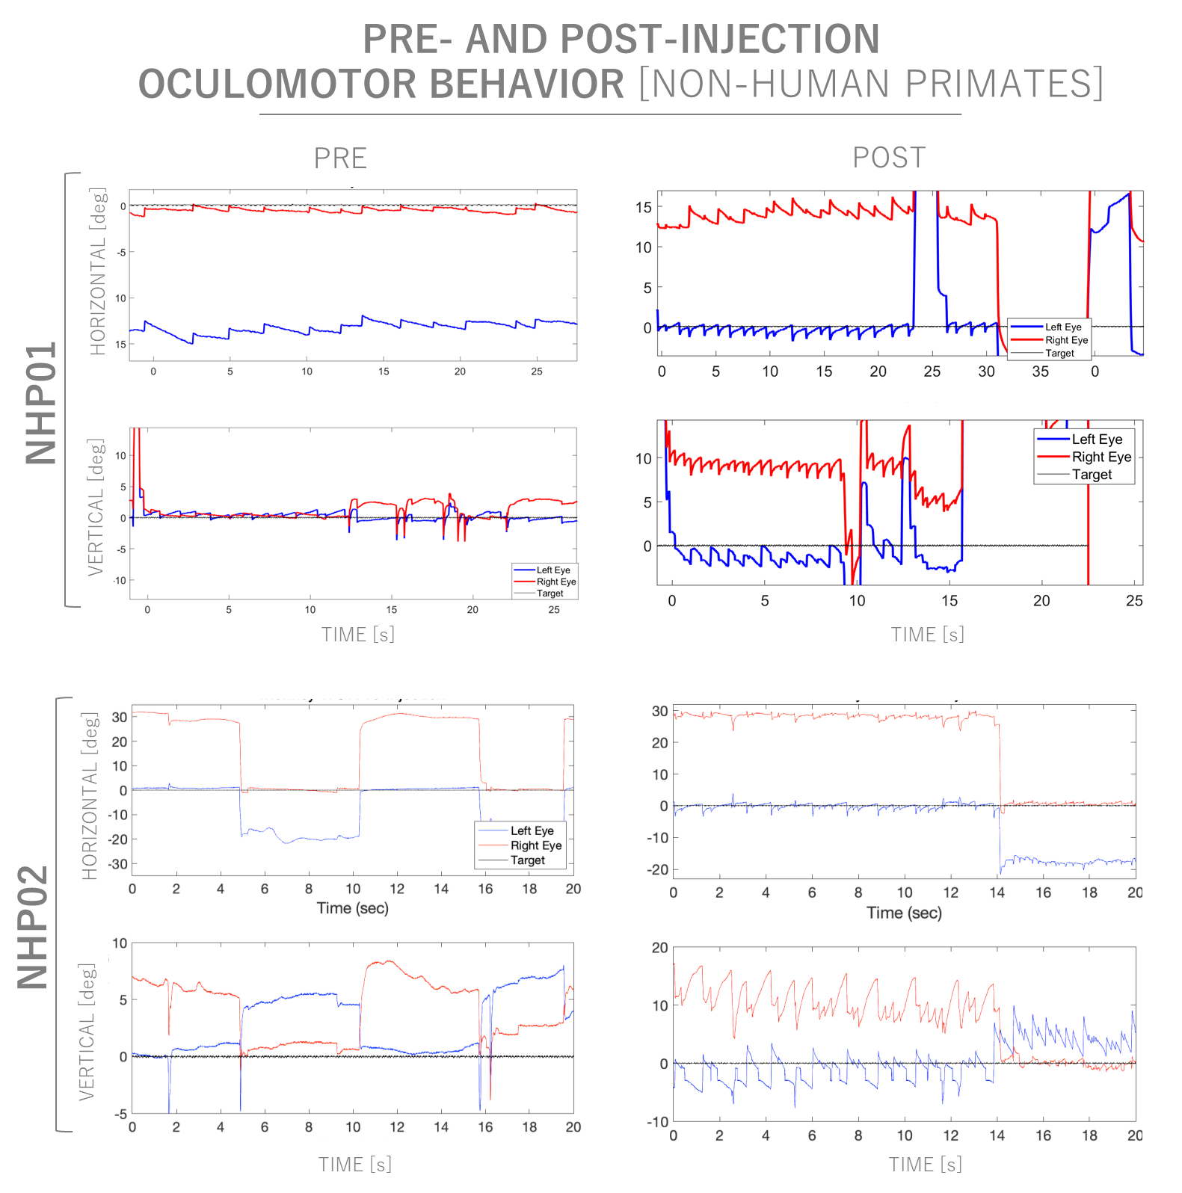
Supplementary Figure 6. The effects of muscimol injections to the NPC area are specific and reversible. Both monkeys show no vergence oscillations at baseline (pre), but clear and pronounced vergence oscillations after injection of muscimol to the unilateral NPC region (post). Monkey NHP01 shows a subtle conjugated nystagmus at baseline, which is not uncommon even in normal monkeys⁷. In addition to vergence oscillations, both monkey show marked vertically disconjugate oscillations, hemi-seesaw nystagmus^{4,10,11}. Note the decelerating slow phases of vergence oscillations in both instances, indicating an integrator deficit^{7–9}.

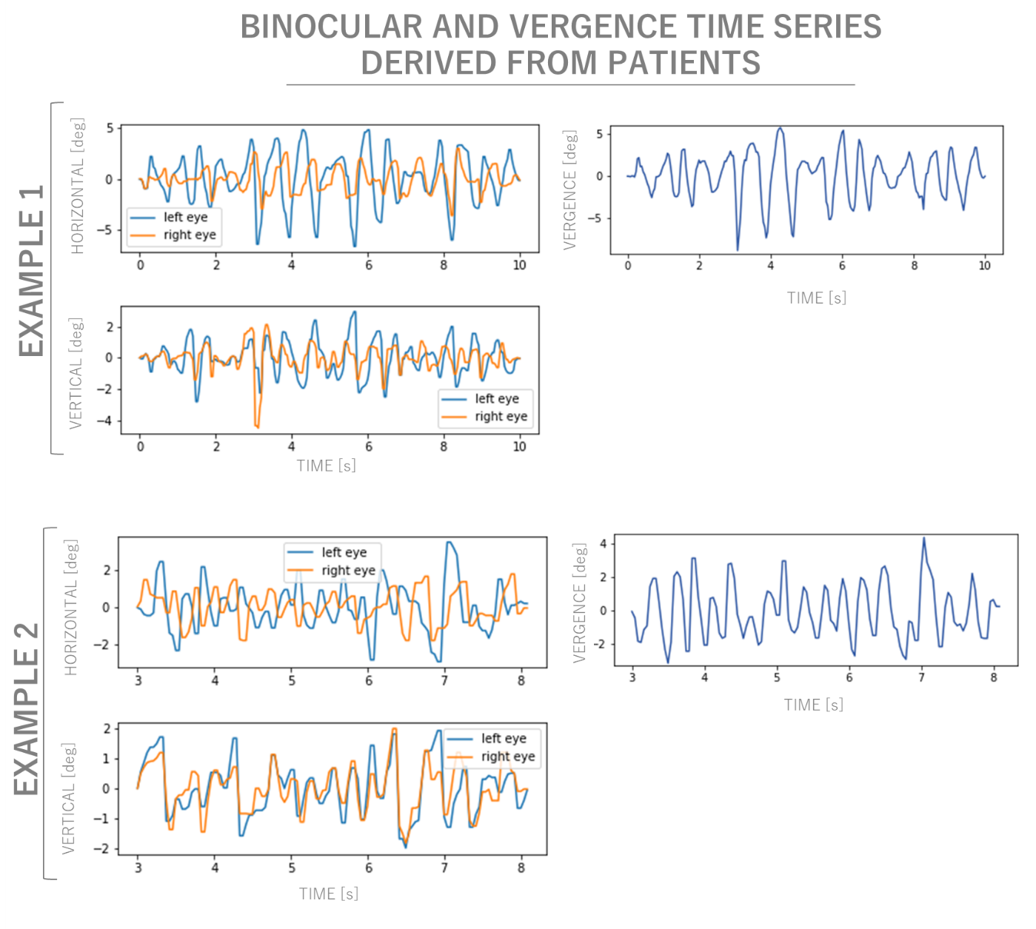
Supplementary Figure 7. Exemplary binocular position traces (left columns) for horizontal and vertical directions (upper and lower plots, respectively) as well as computed horizontal vergence traces from two example patients, extracted using ConVNG⁵. Note the variable binocular asynchrony of vergence oscillations in both instances and the additional vertically disconjugate components in example 1, left lower trace. Waveforms appear more attenuated than in monkeys (Supplementary Figure 6), potentially due to the relatively low temporal resolution of video data (25-30 Hz).

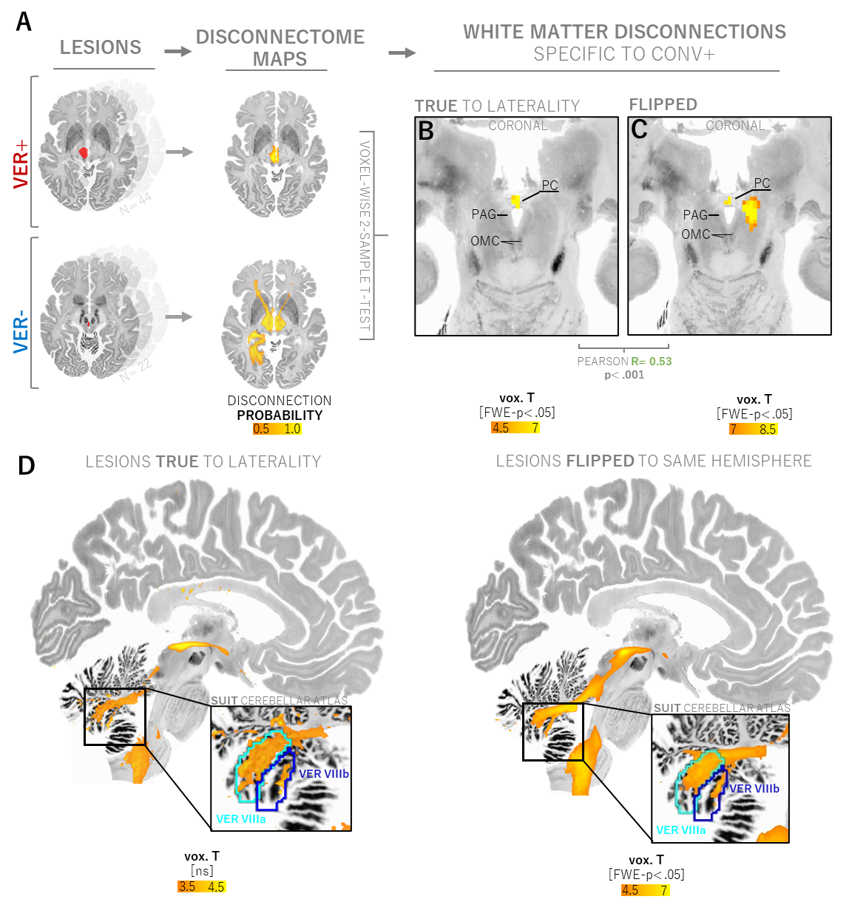
Supplementary Figure 8. Contrasting the structural disconnections associated with vergence deficits using disconnectome mapping¹². A. Disconnectome maps are computed for each of the 66 dorsal midbrain lesions using a high-resolution, 7T diffusion connectome from n= 178 subjects^{13,14}. These maps represent the probability of a tract being disconnected in any given voxel (probability values between 0 and 1). To establish specificity to either subgroup, the unthresholded disconnectome maps associated with CONV+ and CONV- are then contrasted using a whole-brain, voxel-wise two-sample T-test in FSL PALM¹⁵, using lesion size as a covariate. B. The posterior commissure emerges as a highly significant finding (FWE-p <.001). C. The posterior commissure prevails as the peak finding when repeating the two-sample T-test after flipping all disconnectome maps to the same hemisphere to further increase statistical power. However, an additional disconnection is highlighted in the ipsilateral pretectum and the mesencephalic reticular formation. D. Lowering the statistical threshold to appreciate the broader subcortical topography of white matter disconnection specific to CONV+. In addition to the posterior commissure, disconnections can be found in the proximal optic nerve/ chiasm, the dorsal midbrain, superior cerebellar peduncle, cerebellar vermis lobules VIIIa-b (SUIT atlas¹⁶ and the medulla oblongata posterior to the inferior olivary nucleus. These findings only reach significance when all maps are flipped to the same hemisphere for the voxel-wise two-sample T-test. Abbreviations: PC= posterior commissure, PAG= periaqueductal gray, OMC= oculomotor complex.

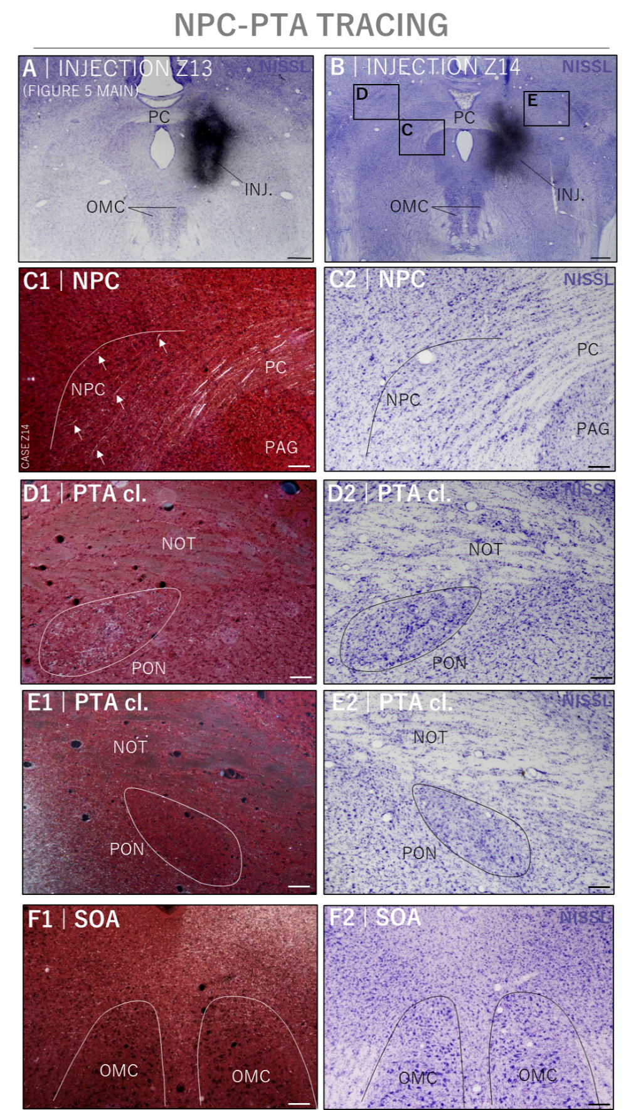
Supplementary Figure 9. Anterograde tracing of nucleus of the posterior commissure (NPC) using ³H-Leucine autoradiography¹⁷. A-B. Verification of NPC injection sites on coronal brain slices at the level of the posterior commissure, case Z13 shown in main figure 5. C. Fibrillary label is found in the ventral posterior commissure, with terminal labelling in the contralateral NPC. D. Terminal labelling is also found in the contralateral pretectal olivary nucleus (PON), sparing the pretectal nucleus of the optic tract (NOT), while an opposite pattern is seen ipsilaterally, where terminal label is found in the NOT, sparing the PON (E.). F. Strong terminal label is also found in the bilateral supraoculomotor area (SOA), more on the ipsilateral side. Collectively, both injection cases show a similar connectivity pattern. Left images darkfield microscopy, right panel corresponding Nissl stainings.

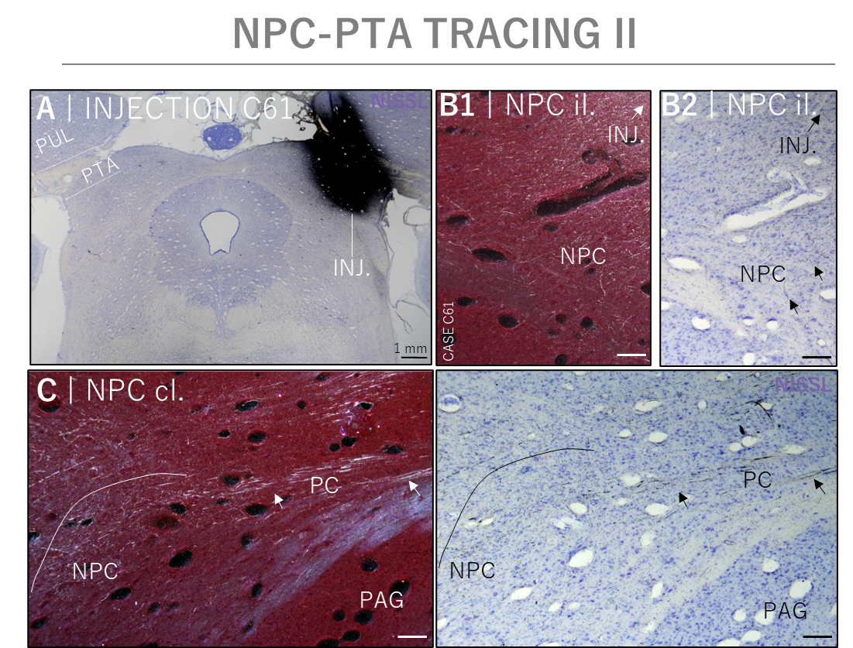
Supplementary Figure 10. Anterograde tracing of the pretectal area (PTA) using ³H-Leucine autoradiography. Data has been previously published in part ¹⁸. A. Injection site involving the pretectal NOT, PON and parts of the thalamic pulvinar. Fibrillary labelling is found in the posterior commissure, with terminal labelling in the ipsilateral (B.) and contralateral NPC (C.).

Supplementary tables
 | Freq. LE | Freq. RE | Freq. Binoc. | Amp. LE | Amp. RE | Amp. Binoc.
Median | 2.01 | 2.24 | 2.13 | 0.92 | 0.91 | 0.83
Mean | 2.14 | 2.26 | 2.20 | 1.12 | 1.02 | 1.07
SD | 0.46 | 0.37 | 0.38 | 0.69 | 0.50 | 0.57
IQR | 0.80 | 0.45 | 0.53 | 0.63 | 0.50 | 0.51
Minimum | 1.49 | 1.64 | 1.57 | 0.46 | 0.46 | 0.52
Maximum | 3.01 | 2.92 | 2.81 | 2.83 | 2.33 | 2.52
Supplementary table 1 Overview of oculographic characterization of vergence oscillations. Legend: Freq.: Frequency, LE: left eye, RE: right eye, Binoc.: binocular averaged.

Recruited | Etiology | Vergence oscillations | Vertical gaze palsy | Lesion side | Age
WUE | Stroke | Y | Y | L | 83
WUE | Stroke | Y | Y | R | 67
WUE | Stroke | Y | Y | R | 78
WUE | Stroke | Y | Y | L | 60
WUE | Stroke | Y | Y | R | 78
MUC | Tumor | Y | Y | L | Mean MUC: 49.3 ± 18.3
MUC | Stroke | Y | Y | L | Mean MUC: 49.3 ± 18.3
MUC | Stroke | Y | Y | L | Mean MUC: 49.3 ± 18.3
MUC | Hemorrhage | Y | Y | R | Mean MUC: 49.3 ± 18.3
MUC | Inflammatory | Y | Y | BILAT | Mean MUC: 49.3 ± 18.3
MUC | Tumor | Y | Y | BILAT | Mean MUC: 49.3 ± 18.3
MUC | Stroke | Y | Y | L | Mean MUC: 49.3 ± 18.3
MUC | Stroke | Y | Y | L | Mean MUC: 49.3 ± 18.3
MUC | Stroke | Y | Y | L | Mean MUC: 49.3 ± 18.3
MUC | Tumor | Y | Y | BILAT | Mean MUC: 49.3 ± 18.3
MUC | Stroke | Y | Y | R | Mean MUC: 49.3 ± 18.3
MUC | Hemorrhage | Y | Y | R | Mean MUC: 49.3 ± 18.3
MUC | Stroke | Y | Y | L | Mean MUC: 49.3 ± 18.3
MUC | Stroke | Y | Y | L | Mean MUC: 49.3 ± 18.3
MUC | Hemorrhage | Y | Y | L | Mean MUC: 49.3 ± 18.3
MUC | Tumor | Y | Y | L | Mean MUC: 49.3 ± 18.3
MUC | Stroke | Y | Y | L | Mean MUC: 49.3 ± 18.3
MUC | Hemorrhage | Y | Y | L | Mean MUC: 49.3 ± 18.3
MUC | Hemorrhage | Y | Y | L | Mean MUC: 49.3 ± 18.3
MUC | Tumor | Y | Y | BILAT | Mean MUC: 49.3 ± 18.3
MUC | Stroke | Y | Y | L | Mean MUC: 49.3 ± 18.3
MUC | Inflammatory | Y | Y | BILAT | Mean MUC: 49.3 ± 18.3
MUC | Stroke | Y | Y | L | Mean MUC: 49.3 ± 18.3
MUC | Stroke | N | Y | BILAT | Mean MUC: 67.9 ± 18.4
MUC | Stroke | N | Y | L | Mean MUC: 67.9 ± 18.4
MUC | Tumor | N | Y | L | Mean MUC: 67.9 ± 18.4
MUC | Stroke | N | Y | L | Mean MUC: 67.9 ± 18.4
MUC | Stroke | N | Y | BILAT | Mean MUC: 67.9 ± 18.4
MUC | Stroke | N | Y | BILAT | Mean MUC: 67.9 ± 18.4
MUC | Stroke | N | Y | L | Mean MUC: 67.9 ± 18.4
MUC | Stroke | N | Y | R | Mean MUC: 67.9 ± 18.4
MUC | Stroke | N | Y | R | Mean MUC: 67.9 ± 18.4
MUC | Stroke | N | Y | R | Mean MUC: 67.9 ± 18.4
MUC | Stroke | N | Y | L | Mean MUC: 67.9 ± 18.4
MUC | Stroke | N | Y | L | Mean MUC: 67.9 ± 18.4
MUC | Stroke | N | Y | L | Mean MUC: 67.9 ± 18.4
MUC | Tumor | N | Y | L | Mean MUC: 67.9 ± 18.4
MUC | Stroke | N | Y | L | Mean MUC: 67.9 ± 18.4
MUC | Stroke | N | Y | BILAT | Mean MUC: 67.9 ± 18.4
MUC | Stroke | N | Y | BILAT | Mean MUC: 67.9 ± 18.4
MUC | Stroke | N | Y | L | Mean MUC: 67.9 ± 18.4
MUC | Stroke | N | Y | R | Mean MUC: 67.9 ± 18.4
MUC | Stroke | N | Y | R | Mean MUC: 67.9 ± 18.4
MUC | Stroke | N | Y | R | Mean MUC: 67.9 ± 18.4
MUC | Stroke | N | Y | L | Mean MUC: 67.9 ± 18.4
MUC | Stroke | N | Y | L | Mean MUC: 67.9 ± 18.4
Supplementary table 2. Clinical characteristics of local dorsal midbrain syndrome cases. WUE= Wuerzburg cohort, MUC= Munich cohort. R= right, L= left, BILAT= bilateral, Y= yes, N= no.

Source | Case ID | Etiology | Vergence oscillations | Vertical gaze palsy | Lesion side | Age
10.1136/bcr-2014-205168 | 1 | Stroke | Y | Y | L | 66
10.1136/bcr-2014-206851 | 1 | Stroke | Y | Y | R | 49
10.1212/WNL.0000000000008332 | 1 | Stroke | Y | Y | R | 51
10.1016/j.msard.2013.09.003 | 1 | Inflammatory | Y | Y | L | 26
10.1212/wnl.38.11.1759 | 1 | Stroke | Y | Y | R | 45
10.1212/wnl.41.8.1229 | 6 | Stroke | Y | Y | R | 62
10.1212/wnl.41.8.1229 | 9 | Stroke | Y | Y | L | 69
10.1212/WNL.0000000000002947 | 1 | Stroke | Y | Y | L | 32
10.1007/BF02226959 | 2 | Stroke | Y | Y | R | 53
10.1212/wnl.55.3.352 | 1 | Stroke | Y | Y | L | 60
10.1212/wnl.55.3.352 | 2 | Stroke | Y | Y | R | 69
10.1212/wnl.55.3.352 | 5 | Stroke | Y | Y | L | 69
10.1212/wnl.55.3.352 | 6 | Stroke | Y | Y | R | 48
PMC8332747 | 1 | Inflammatory | Y | Y | R | 49
10.1002/ana.1263 | 1 | Stroke | Y | Y | L | 62
10.1007/s10792-015-0045-y | 1 | Stroke | Y | Y | L | 59
10.1097/01.wno.0000235588.18169.de | 1 | Stroke | N | Y | R | 47
10.4103/0028-3886.111131 | 1 | Stroke | N | Y | R | 60
10.4103/0028-3886.111131 | 2 | Stroke | N | Y | R | 43
10.4103/0028-3886.111131 | 3 | Hemorrhage | N | Y | R | 69
10.1161/01.str.26.8.1467 | 1 | Stroke | N | Y | BILAT | 86
10.1161/01.str.26.8.1467 | 2 | Stroke | N | Y | R | 47
10.1161/01.str.26.8.1467 | 3 | Stroke | N | Y | R | 72
10.1212/WNL.0b013e3181c04654 | 1 | Stroke | N | Y | R | 45
10.1007/s00415-011-6263-y | 1 | Stroke | N | Y | L | 62
10.1159/000078601 | 1 | Stroke | N | Y | R | 69

Supplementary methods

Literature search strategy
PubMed was systematically screened throughout 2020 for cases of dorsal midbrain syndrome reported in English or German language using the search terms (“dorsal midbrain syndrome” OR “Parinaud syndrome” OR “Koerber-Salus-Elschnig syndrome” OR “vertical gaze palsy” OR “vertical saccade palsy” OR “upgaze palsy” OR “convergence retraction nystagmus” OR “convergence-retraction” OR “convergence nystagmus” OR “retraction nystagmus”) AND (stroke OR infarct* OR hemorrhage OR tumor OR lesion) AND (MRI OR CT OR neuroimaging) AND (case OR case report). Reference lists of identified articles were screened for relevant papers missed by the initial search strategy. A total of 150 studies were identified for further screening.

Inclusion criteria were as follows: (1) acuity of oculomotor findings, defined as their presence of less than 30 days, (2) report and/or photos and/or videos and/or apparative oculography of a sufficiently detailed neuroophthalmological assessment, covering at least evaluation of phorias/ tropias, smooth pursuit, saccades and nystagmus in both horizontal and vertical planes, respectively, (3) evidence of causative focal brain damage with at least one published structural image (CT or MRI or illustration thereof) with (a) a quality high enough to allow for tracing onto a standardized brain image template and (b) sufficient contrast to clearly delineate lesion boundaries and (4), case report or case series format. Applying these inclusion criteria prevented inclusion of lesions with ill-defined boundaries (e. g.^{19,20}), which could generally reduce specificity of lesion-behavior relationships²¹ especially in subcortical areas, where functionally divergent nuclei oftentimes lie in close proximity of each other. Also, lesions detected with delay, e. g. in the setting of chronically progressing oculomotor disorders (e. g.²²), were not included, since symptoms may partially be attributed to reorganization of neural circuit architecture, a process that potentially violates basic assumptions of lesion symptom or network mapping^{23,24}.

A total of n= 26 cases across 16 studies fulfilled inclusion criteria. From these cases, data was systematically extracted and tabulated. This included basic demographic data (when available), lesion etiology as well as a binary coding of presence of a priori defined oculomotor syndrome dimensions known to be associated with dorsal midbrain syndrome, namely (1) vertical gaze or saccade disorder, (2) convergence nystagmus, (3) other nystagmus, (4) horizontal or vertical ocular misalignment and (5) vestibular symptoms (e. g. ocular tilt reaction, skew deviation).

The outlined systematic search, data extraction and reporting process was conducted independently by two authors (MF and JH), based on the 2020 PRISMA guidelines²⁵. Clinical documentation for all cases was evaluated by a junior and senior neuroophthalmologist (MF, AZ) to confirm DMS diagnosis.

Lesion tracing
Prominent topographical landmarks (e. g. red nucleus, aqueduct, posterior commissure) delineated by MRI contrast or by relevant brainstem regions of interest taken from subcortical brain atlases^{26–30} were used as landmarks to accurately transfer lesions onto the standardized template brain¹² using MRIcroGL³¹ or 3D Slicer³². In line with previous work³³, 2D lesions larger than 2 mm in largest diameter (d) were extended by 2 mm along the axis perpendicular to the display plane (e. g. a lesion with a d= 2.5 mm shown in the axial plane is extended by 1 mm dorsally and 1 mm ventrally), while lesions below 2 mm in largest diameter were extended by 1 mm (e. g. a lesion with d= 1 mm in the coronal plane is extended by 1 mm anteriorly and 1 mm posteriorly). To maximize internal reliability, two raters with at least two years of experience in clinical neuroanatomy (JH, HE) independently traced the lesions. All resulting lesion masks were visually inspected for accuracy by an expert in brainstem neuroanatomy (MF) and a final consensus was reached between all three raters when needed. This approach was chosen in accordance with best practices in manual lesion segmentation³⁴. Exemplary lesion masks for each group are shown in Supplementary Figure 2.

Atlases and midbrain regions of interest
To assess topographical relationships, the following MRI atlases were used: THOMAS³⁰, FOcuS²⁸, DISTAL³⁵, SUIT¹⁶ and brainstem navigator³⁶. Midbrain ROIs relevant to eye movement control (interstitial nucleus of Cajal (INC), rostral interstitial nucleus of the medial longitudinal fascicle (RIMLF), pretectal area (PTA)) were manually segmented in MNI space using the identical approach as described for lesion tracing by an expert in brainstem neuroanatomy (MF) and evaluated by a junior investigator focusing on brainstem neuroanatomy (HF)^{3,4}. Topographical relationships were assessed in detail based on human imaging, histological atlas sources^{37–39} and correlation to histological specimens. To optimize tracing accuracy, relevant bordering structures (pulvinar, red nucleus, oculomotor nucleus complex, superior colliculus, aqueduct) were explicitly overlaid for topographical orientation. The final segmentations were reviewed, modified and confirmed by a senior neuroanatomist specialized in oculomotor midbrain anatomy (AH).

Computer vision enabled videonystagmography: ConVNG

ConVNG⁵ leverages the open-source framework DeepLabCut (DLC)^{40,41}, a convolutional neural network (CNN) based on a residual network architecture (ResNet 50), which has been specifically fine-tuned to track a total of 17 landmarks delineating each pupil´s outlines at clock positions three, six, nine and twelve (n=8) as well as anatomically defined support points of interest in the face (eye lid borders, root of the nose, n=9). Accuracy of nystagmus analysis was shown to be in the range of 9-15%, equivalent to gold standard videooculography goggles. Since ConVNG naturally depends on RGB data and ideally operates in settings of high camera stability, instances with either insufficient contrast, spatiotemporal resolution (<320x160px, <20 Hz) or camera stabilization were excluded from analysis (2 available videos).
Supplementary references
1. Büttner-Ennever, J. A., Büttner, U., Cohen, B. & Baumgartner, G. Vertical glaze paralysis and the rostral interstitial nucleus of the medial longitudinal fasciculus. Brain J. Neurol. 105, 125–149 (1982).
2. Crawford, J. D., Cadera, W. & Vilis, T. Generation of torsional and vertical eye position signals by the interstitial nucleus of Cajal. Science 252, 1551–1553 (1991).
3. Friedrich, M. U. et al. Current-dependent ocular tilt reaction in deep brain stimulation of the subthalamic nucleus: Evidence for an incerto-interstitial pathway? Eur. J. Neurol. (2022) doi:10.1111/ene.15257.
4. Friedrich, M. U. et al. Midbrain lesion-induced disconjugate gaze: a unifying circuit mechanism of ocular alignment? J. Neurol. (2024) doi:10.1007/s00415-023-12155-6.
5. Friedrich, M. U. et al. Smartphone video nystagmography using convolutional neural networks: ConVNG. J. Neurol. (2022) doi:10.1007/s00415-022-11493-1.
6. Das, V. E., Leigh, R. J., Swann, M. & Thurtell, M. J. Muscimol inactivation caudal to the interstitial nucleus of Cajal induces hemi-seesaw nystagmus. Exp. Brain Res. 205, 405–413 (2010).
7. Leigh, R. J. & Zee, D. S. The Neurology of Eye Movements. The Neurology of Eye Movements (Oxford University Press, 2015).
8. Gupta, P. & Shaikh, A. G. ‘Leaky’ and ‘Unstable’ Neural Integrator Can Coexist-Paradox Observed in Multiple Sclerosis. J. Neuro-Ophthalmol. Off. J. North Am. Neuro-Ophthalmol. Soc. 40, 226–233 (2020).
9. Sanchez, K. & Rowe, F. J. Role of neural integrators in oculomotor systems: a systematic narrative literature review. Acta Ophthalmol. (Copenh.) 96, e111–e118 (2018).
10. Das, V. E. Response Properties of Cells in the Supraoculomotor Area in Non-Human Primates With Strabismus. Invest. Ophthalmol. Vis. Sci. 51, 2997 (2010).
11. Halmagyi, G. M., Aw, S. T., Dehaene, I., Curthoys, I. S. & Todd, M. J. Jerk-waveform see-saw nystagmus due to unilateral meso-diencephalic lesion. Brain J. Neurol. 117 ( Pt 4), 789–803 (1994).
12. Foulon, C. et al. Advanced lesion symptom mapping analyses and implementation as BCBtoolkit. GigaScience 7, giy004 (2018).
13. Thiebaut de Schotten, M., Foulon, C. & Nachev, P. Brain disconnections link structural connectivity with function and behaviour. Nat. Commun. 11, 5094 (2020).
14. Karolis, V. R., Corbetta, M. & Thiebaut de Schotten, M. The architecture of functional lateralisation and its relationship to callosal connectivity in the human brain. Nat. Commun. 10, 1417 (2019).
15. Winkler, A. M., Ridgway, G. R., Webster, M. A., Smith, S. M. & Nichols, T. E. Permutation inference for the general linear model. NeuroImage 92, 381–397 (2014).
16. Diedrichsen, J. et al. Imaging the deep cerebellar nuclei: a probabilistic atlas and normalization procedure. NeuroImage 54, 1786–1794 (2011).
17. Cowan, W. M., Gottlieb, D. I., Hendrickson, A. E., Price, J. L. & Woolsey, T. A. The autoradiographic demonstration of axonal connections in the central nervous system. Brain Res. 37, 21–51 (1972).
18. Büttner-Ennever, J. A., Cohen, B., Horn, A. K. & Reisine, H. Efferent pathways of the nucleus of the optic tract in monkey and their role in eye movements. J. Comp. Neurol. 373, 90–107 (1996).
19. Margolin, E. & Emami, S. Teaching Video NeuroImages: Convergence retraction nystagmus due to compressive lesion of the dorsal midbrain. Neurology 94, e2285–e2286 (2020).
20. Pierrot-Deseilligny, C. H. et al. Parinaud’s syndrome: electro-oculographic and anatomical analyses of six vascular cases with deductions about vertical gaze organization in the premotor structures. Brain J. Neurol. 105 (Pt 4), 667–696 (1982).
21. de Haan, B. & Karnath, H.-O. A hitchhiker’s guide to lesion-behaviour mapping. Neuropsychologia 115, 5–16 (2018).
22. Moon, S. Y. et al. Isolated vertical diplopia as the initial manifestation of presumed pretectal and anterior hypothalamic germinomas. J. Neuro-Ophthalmol. Off. J. North Am. Neuro-Ophthalmol. Soc. 25, 105–108 (2005).
23. Cotovio, G., Faro Viana, F., Fox, M. D. & Oliveira-Maia, A. J. Lesion network mapping of mania using different normative connectomes. Brain Struct. Funct. (2022) doi:10.1007/s00429-022-02508-8.
24. Rajashekar, D. et al. The Impact of Covariates in Voxel-Wise Lesion-Symptom Mapping. Front. Neurol. 11, (2020).
25. Page, M. J. et al. The PRISMA 2020 statement: an updated guideline for reporting systematic reviews. BMJ 372, n71 (2021).
26. Bianciardi, M. et al. A probabilistic template of human mesopontine tegmental nuclei from in vivo 7T MRI. NeuroImage 170, 222–230 (2018).
27. Singh, K. et al. Probabilistic Template of the Lateral Parabrachial Nucleus, Medial Parabrachial Nucleus, Vestibular Nuclei Complex, and Medullary Viscero-Sensory-Motor Nuclei Complex in Living Humans From 7 Tesla MRI. Front. Neurosci. 13, 1425 (2020).
28. Coiner, B. et al. Functional neuroanatomy of the human eye movement network: a review and atlas. Brain Struct. Funct. 224, 2603–2617 (2019).
29. Saranathan, M., Iglehart, C., Monti, M., Tourdias, T. & Rutt, B. In vivo high-resolution structural MRI-based atlas of human thalamic nuclei. Sci. Data 8, 275 (2021).
30. Su, J. H. et al. Thalamus Optimized Multi Atlas Segmentation (THOMAS): fast, fully automated segmentation of thalamic nuclei from structural MRI. NeuroImage 194, 272–282 (2019).
31. MRIcroGL.
32. Kikinis, R., Pieper, S. D. & Vosburgh, K. G. 3D Slicer: A Platform for Subject-Specific Image Analysis, Visualization, and Clinical Support. in Intraoperative Imaging and Image-Guided Therapy (ed. Jolesz, F. A.) 277–289 (Springer, New York, NY, 2014). doi:10.1007/978-1-4614-7657-3_19.
33. Boes, A. D. et al. Network localization of neurological symptoms from focal brain lesions. Brain 138, 3061–3075 (2015).
34. Ferrara, C., Coslett, B. & Buxbaum, L. Manual Lesion Segmentation. in Lesion-to-Symptom Mapping: Principles and Tools (eds. Pustina, D. & Mirman, D.) 27–51 (Springer US, New York, NY, 2022). doi:10.1007/978-1-0716-2225-4_2.
35. Ewert, S. et al. Toward defining deep brain stimulation targets in MNI space: A subcortical atlas based on multimodal MRI, histology and structural connectivity. NeuroImage 170, 271–282 (2018).
36. Bianciardi, M. Brainstem Navigator. NITRC https://doi.org/10.25790/BML0CM.96 (2021).
37. Olszewski and Baxter’s Cytoarchitecture of the Human Brainstem. (S.Karger AG, 2013).
38. Horn, A. K. E. & Adamczyk, C. Chapter 9 - Reticular Formation: Eye Movements, Gaze and Blinks. in The Human Nervous System (Third Edition) (eds. Mai, J. K. & Paxinos, G.) 328–366 (Academic Press, San Diego, 2012). doi:10.1016/B978-0-12-374236-0.10009-4.
39. Mai, J. K., Majtanik, M. & Paxinos, G. Atlas of the Human Brain. (Academic Press, 2015).
40. Nath, T. et al. Using DeepLabCut for 3D markerless pose estimation across species and behaviors. Nat. Protoc. 14, 2152–2176 (2019).
41. Mathis, A. et al. DeepLabCut: markerless pose estimation of user-defined body parts with deep learning. Nat. Neurosci. 21, 1281–1289 (2018).

