Comparative evaluation of large-language models and purpose-built software for medical record de-identification: Supplementary Material

Comparative evaluation of large-language models and purpose-built software for medical record de-identification: Supplementary Material 1
Supplementary methods 2
Software and models tested 2
AnonCAT fine-tuning 3
Supplementary tables 4
Table S1. Description per dataset 4
Table S2. Frequency of PHI categories within the dataset 6
Table S3. Per model results for classification of PII vs. non-PII. 8
Table S4. Model precision, recall and F1 score per dataset 9
Supplementary figures 11
Figure S1. LLM performance by shot 11

Supplementary methods

Software and models tested

De-identification software

Microsoft Azure de-identification service
The Microsoft Azure de-identification service is a paid-for, purpose-built clinical data de-identification pipeline, based on redacting PII using HIPAA categories¹. The service is accessed within Azure Health Data Services and Microsoft Fabric and can be applied to unstructured or semi-structured text.

AnonCAT
AnonCAT is a transformer-based (RoBERTa-large) model, purpose-built for de-identification of unstructured clinical data². It was trained using 2648 manually annotated clinical documents from King’s College Hospital NHS Foundation Trust in the UK. Two smaller sets from Guy’s and St Thomas’ NHS Foundation Trust (328 documents) and University College London Hospitals NHS Foundation Trust (140 documents) were used for fine-tuning and testing the model. AnonCAT is offered as a paid-for service; the core library and annotation tools are open source.

Large language models

Gemma-7b-IT
The Gemma models are a family of open-source LLMs, trained on 6T tokens of text, based on Google’s Gemini models³. For this study, we evaluated Gemma-7b-IT, which is a 7 billion parameter model.

Llama-3-8B-Instruct
The Meta Llama 3 family of LLMs are open-source, auto-regressive language models that use transformer architecture. The model evaluated in this study has 8 billion parameters and is instruction tuned. Information regarding model training and testing are not available via publication.

Phi-3-mini-128k-instruct
Phi-3-mini is an open-source, 3.8 billion parameter transformer-decoder model, trained on 3.3 trillion tokens, provided by Microsoft⁴. In this study, we evaluated Phi-3-mini-128k-instruct.

GPT3.5-turbo-base and GPT4 turbo
GPT3.5 and GPT4 are paid-for, transformer based LLMs developed by OpenAI⁵. Information regarding model architecture, training and testing are not available via publication.

LLM hyperparameters

To assess LLM output for zero- and few-shot learning, we used the following hyperparameters: 0, one, five and ten-shots; 3000 was set as the maximum number of output tokens, temperature 0.1, top-k 50 and top-p 0.95. We selected these hyperparameters to increase the predictability and conservativeness of LLM output, given the nature of the task.
OpenAI models (GPT-3.5-turbo-base and GPT-4-0125) were used via the Azure OpenAI service, which is an enterprise grade service that does not retain prompt data for training or service improvement.

AnonCAT fine-tuning
We fine-tuned AnonCAT using 365 (10%) randomly selected documents from our annotated data, stratified by dataset. We split the fine-tuning dataset into training (292, 80%) and evaluation (73, 20%) sets. As the ontology of AnonCAT de-identification was not based on HIPAA, we manually coded our labelling ontology to the equivalent categories. For example, ‘GMC’ was coded to ‘H3500’ or ‘Healthcare professional’.
We set a learning rate of 0.000002 over 6 epochs, reporting a final validation loss of 0.06166.
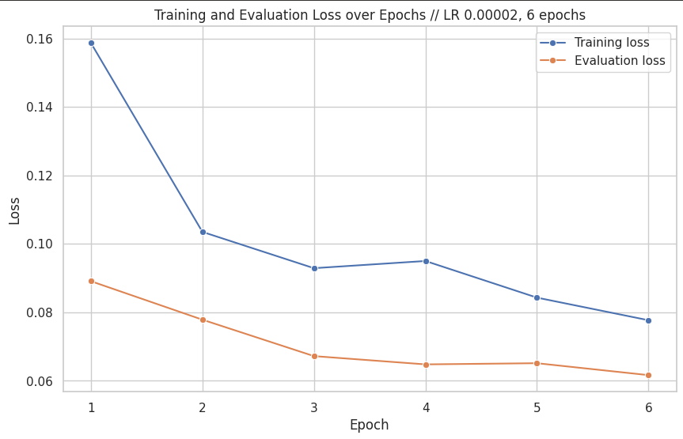

Figure S1. AnonCAT fine-tuning: training and evaluation set loss, over epochs

Supplementary tables

Table S1. Description per dataset
Dataset | Records | Total words | Mean words (IQR) | Prevalence of PHI (%)
Musculoskeletal XR | 550 | 25549 | 46.45 (30-57) | 272 (1.06%)
Musculoskeletal CT | 550 | 40920 | 74.40 (44-94) | 688 (1.68%)
Musculoskeletal MR | 550 | 55513 | 100.93 (58-132) | 452 (0.81%)
General radiology | 1000 | 134385 | 134.49 (61-183) | 1803 (1.34%)
General histopathology | 1000 | 223393 | 223.39 (123-262) | 14281 (6.39%)

Table S2. Frequency of PHI categories within the dataset
PHI category by frequency | PHI subcategory | Count (% of PHI)
Names | Total | 6901 (39.44%)
Names | Patient or relative | 31
Names | Healthcare professional name | 6870
Any other unique identifying number, characteristic, or code | Total | 4758 (21.19%)
Any other unique identifying number, characteristic, or code | Hospital/unit | 570
Any other unique identifying number, characteristic, or code | External healthcare organisation | 1037
Any other unique identifying number, characteristic, or code | Professional details | 3151
Dates | Total | 3641 (20.81%)
Dates | Date | 3628
Dates | Age over 89 years old | 13
Medical record numbers | Total | 1408 (8.05%)
Medical record numbers | Medical record number | 22
Medical record numbers | NHS number | 4
Medical record numbers | Specimen identifier | 1382
Phone numbers | Total | 334 (1.91%)
Address | Total | 133 (0.76%)
Address | House or street number | 35
Address | Street name | 32
Address | City | 27
Address | County | 5
Address | Country | 18
Address | Postcode | 16
Web Universal Resource Locators (URLs) | Total | 144 (0.82%)
Certificate/license numbers | Total | 107 (0.61%)
Certificate/license numbers | GMC number | 103
Certificate/license numbers | NMC number | 0
Certificate/license numbers | Any other license | 4
Electronic email addresses | Total | 59 (0.34%)
Account numbers | Total | 10 (0.06%)
Social security numbers | Total | 1 (0.01%)

Table S3. Per model results for classification of PII vs. non-PII.
Model type | Model name | Number of shots | Precision (95% CI) | Recall (95% CI) | F1 (95% CI)
Inter-annotator |  | N/A | 0.967 (0.932-0.993) | 0.986 (0.971-0.997) | 0.977 (0.957-0.991)
Proprietary de-identification software | Microsoft Azure de-identification service | N/A | 0.916 (0.910-0.922) | 0.950 (0.942-0.957) | 0.933 (0.928-0.938)
Proprietary de-identification software | AnonCAT | No fine-tuning, without requirement to redact professional details | 0.937 (0.930-0.943) | 0.778 (0.767-0.790) | 0.850 (0.843-0.858)
Proprietary de-identification software | AnonCAT | No fine-tuning, with requirement to redact professional details | 0.937 (0.930-0.943) | 0.668 (0.659-0.676) | 0.780 (0.773-0.786)
Proprietary de-identification software | AnonCAT | Fine-tuned, without requirement to redact professional details | 0.981 (0.977-0.985) | 0.787 (0.773-0.800) | 0.873 (0.864-0.882)
Proprietary de-identification software | AnonCAT | Fine-tuned, with requirement to redact professional details | 0.981 (0.977-0.985) | 0.676 (0.665-0.686) | 0.800 (0.843-0.858)
Large language models | Gemma-7b-IT | 0 | 0.047 (0.045-0.048) | 0.870 (0.859-0.880) | 0.089 (0.086-0.092)
Large language models | Gemma-7b-IT | 1 | 0.042 (0.040-0.043) | 0.941 (0.933-0.948) | 0.080 (0.077-0.083)
Large language models | Gemma-7b-IT | 5 | 0.043 (0.042-0.045) | 0.974 (0.969-0.978) | 0.083 (0.080-0.086)
Large language models | Gemma-7b-IT | 10 | 0.021 (0.019-0.023) | 0.905 (0.885-0.923) | 0.041 (0.037-0.044)
Large language models | Llama-3-8B-Instruct | 0 | 0.041 (0.037- 0.045) | 0.943 (0.928- 0.956) | 0.079 (0.072- 0.087)
Large language models | Llama-3-8B-Instruct | 1 | 0.048 (0.043-0.052) | 0.984 (0.976-0.991) | 0.091 (0.083-0.010)
Large language models | Llama-3-8B-Instruct | 5 | 0.110 (0.099-0.121) | 0.990 (0.983-0.995) | 0.198 (0.181-0.216)
Large language models | Llama-3-8B-Instruct | 10 | 0.077 (0.069-0.085) | 0.978 (0.969-0.987) | 0.143 (0.130-0.157)
Large language models | Phi-3-mini-128k-instruct | 0 | 0.080 (0.076-0.084) | 0.829 (0.814-0.845) | 0.146 (0.140-0.153)
Large language models | Phi-3-mini-128k-instruct | 1 | 0.155 (0.145-0.166) | 0.820 (0.804-0.835) | 0.261 (0.246-0.276)
Large language models | Phi-3-mini-128k-instruct | 5 | 0.121 (0.115-0.127) | 0.904 (0.892-0.915) | 0.213 (0.204-0.222)
Large language models | Phi-3-mini-128k-instruct | 10 | 0.297 (0.282-0.314) | 0.904 (0.892-0.915) | 0.448 (0.430-0.467)
Large language models | GPT3.5-turbo-base | 0 | 0.388 (0.371-0.405) | 0.838 (0.822-0.854) | 0.530 (0.514-0.547)
Large language models | GPT3.5-turbo-base | 1 | 0.476 (0.455-0.496) | 0.767 (0.749-0.784) | 0.588 (0.570-0.604)
Large language models | GPT3.5-turbo-base | 5 | 0.764 (0.725-0.796) | 0.761 (0.745-0.777) | 0.763 (0.741-0.781)
Large language models | GPT3.5-turbo-base | 10 | 0.856 (0.812-0.892) | 0.807 (0.788-0.825) | 0.831 (0.807-0.851)
Large language models | GPT-4-0125 | 0 | 0.825 (0.789-0.853) | 0.930 (0.920-0.940) | 0.874 (0.853-0.891)
Large language models | GPT-4-0125 | 1 | 0.814 (0.774-0.848) | 0.931 (0.920-0.941) | 0.868 (0.845-0.888)
Large language models | GPT-4-0125 | 5 | 0.839 (0.797-0.875) | 0.931 (0.921-0.940) | 0.883 (0.858-0.903)
Large language models | GPT-4-0125 | 10 | 0.874 (0.834-0.906) | 0.924 (0.914-0.933) | 0.898 (0.876-0.916)

Table S4. Model precision, recall and F1 score per dataset

Model type | Model name | Number of shots | Dataset | Precision (95% CI) | Recall (95% CI) | F1 (95% CI)
Proprietary de-identification software | Microsoft Azure de-identification service | N/A | Musculoskeletal XR | 0.710 (0.651-0.761) | 0.893 (0.854-0.930) | 0.791 (0.749-0.825)
Proprietary de-identification software | Microsoft Azure de-identification service | N/A | Musculoskeletal CT | 0.818 (0.787-0.847) | 0.965 (0.946-0.981) | 0.886 (0.866-0.903)
Proprietary de-identification software | Microsoft Azure de-identification service | N/A | Musculoskeletal MR | 0.787 (0.747-0.824) | 0.968 (0.949-0.983) | 0.868 (0.841-0.892)
Proprietary de-identification software | Microsoft Azure de-identification service | N/A | General radiology | 0.825 (0.802-0.845) | 0.894 (0.875-0.911) | 0.858 (0.842-0.873)
Proprietary de-identification software | Microsoft Azure de-identification service | N/A | General histopathology | 0.948 (0.942-0.954) | 0.958 (0.949-0.967) | 0.953 (0.947-0.959)
Proprietary de-identification software | AnonCAT | No fine-tuning, without requirement to redact professional details | Musculoskeletal XR | 0.955 (0.920-0.985) | 0.627 (0.565-0.685) | 0.757 (0.709-0.798)
Proprietary de-identification software | AnonCAT |  | Musculoskeletal CT | 0.971 (0.950-0.989) | 0.615 (0.559-0.669) | 0.753 (0.708-0.793)
Proprietary de-identification software | AnonCAT |  | Musculoskeletal MR | 0.955 (0.920-0.985) | 0.627 (0.565-0.685) | 0.757 (0.709-0.798)
Proprietary de-identification software | AnonCAT |  | General radiology | 0.892 (0.865-0.916) | 0.590 (0.544-0.625) | 0.710 (0.681-0.737)
Proprietary de-identification software | AnonCAT |  | General histopathology | 0.939 (0.932-0.947) | 0.825 (0.812-0.838) | 0.879 (0.870-0.887)
Proprietary de-identification software | AnonCAT | No fine-tuning, with requirement to redact professional details | Musculoskeletal XR | 0.955 (0.920-0.984) | 0.562 (0.508-0.616) | 0.707 (0.663-0.749)
Proprietary de-identification software | AnonCAT |  | Musculoskeletal CT | 0.971 (0.950-0.989) | 0.573 (0.526-0.622) | 0.796 (0.790-0.803)
Proprietary de-identification software | AnonCAT |  | Musculoskeletal MR | 0.973 (0.953-0.990) | 0.668 (0.621-0.712) | 0.792 (0.757-0.823)
Proprietary de-identification software | AnonCAT |  | General radiology | 0.892 (0.865-0.916) | 0.565 (0.531-0.597) | 0.691 (0.663-0.717)
Proprietary de-identification software | AnonCAT |  | General histopathology | 0.939 (0.932-0.947) | 0.691 (0.682-0.699) | 0.796 (0.790-0.803)
Proprietary de-identification software | AnonCAT | Fine-tuned, without requirement to redact professional details | Musculoskeletal XR | 0.958 (0.916-0.992) | 0.640 (0.573-0.704) | 0.767 (0.715-0.812)
Proprietary de-identification software | AnonCAT |  | Musculoskeletal CT | 0.955 (0.932-0.975) | 0.735 (0.695-0.776) | 0.830 (0.802-0.858)
Proprietary de-identification software | AnonCAT |  | Musculoskeletal MR | 0.957 (0.930-0.980) | 0.756 (0.708-0.805) | 0.845 (0.812-0.877)
Proprietary de-identification software | AnonCAT |  | General radiology | 0.932 (0.913-0.949) | 0.654 (0.622-0.687) | 0.769 (0.746-0.791)
Proprietary de-identification software | AnonCAT |  | General histopathology | 0.991 (0.987-0.994) | 0.814 (0.798-0.831) | 0.894 (0.883-0.904)
Proprietary de-identification software | AnonCAT | Fine-tuned, with requirement to redact professional details | Musculoskeletal XR | 0.958 (0.916-0.992) | 0.572 (0.511-0.633) | 0.717 (0.667-0.673)
Proprietary de-identification software | AnonCAT | Fine-tuned, with requirement to redact professional details | Musculoskeletal CT | 0.955 (0.932-0.975) | 0.735 (0.695-0.776) | 0.830 (0.802-0.858)
Proprietary de-identification software | AnonCAT | Fine-tuned, with requirement to redact professional details | Musculoskeletal MR | 0.957 (0.930-0.980) | 0.674 (0.629-0.722) | 0.791 (0.757-0.825)
Proprietary de-identification software | AnonCAT | Fine-tuned, with requirement to redact professional details | General radiology | 0.932 (0.913-0.949) | 0.626 (0.594-0.657) | 0.749 (0.725-0.770)
Proprietary de-identification software | AnonCAT | Fine-tuned, with requirement to redact professional details | General histopathology | 0.991 (0.987-0.994) | 0.682 (0.670-0.694) | 0.808 (0.799-0.816)
Large language models | Gemma-7b-IT | 10 | Musculoskeletal radiograph | 0.020 (0.016-0.026) | 0.913 (0.859-0.959) | 0.040 (0.031-0.050)
Large language models | Gemma-7b-IT | 10 | Musculoskeletal CT | 0.031 (0.027-0.035) | 0.886 (0.856-0.913) | 0.060 (0.053-0.067)
Large language models | Gemma-7b-IT | 10 | Musculoskeletal MR | 0.014 (0.012-0.017) | 0.929 (0.899-0.956) | 0.028 (0.023-0.032)
Large language models | Gemma-7b-IT | 10 | General radiology | 0.016 (0.015-0.018) | 0.997 (0.995-0.999) | 0.032 (0.030-0.035)
Large language models | Gemma-7b-IT | 10 | General histopathology | 0.067 (0.065-0.070) | 0.969 (0.962-0.975) | 0.126 (0.121-0.131)
Large language models | Llama-3-8B-Instruct | 10 | Musculoskeletal radiograph | 0.053 (0.041-0.066) | 0.960 (0.923-0.984) | 0.101 (0.079-0.124)
Large language models | Llama-3-8B-Instruct | 10 | Musculoskeletal CT | 0.158 (0.139-0.179) | 0.979 (0.965-0.991) | 0.290 (0.258-0.321)
Large language models | Llama-3-8B-Instruct | 10 | Musculoskeletal MR | 0.049 (0.040-0.059) | 0.988 (0.977-0.996) | 0.094 (0.078-0.111)
Large language models | Llama-3-8B-Instruct | 10 | General radiology | 0.078 (0.071-0.085) | 0.943 (0.929-0.956) | 0.143 (0.132-0.156)
Large language models | Llama-3-8B-Instruct | 10 | General histopathology | 0.233 (0.215-0.253) | 0.976 (0.971-0.980) | 0.376 (0.353-0.402)
Large language models | Phi-3-mini-128k-instruct | 10 | Musculoskeletal radiograph | 0.124 (0.105-0.143) | 0.781 (0.740-0.819) | 0.213 (0.184-0.242)
Large language models | Phi-3-mini-128k-instruct | 10 | Musculoskeletal CT | 0.263 (0.236-0.294) | 0.909 (0.889-0.929) | 0.408 (0.375-0.444)
Large language models | Phi-3-mini-128k-instruct | 10 | Musculoskeletal MR | 0.114 (0.099-0.132) | 0.934 (0.912-0.954) | 0.204 (0.179-0.231)
Large language models | Phi-3-mini-128k-instruct | 10 | General radiology | 0.169 (0.152-0.188) | 0.795 (0.766-0.822) | 0.279 (0.254-0.304)
Large language models | Phi-3-mini-128k-instruct | 10 | General histopathology | 0.192 (0.182-0.202) | 0.949 (0.941-0.956) | 0.319 (0.306-0.334)
Large language models | GPT3.5-turbo-base | 10 | Musculoskeletal radiograph | 0.416 (0.333-0.497) | 0.783 (0.726-0.837) | 0.544 (0.466-0.611)
Large language models | GPT3.5-turbo-base | 10 | Musculoskeletal CT | 0.746 (0.675-0.805) | 0.913 (0.882-0.945) | 0.821 (0.775-0.860)
Large language models | GPT3.5-turbo-base | 10 | Musculoskeletal MR | 0.621 (0.559-0.683) | 0.929 (0.897-0.958) | 0.745 (0.697-0.789)
Large language models | GPT3.5-turbo-base | 10 | General radiology | 0.596 (0.438-0.778) | 0.673 (0.637-0.708) | 0.632 (0.532-0.726)
Large language models | GPT3.5-turbo-base | 10 | General histopathology | 0.953 (0.931-0.968) | 0.817 (0.794-0.839) | 0.880 (0.862-0.896)
Large language models | GPT-4-0125 | 10 | Musculoskeletal radiograph | 0.541 (0.432-0.639) | 0.886 (0.848-0.922) | 0.672 (0.580-0.744)
Large language models | GPT-4-0125 | 10 | Musculoskeletal CT | 0.758 (0.683-0.822) | 0.970 (0.953-0.985) | 0.851 (0.801-0.890)
Large language models | GPT-4-0125 | 10 | Musculoskeletal MR | 0.738 (0.679-0.792) | 0.972 (0.957-0.985) | 0.839 (0.800-0.873)
Large language models | GPT-4-0125 | 10 | General radiology | 0.586 (0.456-0.719) | 0.849 (0.829-0.868) | 0.693 (0.593-0.781)
Large language models | GPT-4-0125 | 10 | General histopathology | 0.967 (0.948-0.978) | 0.932 (0.920-0.943) | 0.949 (0.938-0.958)

Supplementary figures

Figure S1. LLM performance by shot

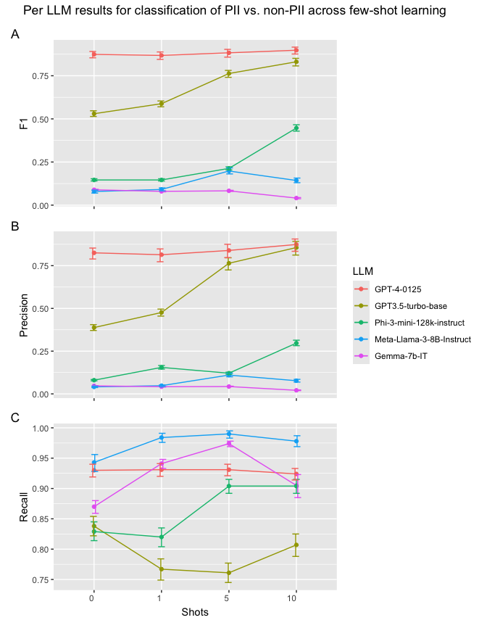

Supplementary references
1. Mavon K. Microsoft De-Identification Service. https://techcommunity.microsoft.com/t5/healthcare-and-life-sciences/announcing-a-de-identification-service-for-health-and-life/ba-p/3949712 Web site. . Accessed June, 2024
2. Kraljevic Z, Shek A, Yeung JA, et al. Validating transformers for redaction of text from electronic health records in real-world healthcare. 2023 IEEE 11th International Conference on Healthcare Informatics (ICHI)
3. Team G, Mesnard T, Hardin C, et al. Gemma: Open models based on gemini research and technology. arXiv preprint arXiv:2403.08295. 2024
4. Abdin M, Jacobs SA, Awan AA, et al. Phi-3 technical report: A highly capable language model locally on your phone. arXiv preprint arXiv:2404.14219. 2024
5. Achiam J, Adler S, Agarwal S, et al. Gpt-4 technical report. arXiv preprint arXiv:2303.08774. 2023

