Category | AM  moisture | NPSH  moisture | Local  moisture | Total  amount
Heavy Meiyu-Baiu season | 20.0 (43.1) | 13.6 (29.4) | 3.3 (7.2) | 46.3
Light Meiyu-Baiu season | 17.9 (42.3) | 11.6 (27.5) | 4.1 (9.7) | 42.2
Normal Meiyu-Baiu season | 20.4 (45.2) | 11.7 (25.9) | 3.9 (8.7) | 45.1
Average | 19.5 (43.7) | 12.2 (27.4) | 3.8 (8.5) | 44.6

TABLE S1. Contribution (mm) of major moisture sources to the total precipitable water in Kyushu for the heavy, light, and normal Meiyu-Baiu seasons. Numbers with brackets are for percentage of major moisture sources to the precipitable water. Total amount of precipitable water (mm) for each category were shown in last column. Arithmetic average values for the 20 Meiyu-Baiu seasons are shown in the last row.

Category | Year | Simulated  rainfall  (mm) | Observed  rainfall  (mm)
Heavy Meiyu-Baiu season | 2010 | 839.24 | 998.06
Heavy Meiyu-Baiu season | 2011 | 932.36 | 1075.55
Heavy Meiyu-Baiu season | 2012 | 1046.20 | 1060.89
Heavy Meiyu-Baiu season | 2015 | 1030.96 | 1171.54
Heavy Meiyu-Baiu season | 2018 | 827.37 | 928.45
Heavy Meiyu-Baiu season | 2020 | 1191.32 | 1373.56
Light Meiyu-Baiu season | 2004 | 344.60 | --
Light Meiyu-Baiu season | 2005 | 451.10 | --
Light Meiyu-Baiu season | 2009 | 589.06 | 715.37
Light Meiyu-Baiu season | 2013 | 559.46 | 542.14
Light Meiyu-Baiu season | 2017 | 511.27 | 658.50
Light Meiyu-Baiu season | 2021 | 511.70 | 641.01
Normal Meiyu-Baiu season | 2006 | 753.59 | 1090.41
Normal Meiyu-Baiu season | 2007 | 714.84 | 918.03
Normal Meiyu-Baiu season | 2008 | 593.11 | 756.54
Normal Meiyu-Baiu season | 2014 | 669.54 | 881.76
Normal Meiyu-Baiu season | 2016 | 818.74 | 1024.93
Normal Meiyu-Baiu season | 2019 | 710.96 | 942.93
Normal Meiyu-Baiu season | 2022 | 649.51 | 771.58
Normal Meiyu-Baiu season | 2023 | 693.74 | 837.14

TABLE S2. Category with simulated and observed Meiyu-Baiu rainfall averaged over Kyushu region for each year during 2004-2023. Unit of rainfall is mm. JMA Radar observed rainfall data is available from 2006 to 2023.

Category | Date  (YYYY/MM/DD) | Simulated  rainfall  (mm/day) | Observed  rainfall  (mm/day) | Date  (YYYY/MM/DD) | Simulated  rainfall  (mm/day) | Observed  rainfall  (mm/day)
Meiyu-Baiu event | 2005/07/05 | 48.03 |  | 2015/06/02 | 49.06 | 71.03
Meiyu-Baiu event | 2007/07/06 | 63.17 | 79.73 | 2015/06/08 | 47.09 | 56.36
Meiyu-Baiu event | 2008/06/11 | 59.47 | 58.42 | 2015/06/17 | 64.69 | 52.24
Meiyu-Baiu event | 2008/06/15 | 85.64 | 38.27 | 2016/06/12 | 59.67 | 28.86
Meiyu-Baiu event | 2008/06/16 | 51.35 | 30.64 | 2016/06/20 | 56.40 | 65.72
Meiyu-Baiu event | 2009/06/23 | 53.39 | 48.37 | 2016/06/27 | 69.37 | 62.77
Meiyu-Baiu event | 2009/07/21 | 48.66 | 33.32 | 2016/06/28 | 45.50 | 65.73
Meiyu-Baiu event | 2010/06/17 | 56.43 | 34.71 | 2016/07/08 | 104.81 | 85.53
Meiyu-Baiu event | 2010/06/18 | 46.88 | 54.80 | 2016/07/13 | 46.38 | 57.34
Meiyu-Baiu event | 2010/06/20 | 65.87 | 49.54 | 2017/06/24 | 63.74 | 68.30
Meiyu-Baiu event | 2010/06/22 | 51.40 | 48.08 | 2018/06/19 | 83.87 | 83.42
Meiyu-Baiu event | 2010/06/25 | 66.27 | 64.54 | 2018/06/20 | 59.70 | 47.53
Meiyu-Baiu event | 2011/06/10 | 76.32 | 79.40 | 2018/07/05 | 65.88 | 50.86
Meiyu-Baiu event | 2011/06/11 | 67.28 | 58.49 | 2018/07/06 | 116.82 | 113.97
Meiyu-Baiu event | 2011/06/12 | 45.89 | 64.40 | 2018/07/07 | 70.96 | 42.61
Meiyu-Baiu event | 2011/06/15 | 73.62 | 81.79 | 2019/07/03 | 76.45 | 75.66
Meiyu-Baiu event | 2011/06/18 | 45.55 | 70.10 | 2019/07/13 | 50.22 | 55.78
Meiyu-Baiu event | 2011/06/19 | 51.63 | 64.50 | 2020/06/18 | 58.78 | 49.04
Meiyu-Baiu event | 2011/07/04 | 47.59 | 25.84 | 2020/06/27 | 66.42 | 82.33
Meiyu-Baiu event | 2011/07/05 | 51.19 | 43.66 | 2020/07/03 | 85.45 | 95.41
Meiyu-Baiu event | 2012/06/15 | 84.18 | 93.46 | 2020/07/05 | 81.52 | 93.73
Meiyu-Baiu event | 2012/06/20 | 59.17 | 31.81 | 2020/07/06 | 73.06 | 94.44
Meiyu-Baiu event | 2012/06/21 | 60.52 | 51.15 | 2020/07/07 | 87.99 | 84.86
Meiyu-Baiu event | 2012/06/23 | 61.05 | 67.48 | 2021/06/15 | 84.30 | 44.02
Meiyu-Baiu event | 2012/06/24 | 68.17 | 52.41 | 2022/06/20 | 47.18 | 56.76
Meiyu-Baiu event | 2012/06/27 | 56.18 | 47.72 | 2022/07/15 | 54.07 | 49.04
Meiyu-Baiu event | 2012/07/11 | 49.40 | 42.20 | 2023/06/01 | 50.10 | 59.08
Meiyu-Baiu event | 2013/06/25 | 60.12 | 41.55 | 2023/06/10 | 61.99 | 44.17
Meiyu-Baiu event | 2014/06/17 | 52.43 | 44.16 | 2023/07/02 | 48.50 | 43.63
Meiyu-Baiu event | 2014/06/21 | 86.20 | 83.44 | 2023/07/03 | 56.53 | 52.89
Meiyu-Baiu event | 2014/06/27 | 47.11 | 40.98
Extratropical cyclone event | 2009/07/24 | 55.46 | 68.91 | 2019/07/10 | 58.21 | 37.87
Extratropical cyclone event | 2015/06/30 | 68.05 | 67.10 | 2021/06/03 | 78.51 | 66.13
Extratropical cyclone event | 2017/06/20 | 48.04 | 50.54 | 2022/06/05 | 68.74 | 62.47
Extratropical cyclone event | 2019/06/14 | 56.40 | 46.82
Typhoon event | 2007/07/13 | 58.52 | 61.20 | 2019/07/20 | 47.09 | 64.52
Typhoon event | 2018/07/03 | 69.84 | 50.95

TABLE S3. Date, simulated and observed rainfall amount averaged over Kyushu region, and event type for the identified 71 extreme rainfall events during the 20 Meiyu-Baiu seasons from 2004 to 2023.

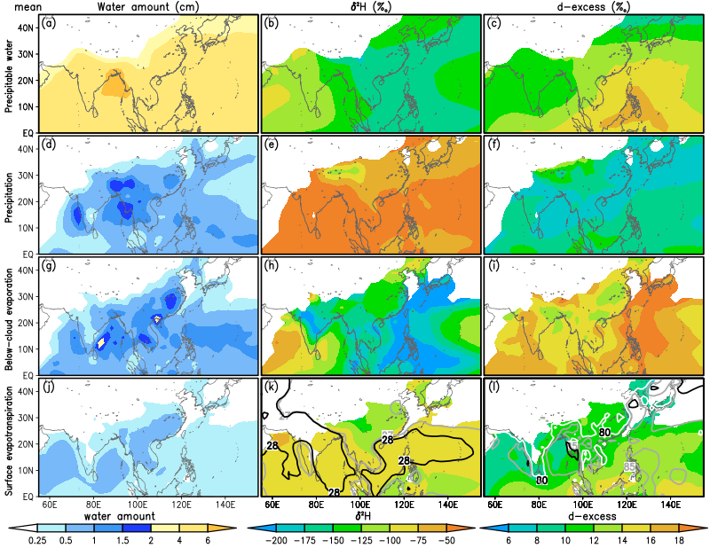
Figure S1. (a–c) Spatial distribution of the IsoGSM simulated total precipitable water (cm), δ²H (‰), and d-excess (‰) in precipitable water (shaded) averaged during the 20 Meiyu-Baiu seasons during 2004-2023. Data with precipitable water of less than 2.5 cm have been suppressed. (d–f) Same as (a–c), but for precipitation. Data with precipitation of less than 0.25 cm day⁻¹ have been suppressed. (g–i) Same as (d–f), but for below-cloud evaporation calculated as condensation minus precipitation. (j–l) Same as (d–f), but for surface evapotranspiration, and δ²H and d-excess of 2-m water vapor. Data with evapotranspiration of less than 0.25 cm day⁻¹ have been suppressed. Contours in (k) indicate the IsoGSM simulated 2-m air temperature (unit of °C; gray lines are for 27°C and black lines are for 28°C). Contours in (l) show 2-m relative humidity obtained from the JRA55 (unit of %; white lines are for 80%, gray lines are for 85%, and black lines are for 90%).

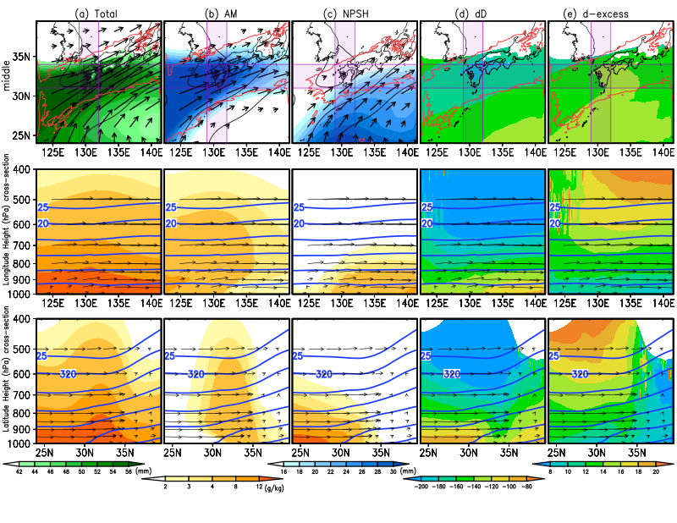
Figure S2. (a) (Upper panel) Horizontal distributions of the IsoRSM simulated total precipitable water (shaded, unit is mm), total condensation (red contour at 0.5 mm h⁻¹), total integrated moisture flux (black vectors, units of kg m⁻¹ s⁻¹, and fluxes of less than 50 kg m⁻¹ s⁻¹ have been suppressed), and SLP (black contours at 1005, 1008, and 1011 hPa); (middle panel) vertical distributions of the total specific humidity (shaded, unit is g kg⁻¹), potential temperature θ (contours, units of K and interval of 5 K), and zonal and vertical wind (vectors, unit is m s⁻¹ for zonal wind and Pa s⁻¹ for vertical wind) averaged over purple shaded zonal zone between 31° N and 34° N for the 61 extreme Meiyu-Baiu rainfall events in the upper panel; (lower panel) same as (middle panel) but for an purple shaded meridional zone between 129° E and 132° E in the upper panel. (b) Same as (a), but for Asian monsoon (AM) moisture. Red contour in the upper panel shows condensation with 0.2 mm h⁻¹. (c) Same as (b), but for North Pacific subtropical high (NPSH) moisture. (d) Same as (c), but for local moisture.

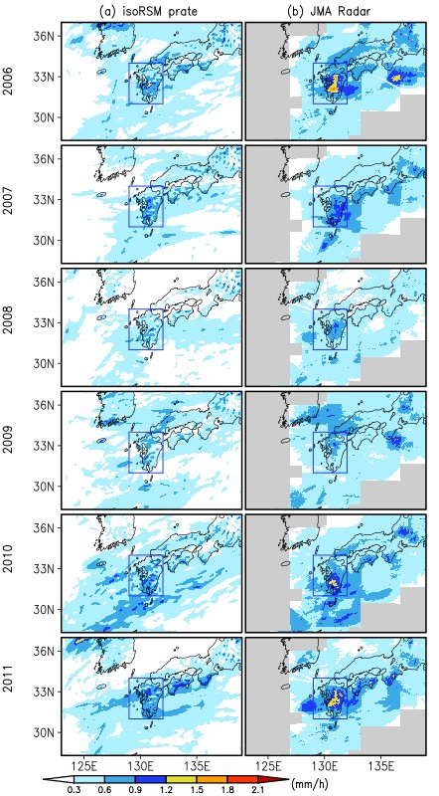
Figure S3. JMA radar observed mean precipitation (a) and corresponding model-simulated precipitation (b) during Meiyu-Baiu season (June-July) from 2006 to 2011. Kyushu region is shown by the solid blue rectangle.
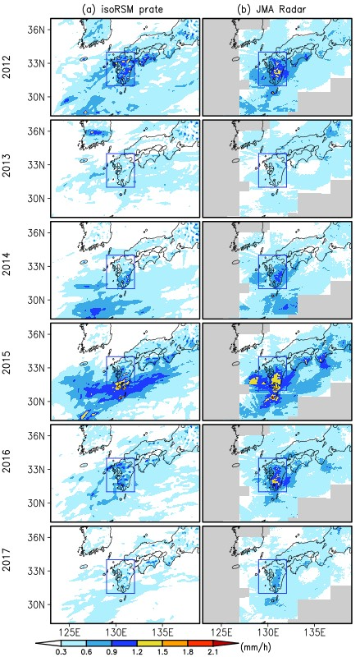
Figure S4. Same as Fig. S3, but for years from 2012 to 2017.

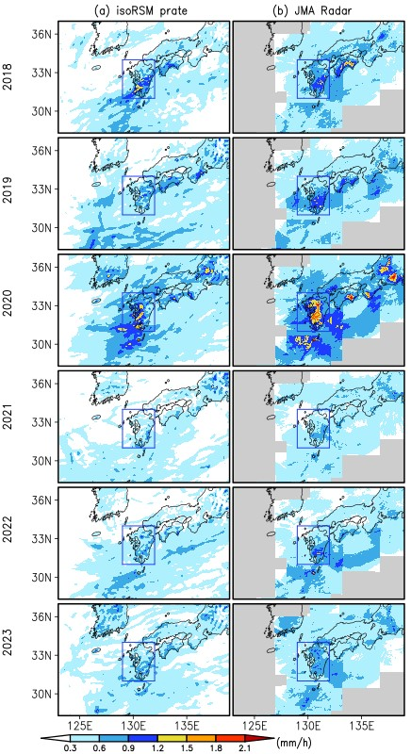
Figure S5. Same as Fig. S3, but for years from 2018 to 2023.

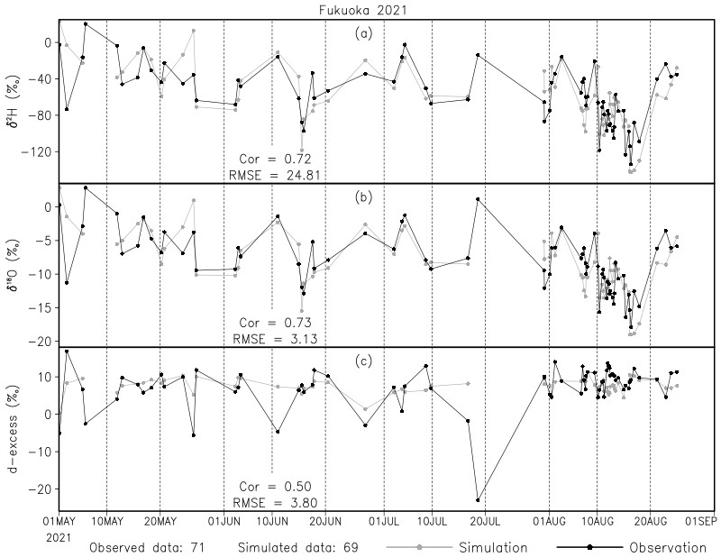
Figure S6. The time series of all observed and corresponding model-simulated δ²H, δ¹⁸O, and d-excess in the precipitation at Fukuoka from May 1 to August 31, 2021.

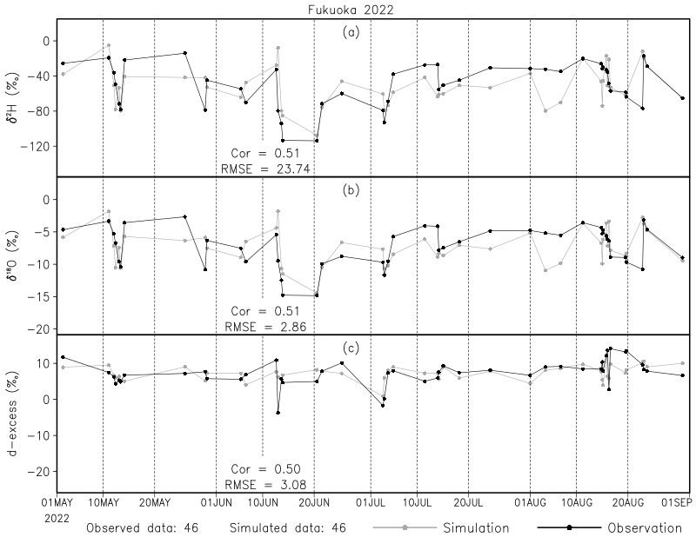
Figure S7. Same as Fig. S6, but for precipitation at Fukuoka in 2022.

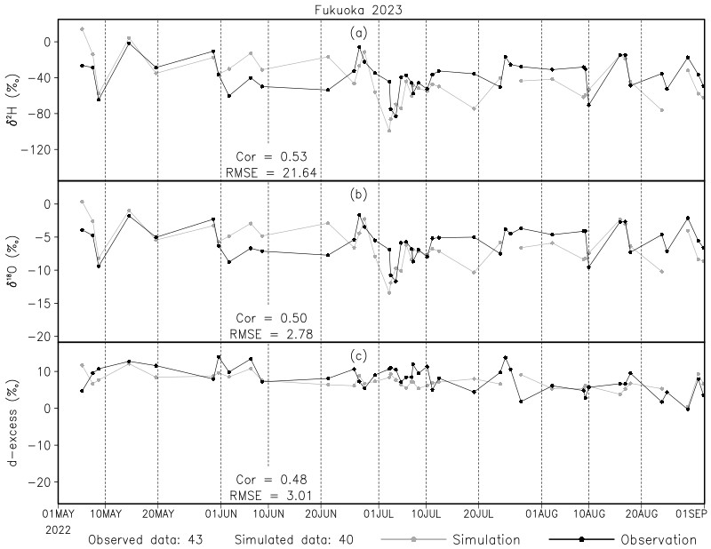
Figure S8. Same as Fig. S6, but for precipitation at Fukuoka in 2023.

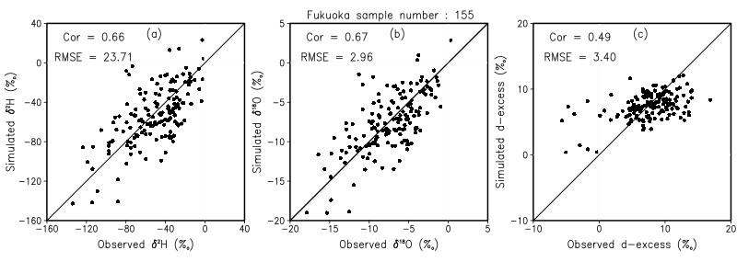
Figure S9. Scatter diagram of all observed and IsoRSM simulated δ²H (a), δ¹⁸O (b), and d-excess (c) in precipitation at Fukuoka in southwestern Japan from May 1 to August 31, in 2021, 2022, and 2023. The location of the sampling site is shown in Figs. 1.

