Supporting Information for
Targeting modulation of the choroid plexus blood-CSF barrier and CSF hypersecretion via lipid nanoparticle-mediated co-delivery siRNA and resveratrol
Authors: Qiguang Wang^{1,2*}, Xue Xia^{2*}, Huan Zhang¹, Yue Li⁴, Lei Zhu³, Yulong Shi², Yuzhao Tang², Jian Cheng¹, Xuhui Hui¹, Huile Gao^{2#}

1.Department of Neurosurgery, West China Hospital, Sichuan University, Chengdu 610041, China
2.Key Laboratory of Drug-Targeting and Drug Delivery System of the Education Ministry, West China School of Pharmacy, Sichuan University, Chengdu 610041, China
3.Institute of Thoracic Oncology, West China Hospital, Sichuan University, Chengdu 610041, China
4.Research Core Facility of West China Hospital, Sichuan University, Chengdu 610041, China

*These authors contributed equally and should be considered as co-first authors.

#Corresponding author:
Huile Gao
Key Laboratory of Drug-Targeting and Drug Delivery System of the Education Ministry, West China School of Pharmacy, Sichuan University, Chengdu 610041, China
E-mail address: gaohuile@scu.edu.cn (Huile Gao)
Tel./fax: +86 187 80288069 (Huile Gao)

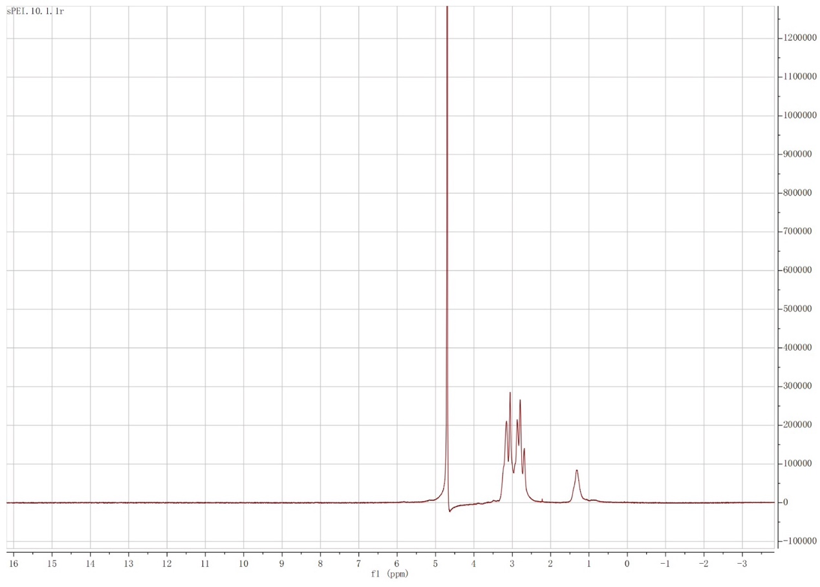
Figure S1. ¹H Nuclear Magnetic Resonance (¹ H NMR,400 MHz) spectra of sPEI (δ 3.16–2.47 (m, NCH2CH2N, NCH2CHMeS), 1.30–1.15 (m, CH3)).

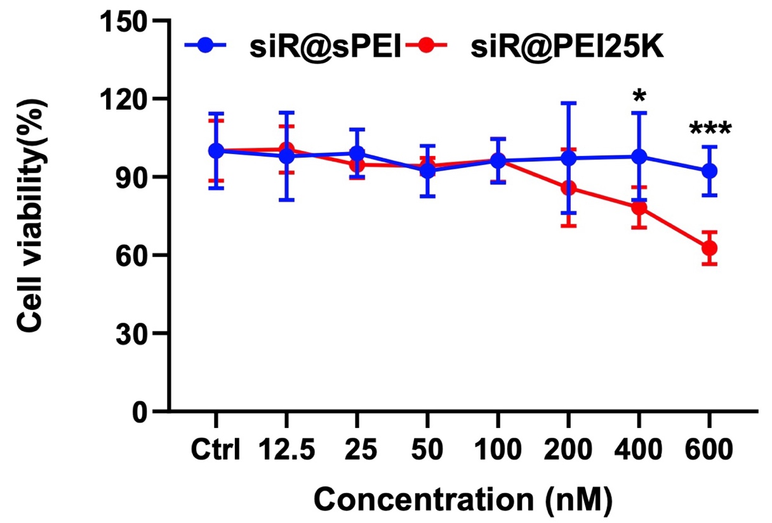
Figure S2. Cell viability of CP cells after incubation with siR@sPEI and siR@PEI25K
Figure S3. Gene silence efficiency of siRNA with different sequences on (A) Primary ChP epithelial cells, (B) HT22 cells and (C) MC3T3 cells. * p＜0.05, **p＜0.01，***p＜0.001 and ****p＜0.0001 by One way ANOVA Dunnett’s test or student t-test.

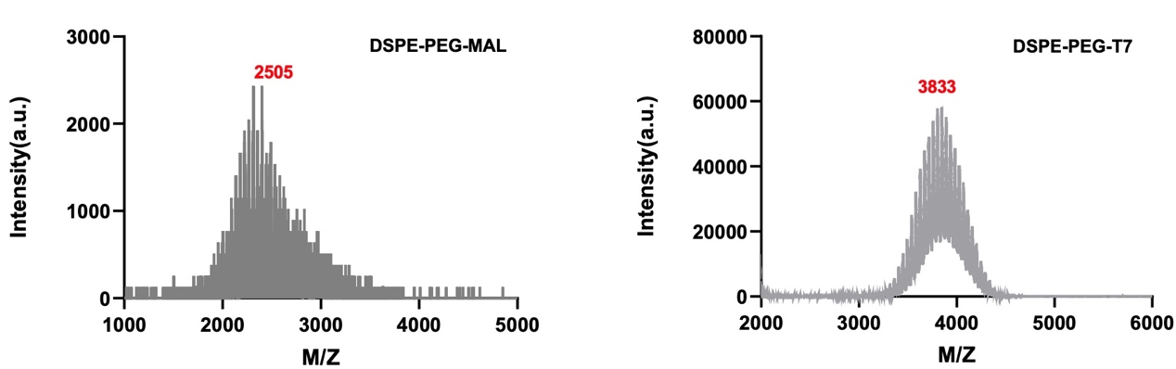
Figure S4. Mass spectra of DSPE-PEG-MAL and DSPE-PEG-T7.

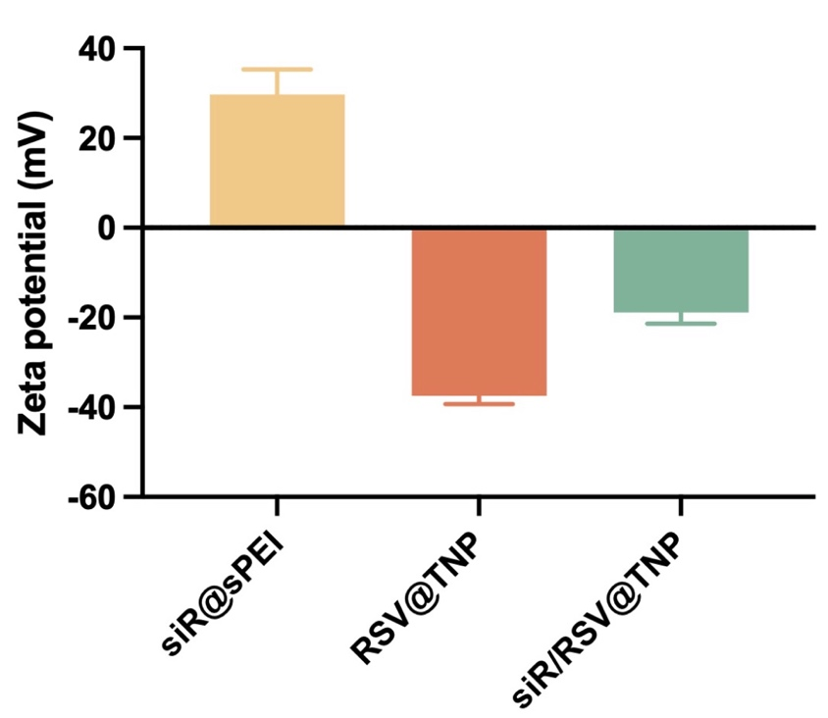
Figure S5. Zeta potential of different formulations.

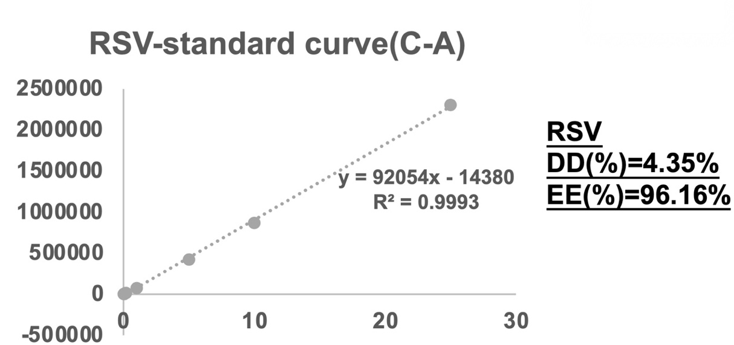
Figure S6. Standard curve of RSV obtained by HPLC analysis.

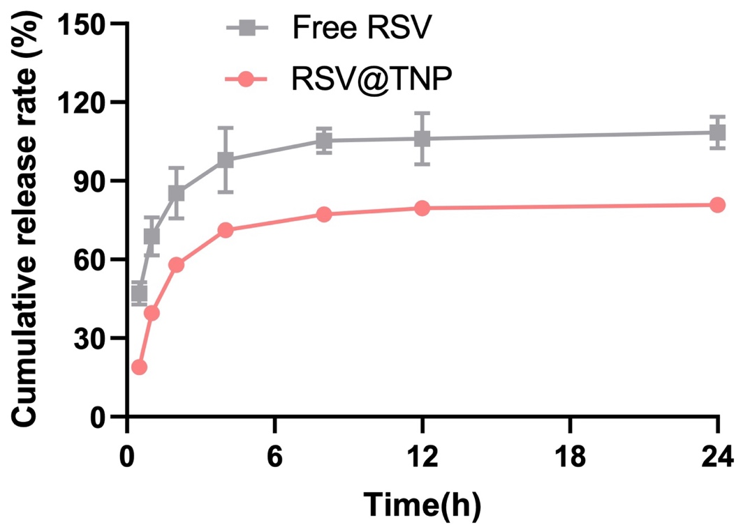
Figure S7. In vitro release of free and RSV/ TNP in PBS containing 1% Tween 80 at pH 7.4.

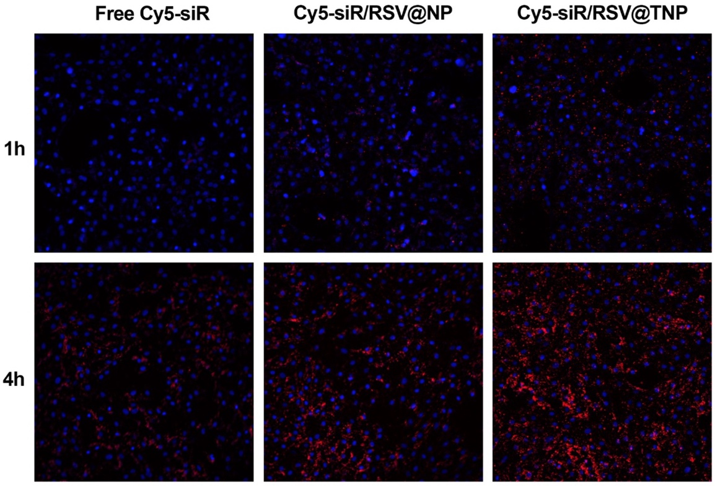
Figure S8. Confocal imaging of cellular uptake of Cy5-siR, RSV/Cy5-siR@NP, RSV/Cy5-siR@TNP.

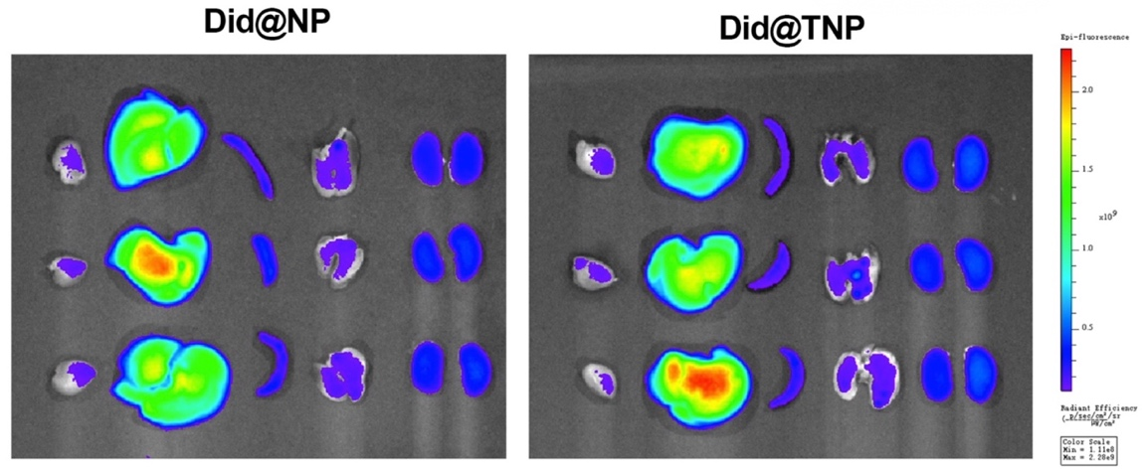
Figure S9. Ex vivo imaging of major organs (heart, liver, spleen, lung, kidney) excised at 2h post administration.

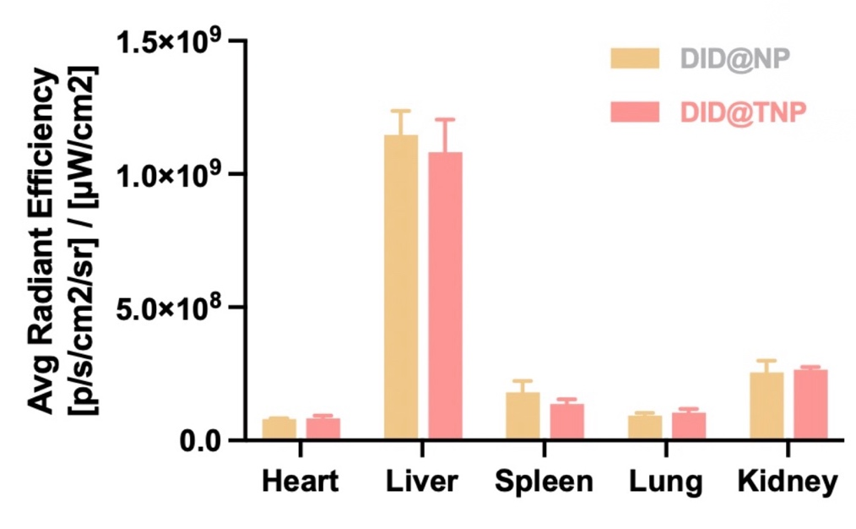
Figure S10. The semiquantitative data on fluorescence intensity are presented as mean ± SD, n=3.

Figure S11. Distribution of Did-siR@TNP (A) and Did-siR@NP (B) in the choroid plexus. Scale bars, 10μm.

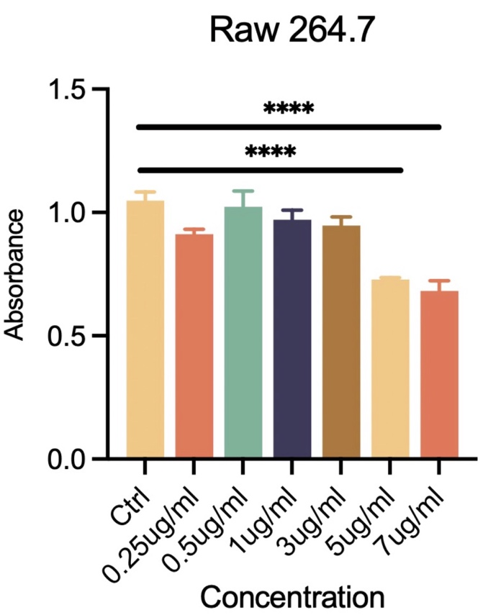
Figure S12. CCK8 results of RAW264.7 cells treated by siR/RSV@TNP with different concentrations. Results are presented as mean ± SD, n=3.

Figure S13. siR/RSV@TNP reduced LPS-induced p-NKCC1 in ChP epithelial cells. (A) Western blot results of p-NKCC1. (B) Immunofluorescence results of p-NKCC1. Scale bars, 10μm.

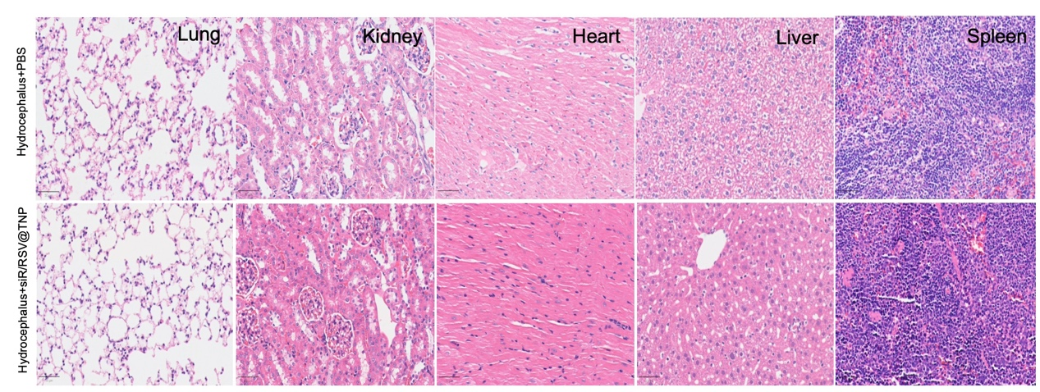
Figure S14. Hematoxylin and eosin staining of brains after treatment, Scale bars, 50μm.

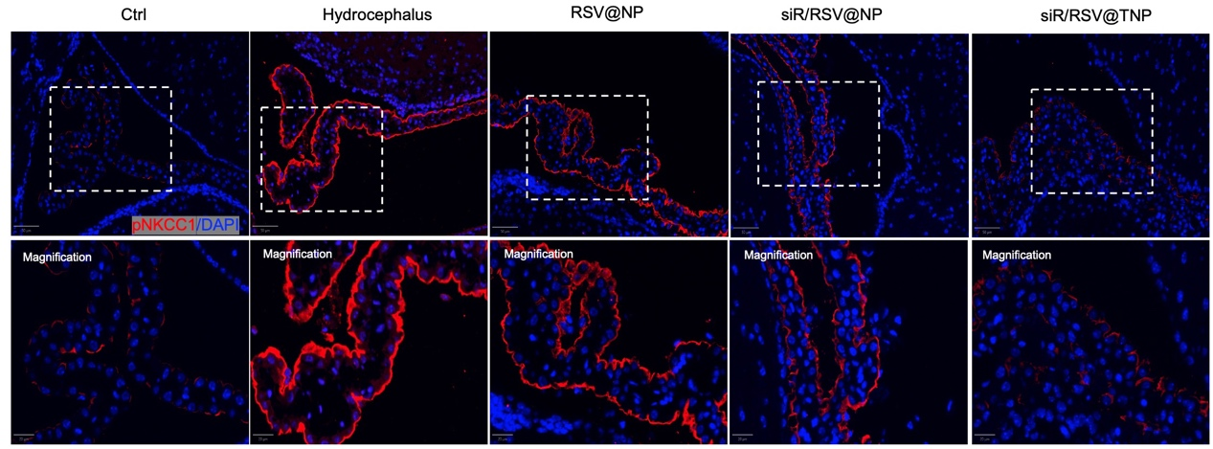

Figure S15. The expression of pNKCC1 in choroid plexus of Ctrl and hydrocephalus mice treated with various lipid nanoparticles. Scale bars, 20 μm.

Table S1: Primer Sequence of Gene designed for Q-PCR.
mRNA |  | Primer pairs
SPAK | FP | TTGCTGACACGAACACCAGACATAG
SPAK | RP | CCAGTCGCCATCTTCAGTCTTGTG
ZO-1 | FP | TGATGATCGTCTGTCCTACCTGTC
ZO-1 | RP | CCGCCTTCTGTATCTGTGTCTTC
NKCC1 | FP | GGGTCAGGCTGGAATAGGTCTCTC
NKCC1 | RP | ATGCTCCTCCTCCTCTCACGAATC
TNF-α | FP | ATGGGCTCCCTCTCATCAGTTCC
TNF-α | RP | CCTCCGCTTGGTGGTTTGCTAC
CCL2 | FP | CTCACCTGCTGCTACTCATTCACTG
CCL2 | RP | CTTCTTTGGGACACCTGCTGCTG
KCNJ13 | FP | GTCCCGCCTGAAAACCACACTATC
KCNJ13 | RP | TGGTGCCATAGCCGATTGTAAGTTG
IL-1β | FP | AATCTCACAGCAGCATCTCGACAAG
IL-1β | RP | TCCACGGGCAAGACATAGGTAGC
SPAK (mouse) | FP | GAGCGATGACGAGATGGATGAGAAG
SPAK (mouse) | RP | GCCACCAGCATTCACCGAGATC
CCL2(mouse) | FP | ACTCACCTGCTGCTACTCATTCAC
CCL2(mouse) | RP | TCTTTGGGACACCTGCTGCTG
IL-6(mouse) | FP | TTCTTGGGACTGATGCTGGTGAC
IL-6(mouse) | RP | GTGGTATCCTCTGTGAAGTCTCCTC

