Synthesis, H₂S releasing properties, antiviral and antioxidant activities and acute cardiac effects of nucleoside 5’-dithioacetates
Miklós Bege,^{1,2,3}* Miklós Lovas,¹ Dániel Priksz,⁴ Brigitta Bernát,⁴ Ilona Bereczki,^{1,5,6} Rasha Ghanem Kattoub,^{1,7} Richárd Kajtár,^{7,8} Simon Eskeif, ^{7,8} Levente Novák,⁹ Jan Hodek,¹⁰ Jan Weber,¹⁰ Pál Herczegh,¹ István Lekli,⁸ Anikó Borbás^{1,2,6}*
¹Department of Pharmaceutical Chemistry, Faculty of Pharmacy, University of Debrecen, Egyetem tér 1, 4032 Debrecen, Hungary; ²HUN-REN-UD Molecular Recognition and Interaction Research Group, University of Debrecen, Egyetem tér 1, 4032 Debrecen, Hungary; ³Institute of Healthcare Industry, University of Debrecen, 4032, Debrecen, Nagyerdei krt. 98, Hungary; ⁴Department of Pharmacology and Pharmacotherapy, Faculty of Medicine, University of Debrecen, Nagyerdei krt. 98, 4032 Debrecen, Hungary; ⁵HUN-REN-UD Pharmamodul Research Group, University of Debrecen, Nagyerdei krt. 98, 4032 Debrecen, Hungary; ⁶National Laboratory of Virology, University of Pécs, Ifjúság útja 20, H-7624 Pécs, Hungary; ⁷Doctoral School of Pharmaceutical Sciences, Faculty of Pharmacy, University of Debrecen, Nagyerdei krt. 98., 4032 Debrecen, Hungary; ⁸Department of Pharmacodynamics, Faculty of Pharmacy, University of Debrecen, Debrecen, Hungary, ⁹Department of Physical Chemistry, Faculty of Science and Technology, University of Debrecen, Debrecen, Hungary; ¹⁰Institute of Organic Chemistry and Biochemistry of the Czech Academy of Science, Prague, 166 10, Czech Republic

Supporting Information

Table of contents

The effect of the compounds on the viability of H9c2 cells measured by MTT assay S3
Anti-SARS-CoV-2 activity and cytotoxicity determination in Calu-3 cells S4
HPLC measurments S5
NMR spectra of the compounds S8

The effect of the compounds on the viability of H9c2 cells measured by MTT assay
Figure S1. Cell viability assay using the MTT method. H9c2 cells were treated with different concentrations (1 µM, 3 µM, 10 µM, 30 µM, 100 µM, 300 µM, 500 µM 1000 µM) of nucleoside analogues or their metabolites and vehicle treated cells were used as control. The measurements were carried out in duplicates. Columns represent the mean ± SEM, (n = 8).

Anti-SARS-CoV-2 activity and cytotoxicity determination in Calu-3 cells
Figure S2. Inhibitory activity of compounds on virus-induced cytopathic effect (CPE) in Calu-3 cells (antiviral EC₅₀ graphs)

Figure S3. Effect of compounds on viability of Calu-3 cells(CC₅₀ graphs)

HPLC measurments
The purity of compounds 22, 32 and 34 was assessed via high-perfomance liquid chromatography (HPLC) measurements, using a LaChrom L-7200 device equipped with a X-Terra MS C18 3,5 µm 3,0×150 column, a L-7400 UV detector and L7100 pump. Samples were eluted with an gradient elution using eluent A (0.05% phosphoric acid in water) and eluent B (0.05% phosphoric acid in acetonitrile). The flow rate was set to 0.5 ml/min. The initial condition was 0% B eluent, followed by a linear gradient to 100% B eluent by 6 min; from 6 to 11.2 min 100% B eluent was retained and then from 11.2 to 13.5 min it was returned to the initial condition and retained to 3.5 min. The column temperature was kept at 30 ºC and the injection volume was 4.0 µL.
For RP-HPLC measurements of compound 22 a Waters 2695 Separations Module (Waters Corp., Milford, USA) was used. The separations were carried out on a VDSphere PUR 100 C18-M-SE, 5 μm, 150 x 4.6 mm column at an injection volume of 10 μL, using a flow rate of 1.0 mL/min with a Waters 2996 DAD as detector set at 254 nm. The following system was used for the elution: Solvent A: Water : MeCN 9 : 1 + 0.0025 V/V% TFA and Solvent B: MeCN. Gradient elution: from 20% of B to 80% from 0 to 40 min and 80% of B from 40-50 min.

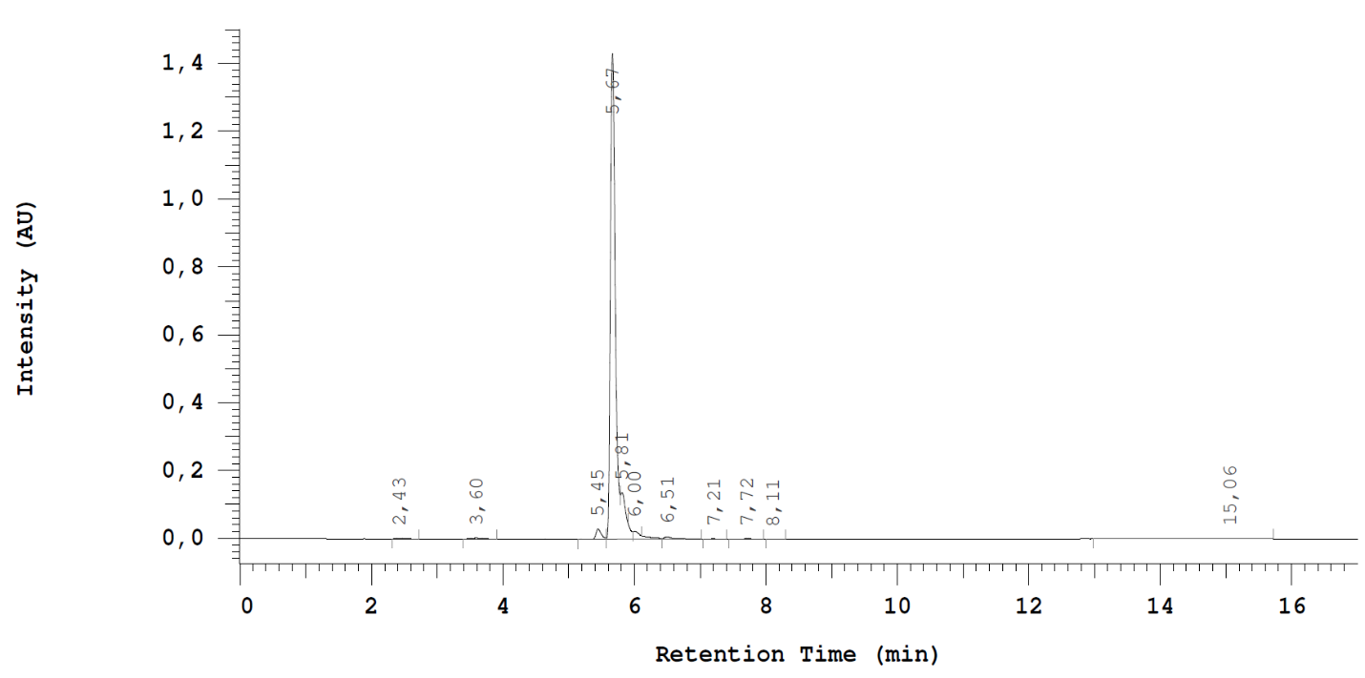
Figure S4. HPLC chromatogram of compound 32
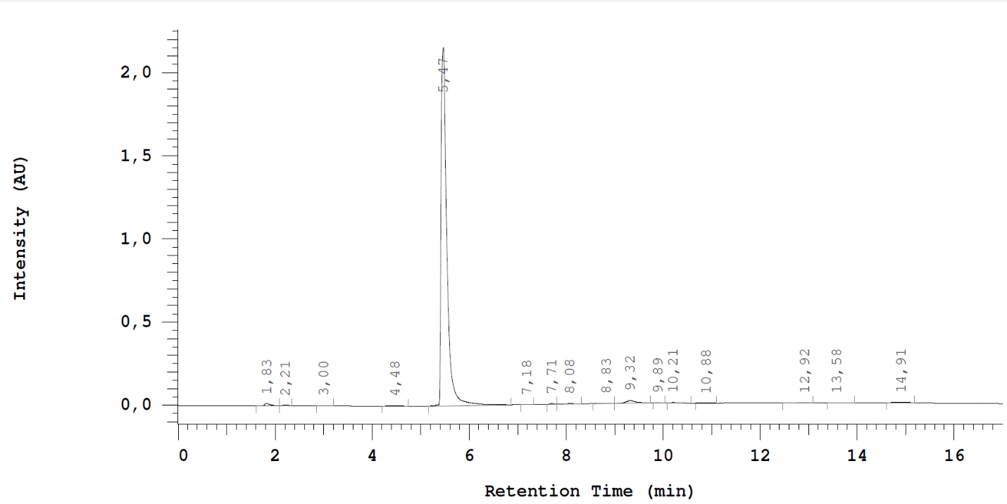
Figure S5. HPLC chromatogram of compound 34

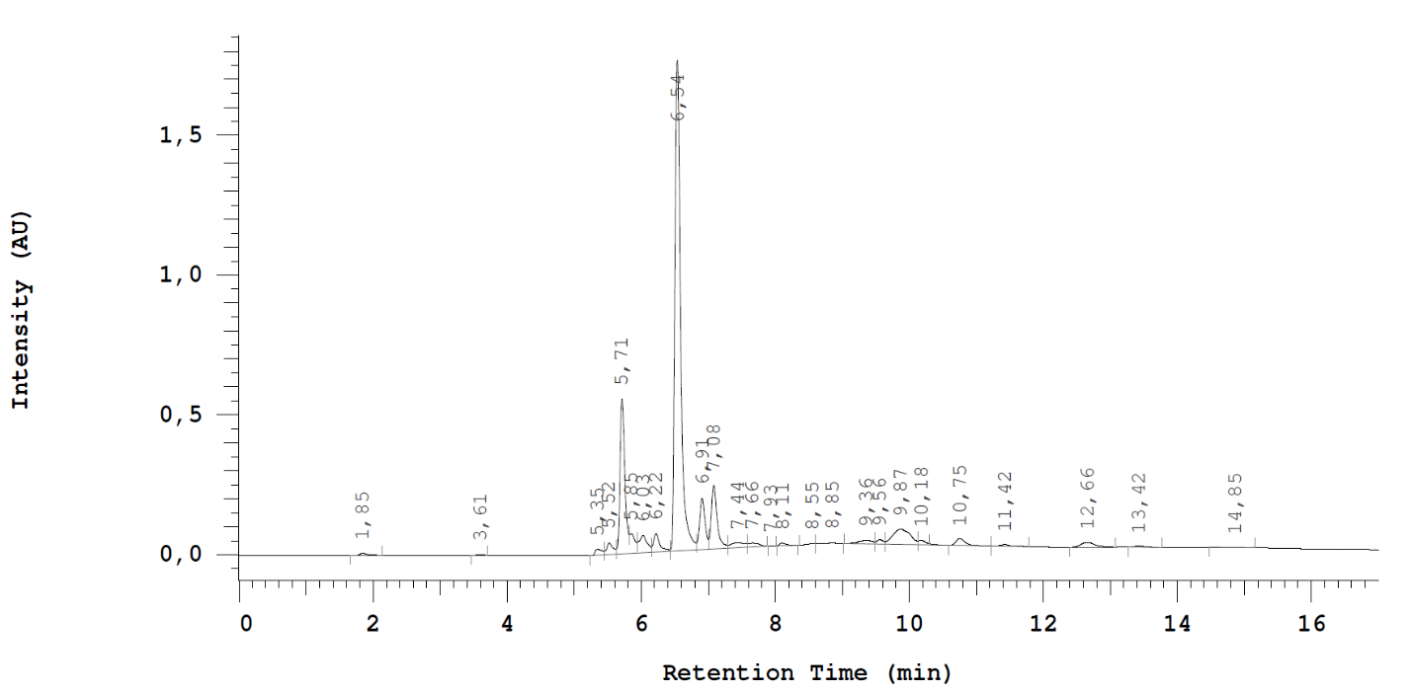
Figure S6. HPLC chromatogram of compound 22

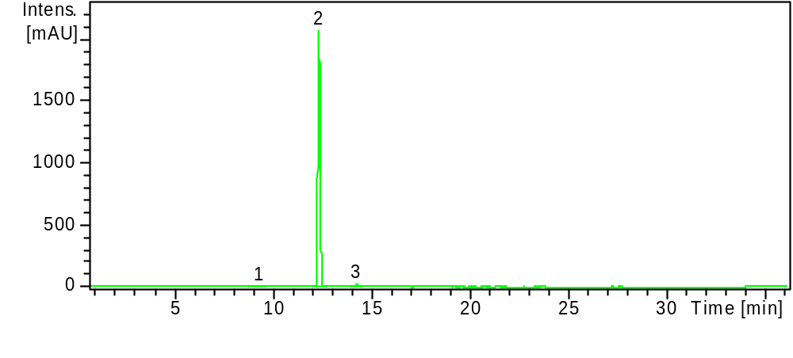
Figure S7: RP-HPLC chromatogram of compound 22

NMR spectra of the compounds
Compound 13
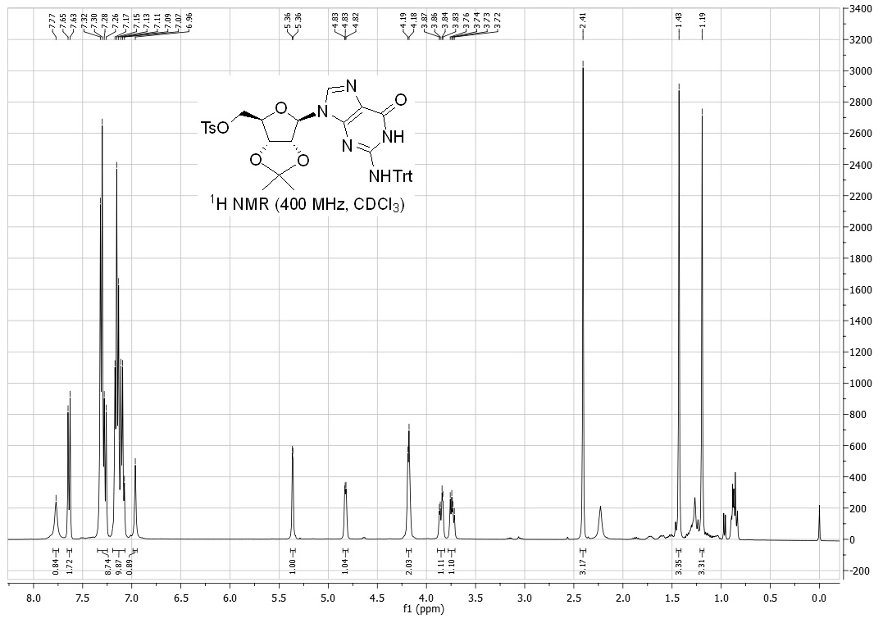
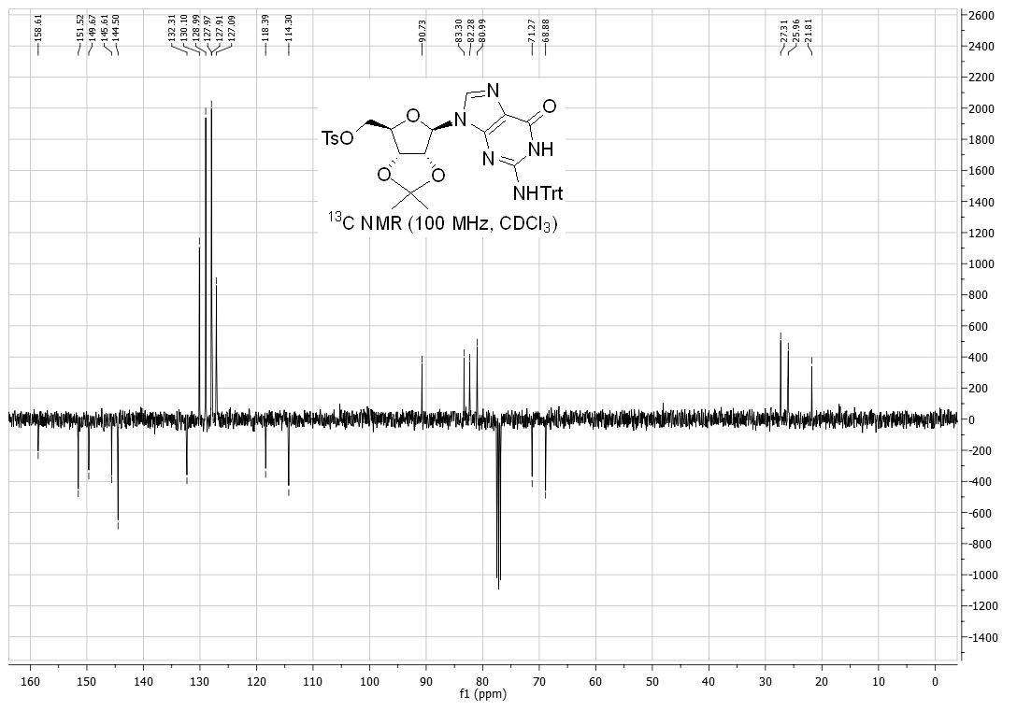

Compound 15
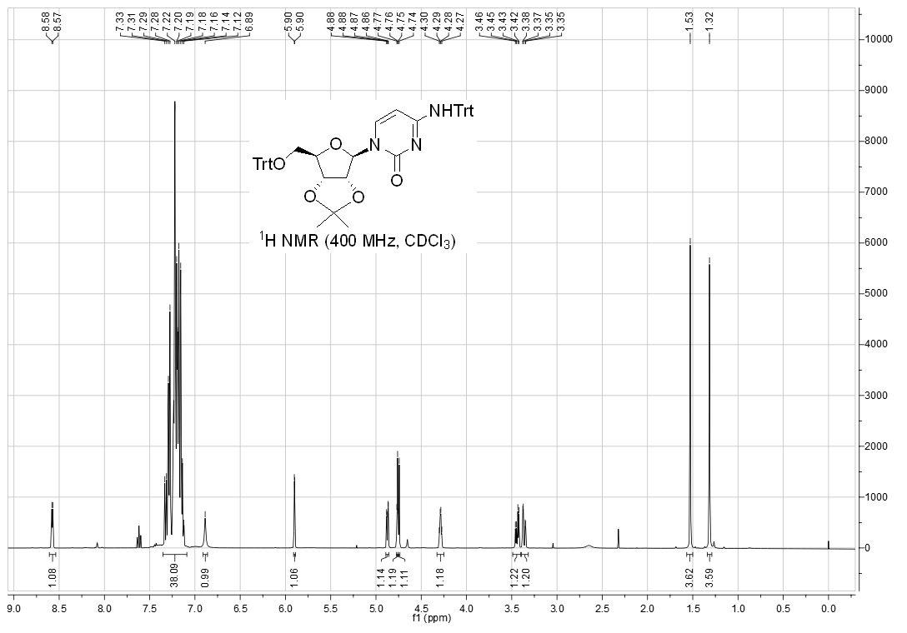
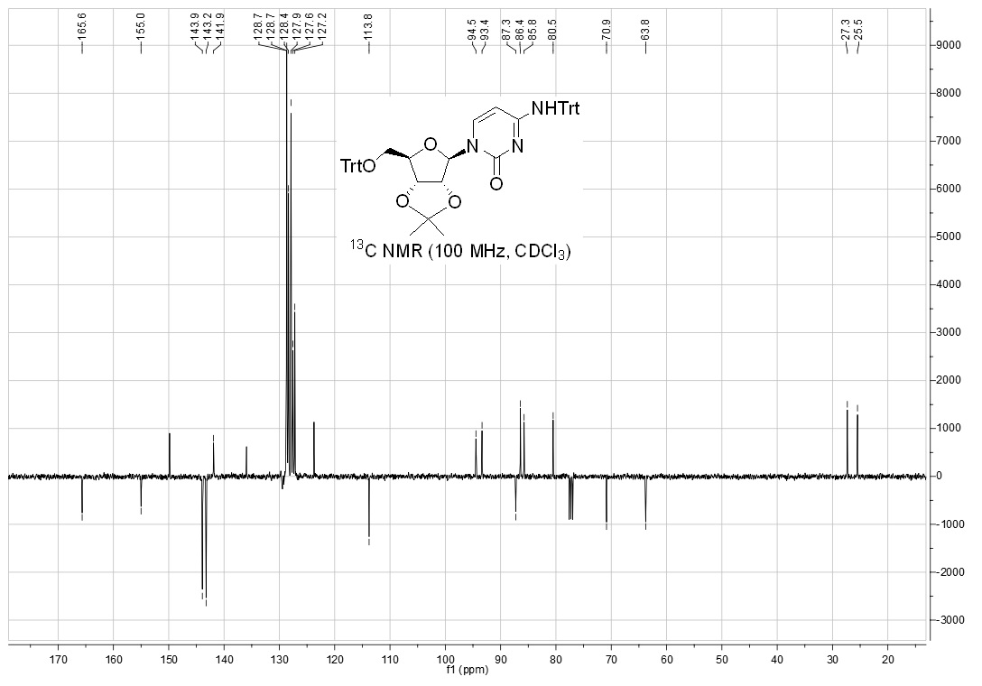
Compound 16
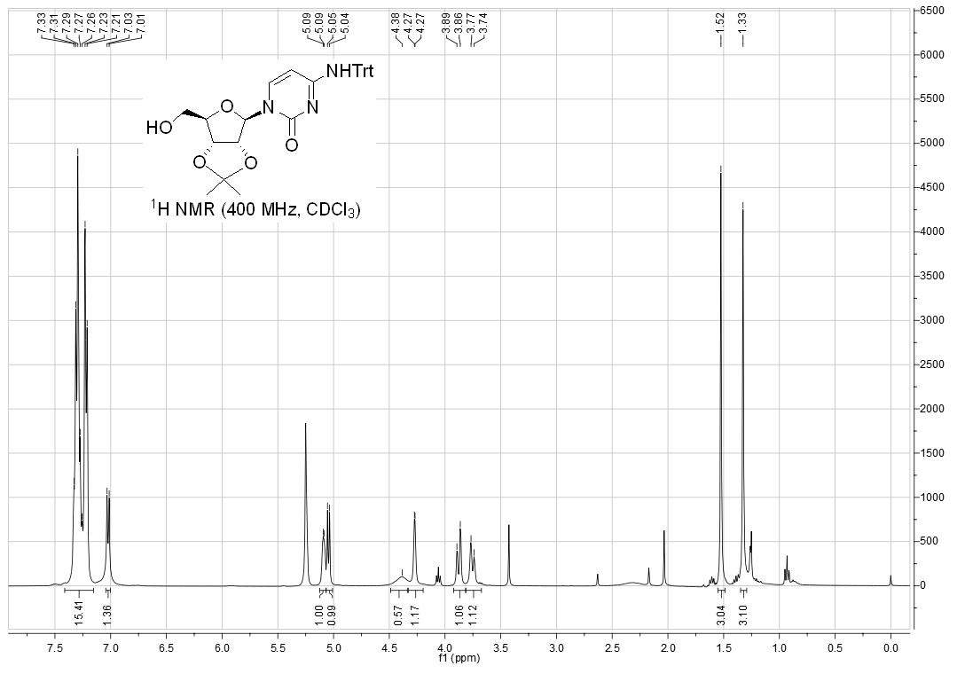
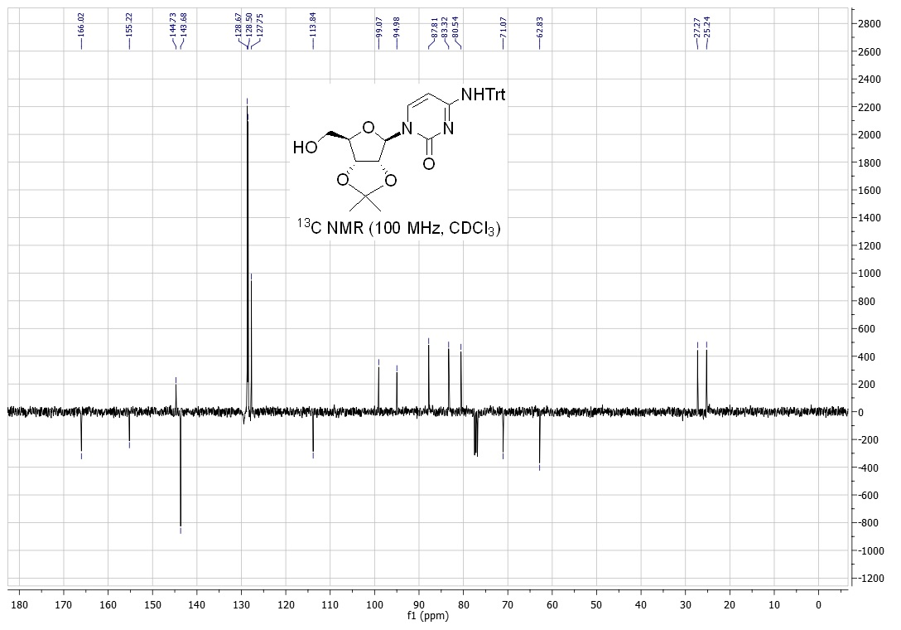
Compound 17
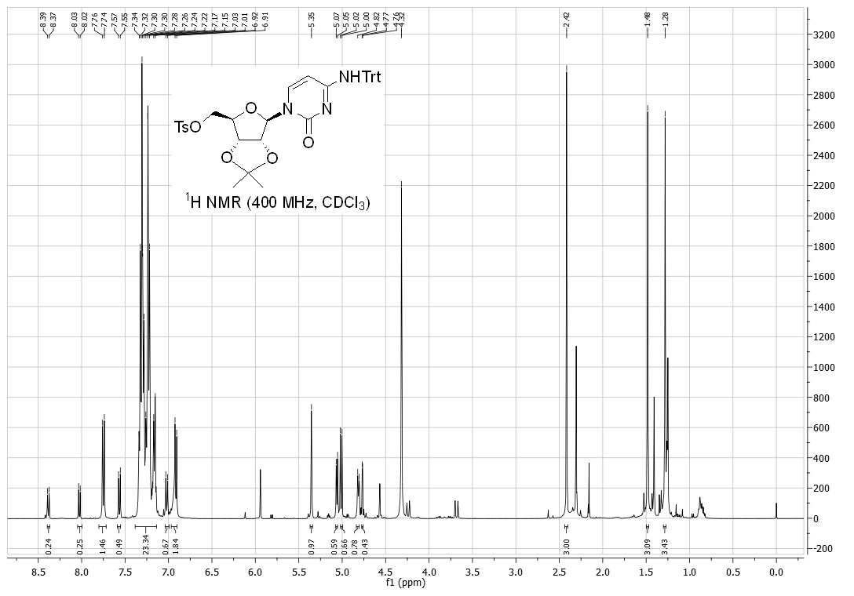
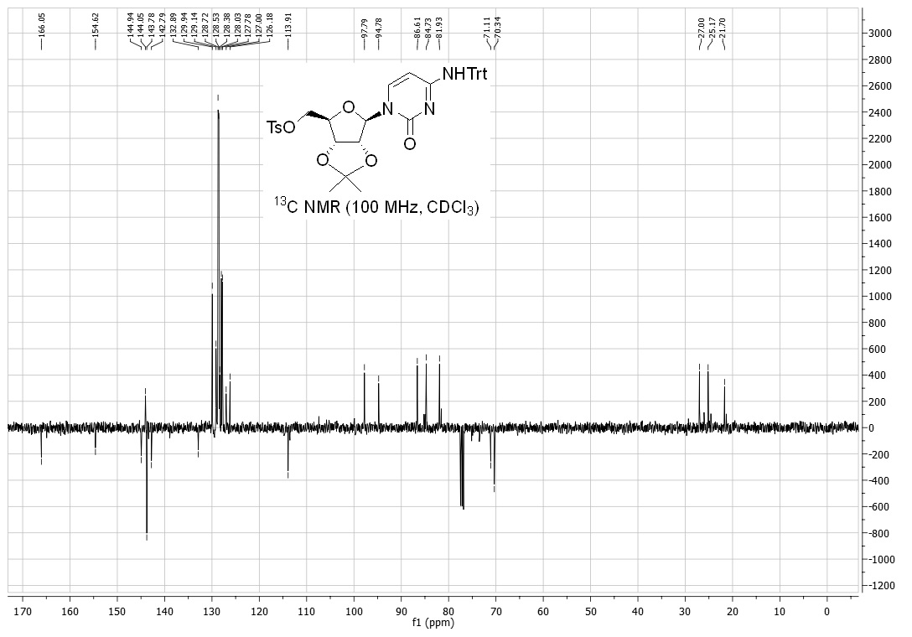
Compound 20
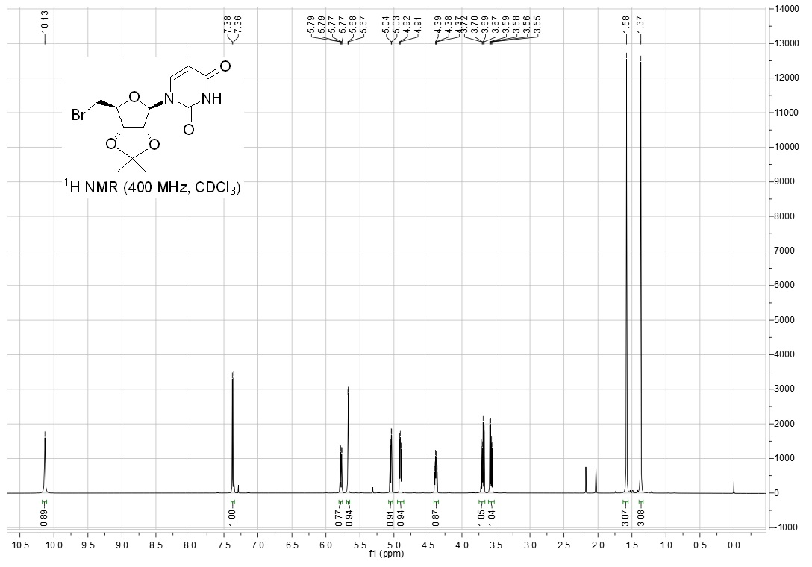
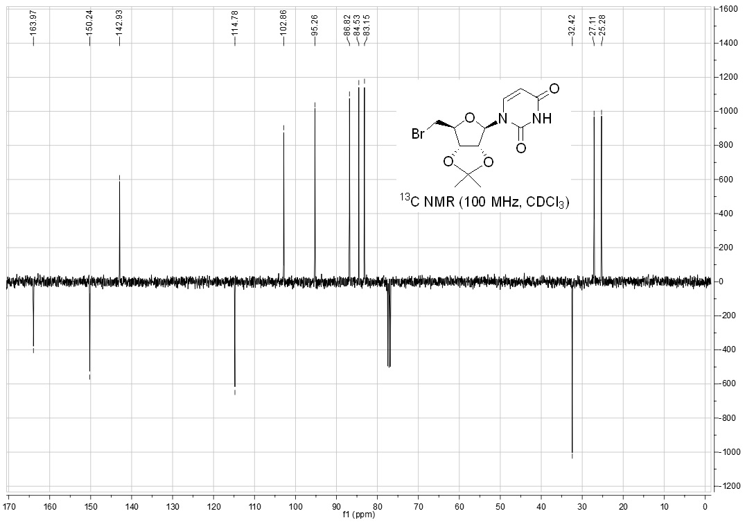
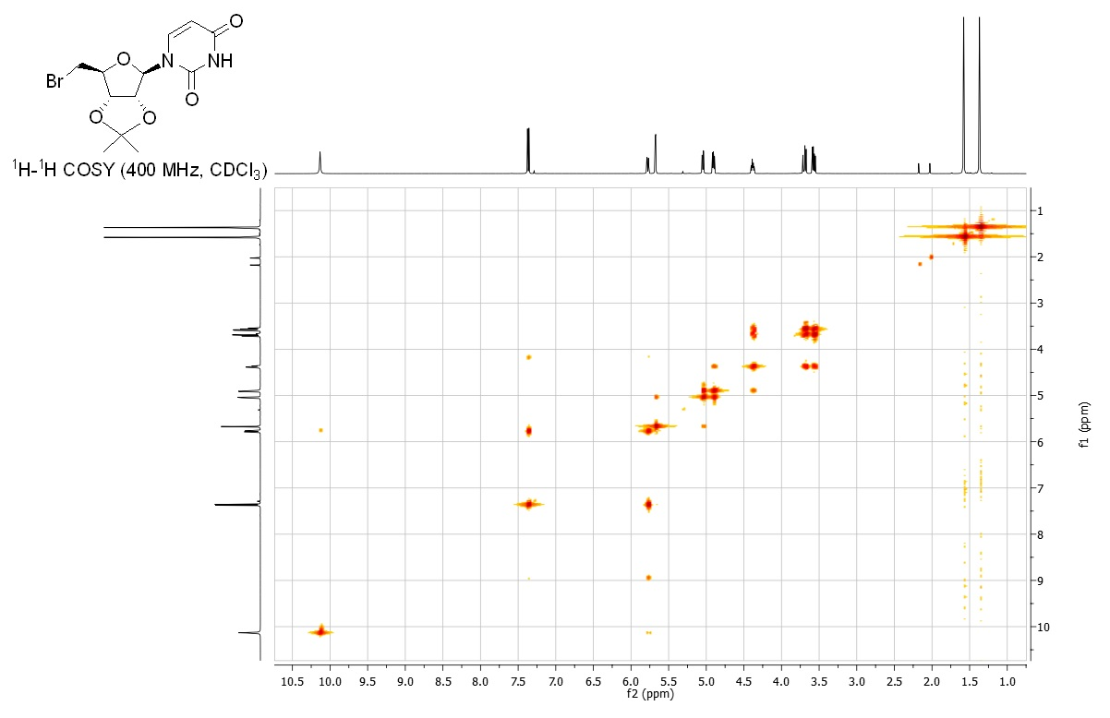
Compound 21
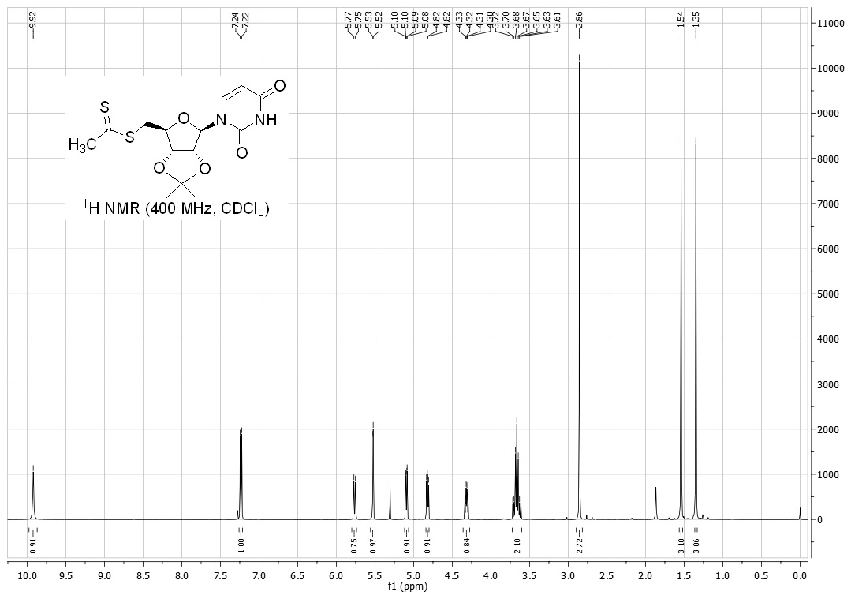
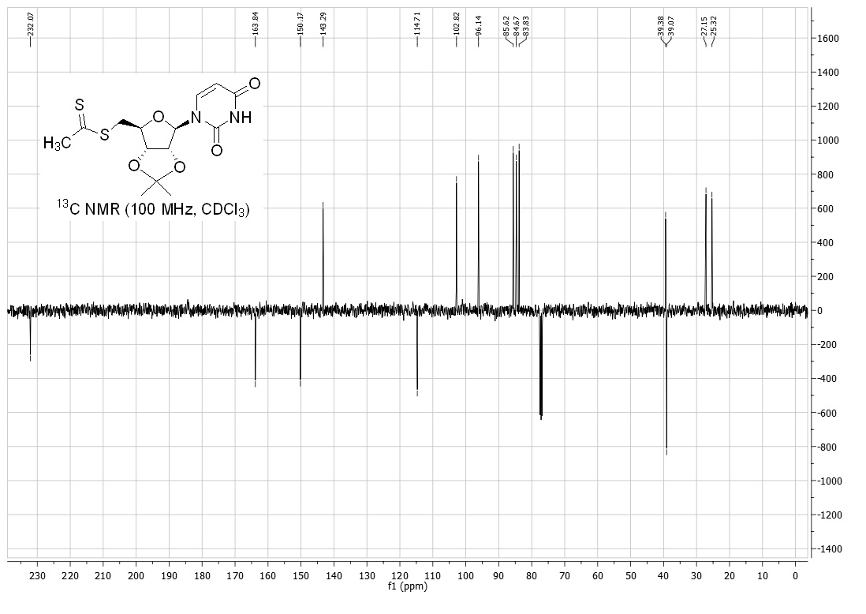
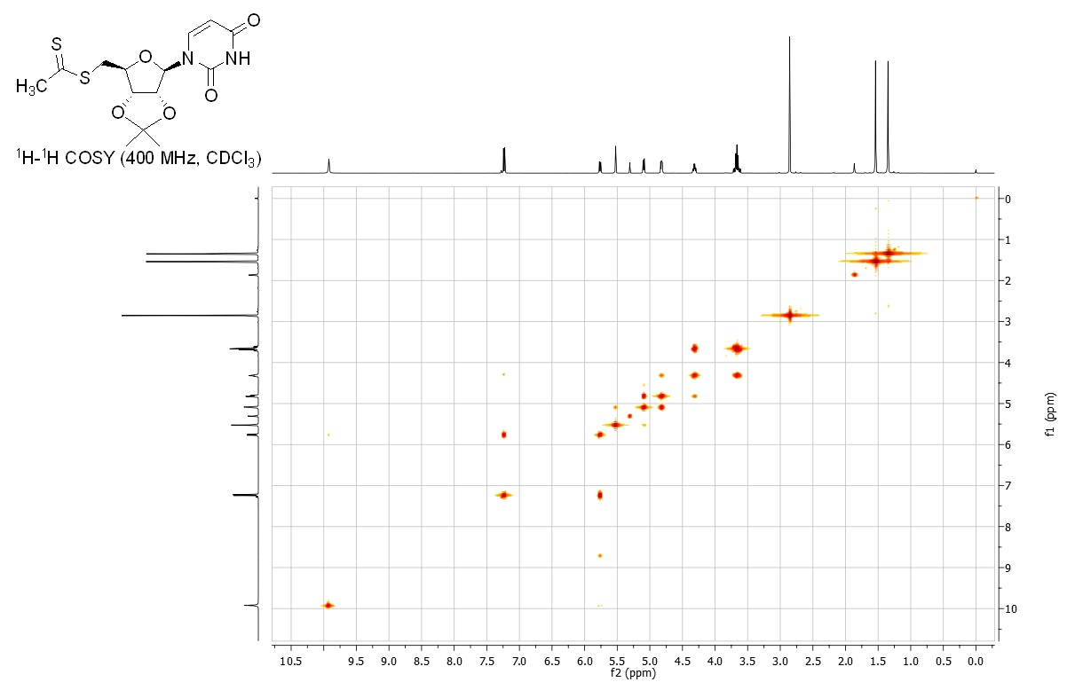
Compound 22
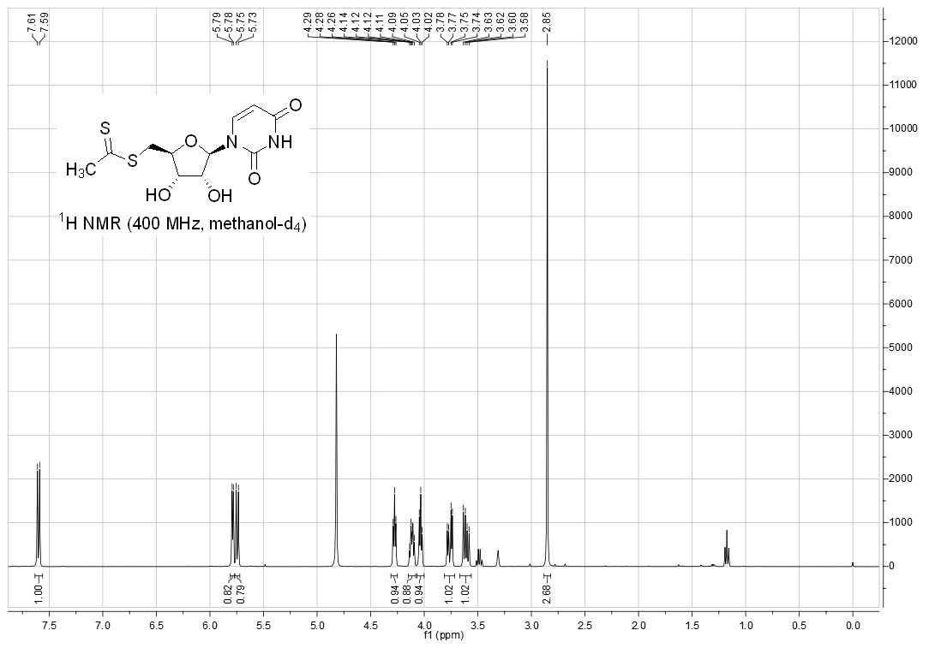
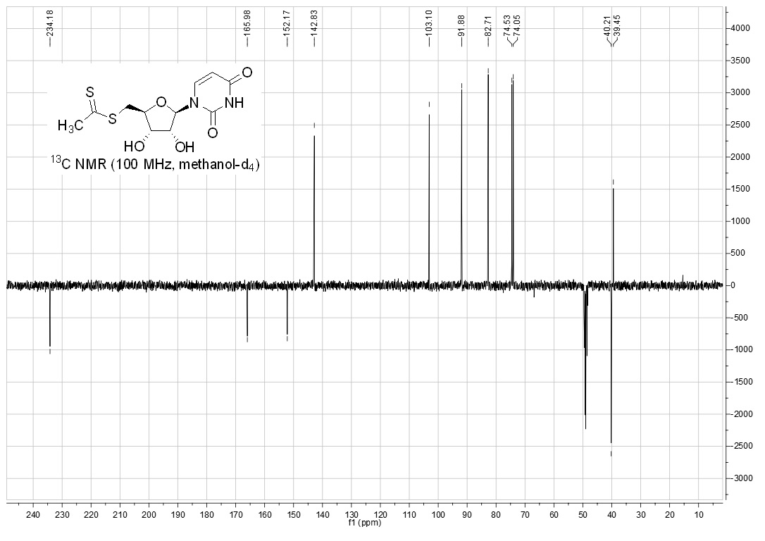
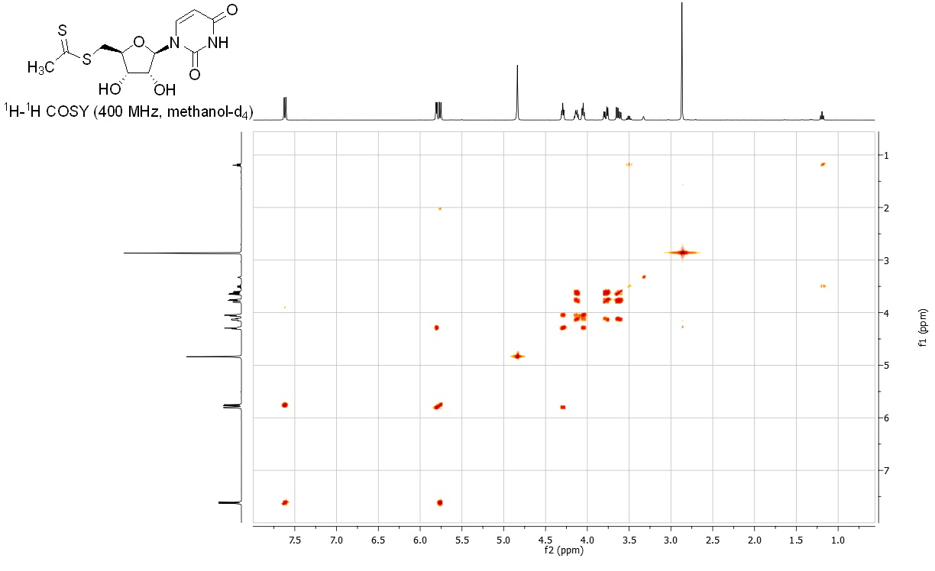
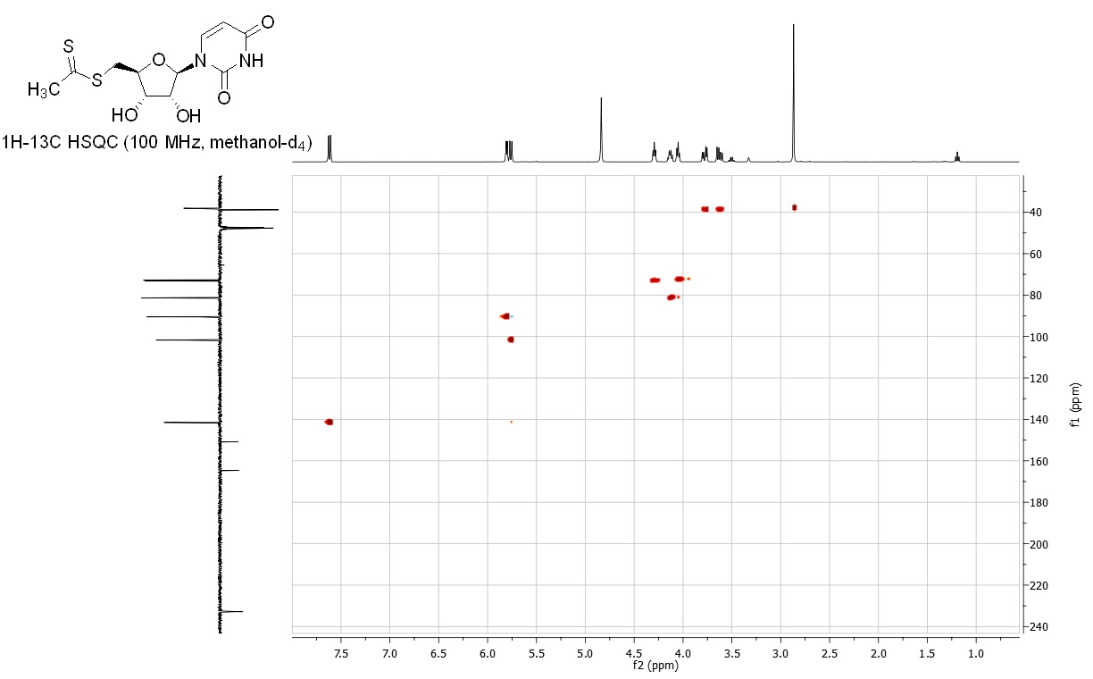

Compound 23
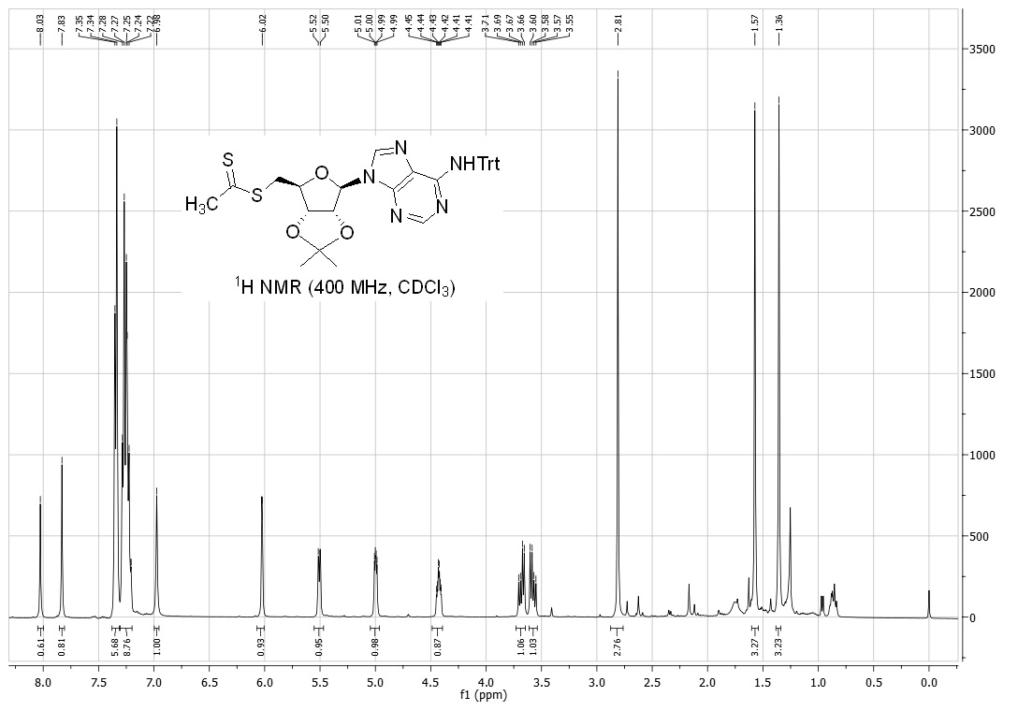
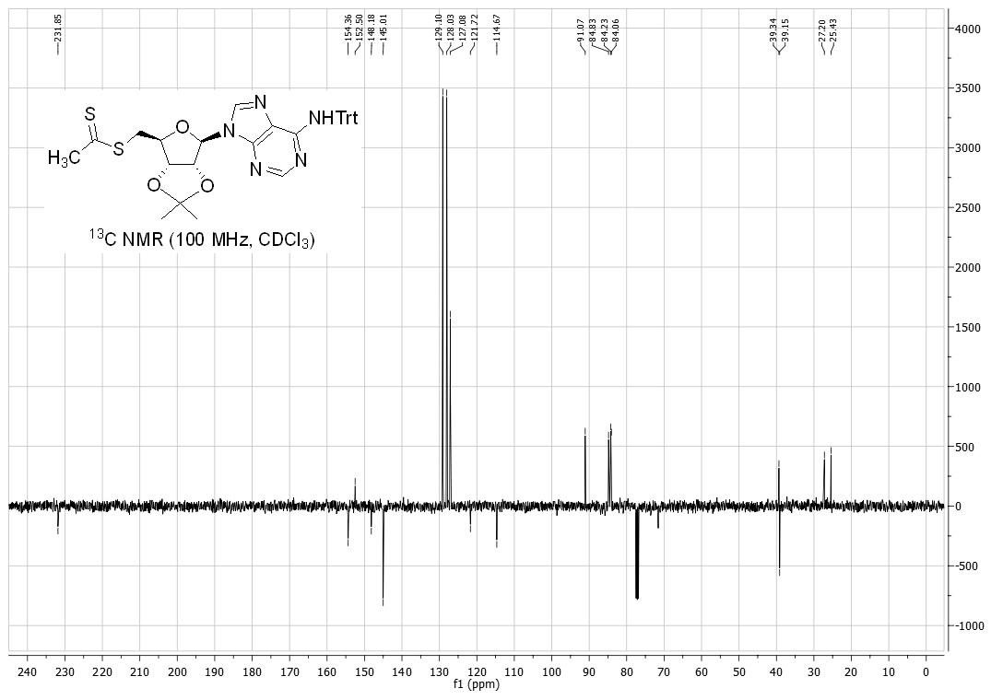
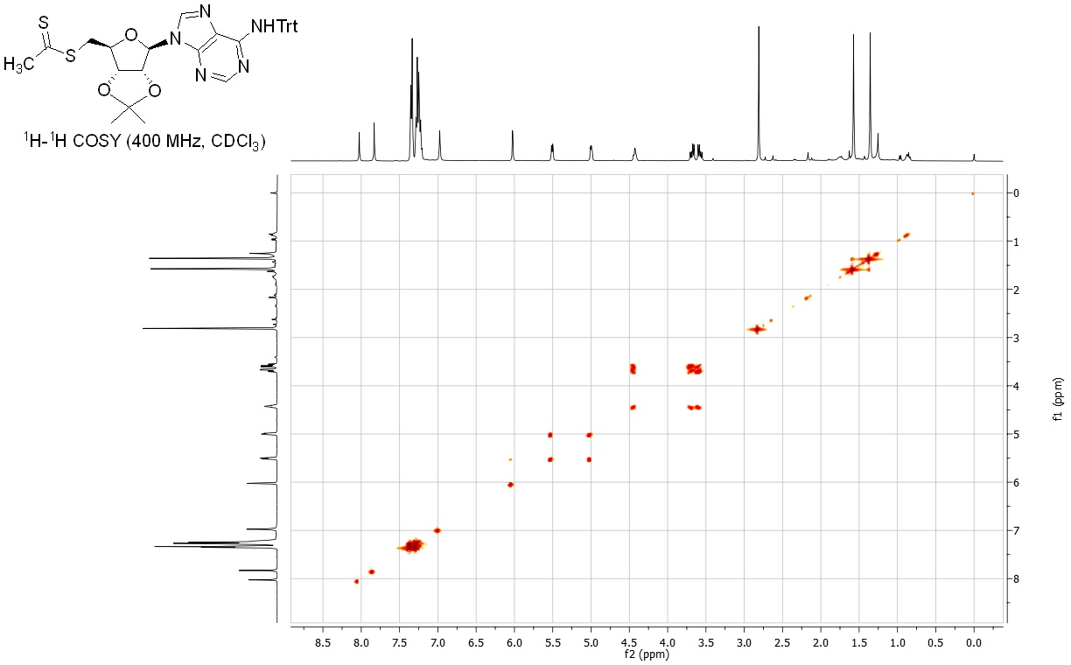
Compound 24
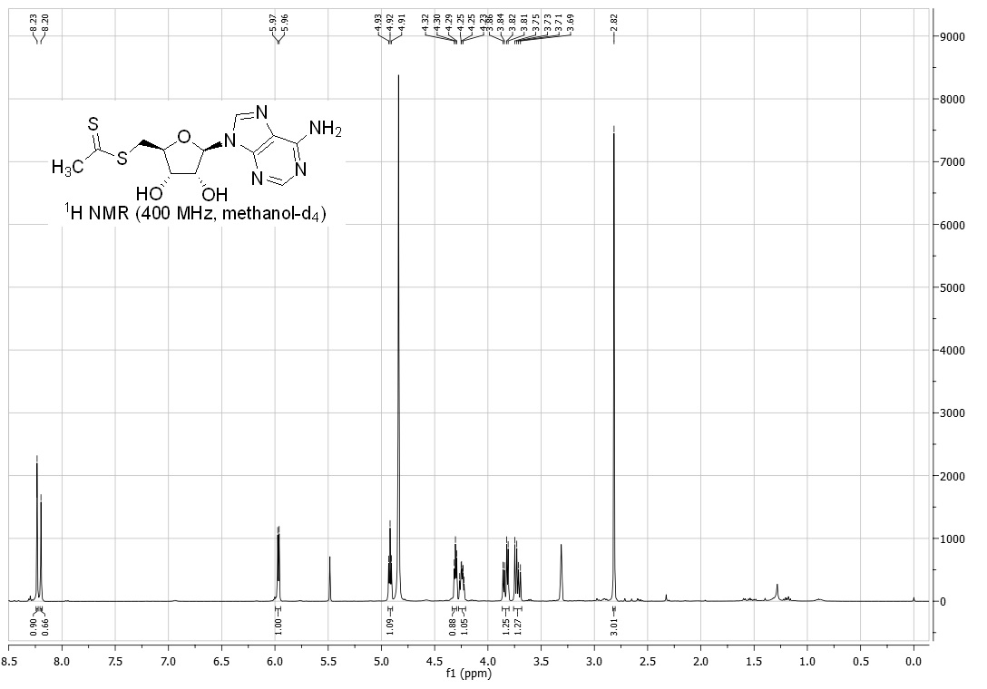
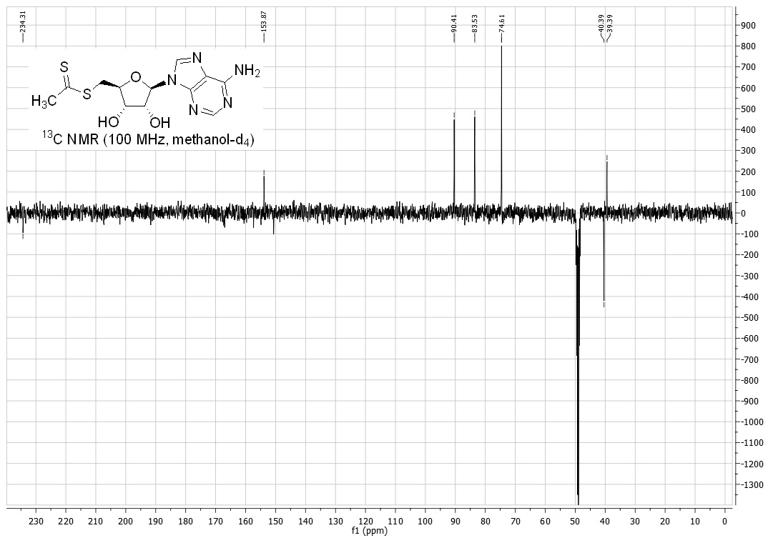
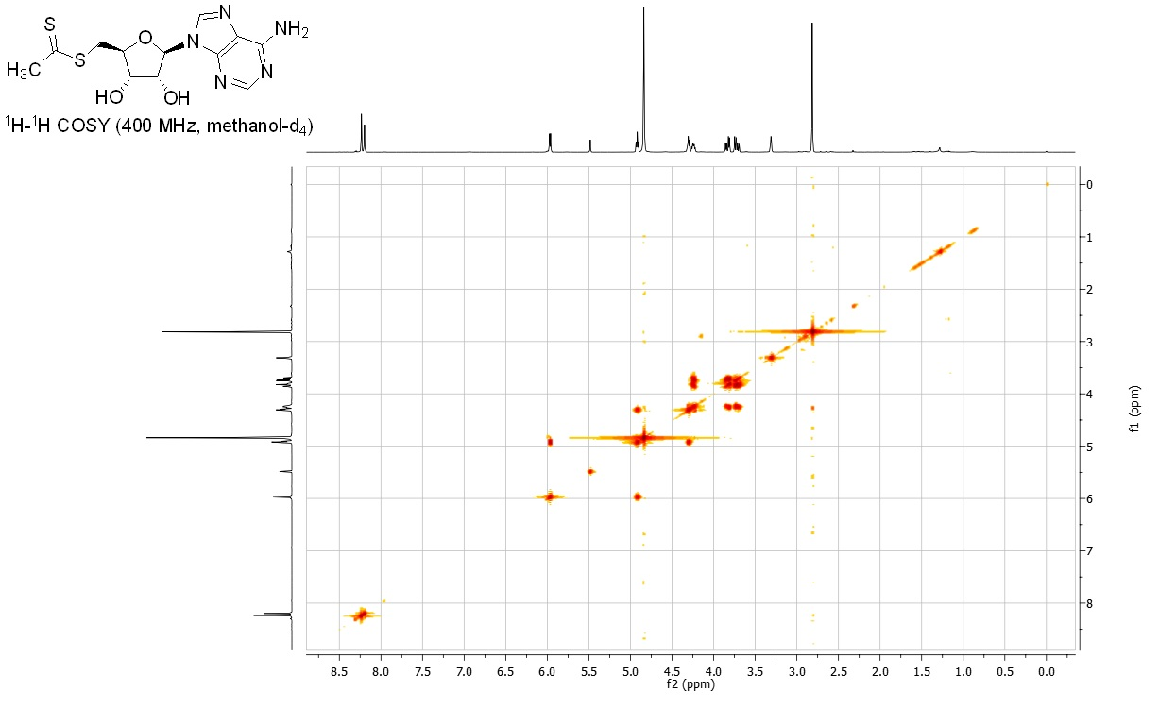

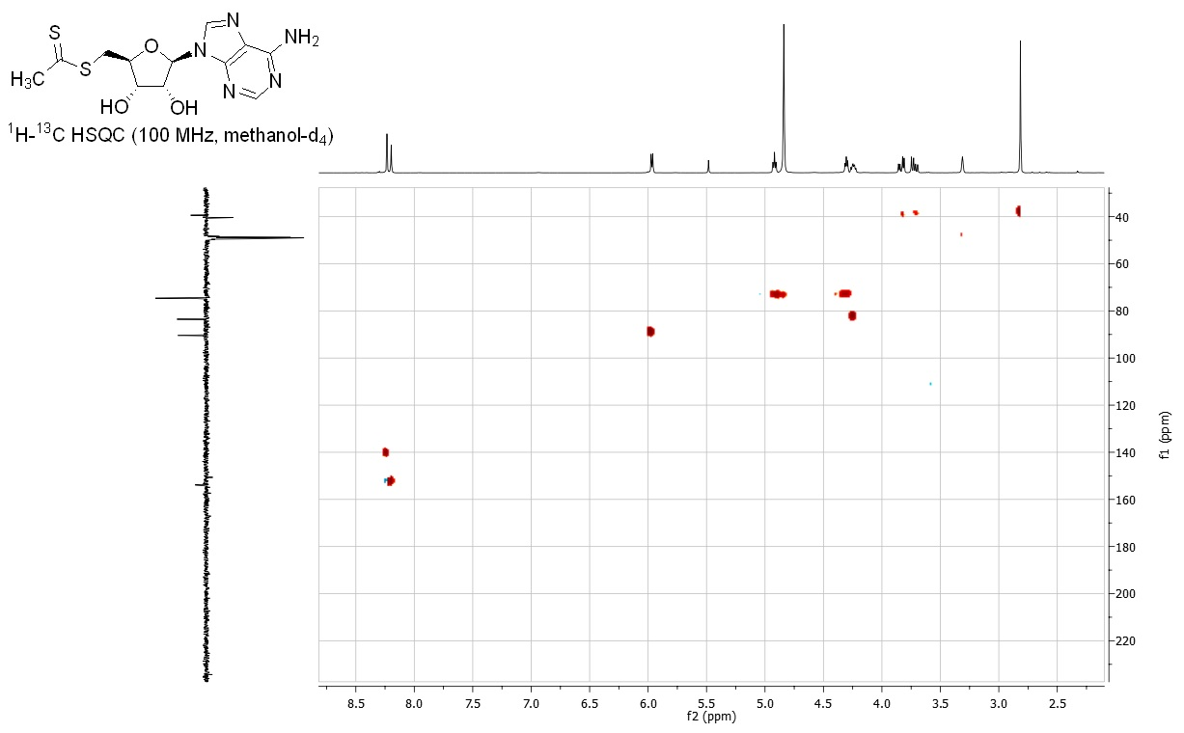
Compound 25
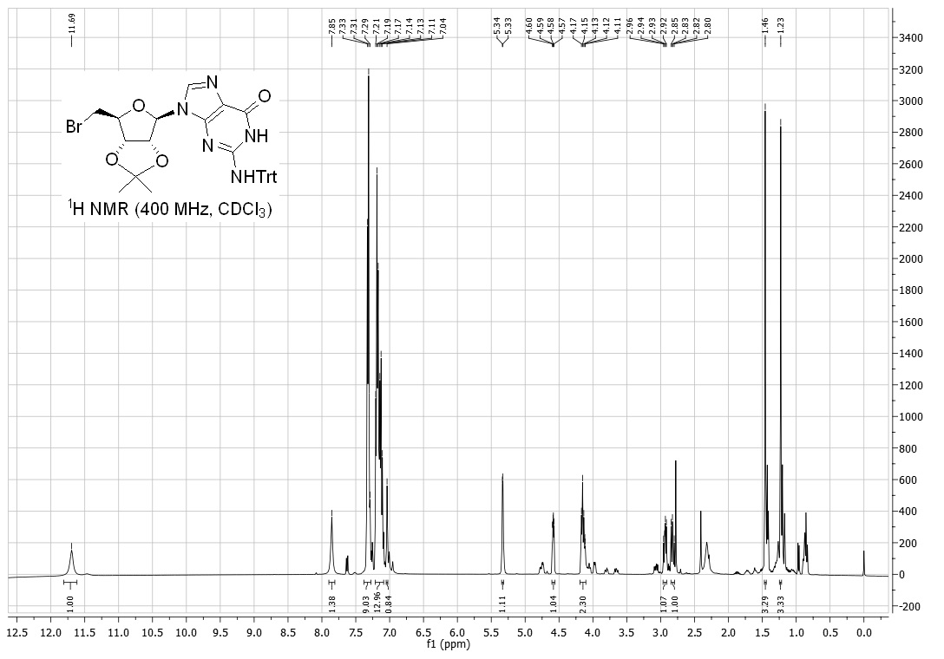
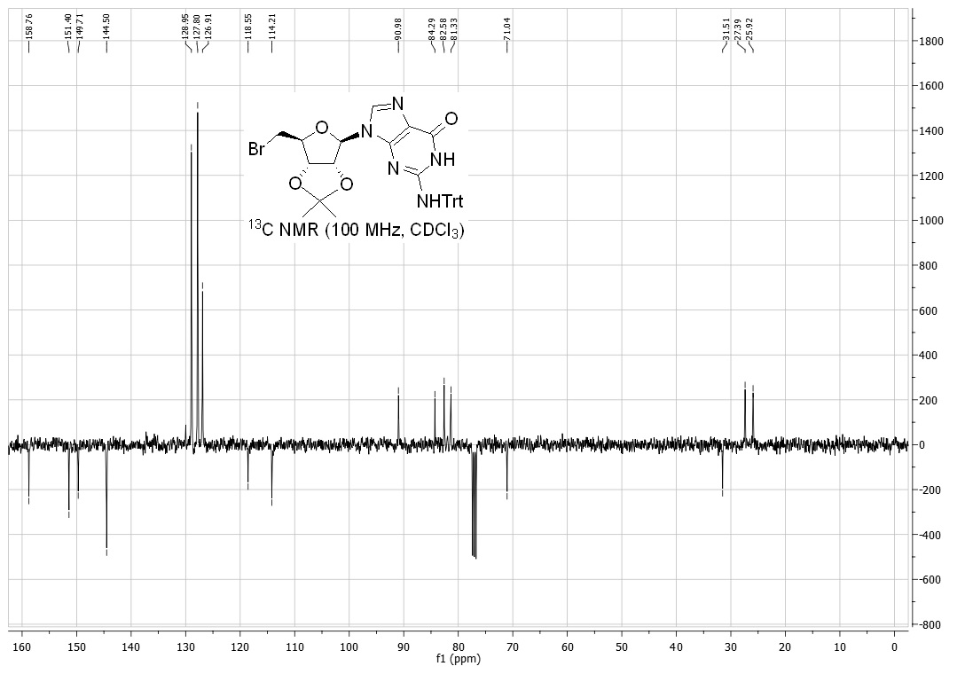
Compound 26
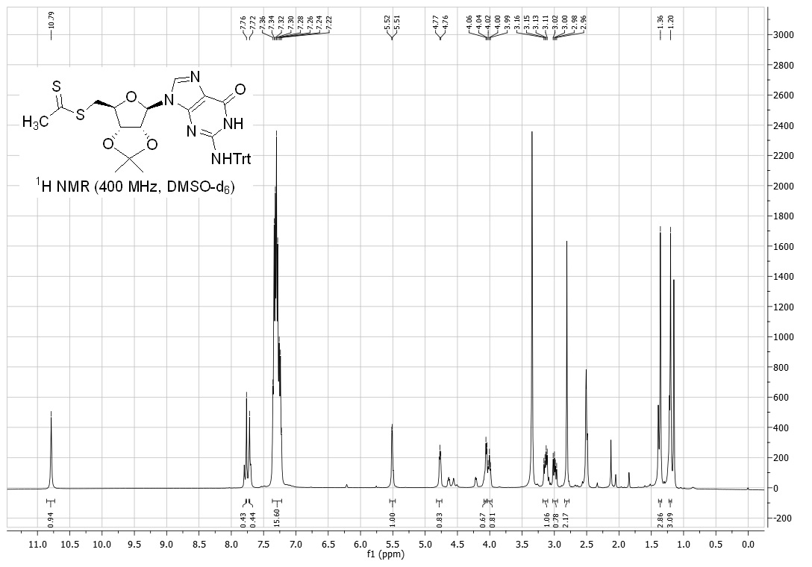
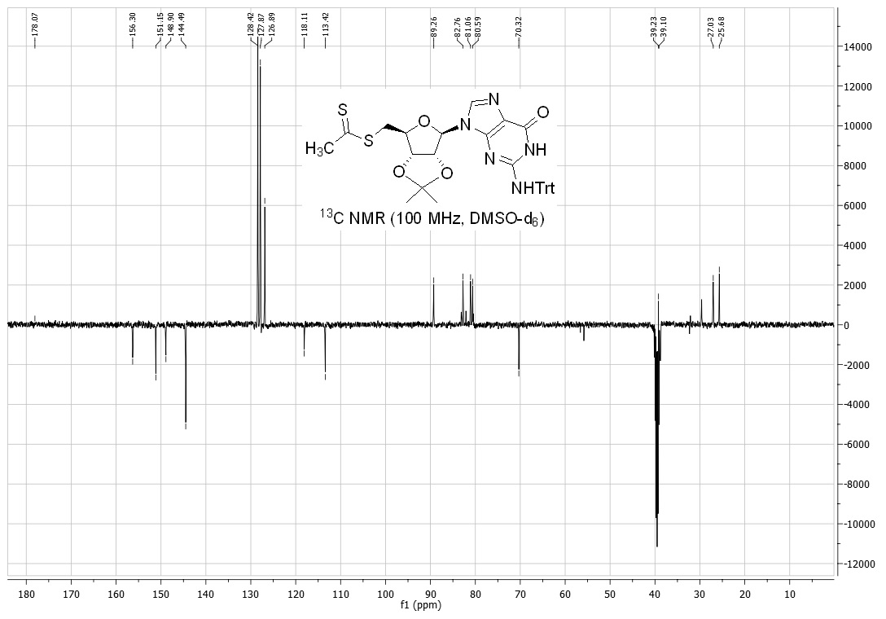
Compound 27
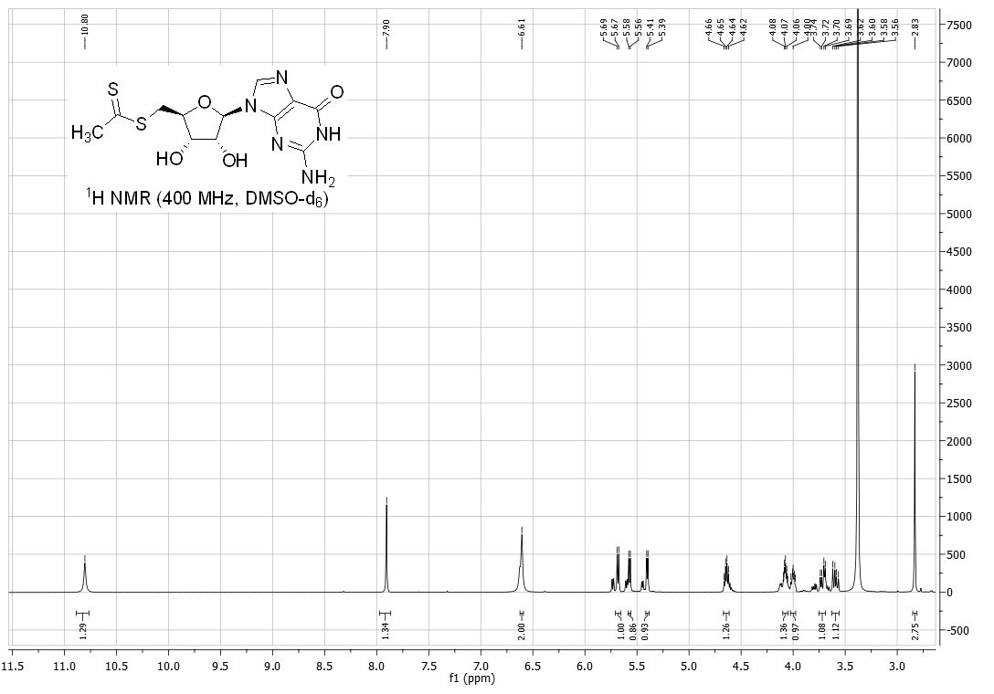
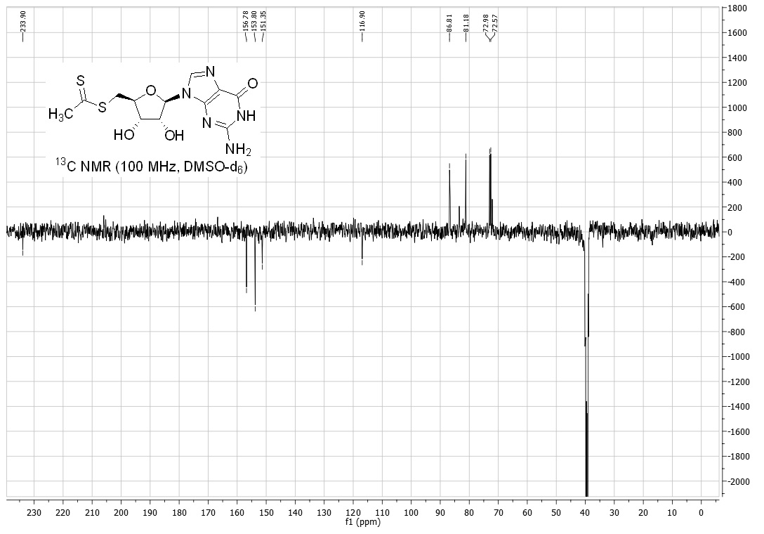
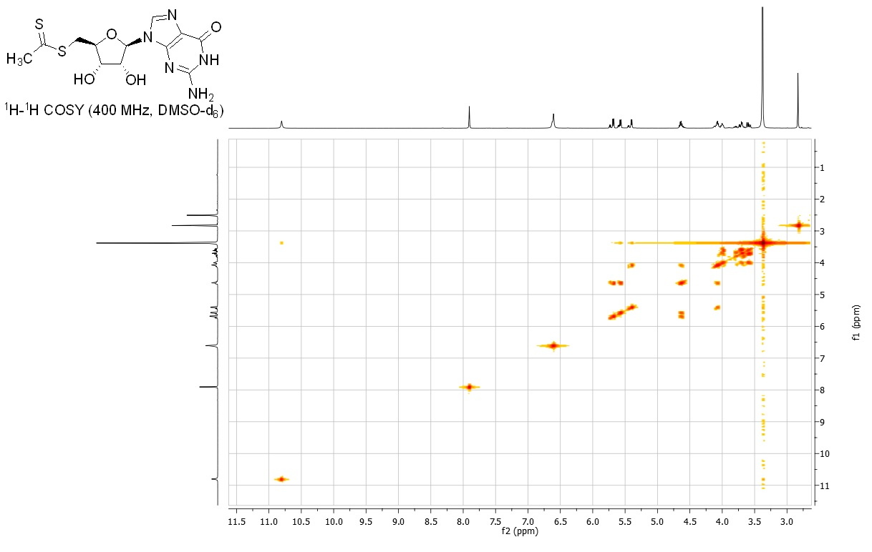
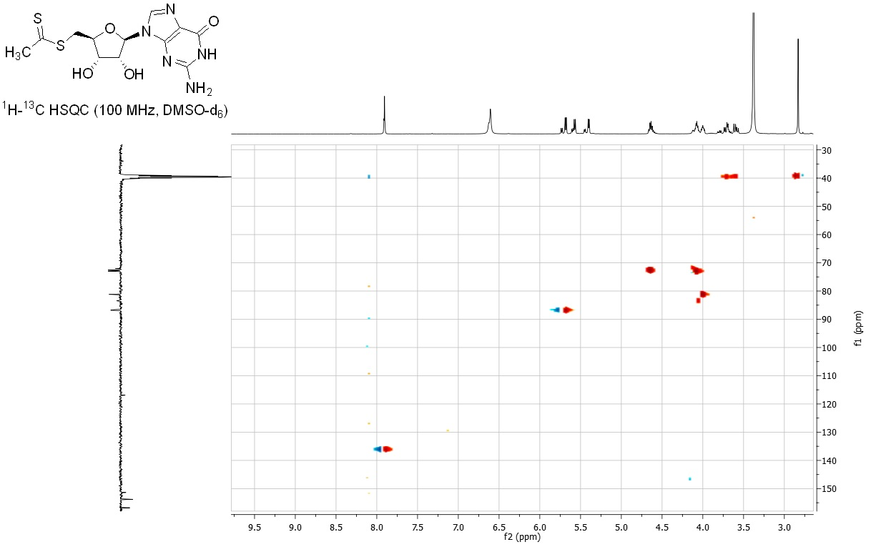
Compound 28
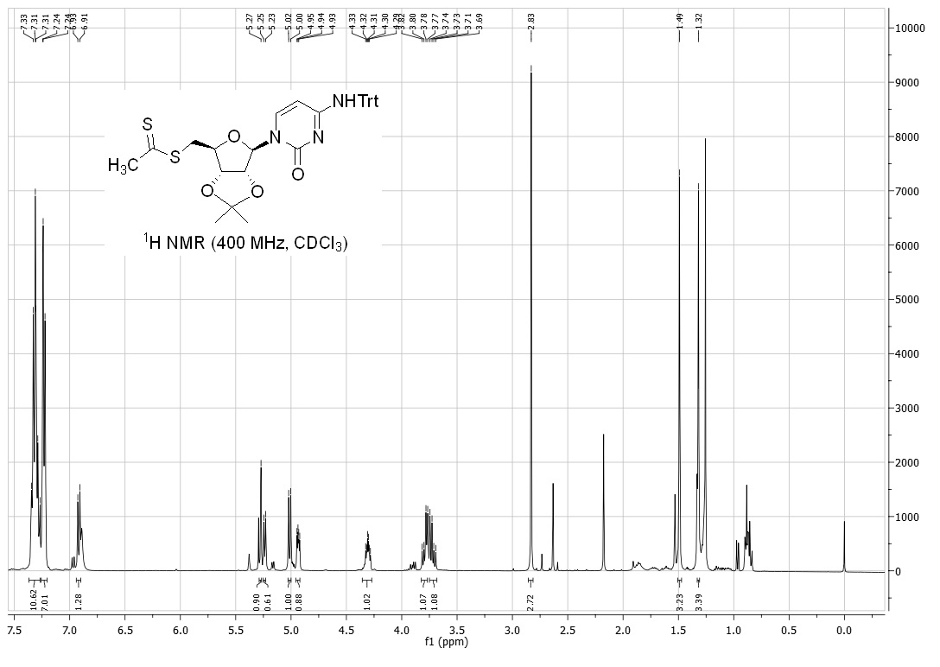
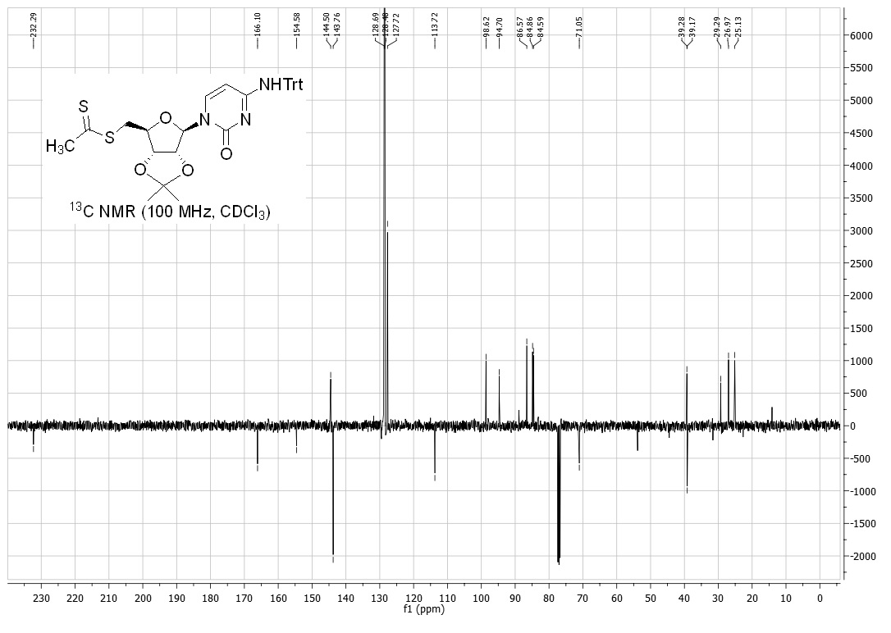
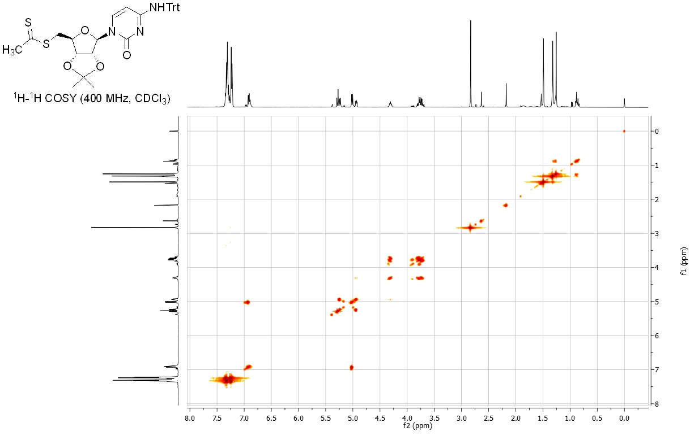
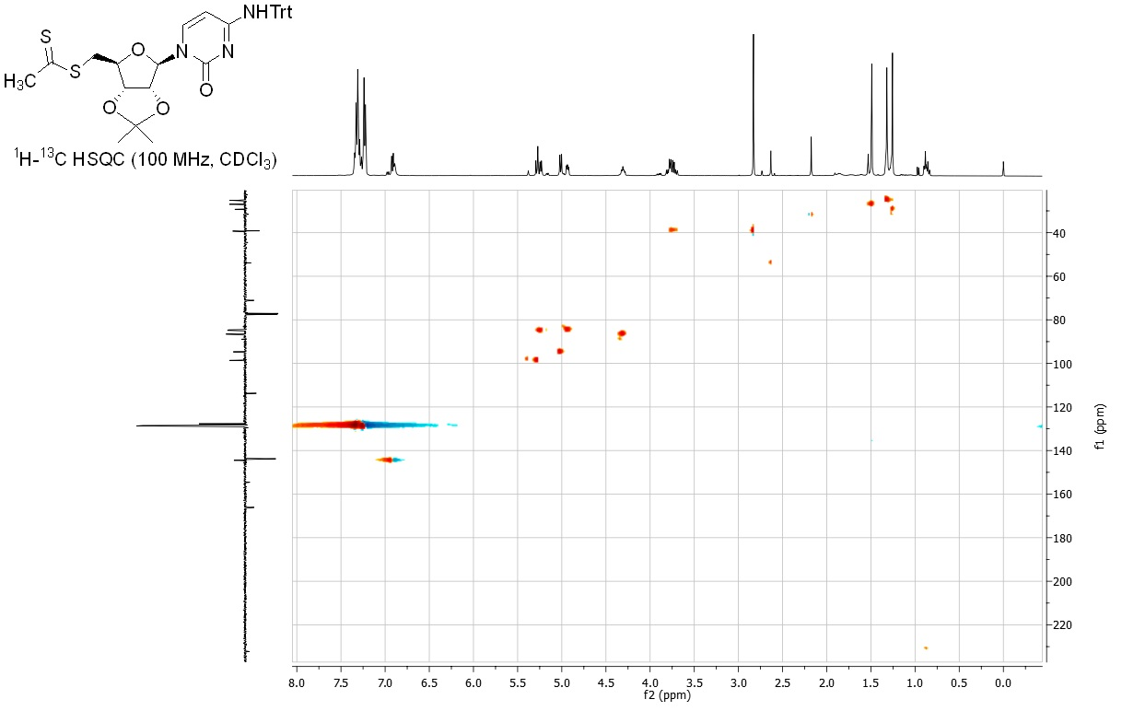
Compound 29
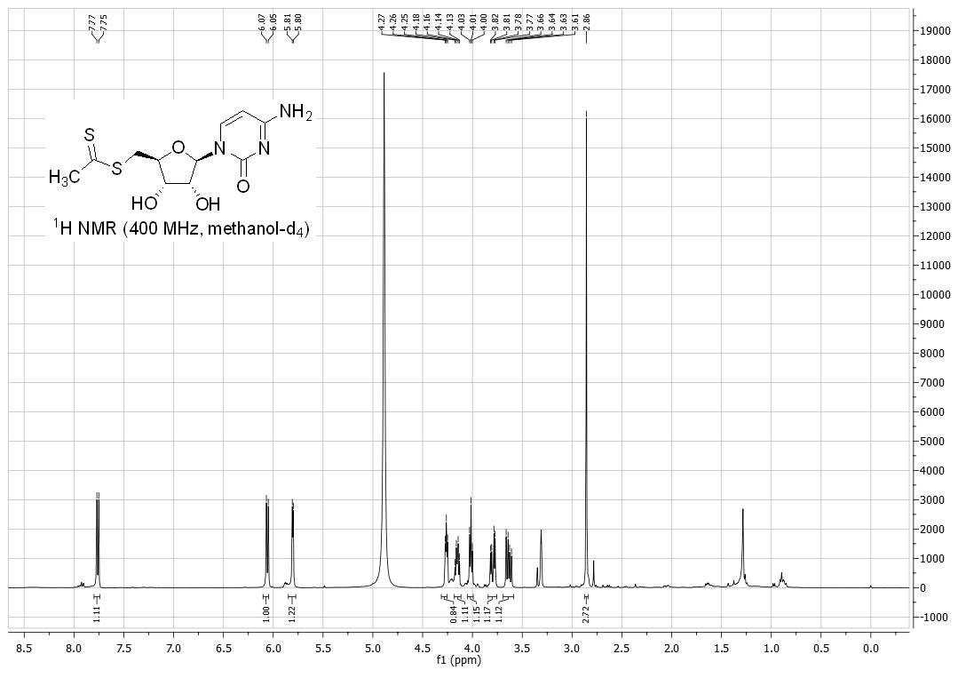
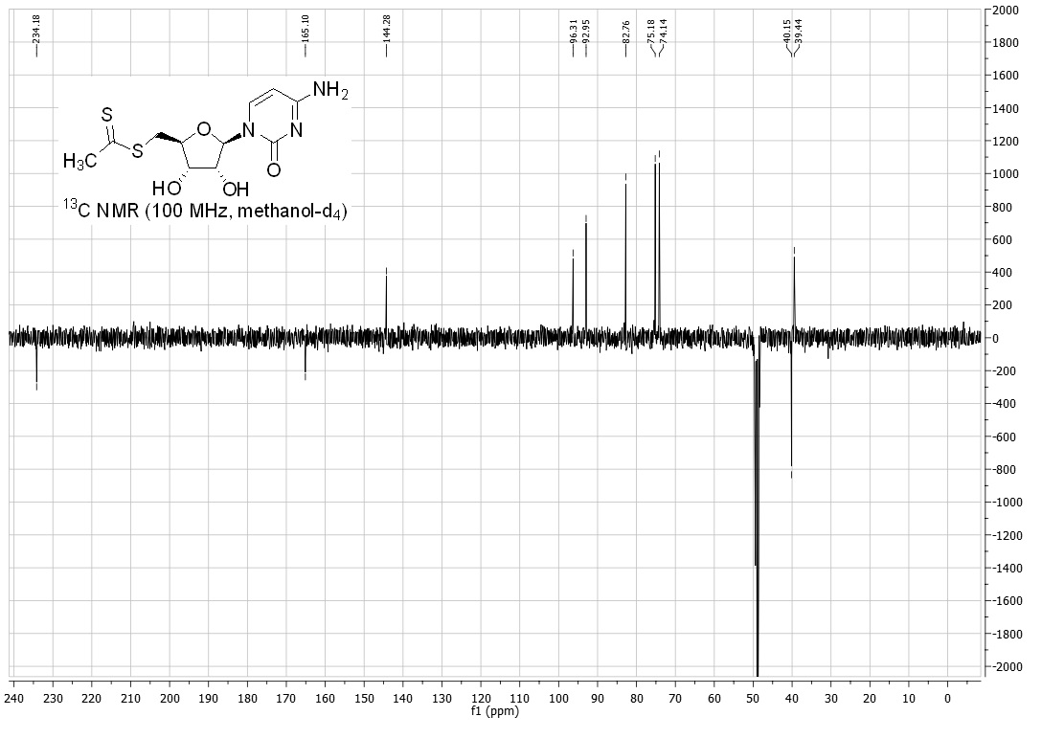
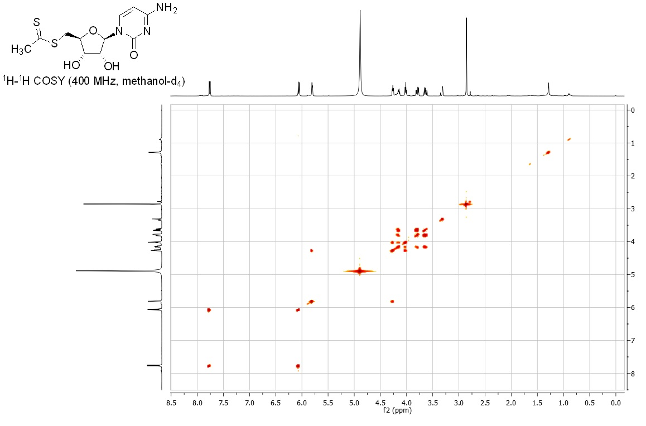
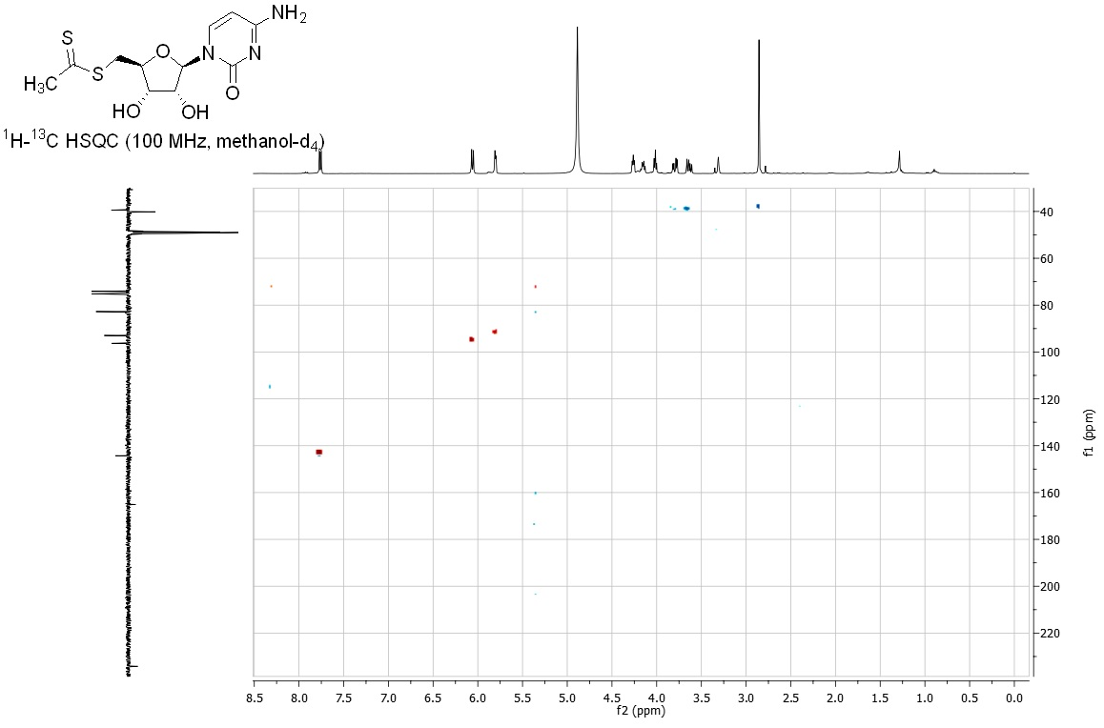
Compound 30
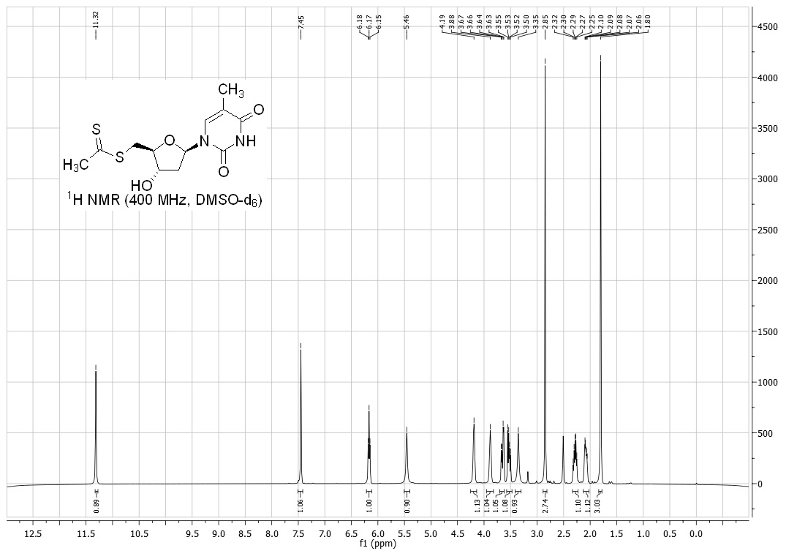
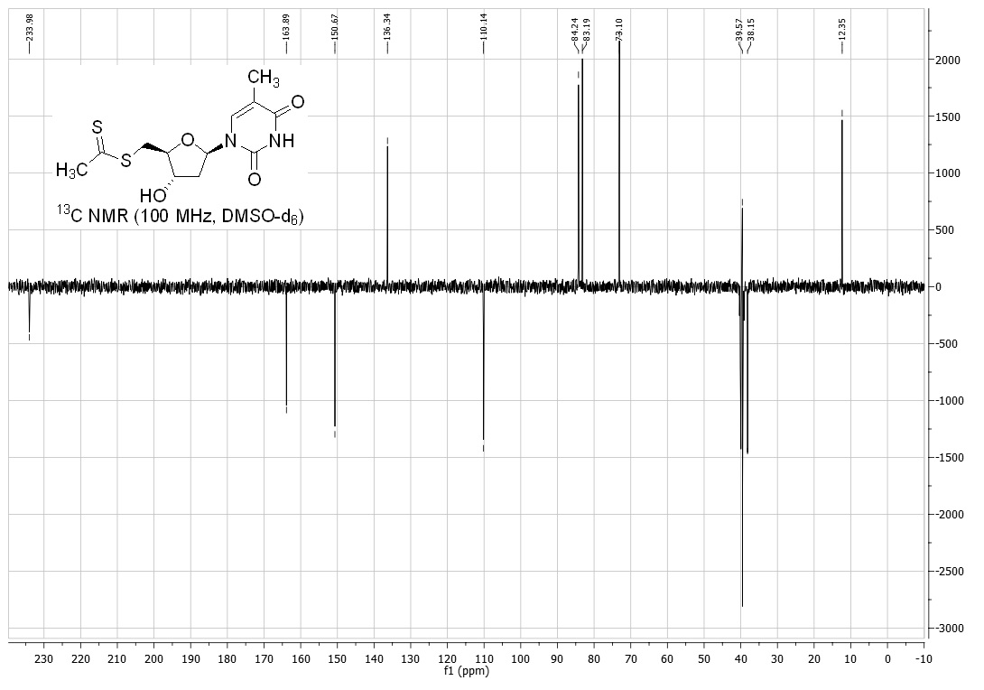
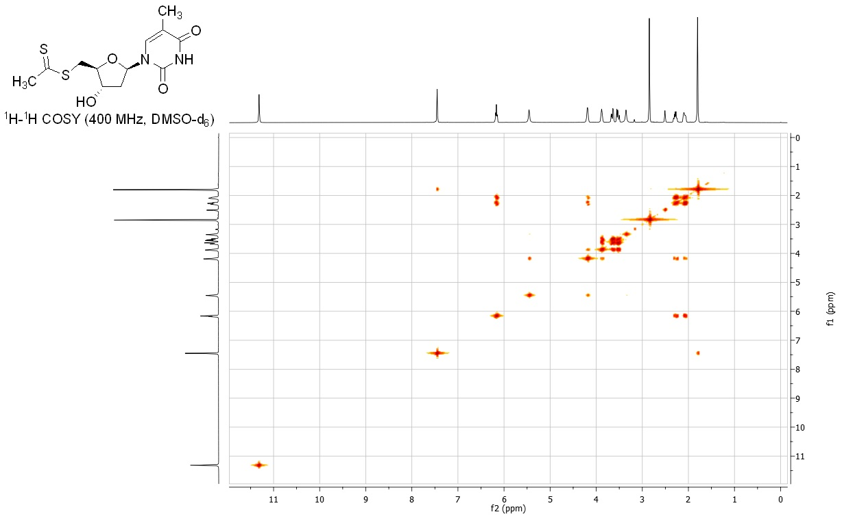
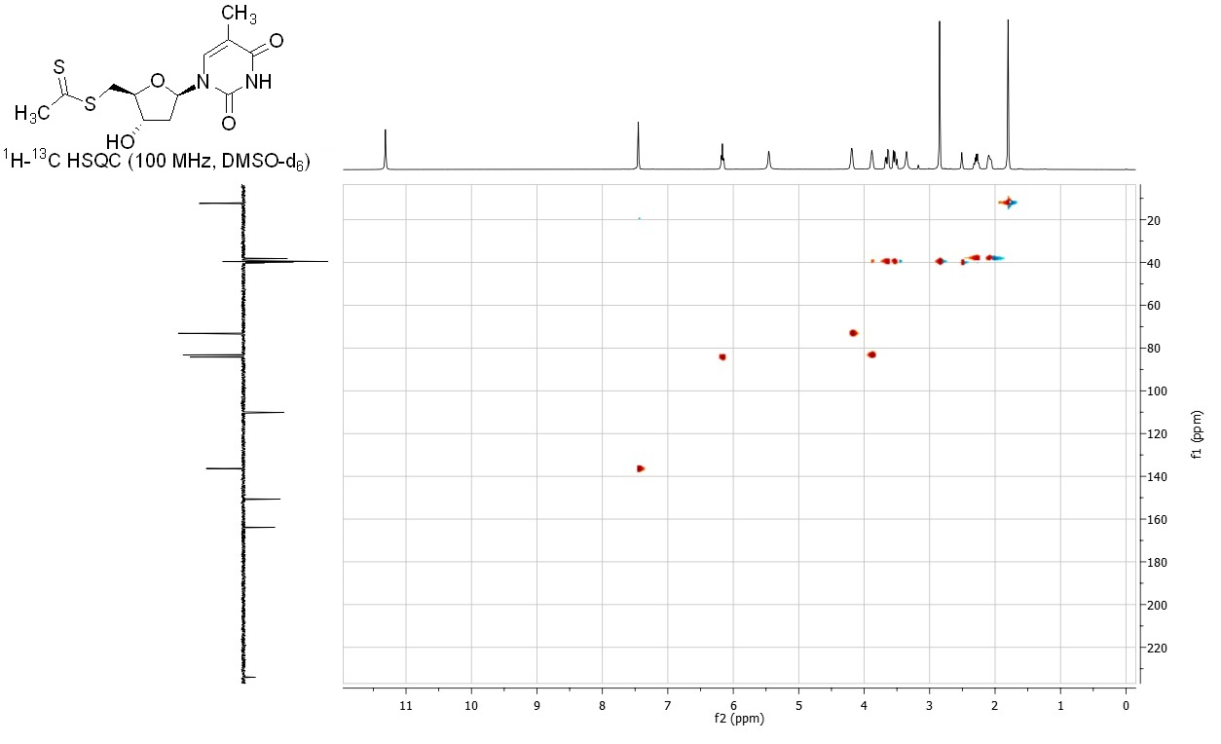
Compound 31
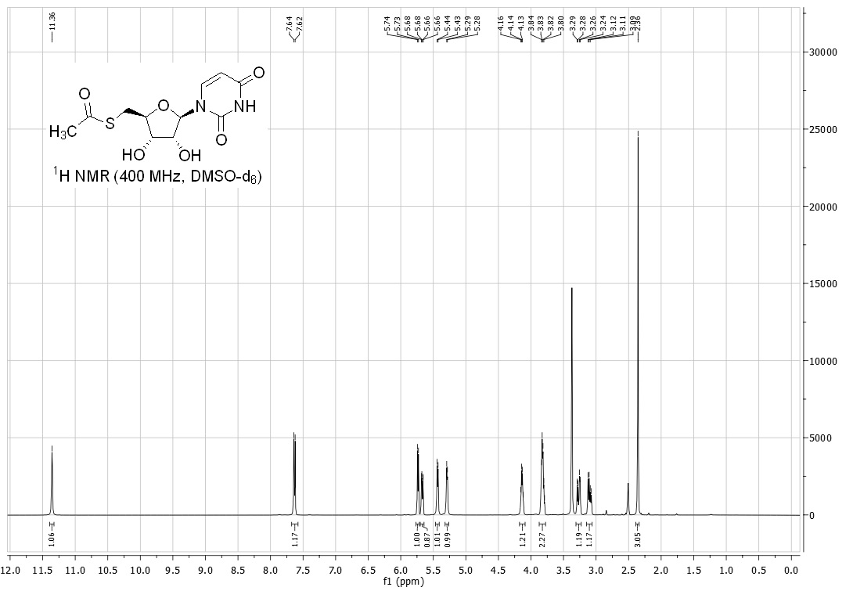
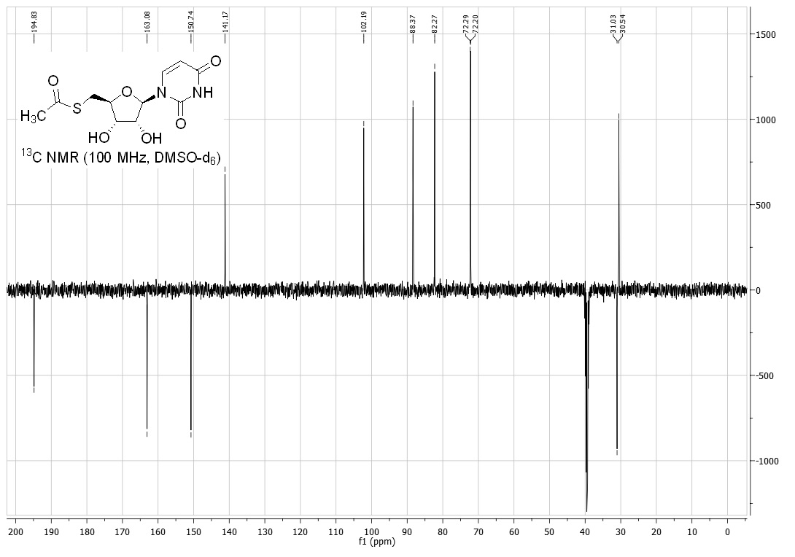
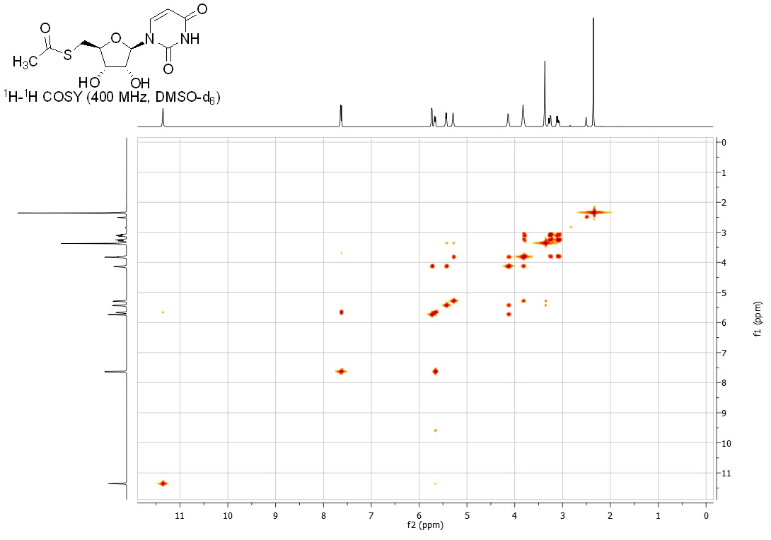
Compound 32
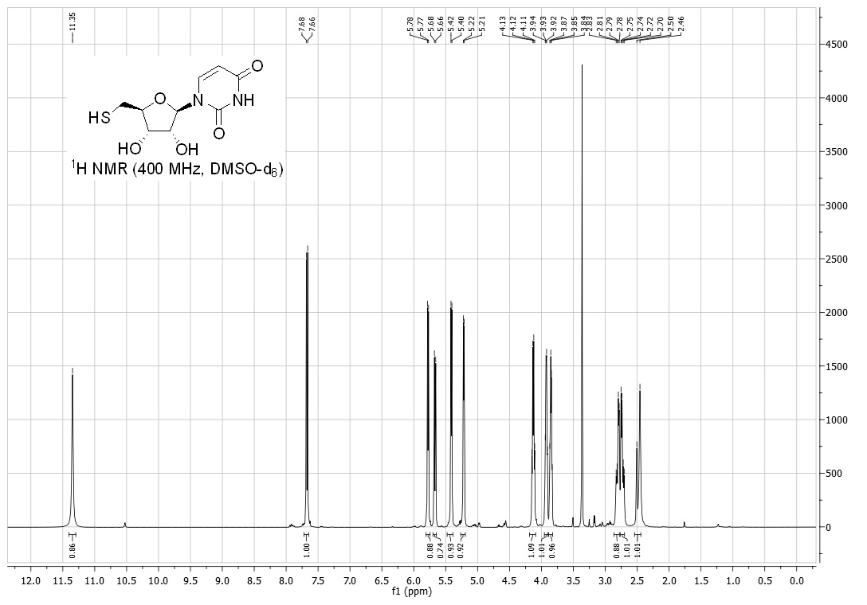
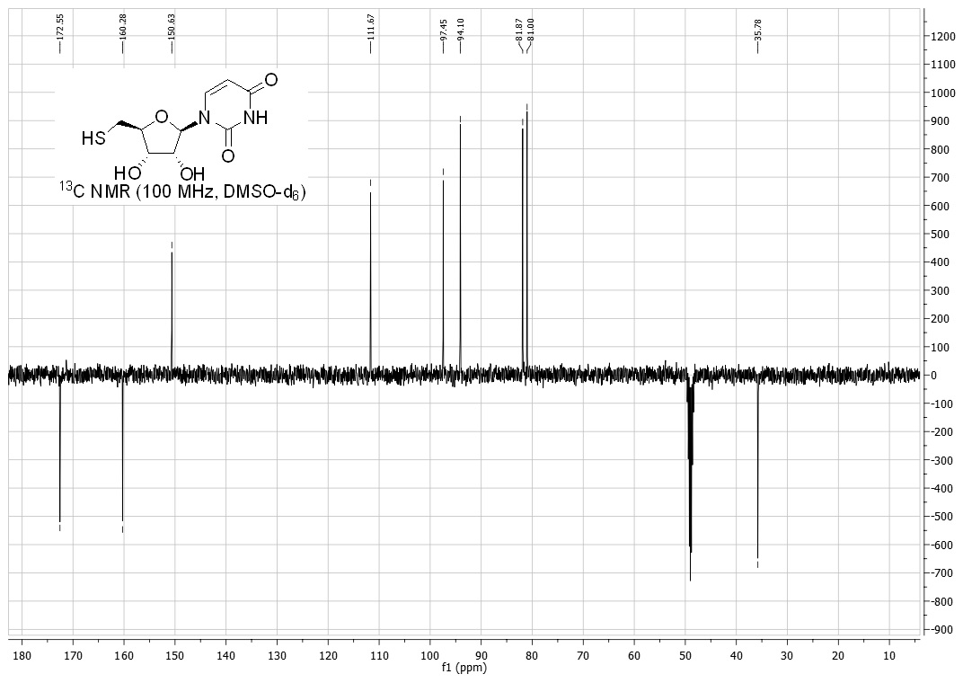
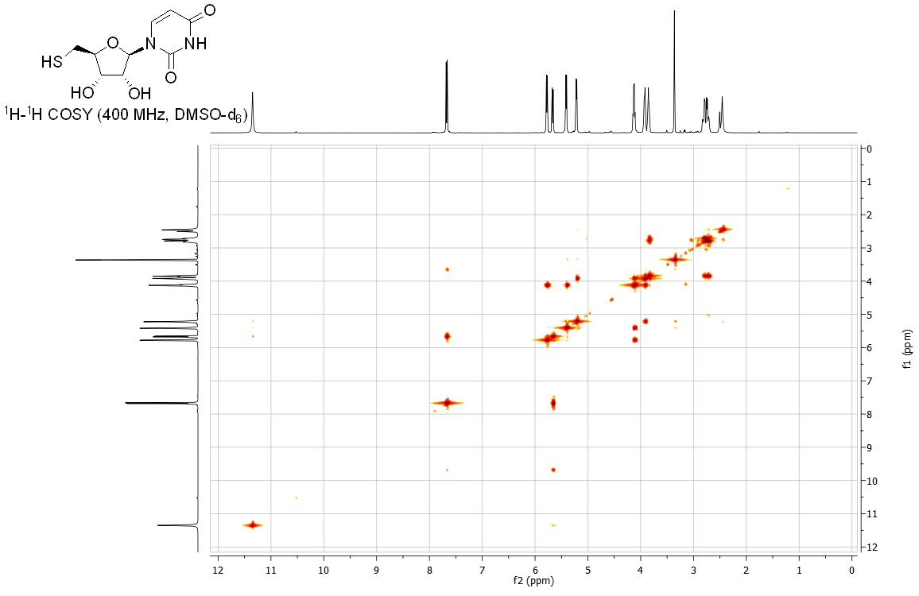
Compound 33
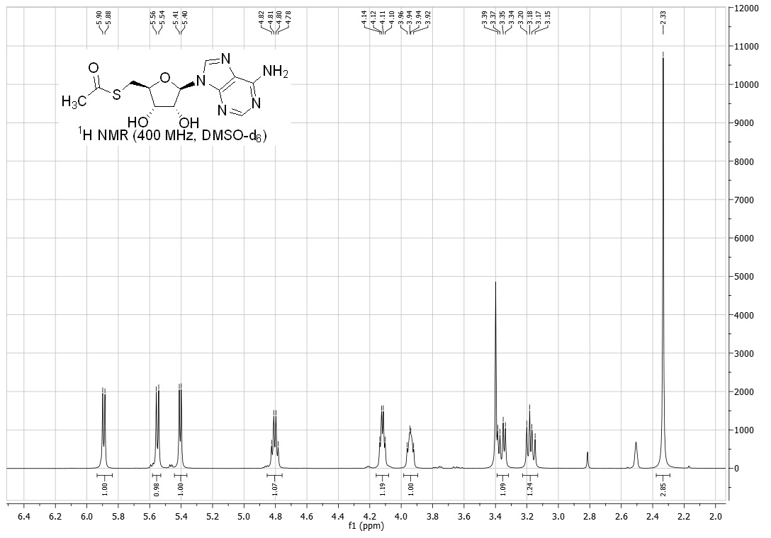
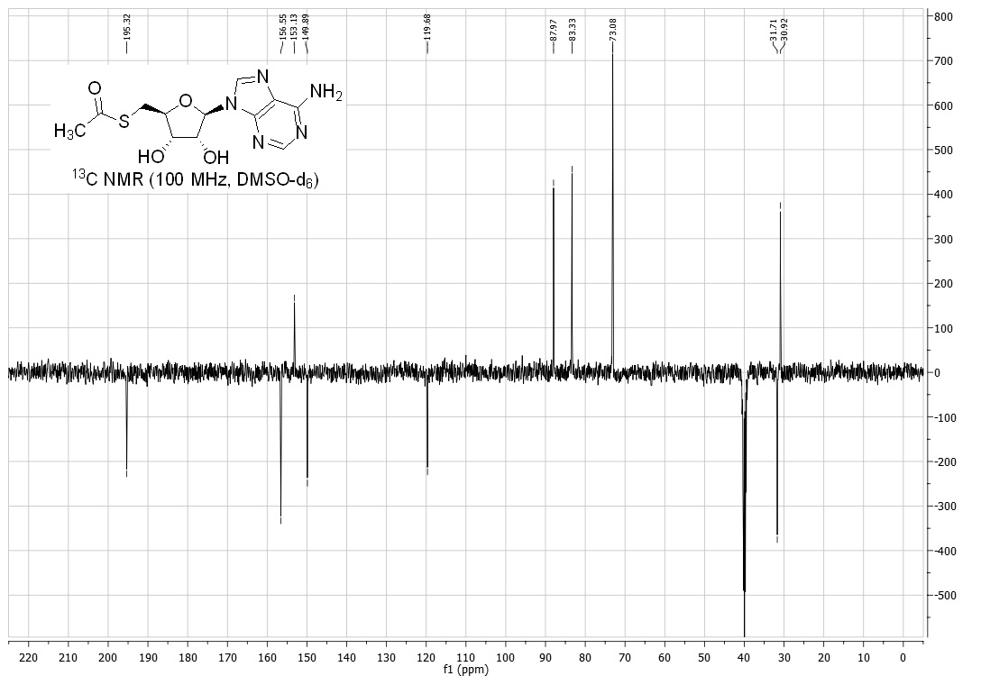
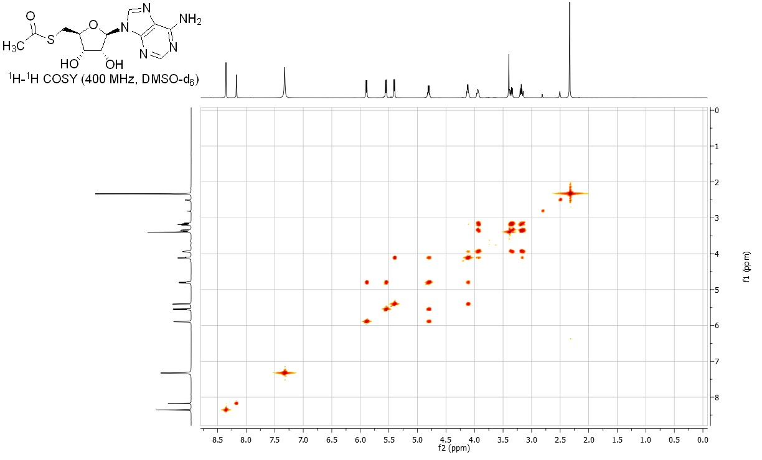
Compound 34
