Fig. S1 Mendelian randomization Leave-one-out analysis. (A) Leave-one-out plots for UC on anxiety. (B) Leave-one-out plots for anxiety on UC. (C) Leave-one-out plots for UC on depression. (D) Leave-one-out plots for depression on UC.
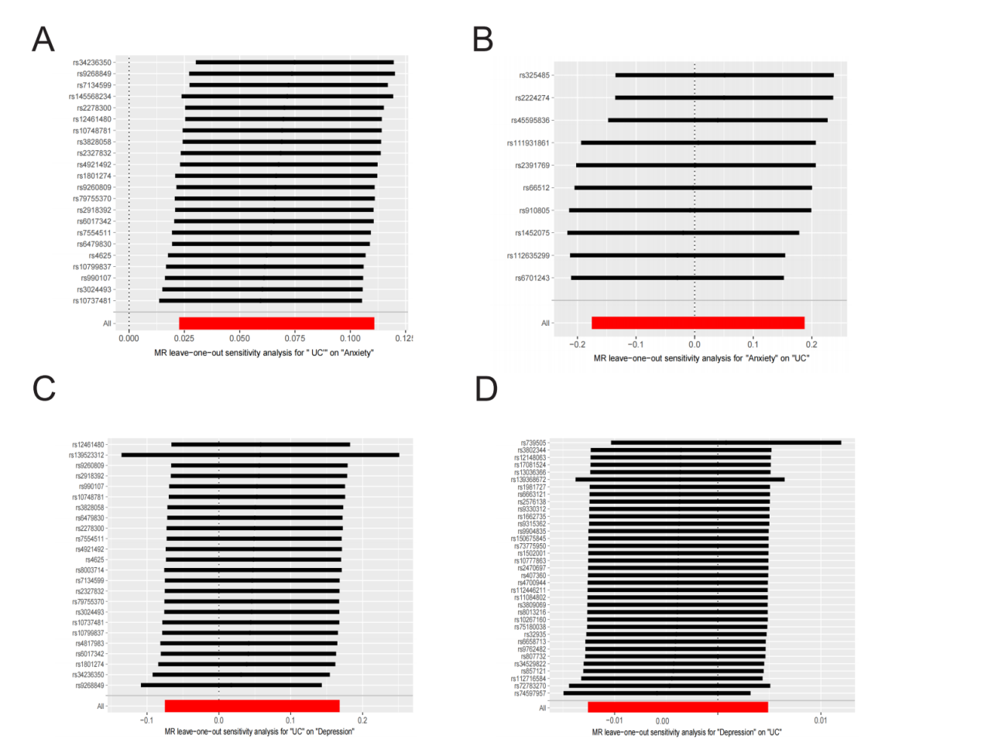

Fig. S2 Magnoflorine affected mice behavior. Magnoflorine increased the times enter in open arms of EPT experiments, but not affected immobility time in TST and FST experiments. Statistical significance was determined using one-way ANOVA, followed by Tukey test. *P < 0.05, ns, not significant.
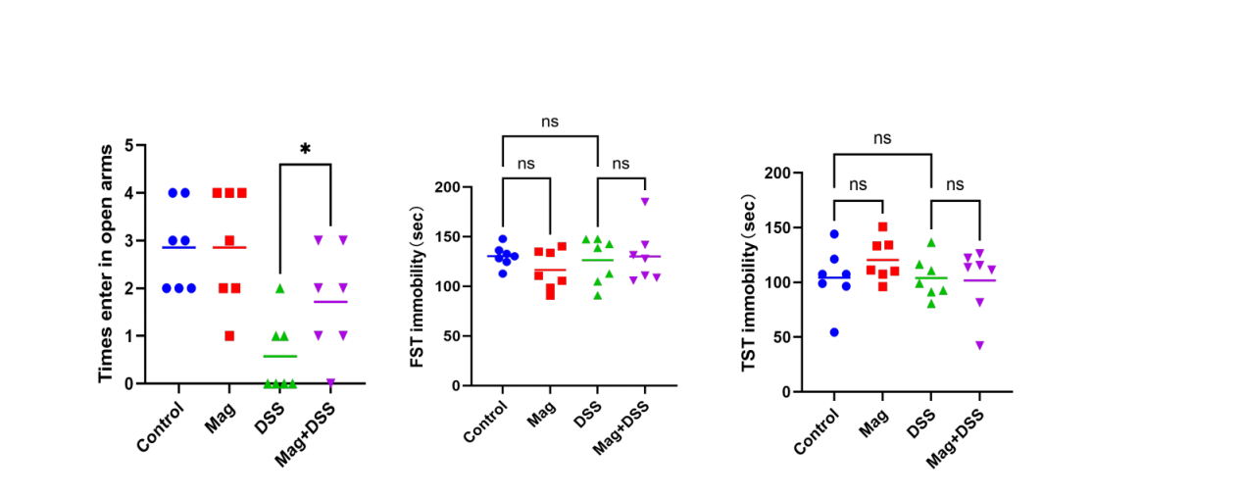
Fig. S3 Magnoflorine regulated colitis microbiota and WGCNA analysis. (A) α-diversity upon magnoflorine therapy represented by the Shannon index, *P < 0.05. (B) The PCoA plots upon magnoflorine therapy. (C) STAMP analysis of microbiota at family level between DSS group and Mag+DSS group. (D) By STAMP analysis, 16sRNA sequencing data analyzed by PICRUSt prediction yielded that K15873 was enriched in the Mag+DSS group. K15873: baiH, NAD+-dependent 7beta-hydroxy-3-oxo bile acid-CoA-ester 4-dehydrogenase. (E) WGCNA analysis. The left diagram showed clustering sampletree and cutHeight = 42, the right diagram showed network topology analysis for different soft-threshold power. The green arrow indicates the selected power value. (F) Venn diagram showing the common part of red and blue ME.
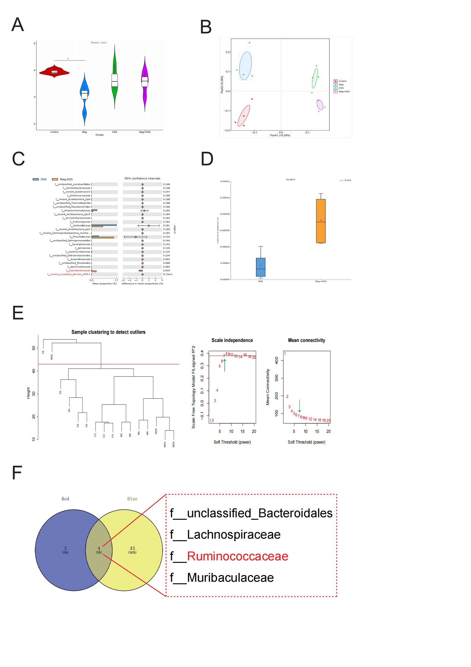

Fig. S4 Magnoflorine alleviated colitis depending on microbiota. (A) Daily body weight change throughout the DSS treatment duration of the ABx experiment. (B) H&E stained colon sections and Pathological scores of colons of the ABx experiment. (C) Daily body weight change throughout the DSS treatment duration of the FMT experiment. (D) H&E stained colon sections and Pathological scores of colons of the FMT experiment.(E) Daily body weight change throughout the DSS treatment duration of the SFF experiment. (F) H&E stained colon sections and Pathological scores of colons of the SFF experiment.. Data were presented as means±SEM. Statistical significance was determined using Tukey test. **P < 0.01, ***P < 0.001, ****P < 0.0001.
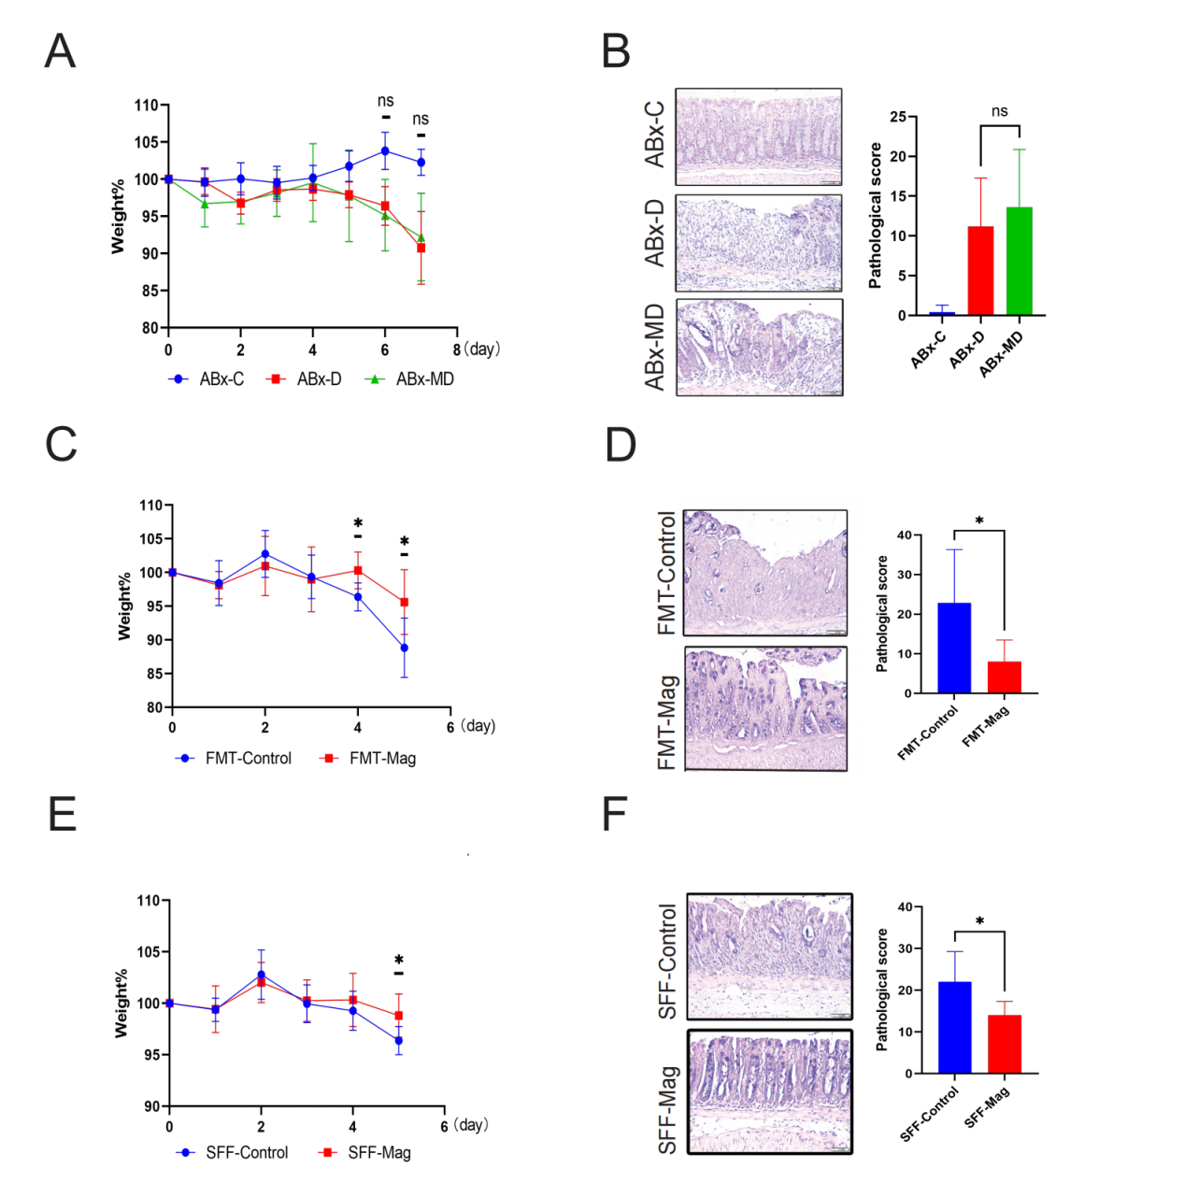

Fig. S5 GO and KEGG analysis based on DEG between DSS group and Mag+DSS group. (A) GO functional enrichment analysis, including BP, CC, and MF. (B) KEGG functional enrichment analysis.
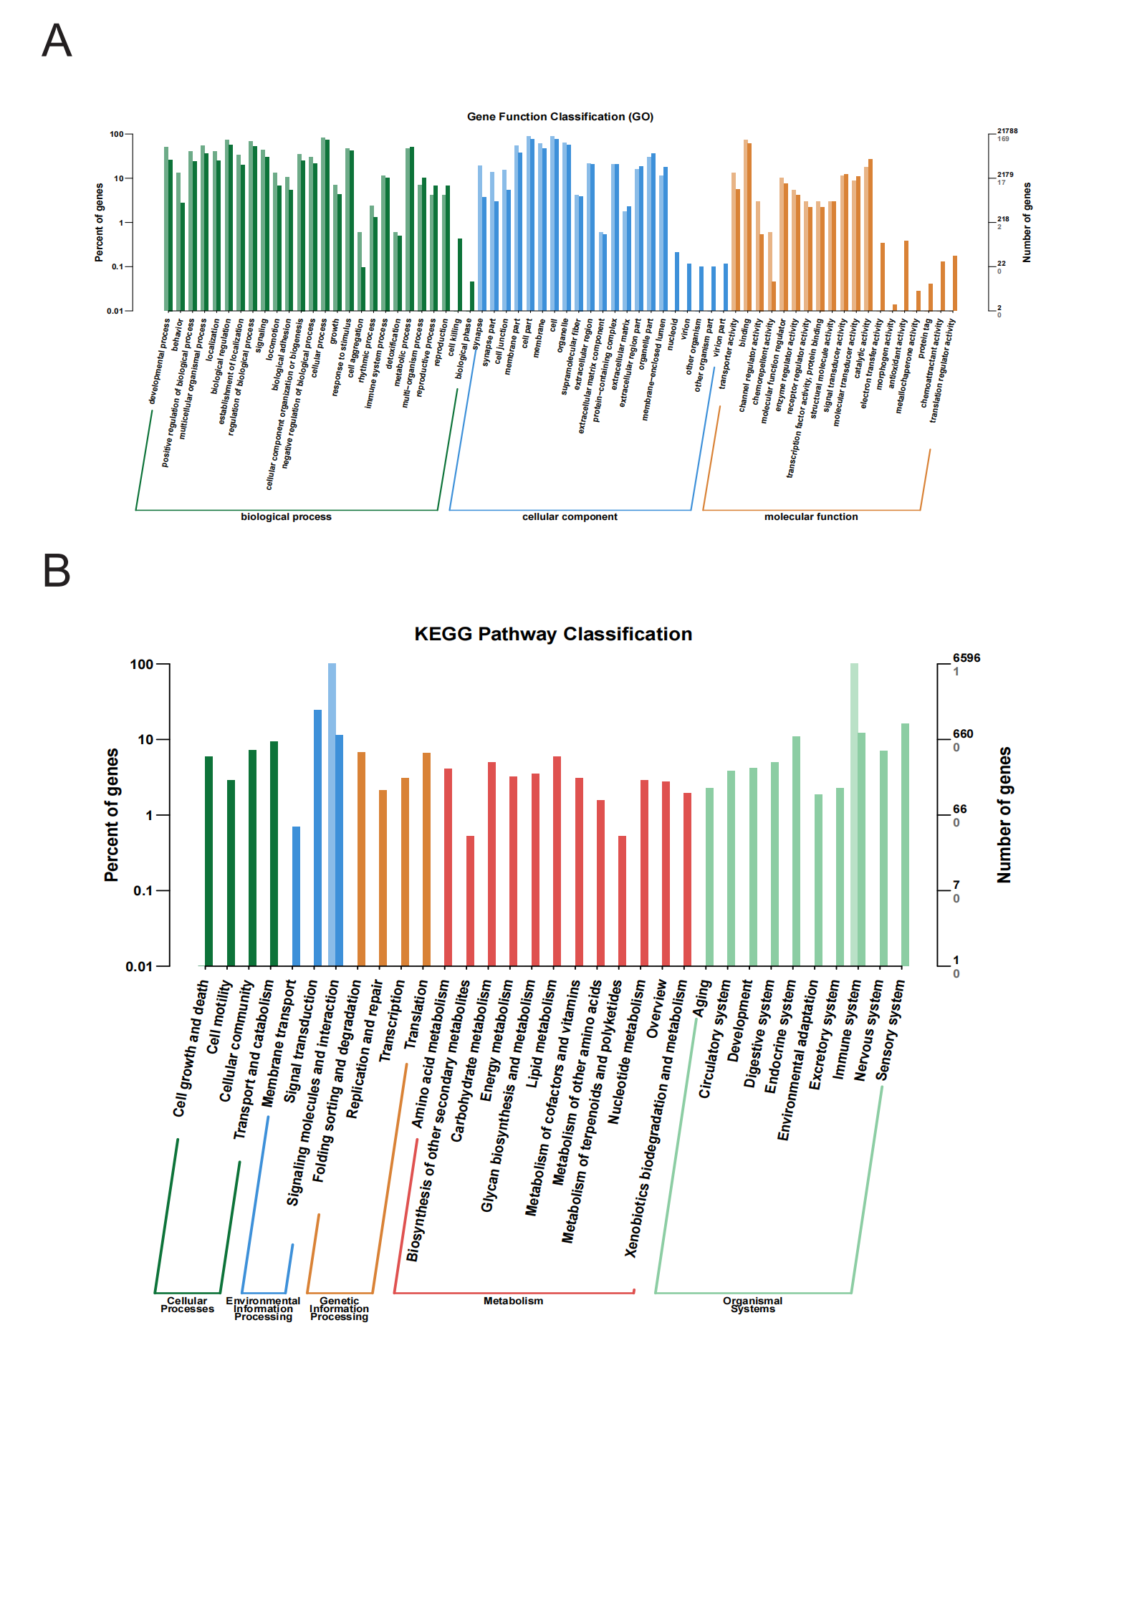

Fig. S6 HDCA alleviated colitis and neuroinfalmmation. (A) Daily body weight and DAI scores change throughout the DSS treatment duration of the HDCA treatment experiment. (B) Images of the colon and the colon length in HDCA treatment experiment. (C) Concentrations of three representative pro-infammatory cytokines at mRNA level in BV2 cells. (D) Representative immunofluorescence images of IBA-1 in BV2 cells. Magnification: 200×, Scale bars: 50μm. Data were presented as means±SEM. Statistical significance was determined using Tukey test. *P < 0.05, **P < 0.01, ***P < 0.001, ****P < 0.0001.
