Table 1. Types of Pomegranate Disorders and their Preventive Measures
Pomegranate Diseases with their sign and preventive measures
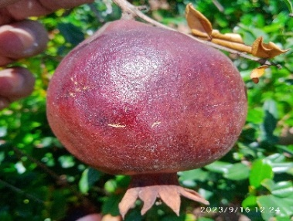
Signs of the Disease:
Alternaria fruit rot, also referred to as blackheart, is a significant disease affecting pomegranates. Infections occur following the formation of wounds on the fruit after flower initiation. The disease manifests on the fruit as small, reddish-brown circular spots. As the infection progresses, these spots coalesce into larger patches, leading to fruit rot. The disease also impacts the arils, which discolor to a pale brown or black, rendering them unfit for consumption.

Preventive Measures:
Cultural Methods:
To manage the disease, it is recommended that all affected fruits be collected and destroyed. This practice helps to reduce the spread of the pathogen and minimize further infection.
Chemical Methods:
The application of mancozeb at a concentration of 0.25% (2.5g/liter) has been demonstrated to effectively control the disease. This fungicide treatment inhibits the development and spread of the pathogen, thus protecting the fruit from further damage.
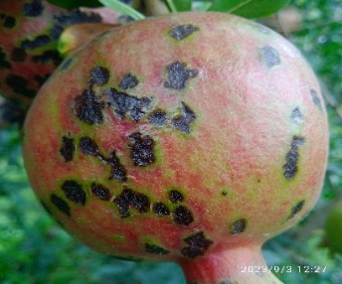
Signs of the Disease:
The disease manifests on leaves as small, either regular or irregularly shaped spots that are light violet or black with yellow halos. Initially, the affected leaves turn yellow before eventually falling off. The disease also presents on flowers. Both young and mature fruits develop spots that start as circular, but become irregular with sunken centers. These spots transition from brown to dark brown and may cover the fruit partially or completely. Additionally, minute black dots, representing acervuli, are distinctly visible on the surface of the fruits.

Preventive Measures:
Cultural Methods:
- Remove all infected plant debris to reduce the pathogen load in the environment.
- Apply a nitrogen solution or bleaching powder to fallen leaves or affected plant parts to promote their degradation.
- Prune and burn all affected branches, and subsequently apply Bordeaux paste or copper oxychloride paste to the cut ends to prevent further spread of the disease.
Chemical Methods:
- Treat the crop with systemic fungicides such as Hexaconazole at a concentration of 1 ml/liter or Carbendazim at 1 g/liter, with applications repeated at 20-day intervals.
- Foliar application of Mancozeb at a concentration of 2.5 g/liter is also effective in managing the disease.
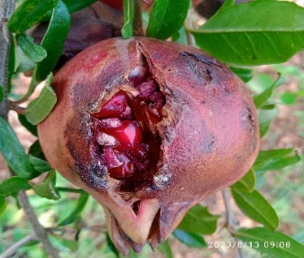
Signs of the Disease:
On the leaves, the disease manifests as one to several small, water-soaked, dark-colored irregular spots, which can lead to premature defoliation in severe cases. The size of these spots’ ranges from 2 to 5 mm in diameter and typically features a necrotic center of pinhead size. On the fruits, the disease produces dark brown, irregular, slightly raised spots with an oily appearance. In severe instances, these spots may cause the fruit to split open with L-shaped cracks.
Preventive Measures:
Cultural Methods:
- Pruning at the appropriate growth stage can effectively reduce the incidence of the disease.
- Implementing clean cultivation practices and maintaining strict sanitation are crucial for minimizing disease occurrence.
- Collect and incinerate fallen leaves to eliminate potential sources of infection.
- Spraying a 1% urea solution on fallen leaves promotes their degradation.
- Application of bleaching agents to fallen leaves helps in reducing the pathogen inoculum.
Chemical Methods:
- Control the disease by applying Bordeaux mixture at a concentration of 1.0% (10 g each of copper sulfate and lime per liter of water).
- Alternatively, use streptocycline at 0.05% (0.5 g per liter of water) or copper oxychloride at 0.3% (3 g per liter of water) to manage the disease effectively.
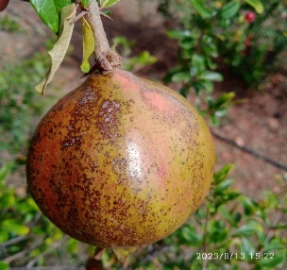
Signs of the Disease:
On the leaves, the disease manifests as one to several small, water-soaked, dark-colored irregular spots, which can lead to premature defoliation in severe cases. The size of these spots’ ranges from 2 to 5 mm in diameter and typically features a necrotic center of pinhead size. On the fruits, the disease produces dark brown, irregular, slightly raised spots with an oily appearance. In severe instances, these spots may cause the fruit to split open with L-shaped cracks.
Preventive Measures:
Cultural Methods:
Collect and destroy all infected plant debris to reduce the potential sources of pathogen inoculum.
Chemical Methods:
Apply systemic fungicides to manage the disease effectively. Options include Carbendazim at a concentration of 1 g/liter, Hexaconazole at 1 ml/liter, or Propiconazole at 1 ml/liter. Repeat the application at 10 to 14-day intervals to ensure effective control.

