Table 1. Contents of Psychoeducation for inpatients with schizophrenia on Shin-Abuyama Hospital
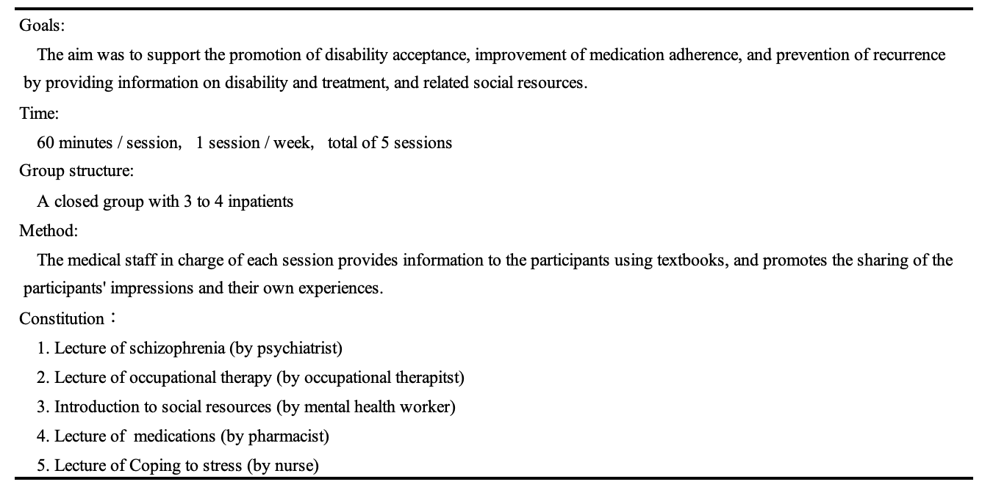

Table 2. Comparison of Characteristics of the program completion group and the program noncompletion group
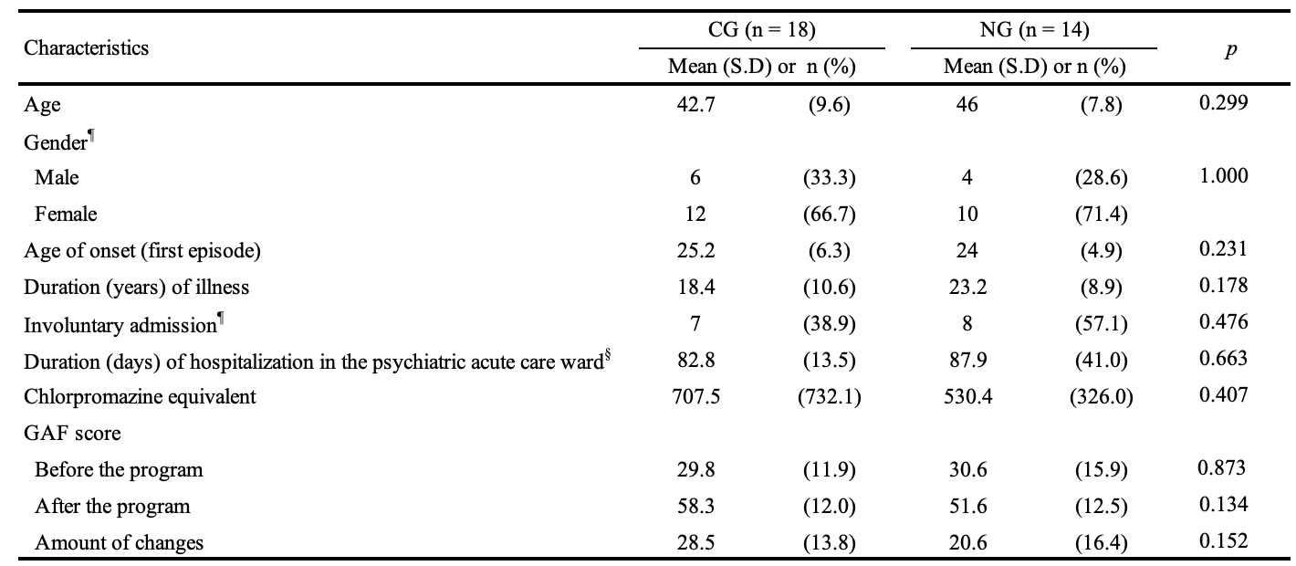
CG: program completion group; NG: program non-completion group; S.D: standard deviation
¶: Fisher's exact test was used, §: The Welch's t-test was used as used because homoscedasticity could not be confirmed by Levene's test.

Table 3. List of program attendance for participants in this study
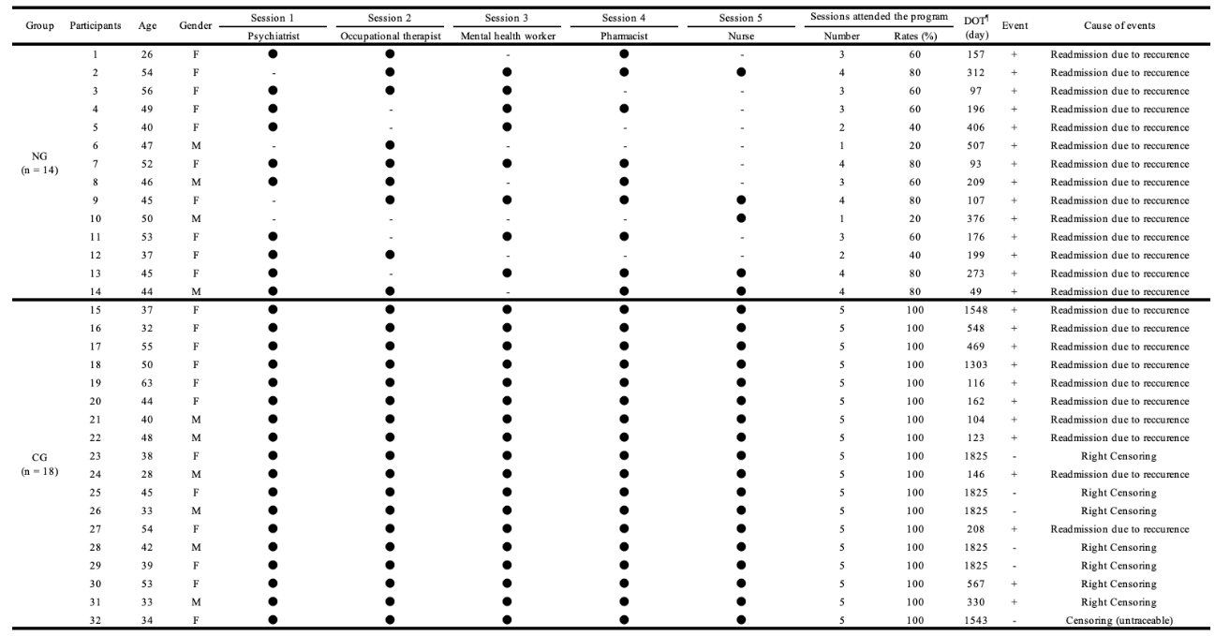
CG: program completion group; NG: program non-completion group; DOT: duration of outpatient treatment
¶: Maximum follow-up period (DOT) in this study is 5 years (1825 days).

Table 4. Univariate and multivariate Cox proportional regression analysis of all-cause discontinuation
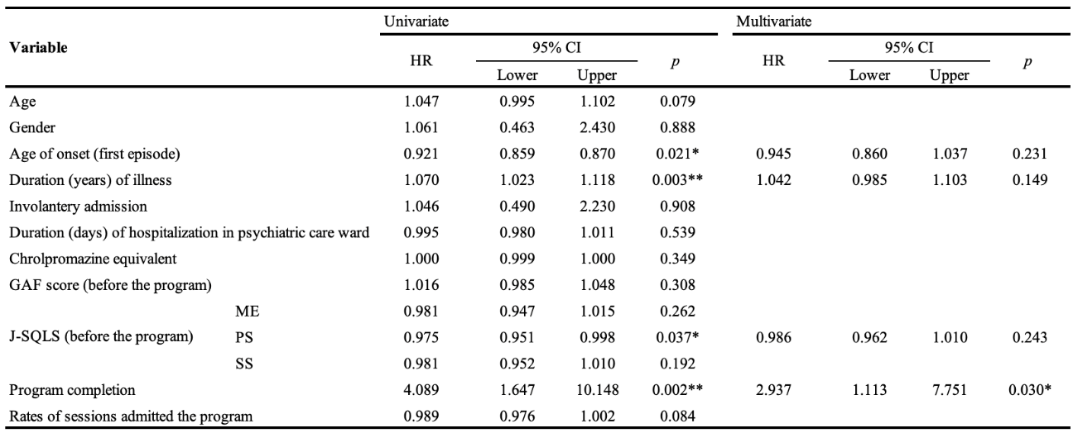
Survival variable: duration of outpatient treatment (DOT), days (up to 1825 days)
HR: hazard ratio; ME: motivation / energy; PS: psychological / social relations; SS: symptoms / side effects; *: p < 0.05; **: p < 0.01

Table 5. Comparison of the percentage of event occurrences by year
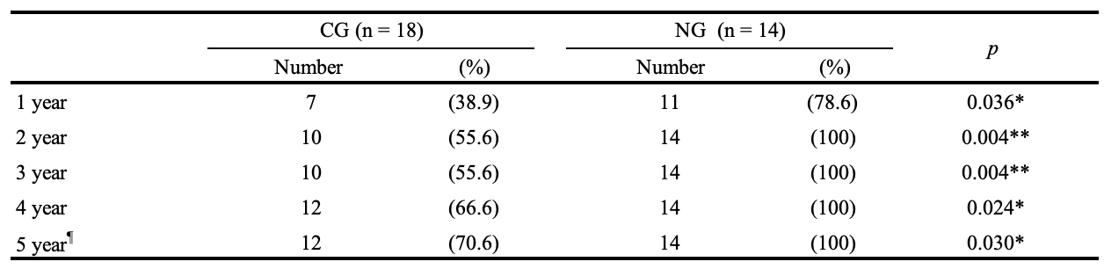
CG: program completion group; NG: program non-completion group; *: p < 0.05; **: p < 0.01
¶: 1 participant was censored during the period due to inability to contact. Hence, the population of CG had been reduced to 17.
Fisher's exact test was used to compare the percentage of event occurrences by year.

Table 6. The mean values subscale scores for the completion and non-completion groups of J-SQLS scores.
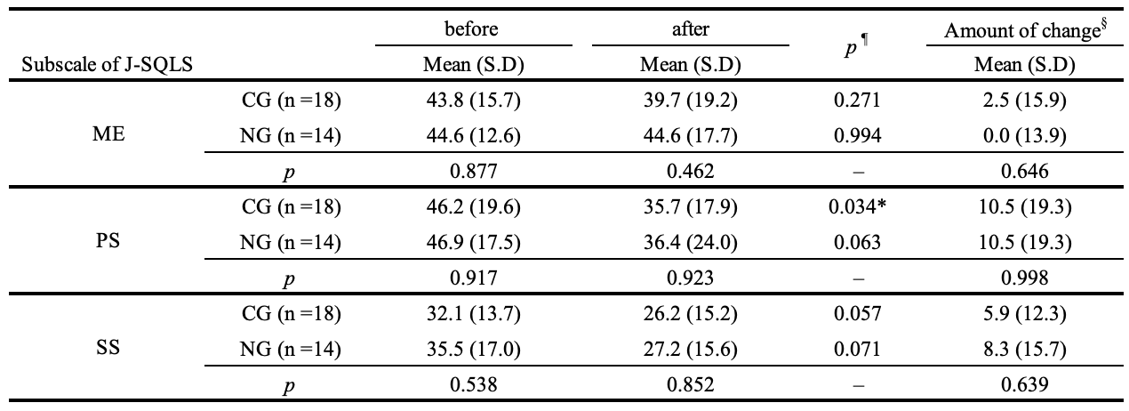
CG: program completion group; NG: program non-completion group; S.D: standard deviation
ME: motivation / energy; PS: psychological / social relations; SS: symptoms / side effects; *: p < 0.05
¶: Paired t-tests were used to analyze within-group comparisons
§: The amount of change means the improvements obtained by subtracting the before value from the after value.

