The following pictures are the cover we chose, the first one is the picture in the paper for the cover. If we can choose the picture not in the article, we also recommend the next two for the cover.
Figure 1 Schematic of the potential distribution of Kengyilia thoroldiana based on the MaxEnt model.

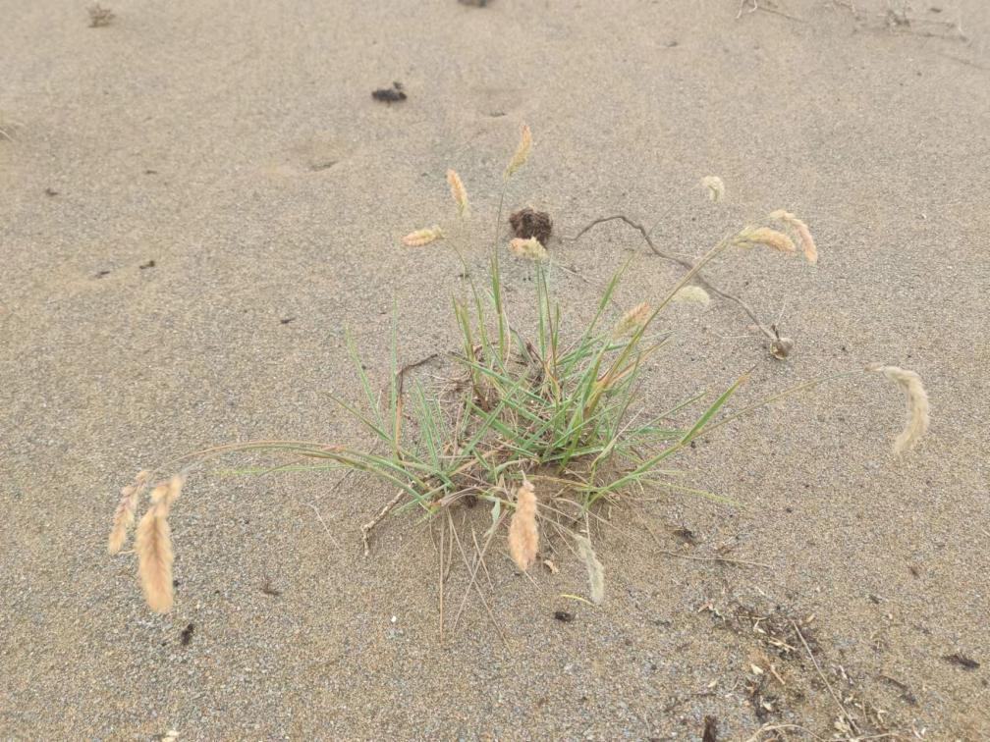
Figure 2 A photo of the Kengyilia thoroldiana
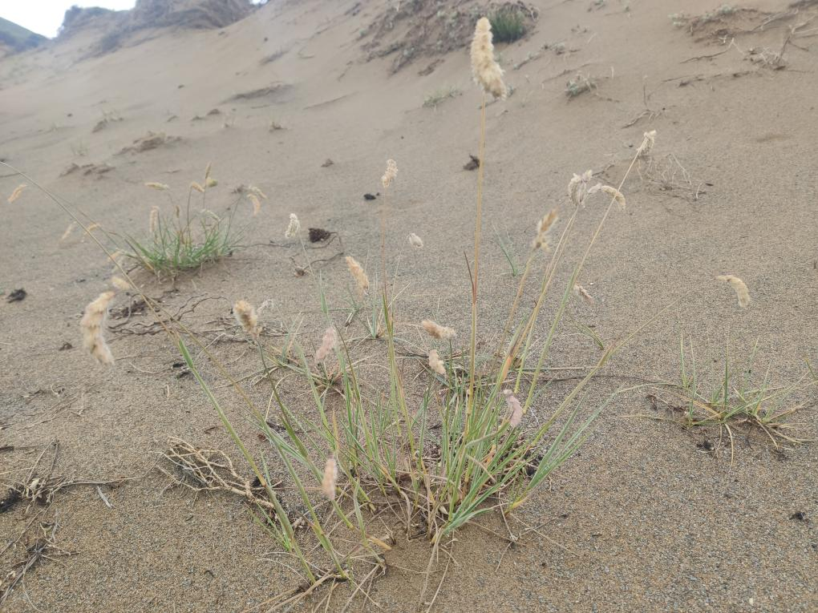
Figure 3 A photo of the Kengyilia thoroldiana

