Supporting information

Biomimetic Freestanding MicroFractals for Flexible Electronics
Amit Baruaª, Rituporn Gogoiª, Pulikanti Guruprasad Reddyª, Timo Laukkanenª, Saman Jolaiy^{b}, Mahdi Bodaghi^{b}, Thomas Speck^{c}, Veikko Sariola^{d}, and Vipul Sharmaª*
ª Department of Mechanical and Materials Engineering, University of Turku, Turku-20014, Finland.
^{b} Department of Engineering, School of Science and Technology, Nottingham Trent University, NG11 8NS, Nottingham, United Kingdom
^{c} Plant Biomechanics Group, University of Freiburg, Schänzlestraße 1, D-79104 Freiburg, Germany
^{d} Faculty of Medicine and Health Technology, Tampere University, Tampere, Finland

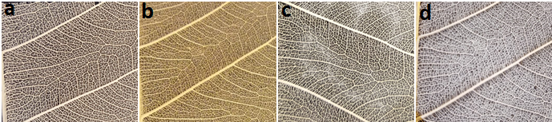
Fig S1. Testing the leaf skeleton metalized leaf skeleton as a collector for the electrospinning process. Digital photograph of (a) normal leaf skeleton (b) Au sputtered metalized leaf skeleton (c) electrospun nanofiber deposition on the normal leaf skeleton (d) electrospun nanofiber deposition on Au sputtered metalized leaf skeleton
The figure 1 shows the leaf skeleton of Ficus Religiosa both uncoated and coated with Au nanoparticles. Ficus Religiosa leaf skeleton was cut into equal dimensions (3 cm x 3 cm) and coated with gold on both surfaces. The sputter coating thickness is 30 nm which is represented in the figure 1 (b). Sputtering current was 7 nA. The collectors were put to test with the electrospinning setup. It is evident from the figure 1 (c, d) that the uncoated leaf skeleton attracts uneven and negligible amount of fiber. Whereas, more fibers seem to have deposited on the coated sample with even distribution.
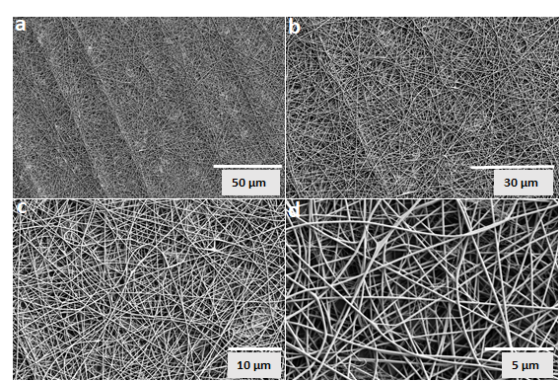
Fig S2. SEM images of N-6 mat at different scales.
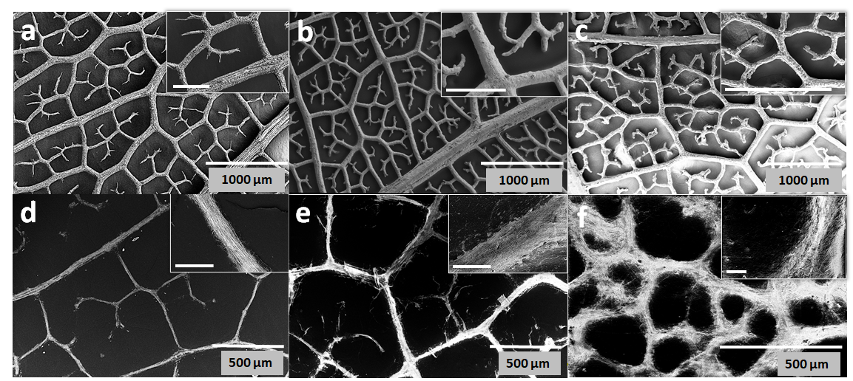
Fig S3. SEM images of different leaf skeletons and different biomimetic replicated surface: (a) F. religiosa leaf skeleton, (b) L. lucidum leaf skeleton, (c) P. tremuloides leaf skeleton, (d) F. religiosa replicated surface, (e) L. lucidum replicated surface, and (f) P. tremuloides replicated surface. The scale bar of the inset figures of (a-c) represents 500 µm and the scale bar of the inset figures of (d-f) represents 40 µm.

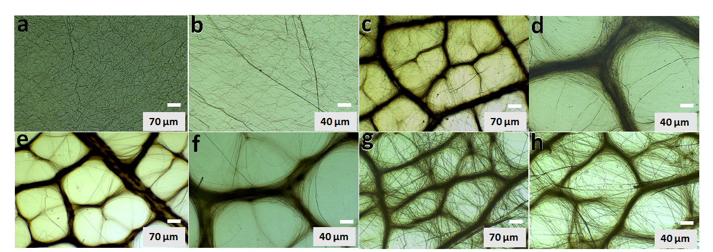
Fig S4. Optical microscope images of the nanofibers produced by Nylon – 6. (a) Nylon – 6 mat (b) F. religiosa replicated (c) L. lucidum replicated (d) P. tremuloides replicated.

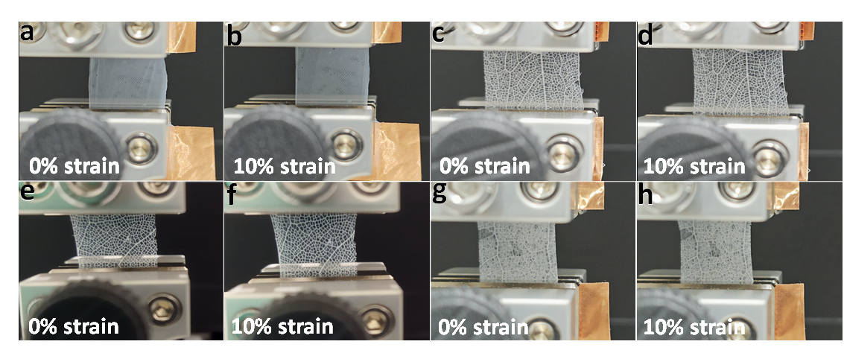
Fig S5. Mechanical testing setup. The images on the left represent the fibers in unloaded condition and the images on the right represent the fibers in loaded condition (a) Nylon 6 mat (b) F. religiosa replicated (c) L. lucidum replicated (d) P. tremuloides replicated.

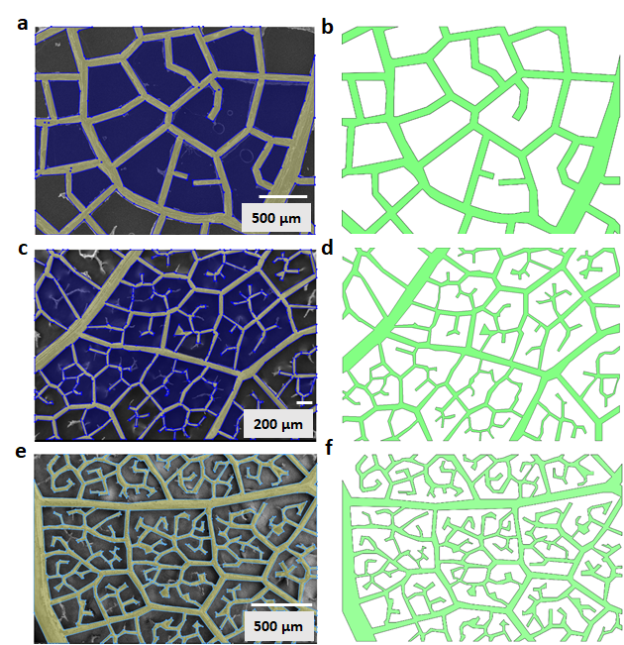
Fig S6. CAD model in SolidWorks software: (a) sketch of the L. lucidum skeleton, (b) CAD model of the L. lucidum skeleton, (c) sketch of the F. religiosa skeleton, (d) CAD model of the F. religiosa skeleton, (e) sketch of P. tremuloides skeleton, and (f) CAD model of the P. tremuloides skeleton.

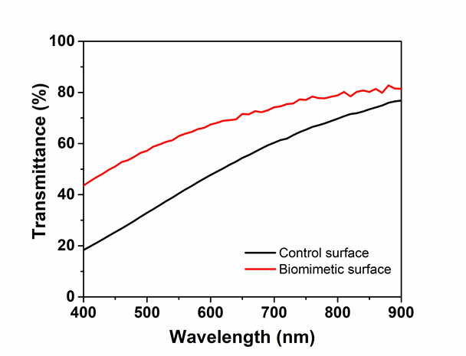
Fig S7. Comparison of transmittance between the control surface and biomimetic surface (AgNW concentration of 200 µg mL⁻¹).

