Online Data Supplement
Associations of furan exposure with the prevalence and mortality in asthma: A prospective cohort study
Shuwen Zhang, MD.^{1, 2}, Kunlu Shen, MD., PhD.^{2, 3}, Bingqing Sun, MD.^{2, 3}, Bowen Liu, MD.^{2, 4}, Chunxiao Li, MD.^{1, 2}, Mengqi Zhou, MD. ^{2, 4}, Xin Hou, MD.^{1, 2}, Min Xiang, MD. ^{2, 4}, Jiangtao Lin, MD., PhD.^{2*}
1. Graduate School of Peking University China-Japan Friendship School of Clinical Medicine, Beijing, 100029, China.
2. Department of Pulmonary and Critical Care Medicine, Center of Respiratory Medicine, China-Japan Friendship Hospital, Beijing, 100029, China.
3. Graduate School of Peking Union Medical College, Chinese Academy of Medical Sciences & Peking Union Medical College, Beijing, 100730, China.
4. Graduate School of Beijing University of Chinese Medicine, Beijing, 100029, China
This online data supplement has been included by the authors to provide readers with additional information about the results. The components of the Online Data Supplement are as follows:

Figure E1. Smoothed curve fitting shows the association between log10-transformed blood furan and lung function after adjusting for confounders (for FEV₁ and FVC: age, sex, ethnicity, BMI, PIR, serum cotinine, and asthma status were considered as confounders; for FEV₁ % predicted and FVC % predicted: BMI, PIR, serum cotinine, asthma status were considered as confounders). The red area indicates a 95% confidence interval. A. absolute value of FEV₁[L]; B. FEV₁ % predicted; C. absolute value of FVC[L]; D. FVC % predicted.
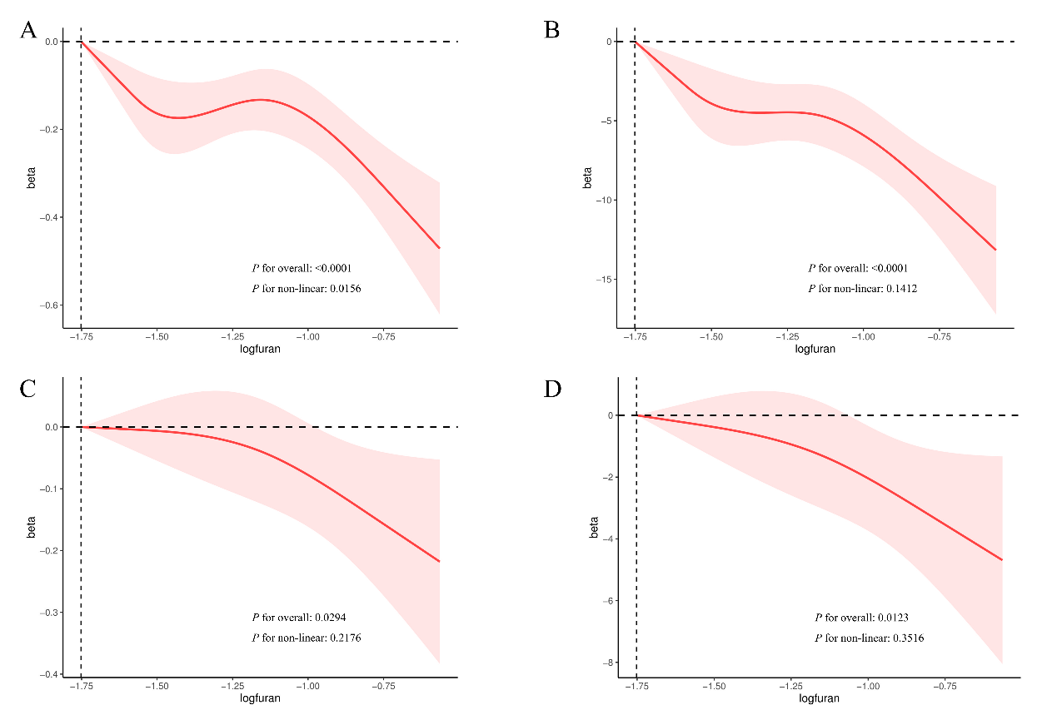

E-TABLES
Table E1. Demographics and clinical characteristics of participants group by log10-transformed blood furan levels.
Variable | All (n=7047) | Low (≤ -1.752 ng/mL) (n=6003) | High (> -1.752 ng/mL) (n=1044) | P-value
Age | 46.00(33.00,59.00) | 46.00(33.00,60.00) | 45.00(34.00,55.00) | 0.01
Sex |  |  |  | 0.04
Female | 3576(51.64) | 3091(52.23) | 485(48.46)
Male | 3471(48.36) | 2912(47.77) | 559(51.54)
Ethnicity |  |  |  | < 0.0001
Mexican American | 1123(8.43) | 1046(9.21) | 77(4.14)
Non-Hispanic Black | 1445(10.96) | 1186(10.57) | 259(13.07)
Non-Hispanic White | 3083(67.56) | 2494(66.17) | 589(75.17)
Other Hispanic | 767(5.79) | 697(6.19) | 70(3.64)
Other Race - Including Multi-Racial | 629(7.25) | 580(7.85) | 49(3.99)
Educational attainment |  |  |  | < 0.0001
College or more | 3482(58.65) | 3108(61.90) | 374(41.41)
High school | 1581(22.42) | 1267(20.80) | 314(31.49)
Middle school or lower | 1975(18.78) | 1620(17.29) | 355(27.10)
Marital status |  |  |  | < 0.0001
Divorced | 745(10.19) | 571(9.08) | 174(16.33)
Living with partner | 542(7.88) | 406(6.87) | 136(13.38)
Married | 3663(55.63) | 3262(58.19) | 401(41.72)
Never married | 1239(18.04) | 1040(17.84) | 199(19.15)
Separated | 258(2.64) | 195(2.25) | 63(4.82)
Widowed | 596(5.59) | 526(5.78) | 70(4.60)
BMI | 27.50(24.01,32.00) | 27.64(24.24,32.24) | 26.65(22.85,30.88) | < 0.0001
PIR | 2.91(1.43,5.00) | 3.15(1.57,5.00) | 1.94(1.00,3.69) | < 0.0001
Serum cotinine | 0.04(0.01,4.98) | 0.03(0.01, 0.14) | 250.00(170.00,346.00) | < 0.0001
Past-year alcohol drinking |  |  |  | < 0.0001
≥4 drinks/day | 1049(15.68) | 776(16.24) | 273(36.25)
1–3 drinks/day | 2800(45.89) | 2415(57.07) | 385(49.66)
Never | 1762(20.37) | 1636(26.69) | 126(14.09)
Spirometry
FEV₁ (L) | 3.18(2.57,3.84) | 3.20(2.59,3.86) | 3.08(2.48,3.64) | < 0.0001
FEV₁% predicted | 98.11(88.51,107.04) | 98.94(90.22,107.83) | 91.90(81.61,101.00) | < 0.0001
FVC (L) | 4.05(3.33,4.87) | 4.05(3.31,4.87) | 4.01(3.44,4.91) | 0.41
FVC% predicted | 101.24(92.16,110.26) | 101.52(92.73,110.49) | 99.99(90.15,108.09) | 0.01
FEV₁/FVC | 3.00(2.11,3.85) | 3.07(2.20,3.92) | 2.50(1.64,3.47) | < 0.0001
Cancer |  |  |  | 0.92
No | 6403(90.78) | 5447(90.94) | 956(90.79)
Yes | 638(9.07) | 551(9.06) | 87(9.21)
Coronary heart disease |  |  |  | 0.39
No | 6764(96.93) | 5761(97.17) | 1003(97.59)
Yes | 252(2.76) | 214(2.83) | 38(2.41)
Diabetes mellitus |  |  |  | 0.41
Borderline | 141(1.93) | 122(1.96) | 19(1.76)
No | 6019(89.20) | 5098(88.97) | 921(90.66)
Yes | 883(8.84) | 779(9.07) | 104(7.58)
HBP |  |  |  | 0.24
No | 4564(69.83) | 3867(69.54) | 697(71.78)
Yes | 2475(30.09) | 2128(30.46) | 347(28.22)
Asthma |  |  |  | < 0.0001
No | 6096(86.08) | 5256(87.15) | 840(80.18)
Yes | 951(13.92) | 747(12.85) | 204(19.82)
BMI, body mass index; PIR, poverty-income ratio; FEV1, forced expiratory volume in 1 s; FVC, forced vital capacity; HBP, high blood pressure.

Table E2. Subgroup analysis of the influence of log 10-transformed blood furan on risk for asthma.
Subgroup | OR (95% CI) | P-value | P for interaction
Age |  |  | 0.072
>=60 | 1.554(0.375, 6.445) | 0.531
<60 | 2.422(1.182, 4.965) | 0.017
BMI |  |  | 0.496
>=30 | 1.423(0.791, 2.561) | 0.229
25-29.9 | 5.592(1.422, 21.990) | 0.016
< 24.9 | 2.607(0.660, 10.296) | 0.164
Sex |  |  | 0.237
Female | 4.159(1.335, 12.960) | 0.016
Male | 1.548(0.694, 3.452) | 0.275
Ethnicity |  |  | 0.285
Non-Hispanic White | 2.949(1.234, 7.047) | 0.017
Other Hispanic | 11.169(1.444, 86.411) | 0.023
Non-Hispanic Black | 0.693(0.224, 2.149) | 0.510
Mexican American | 0.642(0.023, 18.056) | 0.784
Other Race - Including Multi-Racial | 2.184(0.162, 29.483) | 0.535
Marital status |  |  | 0.501
Married | 4.294(1.064, 17.335) | 0.041
Widowed | 0.197(0.009, 4.119) | 0.281
Separated | 0.912(0.057, 14.57) | 0.945
Divorced | 3.903(0.851, 17.889) | 0.078
Never married | 2.1380.990, 4.615) | 0.053
Living with partner | 0.529(0.169, 1.652) | 0.263
Educational attainment |  |  | 0.077
High school | 0.747(0.303, 1.842) | 0.514
Middle school or lower | 3.415(1.317, 8.856) | 0.013
College or more | 5.407(1.496, 19.548) | 0.012
OR, odds ratio; CI, confidence interval; BMI, body mass index.

Table E3. Multiple linear regression associations of log10-transformed blood furan levels and asthma risk with WBCs and lung function among adults in NHANES 2007–2012
Variables | Furan |  | Asthma
 | β (95%CI) | P-value | β (95%CI) | P-value
Lymphocyte | 0.346(0.207, 0.485) | <0.0001 | 0.024(-0.025, 0.074) | 0.323
Monocytes | 0.034(-0.010, 0.078) | 0.129 | 0.001(-0.017, 0.019) | 0.911
Neutrophils | 1.005(0.559, 1.451) | <0.0001 | 0.056(-0.073, 0.184) | 0.381
Eosinophils | -0.01(-0.042, 0.023) | 0.552 | 0.041(0.025, 0.056) | <0.0001
Basophils | -0.001(-0.016, 0.014) | 0.913 | 0.005(-0.003, 0.013) | 0.173
FEV₁ | -0.351(-0.500, -0.202) | <0.0001 | -0.222(-0.293, -0.151) | <0.0001
Adjusted for age, sex, ethnicity, marital status, educational attainment, BMI, PIR, serum cotinine, past-year alcohol drinking, and diabetes mellitus.

Table E4. Weighted univariate cox regression models of demographics and clinical characteristics predicting respiratory mortality of asthma.
Variable | HR (95% CI) | P-value
Age | 1.134(1.083,1.188) | <0.0001
Sex
Female | 1.000 (ref)
Male | 1.849(0.596,5.736) | 0.288
Ethnicity
Non-Hispanic White | 1.000 (ref)
Mexican American | <0.001 (<0.001, <0.001) | <0.0001
Other Hispanic | 0.984(0.182,5.313) | 0.985
Non-Hispanic Black | 1.017(0.278,3.720) | 0.980
Other Race - Including Multi-Racial | 0.952(0.224,4.046) | 0.947
Educational attainment
College or more | 1.000 (ref)
High school | 1.925(0.480, 7.722) | 0.355
Middle school or lower | 3.898(1.282,11.853) | 0.017
Marital status
Married | 0.297(0.031, 2.817) | 0.290
Never married | 0.842(0.168, 4.219) | 0.835
Divorced | 0.901(0.100, 8.093) | 0.926
Living with partner | 3.070(0.411,22.930) | 0.274
Separated | 6.278(1.227,32.118) | 0.027
Widowed
BMI | 0.931(0.847,1.022) | 0.134
PIR | 0.605(0.371,0.986) | 0.044
Serum cotinine | 1.004(1.001,1.007) | 0.007
Cancer
No | 1.000 (ref)
Yes | 1.898(0.589,6.117) | 0.283
Coronary heart disease
No
Yes | 20.977(5.594,78.661) | <0.0001
Diabetes mellitus
No | 1.000 (ref)
Yes/Borderline | 2.243(0.836,6.022) | 0.109
HBP
No | 1.000 (ref)
Yes | 4.689(1.622,13.553) | 0.004
BMI, body mass index; PIR, poverty-income ratio; HBP, high blood pressure.

Table E5. Association of asthma with lung function and participants -reported health outcomes.
Variable | All | Healthy controls | Asthma | P-value
Lung function
FEV₁ (L) | 3.18(2.57,3.84) | 3.21(2.61,3.87) | 3.03(2.31,3.56) | < 0.0001
FEV₁ % predicted | 98.11(88.51,107.04) | 98.78(90.08,107.60) | 92.51(80.34,102.76) | < 0.0001
FVC (L) | 4.05(3.33,4.87) | 4.06(3.36,4.91) | 3.92(3.18,4.64) | 0.003
FVC % predicted | 101.24(92.16,110.26) | 101.67(92.87,110.68) | 98.57(88.03,107.73) | < 0.0001
Obstructive |  |  |  | < 0.0001
No | 4880(72.76) | 4283(87.87) | 597(77.09)
Yes | 740(11.49) | 582(12.13) | 158(22.91)
Restrictive |  |  |  | 0.46
No | 5279(79.90) | 4573(95.26) | 706(94.37)
Yes | 319(4.09) | 274(4.74) | 45(5.63)
Asthma-related health outcomes
Asthma attack in past yr |  |  |  | NA
No | 273(3.73) | NA | 273(48.53)
Yes | 260(3.96) | NA | 260(51.47)
Emergency room visits for asthma in past yr |  |  |  | NA
No | 253(4.13) | NA | 253(79.49)
Yes | 90(1.07) | NA | 90(20.51)
Respiratory symptoms
Wheezing |  |  |  | < 0.0001
No | 6095(86.91) | 5561(91.84) | 534(56.67)
Yes | 947(13.05) | 531(8.16) | 416(43.33)
Phlegm |  |  |  | < 0.0001
No | 4222(57.39) | 3771(93.11) | 451(80.39)
Yes | 436(5.33) | 319(6.89) | 117(19.61)
Cough |  |  |  | < 0.0001
No | 4175(56.22) | 3746(91.69) | 429(75.43)
Yes | 483(6.51) | 344(8.31) | 139(24.57)
Exertional dyspnea |  |  |  | < 0.0001
No | 3130(43.47) | 2886(72.72) | 244(45.96)
Yes | 1524(19.23) | 1202(27.28) | 322(54.04)
Health-related quality of life
Days physical health was not good | 3.59±0.13 | 3.39±0.15 | 4.79±0.34 | 0.001
Days mental health was not good | 4.13±0.13 | 3.87±0.12 | 5.70±0.35 | < 0.0001
Inactive days due to health | 1.83±0.09 | 1.66±0.10 | 2.84±0.36 | 0.004
FEV₁, forced expiratory volume in 1 s; FVC, forced vital capacity; yr, year; NA, not applicable.

Table E6. Association of Log10-transformed blood furan levels with lung function and participants -reported health outcomes.
Variable | All | Low (≤ -1.752 ng/mL) | High (> -1.752 ng/mL) | P-value
Lung function
FEV₁ (L) | 3.18(2.57,3.84) | 3.20(2.59,3.86) | 3.08(2.48,3.64) | < 0.0001
FEV₁ % predicted | 98.11(88.51,107.04) | 98.94(90.22,107.83) | 91.90(81.61,101.00) | < 0.0001
FVC (L) | 4.05(3.33,4.87) | 4.05(3.31,4.87) | 4.01(3.44,4.91) | 0.41
FVC% predicted | 101.24(92.16,110.26) | 101.52(92.73,110.49) | 99.99(90.15,108.09) | 0.01
Obstructive |  |  |  | < 0.0001
No | 4880(72.76) | 4243(88.71) | 637(73.37)
Yes | 740(11.49) | 533(11.29) | 207(26.63)
Restrictive |  |  |  | 0.6
No | 5279(79.90) | 4489(95.08) | 790(95.45)
Yes | 319(4.09) | 268(4.92) | 51(4.55)
Asthma-related health outcomes
Asthma attack in past yr |  |  |  | 0.11
No | 273(3.73) | 216(50.60) | 57(40.44)
Yes | 260(3.96) | 196(49.40) | 64(59.56)
Emergency room visits for asthma in past yr |  |  |  | 0.91
No | 253(4.13) | 196(79.63) | 57(78.96)
Yes | 90(1.07) | 68(20.37) | 22(21.04)
Respiratory symptoms
Wheezing |  |  |  | < 0.0001
No | 6095(86.91) | 5351(89.60) | 744(72.41)
Yes | 947(13.05) | 647(10.40) | 300(27.59)
Phlegm |  |  |  | < 0.0001
No | 4222(57.39) | 3708(93.60) | 514(80.08)
Yes | 436(5.33) | 294(6.40) | 142(19.92)
Cough |  |  |  | < 0.0001
No | 4175(56.22) | 3697(92.65) | 478(73.22)
Yes | 483(6.51) | 305(7.35) | 178(26.78)
Exertional dyspnea |  |  |  | < 0.0001
No | 3130(43.47) | 2770(71.91) | 360(55.35)
Yes | 1524(19.23) | 1229(28.09) | 295(44.65)
Health-related quality of life
Days physical health was not good | 3.59±0.13 | 3.23±0.12 | 5.60±0.39 | < 0.0001
Days mental health was not good | 4.13±0.13 | 3.64±0.10 | 6.87±0.46 | < 0.0001
Inactive days due to health | 1.83±0.09 | 1.60±0.09 | 3.13±0.33 | < 0.0001
FEV₁, forced expiratory volume in 1 s; FVC, forced vital capacity; yr, year.

