Supplementary Information for “Quantifying batch effects for individual genes in single-cell data”

Yang Zhou^{1,2}, Qiongyu Sheng^{1,2}, and Shuilin Jin^{1,2}*

¹ School of Mathematics, Harbin Institute of Technology, Harbin, China
² Zhengzhou Research Institute, Harbin Institute of Technology, Zhengzhou, China

* Correspondence: jinsl@hit.edu.cn

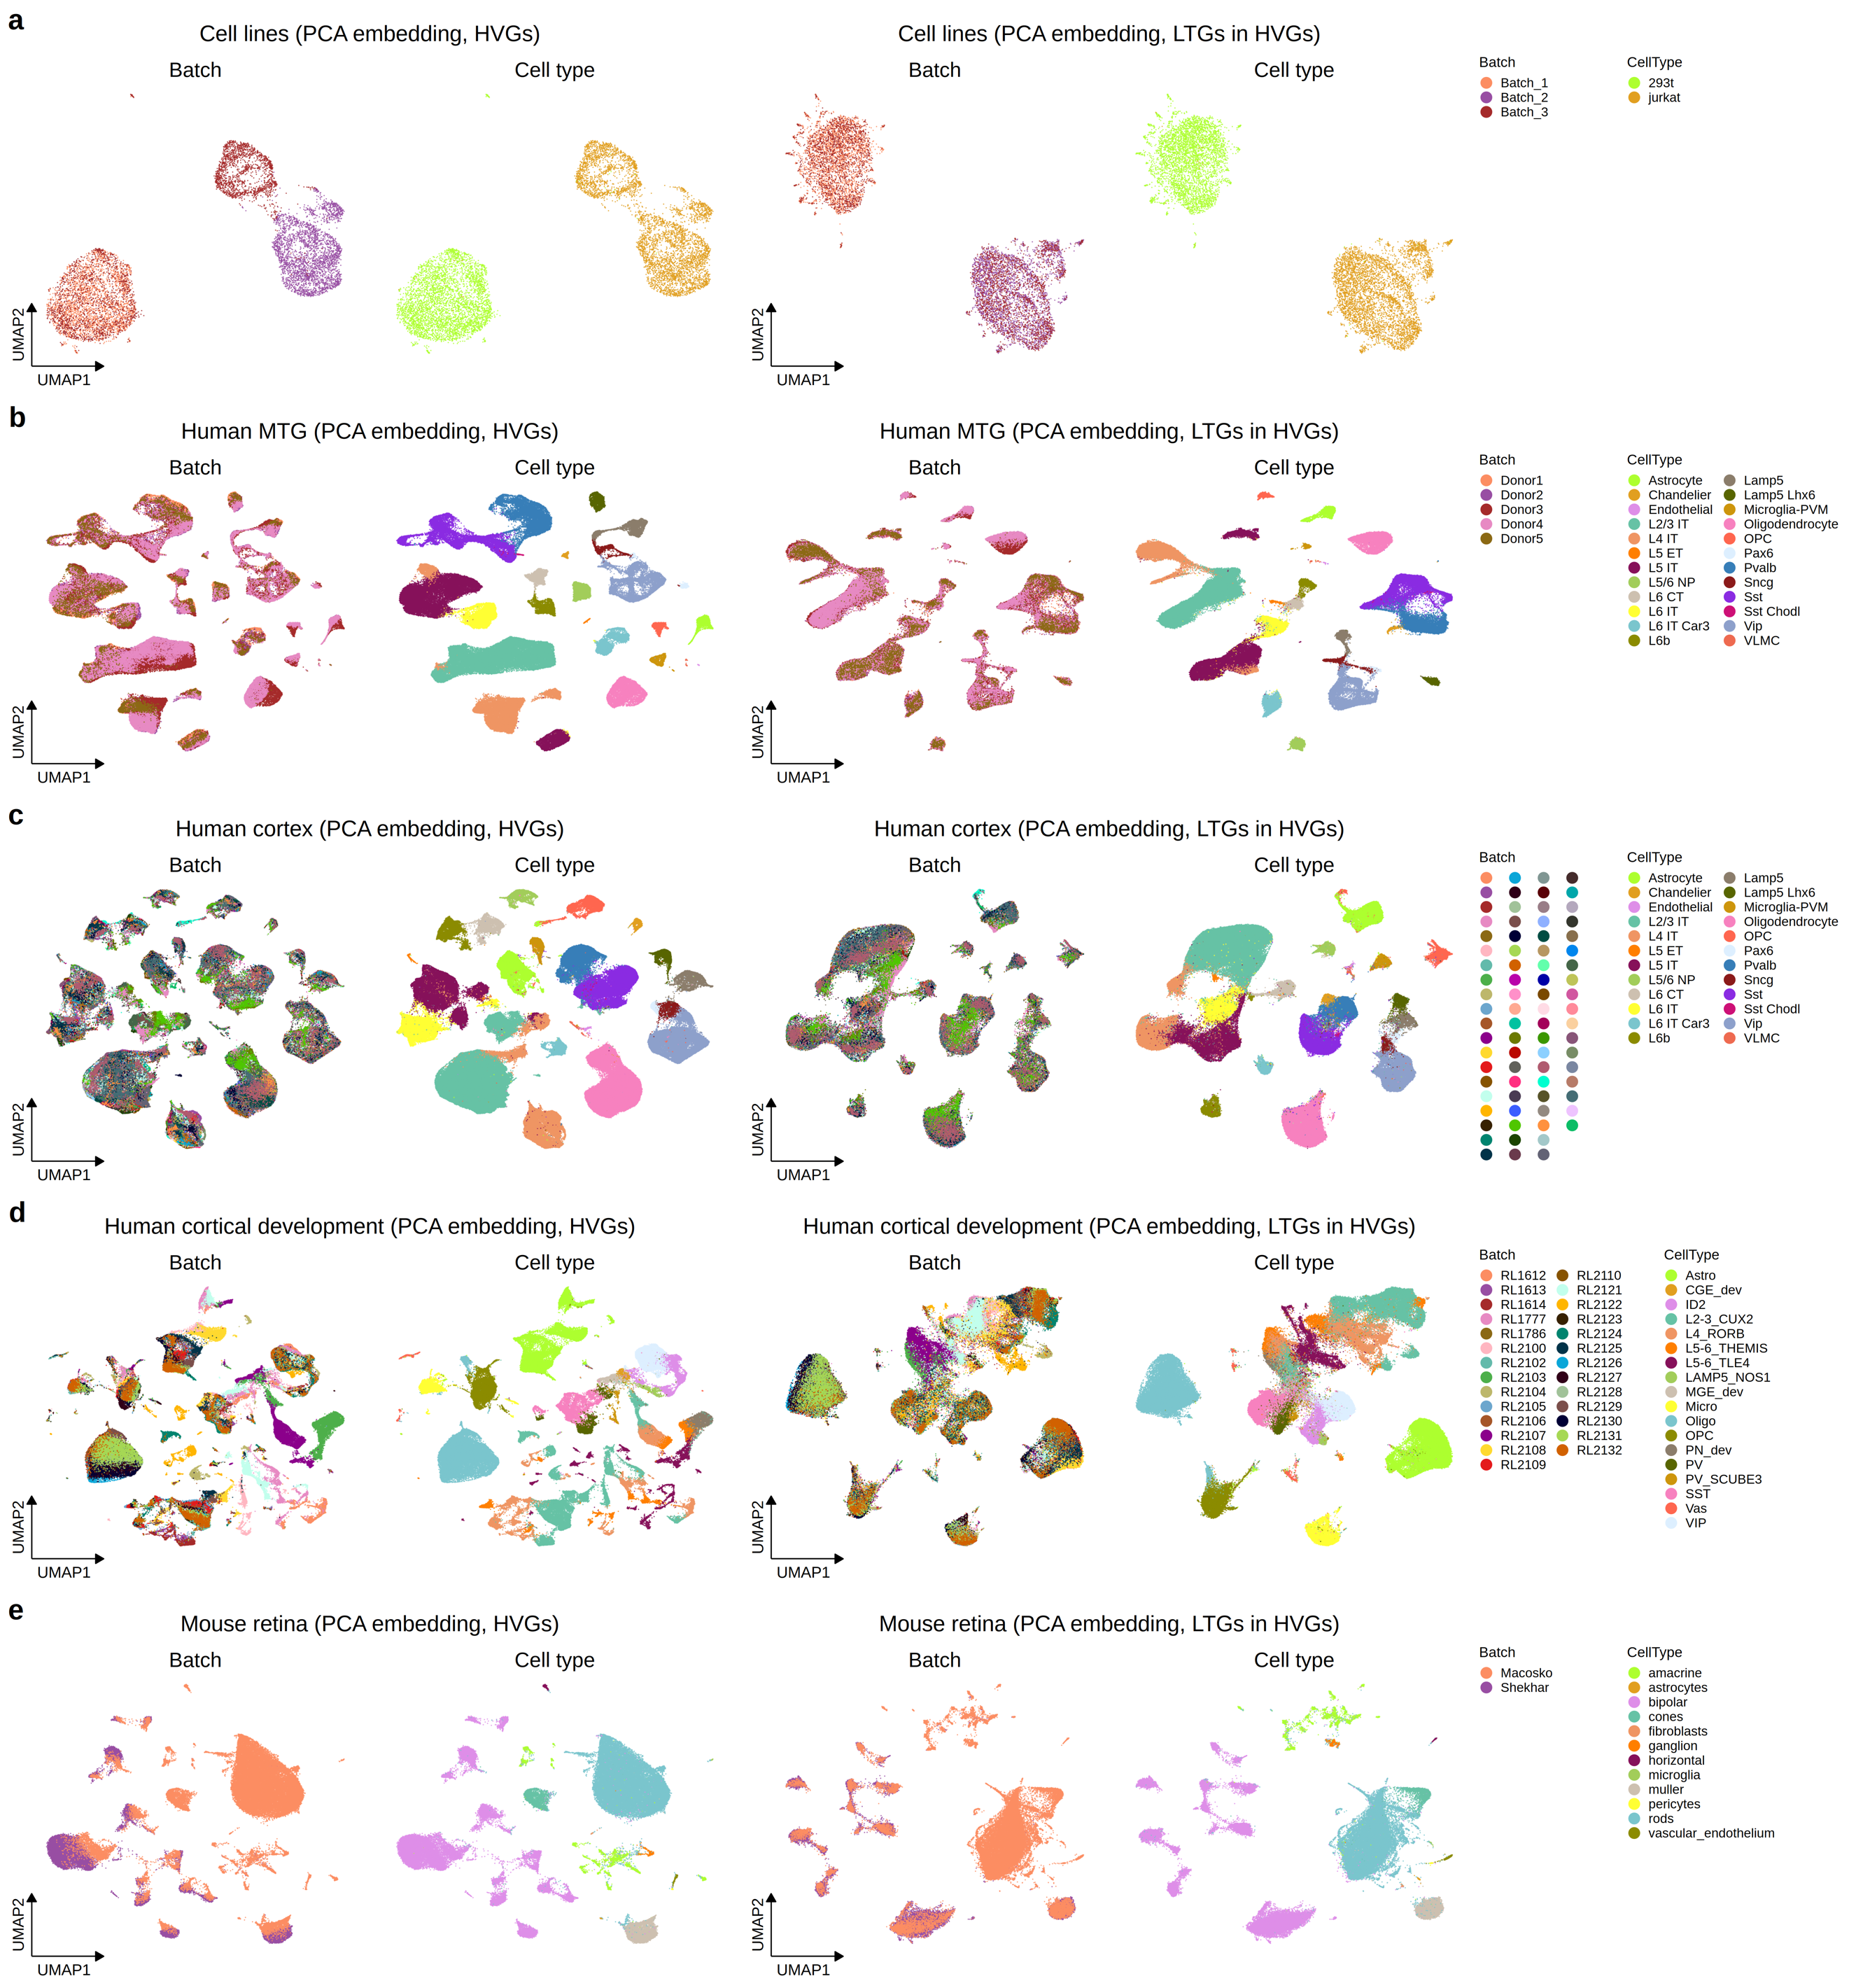
Supplementary Figure 1. UMAP visualizations of different datasets, including cell lines (a), human MTG (b), human cortex (c), human cortical development (d), and mouse retina (e), with HVGs (left two plots) and LTGs within HVGs (right two plots).
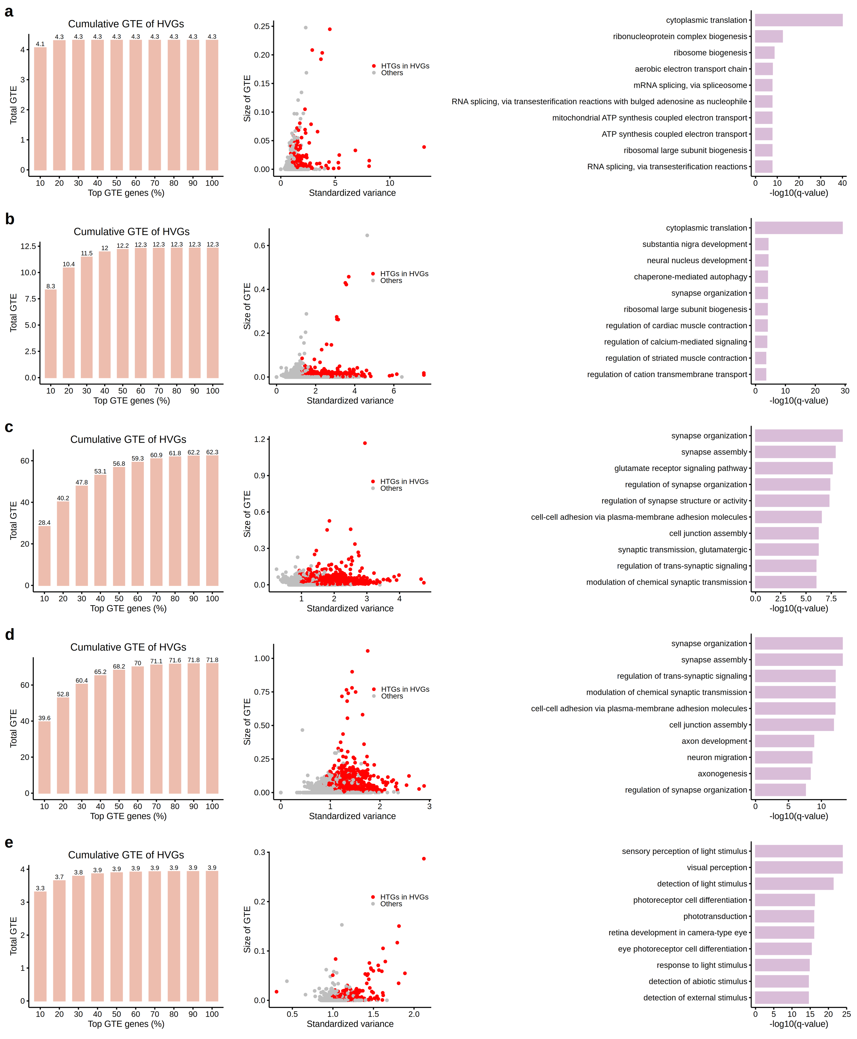
Supplementary Figure 2. Patterns of HTGs across different datasets. Shown are the cumulative technical effects of HVGs (left), distribution of standardized variance and GTE (middle), and pathway enrichment of the highest GTE genes (right) for the cell lines (a), human MTG (b), human cortex (c), human cortical development (d), and mouse retina (e) datasets.
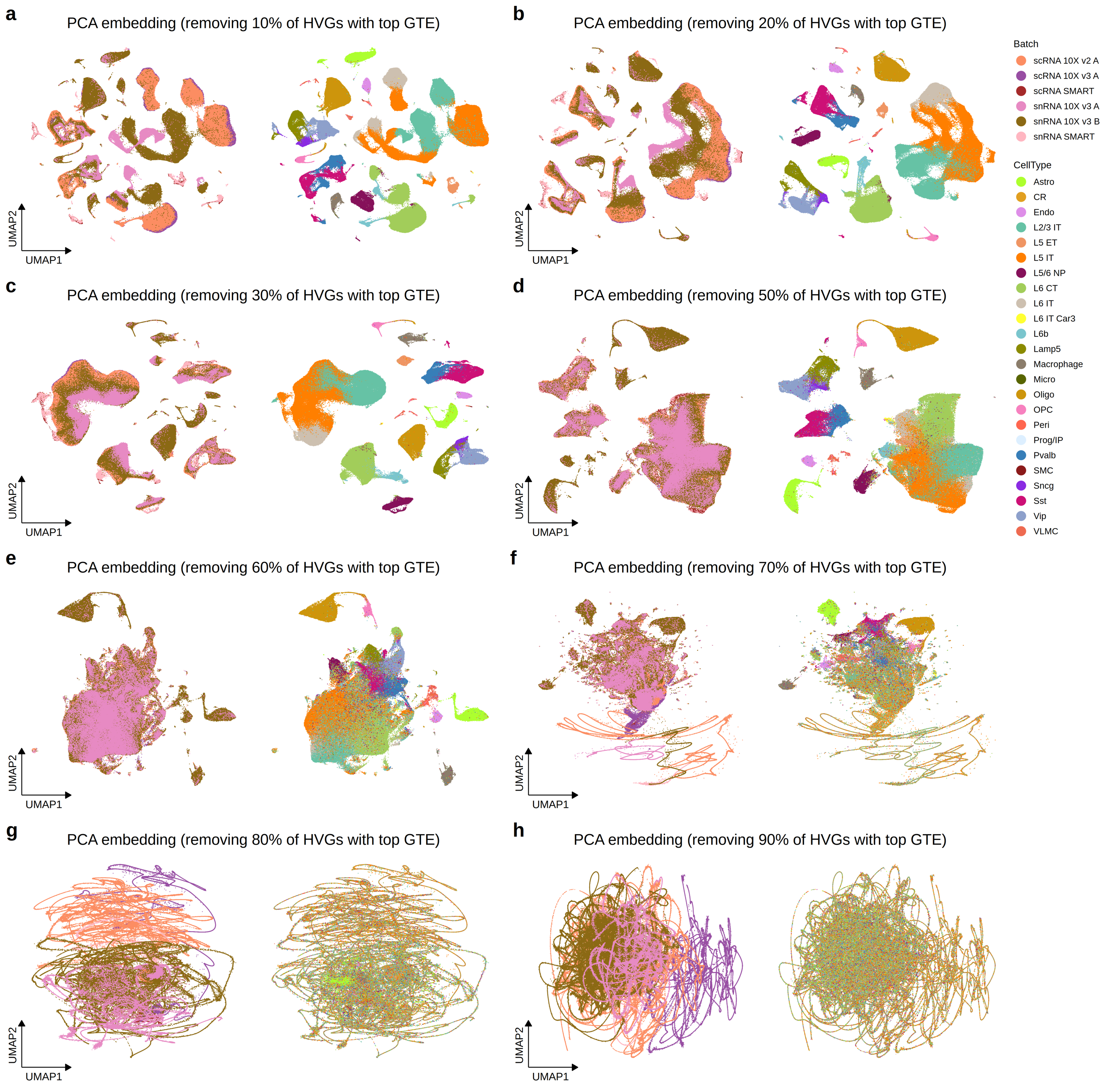
Supplementary Figure 3. UMAP visualizations of the mouse MOp dataset with varying proportions of top GTE genes removed from HVGs: 10% (a), 20% (b), 30% (c), 50% (d), 60% (e), 70% (f), 80% (g), and 90% (h).
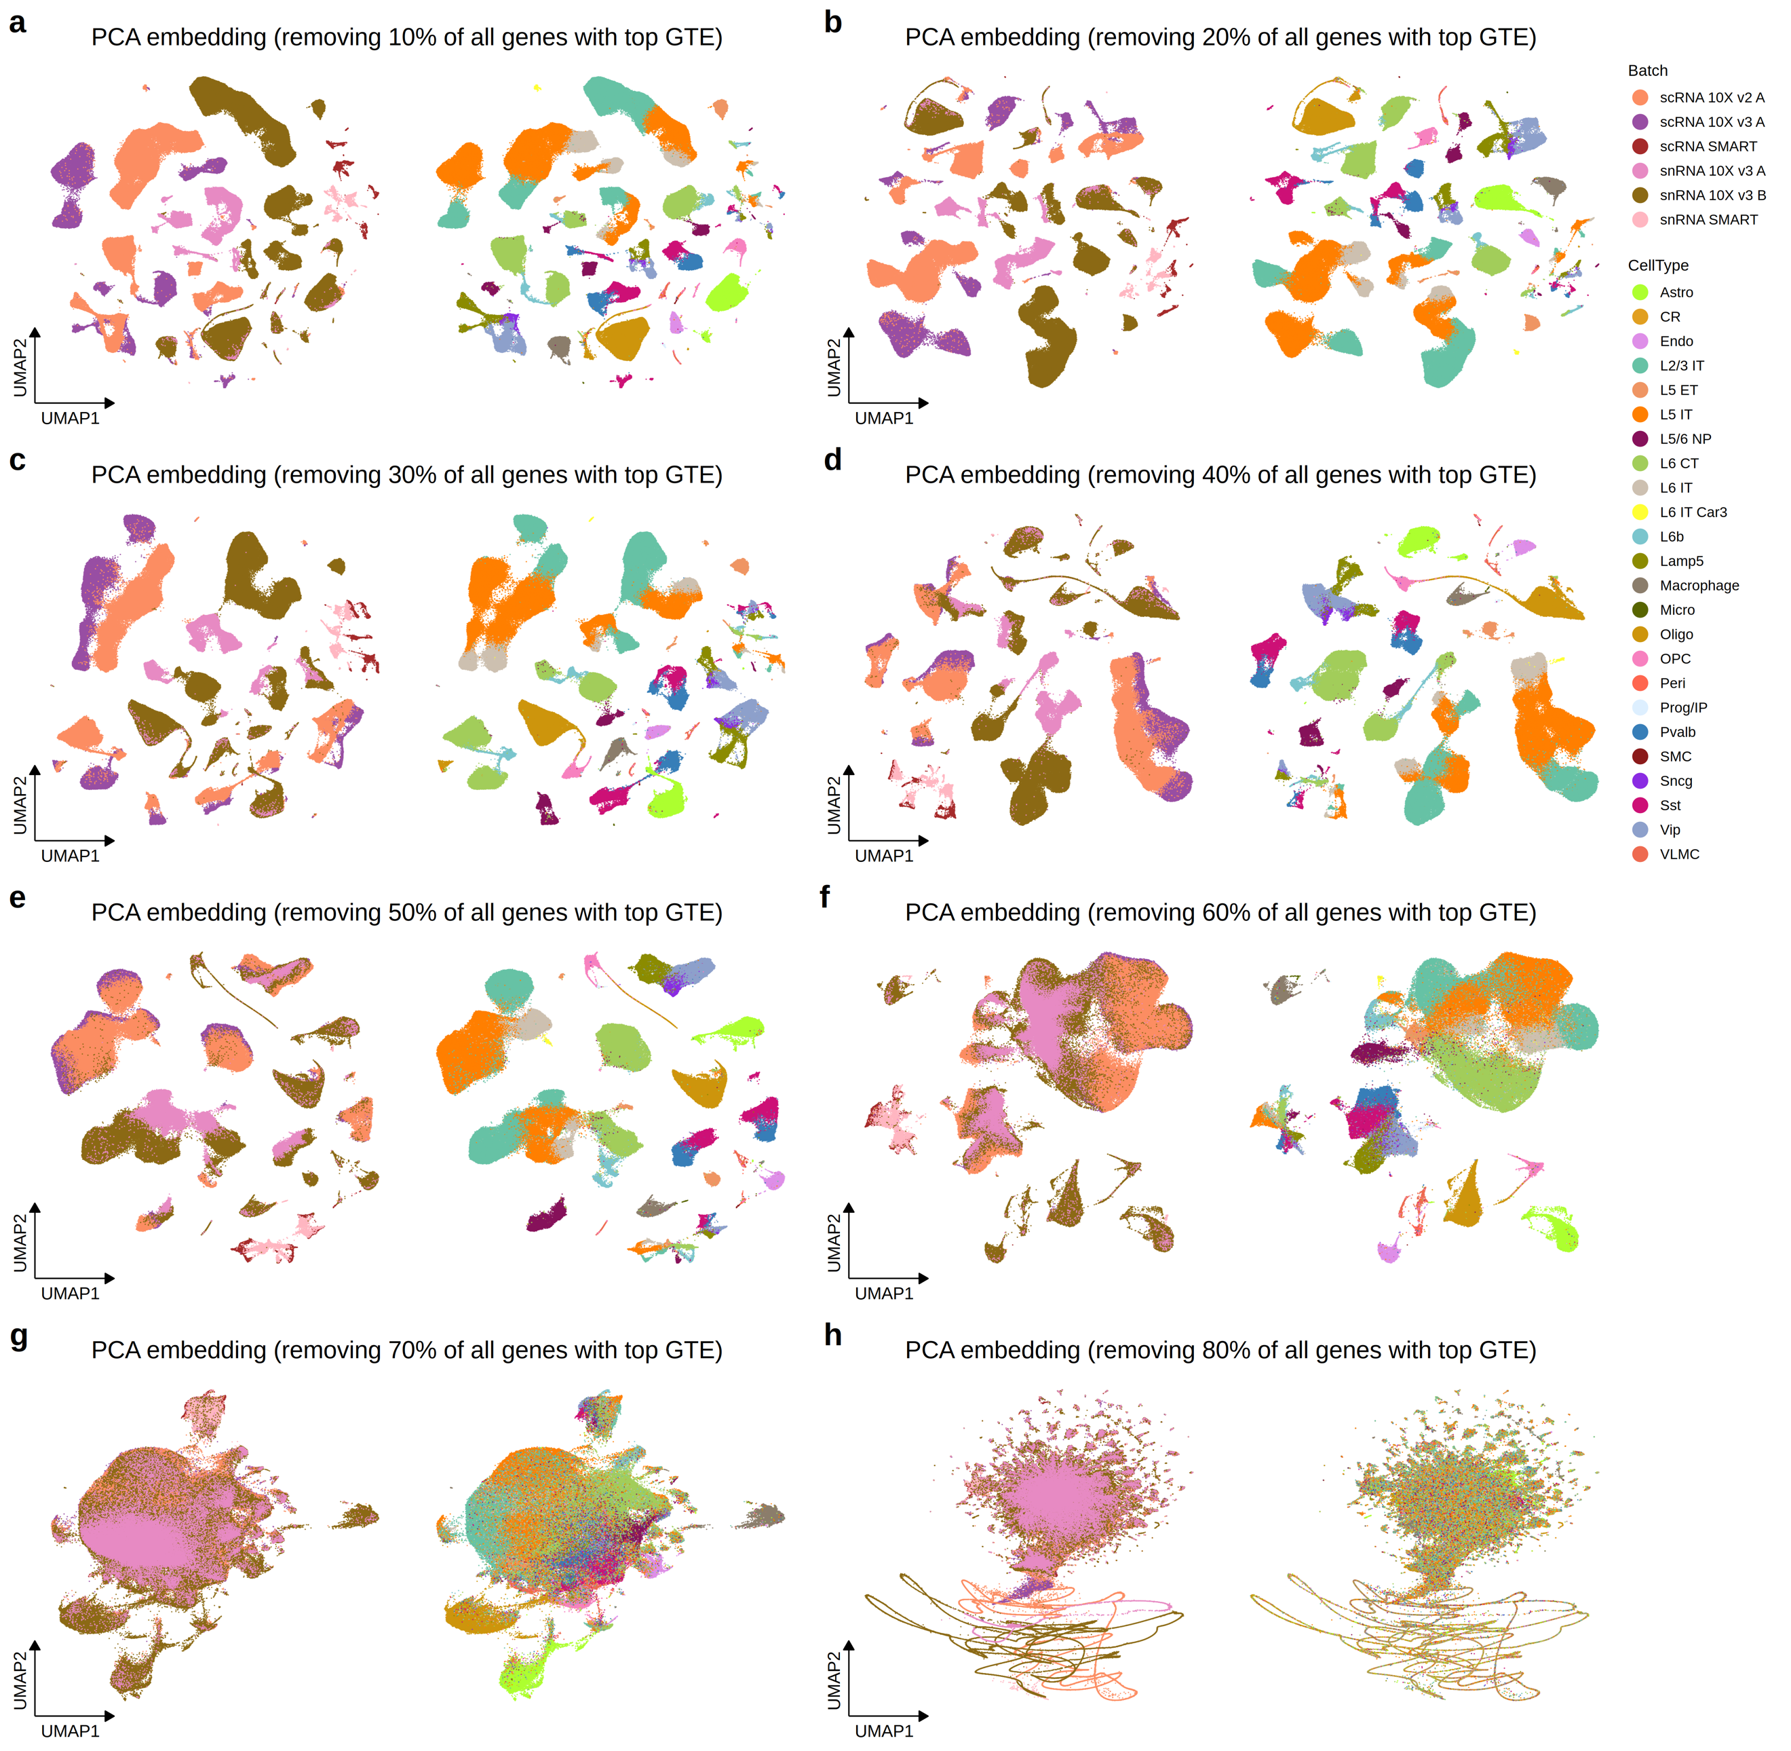
Supplementary Figure 4. UMAP visualizations of the mouse MOp dataset with varying proportions of top GTE genes removed from all genes: 10% (a), 20% (b), 30% (c), 40% (d), 50% (e), 60% (f), 70% (g), and 80% (h).
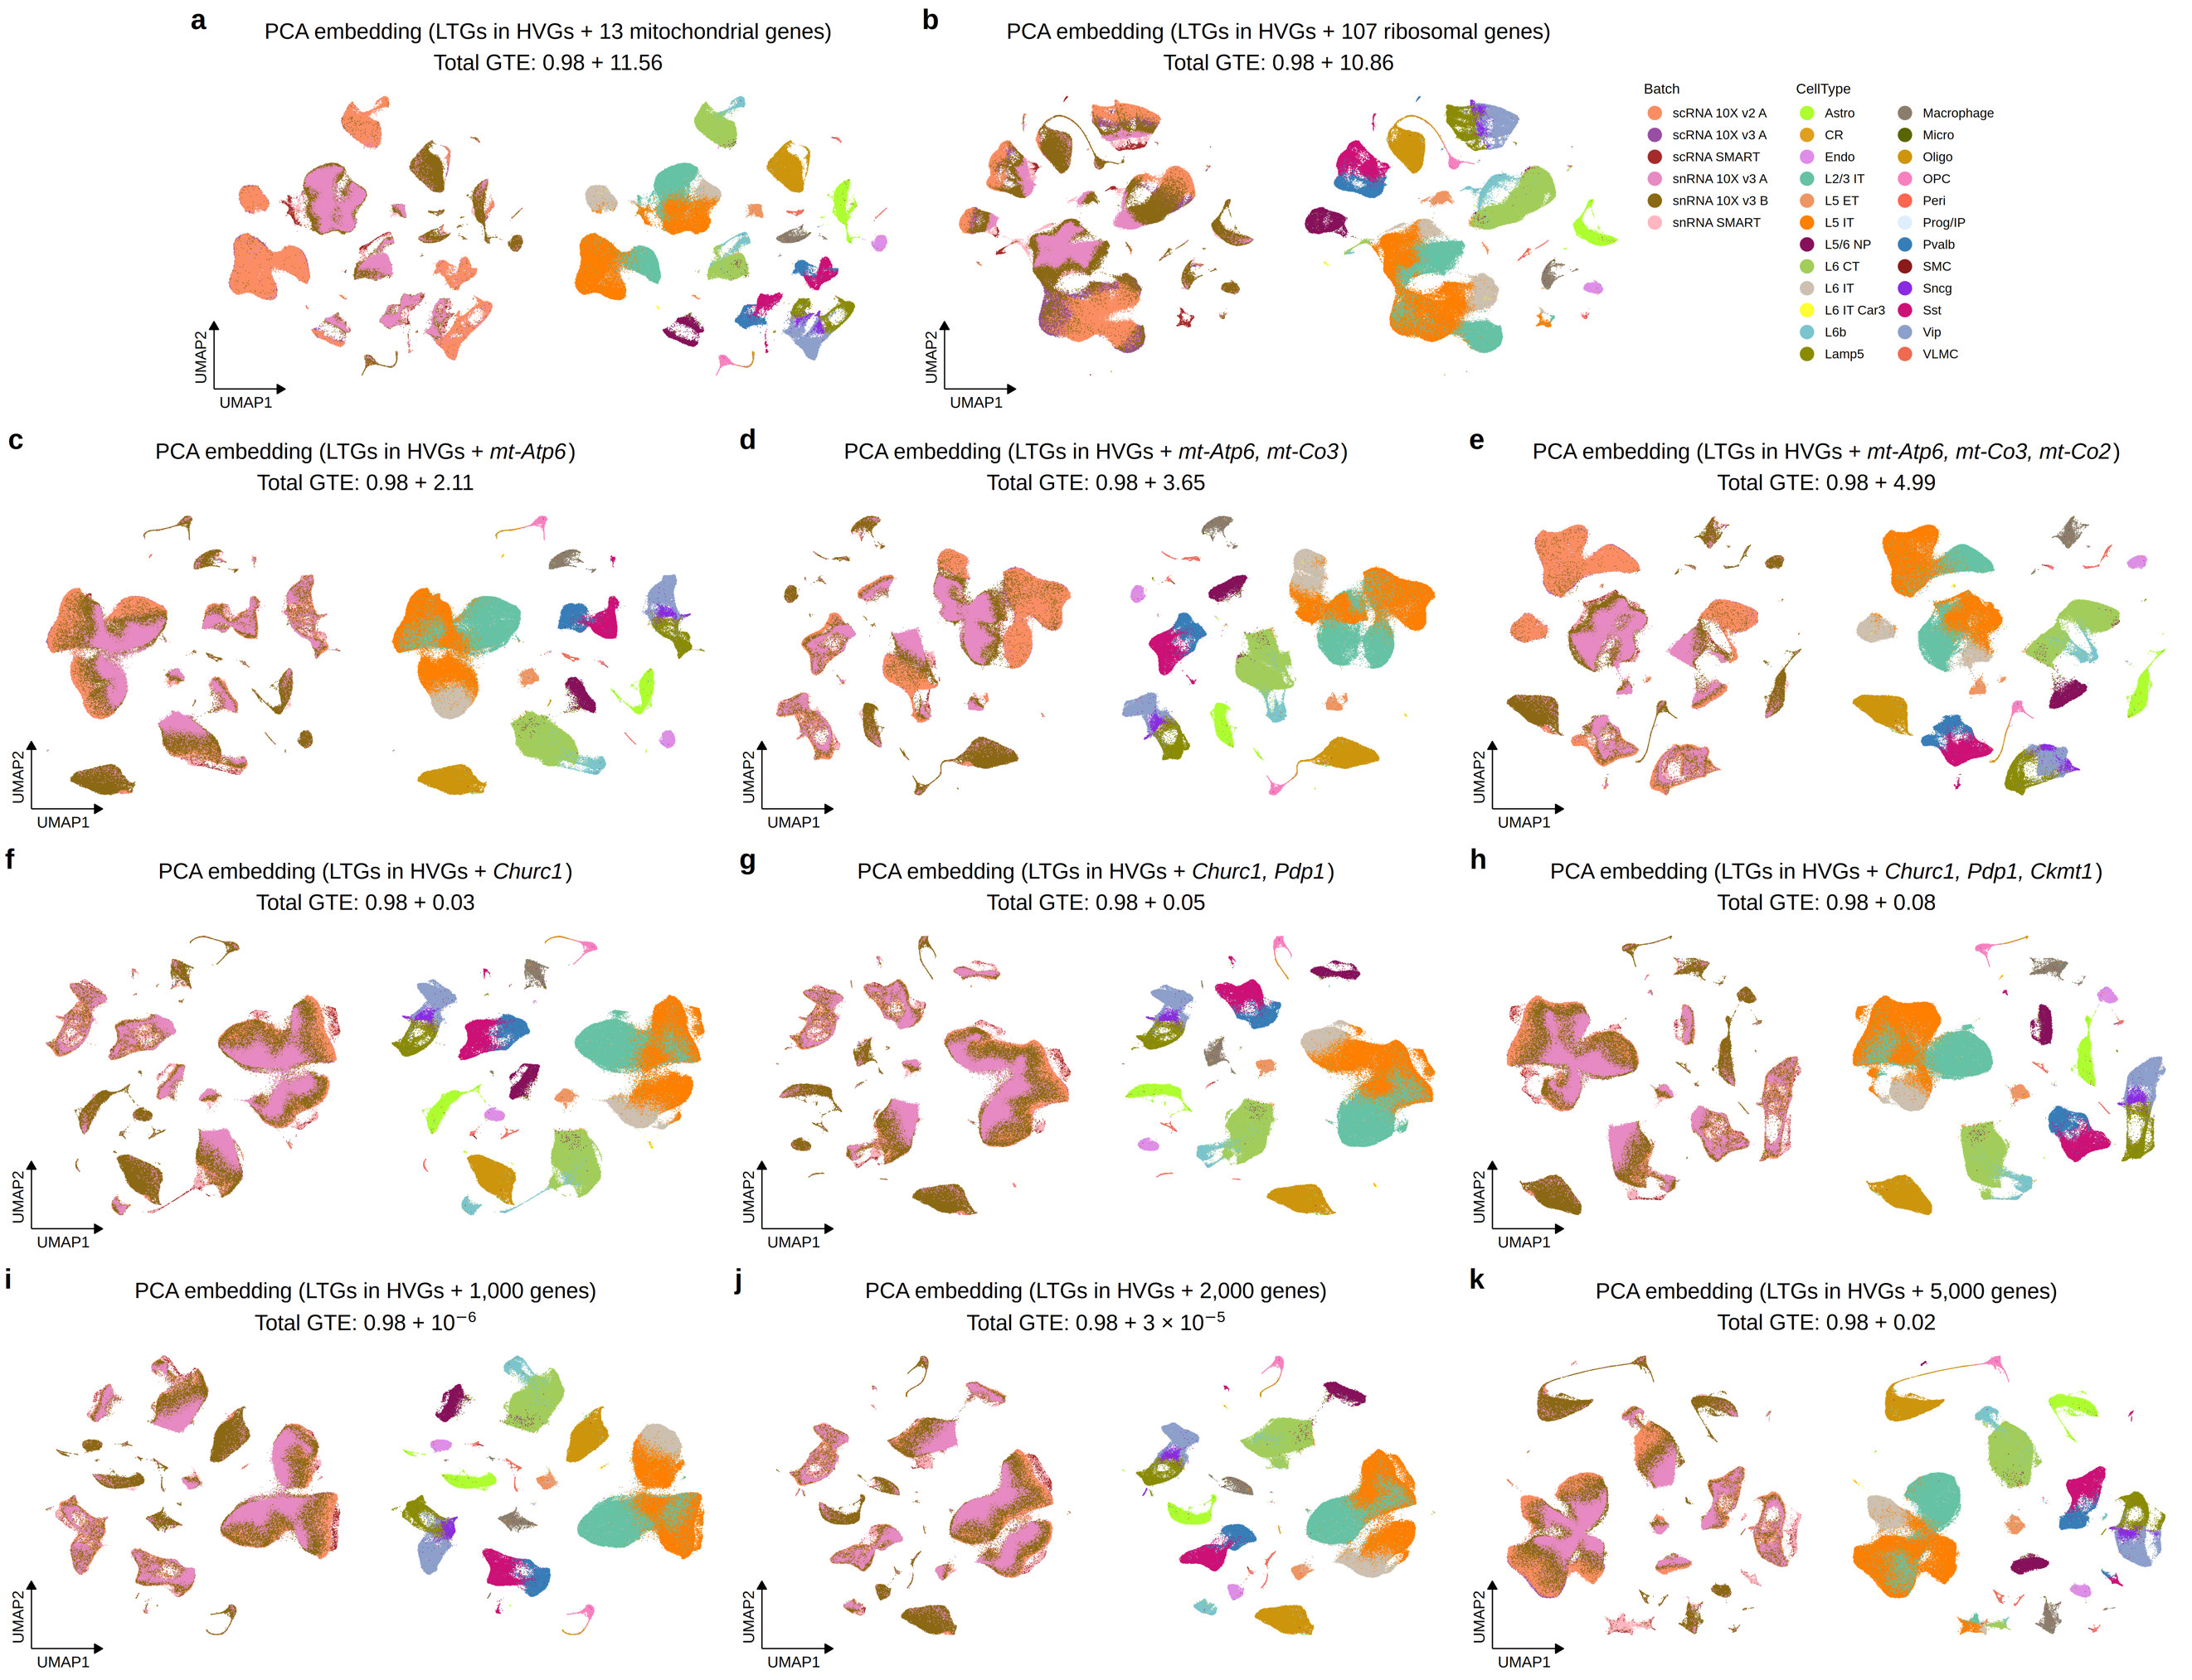
Supplementary Figure 5. UMAP visualizations of the mouse MOp dataset with LTGs in HVGs plus various genes, including 13 mitochondrial genes (a), 107 ribosomal genes (b), the top 1-3 highest GTE genes (c-e), 1-3 genes in the 90th percentile of remaining genes (f-h), and 1,000, 2,000, and 5,000 genes with the lowest GTE (i-k).

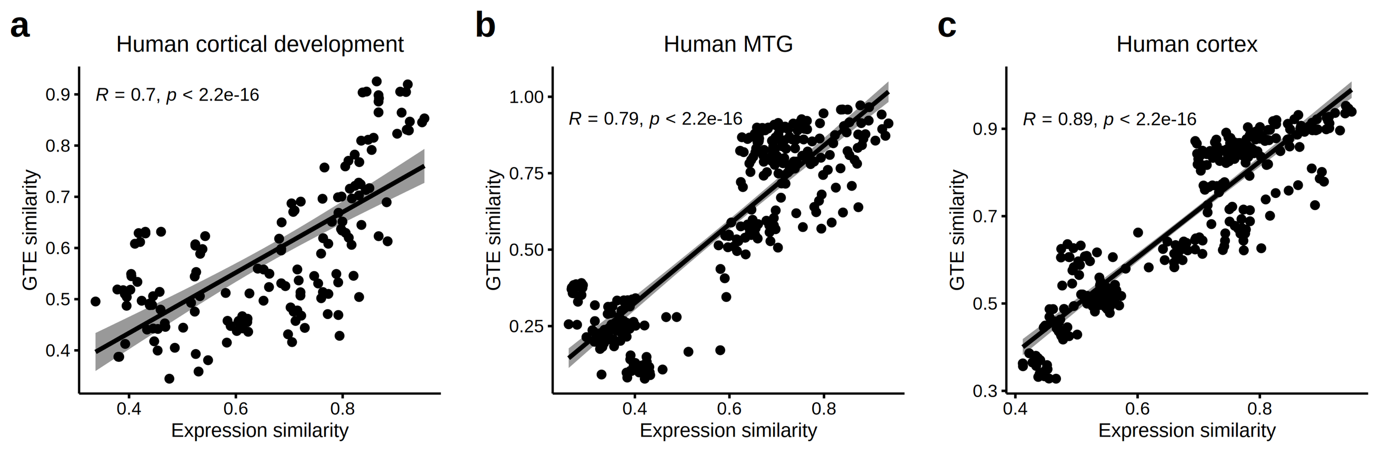
Supplementary Figure 6. Correlation of gene expression similarity with GTE similarity for each cell type pair in the human cortical development (a), human MTG (b), and human cortex (c) datasets. R and P values were calculated using Spearman correlation and two-sided t-tests, respectively. The shaded region represents a 95% confidence interval.

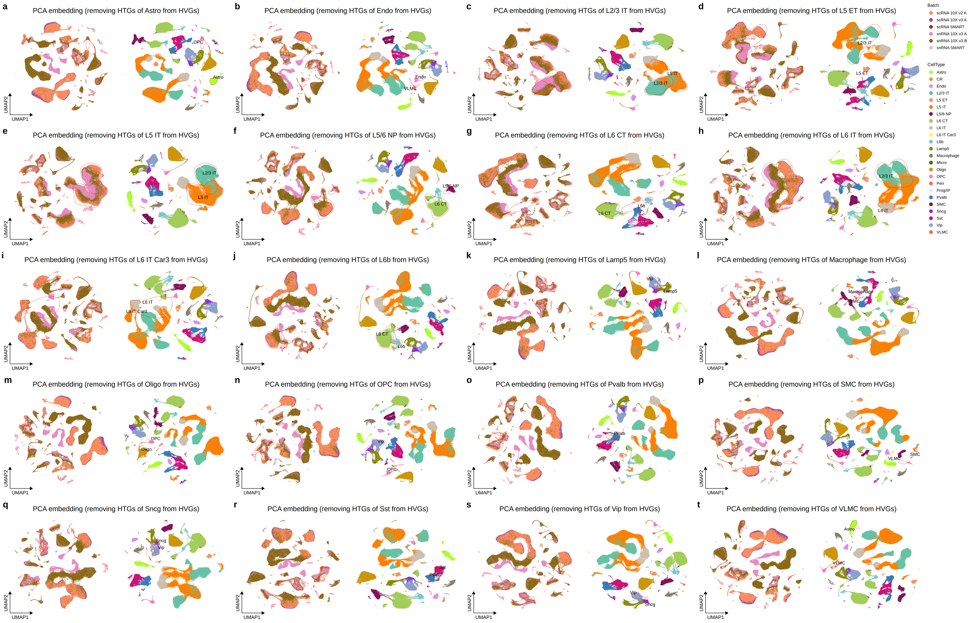
Supplementary Figure 7. UMAP visualizations of the mouse MOp dataset with HTGs removed for different cell types. Distinct cell types and their most similar counterparts are indicated.
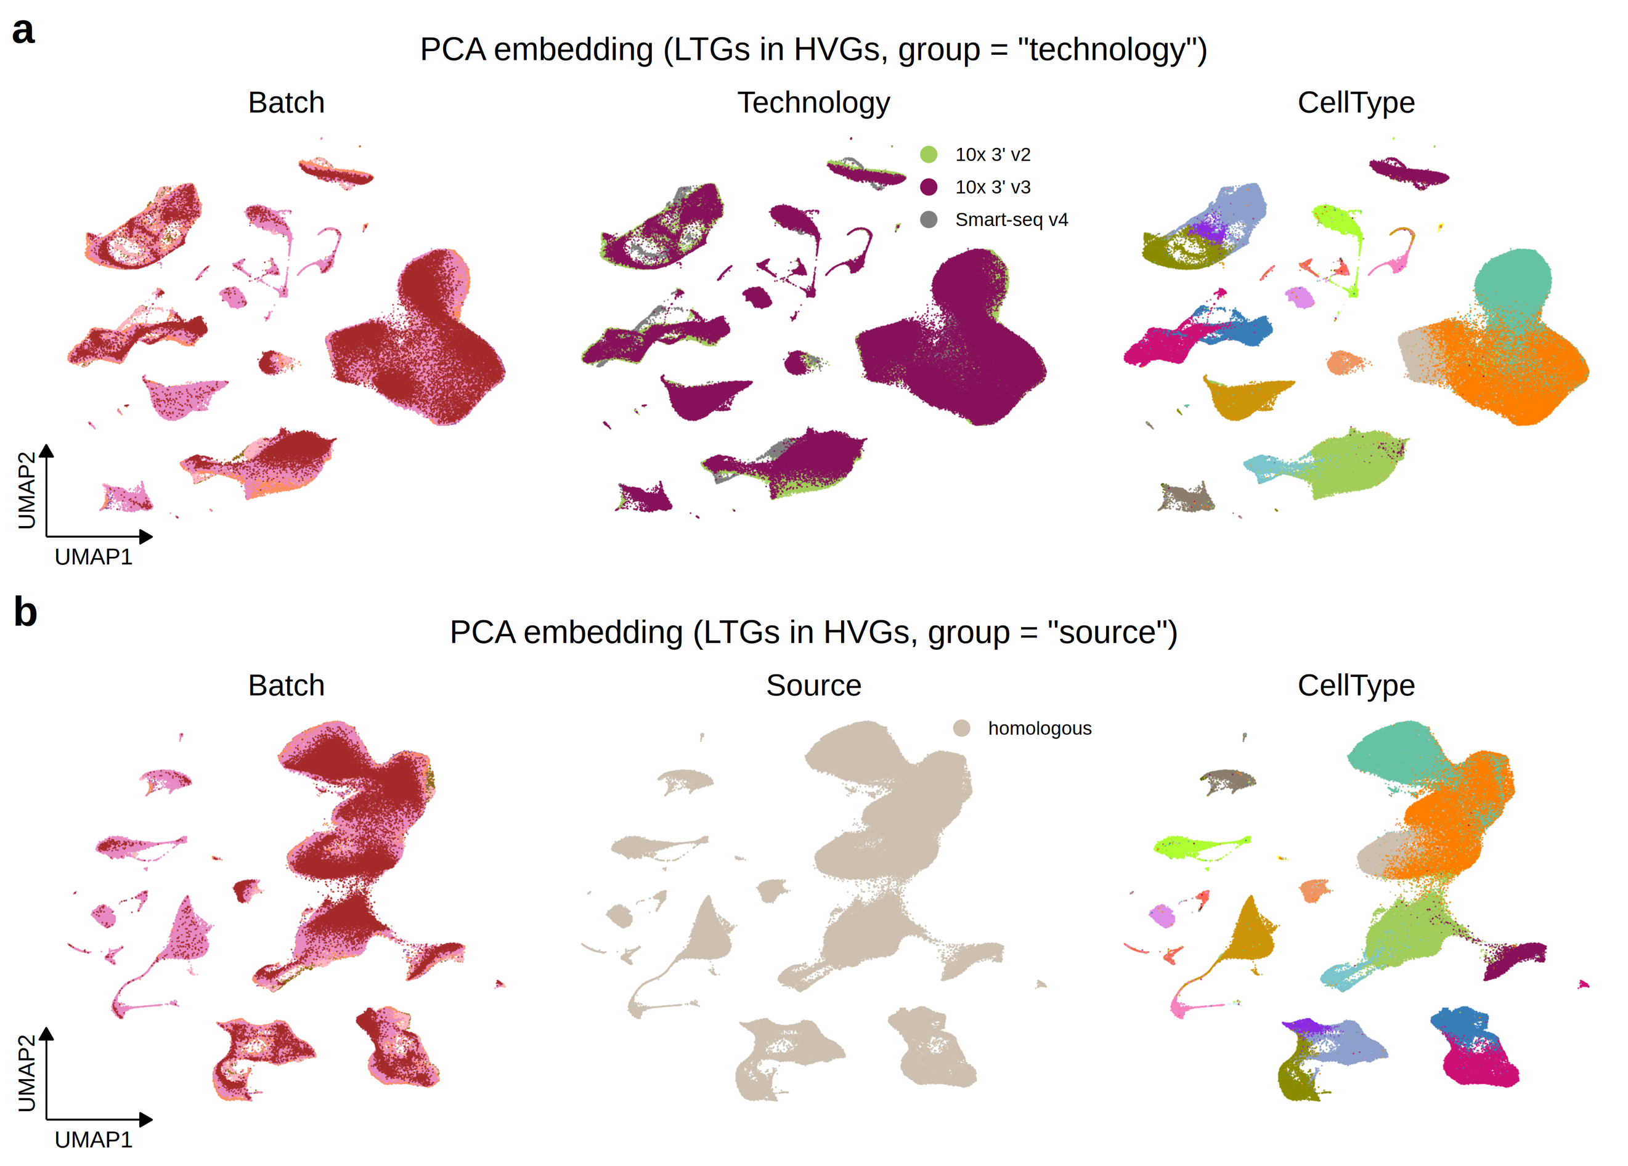
Supplementary Figure 8. UMAP visualizations of the mouse MOp dataset with LTGs in HVGs under the group variable technology (a) and source (b). Cells are colored by batch (left), technology (middle), and cell type (right).
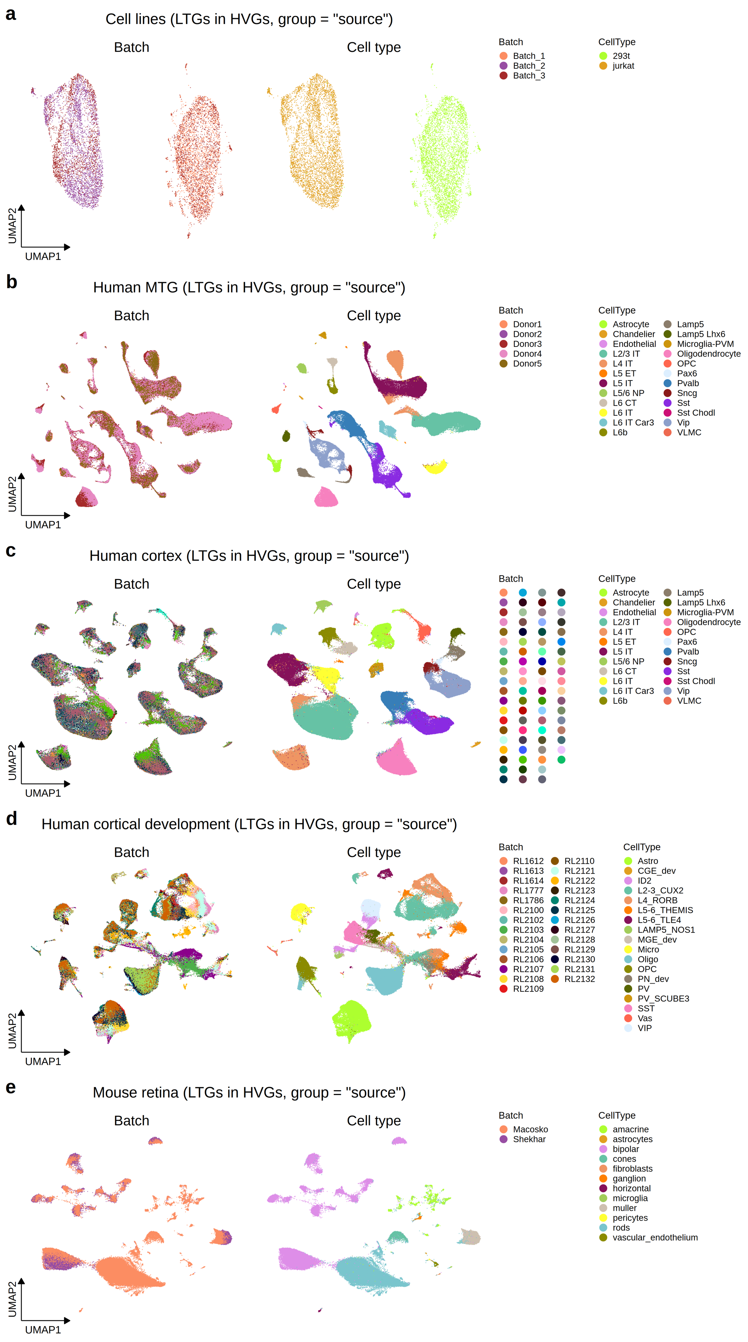
Supplementary Figure 9. UMAP visualizations of different datasets, including cell lines (a), human MTG (b), human cortex (c), human cortical development (d), and mouse retina (e), with LTGs in HVGs under the group variable “source”. Cells are colored by batch (left) and cell type (right).
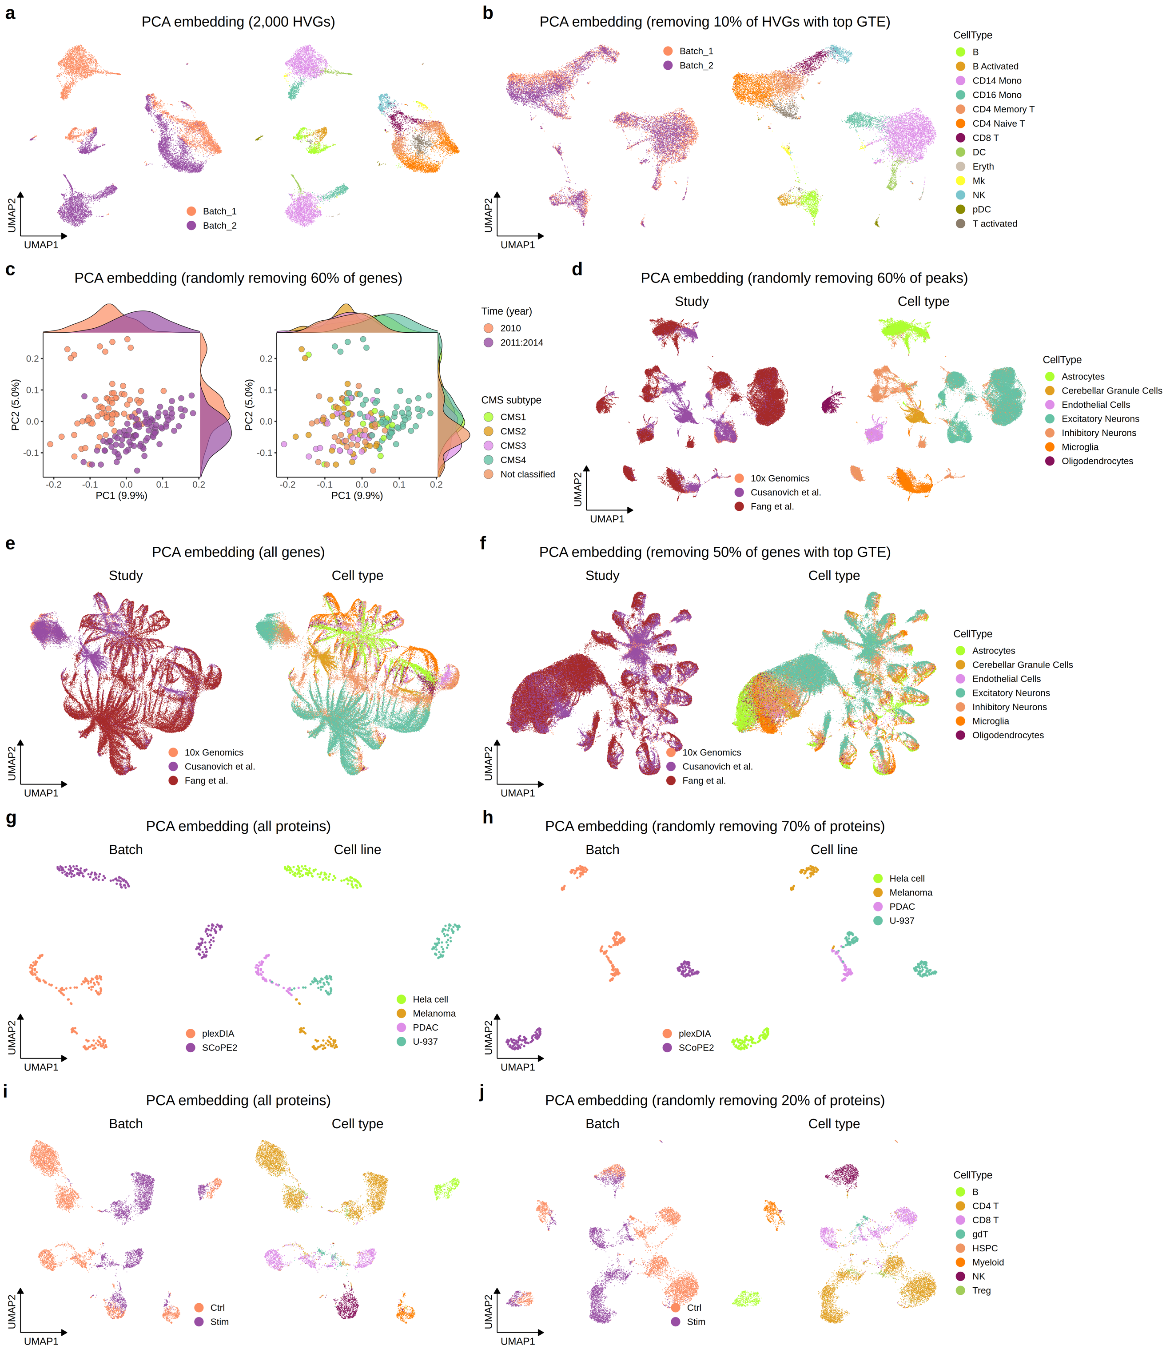
Supplementary Figure 10. UMAP visualizations of different datasets with various sets of features. a, b. UMAP visualizations of the human PBMCs dataset with HVGs (a) and LTGs in HVGs (b) under the group variable “source”, colored by batch (left) and cell type (right). c. PCA plots of the TCGA READ dataset with 60% of genes randomly removed, colored by batch (left) and CMS subtype (right). d. UMAP visualizations of the mouse brain dataset (peak version) with 60% of peaks randomly removed, colored by study (left) and cell type (right). e, f. UMAP visualizations of the mouse brain dataset (gene activity version) with all genes (e) and 50% of top GTE genes removed (f), colored by study (left) and cell type (right). g, h. UMAP visualizations of the cancer cell lines dataset with all proteins (g) and 70% of proteins randomly removed (h), colored by batch (left) and cell line (right). i, j. UMAP visualizations of the human PBMCs dataset (CITE-seq) with all proteins (i) and 20% of proteins randomly removed (j), colored by batch (left) and cell type (right).

