Supporting Information

Detection of Aβ40 in Cerebrospinal Fluid and Plasma of Alzheimer’s Disease patients Using Photoelectrochemical Biosensors
Liting Li^{1, 3}·Na Wei³·Yiwei Guo²·Xingyu Zhu³·Lin Wang²·Yanzhao Zhu⁴·Ke Fang²·Shenhui Ma^{2·}Yingying Zhang³·Yan Zhang³·Xiaofei Zhou³·†Gang Zhao^{1, 4*}·†Yuyu Bu^{2*}· †Linfu Zhou^{1, 4*}

†Correspondence: zhoelfu@nwu.edu.cn; yybu@xidian.edu.cn; zhaogang@nwu.edu.cn; Tel.: 86 29 8953 9061.

MICROCHIMICA ACTA
Linfu Zhou, zhoelfu@nwu.edu.cn. Department of Neurology, Northwest University First Hospital, Xi’an 710043, China; Department of Neurology, Northwestern University School of Medicine, Xi’an 710068, China
Yuyu Bu, yybu@xidian.edu.cn. Key Laboratory of Wide Band-Gap Semiconductor Materials and Devices, School of Microelectronics, Xidian University, Xi’an, 710071, China
Gang Zhao, zhaogang@nwu.edu.cn. Department of Neurology, Northwest University First Hospital, Xi’an 710043, China; Department of Neurology, Northwestern University School of Medicine, Xi’an 710068, China

Table of Contents
1 Chemicals
2 Apparatus and Methods
3 the SEM images of TiO₂ EPD progress under different deposition voltages
4 the Current-time curves during the TiO₂ EPD process under different deposition voltages
5 the Current-time curves during the TiO₂ EPD process under different deposition time
6 the SEM image of TiO₂ after annealing
7 XPS survey spectra
8 CLSM images
9 Chronocoulometric measurement
10 Perform CC in Tris-HCl buffer with the following parameters
11 Comparison of analytical parameters of this work with reference works for Aβ40 analysis) from 2018 to 2023
12 References

Supplementary Chemicals
6-mercapto-1-hexanol (MCH), was purchased from Sigma-Aldrich (St. Louis, USA). Acetone (C₃H₆O, AR) was acquired from Shaanxi Peace Glass Co. Iodine. titanium dioxide (≥99.0%). melamine (C₃H₆N₆, ≥99.0%), was obtained from China Pharmaceutical and Biological Reagent Co. Phosphite (H₃PO₃, ≥99.0%) was supplied by Shanghai McLean Biochemical Science and Technology Co. Ltd. Glycerol (C₃H₈O₃, AR), anhydrous ethanol ( ≥ 99.0%) was procured from China Pharmaceutical and Biological Reagent Co. Ltd. Chloroauric acid (HAuCl₄﹒4H2O, ≥99.9%) , artificial saliva was obtained from Tianjin Huasheng Chemical Reagent Co.The Aβ40 aptamer (1μM, the sequence of 5’-SH-GCT GCC TGT GGT GTT GGG GCG GGT GCG-3’) was synthesized by Shanghai Biotechnology Co. Ltd. Aβ40 (C₁₉₄H₂₉₅N₅₃O₅₈S≥90% (HPLC), powder) from Sigma-Aldrich (St. Louis, MO, USA). 1× PBS solution was provided by China Sangong Biotechnology Co. Ltd. Throughout the investigation, All raw materials used were analytical grade reagents and were employed without further purification. Milli-Q grade water (Millipore water purification system Z18 MΩ, Milli-Q, Millipore, Billerica, MA) was used in the whole experiment. The FTO was bought from Zhuhai Kaivo Optoelectronic Technology Co. Ltd.

Apparatus and Methods
X-ray diffraction (XRD) was performed using a D-MAX 2500/PC instrument from Rigaku (Japan), while X-ray photoelectron spectroscopy (XPS) analysis was performed using a Thermo ESCALAB 250Xi instrument from Thermo Fisher Scientific (USA) to characterize and confirm the structure of the materials. The morphology of TiO₂, Au-C₃N₄ and TiO₂/Au-C₃N₄ heterojunction was characterized by scanning electron microscopy (SEM) using a Phenom Pro instrument from PhenomWorld (Netherlands) and high-resolution transmission electron microscopy (HRTEM) using a Tecnai G2 F30 instrument from FEI Company (USA).
Confocal laser scanning microscopy (CLSM) (Leica TCS SP8, Germany) visualized the distribution of 6-carboxyfluorescein (6-FAM)-labeled DNA aptamers on the electrode surface. The ultraviolet-visible diffuse reflectance spectrophotometer (UV-Vis DRS) analysis of light absorption was performed using a TU-1901 instrument from Puxi (Beijing) to analyze the light absorption range of TiO₂ electrode. Electrochemical impedance spectroscopy (EIS) was performed over a frequency range of 100 kHz to 100 MHz using a Zahner Zennium pro electrochemical workstation (Zahner, Germany). Photocurrent measurements were performed with a Covestro CS100 portable electrochemical analyzer using a 1W PLS-LED100C UV light source (Shanghai Maomo Scientific Instrument Co., Ltd.), and data were recorded on a Lenovo tablet. A platinum (Pt) plate electrode and a saturated Ag/AgCl electrode were used as counter and reference electrodes, respectively. The electrolyte solution consisted of 4 mL phosphate buffer solution PBS (0.1 M, pH 7.4). The photocurrent signal of the sensor was recorded during illumination.
Preparation of TiO₂ by EPD
A 0.048 g sample of TiO₂ was dispersed in 30 mL of acetone supplemented with 0.013 g of iodine, followed by 30 min of ultrasonication. The suspension was subsequently stirred for 1.5 h on a magnetic stirring platform. EPD was conducted using two F-doped SnO₂ (FTO) glass electrodes, one serving as the working electrode and the other as the counter electrode. Two electrodes were positioned parallelly, spaced 1 cm apart within the solution. A constant DC voltage of 45 V was applied across the electrodes. The deposition process lasted 60 s, during which positively charged TiO₂ particles migrated towards the working electrode. Finally, the partially processed TiO₂ was annealed in a nitrogen atmosphere at 400 °C for 2 h to enhance crystallinity.
Synthesis of Au-C₃N₄
Initially, 4 g of melamine was mixed with 4.8 g of phosphite and stirred in ultra-pure water at 80°C in a water bath. Then, chloroauric acid was added to the above mixture and stirred thoroughly, followed by hydrothermal heating dried for 2~3 h to obtain powder. The whole powder was then mixed with glycerol and ethanol and refluxed at 110°C using an asbestos mesh. Fourth, sample was filtered, dried, and heated in a muffle furnace. Obtained 50 mg of Au-C₃N₄, mixed in a 1:1 ratio of water and ethanol, and subjected it to ultrasonic treatment at 100% power to obtain an ultrasonic suspension.
Chronocoulometry (CC) provides a powerful method for quantitatively analyzing the adsorption of dissolved substances on electrode surfaces and within electrolytes^{1, 2}. This method utilizes the redox charge of Ru(NH₃)₆Cl₃ molecules to accurately measure the quantity of DNA aptamers adsorbed on the electrode surface. The charge (Q) of the redox marker (Ruthenium ion) is determined by calculating the tangent to one of the two curves through the endpoint of one curve to the y-axis, and then measuring the intercept difference between the two tangent points.From the total charge, the surface density of the redox marker can be determined using the following formula: 𝑄 = 𝑛𝐹𝐴Г0. n is the number of electrons per molecule that are involved in a redox reaction, F is Faraday constant (C/equivalent), A is the electrode area (cm²) and Г₀ is the density of adsorbed ruthenium ion. The density of the redox marker can be translated into aptamer coverage using the formula Γ_{apt}=Γ₀(zm)𝑁_{𝐴}, where Γ_{apt} represents the aptamer density, m denotes the number of bases in the aptamer, z is the charge of the redox molecule, andN_{A} is Avogadro's number.
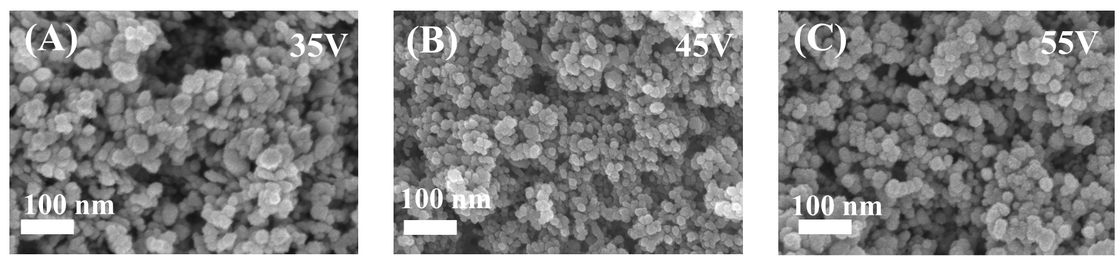
Fig. S1 the SEM images of TiO₂ EPD progress under different deposition voltages. (A) 35V, (B) 45V, (C) 55V

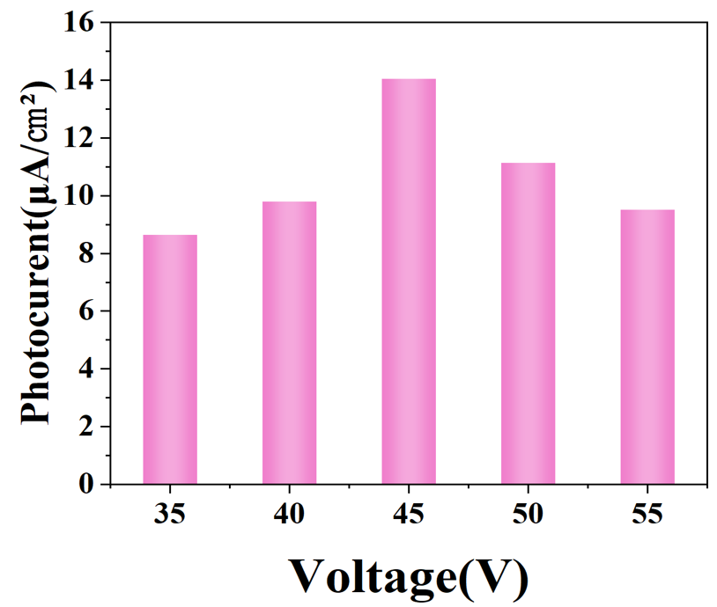
Fig. S2 the Current-time curves during the TiO₂ EPD process under different deposition voltages
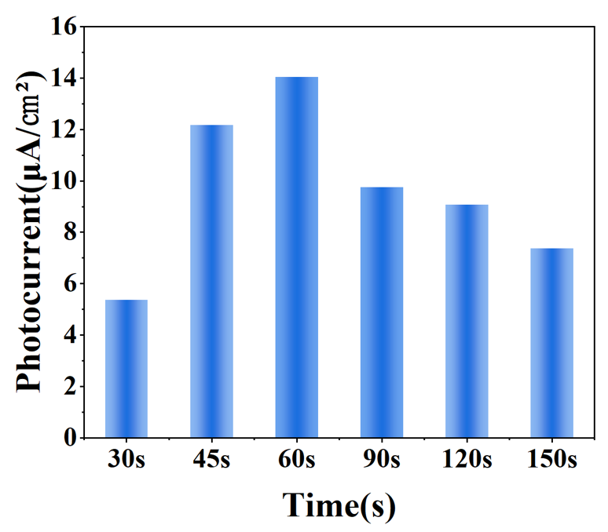
Fig. S3 the Current-time curves during the TiO₂ EPD process under different deposition time

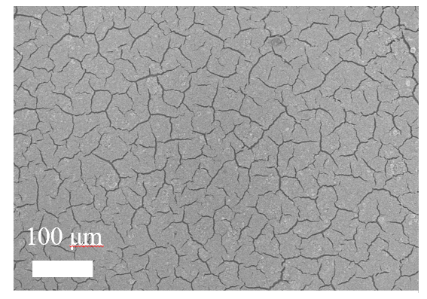
Fig. S4 the SEM image of TiO₂ electrode surface after annealing

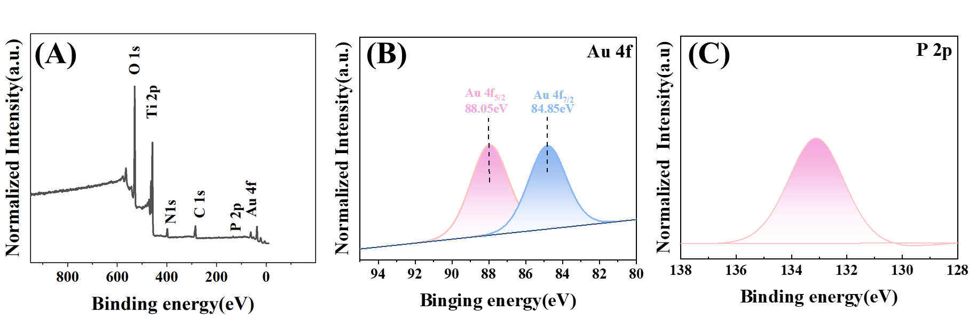
Fig. S5 (A) XPS survey spectra; (B) high-resolution XPS spectra of Au 4f; (C) high-resolution XPS spectra of P 2p
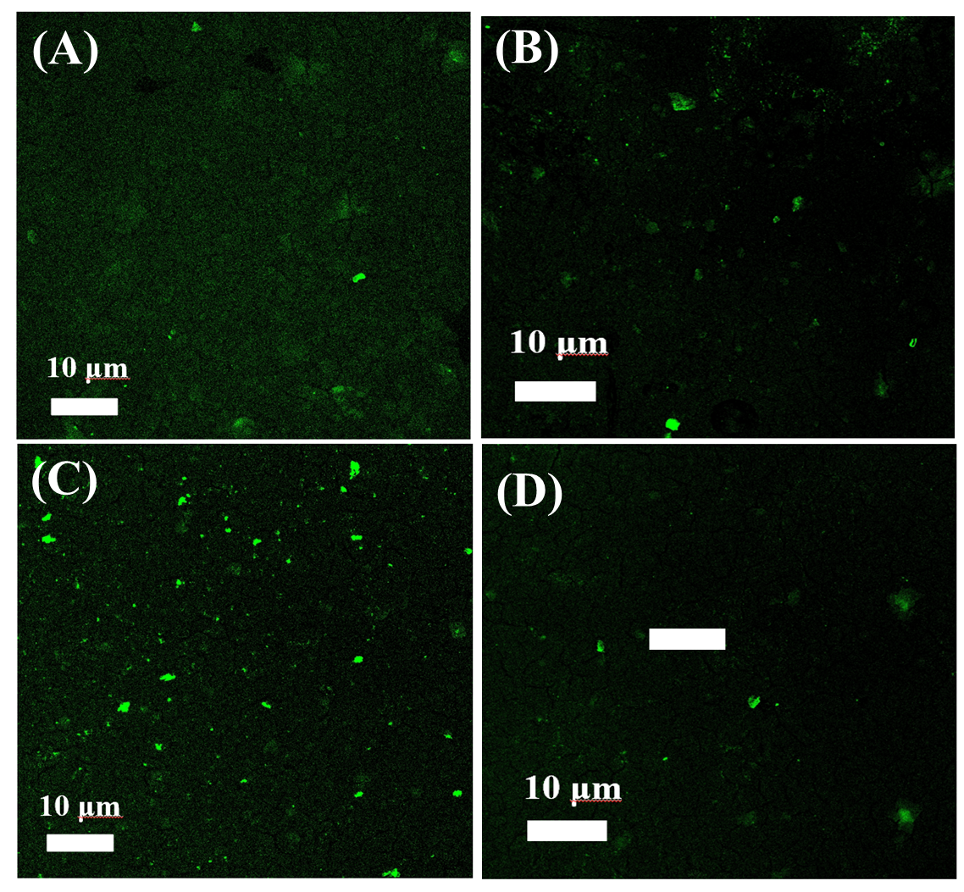
Fig. S6 CLSM images of sensors incubated with equal concentrations of fluorescently labeled aptamers under different volumes of Au-C₃N₄. (a) 0 µL, (b) 100 µL, (c) 150 µL, (d) 200 µL

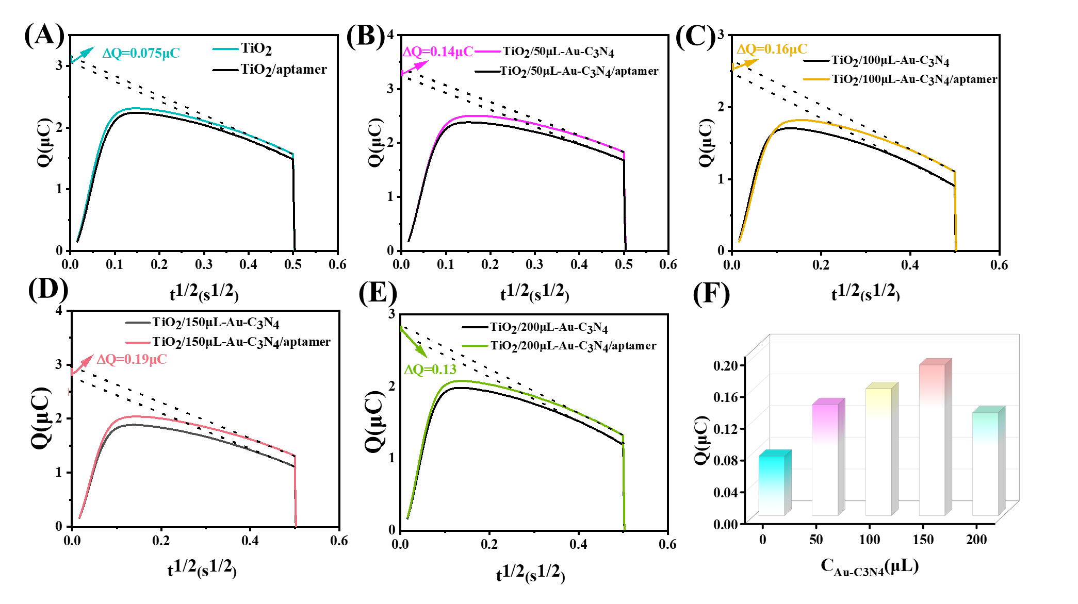
Fig. S7 Chronocoulometric measurement of aptamer density under different volumes of Au-C₃N₄. (a) 0 μL, (b) 50 μL, (c) 100 μL, (d) 150 μL, (e) 200 μL, (f) Summary of the results above.
Detailed experimental parameters can be found as fallows: Perform CC in Tris-HCl buffer with the following parameters: potential step from 0 to 0.5V, step = 2, pulse width = 0.25s, sample interval = 2.5e⁻⁴, quiet time = 2.0 s, sensitivity(A/V) = 0.01.

Table S1 Comparison of analytical parameters of this work with reference works for Aβ40 analysis) from 2018 to 2024
No. | Method | Target | Linear range | （LOD） | sample | reference
1 | label-free  colorimetric aptasensor | Aβ40-O | 10.00 nM~ to 100.0 nM. | 3.03 nM | artificial CSF | S26
2 | Electrochemistry | Aβ40O | 60 pM to 6.0 nM | 26 pM. | artificial CSF, CSF | S27
3 | Photoelectrochemical | Aβ40 | 1 pg/mL ∼ 1 μg/mL | 0.52 pg/mL |  | S28
4 | Electrochemistry | Aβ40 | 10⁻¹~10³pg/mL | 100fM | plamsa | S29
5 | Electrochemistry | Aβ40 | 20pM~2pM | 6.63 pg/mL | Serum | S30
6 | Photoelectrochemical | Aβ40 | 10-15~10-11g/mL | 0.33fg/mL | CSF;Plasma; artificial saliva | This work
References
[1] Haque MH, Gopalan V, Islam MN, Masud MK, Bhattacharjee R, Hossain MSA, Nguyen NT, Lam AK, Shiddiky MJA (2017) Quantification of gene-specific DNA methylation in oesophageal cancer via electrochemistry. Anal Chim Acta 976:84-93. https://doi.org/10.1016/j.aca.2017.04.034
[2] Guo Y, Dai X, Zhang Y, Ma S, Yang L, Bu Y, Hao Y (2023) Universal Hydrogen-Treated TiO2 Nanorod Array/Ti2COX MXene PEC Aptamer Sensor Modulated by the Transport Characteristic of Photogenerated Holes. Anal Chem 95(19):7560-7568. https:// 10.1021/acs.analchem.3c00046

