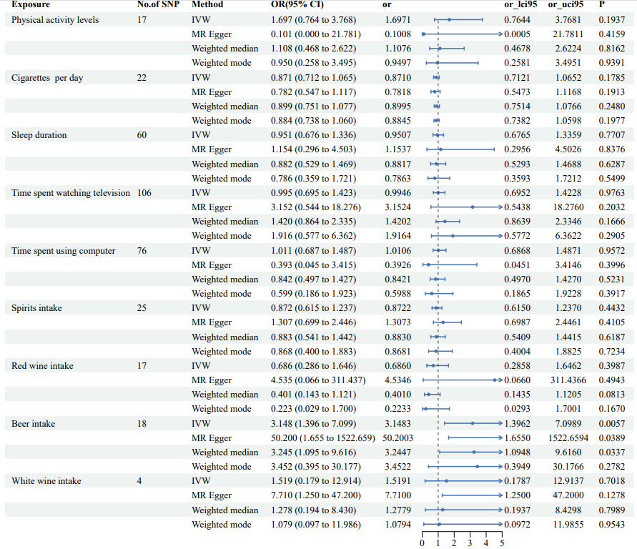
Supplementary Figure 1(a) The forest plots for Mendelian randomization causal estimates of Alzheimer's disease
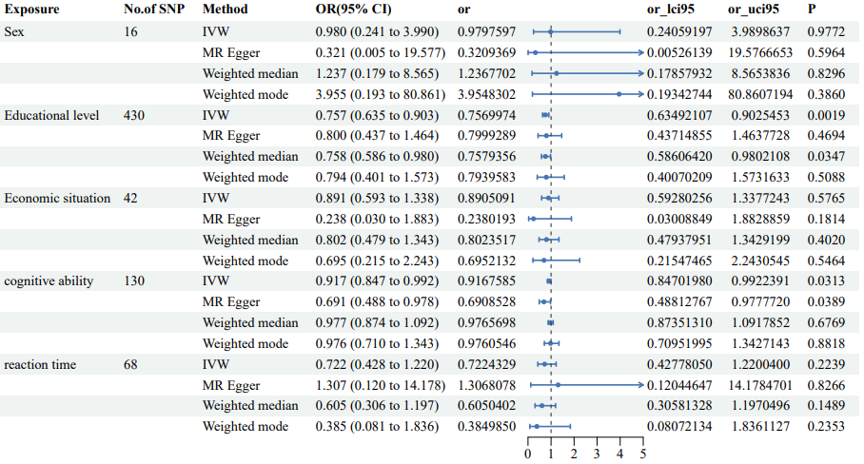
Supplementary Figure 1(b) The forest plots for Mendelian randomization causal estimates of Alzheimer's disease
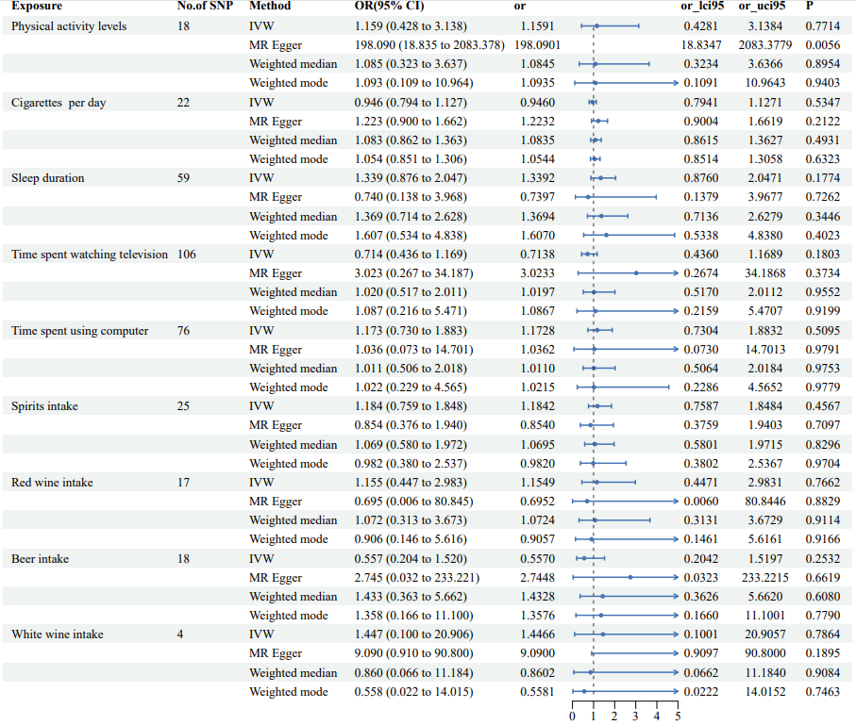
Supplementary Figure 2(a) The forest plots for Mendelian randomization causal estimates of Parkinson's disease
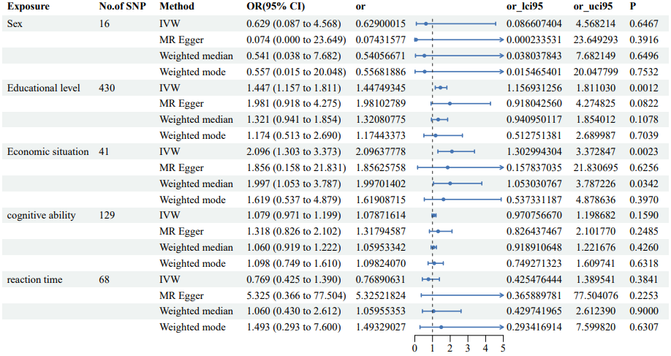
Supplementary Figure 2(b) The forest plots for Mendelian randomization causal estimates of Parkinson's disease

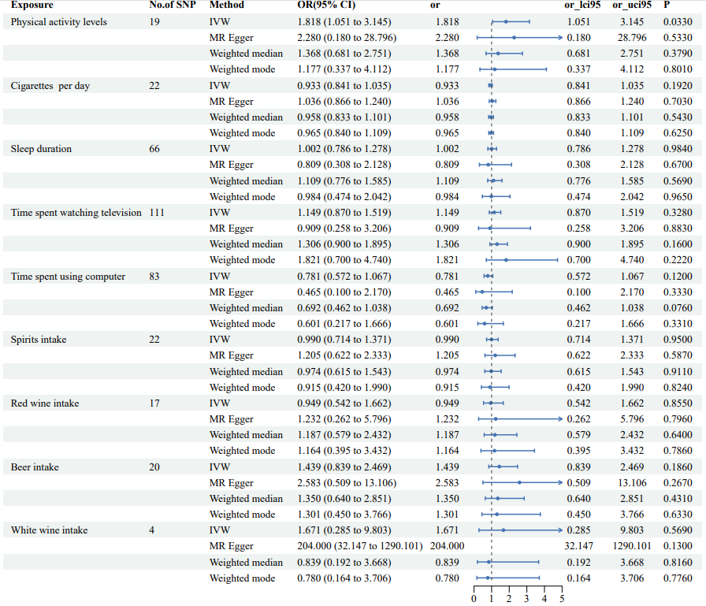
Supplementary Figure 3(a) The forest plots for Mendelian randomization causal estimates of amyotrophic lateral sclerosis
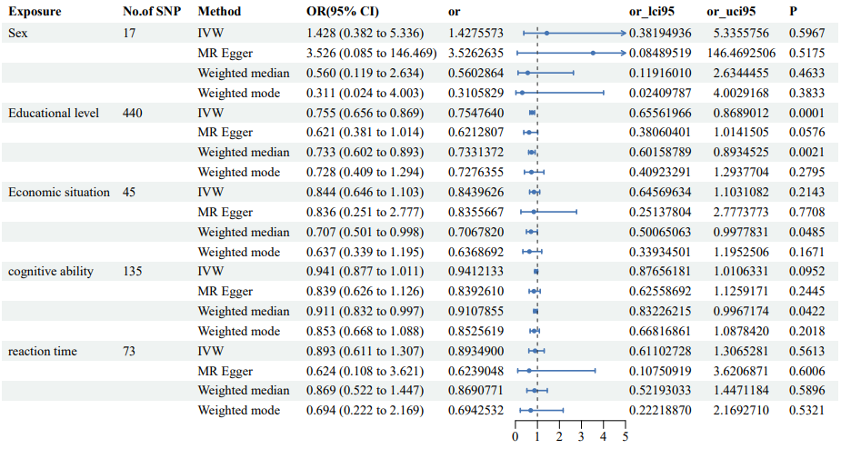
Supplementary Figure 3(b) The forest plots for Mendelian randomization causal estimates of amyotrophic lateral sclerosis
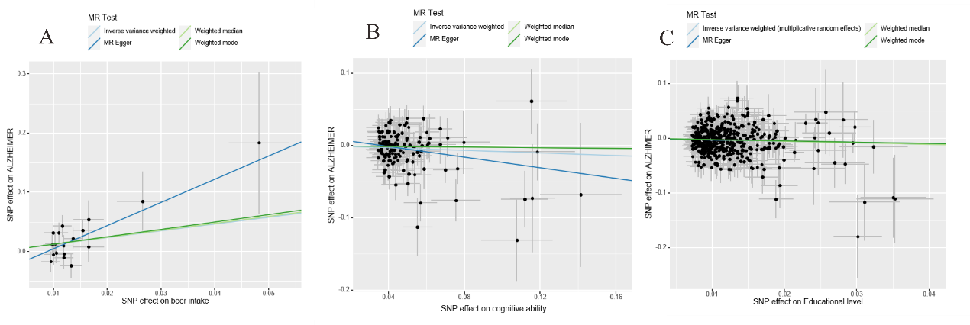
Supplementary Figure 4 The scatter plots for Mendelian randomization analyses of Alzheimer's disease: (A) The scatter plot of beer intake and Alzheimer's disease (B) The scatter plot of cognitive ability and Alzheimer's disease (C) The scatter plot of educational level and Alzheimer's disease
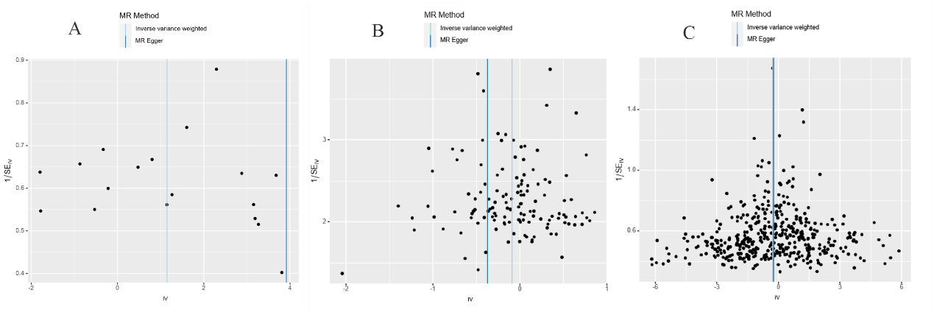
Supplementary Figure 5 The funnel plots for Mendelian randomization analyses of Alzheimer's disease: (A) The funnel plot of beer intake and Alzheimer's disease (B) The funnel plot of cognitive ability and Alzheimer's disease (C) The funnel plot of educational level and Alzheimer's disease

Supplementary Table 1 Mendelian randomization sensitivity analysis results for Alzheimer's disease
Exposure | Outcome | Cochran's tests for heterogeneity |  |  |  | horizontal pleiotropy
Exposure | Outcome | MR-Egger Q | MR-Egger P | IVW Q | IVW P | MR-Egger Intercept | MR-Egger Se | MR-Egger P
Beer intake | Alzheimer's disease | 17.42 | 0.36 | 20.33 | 0.26 | -0.03 | 0.02 | 0.12
Cognitive ability | Alzheimer's disease | 143.57 | 0.16 | 146.58 | 0.13 | 0.01 | 0.008 | 0.10
Educational level | Alzheimer's disease | 78.60 | 0.10 | 85.99 | 0.05 | -0.03 | 0.01 | 0.06

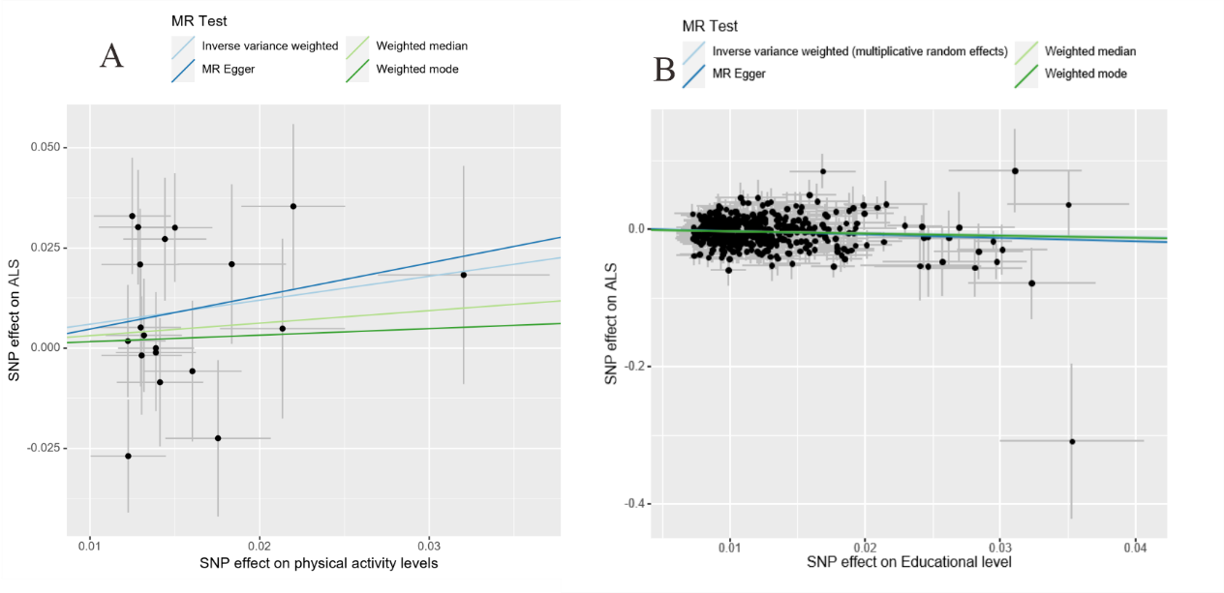
Supplementary Figure 6 The scatter plots for Mendelian randomization analyses of amyotrophic lateral sclerosis: (A) The scatter plot of physical activity level and amyotrophic lateral sclerosis (B) The scatter plot of educational level and amyotrophic lateral sclerosis
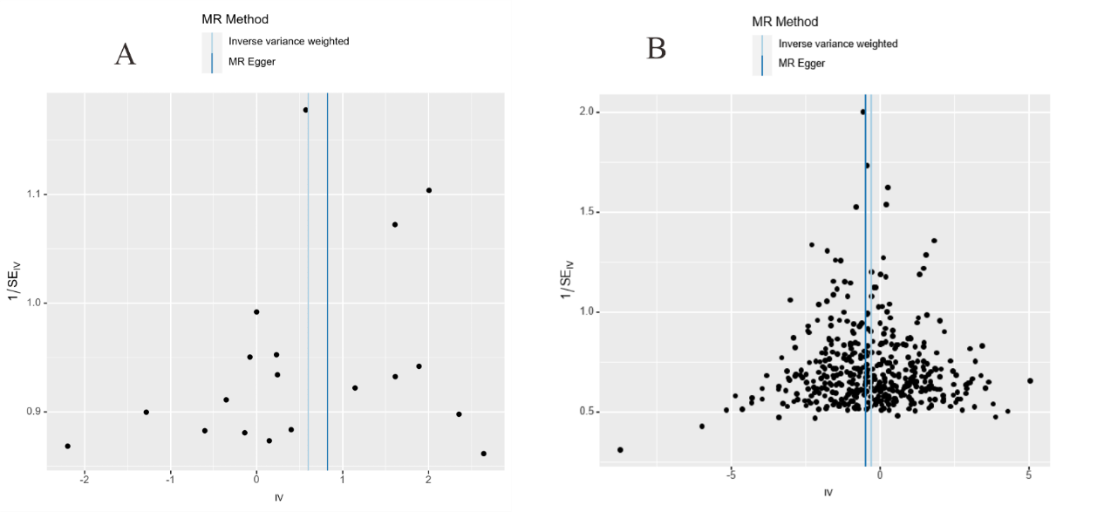
Supplementary Figure 7 The funnel plots for Mendelian randomization analyses of amyotrophic lateral sclerosis: ((A) The funnel plot of physical activity level and amyotrophic lateral sclerosis (B) The funnel plot of educational level and amyotrophic lateral sclerosis
Supplementary Table 2 Mendelian randomization sensitivity analysis results for Amyotrophic lateral sclerosis
Exposure | Outcome | Cochran's tests for heterogeneity |  |  |  | horizontal pleiotropy
Exposure | Outcome | MR-Egger Q | MR-Egger P | IVW Q | IVW P | MR-Egger Intercept | MR-Egger Se | MR-Egger P
Physical activity level | Amyotrophic lateral sclerosis | 23.986 | 0.120 | 24.032 | 0.154 | -0.003 | 0.019 | 0.86
Educational level | Amyotrophic lateral sclerosis | 118.464 | 0.063 | 120.005 | 0.086 | 0.012 | 0.012 | 0.35

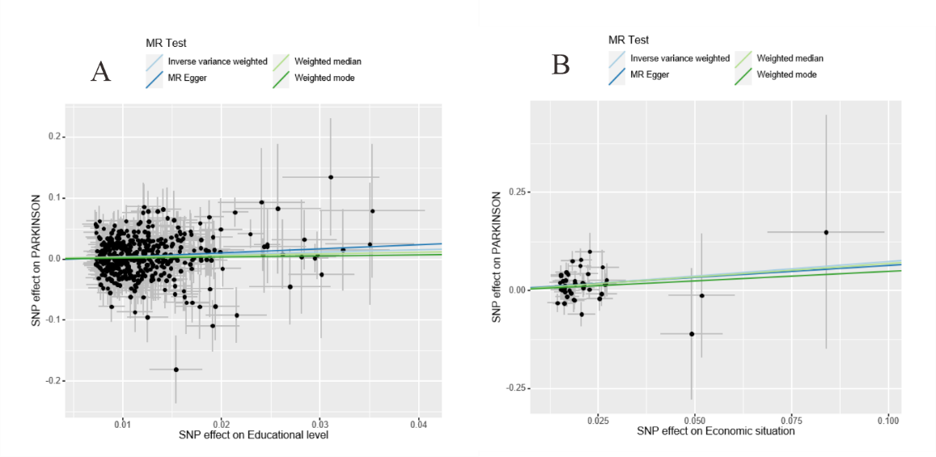
Supplementary Figure 8 The scatter plots for Mendelian randomization analyses of Parkinson's disease: (A) The scatter plot of educational level and Parkinson's disease (B) The scatter plot of economic situation and Parkinson's disease

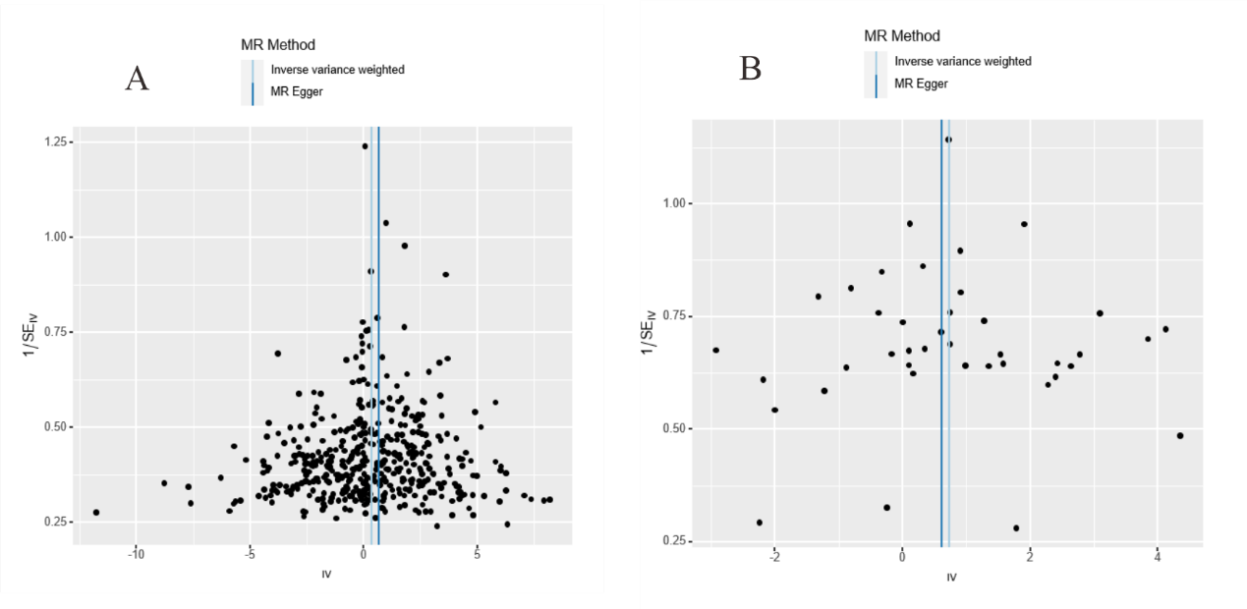
Supplementary Figure 9 The funnel plots for Mendelian randomization analyses of Parkinson's disease: (A) The funnel plot of educational level and Parkinson's disease (B) The funnel plot of economic situation and Parkinson's disease

Supplementary Table 3 Mendelian randomization sensitivity analysis results for Parkinson's disease
Exposure | Outcome | Cochran's tests for heterogeneity |  |  |  | horizontal pleiotropy
Exposure | Outcome | MR-Egger Q | MR-Egger P | IVW Q | IVW P | MR-Egger Intercept | MR-Egger Se | MR-Egger P
Economic situation | Parkinson's disease | 48.057 | 0.152 | 48.069 | 0.178 | 0.002 | 0.024 | 0.922
Educational level | Parkinson's disease | 464.650 | 0.107 | 465.408 | 0.109 | -0.004 | 0.004 | 0.403

