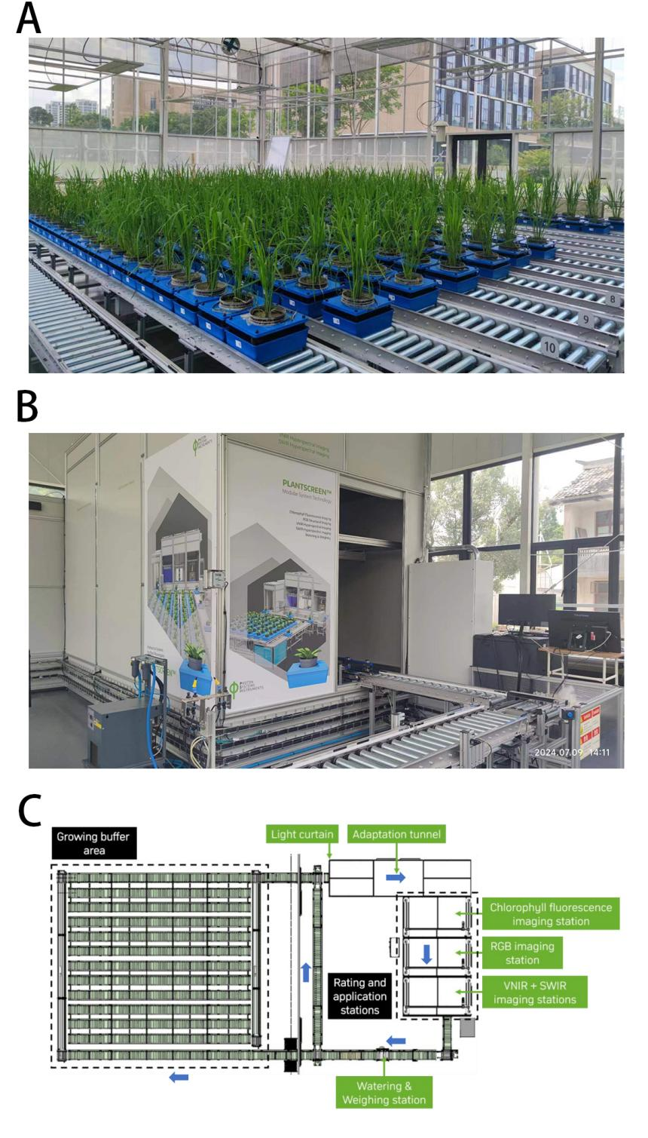
Fig.S1. The PlantScreen™ System platform designed and constructed by Photon Systems Instruments (https://psi.cz/) which is located in China National Rice Research Institute. (A) Plant growing buffer area of the PlantScreen™ System. Plants are placed in the growing buffer area and waiting to be imaged. (B) Outward appearance of the imaging station. (C) Sketch map for demonstrating the PlantScreen™ System. This sketch map is cited from Photon Systems Instruments.

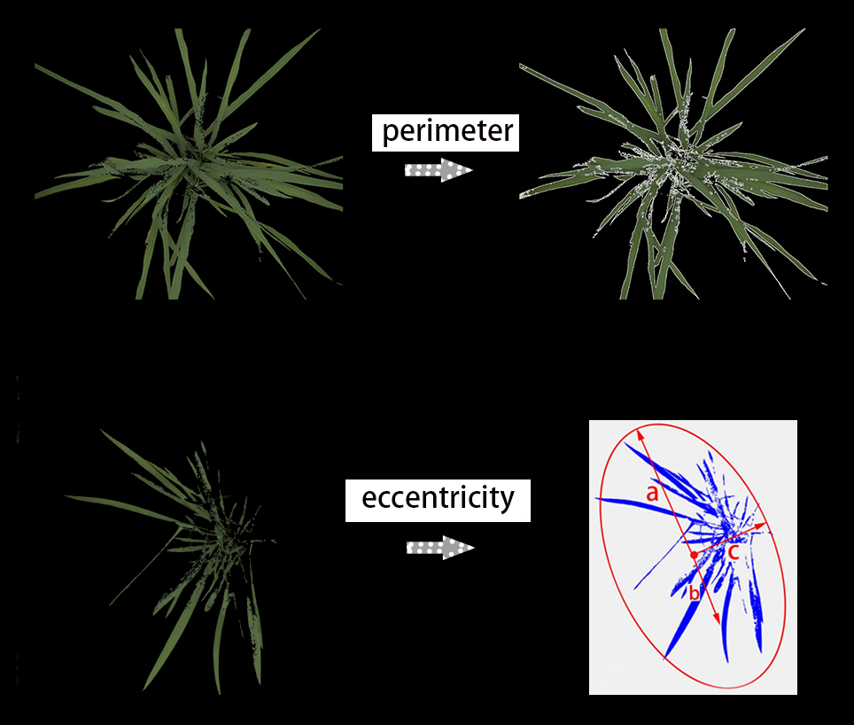
Fig. S2. Demonstration of calculating perimeter and eccentricity in rice using the PlantScreen™ System. Note that the roundness, roundness2, isotropy, compactness, eccentricity, RMS, and SOL, are designed for studying dicot rosette plants like Arabidopsis, and are not specifically designed for studying rice. Using these parameters in rice research may yield interesting results. The formula for calculating eccentricity: eccentricity = (area(circle only)+area(convex hull only))/area(intersection) in the PlantScreen™ System is similar to the common knowledge that eccentricity = semi_focal_length/semi_major_axis. The semi-focal length and the semi-major axis are indicated by "b" and "a", respectively, in the Figure.

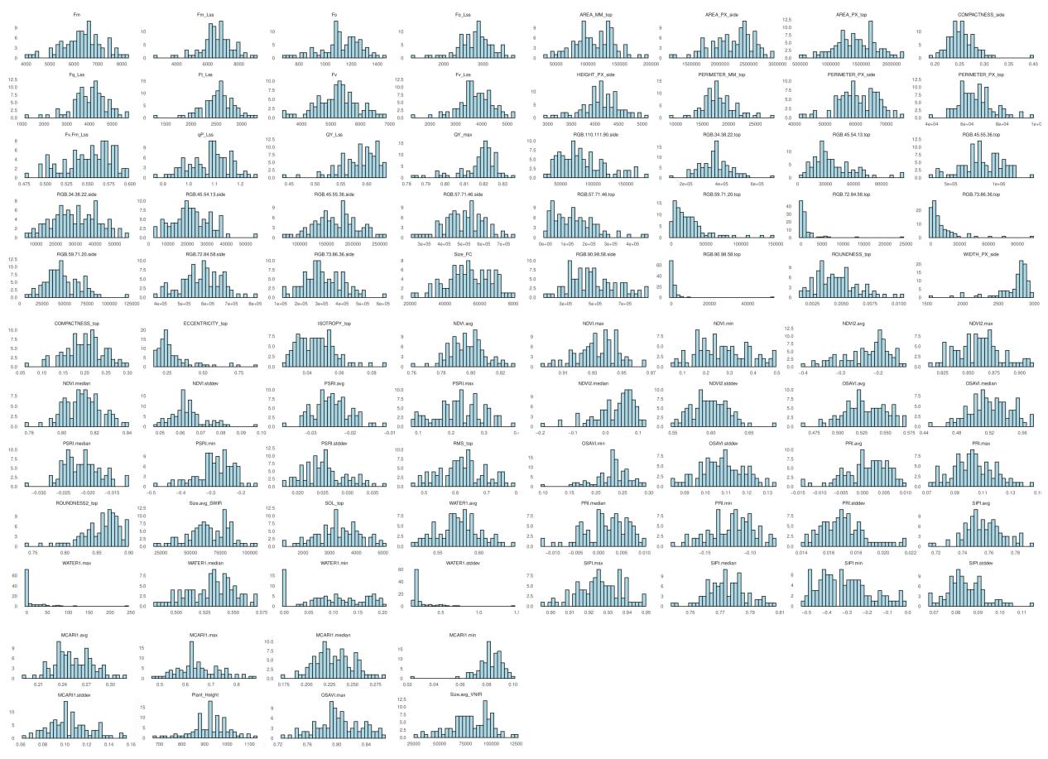
Fig.S3. Frequency distributions of 88 high-throughput phenotypic traits obtained at jointing stage. See Materials and Methods section for detailed information on the 88 traits.
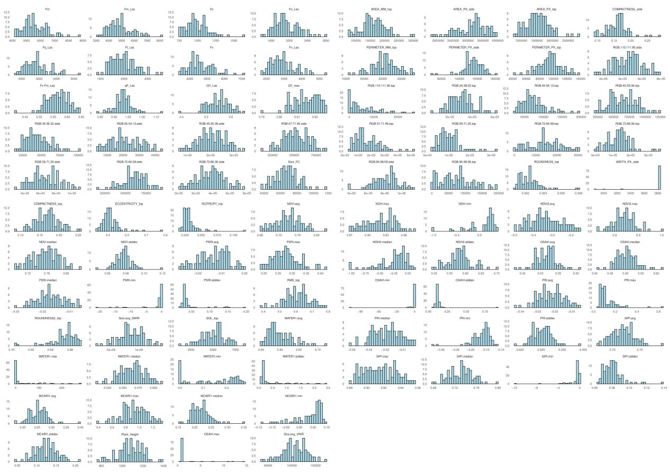
Fig.S4. Frequency distributions of 88 high-throughput phenotypic traits obtained at grain filling stage. See Materials and Methods section for detailed information on the 88 traits.

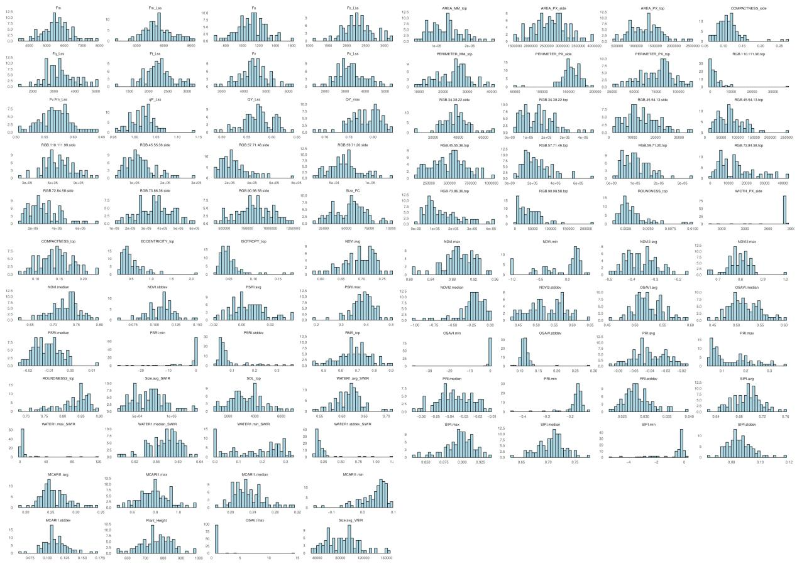
Fig.S5. Frequency distributions of 88 high-throughput phenotypic traits obtained at 20 days after grain filling stage. See Materials and Methods section for detailed information on the 88 traits.

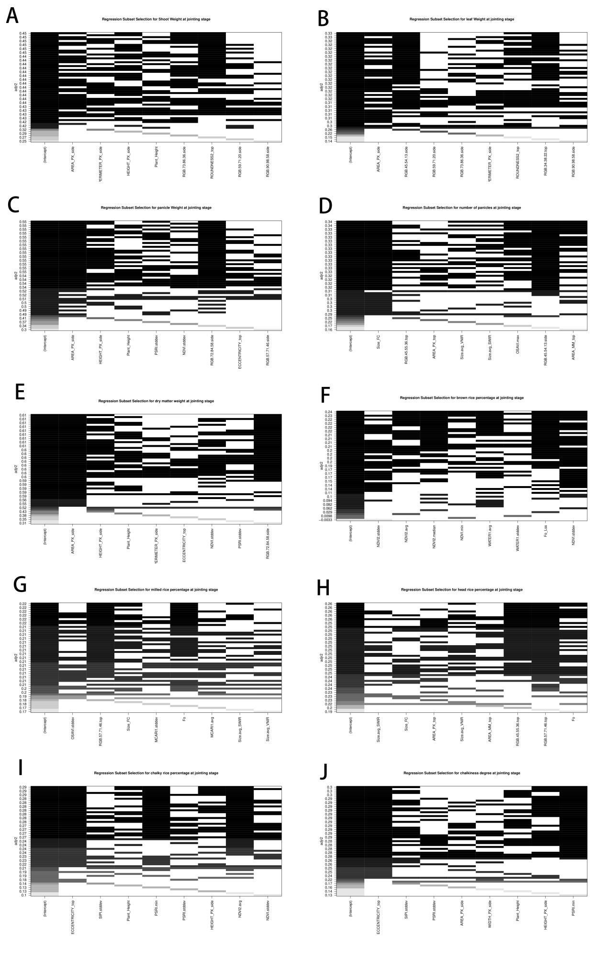
Fig.S6. The Subset Selection Regression which is used to determine the best regression formula at jointing stage to predict the final yield and grain quality at rice maturity stage.

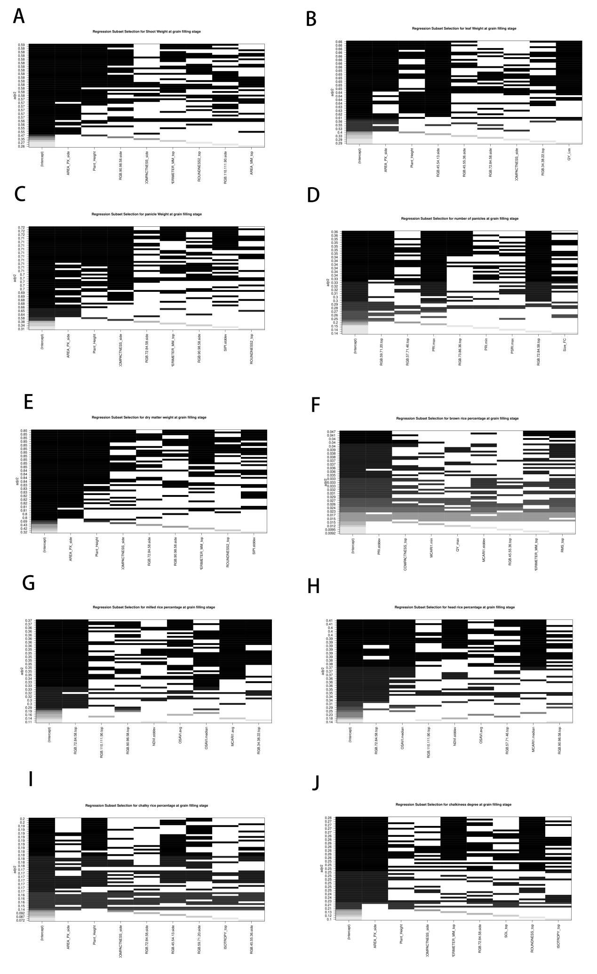
Fig.S7. The Subset Selection Regression which is used to determine the best regression formula at grain filling stage to predict the final yield and grain quality at rice maturity stage.

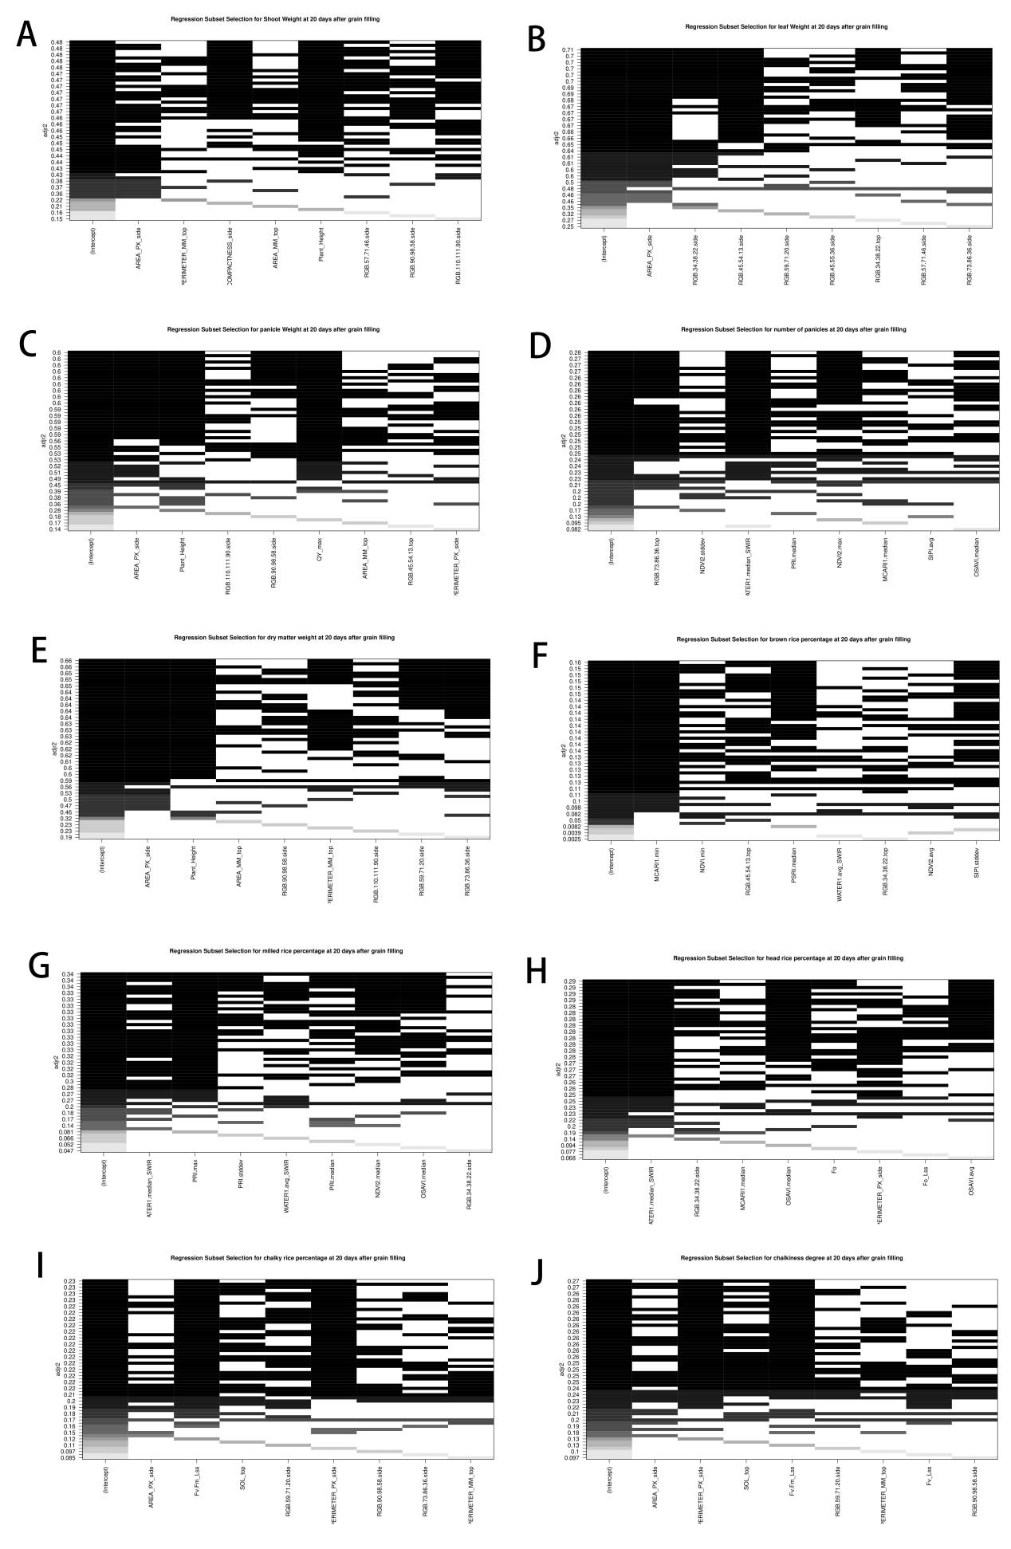
Fig.S8. The Subset Selection Regression which is used to determine the best regression formula at 20 days after grain filling to predict the final yield and grain quality at rice maturity stage.

