Supplementary material
Figure S1. ROC analysis of a model including CRP + leucocyte count + NEWS + SOFA, and individual biomarkers to predict bacterial sepsis
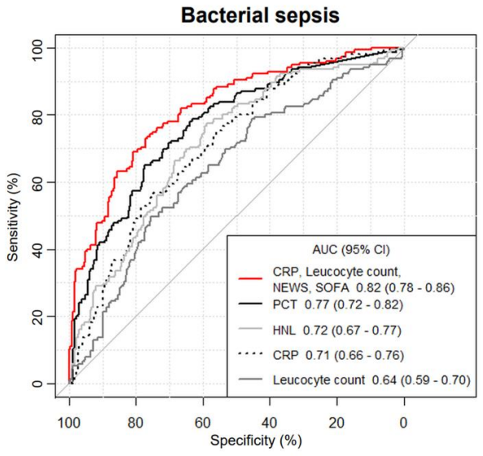
ROC = receiver operating characteristic; AUC = area under the curve; CI = confidence interval; PCT = Procalcitonin; CRP = C-reactive protein; HNL = Human Neutrophil Lipocalin.

Figure S2. ROC analysis of PCT, HNL, CRP and leucocyte count to predict bacterial infection
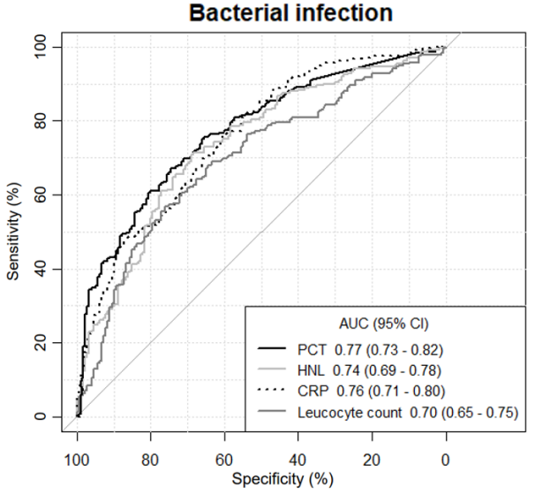
ROC = receiver operating characteristic; AUC = area under the curve; CI = confidence interval; PCT = Procalcitonin; CRP = C-reactive protein; HNL = Human Neutrophil Lipocalin.

Table S1. Performance of biomarker cut-offs to identify bacterial infection
Biomarker | Cut-off | Sensitivity,  % (95%CI) | Specificity,  % (95%CI) | +LR (95%CI) | -LR (95%CI)
CRP | 10 mg/l | 95.9 (94.0-97.8) | 28.9 (24.6-33.2) | 1.35 (1.16-1.56) | 0.14 (0.09-0.23)
 | 37 mg/l (YI) | 75.5 (70.9-79.6) | 61.1 (55.6-66.3) | 1.94 (1.54-2.45) | 0.40 (0.31-0.52)
 | 50 mg/l | 70.1 (65.6-74.6) | 65.0 (59.7-70.3) | 2.00 (1.60-2.50) | 0.46 (0.35-0.61)
 | 100 mg/l | 51.0 (46.3-55.7) | 81.7 (77.8-85.1) | 0.63 (0.50-0.80) | 0.60 (0.53-0.68)
PCT | 0.1 ng/ml | 80.1 (75.9-83.6) | 57.2 (52.0-62.3) | 1.87 (1.48-2.36) | 0.35 (0.27-0.46)
 | 0.16 ng/ml (YI) | 67.2 (62.5-71.6) | 74.4 (69.6-78.6) | 2.63 (2.09-3.31) | 0.44 (0.35-0.55)
 | 0.25 ng/ml | 55.6 (50.9-60.1) | 83.3 (79.7-86.4) | 3.33 (2.97-4.16) | 0.53 (0.45-0.63)
 | 0.5 ng/ml | 47.1 (42.4-51.9) | 87.2 (83.9-89.9) | 3.72 (2.93-4.72) | 0.61 (0.52-0.71)
HNL | 184 µg/ml (YI) | 71.0 (66.3-75.1) | 68.9 (63.7-73.6) | 2.28 (1.81-2.87) | 0.42 (0.34-0.53)
Leucocyte count | 10 x10⁹/l | 68.5 (63.8-72.7) | 63.3 (58.1-68.2) | 1.43 (1.15-1.78) | 0.61 (0.50-0.74)
 | 11.5 x10⁹/l (YI) | 56.8 (52.0-61.5) | 76.1 (71.6-80.1) | 2.38 (1.90-2.98) | 0.57 (0.47-0.69)
 | 15 x10⁹/l | 30.7 (26.5-35.2) | 90.6 (87.8-92.8) | 1.72 (1.34-2.21) | 0.85 (0.78-0.93)
CRP = C-reactive protein; PCT = Procalcitonin; HNL = Human Neutrophil Lipocalin; YI = Youden’s Index

