Supplementary Materials for

RORγt⁺ APCs require a distinct cis-regulatory element to instruct tolerance
to dietary antigens

Jie Zhao^{1,2,3,4,9}, Jiacheng Hao^{1,2,3,4,9}, Jincheng Chen^{1,2,3,4,9}, Mengze Lyu^{5,6,7}, Haoyu Liu^{1,2,3,4}, Na Li^{1,2,3,4}, Panwei Song^{1,2,3,4}, Wenyan Wang^{1,2,4}, Coco Chu^{1,2,3}, Gregory F. Sonnenberg^{5,6,7}, Xiaohuan Guo^{1,2,3,4,8 #}

¹Institute for Immunology, Tsinghua University, Beijing 100084, China
²School of Basic Medical Sciences, Tsinghua Medicine, Tsinghua University, Beijing 100084, China
³Beijing Key Laboratory of Immunological Research of Allergy (LIRA); Tsinghua University, Beijing 100084, China
⁴State Key Laboratory of Molecular Oncology, School of Basic Medical Sciences; Tsinghua University, Beijing 100084, China
⁵Jill Roberts Institute for Research in Inflammatory Bowel Disease, Weill Cornell Medicine, Cornell University, New York, NY, USA
⁶Joan and Sanford I. Weill Department of Medicine, Division of Gastroenterology & Hepatology, Weill Cornell Medicine, Cornell University, New York, NY, USA
⁷Department of Microbiology & Immunology, Weill Cornell Medicine, Cornell University, New York, NY, USA
⁸SXMU-Tsinghua Collaborative Innovation Center for Frontier Medicine, Shanxi Medical University; Taiyuan, Shanxi 030001, China
⁹These authors contributed equally: Jie Zhao, Jiacheng Hao, Jincheng Chen

#Correspondence: guoxiaohuan@tsinghua.edu.cn (X.G.)

This PDF file includes:
Materials and Methods
Extended Data Figure 1 to 14

Materials and Methods
Mice
Rorc^{Δ369} and Rorc^{Δ225} mice were generated on the C57BL/6J background using the CRISPR-Cas9 system. Guide RNAs (gRNA) were designed with CRISPOR web tool (CRISPOR.org). The efficiency of candidate gRNAs were tested using a commercial kit (TransGen), and gRNAs with high efficiency were in vitro transcribed with the MEGAshortscript kit. Micro-injection of gRNA and Cas9 mRNA was performed by the Laboratory Resources Animal Center of Tsinghua University. The edited mice were confirmed by genotyping, and were then selected and backcrossed for multiple generations to establish a stable germline-deficient strain. Rag1–/– mice were purchased from Jackson Laboratory. OT-II TCR transgenic mice were generously provided by Chen Dong (Westlake University, Hangzhou). CD45.1 mice were bought from Laboratory Resources Animal Center of Tsinghua University. Foxp3-RFP mice were generously provided by Yan Shi (Tsinghua University, Beijing). Rorc^{GFP} mice were provided by Coco Chu (Tsinghua University, Beijing). Rorc^{cre}H2-Ab1^{fl/fl} mice were generously provided by Gregory F. Sonnenberg (Weill Cornell Medicine, New York). All mice were bred and maintained under specific pathogen-free (SPF) conditions on a 12/12-hour light–dark cycle. Unless otherwise noted, 6–12-week-old and sex matched mice were used for experiments. All animal experiments in this study were approved by the Institutional Animal Care and Use Committee (IACUC) of Tsinghua University.

Isolation of immune cells
The isolation of intestinal lamina propria lymphocytes (LPLs) were performed as previously reported¹. Briefly, intestines were longitudinally opened, Peyer’s patches (PPs) and luminal contents were removed, and the tissue was cut into around 2 cm pieces. The tissue was washed twice in PBS, and incubated in HBSS containing 1 mM DTT (Sigma, D0632), 5 mM EDTA, 15 mM HEPES, and 3% FBS for 15 min twice. Then the tissue was washed in HBSS with 15 mM HEPES and transferred to digestion buffer (3% FBS RPMI 1640 medium containing 0.05% DNase I (Sigma, DN25) and 0.1 mg/mL Liberase (Roche, 05401020001)) in C tubes (Miltenyi Biotech) for 20 (small intestine) or 30 min (large intestine) at 37°C. Then the tissues were homogenized by gentleMACS Dissociator (Miltenyi Biotech) and passed through a 70 μm cell strainer. Single-cell suspensions were collected from 40-80% Percoll Density Gradient Media (GE Healthcare) after centrifuge at 2300 rpm for 20 min without brake. For other tissues, including the thymus, spleen, PPs, and lymph nodes, cells were mechanically dissociated, passed through a 70 em strainer, and used for further analysis.

Flow cytometry analysis, ex vivo stimulation and FACS sorting
Isolated single-cell suspensions were washed twice with 3% FBS RPMI 1640 medium, resuspend in FACS buffer ( PBS buffer containing 2% FBS and 0.02% NaN₃), and blocked with anti-CD16/CD32 antibody (eBioscience). Cells were stained with antibody cocktails for surface markers and Fixable Viability Dye (eBioscience) at 4℃ for 40 min. For transcription factor staining, cells were fixed in Foxp3/Transcription Factor Staining Buffer Set (eBioscience) at 4℃ overnight, then permeabilized and stained with antibody cocktails for 30 min at room temperature. For ex vivo stimulation and intracellular cytokine staining, cells were resuspended in 10% FBS RPMI 1640 medium containing Glutamax (Gibco), 10 mM HEPES, sodium pyruvate (Gibco), and 2-Mercaptoethanol (Gibco). Cells were stimulated with PMA and Ionomycin (P.I.) or IL-23 and IL-1β (10 ng/mL) for 2 h, followed by addition of Brefeldin A for the next 2 h. Cells were collected, stained for surface markers, fixed overnight in IC fixation buffer (eBioscience), permeabilized, and stained with anti-IL-22, anti-IL-17A, anti-IL-5, anti-IL-13, and anti-IFN-γ antibodies (Biolegend). Flow cytometry was performed on Fortessa instruments (BD Biosciences) and analyzed with FlowJo software. For FACS sorting, cells were resuspended in PBS buffer containing 2% FBS and 5 mM EDTA, and sorted by BD FACSAria™ flow cytometer. ILC3s were gated as live lineage–KLRG1–CD90^{high}CD45^{low} cells from intestinal LPLs.

Construction of bone marrow chimera mice
Bone marrow (BM) cells from WT CD45.1 mice were 1:1 mixed with BM cells from the Rorc^{Δ369} or Rorc^{WT} mice and intravenously transferred to irradiated (5.5 Gy×2) CD45.1 mice. Mice were sacrificed 8 weeks later for flow cytometry analysis.

Analysis of bone marrow progenitors
Bone marrow cells were isolated from Rorc^{WT} or Rorc^{Δ369} mice and treated with red blood cells (RBCs) lysis buffer to remove RBCs. Cells were stained with a lineage antibodies cocktail (CD3, NK1.1, Ter-119, CD11b, Gr-1, B220) and other antibodies. CLPs (lineage–CD127⁺Flt3⁺α4β7–), CHILPs (lineage–CD127⁺Flt3–α4β7⁺CD25–PD-1–), and CHILPs (lineage–CD127⁺Flt3–α4β7⁺CD25–PD-1⁺) were analyzed by flow cytometry.

CHILP in vitro differentiation
OP9-DL1 stromal cells were cultured and irradiated 1 day before use. CHILPs were isolated and purified from bone marrow of age- and sex-matched donor mice, negatively selected by magnetic Dynabeads (Invitrogen) with biotin-labeled lineage antibodies (CD3, NK1.1, Ter-119, CD11b, Gr-1, B220), and then sorted as lineage–CD127⁺Flt3–α4β7⁺CD25–PD-1–cells using a BD FACSAria™ flow cytometry. CHILPs were cultured on OP9-DL1 cells in α-MEM medium including 20% FBS, 10 mM HEPES, 100 U/mL Penicillin-Streptomycin (Thermo Fisher), 1 mM sodium pyruvate, 8 mg/mL Glutamine, 2-Mercaptoethanol (Gibco), and mIL-7 (Novoprotein, CC73, 20 ng/mL) and mSCF (Novoprotein, C775, 10 ng/mL). The medium was refreshed at day 5, and cells were harvested at day 10 for flow cytometry analysis.

Th17 and Treg in vitro differentiation
Naïve T cells were sorted as live CD45⁺CD3⁺CD8α–CD4⁺CD62L^{high}CD44^{low} cells from the spleen and lymph nodes and cultured in anti-CD3/CD28 antibody (10 μg/mL)-coated cell culture plates in 10% FBS complete 1640 medium with different cytokine cocktails: Th17 condition (IL-6 (Peprotech, 216-16, 20 ng/mL), TGF-β (R&D, 240-B-010, 1 ng/mL), IL-1β (Peprotech, 211-11B, 10 ng/mL), IL-23 (R&D, 1887-ML-010, 25 ng/mL)); Treg condition (TGF-β (R&D, 7666-MB, 2 ng/mL) and IL-2 (Peprotech, 212-12, 10 ng/mL)). Cells were analyzed at day 4 after 2 h stimulation with P.I. and Golgi Stop (Thermo Fisher, 00-4980-93) for 4 h for intracellular staining and flow cytometry analysis.

DNA-pulldown and Mass spectrometry
Biotin-labeled DNA-pulldown assay was performed according to the previous report^{2,3} with modifications. In brief, 1×10⁶ FACS sorted ILC3s were washed twice in cold PBS and nuclear proteins were extracted with a Nuclear and Cytoplasmic Protein Extraction Kit (Beyotime, P0027). Protein concentration was determined by BCA assay (Thermo Fisher, 23225), and adjusted with DNA-protein binding buffer (120 mM NaCl, 0.44 mM EDTA, 0.8 mM MgCl₂ and 6% glycerol). The biotin-labeled DNA probes were prepared by PCR using Q5® High-Fidelity DNA Polymerase (NEB, M0491S) with 5’-biotin labeled primers and purified from 2% agarose gel. Pulldown assays were performed with BeyoMag™ Streptavidin Magnetic Beads (Beyotime, P2151). DNA probes were incubated with Streptavidin Magnetic Beads in Binding & Washing Buffer (10 mM Tris-HCl (pH 7.5), 1 mM EDTA, 2 M NaCl, 0.01%-0.1% Tween-20) at 4℃ for 3 h, washed twice, and incubated with nuclear extracts in DNA-protein binding buffer (containing 100 μg/mL salmon sperm DNA (Thermo Fisher, 15632011) and 0.125 mg/mL poly (dIdC) to nonspecific binding reduction) at 4℃ overnight. Beads were washed twice with 0.05% PBST and eluted with 1×SDS-PAGE loading buffer at 95℃ for 5 min. Eluted proteins were analyzed by 15% SDS-PAGE followed by Silver staining (Thermo Fisher, 24612), and bands were excised for mass spectrometry identification using a Q Exactive LC-MS/MS (Thermo Fisher) by Technology Center for Protein Science, Tsinghua UniversityThermo Fisher.

CUT&RUN assay
5×10⁵ sorted ILC3 and in vitro differentiated Th17 cells were collected for CUT&RUN library preparation (YEASEN 12598) following the manufacturer's instructions. Anti-RUNX3 (CST, #9647) and Isotype Rabbit IgG (Abcam, ab171870) were used for immunoprecipitation. RUNX3-bound DNA was amplified via 15 cycles of PCR and then purified with magnetic beads. DNA fragments were detected by SYBR Green qPCR analysis (YEASEN, 11203ES), normalized by Ct value relative to E. coli spike-in controls.

Dual-Luciferase reporter assay
The OCR369 and RORγt-promoter elements were cloned into the firefly luciferase pGL3 vector. RUNX3-CDS was inserted into the pcDNA3.4 vector (provided by Chen Dong, Westlake University, Hangzhou). pGL3 vectors, pcDNA3.4 vectors and renilla luciferase control vector pRL-TK were 5:5:1 co-transfected into HEK293T cells (provided by Yang-Xin Fu, Tsinghua University, Beijing) by Lipofectamine™ 3000 Transfection Reagent (Thermo Fisher, L3000001). The luciferase activity was measured using the Dual-Luciferase® Reporter Assay System (Promega, E1910) on a Glomax Multi detection system (Promega). Relative Luciferase activity was calculated as firefly luciferase activity divided by renilla luciferase activity.

Quantitative analysis of chromosome conformation capture assays (3C-qPCR)
B16 and MNK-3 cell line were provided by Yun-Cai Liu (Tsinghua University, Beijing) and James R. Carlyle (University of Toronto, Toronto)/David S.J. Allan (NHLBI, NIH, Bethesda), respectively. 3C-qPCR was performed as previously reported^{4,5} with modifications. In brief, 2~5×10⁶ cells were harvested and resuspended in cold PBS with 10% FBS, fixed with 1% formaldehyde (Thermo Fisher, 28908) for 10 min at room temperature, then quenched by 1 M cold glycine. Nuclei were extracted by cold lysis buffer (10 mM Tris-HCl, 10 mM NaCl, 0.2% NP-40, pH 7.5) with protease inhibitor (Roche, 11836145001) on ice for 20 min. The pellets of nuclei were incubated in rCutsmart buffer (NEB) with 0.3% SDS for 1 h at 37°C, followed by addition of 1% Triton X-100 for 1 h at 37°C. Nuclei were digested by NlaIII restriction enzyme at 37°C overnight. The reaction was inactivated by addition of 1.6% SDS and incubate at 65°C for 10 min. Samples were diluted with T4 DNA ligase buffer (NEB), added with 1% Triton X-100 and incubate for 1 h. 400U T4 DNA ligase was added and incubated at 16°C overnight. Ligation was stopped by adding protease K (Beyotime) and then the crosslinks were reversed at 65°C overnight. The samples were digested with 10 µg/mL of RNase I (Beyotime) at 37°C for 45 min and DNA was purified by Universal DNA Purification Kit (TIANGEN, DP214). The 3C products were analyzed with TaqMan qPCR master mix (YEASEN, 11208ES) on a StepOnePlus Real-Time PCR System (Thermo Fisher). Relative crosslinking was calculated by normalizing Ct values to Gapdh. Primers for the 3C-qPCR are listed in Supplementary Data Table 8.

Bulk RNA sequencing
RNA was extracted from ~0.5 cm of small intestine using TRIzol reagent (Invitrogen, 15596026CN). RNA quality was confirmed by 1% agarose gel electrophoresis, and sample were sent to The Beijing Genomics Institute (BGI) for library preparation and sequencing. Clean reads were aligned to the mouse reference genome (mm10). Differential gene expression analysis was conducted using DESeq2 (DEG identified by q value < 0.05 and fold change > 1). Gene Ontology (GO) enrichment, KEGG pathway enrichment were performed by Dr. Tom tool (biosys.bgi.com).

Gene set enrichment analysis (GSEA)
The gene-level count matrix was generated by BGI data analysis server, and then the genes were pre-ranked by signal2noise and a custom set of MSigDB gene sets, including Reactome pathways and a gene set of the top 300 up-regulated genes in the intestinal epithelium of mice infected with N. brasiliensis compared to non-infected controls⁹. GSEA was performed, and enrichplot (v.1.24.4) package was used for visualization.

Immunofluorescence staining and histology analysis
Intestinal tissue was coiled into a “Swiss roll” and fixed in the 4% paraformaldehyde (PFA) and paraffin-embedded. After dewaxing, rehydration and antigen retrieval, 10 μm tissue sections were blocked in PBS with 3% BSA and 0.3% Triton X-100 for 1 h at room temperature. Sections were stained with indicated primary antibody overnight at 4°C, followed by secondary antibody and DAPI. Images were acquired using an FV3000 Olympus confocal microscope (20× or 40× magnification), and 5 random images per tissue were selected for statistical analysis. For histology, Hematoxylin and eosin (H&E) staining was performed after dewaxing and rehydration. Intestinal goblet cells were stained with AB-PAS staining kit (Solarbio, G1285). Deposition of extracellular matrix was stained by Sirius Red Stain Kit (Solarbio, G1572). Tissue sections were scanned by a PANNORAMIC SCAN II scanner (3DHISTECH). The average length of villi and crypt, the numbers of tuft cell, mast cell and goblet cell were calculated from at least 10 villi/crypt units for each section of mice.

RNA extraction and real-time PCR
RNA was extracted from ~0.5 cm of small intestine using TRIzol reagent (Invitrogen, 15596026CN). cDNA synthesis was conducted with RevertAid First Strand cDNA Synthesis Kit (Thermo Fisher, K1622). qPCR was performed with SYBR Green qPCR mix (YEASEN, 11203ES) on a StepOnePlus Real-Time PCR System (Thermo Fisher). Relative gene expression was normalized by Gapdh or Actb.

OT-II T cell adoptive transfer & Treg rescue
For the OT-II T cell adoptive transfer experiment in Rorc^{Δ369} mice, naïve OT-II CD4⁺ T cells were sorted as live CD45⁺CD3⁺CD8α–CD4⁺CD62L^{high}CD44^{low}cell from the spleen and lymph nodes. 1×10⁶ cells were intravenously transferred to each mouse, which were then orally treated with 50 mg ovalbumin (OVA) dissolved in water (YEASEN, 36121ES) daily. Mice were sacrificed at day 8 for immune cell analysis in SI-LPL, PPs, and mLN. For CFSE labeling assay, the sorted OT-II T cells were labeled with 1 μM CFSE for 15 min at 37°C, washed twice and then transferred. For the OT-II T cell adoptive transfer experiment in Rorc^{cre}H2-Ab1^{fl/fl} mice, after OT-II T cell transfer, mice received drinking water containing 1% OVA (v/w) throughout the experiment and also received OVA by oral gavage (20 mg/mouse; A5503; Sigma) every other day. Cells of SI-LP and mLN were analyzed 13 days post-transfer. For Treg rescue experiment, Treg cells sorted as live CD45⁺CD3⁺CD4⁺FOXP3-RFP⁺ cells from the spleen and lymph nodes. 5×10⁵ Treg cells were intravenously transferred to Rorc^{Δ369} mice every 4 weeks starting at 4 weeks of age. Mice were sacrificed and analyzed at around 20 weeks old.

Citrobacter rodentium infection model
Mice were orally gavaged with C. rodentium strain DBS100 (ATCC 51459). C. rodentium was cultured in LB broth overnight and the bacterial concentration was determined by measuring the optical density at 600 nm (OD600). Mice were infected with 2×10⁹ CFU in 200 μL PBS. Bodyweight was measured every 2 days, and fecal pellets were collected, homogenized, and plated on MacConkey agar to determine CFU counts..

OVA tolerance generation in DTH model
Mice were tolerized by oral gavage with 50 mg OVA (YEASEN, 36121ES) for 2 consecutive days. Two weeks later, mice were immunized subcutaneously with 200 μg OVA (Sigma, A5503) in PBS mixed 1:1 with Complete Freund’s Adjuvant (Sigma, F5881). One week later, mice were challenged subcutaneously with 50 μg OVA in the left footpad, along with 20μL PBS in the right footpad as control. Rectal temperatures were measured every 5 min after challenge for at least 40 min. Footpad thickness was measured in a blinded fashion before and 48 h after injection with a digital precision caliper. Footpad swelling was calculated as [(left footpad thickness − right footpad thickness)] at 48 h – [(left footpad thickness − right footpad thickness )] at 0 h. Serum was collected at 0 h and 72 h for OVA-specific Ig detection. Mice were sacrificed at 72 h for flow cytometry analysis, and footpads were fixed in 4% FPA for histology analysis.

Enzyme-linked immunosorbent assay (ELISA)
To detect OVA-specific antibodies in the serum, 96-well plates were coated with 75 μL OVA/PBS (10 μg/mL) at 4°C overnight. Plates were blocked with 3% FBS/PBS for 1 h, washed with 0.05% PBST, and incubated with 5-fold serially diluted serum. Secondary HRP-conjugated antibodies were added, and plates were developed with TMB solution (Thermo Fisher, 00-4201-56). Absorbance was measured at 450–570 nm using a ELX808IU microplate readerThermo Fisher (BioTek).

Helicobacter hepaticus colonization and HH7-tg T cell transfer
H. hepaticus and HH7-tg mice were provided by Mo Xu (National Institute of Biological Sciences, Beijing), and the experiment was conducted as previous reported⁶. In brief, H. hepaticus was cultured on 5% sheep blood agar plates in a micro-aerobic atmosphere (1% O₂) at 37°C. For infection, H. hepaticus was resuspended in Brucella broth at the OD600 readings of 1-1.5, then each mouse was orally administrated in two doses (0.2 mL each). For adoptive transfer, Naïve CD4⁺ T cells were sorted from the spleen and LNs of HH7-tg mice, and 2×10⁵ cells were intravenously transferred to each mouse. Mice were analyzed 14 days later for LI-LPLs and colon-draining mLN (c-mLN) cells by flow cytometry.

Antibiotics cocktail treatment and protein-free elemental diet administration
To deplete gut microbiota, 3-week-old mice received an antibiotics cocktail in drinking water (vancomycin (0.5 g/L), ampicillin(1g/L), neomycin (1g/L), metronidazole (1g/L)) for 5 weeks. For protein-free elemental diet studies, mice were fed a modified XT-93G diet (protein replaced with amino acids) (Xietong Pharmaceutical Bio-Engineering) from birth. Mice were analyzed at 8 weeks old.

Analysis of RORγt⁺ APCs
Mice were euthanized and the mLNs were digested in RPMI1640 medium containing 10% FBS (Gibco), 1% L-glutamine, 1% penicillin–streptomycin, 10 mM HEPES, 1 mg/mL collagenase A (Sigma, 11088793001), and 1 U/mL DNase I (Sigma, 10104159001) for 45 min at 37°C, 250 rpm. Digested samples were filtered through 70 μm strainers and centrifuged. Cells were resuspended in RPMI 1640 medium with 10% FBS for further analysis. For flow cytometry analysis, cells were firstly stained with biotin-labelled lineage antibodies (CD3, B220, TCRβ, TCRγδ, NK1.1, Ter-119, F4/80, Gr-1, SIGLEC-F), and then cells were stained with other antibodies for analysis. MHCII⁺ ILC3s were gated in lineage–MHCII⁺RORγt⁺CXCR6⁺; CXCR6–RORγt⁺ APCs (non-ILC3 RORγt⁺ APCs) were gated in lineage–MHCII⁺RORγt⁺CXCR6–; RORγt⁺ DC-like cells were gated in lineage–MHCII⁺RORγt⁺CXCR6–NCAM-1–CCR6⁺NRP1⁺; RORγt⁺ eTAC I cells were gated in lineage–MHCII⁺RORγt⁺CXCR6–NCAM-1⁺; RORγt⁺ eTAC II cells were gated in lineage–MHCII⁺RORγt⁺CXCR6–NCAM-1–CCR6–NRP1–CD11b–; migratory DCs were gated in lineage–MHCII⁺RORγt⁺CXCR6–NCAM-1–CCR6–NRP1–CD11b⁺. Besides, Janus cells were gated as Dump– (TCRβ, TCRγδ, CD3, B220, EpCAM) MHCII⁺RORγt ⁺CD127–CXCR6–.

In vitro OT-II CD4⁺ T cell culture
Naive CD3⁺CD4⁺CD25–CD62L^{high}CD44^{low} OT-II T cells were isolated from OT-II mice. Different APCs in mLNs, including cDC2s (lineage–RORγt-GFP–CD11c⁺MHCII⁺), CXCR6–RORγt⁺ APCs (lineage–MHCII⁺RORγt-GFP⁺CXCR6–) and MHCII⁺ ILC3s (lineage–MHCII⁺RORγt-GFP⁺CXCR6⁺) were isolated from Rorc^{GFP} mice, with the biotin labelled lineage antibodies cocktail (CD3, B220, TCRβ, TCRγδ, NK1.1, Ter-119, F4/80, Gr-1, SIGLEC-F). MHCII⁺ ILC3s from mLNs of Rorc^{WT} and Rorc^{Δ369} mice were gated in lineage–MHCII⁺CXCR6⁺. T cells were co-cultured at a ratio of 300 APCs to 1.5×10³ T cells in the presence of OVA₃₂₃₋₃₃₉ peptide (1 µg/mL, MCE, HY-P0286) with 2 ng/mL TGF-β1 (R&D Systems, 240-B-010) and 10 ng/mL IL-2 (Peprotech, 212-12). Cell number, proportion and FOXP3 expression was assessed after 4 days of culture.

scRNA-seq sample preparation
For analysis of APCs in P18 Rorc^{WT} and Rorc^{Δ369} mice, live CD45⁺lineage–MHCII⁺ cells in mLNs were sorted and prepared for scRNA-seq. For analysis of immune cells in 6-week-old Rorc^{WT} and Rorc^{Δ369} mice, live CD45⁺lineage–CD127⁺ ILCs and CD45⁺CD3⁺CD4⁺ T cells from the small intestines were sorted and mixed at a 1:1 ratio. For analysis of immune cells in 28-week-old Rorc^{WT} and Rorc^{Δ369} mice, live CD45⁺B220– cells from the small intestines were sorted and prepared for scRNA-seq.

scRNA-seq data analysis
Celescope (v.2.1.0) developed by Singleron Biotechnologies was employed for barcode processing, alignment to the mm10 reference genome, and single-cell counting. Seurat (v.5.2.1) was used for downstream analysis. For quality control, scDblFinder (1.18.0) was used to remove doublets. According to the data quality of each sample, barcodes were filtered based on the percentage of mitochondrial transcripts (> 5% to 10%), the number of detected genes (> 500 and < 5000), and the number of detected transcripts (> 1000 and < 25000 to 50000). As described above, we performed scRNA-seq for control and Rorc^{Δ369} mice for each condition. After quality control and clustering, data were merged and normalized using SCTransform function. For dimensional reduction, we performed principal component analysis (total number of principal components = 50) and used the top 30 principal components for FindNeighbor, FindCluster, and RunUMAP functions. For FindCluster, leiden algorithm was used with resolution = 0.4 to 0.5. After manual annotation, for scRNA-seq data performed with cells from the small intestine lamina propria of 6-week-old and 28-week-old mice, we divided the ILC compartment and CD4⁺ T cell compartment into various subsets for downstream analysis. For scRNA-seq data performed with cells from mLNs of P18 mice, residual B cells and Plasma cells were removed for downstream analysis. FindMarkers was used for identifying differentially expressed genes. And the scRNA-seq data of P18 mice was also integrated with datasets from Akagbosu et al. (GSE174405)⁷ and Narasimhan et al. (S-BSST1322)⁸. Batch correction and integration was achieved with IntegrateLayers function using anchor-based RPCA integration.

ATAC-seq
RORγt⁺ Treg cells were isolated from the intestine of 8-week-old Rorc^{GFP} mice as live CD45⁺CD3⁺CD4⁺RORγt-GFP⁺CD25⁺ cells. ATAC-seq was performed using the Hieff NGS® ATAC-Seq Library Prep Kit for Illumina® (YEASEN) according to the manufacturer’s instructions. DNA fragments were extracted and purified by the magnetic beads, then a DNA library was constructed and used for sequencing. Sequenced ATAC-seq datasets were mapped to the mouse mm10 genome with Bowtie2. Mapped reads were deduplicated and then converted to bigwig file using bamcoverage with RPKM normalization. The results were presented by Integrative Genomics Viewer software.

Data availability
All data supporting the findings of this study are available within the article and its supplementary materials.

Statistical analyses
P values of mouse datasets were determined by parametric unpaired two-tailed Student’s t-test with a 95% confidence interval. Variance was analyzed using F-test. Welch’s correction was performed in case of unequal variance. Where appropriate, ordinary two-way ANOVA followed by Bonferroni post-tests, or ordinary one-way ANOVA with Tukey’s multiple comparisons test were performed. All statistical tests were performed with GraphPad Prism v.10 software. P values or adjusted P values less than 0.05 were considered significant; ∗p < 0.05, ∗∗p <0.01, ∗∗∗p <0.001, ∗∗∗∗p < 0.0001; n.s., no significance. Results are presented as mean ± SEM unless otherwise indicated.

References
1 Guo, X., Muite, K., Wroblewska, J. & Fu, Y.-X. in Gastrointestinal Physiology and Diseases: Methods and Protocols (ed Andrei I. Ivanov) 189-196 (Springer New York, 2016).
2 Muller, G. A. & Engeland, K. DNA Affinity Purification: A Pulldown Assay for Identifying and Analyzing Proteins Binding to Nucleic Acids. Methods Mol Biol 2267, 81-90, doi:10.1007/978-1-0716-1217-0_6 (2021).
3 Tacheny, A., Dieu, M., Arnould, T. & Renard, P. Mass spectrometry-based identification of proteins interacting with nucleic acids. Journal of Proteomics 94, 89-109, doi:10.1016/j.jprot.2013.09.011 (2013).
4 Hagege, H. et al. Quantitative analysis of chromosome conformation capture assays (3C-qPCR). Nature protocols 2, 1722-1733, doi:10.1038/nprot.2007.243 (2007).
5 Tian, Y. et al. SOX-5 activates a novel RORγt enhancer to facilitate experimental autoimmune encephalomyelitis by promoting Th17 cell differentiation. Nature Communications 12, 481, doi:10.1038/s41467-020-20786-w (2021).
6 Xu, M. et al. c-MAF-dependent regulatory T cells mediate immunological tolerance to a gut pathobiont. Nature 554, 373-377, doi:10.1038/nature25500 (2018).
7 Akagbosu, B. et al. Novel antigen-presenting cell imparts T(reg)-dependent tolerance to gut microbiota. Nature 610, 752-760, doi:10.1038/s41586-022-05309-5 (2022).
8 Narasimhan, H. et al. RORgammat-expressing dendritic cells are functionally versatile and evolutionarily conserved antigen-presenting cells. Proceedings of the National Academy of Sciences of the United States of America 122, e2417308122, doi:10.1073/pnas.2417308122 (2025).
9 Lindholm, H. T. et al. BMP signaling in the intestinal epithelium drives a critical feedback loop to restrain IL-13-driven tuft cell hyperplasia. Sci Immunol 7, eabl6543, doi:10.1126/sciimmunol.abl6543 (2022).

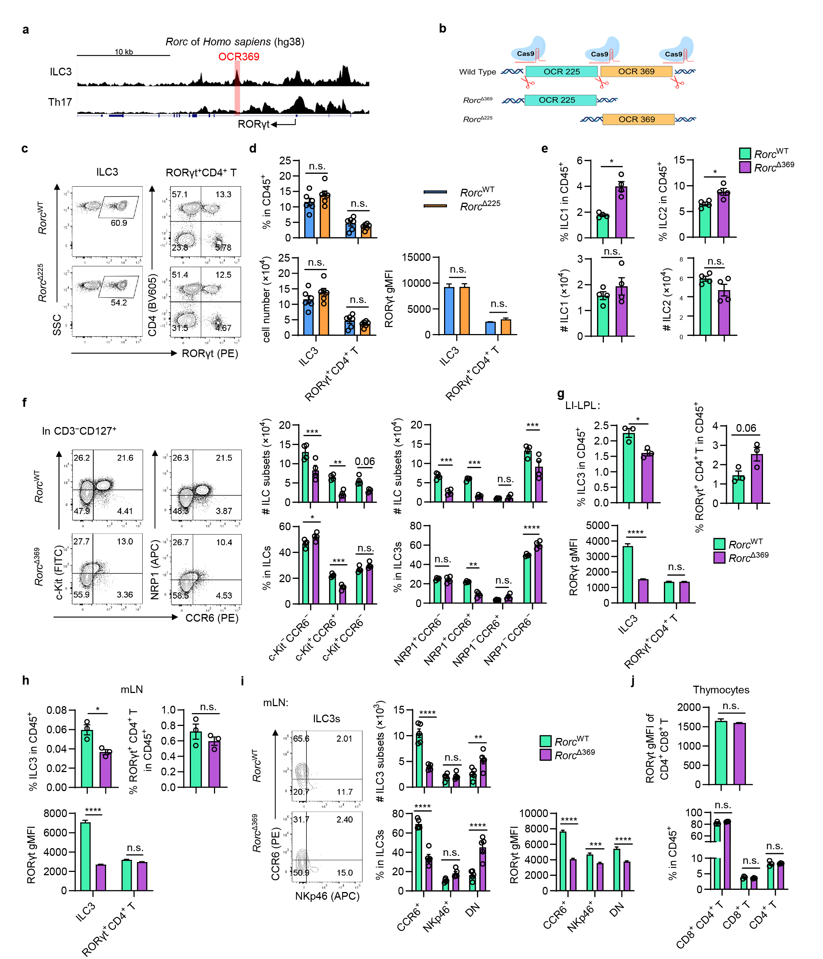
Extended Data Fig. 1| OCR369-deficient mice showed decreased ILC3s in colon and mLN.
a, Chromatin accessibility at the Rorc locus in human ILC3 and Th17 cells was analyzed with the Cistrom database (cistrome.org/db/). Conserved OCR369 in human was identified using the VISTA tool (genome.lbl.gov/vista/index.shtml).
b, Schematic design of generating OCR225-deficient (Rorc^{Δ225}) and OCR369-deficient (Rorc^{Δ369}) mice with the CRISPR-Cas9 system. A common gRNA (between OCR225 and OCR369) was used for the genomic editing.
c and d, Flow cytometry analysis of ILC3s and RORγt⁺CD4⁺ T cells in the SI-LPL of control and Rorc^{Δ225} mice, n=6. And the expression levels of RORγt were shown.
e, The percentages and absolute numbers of ILC2 (lin–CD127⁺GATA3⁺) and ILC1 (lin–CD127⁺GATA3–RORγt–T-bet⁺) in the small intestine of 6-week-old control and Rorc^{Δ369}mice, n=4.
f, The percentages and absolute numbers of ILC subsets (gated as CD45⁺CD3–CD127⁺) marked by c-Kit, NRP1 and CCR6 in the small intestine of 6-week-old control and Rorc^{Δ369}mice, n=4.
g and h, Proportions and RORγt expression levels of ILC3 and RORγt⁺CD4⁺ T cells in the large intestinal LPL (g) and mLN (h) of adult Rorc^{WT} and Rorc^{Δ369} mice, n=3.
i, The percentages, cell numbers and RORγt expression levels of CCR6⁺, NKp46⁺, and DN ILC3 subsets in mLN of adult mice, n=5.
j, RORγt expression level in the CD4⁺CD8α⁺ thymocytes and proportion of thymocytes in the thymus, n=3.
Data are representative of two (c, f, j, g) or three (e, h, i) independent experiments, the cell proportion and number in (d) were pooled from two independent experiments. Each symbol represents one mouse (d-j). Data were analyzed by two-tailed unpaired Student’s t-tests (d, e, g, h, j) and Two-way ANOVA with multiple comparisons (f and i). Data represent Mean ± SEM; n.s., no significance, *p < 0.05, **p < 0.01, ***p < 0.001, ****p < 0.0001.

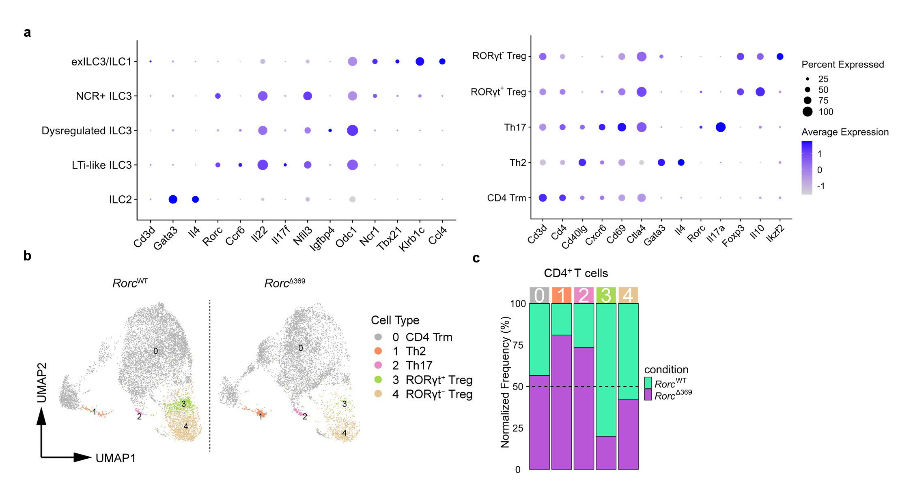
Extended Data Fig. 2 | scRNA-seq analysis on the intestinal ILCs and CD4⁺ T cells of the 6-week-old Rorc^{WT} and Rorc^{Δ369} mice.
ILCs (lin⁻CD90⁺) and CD4⁺ T cells were sorted from the small intestines of 6-week-old Rorc^{WT} and Rorc^{Δ369} mice, 1:1 mixed and analyzed by scRNA-seq.
a, Dot plot showing the expression pattern of representative marker genes in ILC clusters and CD4⁺ T cell clusters.
b, UMAP plot of four CD4⁺ T cell clusters: CD4⁺ Trm, Th2, Th17, RORγt⁺ Treg and RORγt⁻ Treg.
c, Bar graph of cluster frequencies from (b), normalized to total sequenced cells per mouse line.

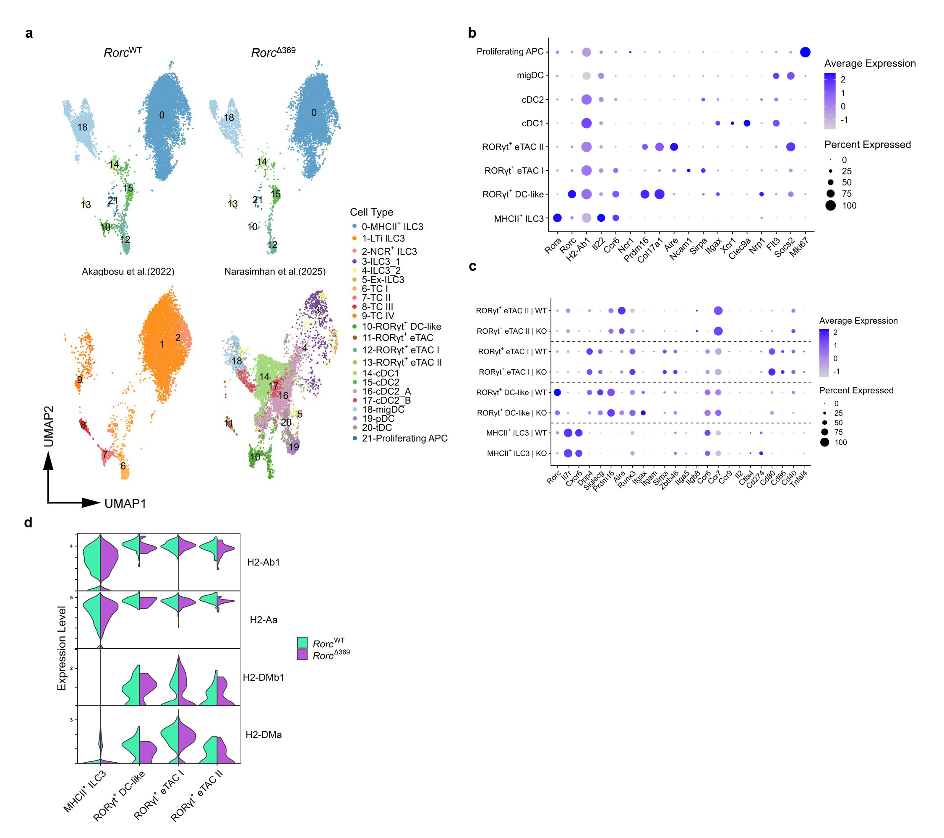
Extended Data Fig. 3 | OCR369 regulates RORγt⁺ APCs in the mLN of P18 mice.
Live CD45⁺lineage–MHCII⁺ cells sorted from the mLNs of P18 Rorc^{WT} (WT) and Rorc^{Δ369} (KO) mice were analyzed by scRNA-seq.
a, UMAP visualization of integrated scRNA-seq data of Figure 2f, g. The scRNA-seq data was integrated analyzed with datasets from Akagbosu et al.⁷ and Narasimhan et al.⁸.
b, Dot plot showing the expression pattern of representative marker genes in the MHCII⁺ APC clusters from the mLN of P18 mice.
c, Dot plot comparing the expression of representative genes in RORγt⁺ APCs between WT and KO mice.
d, Violin plot of MHC class II gene expression in indicated RORγt⁺ APCs.

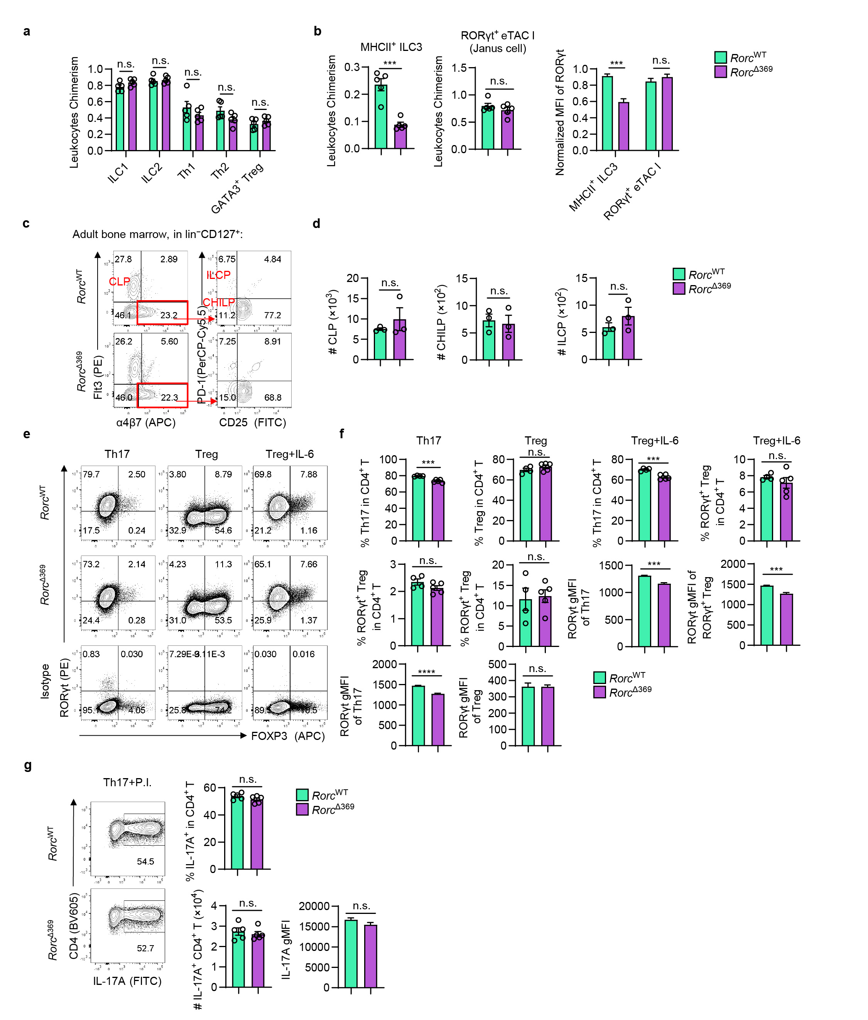
Extended Data Fig. 4 | The intrinsic regulatory effects of OCR369 on ILCs and T cells.
a and b, Mixed bone marrow chimeric mice were generated by transferring CD45.2⁺ Rorc^{WT} or Rorc^{Δ369} 1:1 mixed with CD45.1⁺ bone marrow cell to the CD45.1 recipients as described in Fig. 3a-e.
a, Normalized proportions of CD45.2⁺ cells, including ILC1, ILC2, Th1, Th2 and GATA3⁺ Treg cells, in the SI-LPL of the bone marrow chimera mice, n=5.
b, Normalized proportions of CD45.2⁺MHCII⁺ ILC3 (live Dump– (TCRβ, TCRγδ, B220, Gr-1, Epcam) RORγt⁺MHCII⁺CD45.2⁺CD127⁺CXCR6⁺) and RORγt⁺ eTAC I (Janus cells) (live Dump⁻RORγt⁺MHCII⁺CD45.2⁺CD127⁻CXCR6⁻) and their RORγt expression, normalized by CD45.1⁺ cells, n=5.
c and d, Flow cytometry analysis and absolute numbers of ILC progenitors in the bone marrow of adult mice, ILC progenitors were gated as lin⁻ (CD11b, Gr-1, B220, NK1.1, Ter-119, CD3) CD127⁺, including CLP (Flt3⁺), ILCP (α4β7⁺PD-1⁺) and CHILP (α4β7⁺ PD-1⁻), n=3.
e-g, Flow cytometry analysis of in vitro differentiated Th17 and RORγt⁺ Treg cells from naïve CD4⁺ T cells (sorted as live CD45⁺CD3⁺CD4⁺CD44^{lo}CD62L^{hi}) cultured under Th17, Treg or Treg+IL-6 condition, analyzed at 96 h. f, The cell percentages and RORγt expression levels of differentiated Th17 and RORγt⁺ Treg cells (Rorc^{WT} n=4 and Rorc^{Δ369} n=5). g, IL-17 production by Th17 cells after PMA+Ionomycin (P.I.) stimulation for 4 h (n=5).
Data are representative of three (a, b, e-g) or two (c and d) independent experiments. Each symbol represents one mouse (a, b, d) or technical replicate (f, g). Data were analyzed by two-tailed unpaired Student’s t-tests (a, b, d, f, g) and represent Mean ± SEM; n.s., no significance, *p < 0.05, **p < 0.01, ***p < 0.001, ****p < 0.0001.

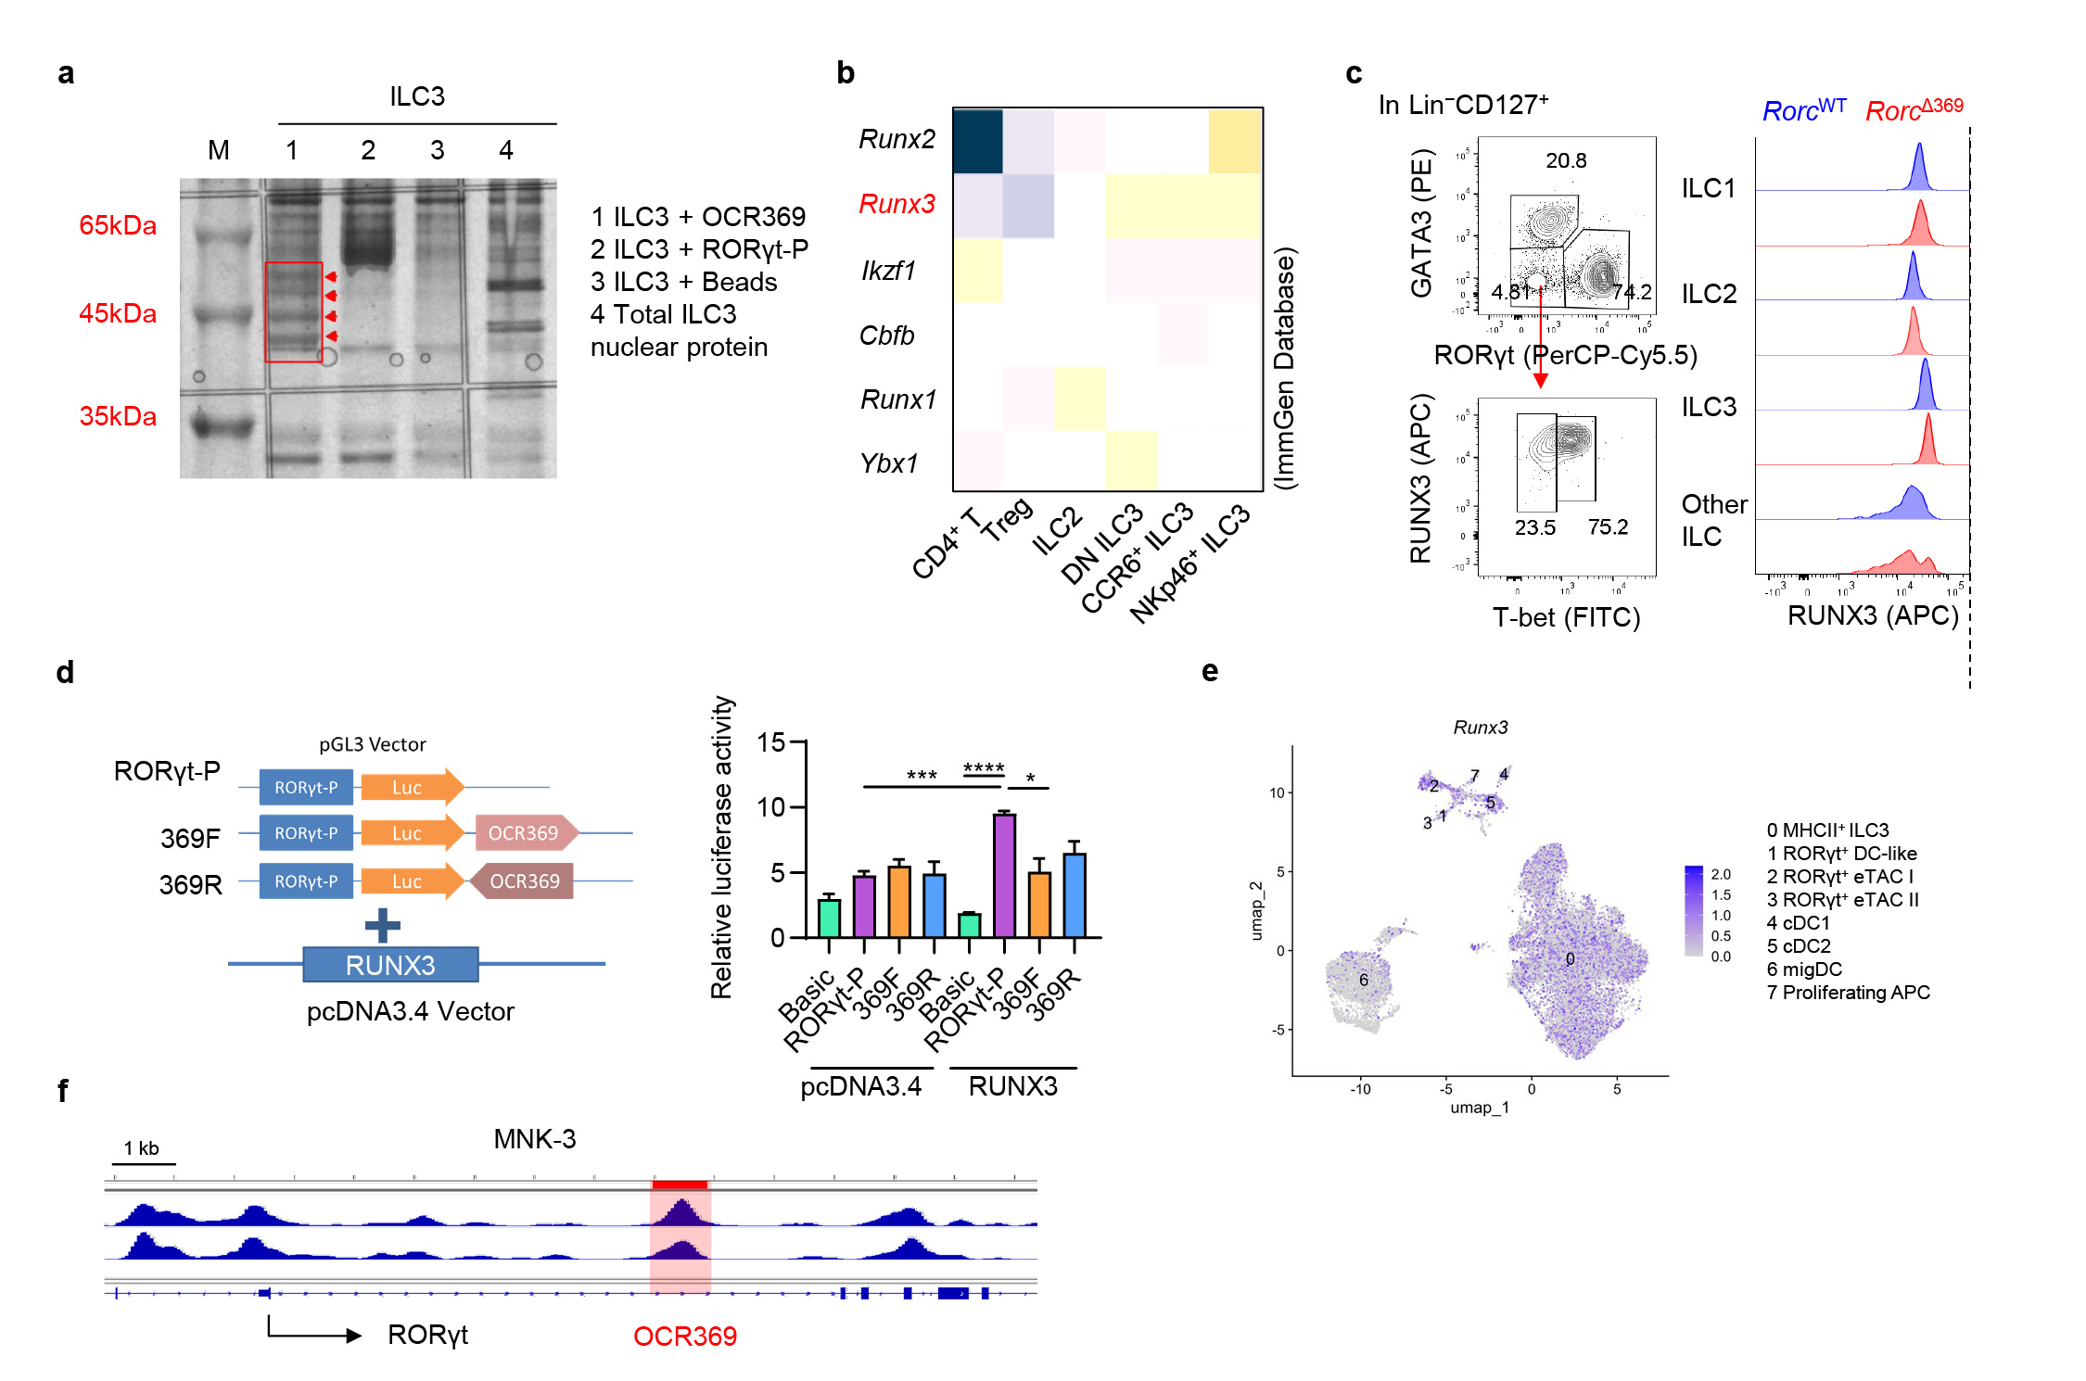
Extended Data Fig. 5 | The expression of RUNX3 in ILCs and RORγt⁺ APCs.
a, 1×10⁶ ILC3s were sorted from small intestine, and nuclear proteins were extracted and pull-downed by OCR369-binded beads. Silver staining of DNA-pulldown proteins on a PAGE gel. The bands specifically interacted with OCR369 (marked in red) were collected for Mass Spectrometry identification.
b, Expression levels of candidate transcription factors (TFs) and RUNX family members in T cells and ILCs from ImmGen database (immgen.org).
c, Flow cytometry analysis of RUNX3 expression in intestinal lin⁻CD127⁺ ILCs, including ILC1 (GATA3⁻RORγt⁻T-bet⁺), ILC2 (GATA3⁺), ILC3 (RORγt⁺) and other ILCs (GATA3⁻RORγt⁻T-bet⁻).
d, Schematic design of dual luciferase reporter assay in HEK-293T cells. The relative positions of the RORγt promoter (~500 bp around TSS), luciferase gene (Luc), and OCR369 (369F and 369R (3’-5’ reversed sequence of OCR369)) are shown. pGL3 vectors were co-transfected with RUNX3-pcDNA3.4 or control vectors, and luciferase activity was analyzed after 24 h. Relative luciferase activity was calculated as (Firefly luciferase activity)/(Renilla luciferase activity). Each dot represents one well, n=3.
e, The scRNA-seq analysis (from Fig. 2) showed the expression of Runx3 in lin⁻MHCII⁺ APCs isolated from the mLNs of P18 mice.
f, ATAC-seq visualization results for MNK-3 cell lines form GSE191312.
Data are representative of two (a, c) or three independent experiments (d). Data were analyzed by one-way ANOVA, and two-tailed unpaired Student’s t-tests were used to compare indicated groups (d); represent Mean ± SEM; *p < 0.05, ***p < 0.001, ****p < 0.0001.
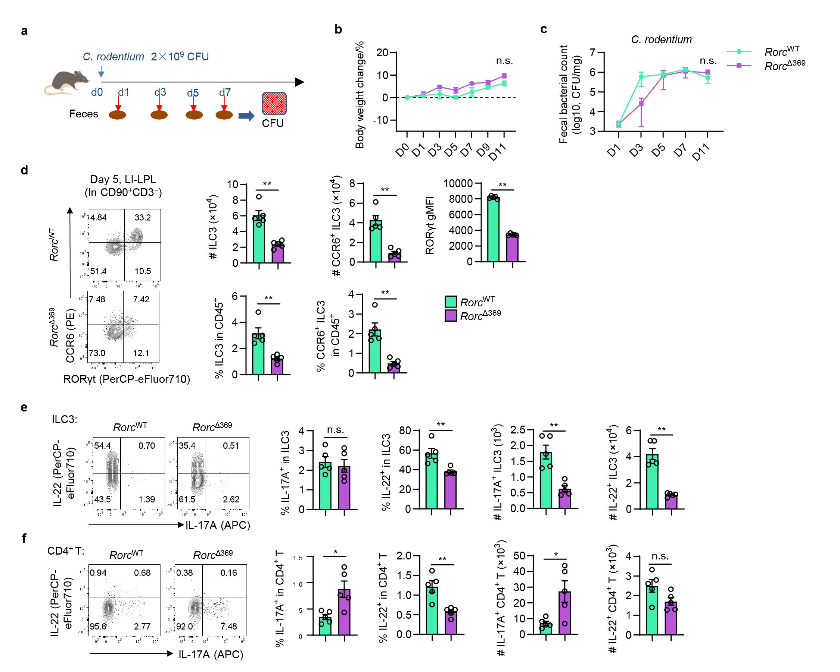
Extended Data Fig. 6 | OCR369 is not necessary for host protection against C. rodentium infection.
a, Schematic design of C. rodentium infection in mice. Mice were infected with 2×10⁹ CFU of C. rodentium by oral gavage, and the body weight changes and fecal bacterial loads were analyzed.
b and c, The body weight change and fecal C. rodentium load were monitored every other day (n=4).
d, Flow cytometry analysis of colonic ILC3s (gated in CD3–CD90⁺) and CCR6⁺ ILC3s at Day 5, n=5.
e and f, Flow cytometry analysis of cytokine production by colonic ILC3s (gated as CD3–CD90⁺ RORγt⁺) and CD4⁺ T cells (gated as CD3⁺CD4⁺), n=5.
Data are representative of three independent experiments (b-f) and each symbol represents one mouse (d-f). Data were analyzed by two-tailed unpaired Student’s t-tests (d-f) and Two-way ANOVA with multiple comparisons (b and c). Data represent Mean ± SEM; n.s., no significance, *p < 0.05, **p < 0.01, ***p < 0.001, ****p < 0.0001.

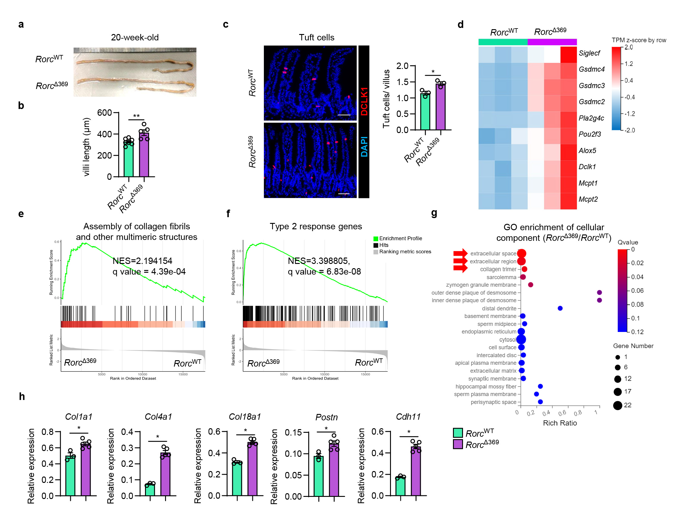
Extended Data Fig. 7 | OCR369-deficient mice developed spontaneous small intestinal inflammation.
a, Representative images of small intestines from 20-week-old Rorc^{WT} and Rorc^{Δ369} littermates.
b, Villi length of small intestine of 20-week-old Rorc^{WT} (n=7) and Rorc^{Δ369} (n=5) littermates analyzed by H.E. staining.
c, Representative immunofluorescence staining results of DCLK1⁺ tuft cells (red) in the small intestine of 20-week-old Rorc^{WT} and Rorc^{Δ369} littermates (n=3, scale bar = 50 μm).
d-g, Bulk RNA-seq analysis of small intestine tissues from 20-week-old Rorc^{WT} and Rorc^{Δ369} littermates (n=3). d, Heatmap of representative type 2 response Differentially Expressed Genes (DEGs) (Fold change >1, Q-value < 0.05). e and f, GSEA enrichment results on Assembly of collagen fibrils and other multimeric structures and type 2 response gene sets. g, GO enrichment of cellular component. Red arrows indicate pathways related to the extracellular matrix.
h, RT-qPCR confirmation results of genes relative to collagen deposition (Rorc^{WT} n=7) and (Rorc^{Δ369} n=5).
Data are representative of at least two independent experiments (a-c, h). Each symbol represents one mouse (b, c, h). Data were analyzed by two-tailed unpaired Student’s t-tests (b, c, h) and represent Mean ± SEM; n.s., no significance, *p < 0.05, **p < 0.01, ***p < 0.001, ****p < 0.0001.

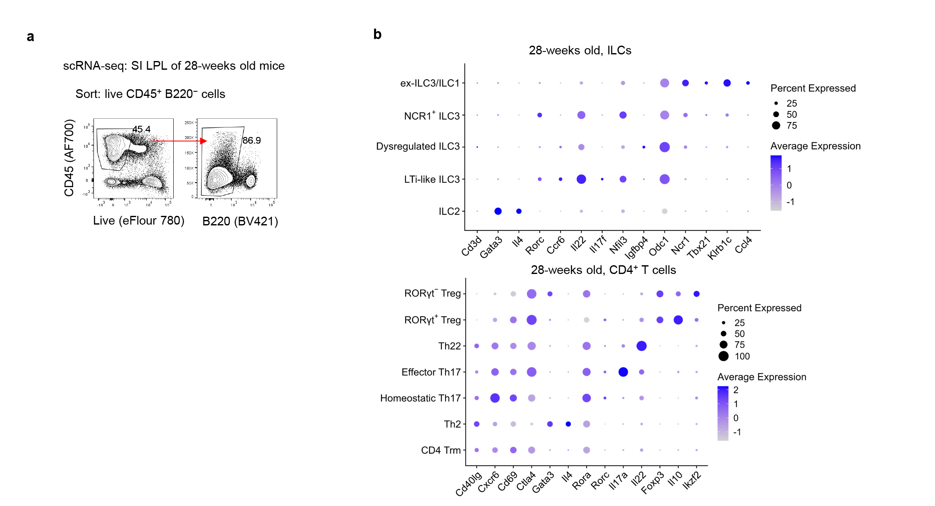
Extended Data Fig. 8 | ScRNA-seq on the small intestinal immune cells of 28-week-old Rorc^{WT} and Rorc^{Δ369} mice.
a and b, Sc-RNA-seq on Live CD45⁺ B220⁻ immune cells sorted from SI-LPL of 28-week-old Rorc^{WT} and Rorc^{Δ369} mice. a, Gating strategy of sorting Live CD45⁺ B220⁻ immune cells. b, Among the immune cell clusters, five ILC clusters and seven CD4⁺ T cell clusters were identified, and dot plots of the expression pattern of representative marker genes are shown.

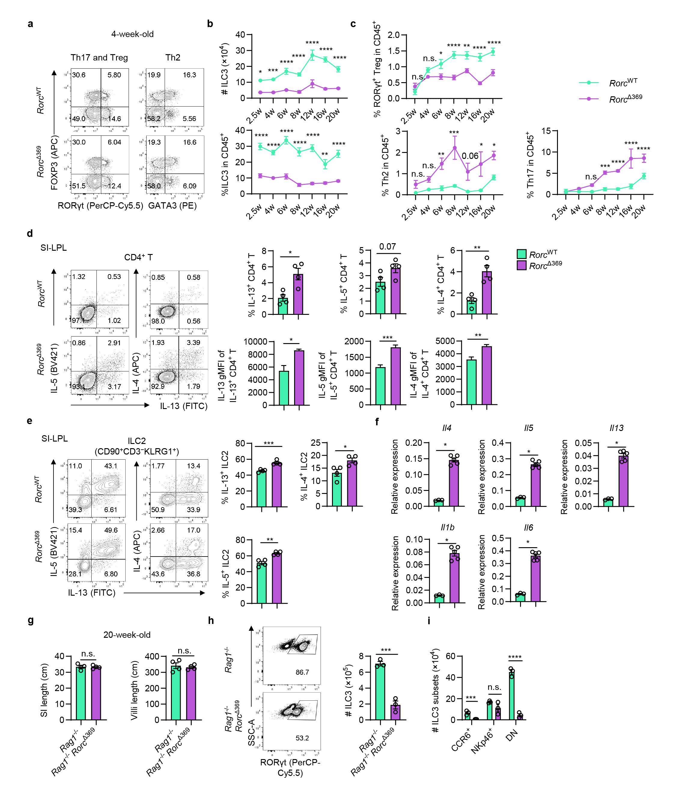
Extended Data Fig.9 | OCR369-deficient mice exhibited imbalanced Th/Treg in the small intestine.
a-c, Kinetic changes of small intestinal Th cells and ILC3s at different ages in Rorc^{Δ369} and control mice. a, Representative flow cytometry result of RORγt⁺ Treg, Th17 and Th2 in 4-week-old mice. b, Absolute numbers and proportions of ILC3 (CD90⁺CD3⁻) at different ages. c, Proportions of the small intestinal RORγt⁺ Treg, Th17 and Th2 as showed in Fig. 5j. 2.5 w, n=6; 4 w, n=5; 6 w, Rorc^{WT} n=4 and Rorc^{Δ369} n=5; 8 w and 12 w, Rorc^{WT} n=5 and Rorc^{Δ369} n=4; 16 w, Rorc^{WT} n=4 and Rorc^{Δ369} n=3; 20 w, Rorc^{WT} n=5 and Rorc^{Δ369} n=5.
d and e, Flow cytometry analysis of IL-13, IL-5 and IL-4 production by CD4⁺ T cells and ILC2 (CD90⁺ CD3⁻KLRG1⁺) of elder mice (>20-week-old, n=4) after ex vivo P.I. stimulation for 4h.
f, RT-qPCR analysis of inflammatory cytokines in the small intestine tissue of the mice over 20-week-old, Rorc^{WT} n=3 and Rorc^{Δ369} n=5.
g, Length of small intestine and intestinal villi in the 20-week-old Rag1^{−/−} and Rag1^{−/−} Rorc^{Δ369}mice, n=4.
h and i, Flow cytometry analysis on the cell number of ILC3 and ILC3 subsets in the small intestine of 7-week-old mice, n=3.
Data are representative of at least two independent experiments (d-i). Each symbol represents one mouse (b, c, d, e, h). Data were analyzed by Two-way ANOVA with multiple comparisons (b, c, i) and two-tailed unpaired Student’s t-tests (d-h) and represent Mean ± SEM; n.s., no significance, *p < 0.05, **p < 0.01, ***p < 0.001, ****p < 0.0001.

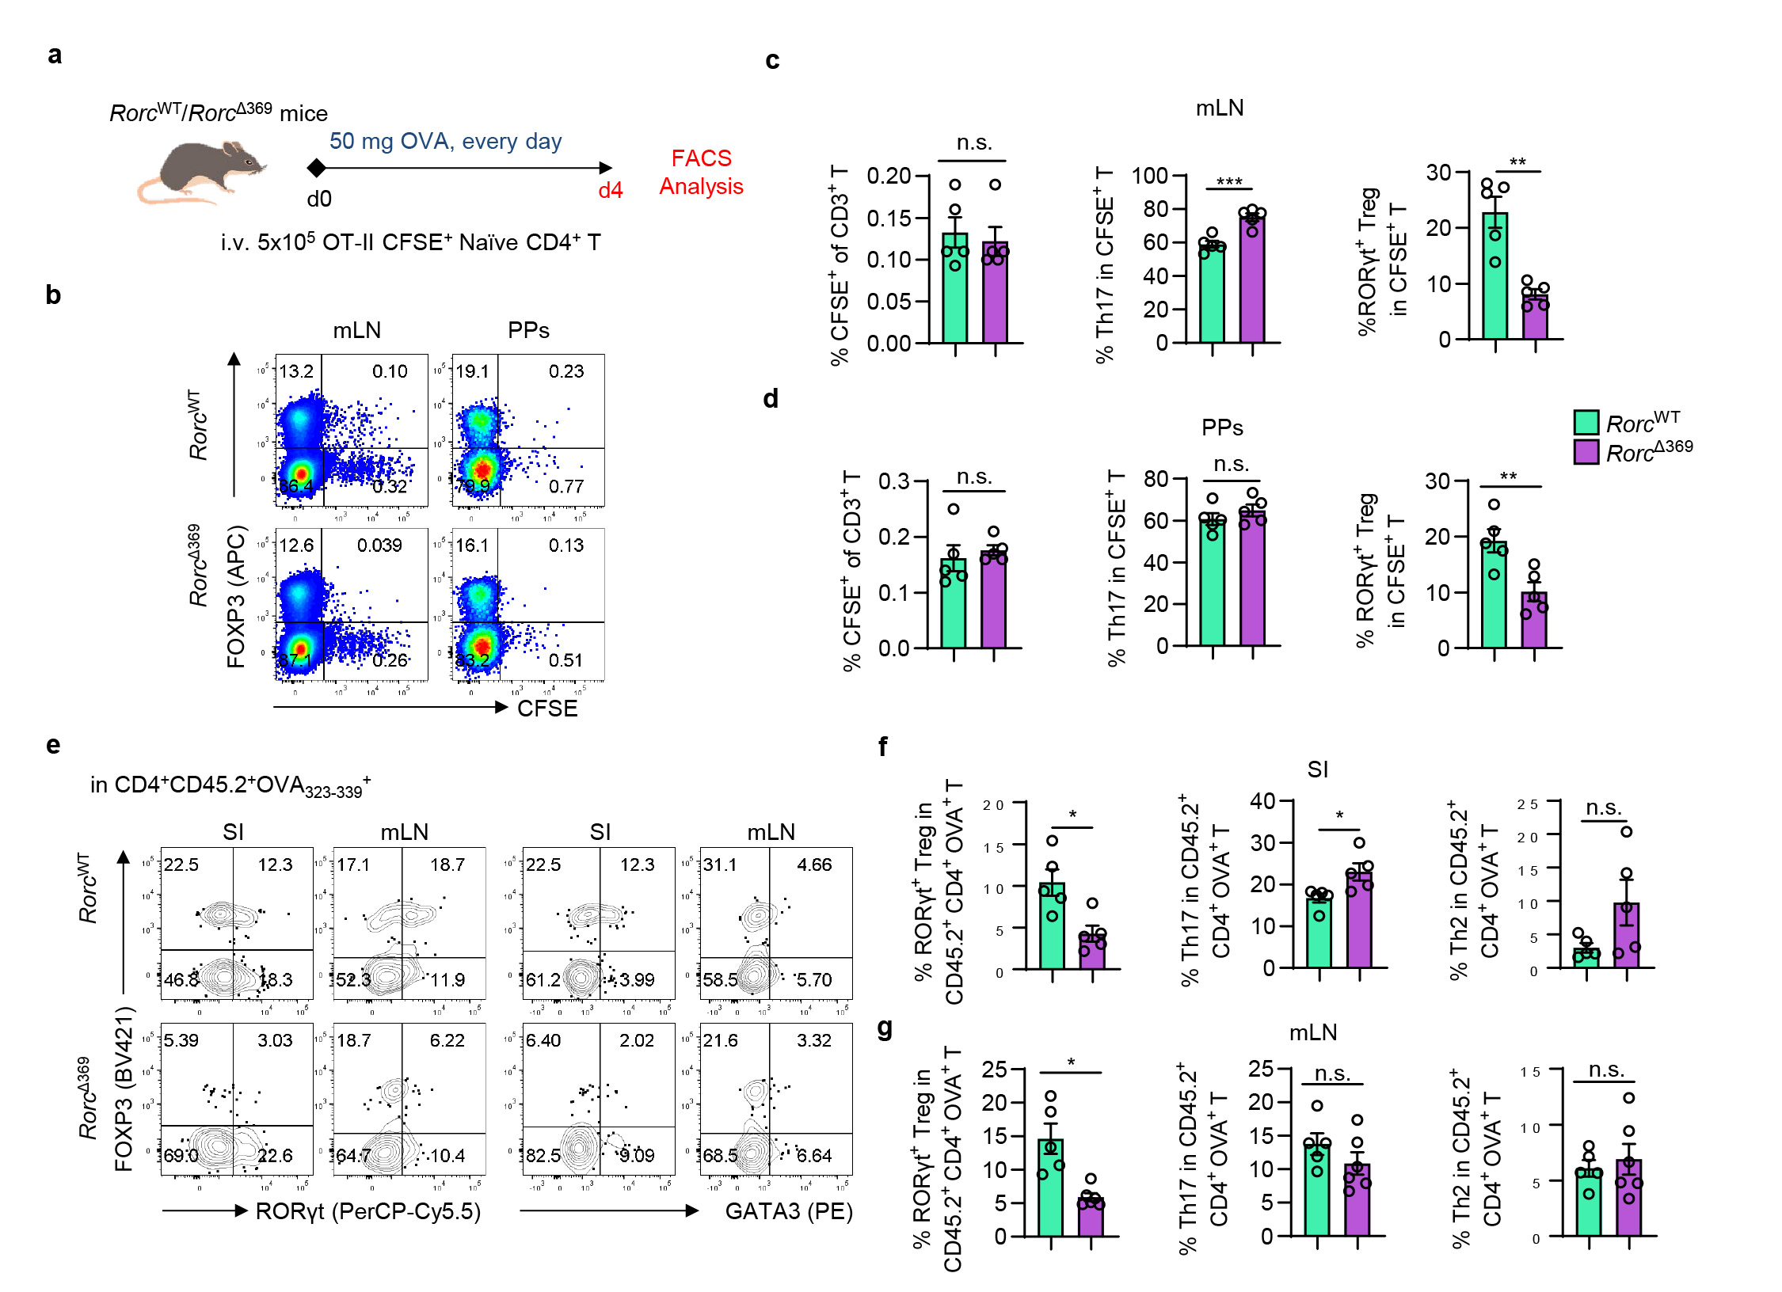
Extended Data Fig. 10 | OCR369-dependent RORγt⁺ APCs regulate Treg differentiation in response to dietary antigen.
a, Schematic design of transferring CFSE-labeled naïve CD4⁺ OT-II T cells to the Rorc^{Δ369}or Rorc^{WT} mice, followed by oral OVA treatment for four days. b-d, Flow cytometry analysis of the proportions of CFSE⁺ OT-II RORγt⁺ Treg and Th17 cells in the mLN (b, c) and PPs (b, d), n=5.
e-g, Rorc^{Δ369}or Rorc^{WT} mice were transferred with naïve CD45.1⁺CD4⁺ OT-II T cells, followed by oral OVA treatment for 7 days as shown in Fig. 6e. Endogenous OVA-specific CD45.2⁺ T cells marked by OVA₃₂₃₋₃₃₉ –tetramer (CD4⁺ CD45.2⁺ OVA₃₂₃₋₃₃₉⁺) in the SI and mLN were analyzed by flow cytometry, n=5.
Data are representative of two independent experiments (b-g). Each symbol represents one mouse (c,d,f,g). Data were analyzed by two-tailed unpaired Student’s t-tests (c,d,f,g) and represent Mean ± SEM; n.s., no significance, *p < 0.05, **p < 0.01, ***p < 0.001.

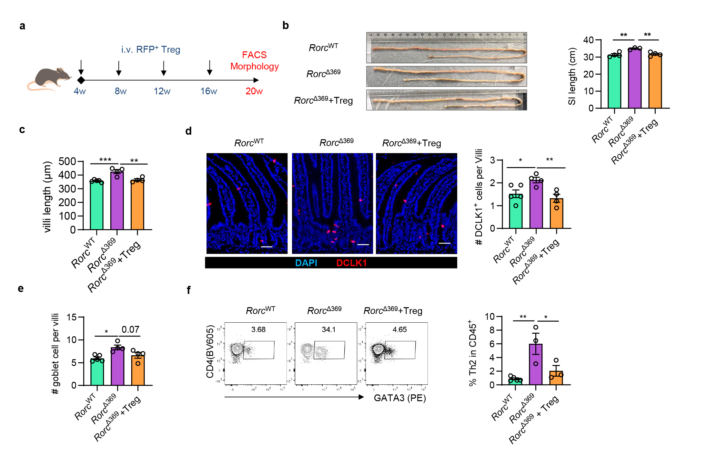
Extended Data Fig. 11 | Tregs transfer rescued intestinal inflammation in OCR369-deficient mice.
a-f, Rorc^{WT}/ Rorc^{Δ369} mice were transferred with ~ 5×10⁵ FOXP3-RFP⁺ Treg cells every 4 weeks started from 4-week-old, then sacrificed for histology analysis and flow cytometry at 20-weeks old, Rorc^{WT} n=5, Rorc^{Δ369} n=4 and Rorc^{Δ369}+Treg n=4. b, Representative images of small intestine and statistic result of small intestine length. c, Statistic summary of villi length from H&E staining. d, Average cell counts of DCLK1⁺ tuft cells of each villi/crypt unit, Scale bar = 50 μm. e, average goblet cell number of each villus from AB-PAS staining. f, Percentage of Th2 (CD4⁺ FOXP3⁻ GATA3⁺) cells in the SI-LPL, one plot of Rorc^{Δ369} and Rorc^{Δ369}+Treg group was excluded due to failure of LPL isolation.
Data are representative of two independent experiments (b-f), and each symbol represents one mouse (b-f). Data were analyzed by ordinary one-way ANOVA with Tunkey’s multiple comparisons test (b-f) and represent Mean ± SEM; n.s., no significance, *p < 0.05, **p < 0.01, ***p < 0.001, ****p < 0.0001.

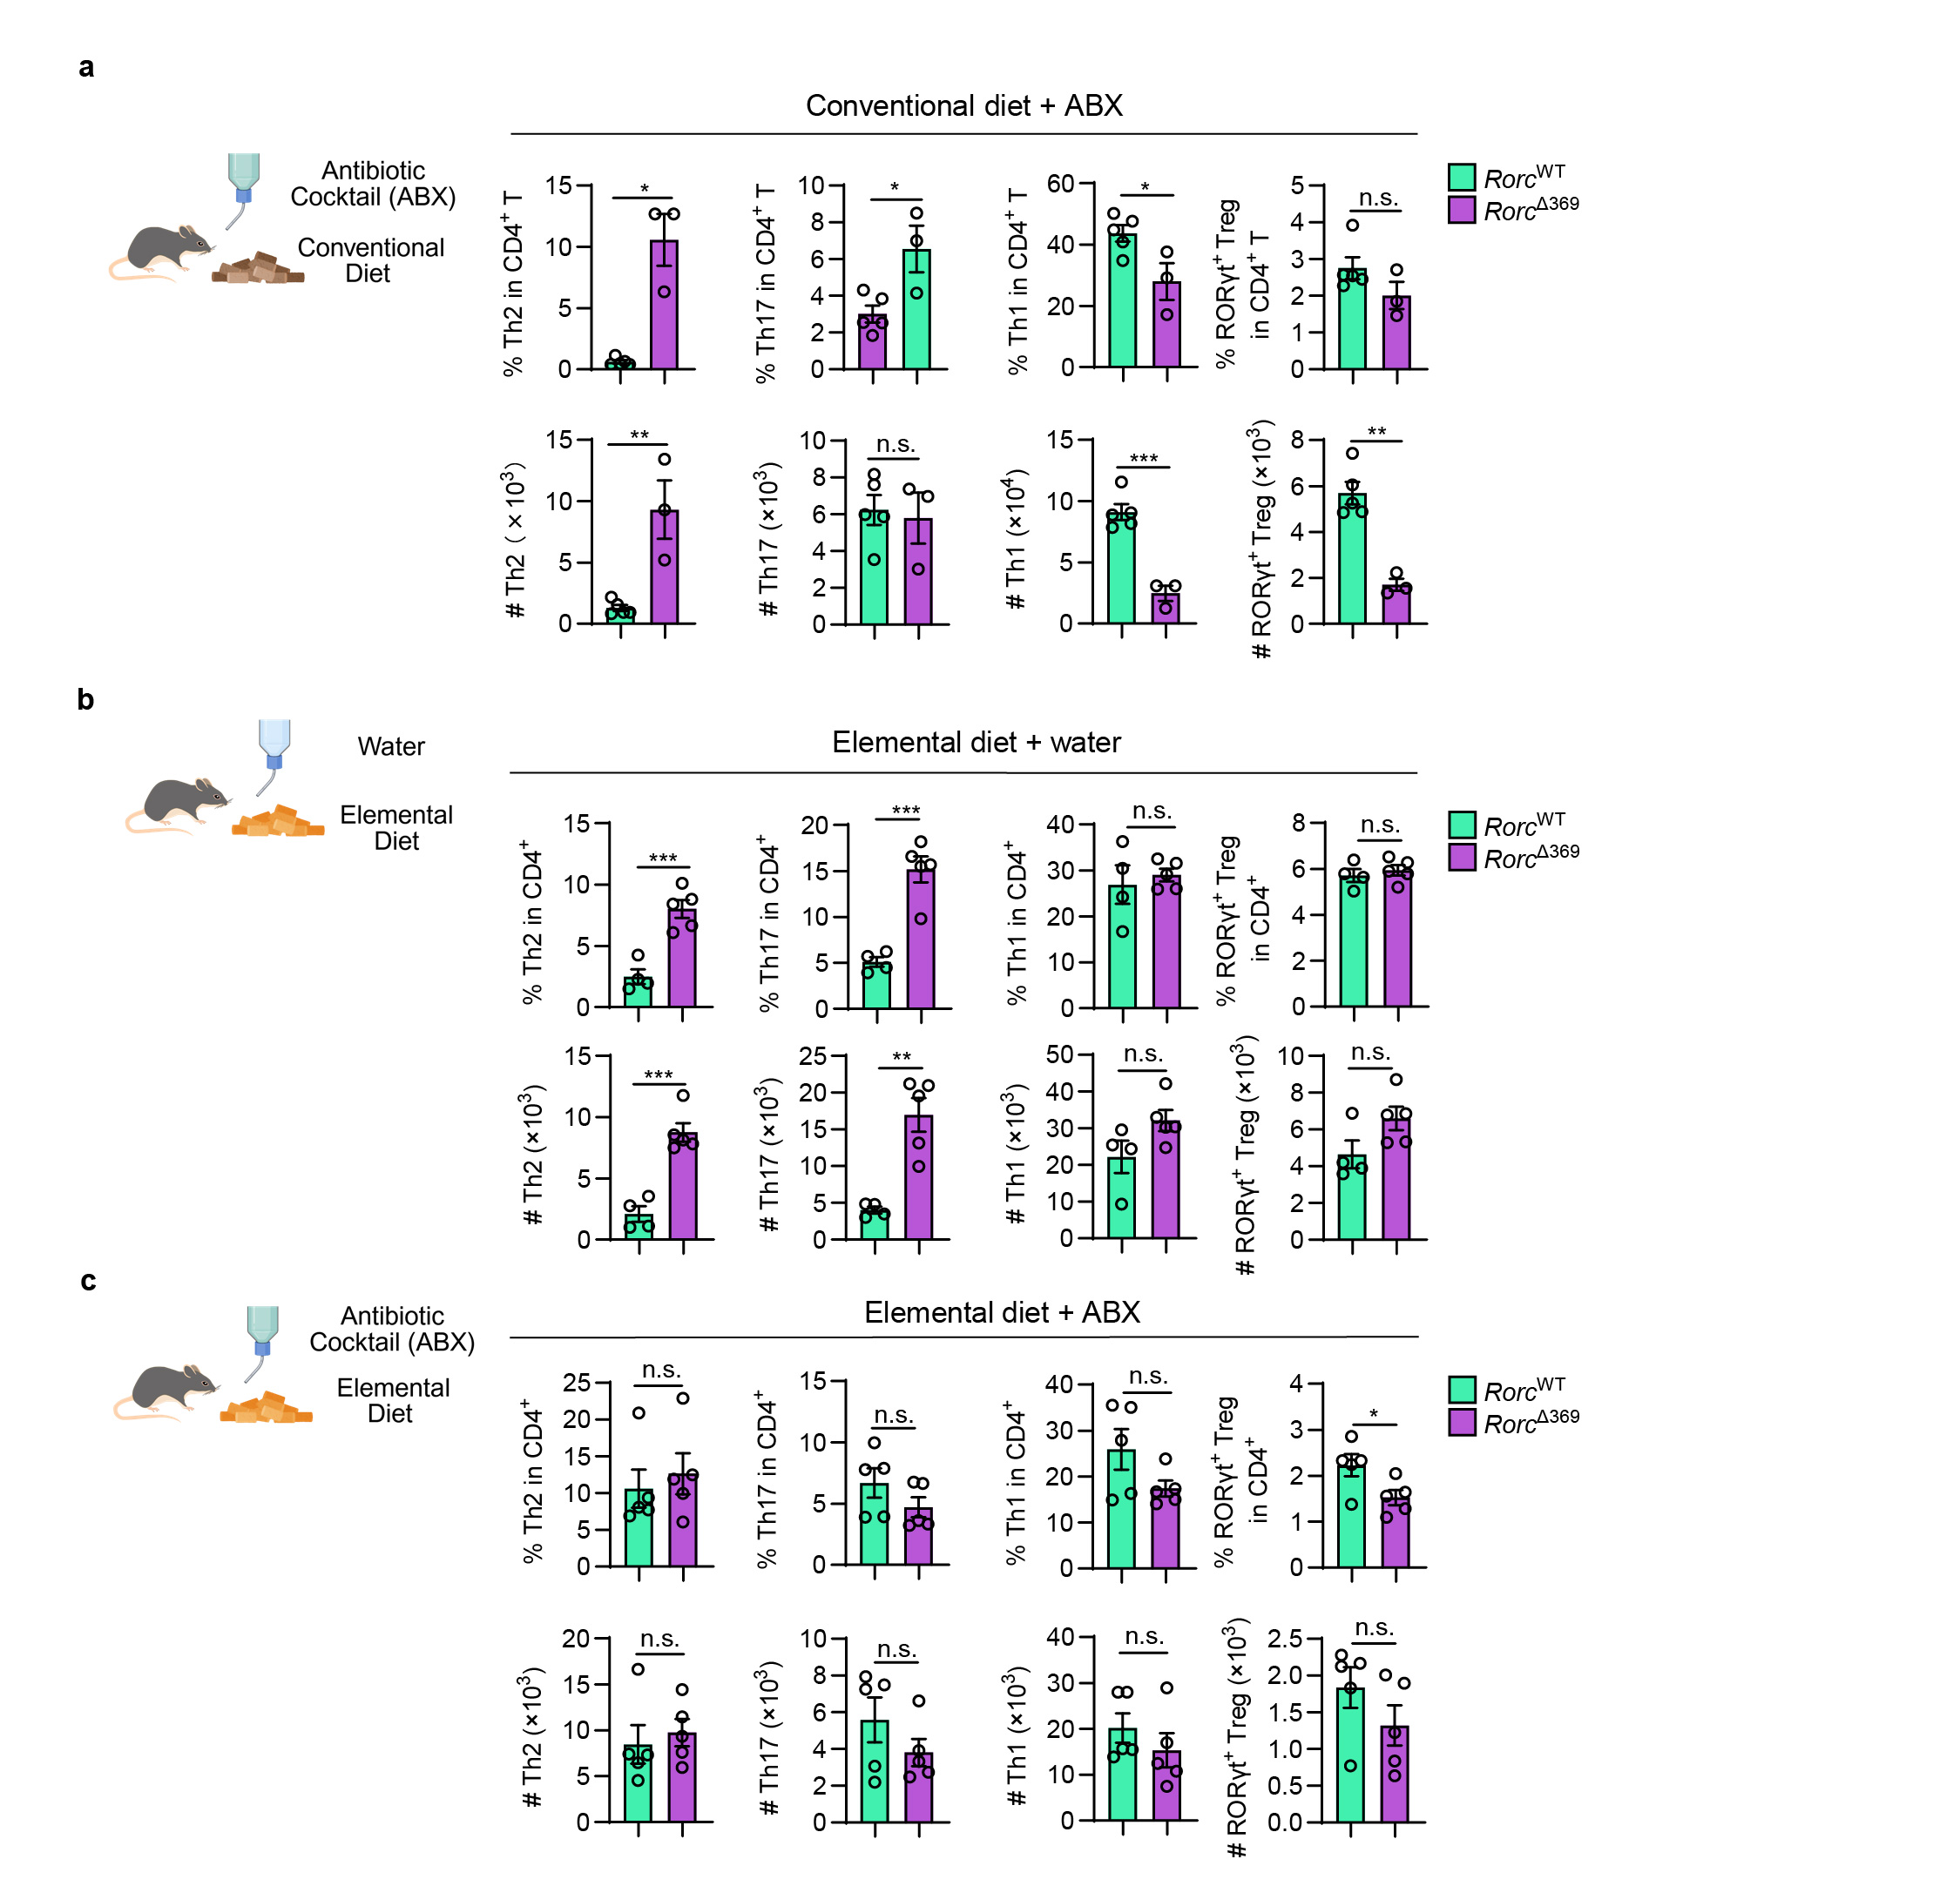
Extended Data Fig. 12 | OCR369-dependent RORγt⁺ APCs regulating Th and Treg cells is dependent on dietary and microbiota antigens.
a, Mice were administrated with antibiotic cocktail (ABX) drinking water after weaning at 3-week-old until 8-week-old, and the proportions and numbers of small intestinal Th and RORγt⁺ Treg were analyzed by flow cytometry, Rorc^{WT} n=5 and Rorc^{Δ369} n=3.
b, Mice were administrated with protein-free elemental diet since born, and the proportions and numbers of small intestinal Th and RORγt⁺ Treg were analyzed by flow cytometry at 8 weeks old, Rorc^{WT} n=4 and Rorc^{Δ369} n=5.
c, Mice were administrated with protein-free elemental diet since born and treated with ABX drinking water after weaning, and the proportions and numbers of small intestinal Th and RORγt⁺ Treg were analyzed by flow cytometry at 8 weeks old, n=5 per group.
Data are representative of two independent experiments (a-c), and each symbol represents one mouse (a-c). Data were analyzed by two-tailed unpaired Student’s t-tests (a-c) and represent Mean ± SEM; n.s., no significance, *p < 0.05, **p < 0.01, ***p < 0.001.
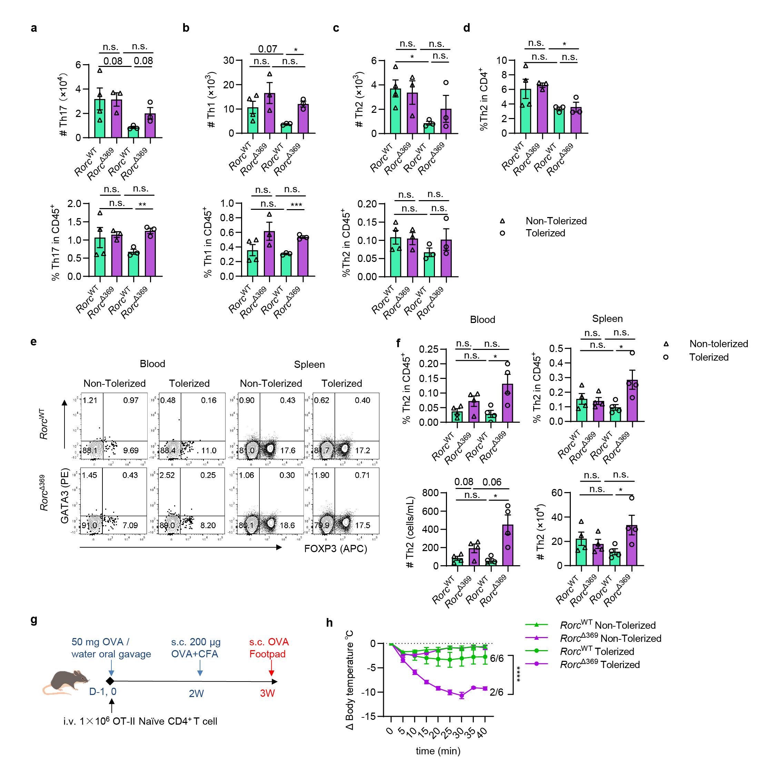
Extended Data Fig. 13 | OCR369-deficient mice exhibit impaired oral tolerance.
a-f, 8-week-old mice were pre-treated with OVA orally twice to generate tolerance for the DTH model (OVA-DTH), then challenged by OVA injection at foot pad at 3 weeks and analyzed after 72 h as showed in Fig. 7a. a-d, Absolute numbers and percentages of Th17, Th1 and Th2 cells (gated in CD3⁺CD4⁺FOXP3⁻) in the draining popliteal lymph nodes of challenged side as showed in Fig. 7f and g, Non-Tolerized Rorc^{WT} (n=4) and Rorc^{Δ369} (n=3); Tolerized Rorc^{WT} (n=3) and Rorc^{Δ369} (n=3). e and f, Absolute numbers and percentages in CD45⁺ immune cells of Th2 (FOXP3⁻GATA3⁺) cells in peripheral blood and spleen, n=4.
g, Schematic design of the modified OVA-DTH model. 8-week-old mice were transferred with naïve CD4⁺ OT-II T cells and pre-treated with OVA orally twice to generate tolerance for the DTH model (OVA-DTH), then challenged by OVA injection at foot pad at 3 weeks and analyzed.
h, Body temperature changes after OVA challenge in the footpad, four of six “tolerized” Rorc^{Δ369} mice died within 30 min after the challenge, Rorc^{Δ369} (n=5) or Rorc^{WT} (n=6) for each group.
Data are representative of two independent experiments (a-h), and each symbol represents one mouse (a-d, f). Data were analyzed by Two-way ANOVA with multiple comparisons (h) and two-tailed unpaired Student’s t-tests on indicated groups (a-d, f) and represent Mean ± SEM; n.s., no significance, *p < 0.05, **p < 0.01, ***p < 0.001, ****p < 0.0001.

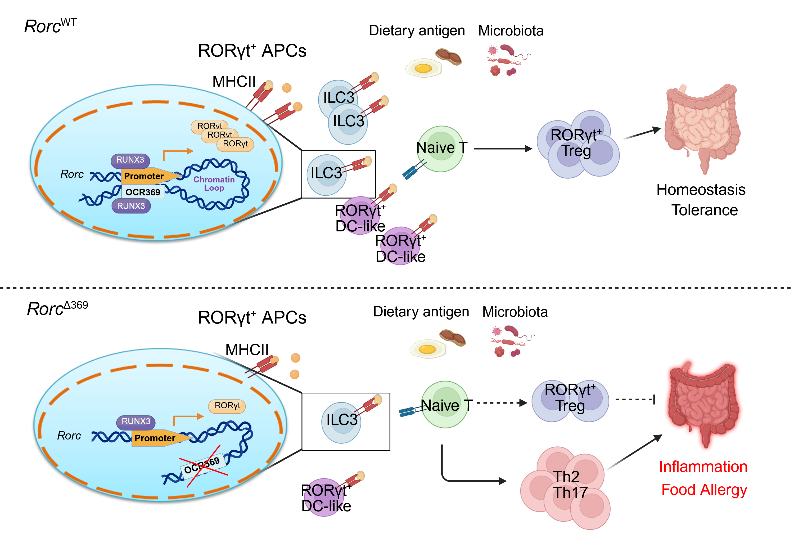
Extended Data Fig. 14 | OCR369 is required for RORγt⁺ APCs to regulate RORγt⁺ Treg development and tolerance in the intestine.
Schematic summary of this article. Here we identified a distinct cis-regulatory element, OCR369, that specifically regulates RORγt expression in ILC3s and RORγt⁺ DC-like cells, but not T cells, through interacting with RUNX3 and participating in forming chromatin loops. OCR369-dependent RORγt⁺ APCs is required for intestinal RORγt⁺ Tregs differentiation in response to dietary and microbiota antigens. Impaired RORγt⁺ APCs by the OCR369 deletion leads to a spontaneous small intestinal inflammation and increased food allergy susceptibility.

Supplementary Table 1.
Differentially expressed genes of ILC and CD4⁺ T subsets from the small intestinal lamina propria of 6-week-old control and Rorc^{Δ369} mice.

Supplementary Table 2.
Differentially expressed genes of antigen presenting cells from the mLN of P18 control and Rorc^{Δ369} mice.

Supplementary Table 3.
Mass spectrometry identified nuclear factors that binds to OCR369 DNA.

Supplementary Table 4.
TFBS prediction results of OCR369 on JASPAR database.

Supplementary Table 5
Bulk RNA-seq results of DEGs readcounts on 20-week-old Rorc^{Δ369} and control littermate mice.

Supplementary Table 6.
GSEA enrichment results on the RNA-seq results of 20-week-old mice.

Supplementary Table 7
Differentially expressed genes of ILC and CD4⁺ T subsets from the small intestinal lamina propria of 28-week-old control and Rorc^{Δ369} mice.

Supplementary Table 8
Primer list of qPCR, PCR and CRISPR in this article.

