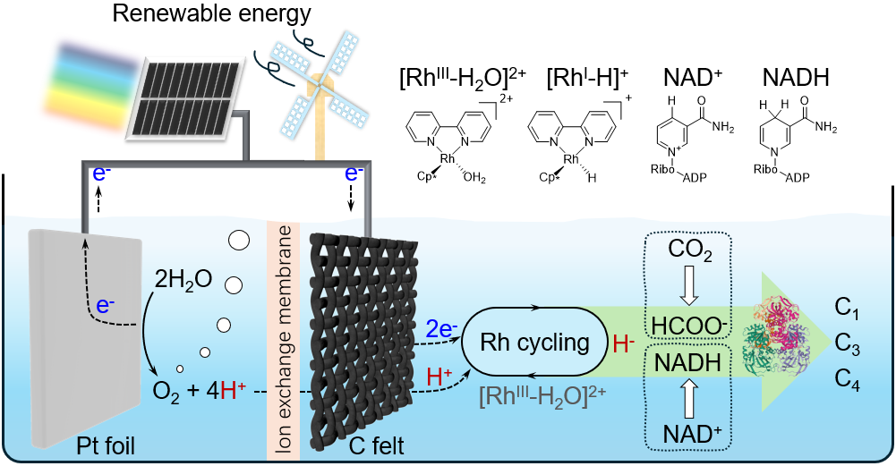
Scheme 1. Bifunctional Rh^{III}-complex catalyzed CO₂ reduction and NADH regeneration for direct bioelectrochemical synthesis of C₂₊ products.

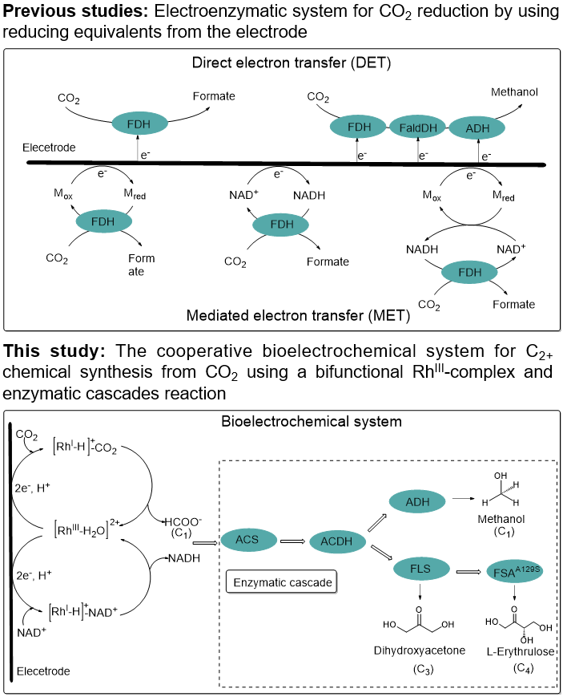
Scheme 2. Overview of previous studies and this study. Different bioelectrochemical systems for CO₂ reduction to value-added chemicals.
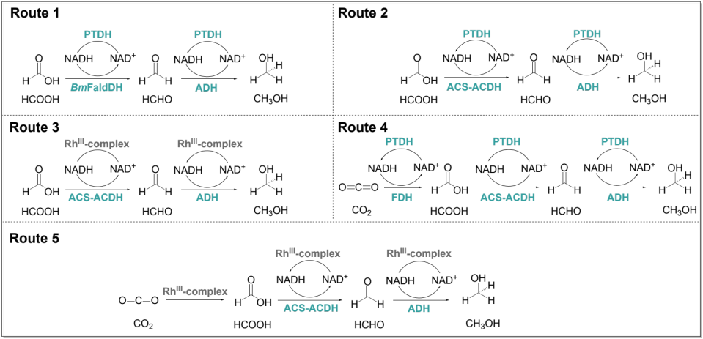
Scheme 3. The schematic of different enzymatic or bioelectrochemical pathways for the conversion of CO₂ into methanol. Unless specified, the reactions were conducted with 1% EMIM-Ac as a cosolvent.
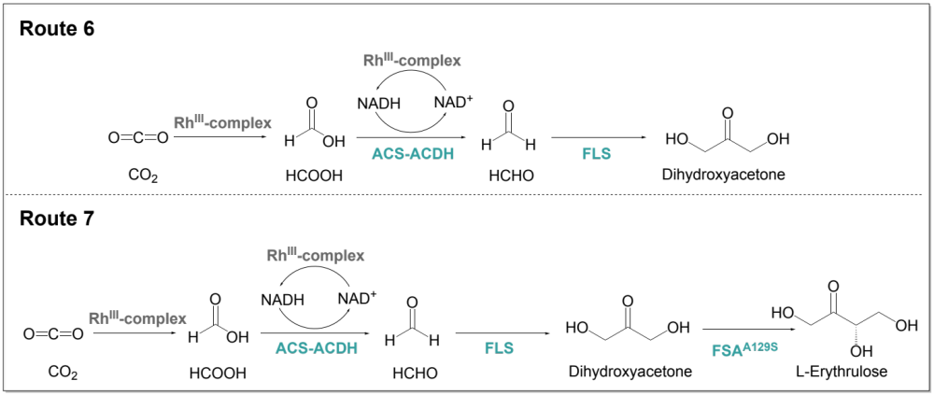
Scheme 4. The schematic of one-pot cooperative bioelectrochemical system for synthesizing DHA and L-erythrulose from CO₂.

