Supplementary Information for
Filming nanodroplet running and jetting mediated by nanoscale solid-gas
and solid-liquid interface

Linfeng Xu¹, Zetan Cao¹, Zhiwen Liu¹, Cheng Zheng¹, Simin Peng¹, Yong Lu¹ and Bin Chen^{1,2}*

¹Center for Ultrafast Science and Technology, School of Chemistry and Chemical Engineering, and School of Physics and Astronomy, Shanghai Jiao Tong University, Shanghai 200240, China
²Zhangjiang Institute for Advanced Study, Shanghai Jiao Tong University, Shanghai 201203, China

E-mail: cbcce@sjtu.edu.cn

Contents
Supplementary Figure 1. Structural evolution of HgS NC in gas cell during the broken process.
Supplementary Figure 2. Time-dependent TEM images of the structural dynamics in liquid cell.
Supplementary Figure 3. Time-dependent TEM images of the formation of large voids in liquid cell.
Supplementary Figure 4. The relationship between the ink-jetting starting time and the dose rate.
Supplementary Figure 5. Excitation of multiple HgS NCs in the liquid environment.
Supplementary Figure 6. Elemental analysis of Hg and S as a function of the dose rate.
Supplementary Figure 7. Schematic of electron range R_{e} under the e-beam excitation of HgS NC.
Supplementary Figure 8. The ratchet effect on the movement of Hg nanodroplets.
Supplementary Figure 9. Obvious bubbles observed in the liquid cell.
Supplementary Figure 10. Ex-situ control experiments with the addition of Co²⁺ or H₂O₂ into the HgS dispersion.
Supplementary Table 1. Parameters for calculating the carrier pair generation rate.
Supplementary Table 2. The relevant parameters used for the calculation of the penetration depth in HgS system.
Supplementary Table 3. Power law parameters α_{i} and β_{i} for calculating the Steady-state concentration of radiolysis species.
Supplementary Table 4. Parameters for calculating the radiation dose rate in liquid cell.
Supplementary Table 5. Estimated steady-state concentration of the common radiolysis species
in liquid cell.
Supplementary Table 6. Standard redox potentials of major radiolysis species generated by the e-beam irradiation.
Supplementary Movie 1. In-situ TEM observation of the nucleation and growth dynamics of voids and Hg nanodroplets in the gas cell under a dose rate of ~3240 e/Å²·s from 0 to 1150 s and a dose rate of ~7350 e/Å²·s from 1150 to 1250 s. Movie at twenty-fold acceleration (20 ×)
Supplementary Movie 2. In-situ video of the coalescence process of the voids in the gas cell under a dose rate of ~1790 e/Å²·s. Movie at nine-fold acceleration (9 ×).
Supplementary Movie 3. In-situ TEM observation of the coalescence behavior of the Hg nanodroplets in the gas cell under a dose rate of ~2830 e/Å²·s. Movie at nine-fold acceleration (9 ×).
Supplementary Movie 4. In-situ TEM observation of the ink-jetting events in the liquid cell under a dose rate of ~5200 e/Å²·s. Movie at nine-fold acceleration (9 ×).
Supplementary Movie 5. In-situ video of the ink-jetting behavior in the liquid cell with the effect from additional methanol. Movie at two-fold acceleration (2 ×)

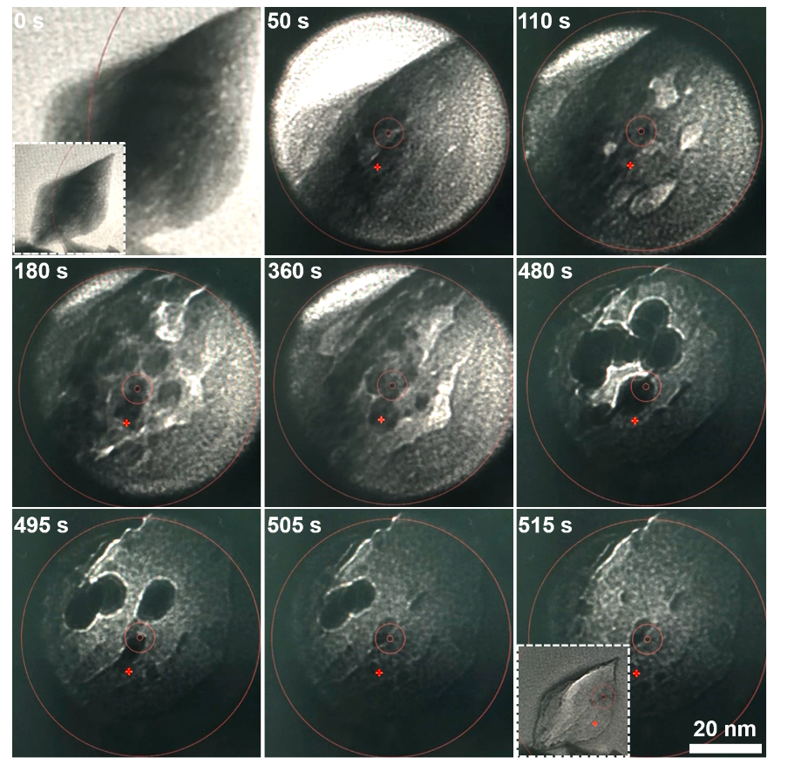
Supplementary Figure 1. Structural evolution of HgS NC in gas cell during the broken process. A series of time-dependent transmission electron microscopy (TEM) images revealing the formation and growth of the voids and Hg nanodroplets upon the electron beam (e-beam) irradiation of the HgS Nanocrystal (NC). The Hg nanodroplets gradually grew up and became relatively stable at a size of approximately 40 nm at 480 s. Afterwards, we intentionally focused the e-beam tightly into the small size, and the gas cell was broken. Such big nanodroplets started to fade away, rather than the enlargement of the droplets in the closed gas cell observed in the main text. These nanodroplets almost disappeared at 515 s. The inset images at 0 and 515 s correspond to the initial and final states of the whole HgS NC.

Supplementary Figure 2. Time-dependent TEM images of the structural dynamics in liquid cell. These TEM images were taken from Supplementary Movie 4, showing the evolution of the voids and nanodroplets at the preliminary stage.

Supplementary Figure 3. Time-dependent TEM images of the formation of large voids in liquid cell. The large void was formed by the coalescence process through the bridge.

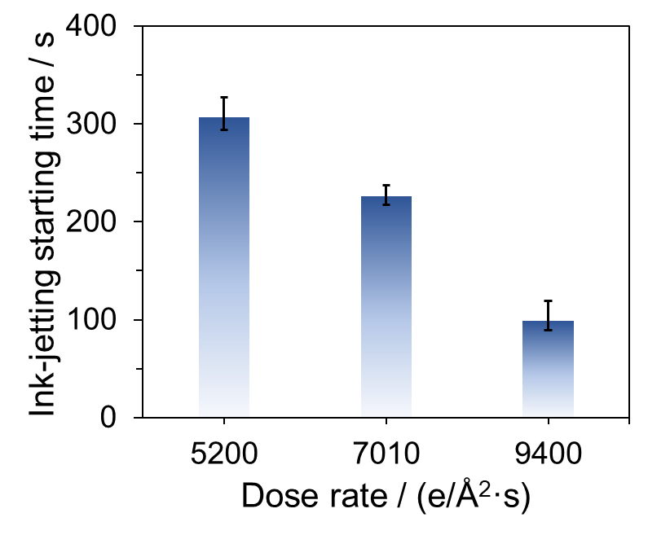
Supplementary Figure 4. The relationship between the ink-jetting starting time and the dose rate. The period needed to initiate the ink-jetting event was decreased from ~307 to 99 s with the increment of dose rate from 5200 to 9400 e/Å²·s.

Supplementary Figure 5. Excitation of multiple HgS NCs in the liquid environment. A series of time-dependent TEM images showing the continuous ink-jetting phenomenon. Compared to the behavior in the liquid cell with a single NC, similar evolution processes were observed. The inset images at 0 and 294 s were the NCs at the initial and end state, respectively.

Supplementary Figure 6. Elemental analysis of Hg and S as a function of the dose rate. HgS NCs were irradiated under different dose rates from 0.39 to 4110 e/Å²·s for 5 min, respectively. The energy dispersive X-ray spectroscopy (EDS) results revealed that the loss of Hg was more than that of the S element under the e-beam irradiation. For the EDS measurement, several areas were selected to show the better tendency.

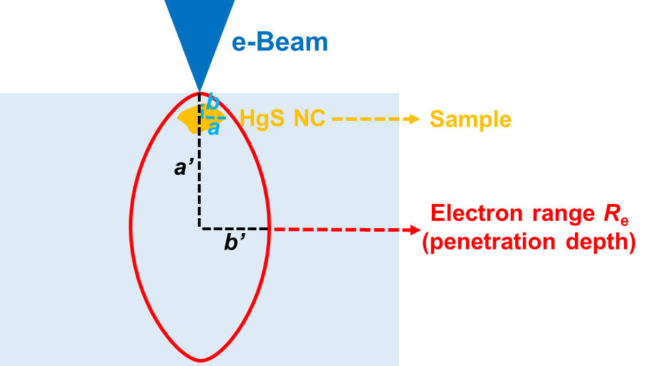
Supplementary Figure 7. Schematic of electron range R_{e} under the e-beam excitation of HgS NC. For simplicity, the spheroid geometry was assumed for the estimation of the quantity of carrier pairs upon irradiation. a and b were the equatorial radii of the HgS NC, while a’ and b’ corresponded to that of the e-beam excitation volume.

Supplementary Figure 8. The ratchet effect on the movement of Hg nanodroplets. a Typical atomic force microscopy image of the HgS NC. b Typical surface profile of the HgS NC, presenting the saw-tooth characteristics. c Schematic showing the pressure difference on the ratchet surface step. Upon the e-beam excitation, the nucleation of the nanodroplets occurred once the vapor pressure of Hg exceeded the saturated one. The Hg nanodroplets preferred to curve concavely near the top of the ridge (point A) while had the convex feature elsewhere (e.g., point B). The variation of the surface curvature then generated a pressure differential Δp = p_{A} - p_{B} between the concave ridge and the neighboring convex position, forming a net force to drive the movement of the nanodroplet.

Supplementary Figure 9. Obvious bubbles observed in the liquid cell. Time-dependent TEM images showing the obvious bubbles (marked by the arrows) in the carbon liquid cell. The images at 12-17 s were further enlarged to have the better view of the bubbles.

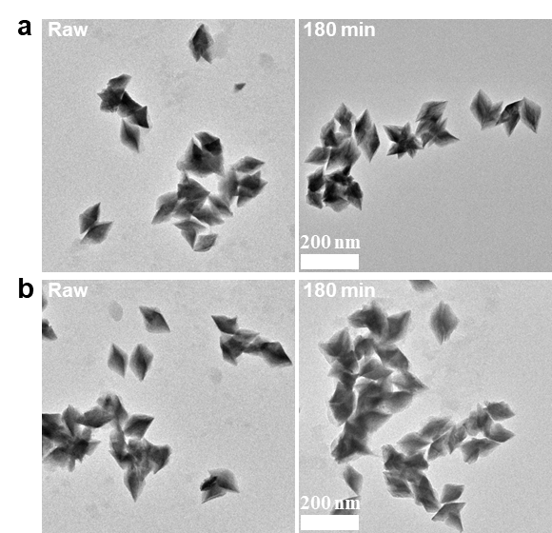
Supplementary Figure 10. Ex-situ control experiments with the addition of Co²⁺ or H₂O₂ into the HgS dispersion. a, b TEM images of the raw HgS NCs and the ones treated by the addition of Co²⁺ and H₂O₂ after 180 min, respectively.

Supplementary Notes
Calculation of the carrier pair generation
The local rate of carrier pair generation is estimated by the following equation,
$\text{g}\text{ = <}\text{g}\text{>}\frac{\text{EI}\text{(1-}\text{f}\text{)}}{\text{q}{\text{E}}_{\text{eh}}}\text{(carrier pairs/s)}$ (1)
where <g> is the normalized distribution, E is the energy of e-beam, I is the beam current, f is the fraction of e-beam reflected by the sample, q is the electron charge, and E_{eh} is the energy cost for the formation of a single electron-hole (e–h) pair.¹ The relevant parameters used for the estimation are listed in Supplementary Table 1.

Supplementary Table 1. Parameters for calculating the carrier pair generation rate.
<g> | E (keV) | I (nA) | f* | q I | E_{eh}* (eV) | g  (carrier pairs/s)
1 | 200 | 1.2 | 0.09 | 1.6×10⁻¹⁹ | 6 | 2.5×10¹⁴
* f value is obtained from Ref. 2 and E_{eh} value is acquired from Ref. 3

For simplicity, the HgS NC was considered as a spheroid structure with the equatorial radii a and b along the x and y axes, and the polar radius c along the z axe (Supplementary Fig. 7). Herein, a, b and c were estimated to be ~50 nm, 25 nm and 25 nm from the TEM image, respectively. Meanwhile, the geometry of e-beam was normally modeled to be a spheroid with a’, b’ and c’ along the x, y and z axes, respectively. In general, a’, b’ and c’ values roughly equal to ~1/2 R_{e}, 1/4R_{e} and 1/4 R_{e}, where R_{e} is the penetration depth of the e-beam.⁴
The electron range R_{e} (penetration depth) varies with respect to the accelerating voltage, which is calculated from the following equation,
${\text{R}}_{\text{e}}\text{ = }\frac{\text{2.76} \text{×}{ \text{10}}^{\text{-11}}\text{A}{{\text{E}}_{\text{0}}}^{\text{5/3}}}{\text{ρ} \text{×}{ \text{Z}}^{\text{8/9}}}$ (2)
where E₀ is the beam energy (keV), A is the atomic weight (g mol⁻¹), ρ is the density (g cm⁻³), and Z is the atomic number of the material.⁵ These values are listed in Supplementary Table 2.

Supplementary Table 2. The relevant parameters used for the calculation of the penetration depth in HgS system.
E₀ (keV) | A (g mol⁻¹) | ρ (g cm⁻³) | Z | R_{e} (μm)
200 | 232 | 8.1 | 96 | 93.5

By substituting the above values into eq. (2), the electron range R_{e} was calculated to be 93.5 μm. Based on the geometry shown in Supplementary Fig. 7, the volume fraction of the HgS NC inside the electron range was estimated,
φ_{HgS} =V_{HgS}/ V_{beam} = (4πabc/3) / (4πa’b’c’/3) = 1.22 × 10⁻⁹ (3)
Therefore, the generation of the carrier pairs in the HgS NC was,
N_{carrier pair} = g × φ_{HgS} = 2.5×10¹⁴ × 1.22 × 10⁻⁹ = 3.05 × 10⁵ (carrier pairs/s) (4)
In the case of e-beam excitation for 2 s and 400 s presented in the main text, the number of carrier pairs were finally estimated to be ~6.10 × 10⁵ and 1.22 × 10⁸, respectively.

Calculation of the number of Hg atoms in one Hg nanodroplet
Based on the basic parameters of Hg (one unit-cell volume is 69.2 Å³, which contains 40 Hg atoms), the number of Hg atoms were calculated to be ~2.42 × 10³ and 3.02 × 10⁵ for the 2 nm-sized and 10 nm-sized Hg, respectively.

Estimation of the steady-state concentration of radiolysis species
The steady-state concentration C_{ss,i} of the radiolysis species in a liquid cell produced by a 200 kV electron beam can be estimated with the following formula,
${\text{C}}_{\text{ss,i}}\text{ \sim }{ \text{α}}_{\text{i}}{\text{ψ}}^{{\text{β}}_{\text{i}}}$ (5)
where the coefficients α_{i} and β_{i} are listed in Supplementary Table 3 from Ref. 6, and ψ (Gys⁻¹) is the dose rate for a thin liquid layer,
$\text{ψ}\text{ = }\frac{\text{SI}{\text{10}}^{\text{5}}}{{\text{a}}^{\text{2}}\text{π}}$ (6)
where S (MeV cm²/g electron) is the density-normalized, stopping power in liquid, I (A) is the electron beam current, a (μm) is the beam radius, and the factor 10⁵ (m² electron Gy g/cm² MeV C) converts the commonly used radiation units into SI units.⁶
Supplementary Table 3. Power law parameters α_{i} and β_{i} for calculating the Steady-state concentration of radiolysis species.

Species | α_{i} | β_{i}
•OH | 1.45 × 10⁻⁸ | 0.46
H₂O₂ | 2.20 × 10⁻⁷ | 0.44
•O₂⁻ | 8.21 × 10⁻¹⁰ | 0.51
H• | 6.31 × 10⁻⁹ | 0.38
e_{h}⁻ | 2.49 × 10⁻¹⁰ | 0.51

The relevant parameters of the e-beam are listed in Supplementary Table 4. Therefore, the steady-state concentrations of the radiolysis species in liquid cells produced by a 200 kV electron beam were calculated, as shown in Supplementary Table 5.

Supplementary Table 4. Parameters for calculating the radiation dose rate in liquid cell.

S (MeV cm²/g electron) ª | I (nA) ^{b} | a (μm) ^{b} | ψ (Gy s⁻¹)
2.78 | 1.223 | 0.1 | 1.08 × 10¹⁰
ª Obtained from ESTAR database.
^{b} Parameters used in the experiment.

Supplementary Table 5. Estimated steady-state concentration of the common radiolysis species
in liquid cell.

Species | Steady-state concentration (mM)
•OH | 0.598
H₂O₂ | 5.716
•O₂⁻ | 0.107
H• | 0.041
e_{h}⁻ | 0.033

Supplementary Table 6. Standard redox potentials of major radiolysis species
generated by the e-beam irradiation.

Species | Standard redox potential (V)*
•OH | 2.73
H₂O₂ | 1.78
•O₂⁻ | 1.50
H• | -2.30
e_{h}⁻ | -2.90
* These values are obtained from Ref. 7

References
1. Leamy, H. J. Charge collection scanning electron microscopy. J. Appl. Phys. 53, 51–80 (1982).
2. Klein, C. A. Bandgap dependence and related features of radiation ionization energies in semiconductors. J. Appl. Phys. 39, 2029–2038 (1968).
3. Fiebiger, J. R. & Muller, R. S. Pair‐Production energies in silicon and germanium bombarded with low‐energy electrons. J. Appl. Phys. 43, 3202–3207 (1972).
4. Salviati, G., Lazzarini, L., Sekiguch, T. & Chen, B. Assessment of semiconductors by scanning electron microscopy techniques. Compr. Semicond. Sci. Tech. 4, 308–356 (2011).
5. Kanaya, K. & Okayama, S. Penetration and energy-loss theory of electrons in solid targets. J. Phys. D: Appl. Phys. 5, 43–58 (1972).
6. Schneider, N. M. et al. Electron−water interactions and implications for liquid cell electron microscopy. J. Phys. Chem. C 118, 22373−22382 (2014).
7. Ye, M. et al. Revealing dominant oxidative species in reactive oxygen species-driven rapid chemical etching. Nano Lett. 23, 7319−7326 (2023).

