Rapid detection of N-lactoyl-phenylalanine for exercise evaluation using dual DNA biosensors based on solution-gated graphene field-effect transistor
Jiacheng Li ª, Ming Zhang ª, Cailing Zhang ª, Yin Zhang ª, Wenbin Chen ª, Jian Liu ^{a*}, Hao Qu ^{a*}, Lu Wang ^{a, b *}

ª School of Food and Biological Engineering, Hefei University of Technology, Hefei, Anhui, 230009, China.

^{b} Engineering Research Center of Bio-process, Ministry of Education, Hefei University of Technology, Hefei, 230009, China.

* Corresponding authors at:

School of Food and Biological Engineering, Hefei University of Technology, Hefei, Anhui, 230009, China.
E-mail addresses: jianliu509@hfut.edu.cn (Jian Liu), quhao@hfut.edu.cn (Hao Qu), wanglu@hfut.edu.cn (Lu Wang).
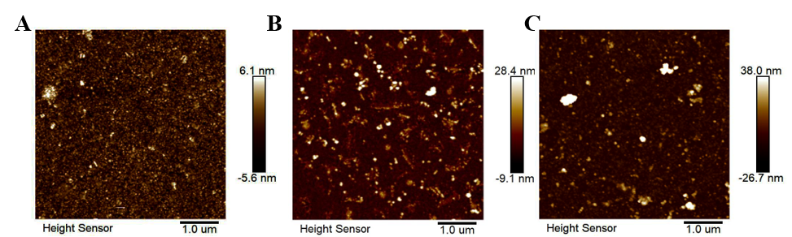
Fig S1. Results of AFM images (a) Bare Au, (b) Electrodes modified with L-Lac aptamers, (c) Electrodes modified with L-Phe aptamers.
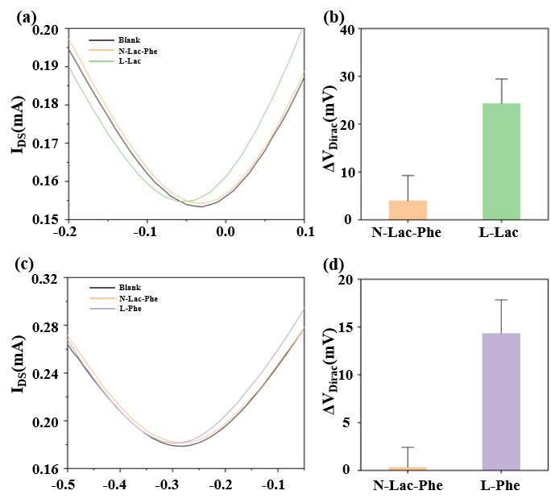
Fig S2. Detection results of N-Lac-Phe by the biosensor. (a) The transfer curves of aptamers modified L-Lac biosensor for detecting N-Lac-Phe and L-Lac, (b) Detection of N-Lac-Phe and L-Lac, (c) The transfer curves of aptamers modified L-Lac biosensor for detecting N-Lac-Phe and L-Phe, (d) Detection of N-Lac-Phe and L-Phe.

