Supporting Information
3D printed multi-functional scaffolds based on poly(ε-caprolactone) and hydroxyapatite composite
Liu, et al.
S1. The thermo properties of pure PCL and PCL/HA scaffolds
Thermogravimetric analysis (TGA) was carried out to investigate the thermal properties of the scaffolds. Before measurement, the scaffolds were cut into short pieces, and the specimens with a weight of ≈10 mg were placed in an aluminum crucible. The measurements were carried out over a temperature range of 25-600 °C at a heating rate of 10 °C min⁻¹. Table S1 lists the thermal properties of the PCL/HA scaffolds.
Table S1 Thermo properties of PCL/HA scaffolds. Here, T_{10%}, T_{50%}, T_{80%} and T_{≈100%} represent the degradation temperature at the weight loss of 10%, 50%, 80%,≈100%, respectively.
Heating rate (℃/min) | T_{10%} (℃) | T_{50%} (℃) | T_{80%} (℃) | T_{≈100%} (℃) | Residue at 400 ℃ (%) | Residue at 450 ℃ (%)
PCL | 389.7 | 415.0 | 430.3 | 492.2 | 79.53 | 3.88
PCL/5%HA | 388.6 | 415.2 | 432.0 | 501.3 | 79.02 | 9.14
PCL/10%HA | 378.8 | 414.1 | 434.0 | 500.4 | 74.28 | 13.00
PCL/15%HA | 375.0 | 414.6 | 439.9 | 529.7 | 73.90 | 17.09
PCL/20%HA | 367.1 | 413.7 | 460.8 | 533.8 | 70.03 | 21.05
PCL/25%HA | 363.3 | 414.0 | — | 558.0 | 68.97 | 27.06

S2. In vitro degradation property of PCL/HA scaffolds
The PCL/HA samples for mechanics testing are further prepared by the thermoforming of PCL/HA composite materials in a standard mold (dumbbell shape) on an injection molding machine. In vitro degradation test is also measured using PCL/HA samples according to the above same method as PCL/25wt% HA scaffolds. Tensile properties are evaluated using a universal testing machine at a stretching rate of 1 mm min⁻¹. Each experiment is repeated three times and the results are averaged. The tensile properties of PCL/25wt% HA after degradation are measured and summarized in Table S2.
Table S2 Mechanical properties of PCL/25wt%HA scaffolds after degradation.
Degradation time (days) | Young’s modulus (MPa)
30 | 307.23±2.35
60 | 290.90±5.65
90 | 300.00±4.65
120 | 264.96±3.40

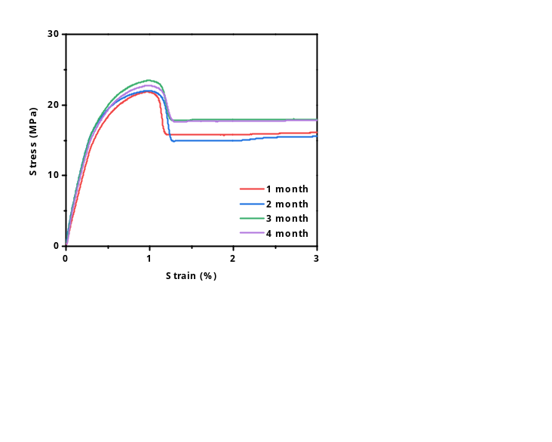
Figure S2 Stress-strain curves of PCL/HA scaffolds after degradation.
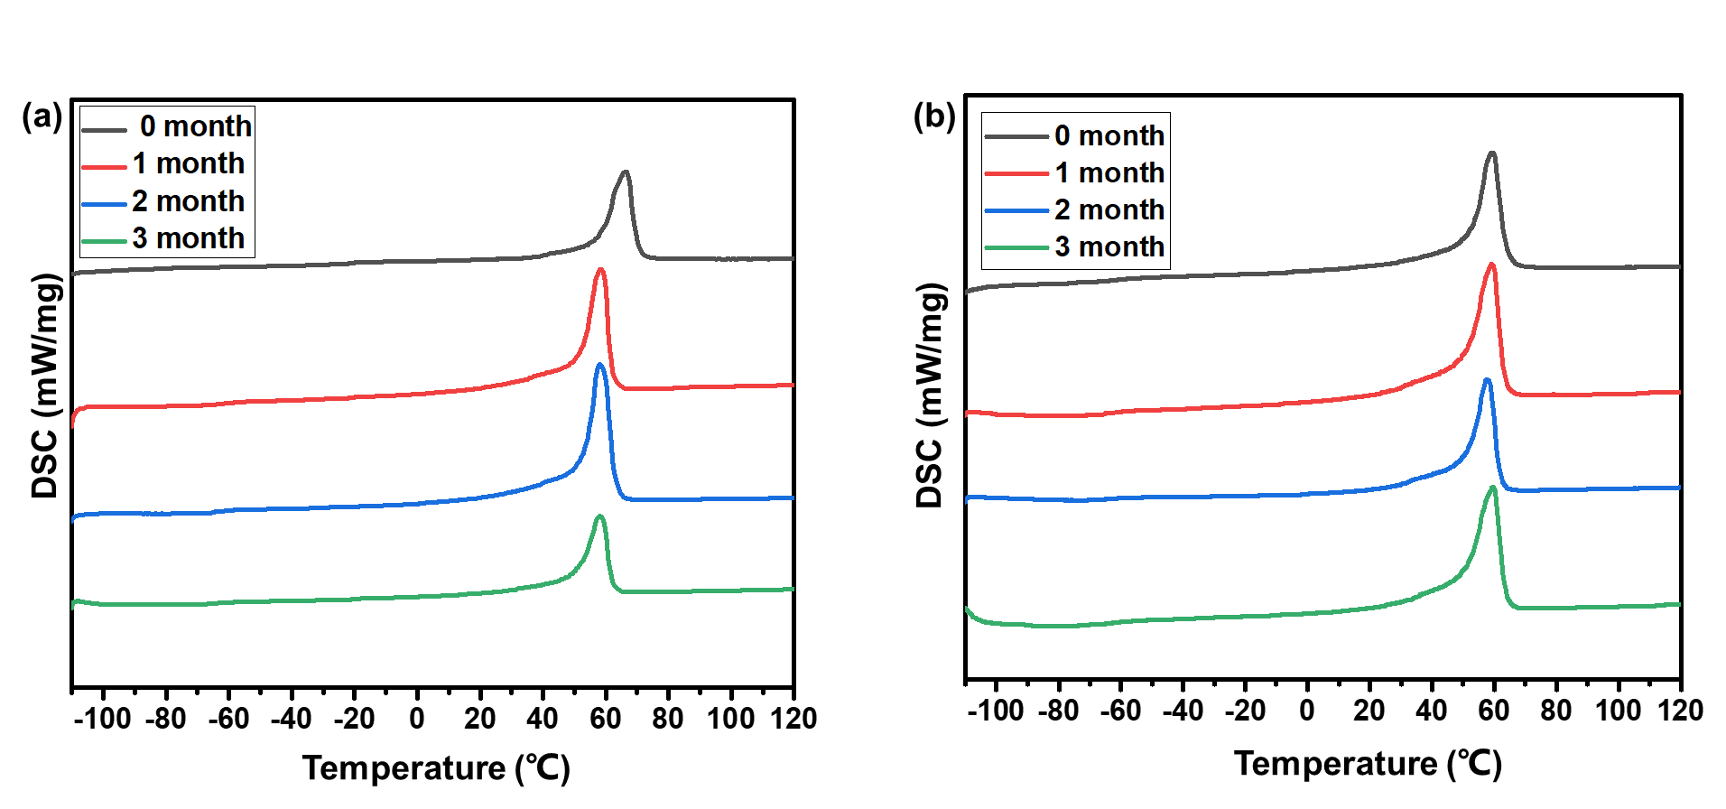
Figure S3 DSC curves of pure PCL and PCL/25wt% HA after degradation. (a) pure PCL scaffolds; and (b) PCL/25wt% HA.

S3. Characterization of PCL/HA/DOX scaffolds coated with collagen I
The SEM images clearly show the surface condition of multi-functional PCL/HA/DOX scaffolds (Figure S4). Limited by the resolution of SEM, the structure of small triple helix could not be seen clearly, but collagen fibrils are observable with the diameter of about 100 nm. The appearance of N 1s absorption peak in the survey X-ray photoelectron spectroscopy (XPS) spectrum at 398 eV indicates that the collagen I is successfully coated onto the surface of PCL/HA/DOX scaffolds (Figure S4b). Such observation is further affirmed from the XPS analysis on other three sample discs.
Figure S4 The characteristics of scaffolds with coating Collagen I. (a) SEM images of Collagen fibrils were obvious coating on the surface of PCL/HA scaffolds; (b) The survey XPS spectra of PCL/25wt%HA and PCL/HA/DOX.,

S4. Magnetic resonance imaging of the position of implanted PCL/HA scaffolds in the thigh-bone of rabbit
The MRI images show the multi-functional PCL/HA/DOX scaffolds was implanted in the thigh-bone of rabbit (Figure S5).
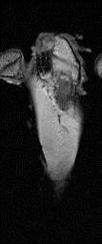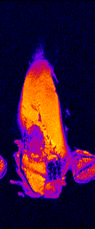
Figure S5 Magnetic resonance imaging of the position of implanted PCL/HA scaffolds in the thigh-bone of rabbit.

