Supplementary Information

1 - Growing medium

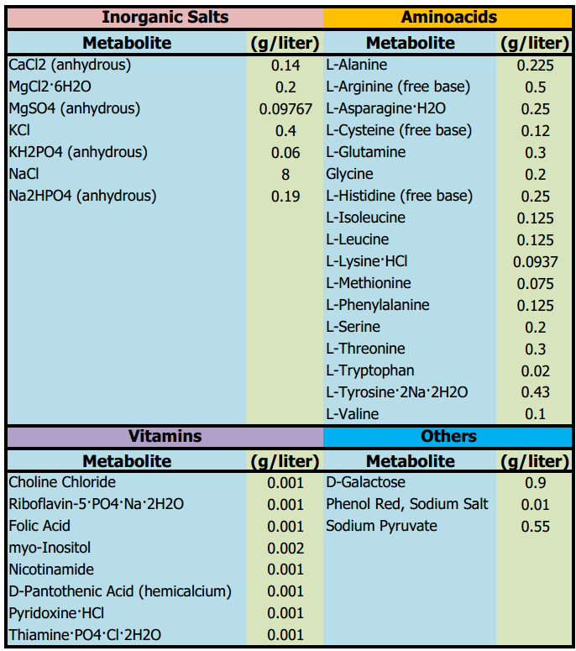

Table 1. Culture Medium
The culture medium used for reconstitutions was based on Leibovitz L-15 Medium 30-2008.
More Information on medium: https://www.atcc.org/products/30-2008

2 - Characteristics of the metabolic reconstructions

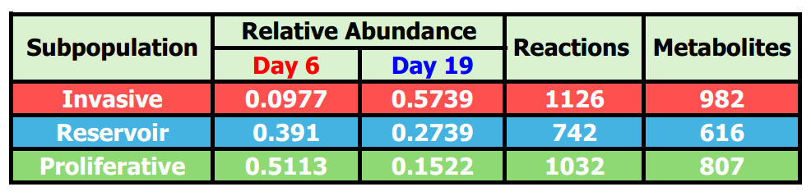

Table 2. Characteristics of the metabolic reconstructions.
Included are the count of metabolic reactions within each GEM as well as the number of metabolites within each of these classified as I - Invasive, R - Reservoir, and P - Proliferative. For more information on the reconstruction, consult the MEMOTE reports for each reconstruction.

3 - Output files of community simulation with MICOM
Supplementary file 1 contains 4 tables of MICOM output files:

- Community fluxes on day 6 (Day6_fluxes)
- Community fluxes on Day 19 (Day19_fluxes)
- Exchanges fluxes with the medium on day 6 (Exchanges_day6)
- Exchange fluxes with the medium on day 19 (Exchanges_day19)

Download the files in the Github, MICOM/Output_files/ csv_files folder: https://github.com/resendislab/Modeling_Heterogeneity_Cancer_Metabolism_MICOM

4 - Reports of quality with MEMOTE
- Supplementary File 4 - Report of MEMOTE (Invasive.html)
- Supplementary File 5 - Report of MEMOTE (Reservoir.html)
- Supplementary File 6 - Report of MEMOTE (Proliferative.html)

Download the files in the Github, MICOM/Output_files/ Reports_of_quality folder: https://github.com/resendislab/Modeling_Heterogeneity_Cancer_Metabolism_MICOM

5 - Enrichment of metabolic pathways with active reactions

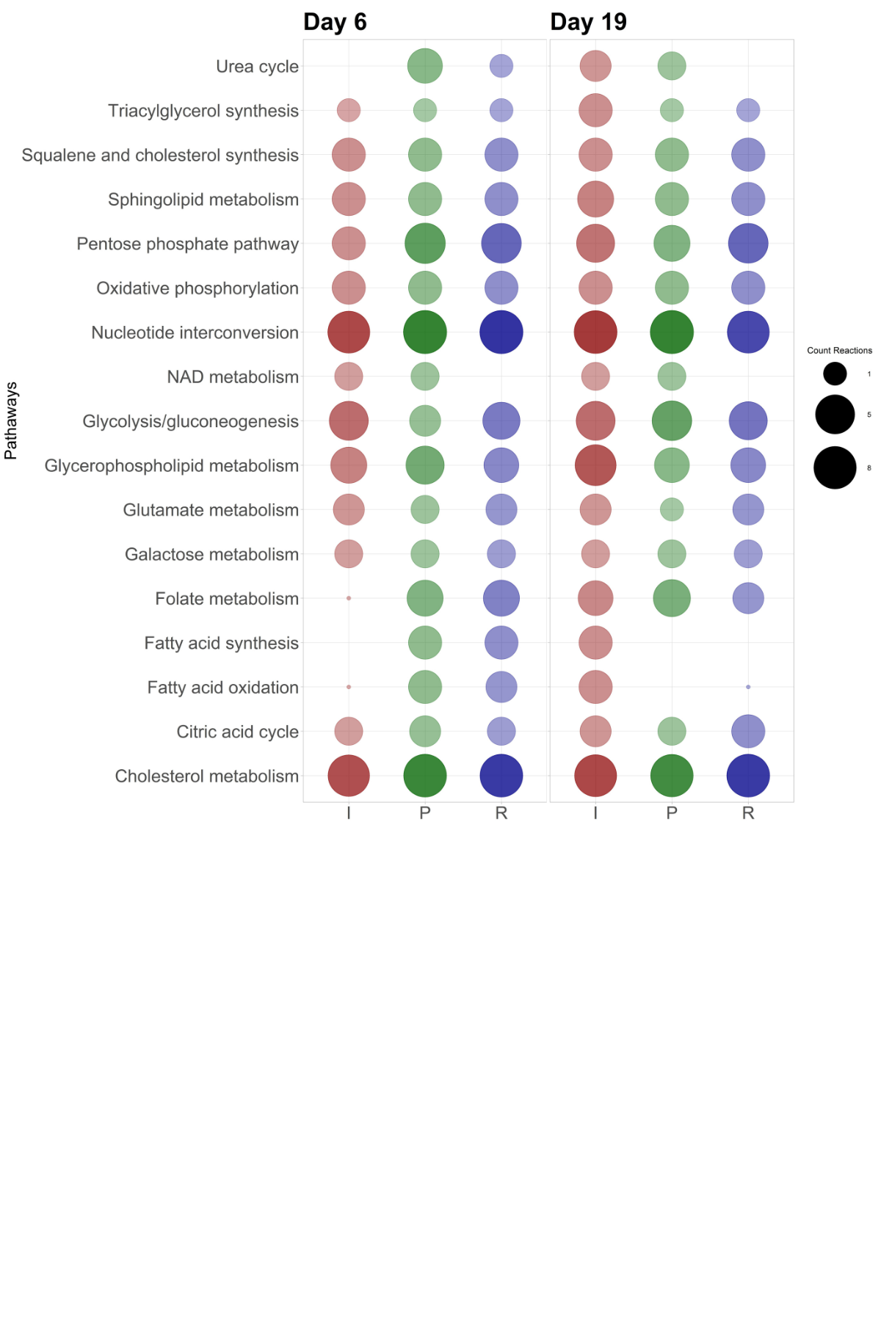

Figure 1. Counting of reactions with fluxes per metabolic pathway.
The size of the spheres corresponds to the number of active reactions within each pathway for the 3 subpopulations. The cases in which a blank space is identified correspond to the fact that the reactions had fluxes equal to zero, reason for discarding. This behavior differs between days 6 and 19 as it can be deduced that depending on the day the metabolism is reconfigured, different metabolic behaviors are observed between the subpopulations depending on the day of the study.

6 - Intracellular reactions with activity (Reaction directionality)

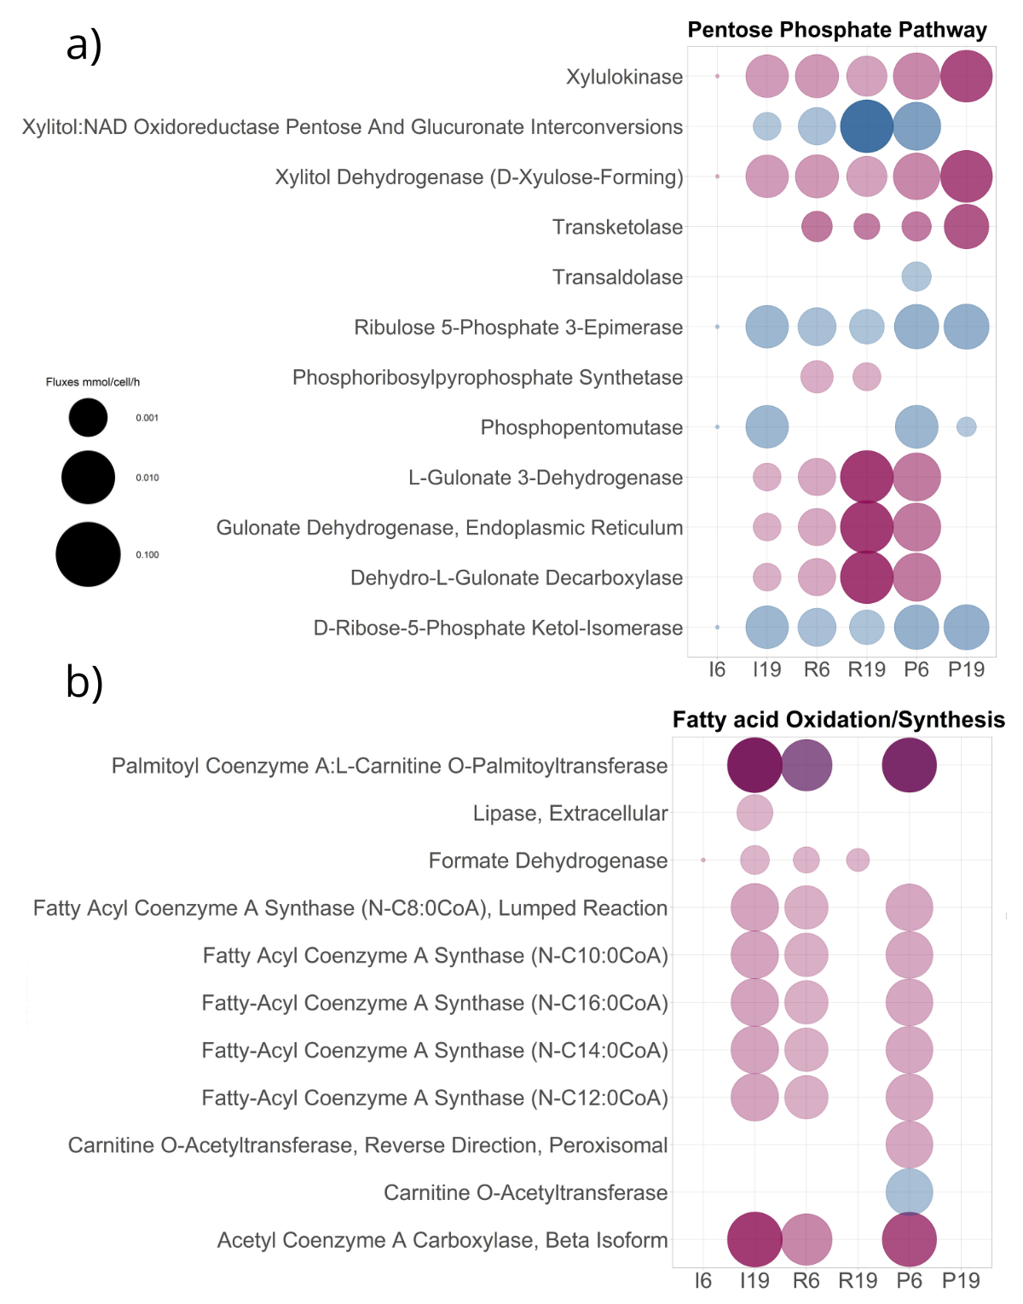

Figure 2. Enzymes with metabolic activity
The metabolic pathways were grouped according to the VMH database (see methods section), in which each reaction is assigned a subsystem such as a) Pentose Phosphate pathway b) Fatty acid Oxidation/Synthesis. Only reactions with activity in at least one of the three subpopulations were considered for visualization. To represent the directionality, a color identifier (reddish) corresponds to the directionality of the reaction in its classical pathway described in the database, and (blue) corresponds to a reversal of the directionality of the reaction when observed. The blanks do not exclude the presence of enzymes in the reconstruction; they only reflect whether there was activity. The units of the FBA modeling correspond to the metabolic biotransformation rate, mmol/cell/hour, reflected in the size of the spheres for each reaction.

7 - Community response to oxygen gradients

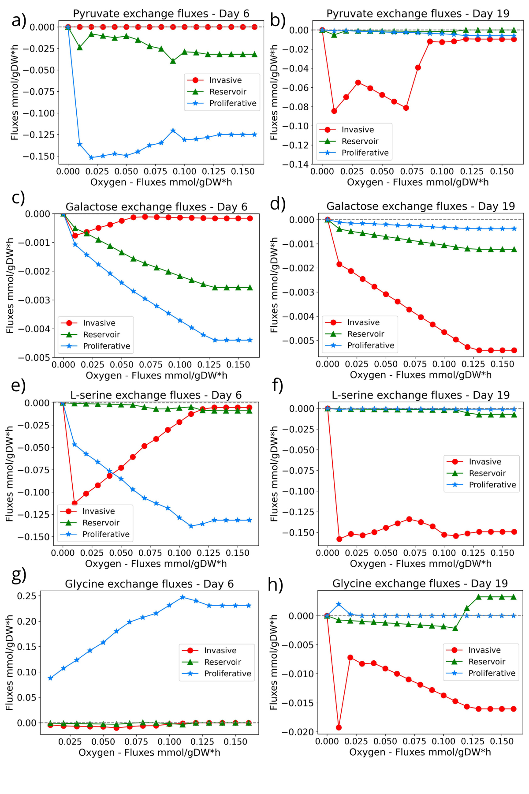

Figure 3. Community response to oxygen depletion
From right to left, the gradient from normoxia to hypoxia is represented, where oxygen fluxes are decreasing, and each of the 16 marked points reflects the behavior of the subpopulations about the consumption or production of a metabolite. Values above zero represent secretion, and those below zero consumption. Red lines correspond to invading cells, green lines to reservoirs, and blue lines to proliferative cells. Each point on the X-axis represents a different community simulation or scenario. Since this is a deterministic scenario, we do not have any statistics since there are no variations in the repetitions of the simulations. To visualize the behavior of the community with the disposition of the elements of the medium, we selected metabolites that could be used as an energy source on different study days: a) pyruvate, c) galactose, e) L-serine, g) lysine on day six, and b) pyruvate, d) galactose, f) L-serine, h) glycine on day 19.

8 - Doubling times

According to Meadows et al.¹, the doubling time results from dividing the natural logarithm of 2 by the biomass or growth rate. The simulation indicated a 0.026 mmol/cell/h rate, corresponding to an approximate ~ 26-hour doubling time on both days. The doubling time is a characteristic unit (a natural unit of scale) for the exponential growth equation, and its reciprocal for exponential decay is the half-life.

$$DoublingTime=ln{\left(2\right)}/{Biomass}$$

1. Meadows, D. H. Thinking in Systems: A Primer. (Chelsea Green Publishing, 2008).

