Supplementary materials for
Interparticle Distance-Driven Diffusion Field Transforming Selectivity in Oxygen Reduction Reaction
Guangxing Yang,^{a,#} Jie Chen, ^{a,#} Dongqin Liu, ª Jiayu Yuan,^{b} Zenan Wu,ª Zhiting Liu,ª Qiao Zhang,ª Hao Yu,^{b} and Feng Peng^{a,}*
ªSchool of Chemistry and Chemical Engineering, Guangzhou University, Guangzhou 510006 China
^{b}South China University of Technology, Guangzhou 510641 China
# Authors contribute equally.
E-mail: fpeng@gzhu.edu.cn (F. Peng)

This PDF file includes:

Supplementary text
Supplementary Figures S1-8
Supplementary Table S1
Supplementary References

Supplementary text
Calculations
The ratio of distance between particles to particle size (δ=d/D) was used as a descriptor for the particle spacing effect.
n_{i} represents the number of particles with a diameter of d_{i}, and the average particle size is calculated by the following formula:
$$D=\frac{\sum_{i=1}^{n}{n_{i}d_{i}^{3}}}{\sum_{i=1}^{n}{n_{i}d_{i}^{2}}}$$
d represents the particle distance is calculated by the following formula:
$d=\sqrt{ρD^{3}S_{c}\frac{100-y}{6\sqrt{3y}}}$
where, ρ represents the density of Pt, g nm⁻³.D represents the average particle diameter, nm. S_{c} is the specific surface area of the carbon support, nm² g⁻¹. y represents the mass fraction of metal in the Pt/C catalyst.
Catalysts were denoted as Pt_{δ}, representing the Pt/C catalyst with a ratio of δ between particles to particle size.
Measurement of H₂O₂
In acidic conditions, cerium sulfate can undergo a redox reaction with hydrogen peroxide, described by the following mechanism:
2Ce⁴⁺+H₂O₂→2Ce³⁺+2H⁺+O₂↑
The orange-yellow Ce⁴⁺ is reduced to colorless and transparent Ce³⁺, leading to a change in the absorbance of the solution. Since Ce⁴⁺ has a maximum absorption at 320 nm, the concentration of hydrogen peroxide can be calculated according to the reaction quantitative relationship between cerium sulfate and hydrogen peroxide in solution.
Measurement of standard curves of data as shown in Table S1.
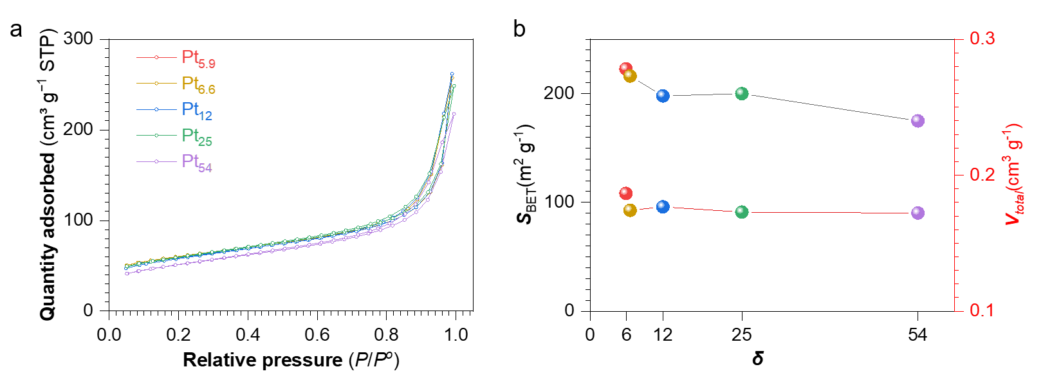
Figure S1. (a) Adsorption and desorption isotherms of N₂ at 77 K; (b) BET surface area of each material.

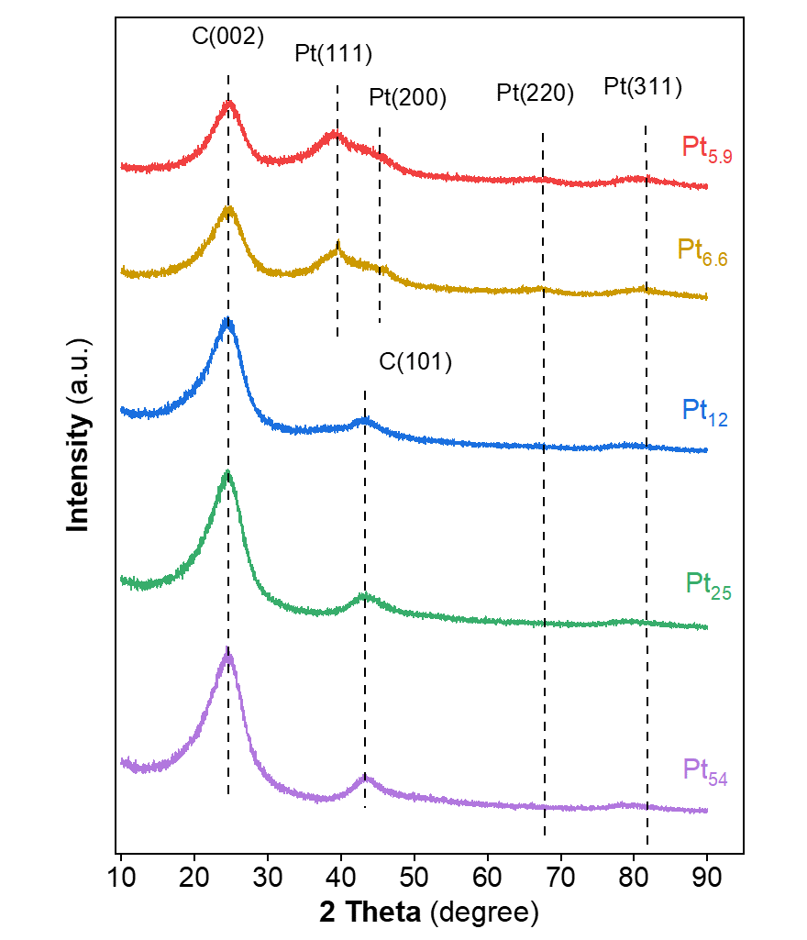
Figure S2. XRD patterns of Pt_{δ} materials

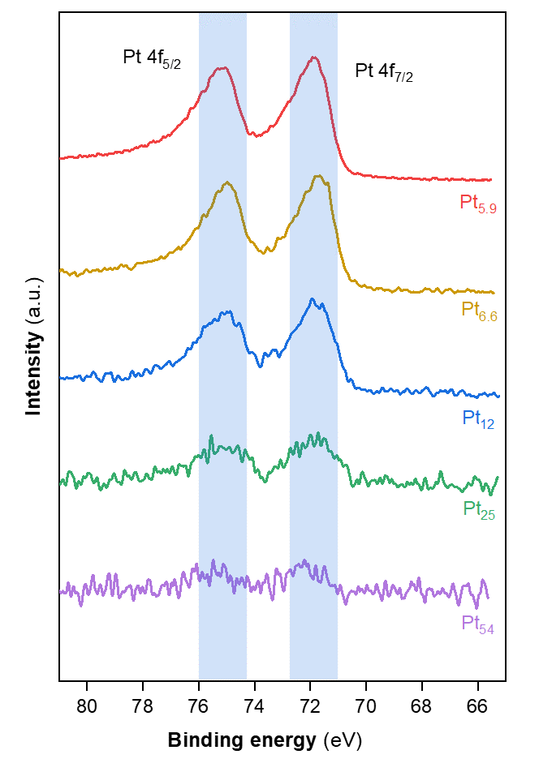
Figure S3. XPS spectra of Pt_{δ} materials

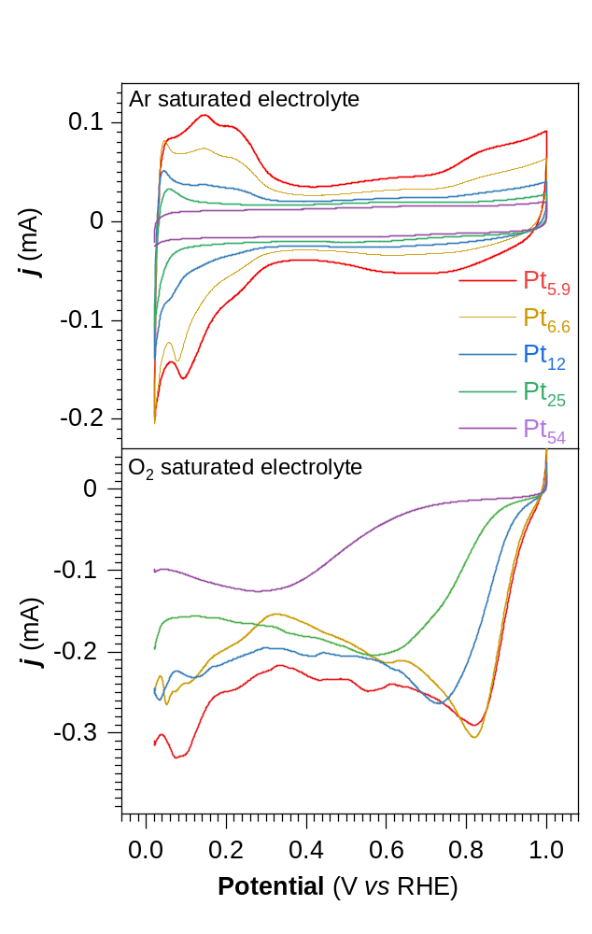
Figure S4. (top) Cyclic voltametric curves of Pt_{δ} materials in the Ar-saturated HClO₄ electrolyte at the scan rate of 50 mV s⁻¹. (bottom) Linear scan curves of Pt_{δ} materials in the O₂-saturated HClO₄ electrolyte at the scan rate of 10 mV s⁻¹ from the positive to negative potential.

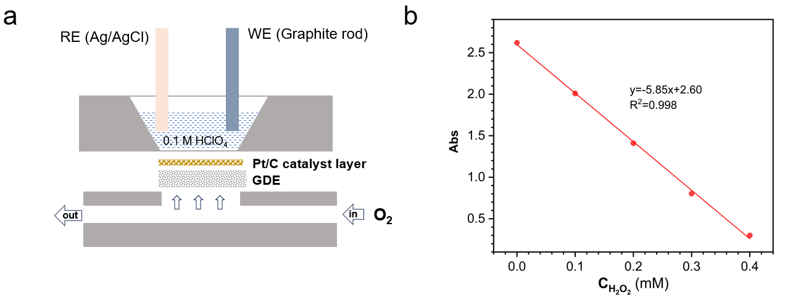

Figure S5. Schematic of the GDE cell for H₂O₂ generation. (b) Calibration curve of absorbance with respect to H₂O₂ concentration.
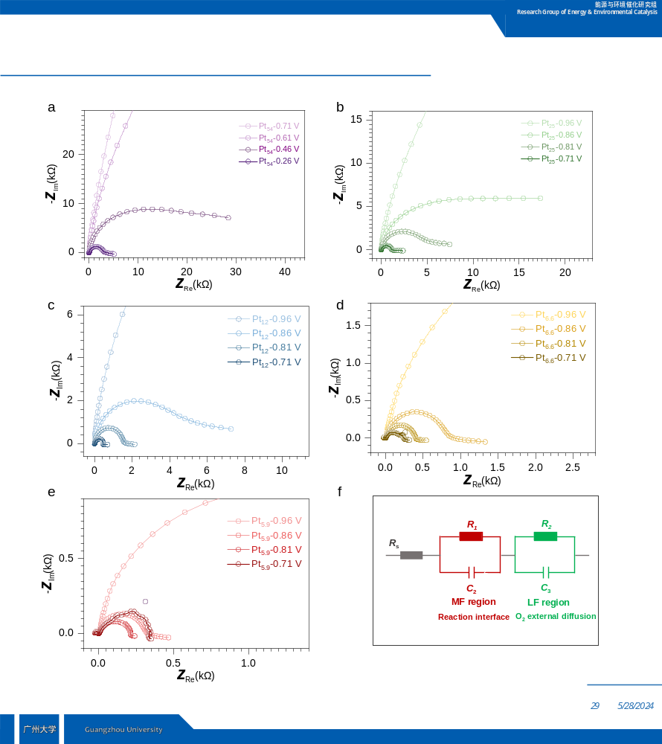
Figure S6. Potential effect on the Nyquist plots of (a) Pt₅₄, (b) Pt₂₅, (c) Pt₁₂, (d) Pt_{6.6} and (e) Pt_{5.9} at 1600 rpm with total catalyst loading of 20 μg in O₂ bubbling electrolyte. (f) equivalent electric circuit.
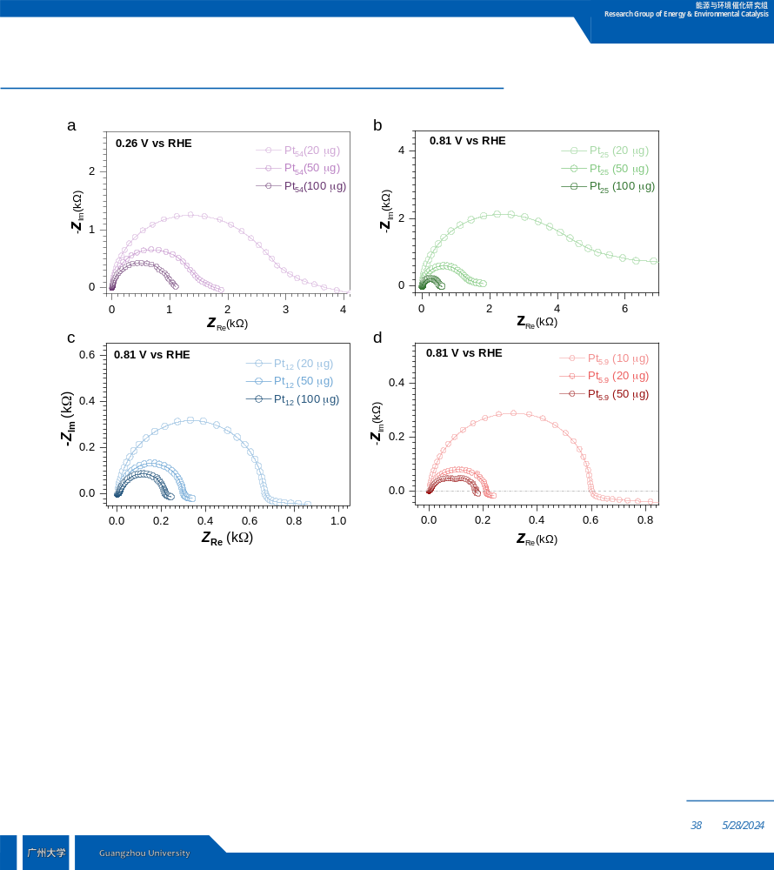
Figure S7. Catalyst loading effect on the Nyquist plots of (a) Pt₅₄, (b) Pt₂₅, (c) Pt₁₂, and (d) Pt_{5.9} at 1600 rpm in O₂ bubbling electrolyte.

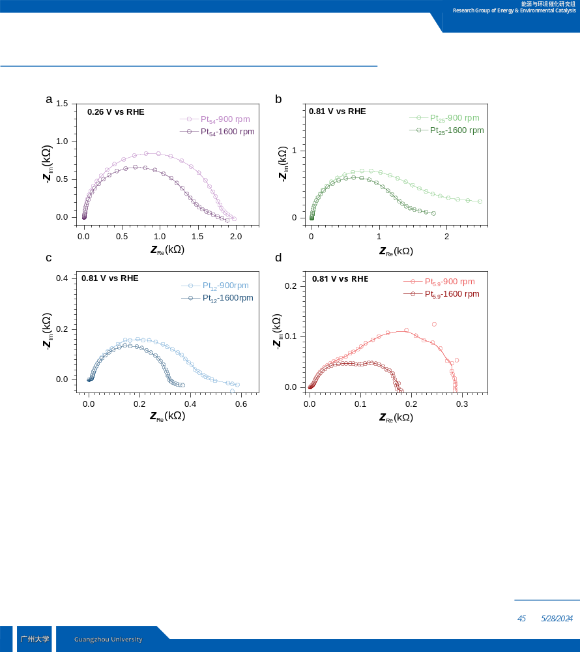
Figure S8. Ration rate effect on the Nyquist plots of (a) Pt₅₄, (b) Pt₂₅, (c) Pt₁₂, and (d) Pt_{5.9} with total catalyst loading of 20 μg in O₂ bubbling electrolyte.
Table S1 The concentration of the components of the standard solution
 | C_{H2O2}/mM | 1 mM Ce(SO₄)₂/mL | 0.5 M H₂SO₄/mL | 10 mM H₂O₂/μL
1 | 0 | 5.00 | 5.00 | 0
2 | 0.1 | 5.00 | 4.95 | 50
3 | 0.2 | 5.00 | 4.90 | 100
4 | 0.3 | 5.00 | 4.85 | 150
5 | 0.4 | 5.00 | 4.80 | 200

