Supplementary Figures

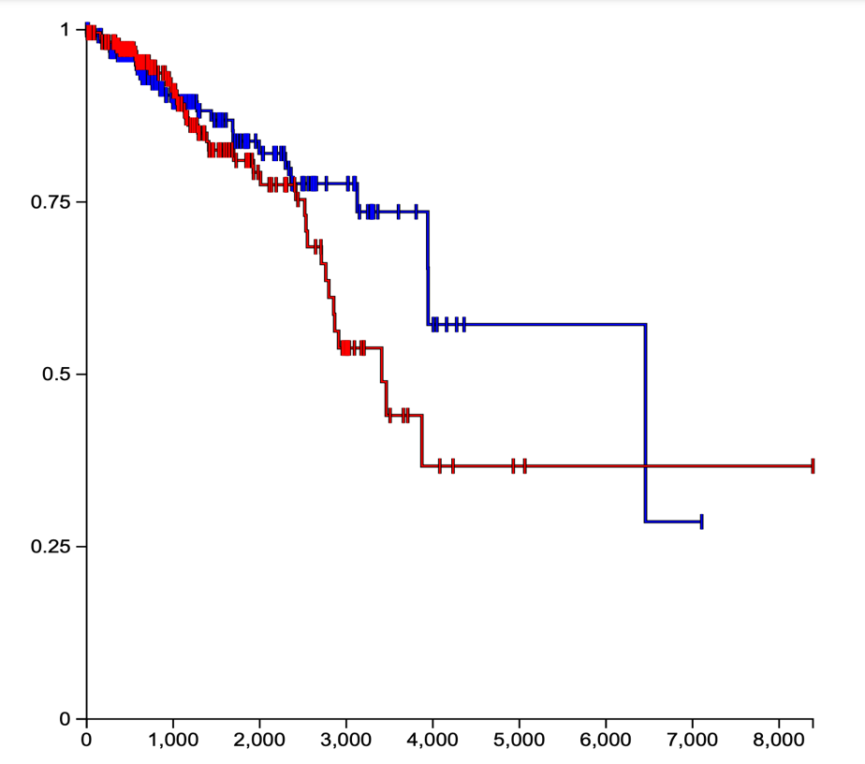

Supplementary Fig. 1. Elevated TWF1 mRNA expression did show a trend toward poor overall survival between the first and the last quartiles (log-rank test, P=0.20).

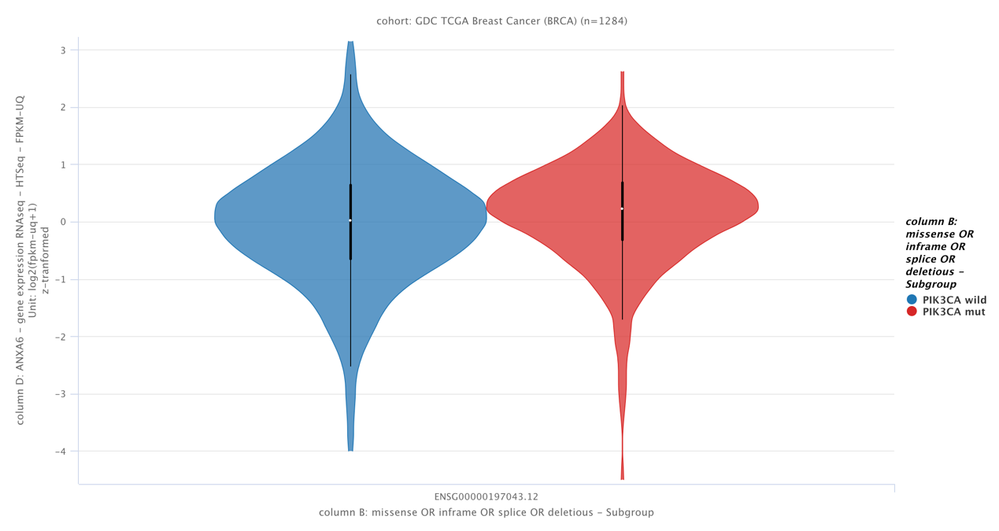
Supplementary Fig 2. ANXA6 mRNA was differentially expressed between PIK3CA mutant and wild breast cancers (Welch's t-test, P = 0.01).

