Title: A 15-Year Analysis of Inflammatory Bowel Disease in Africa Using Google Trends

Supplemental Figures and Table

Please see the mp4 files for Supplemental files 1-3.

Supplemental Figure 1: A 15-year comparison of “Crohn’s disease (disease)” interest in Africa.
Supplemental Figure 2: A 15-year comparison of “Ulcerative colitis (disease)” interest in Africa.

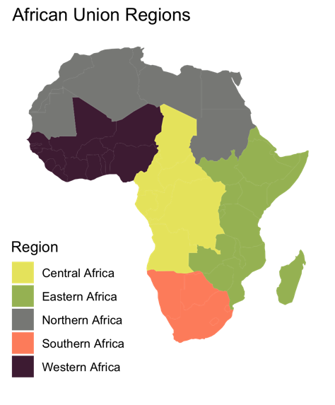

Supplemental Figure 3: A network of the Top Topics associated with “Crohn’s disease (disease)” within Africa during 2023. The top topics are colored in a faint gray, and the countries (labeled COUNTRY_name), are color coded based on the geographical region within Africa. The networks for top related searches have weighted edges for the related searches which have been most prevalent in a country.

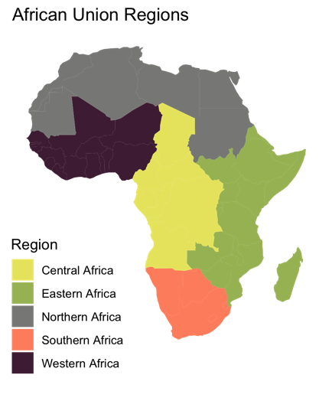

Supplemental Figure 4: A network of the Top Topics associated with “Ulcerative colitis (disease)” within Africa during 2023. The top topics are colored in a faint gray, and the countries (labeled COUNTRY_name), are color coded based on the geographical region within Africa. The networks for top related searches have weighted edges for the related searches which have been most prevalent in a country.

Supplemental Table 1: Listing the Top Topics and their frequency based on the categories assigned in Table 1.

 | IBD | Freq. | CD | Freq. |  | UC | Freq.
Either a symptom or a differential diagnosis | Abdomen | 8 | Abdomen |  | 9 | Abdomen |  | 5
Either a symptom or a differential diagnosis | Abdominal pain | 2 | Abdominal pain |  | 2 | Abdominal pain |  | 2
Either a symptom or a differential diagnosis | Anus | 2 | Anal fistula |  | 1 | Bleeding |  | 5
Either a symptom or a differential diagnosis | Bleeding | 1 | Anti-inflammatory |  | 1 | Blood |  | 3
Either a symptom or a differential diagnosis | Blood | 7 | Anus |  | 5 | Cancer |  | 9
Either a symptom or a differential diagnosis | Blood in stool | 2 | Appendicitis |  | 2 | Chronic condition |  | 7
Either a symptom or a differential diagnosis | Bowel obstruction | 1 | Autoimmune disease |  | 1 | Colitis |  | 29
Either a symptom or a differential diagnosis | Cancer | 5 | Blood |  | 4 | Colon |  | 6
Either a symptom or a differential diagnosis | Chronic condition | 6 | Bowel obstruction |  | 1 | Colorectal cancer |  | 3
Either a symptom or a differential diagnosis | Colitis | 9 | Cancer |  | 8 | Crohn's disease |  | 20
Either a symptom or a differential diagnosis | Colon | 1 | Celiac disease |  | 5 | Diarrhea |  | 9
Either a symptom or a differential diagnosis | Colorectal cancer | 2 | Chemotherapy |  | 1 | Diet |  | 5
Either a symptom or a differential diagnosis | Crohn's disease | 12 | Chronic condition |  | 1 | Eating |  | 1
Either a symptom or a differential diagnosis | Diarrhea | 8 | Colitis |  | 18 | Feces |  | 11
Either a symptom or a differential diagnosis | Digestion | 1 | Colon |  | 6 | Flatulence |  | 1
Either a symptom or a differential diagnosis | Drainage | 1 | Diarrhea |  | 10 | Food |  | 2
Either a symptom or a differential diagnosis | Feces | 11 | Diet |  | 5 | Gastrointestinal tract |  | 1
Either a symptom or a differential diagnosis | Gastroenteritis | 1 | Digestion |  | 2 | Hemorrhoids |  | 1
Either a symptom or a differential diagnosis | Gastrointestinal tract | 2 | Diverticulitis |  | 2 | Human digestive system |  | 1
Either a symptom or a differential diagnosis | Hemorrhoids | 1 | Erythema |  | 1 | Infection |  | 2
Either a symptom or a differential diagnosis | Infection | 2 | Feces |  | 10 | Inflammation |  | 12
Either a symptom or a differential diagnosis | Inflammation | 23 | Fistula |  | 4 | Inflammatory bowel disease |  | 7
Either a symptom or a differential diagnosis | inflammatory disease | 2 | Gallstone |  | 1 | Intestine |  | 5
Either a symptom or a differential diagnosis | Intestine | 17 | Gas |  | 1 | Irritable bowel syndrome |  | 8
Either a symptom or a differential diagnosis | Irritable bowel syndrome | 11 | Gastrointestinal tract |  | 1 | Large intestine |  | 9
Either a symptom or a differential diagnosis | Large intestine | 18 | Gluten |  | 1 | Management of ulcerative colitis |  | 8
Either a symptom or a differential diagnosis | Management | 1 | Hemorrhoids |  | 2 | Mucous membrane |  | 1
Either a symptom or a differential diagnosis | Microbiota | 1 | Hepatitis |  | 1 | Mucus |  | 1
Either a symptom or a differential diagnosis | Pain | 10 | Hernia |  | 1 | Pain |  | 6
Either a symptom or a differential diagnosis | Peptic ulcer disease | 4 | Ileum |  | 1 | Peptic ulcer disease |  | 5
Either a symptom or a differential diagnosis | Polyp | 1 | Infection |  | 1 | Rectum |  | 5
Either a symptom or a differential diagnosis | Side effect | 1 | Inflammation |  | 13 | Side effect |  | 3
Either a symptom or a differential diagnosis | Signs and symptoms | 1 | Inflammatory bowel disease |  | 9 | Signs and symptoms |  | 2
Either a symptom or a differential diagnosis | Stomach | 7 | Intestine |  | 10 | Stomach |  | 11
Either a symptom or a differential diagnosis | Surgery | 1 | Irritable bowel syndrome |  | 9 | Stomach rumble |  | 1
Either a symptom or a differential diagnosis | Symptom | 14 | Lactose intolerance |  | 1 | Surgery |  | 2
Either a symptom or a differential diagnosis | Ulcerative colitis | 9 | Large intestine |  | 9 | Symptom |  | 18
Either a symptom or a differential diagnosis |  |  | Lesion |  | 1 | Ulcer |  | 6
Either a symptom or a differential diagnosis |  |  | Mucus |  | 2
Either a symptom or a differential diagnosis |  |  | Pain |  | 9
Either a symptom or a differential diagnosis |  |  | Patient |  | 7
Either a symptom or a differential diagnosis |  |  | Peptic ulcer disease |  | 2
Either a symptom or a differential diagnosis |  |  | Side effect |  | 2
Either a symptom or a differential diagnosis |  |  | Signs and symptoms |  | 4
Either a symptom or a differential diagnosis |  |  | Skin |  | 1
Either a symptom or a differential diagnosis |  |  | Stomach |  | 9
Either a symptom or a differential diagnosis |  |  | Surgery |  | 3
Either a symptom or a differential diagnosis |  |  | Symptom |  | 18
Either a symptom or a differential diagnosis |  |  | Tuberculosis |  | 2
Either a symptom or a differential diagnosis |  |  | Typhoid fever |  | 1
Either a symptom or a differential diagnosis |  |  | Ulcer |  | 1
Either a symptom or a differential diagnosis |  |  | Ulcerative colitis |  | 18
Clinical research focus | Calprotectin | 2 | Azathioprine |  | 1 | Anemia |  | 1
Clinical research focus | Cause | 14 | Biological therapy for inflammatory bowel disease |  | 1 | Cause |  | 11
Clinical research focus | Cell | 2 | Calprotectin |  | 1 | Cell |  | 2
Clinical research focus | Cure | 2 | Cause |  | 13 | Child |  | 1
Clinical research focus | Diagnosis | 5 | Cell |  | 1 | Cure |  | 2
Clinical research focus | Disease | 25 | Cyst |  | 1 | Diagnosis |  | 6
Clinical research focus | Drug | 2 | Diagnosis |  | 8 | Disease |  | 24
Clinical research focus | ECCO Outlet | 1 | Drug |  | 1 | Dose |  | 1
Clinical research focus | Faecal calprotectin | 2 | Gastroenterology |  | 2 | Herb |  | 3
Clinical research focus | Food | 1 | ICD-10 |  | 1 | HIV |  | 1
Clinical research focus | Gastroenterology | 2 | Ileitis |  | 2 | ICD-10 |  | 1
Clinical research focus | Health | 1 | Immunity |  | 1 | Lymphangitis |  | 1
Clinical research focus | Liver | 1 | Injection |  | 1 | Medicine |  | 3
Clinical research focus | Medicine | 3 | Liver |  | 1 | Mesalamine |  | 4
Clinical research focus | Nestle Health Science MODULEN IBD Pulver für besondere medizinische Zwecke | 1 | Pathology |  | 1 | Nutritiology |  | 1
Clinical research focus | Patient | 5 | Pathophysiology |  | 1 | Patient |  | 9
Clinical research focus | Pharmaceutical drug | 4 | Pharmaceutical drug |  | 4 | Pharmaceutical drug |  | 5
Clinical research focus | PubMed | 1 | Radiology |  | 1 | Reflex |  | 1
Clinical research focus | Rate | 1 | Risk factor |  | 1 | Risk | Brilliant Math & Science Wiki |  | 2
Clinical research focus | Risk | Brilliant Math & Science Wiki | 1 | Syndrome |  | 13 | Smoking |  | 1
Clinical research focus | Syndrome | 11 | Therapy |  | 15 | Syndrome |  | 5
Clinical research focus | Therapy | 10 |  |  |  | Therapy |  | 15
Clinical research focus | Ultrasonography | 1
Clinical research focus | Vaccine | 1
Clinical research focus | Vitamin | 1
Other | Abbreviation | 2 | Complication |  | 4 | Human body |  | 1
Other | Bank | 1 | Human back |  | 1 | Juice |  | 1
Other | connect | 3 | Necrosis |  | 1 | Kidney |  | 1
Other | important | 1 | Nurse |  | 1 | Life |  | 1
Other | left | 1 | Oxygen |  | 1 | succeeding |  | 1
Other | Lille | 1 | Spa |  | 1

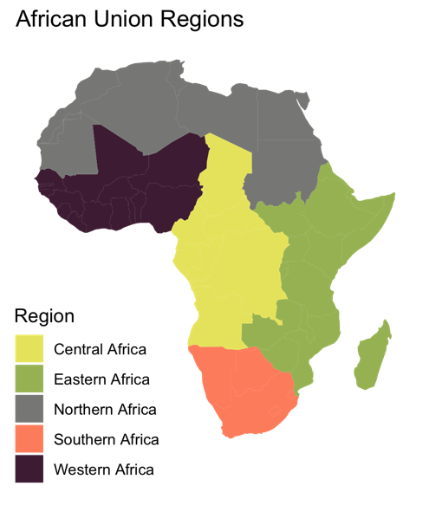

Supplemental Figure 5: A network of the Rising Topics associated with “Crohn’s disease (disease)” within Africa during 2023. The top topics are colored in a faint gray, and the countries (labeled COUNTRY_name), are color coded based on the geographical region within Africa.

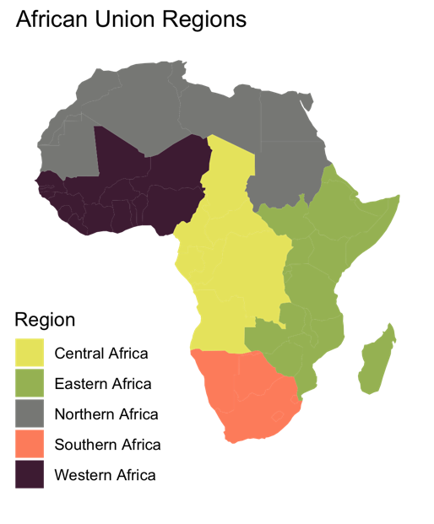

Supplemental Figure 6: A network of the Rising Topics associated with “Ulcerative colitis (disease)” within Africa during 2023. The top topics are colored in a faint gray, and the countries (labeled COUNTRY_name), are color coded based on the geographical region within Africa.

