Additional File 2: Statistical Analysis
- Question (Q8, Q25, Q42, Q59): Preparation for exam
Independent samples Kruskal Wallis Test
All were significant for KS test and SW test so we must run a nonparametric test
H=15.569 (3), p=.001
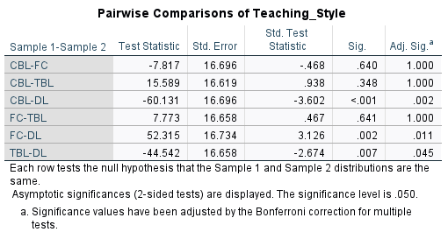
The results indicate that students were significantly more ready for DL style classes compared to FC, TBL, and CBL teaching styles.
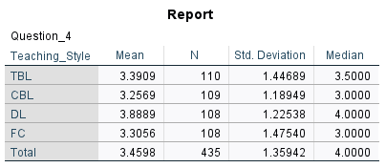

- Questions (Q9-11, Q26-28, Q43-45, Q60-62): Application to clinical experiences
Independent samples Kruskal Wallis Test
H=21.475 (3), p<.001
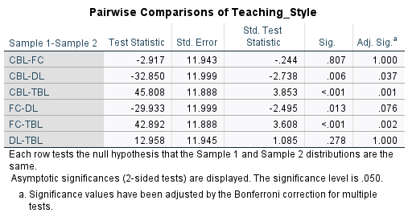
In terms of Clinical Preparedness: TBL was significantly higher compared to FC and CBL. Additionally DL was significantly higher compared to CBL.
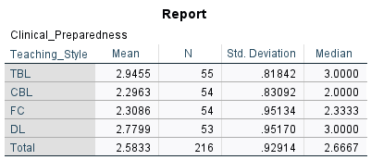

- Question (Q12, 29, 46, 63): Defining their own learning needs
Independent samples Kruskal Wallis Test
H=18.927 (3), p<.001
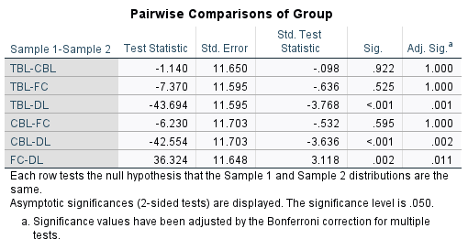
In terms of Learning Needs: DL was significantly higher compared to TBL, CBL, and FC. No other differences were found.
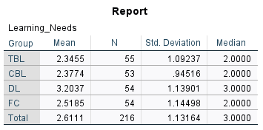

- Question (Q15, 32, 49, 66): Monitoring their learning progress
Independent samples Kruskal Wallis Test
H=11.708 (3), p=.008
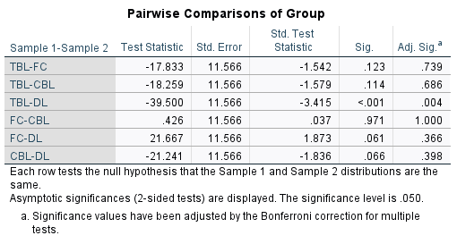
In terms of Learning Process: DL was significantly higher compared to TBL. No other differences were found.
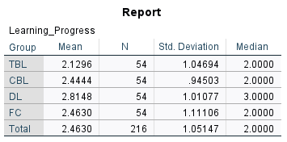

- Question (Q13-14, Q30-31, Q47-48, Q64-65): Information literacy/resource findings
Independent samples Kruskal Wallis Test
H=14.914 (3), p<.001
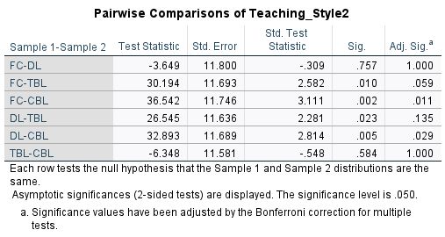
In terms of Information Literacy: CBL was significantly higher compared to FC and DL.
