Supplemental Online Content

Supplementary Table 1. Association of educational status with COVID-19 hospitalization
Supplementary Table 2. Total, mediation, and direct effects of educational status through smoking history on COVID-19 hospitalization, and the proportion of total effect mediated (%) in Female Group
Supplementary Table 3. Total, mediation, and direct effects of educational status through smoking history on COVID-19 hospitalization, and the proportion of total effect mediated (%) in Male Group
Supplementary Table 4. Characteristics in different educational status for participants under the analytic sample. Values are numbers(percentages)
Supplementary Table 5. Association of educational status with COVID-19 hospitalization after IPW
Supplementary Figure 1. Flow diagram of participants
Supplementary Figure 2. Adjusted association of educational status with COVID-19 hospitalization in the absence and presence of smoking history as the mediation
Supplementary Figure 3. Love plot of standardized differences of covariates Before(blue) and After (Red) IPW adjustment

This supplemental material has been provided by the authors to give readers additional information about their work.

Supplementary Table 1. Association of educational status with COVID-19 hospitalizationª
Variables | Model 1 |  |  | Model 2 |  |  | Model3
Variables | (OR,95% CI) | P value |  | (OR, 95% CI) | P value |  | (OR,95% CI) | P value
Educational Status
College or above | 1[reference] | NA |  | 1[reference] | NA |  | 1[reference] | NA
Junior college | 1.25 (1.09,1.44) | <.001 |  | 1.16 (1.00,1.35) | .04 |  | 1.13 (0.98,1.31) | .10
High school/ Technical secondary school | 1.70 (1.48,1.94) | <.001 |  | 1.52 (1.31,1.76) | <.001 |  | 1.44 (1.24,1.66) | <.001
Junior high school | 1.92 (1.64,2.24) | <.001 |  | 1.59 (1.34,1.89) | <.001 |  | 1.48 (1.25,1.76) | <.001
Primary school or below | 2.68 (2.18,3.31) | <.001 |  | 1.95 (1.56,2.44) | <.001 |  | 1.84 (1.46,2.31) | <.001
Age, y
20-29 | NA | NA |  | 1[reference] | NA |  | 1[reference] | NA
30-49 | NA | NA |  | 1.02 (0.89,1.17) | .80 |  | 1.02 (0.89,1.17) | .80
50-64 | NA | NA |  | 0.90 (0.76,1.06) | .21 |  | 0.90 (0.76,1.06) | .21
≥65 | NA | NA |  | 1.13 (0.85,1.51) | .41 |  | 1.13 (0.84,1.50) | .42
Sex
Female | NA | NA |  | 1[reference] | NA |  | 1[reference] | NA
Male | NA | NA |  | 1.30 (1.17,1.44) | <.001 |  | 1.19 (1.07,1.33) | <.001
Salary (RMB/M)
≥10000 | NA | NA |  | 1[reference] | NA |  | 1[reference] | NA
6000-9999 | NA | NA |  | 1.08 (0.95,1.23) | .23 |  | 1.07 (0.94,1.21) | .32
3000-5999 | NA | NA |  | 1.11 (0.96,1.30) | .17 |  | 1.11 (0.95,1.29) | .20
≤2999 | NA | NA |  | 1.37 (1.12,1.68) | <.001 |  | 1.36 (1.11,1.67) | <.001
Residency
Urban area | NA | NA |  | 1[reference] | NA |  | 1[reference] | NA
Rural area | NA | NA |  | 1.14 (1.02,1.27) | .02 |  | 1.16 (1.04,1.30) | <.001
Insurance
No | NA | NA |  | 1[reference] | NA |  | 1[reference] | NA
Yes | NA | NA |  | 1.08 (0.81,1.43) | .60 |  | 1.03 (0.78,1.36) | .85
Vaccine
No | NA | NA |  | 1[reference] | NA |  | 1[reference] | NA
Yes | NA | NA |  | 0.62 (0.55,0.70) | <.001 |  | 0.56 (0.49,0.63) | <.001
Cardiovascular diseases
No | NA | NA |  | 1[reference] | NA |  | 1[reference] | NA
Yes | NA | NA |  | 1.94 (1.72,2.19) | <.001 |  | 1.83 (1.62,2.07) | <.001
Diabetes (Type I/II)
No | NA | NA |  | 1[reference] | NA |  | 1[reference] | NA
Yes | NA | NA |  | 2.02 (1.78,2.30) | <.001 |  | 1.88 (1.65,2.14) | <.001

Supplementary Table 1. Association of educational status with COVID-19 Hospitalizationª (continued)
Variables | Model 1 |  |  | Model 2 |  |  | Model3
Variables | (OR,95% CI) | P value |  | (OR, 95% CI) | P value |  | (OR,95% CI) | P value
Chronic respiratory diseases
No | NA | NA |  | 1[reference] | NA |  | 1[reference] | NA
Yes | NA | NA |  | 1.53 (1.34,1.73) | <.001 |  | 1.43 (1.25,1.63) | <.001
Digestive system diseases
No | NA | NA |  | 1[reference] | NA |  | 1[reference] | NA
Yes | NA | NA |  | 1.20 (1.03,1.40) | .02 |  | 1.17 (1.00,1.37) | .05
Chronic liver diseases
No | NA | NA |  | 1[reference] | NA |  | 1[reference] | NA
Yes | NA | NA |  | 1.03 (0.85,1.26) | .75 |  | 1.02 (0.84,1.24) | .84
Chronic kidney diseases
No | NA | NA |  | 1[reference] | NA |  | 1[reference] | NA
Yes | NA | NA |  | 1.49 (1.19,1.85) | <.001 |  | 1.48 (1.19,1.84) | <.001
Cancer
No | NA | NA |  | 1[reference] | NA |  | 1[reference] | NA
Yes | NA | NA |  | 1.03 (0.79,1.35) | .84 |  | 1.01 (0.77,1.32) | .95
Hematological diseases
No | NA | NA |  | 1[reference] | NA |  | 1[reference] | NA
Yes | NA | NA |  | 0.88 (0.65,1.19) | .40 |  | 0.89 (0.66,1.20) | .44
Allergic diseases
No | NA | NA |  | 1[reference] | NA |  | 1[reference] | NA
Yes | NA | NA |  | 1.09 (0.89,1.34) | .38 |  | 1.07 (0.87,1.30) | .52
Depression/anxiety
No | NA | NA |  | 1[reference] | NA |  | 1[reference] | NA
Yes | NA | NA |  | 1.42 (1.17,1.72) | <.001 |  | 1.37 (1.13,1.66) | <.001
Smoking history
No | NA | NA |  | NA | NA |  | 1[reference] | NA
Yes | NA | NA |  | NA | NA |  | 1.52 (1.35,1.70) | <.001
Model fit parameters
Likelihood Ratio Test  P value | <.001 |  |  | <.001 |  |  | <.001
Pseudo R² | .014 |  |  | .062 |  |  | .066
Abbreviation: CI, confidence interval; OR, odds ratio.
ª Model 1 was adjusted by educational status. Model 2 added age, sex, salary, city, insurance, vaccine, cardiovascular diseases, diabetes (Type I/II), chronic respiratory diseases, digestive system diseases, chronic liver diseases, chronic kidney diseases, cancer, hematological diseases, allergic diseases, depression/anxiety as covariates to the base model. Model 3 added smoking history as a covariate based on Model 2.

Supplementary Table 2. Total, mediation, and direct effects of educational status through smoking history on COVID-19 hospitalization, and the proportion of total effect mediated (%) in female group

 | Total effects ª |  |  | Mediation effects through smoking history ^{b} |  |  |  | Direct effects ^{c}
 | (OR,95% CI) | P value |  | (OR, 95% CI) | P value | Mediation (%)^{d} |  | (OR,95% CI) | P value
Educational status
College or above | 1[reference] | NA |  | 1[reference] | NA |  |  | 1[reference] | NA
Junior college | 1.17(0.91,1.51) | .21 |  | NA | NA |  |  | 1.14(0.89,1.47) | .30
High school/ Technical secondary school | 1.41(1.09,1.81) | .008 |  | 1.06(1.01,1.10) | .01 | 15.92 |  | 1.33(1.04,1.71) | .03
Junior high school | 1.50(1.12,2.00) | .007 |  | 1.09 (1.04,1.14) | <.001 | 21.20 |  | 1.37 (1.02,1.84) | .03
Primary school or below | 2.17(1.49,3.16) | <.001 |  | 1.12 (1.06,1.17) | <.001 | 14.33 |  | 1.94 (1.33,2.84) | .001
Abbreviation: CI, confidence interval; OR, odds ratio; NA, not applicable.
ª Total effect was the effect of educational status on COVID-19 hospitalization adjusted for all the covariates except for smoking history.
^{b} Mediation effect was the effect of educational status on COVID-19 hospitalization through smoking history.
^{c} Direct effect was the effect of educational status on COVID-19 hospitalization adjusted for all the covariates including smoking history.
^{d} Mediation (%) was calculated by mediation effect/total effect ×100%.

Supplementary Table 3. Total, mediation, and direct effects of educational status through smoking history on COVID-19 hospitalization, and the proportion of total effect mediated (%) in male group

 | Total effects ª |  |  | Mediation effects through smoking history ^{b} |  |  |  | Direct effects^{c}
 | (OR, 95% CI) | P value |  | (OR, 95% CI) | P value | Mediation (%) ^{d} |  | (OR,95% CI) | P value
Educational status
College or above | 1[reference] | NA |  | 1[reference] | NA |  |  | 1[reference] | NA
Junior college | 1.13(0.94,1.36) | .18 |  | NA | NA |  |  | 1.11(0.93,1.33) | .26
High school/ Technical secondary school | 1.54(1.29,1.84) | <.001 |  | 1.04(1.01,1.06) | .002 | 8.70 |  | 1.49(1.24,1.77) | <.001
Junior high school | 1.61(1.30,1.99) | <.001 |  | 1.04(1.02,1.07) | .002 | 9.08 |  | 1.54(1.25,1.91) | <.001
Primary school or below | 1.81(1.36,2.40) | <.001 |  | 1.03(1.01,1.05) | .01 | 4.46 |  | 1.76(1.32,2.34) | <.001
Abbreviation: CI, confidence interval; OR, odds ratio; NA, not applicable.
ª Total effect was the effect of educational status on COVID-19 hospitalization adjusted for all the covariates except for smoking history.
^{b} Mediation effect was the effect of educational status on COVID-19 hospitalization through smoking history.
^{c} Direct effect was the effect of educational status on COVID-19 hospitalization adjusted for all the covariates including smoking history.
^{d} Mediation (%) was calculated by mediation effect/total effect ×100%.

Supplementary Table 4. Characteristics in different educational status for participants under the analytic sample. Values are numbers(percentages).
Educational status/  Variables | College or above  (n=9381) | Junior college  (n=6301) | High school/ Technical secondary school  (n=5938) | Junior high school  (n=3123) | Primary school or below  (n=1084) | Standardized  difference (%)
Age, No. (%), y
20-29 | 1664 (17.7) | 1092 (17.3) | 1004 (16.9) | 1304 (41.8) | 195 (18.0) | 3.9
30-49 | 5583 (59.5) | 3767 (59.8) | 3537 (59.6) | 580 (18.6) | 624 (57.6) | 3.9
50-64 | 1787 (19.0) | 1238 (19.6) | 1188 (25.0) | 612 (19.6) | 229 (21.1) | 3.9
≥65 | 347 (3.8) | 204 (3.3) | 209 (3.5) | 98 (3.0) | 36 (3.3) | 3.9
Sex, No. (%)
Male | 5315 (56.7) | 3649 (57.9) | 3327 (56.0) | 1650 (52.8) | 636 (58.7) | 5.5
Female | 4066 (43.3) | 2652 (42.1) | 2611 (44.0) | 1473 (47.2) | 448 (41.3) | 5.5
Salary, No. (%), (RMB/M)
≥10000 | 1503 (16.0) | 1455 (23.1) | 2171 (36.6) | 1625 (52.0) | 731 (67.4) | 70.9
6000-9999 | 2927 (31.2) | 2994 (47.5) | 2698 (45.4) | 1099 (35.2) | 223 (20.6) | 70.9
3000-5999 | 3192 (34.0) | 1524 (24.2) | 825 (13.9) | 303 (9.7) | 89 (8.2) | 70.9
≤2999 | 1759 (18.8) | 328 (5.2) | 244 (4.1) | 96 (3.1) | 41 (3.8) | 70.9
Residency, No.(%)
Urban area | 7797 (83.1) | 4511 (71.6) | 3734 (62.9) | 1819 (58.2) | 722 (66.6) | 26.2
Rural area | 1584 (16.9) | 1790 (28.4) | 2204 (37.1) | 1304 (41.8) | 362 (33.4) | 26.2
Insurance, No. (%)
Yes | 9164 (97.7) | 6148 (97.6) | 5696 (95.9) | 2899 (92.8) | 974 (89.9) | 17.8
No | 217 (2.3) | 153 (2.4) | 242 (4.1) | 224 (7.2) | 110 (10.1) | 17.8

Supplementary Table 4. Characteristics in different educational status for participants under the analytic sample. Values are numbers(percentages). (continued)
Educational status/  Variables | College or above  (n=9381) | Junior college  (n=6301) | High school/ Technical secondary school  (n=5938) | Junior high school  (n=3123) | Primary school or below  (n=1084) | Standardized  difference (%)
Vaccine, No. (%)
Yes | 8266 (88.1) | 5505 (87.4) | 5169 (87.0) | 2605 (83.4) | 759 (70.0) | 20.5
No | 1115 (11.9) | 796 (12.6) | 769 (13.0) | 518 (16.6) | 325 (30.0) | 20.5
Cardiovascular diseases, No. (%)
Yes | 864 (9.2) | 788 (12.5) | 959 (16.2) | 670 (21.5) | 381 (35.1) | 31.0
No | 8517 (90.8) | 5513 (87.5) | 4979 (83.8) | 2453 (78.5) | 703 (64.9) | 31.0
Diabetes (TypeI/II), No. (%)
Yes | 624 (6.7) | 732 (11.6) | 861 (14.5) | 583 (18.7) | 199 (18.4) | 18.5
No | 8757 (93.3) | 5569 (88.4) | 5077 (85.5) | 2540 (81.3) | 885 (81.6) | 18.5
Chronic respiratory diseases, No. (%)
Yes | 894 (9.5) | 917 (14.6) | 941 (15.8) | 529 (16.9) | 169 (15.6) | 9.5
No | 8487 (90.5) | 5384 (85.4) | 4997 (84.2) | 2594 (83.1) | 915 (84.4) | 9.5
Digestive system diseases, No. (%)
Yes | 723 (7.7) | 609 (9.7) | 629 (10.6) | 350 (11.2) | 107 (9.9) | 5.4
No | 8658 (92.3) | 5692 (90.3) | 5309 (89.4) | 2773 (88.8) | 977 (90.1) | 5.4

Supplementary Table 4. Characteristics in different educational status for participants under the analytic sample. Values are numbers(percentages). (continued)
Educational status/  Variables | College or above  (n=9381) | Junior college  (n=6301) | High school/ Technical secondary school  (n=5938) | Junior high school  (n=3123) | Primary school or below  (n=1084) | Standardized  difference (%)
Chronic liver diseases, No. (%)
Yes | 391 (4.2) | 386 (6.1) | 379 (6.4) | 207 (6.6) | 60 (5.5) | 5.1
No | 8990 (95.8) | 5915 (93.9) | 5559 (93.6) | 2916 (93.4) | 1024 (94.5) | 5.1
Chronic kidney diseases, No. (%)
Yes | 220 (2.3) | 215 (3.4) | 229 (3.9) | 126 (4.0) | 57 (5.3) | 6.8
No | 9161 (97.7) | 6086 (96.6) | 5709 (96.1) | 2997 (96.0) | 102 (94.7) | 6.8
Cancer, No. (%)
Yes | 161 (1.7) | 181 (2.9) | 182 (3.1) | 115 (3.7) | 49 (4.5) | 7.5
No | 9220 (98.3) | 6120 (97.1) | 5756 (96.9) | 3008 (96.3) | 1035 (95.5) | 7.5
Hematological diseases, No. (%)
Yes | 133 (1.4) | 131 (2.1) | 139 (2.3) | 93 (3.0) | 41 (3.8) | 7.2
No | 9248 (98.6) | 6170 (97.9) | 5799 (97.7) | 3030 (97.0) | 1043 (96.2) | 7.2
Allergic diseases, No. (%)
Yes | 582 (6.2) | 364 (5.8) | 327 (5.5) | 212 (6.8) | 62 (5.7) | 2.5
No | 8799 (93.8) | 5937 (94.2) | 5611 (94.5) | 2911 (93.2) | 1022 (94.3) | 2.5
Depression/anxiety, No. (%)
Yes | 516 (5.5) | 351 (5.8) | 338 (5.7) | 193 (6.2) | 64 (5.9) | 1.4
No | 8865 (94.5) | 5950 (94.2) | 5600 (94.3) | 2930 (93.8) | 1020 (94.1) | 1.4
Smoking history, No. (%)
No | 7569 (80.7) | 4564 (72.4) | 3961 (66.7) | 1980 (63.4) | 711 (65.6) | 18.6
Yes | 1812 (19.3) | 1737 (27.6) | 1977 (33.3) | 1143(36.6) | 373 (34.4) | 18.6

Supplementary Table 5. Association of educational dtatus with COVID-19 hospitalization after IPW
Variables | Model
Variables | (OR,95% CI) | P value
Educational status
College or above | ref. | NA
Junior college | 1.12 (0.94,1.33) | .20
High school/ Technical secondary School | 1.38 (1.17,1.63) | <.001
Junior high school | 1.58 (1.29,1.93) | <.001
Primary school or below | 2.31 (1.67,3.21) | <.001
Age
20-29 | ref. | NA
30-49 | 0.97 (0.81,1.14) | .68
50-64 | 0.82 (0.66,1.00) | .05
≥65 | 1.06 (0.75,1.49) | .73
Sex
Female | ref. | NA
Male | 1.16 (1.01,1.33) | .04
Salary (RMB/M)
≥10000 | ref. | NA
6000-9999 | 1.10 (0.94,1.29) | .24
3000-5999 | 1.14 (0.95,1.36) | .16
≤2999 | 1.29 (1.01,1.64) | .04
Residency
Urban area | ref. | NA
Rural area | 1.12 (0.97,1.29) | .12
Insurance
No | ref. | NA
Yes | 0.74 (0.47,1.15) | .17
Vaccine
No | ref. | NA
Yes | 0.56 (0.48,0.67) | <.001
Cardiovascular diseases
No | ref.
Yes | 1.90 (1.62,2.23) | <.001
Diabetes (TypeI/II)
No | ref. | NA
Yes | 1.74 (1.46,2.08) | <.001
Chronic respiratory diseases
No | ref. | NA
Yes | 1.35 (1.14,1.60) | <.001
Digestive system diseases
No | ref. | NA
Yes | 1.26 (1.02,1.55) | .03
Chronic liver diseases
No | ref. | NA
Yes | 0.95 (0.75,1.22) | .71
Chronic kidney diseases
No | ref. | NA
Yes | 1.42 (1.07,1.88) | .01
Cancer
No | ref. | NA
Yes | 0.86 (0.61,1.20) | .37
Hematological diseases
No | ref. | NA
Yes | 0.78 (0.52,1.16) | .21
Allergic diseases
No | ref. | NA
Yes | 1.16 (0.90,1.49) | .25
Depression/anxiety
No | ref. | NA
Yes | 1.22 (0.95,1.55) | .12
Smoking history
No | ref. | NA
Yes | 1.46 (1.25,1.70) | <.001
Abbreviation: CI, confidence interval; OR, odds ratio.

Supplementary Fig 1. Flow diagram of participants

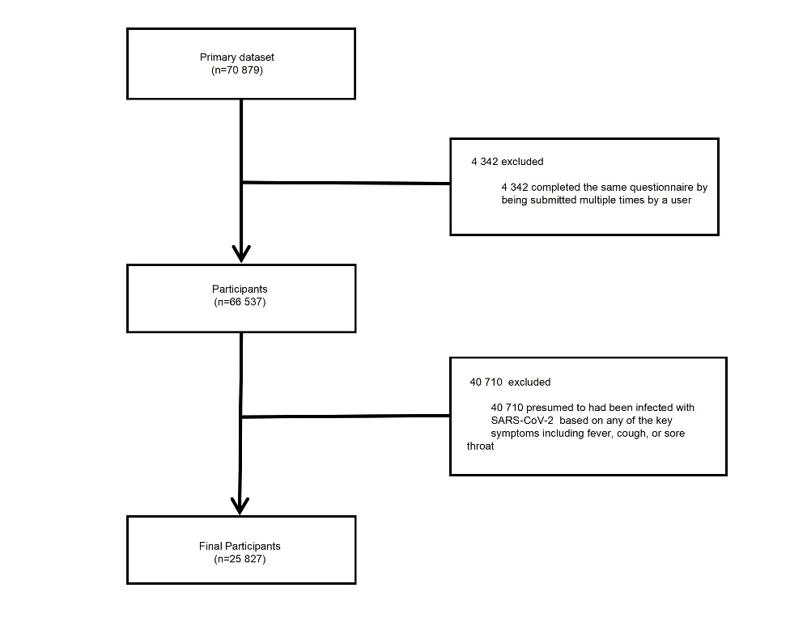

Supplementary Fig 2. Adjusted association of educational status with COVID-19 hospitalization in the absence and presence of smoking history as the potential mediation
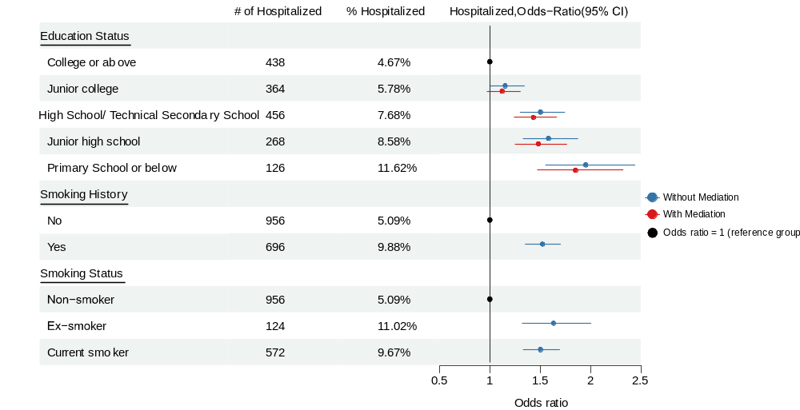
Abbreviation: CI, confidence interval.
Notes: The models were also adjusted for other covariates.

Supplementary Fig 3. Love plot of standardized differences of covariates Before(blue) and After (Red) IPW Adjustment.
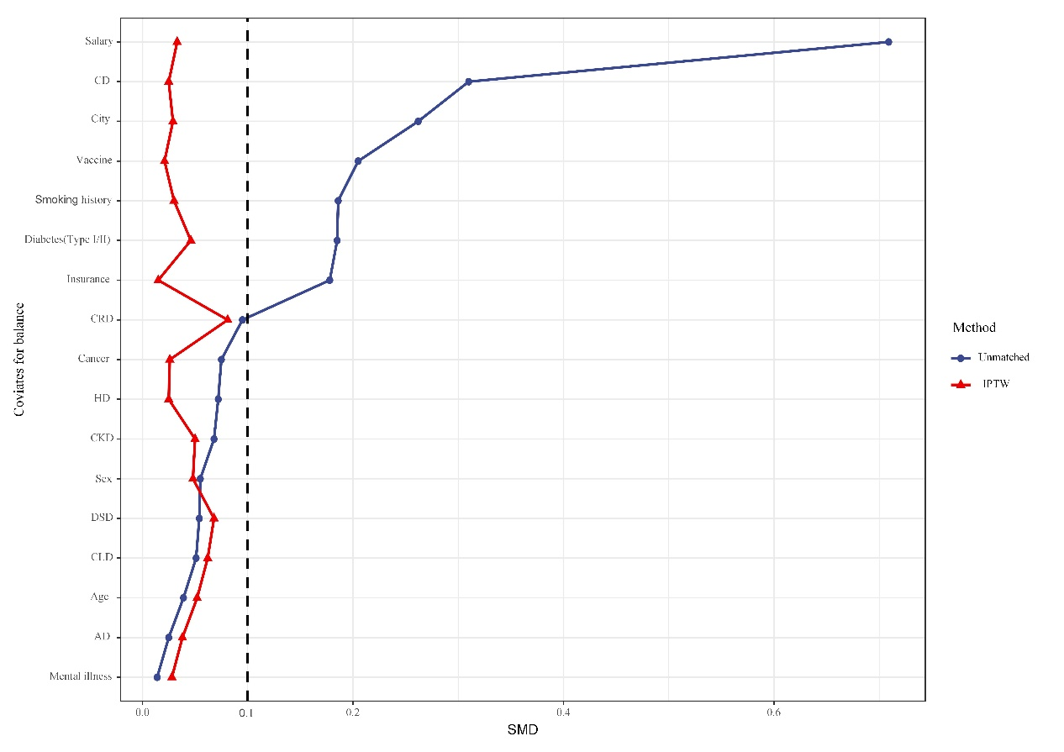
Abbreviation: CD, Cardiovascular Diseases; CRD, Chronic Respiratory Diseases; HD, Hematological Diseases; CKD, Chronic Kidney Diseases; DSD, Digestive System diseases; CLD, Chronic Liver Diseases; AD, Allergic Diseases; SMD, Absolute standardized mean differences; IPW, Inverse propensity weighting.
Notes: After inverse probability weighting adjustment, participants with different educational status were well matched on all characteristics, with an absolute standardized difference less than 10%. (all the red points lower than dashed line）.

