Supplementary Materials for

Identification of potential SARS-CoV-2 genetic markers resulting from host domestication

Janusz Wiśniewski* and Heng-Chang Chen*

*Corresponding authors. Email: Janusz.Wisniewski@port.lukasiewicz.gov.pl; heng-chang.chen@port.lukasiewicz.gov.pl

This PDF file includes:

Supplementary Text
Figs. S1 to S6
Tables S1 to S13

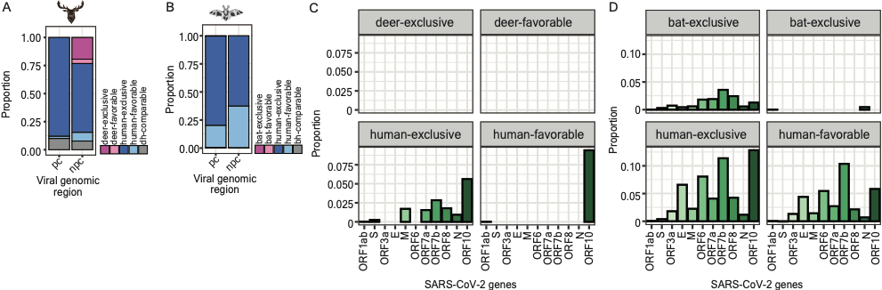

Fig. S1.
Landscapes of enriched k-mers across the SARS-CoV-2 genome. (A, B) Stacked bar charts representing the proportion of enriched k-mers that overlay with the protein-coding (pc) and non-protein coding (npc) regions throughout the SARS-CoV-2 genome (A, enriched k-mers identified in the deer dataset; B, enriched k-mers identified in the bat dataset). The dark pink color indicates the SARS-CoV-2 genomic loci overlaid exclusively with enriched k-mers identified in deer (A) or bat (B) isolates; The light pink color indicates the loci overlaid preferentially with enriched k-mers identified in deer (A) or bat (B) isolates; the dark blue color indicates the SARS-CoV-2 genomic loci overlaid exclusively with enriched k-mers identified in human isolates collected in the deer (A) or bat (B) dataset; the light blue color indicates the SARS-CoV-2 genomic loci overlaid preferentially with enriched k-mers identified in human isolates collected in the deer (A) or bat (B) dataset; the grey color indicates the loci targeted by the identical number of enriched k-mers between animal (deer and bat) and human isolates. (C, D) Bar charts representing the enrichment of enriched k-mers identified in the deer (C) and bat (D) datasets per SARS-CoV-2 gene. The calculation of the enrichment is described in the Materials and Methods. Four facets in the panel (C) and (D) are separated based on the intrinsic property of a genomic locus designated as deer- (C) or bat- (D) exclusive sites or deer- (C) or bat- (D) favorable sites. Details are referred to in the main text.

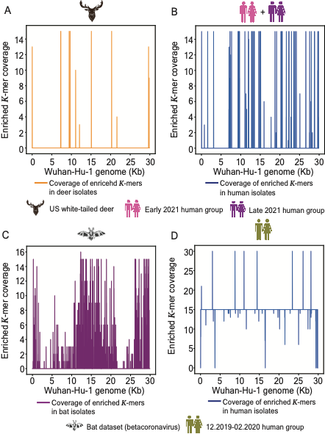

Fig. S2.
The coverage landscapes of enriched k-mers across the SARS-CoV-2 genome. (A, B, C, D) Line plots representing the coverage of the SARS-CoV-2 genome per site overlaid with enriched k-mers identified in deer (A) and human (B) isolates collected in the deer dataset or bat (C) and human (D) isolates collected in the bat dataset.

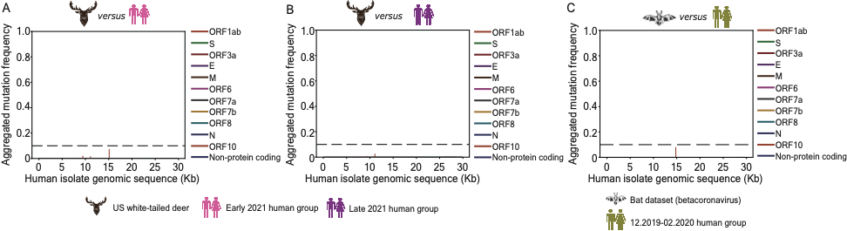

Fig. S3.
Verification of the specificity of mutations emerging from the enriched k-mers identified in animal isolates. (A, B) Line plots representing the frequency of the presence of mutations detected from the enriched k-mers in deer isolates against the genomic sequences of human isolates collected in the early (A) and late (B) 2021 human groups. (C) Line plots representing the frequency of the presence of mutations detected from the enriched k-mers in bat isolates against the genomic sequences of human isolates collected in the bat dataset.
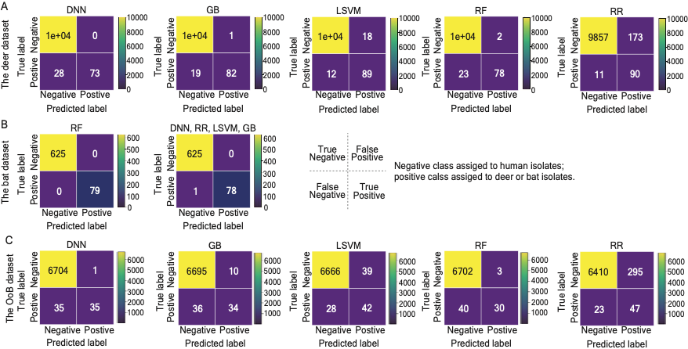

Fig. S4.
Prediction summary of the robustness of testing classifiers subjected to different model architectures. Confusion matrices summarizing the number of predictions that are true negative (top corner on the left-hand side), true positive (bottom corner on the right-hand side), false negative (bottom corner on the left-hand side), and false positive (top corner on the right-hand side). The negative class is designated to individual SARS-CoV-2 genomes predicted as human isolates; the positive class is designated to individual SARS-CoV-2 genomes predicted as animal (deer or bats) isolates. Classifiers were constructed based on the total count of enriched k-mers and subjected to the following models, dense neural network (DNN), gradient boosting (GB), linear support vector machine (LSVM), random forest (RF), ridge regression (RR). We applied them to predict the most probable host species of individual SARS-CoV-2 genomic sequences collected in the deer (A), bat (B), and out of the bag (OoB) datasets (C).
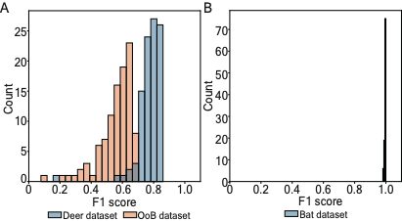

Fig. S5.
Bootstrapping on the subsets of metagenomes in testing datasets. (A, B) Histogram representing the distribution of F1 scores measured from 100 independent train-test splits on single genomes of isolates collected in the deer, OoB (A), and bat (B) datasets.
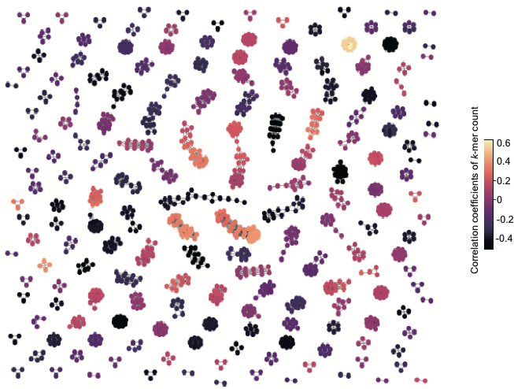

Fig. S6.
Correlation distribution of a subset of enriched k-mers identified in the deer dataset based on their counts. Graph network representing a correlation of the groups of k-mers with a high correlation of their counts. Nodes represent individual enriched k-mers; edges represent a correlation coefficient of more than 0.9 between two adjacent nodes. The color scale represents the absolute value of the correlation coefficient computed based on the count of enriched k-mers.

Table S1.
Deer dataset: US white-tailed deer group - EPI_SET_240422va, https://doi.org/10.55876/gis8.240422va.
GISIAD supplemental table for deer coronavirus sequences of deer dataset.

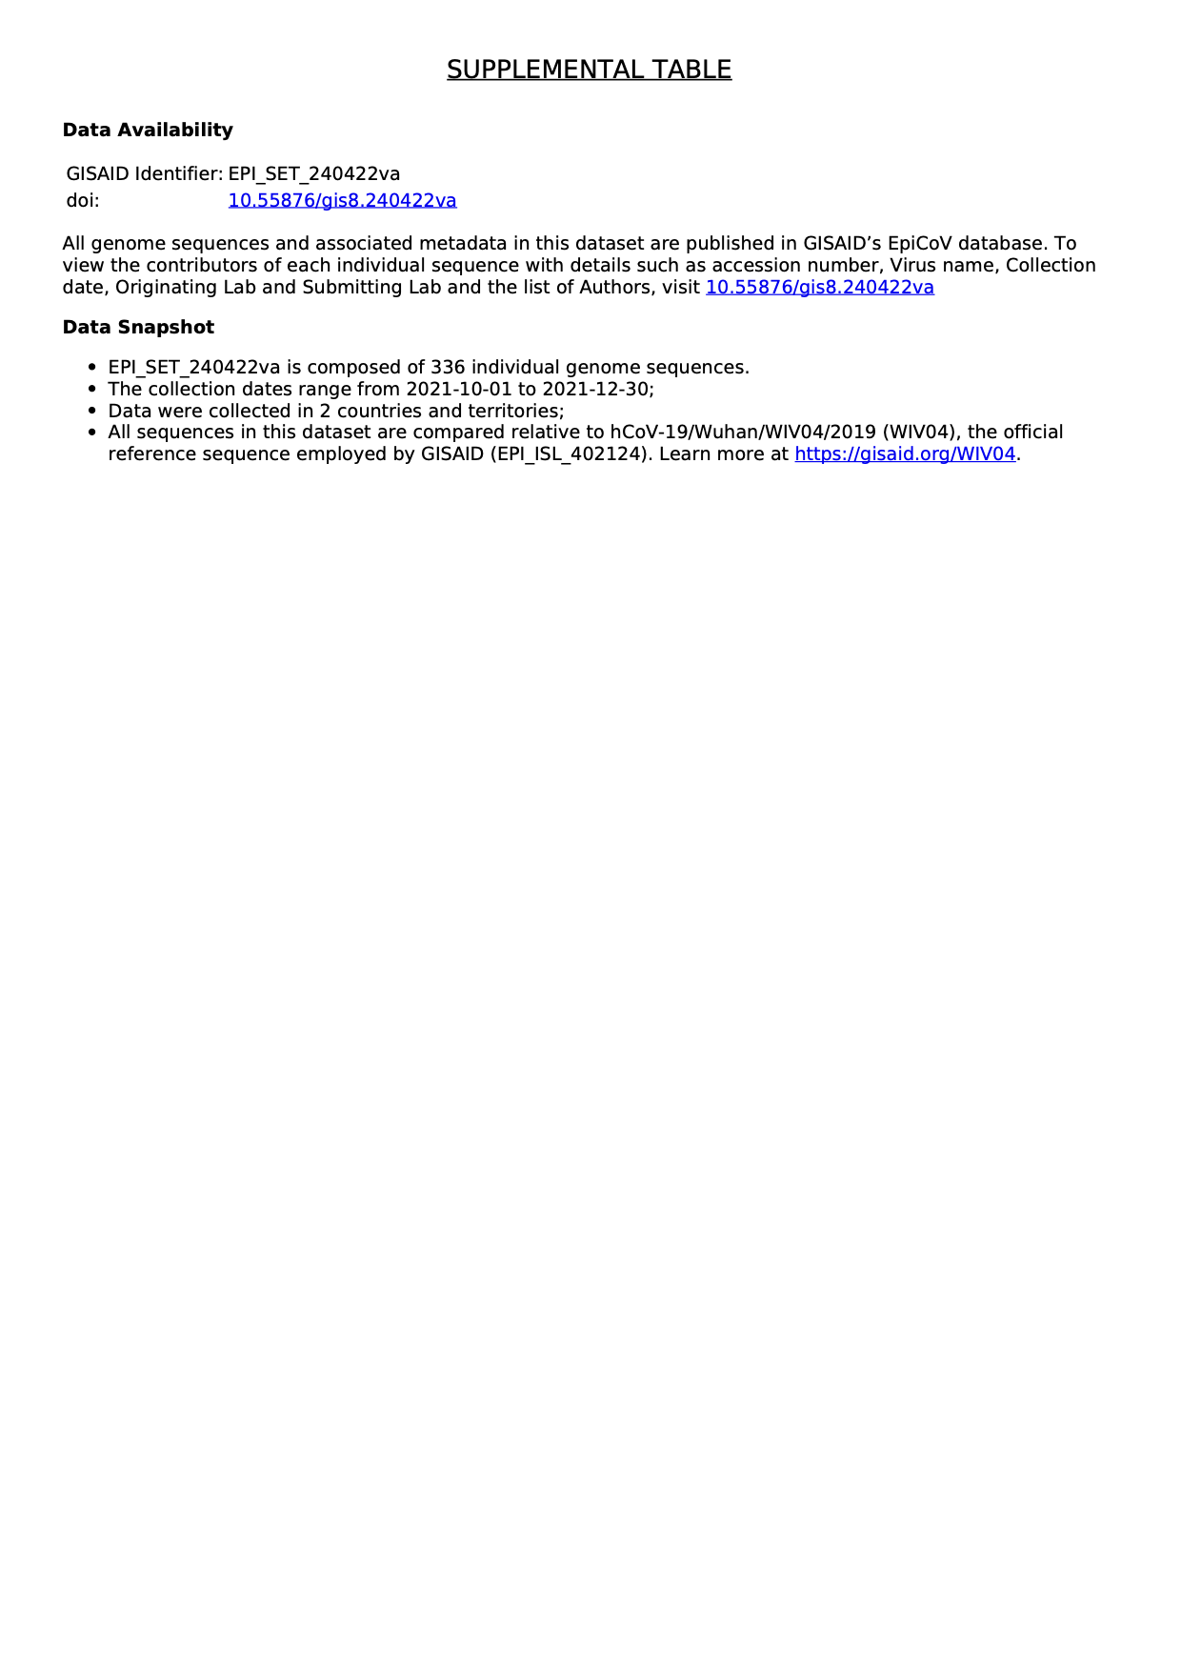

Table S2.
Deer dataset: early 2021 human group (April 2021) - EPI_SET_240422rw, https://doi.org/10.55876/gis8.240422rw.
GISIAD supplemental table for early 2021 human coronavirus sequences of deer dataset.
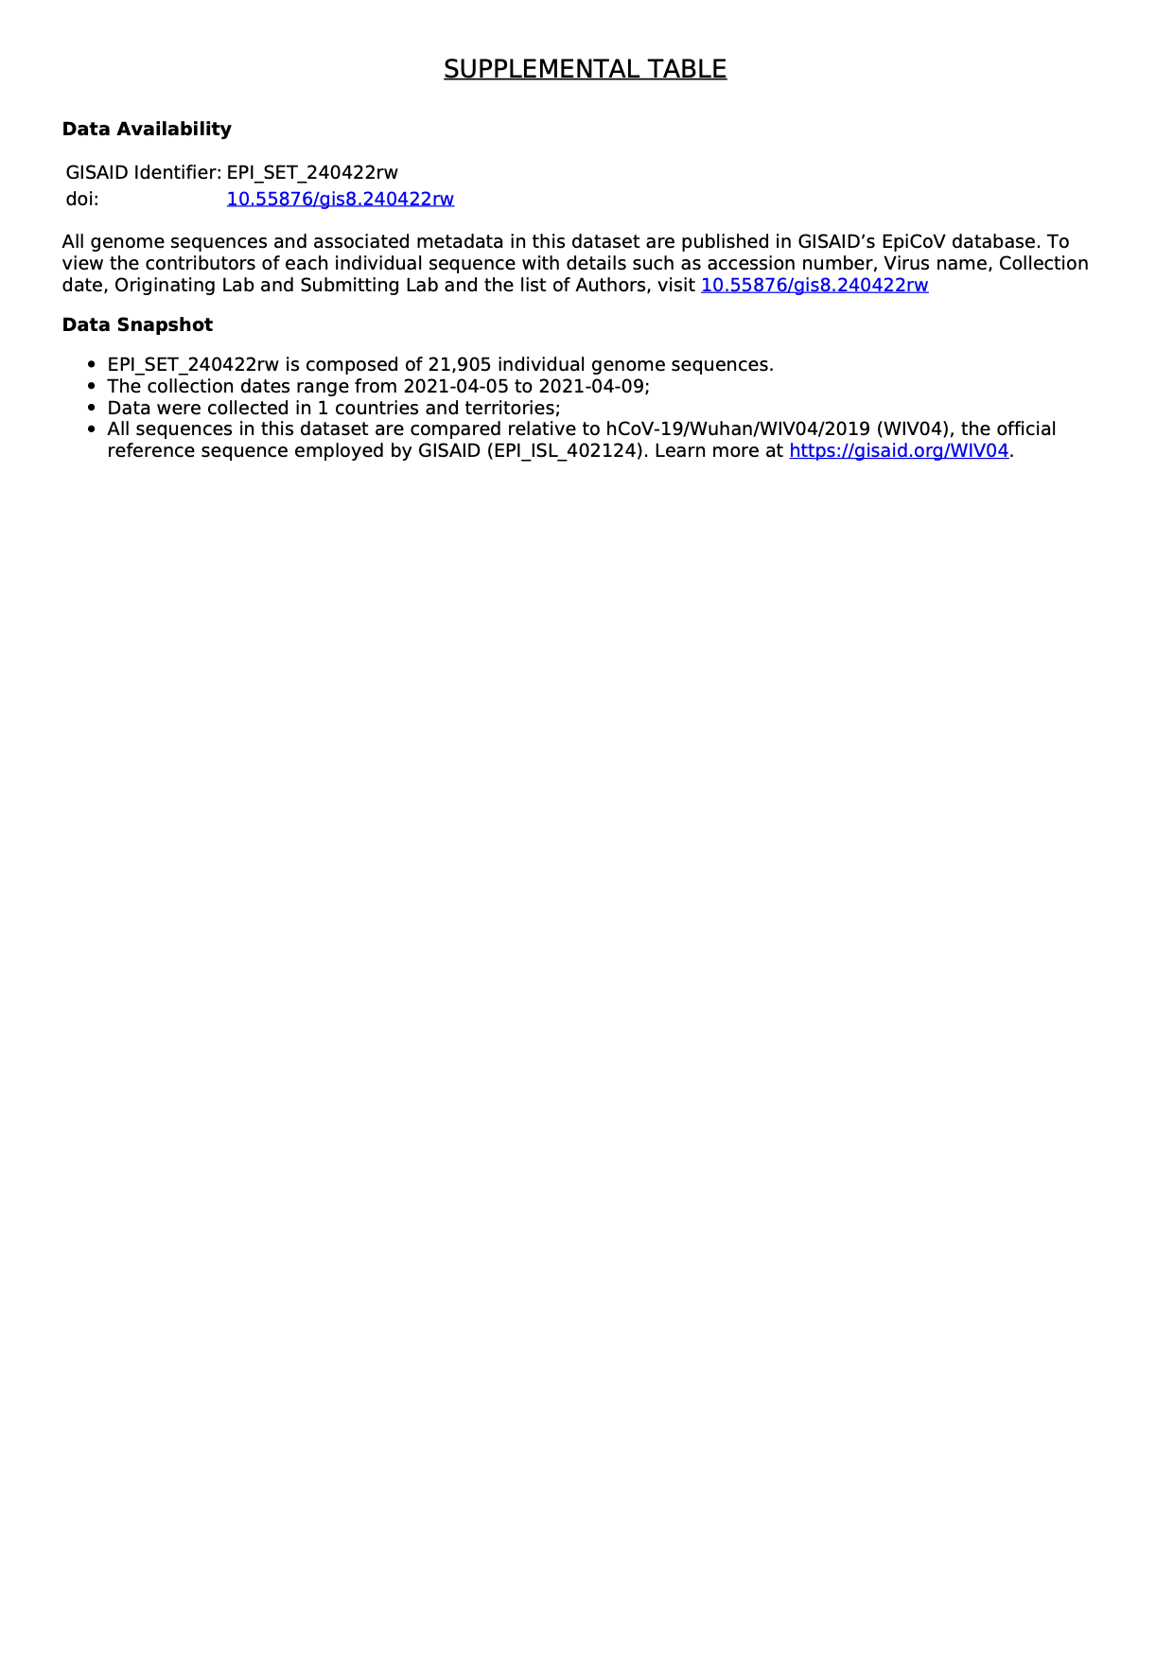

Table S3.
Deer set: late 2021 human group (November 2021) - EPI_SET_240422qc, https://doi.org/10.55876/gis8.240422qc.
GISIAD supplemental table for late 2021 human coronavirus sequences of deer dataset.
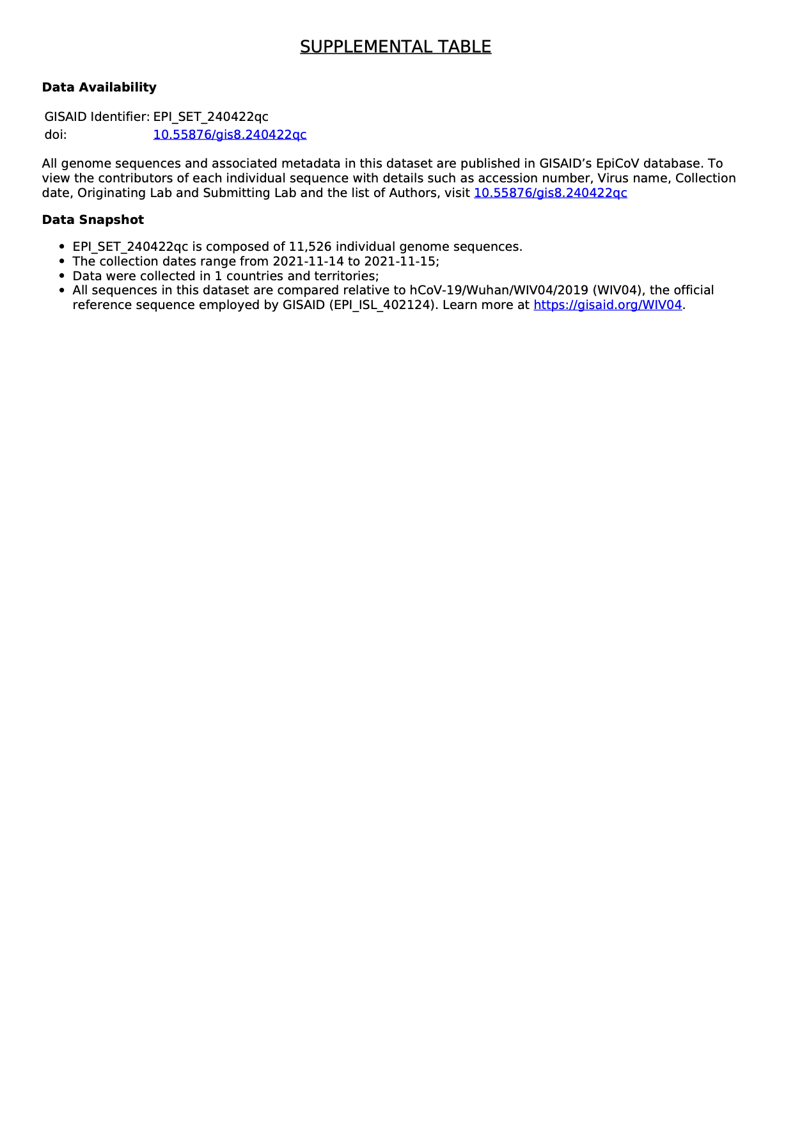

Table S4.
OoB dataset: US white-tailed deer group - EPI_SET_240422oy, https://doi.org/10.55876/gis8.240422oy.
GISIAD supplemental table for deer coronavirus sequences of OoB dataset.
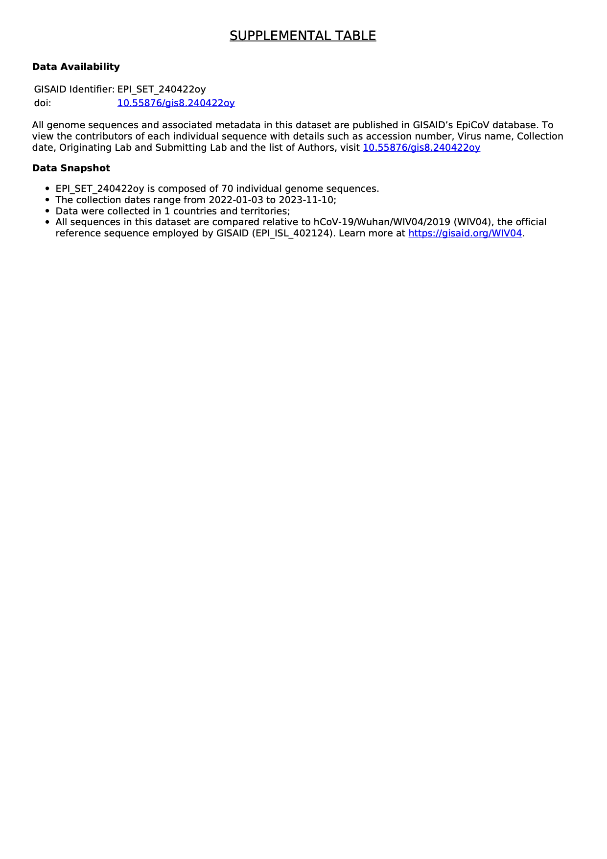

Table S5.
OoB dataset: human group - EPI_SET_240422xu, https://doi.org/10.55876/gis8.240422xu.
GISIAD supplemental table for human coronavirus sequences of OoB dataset.
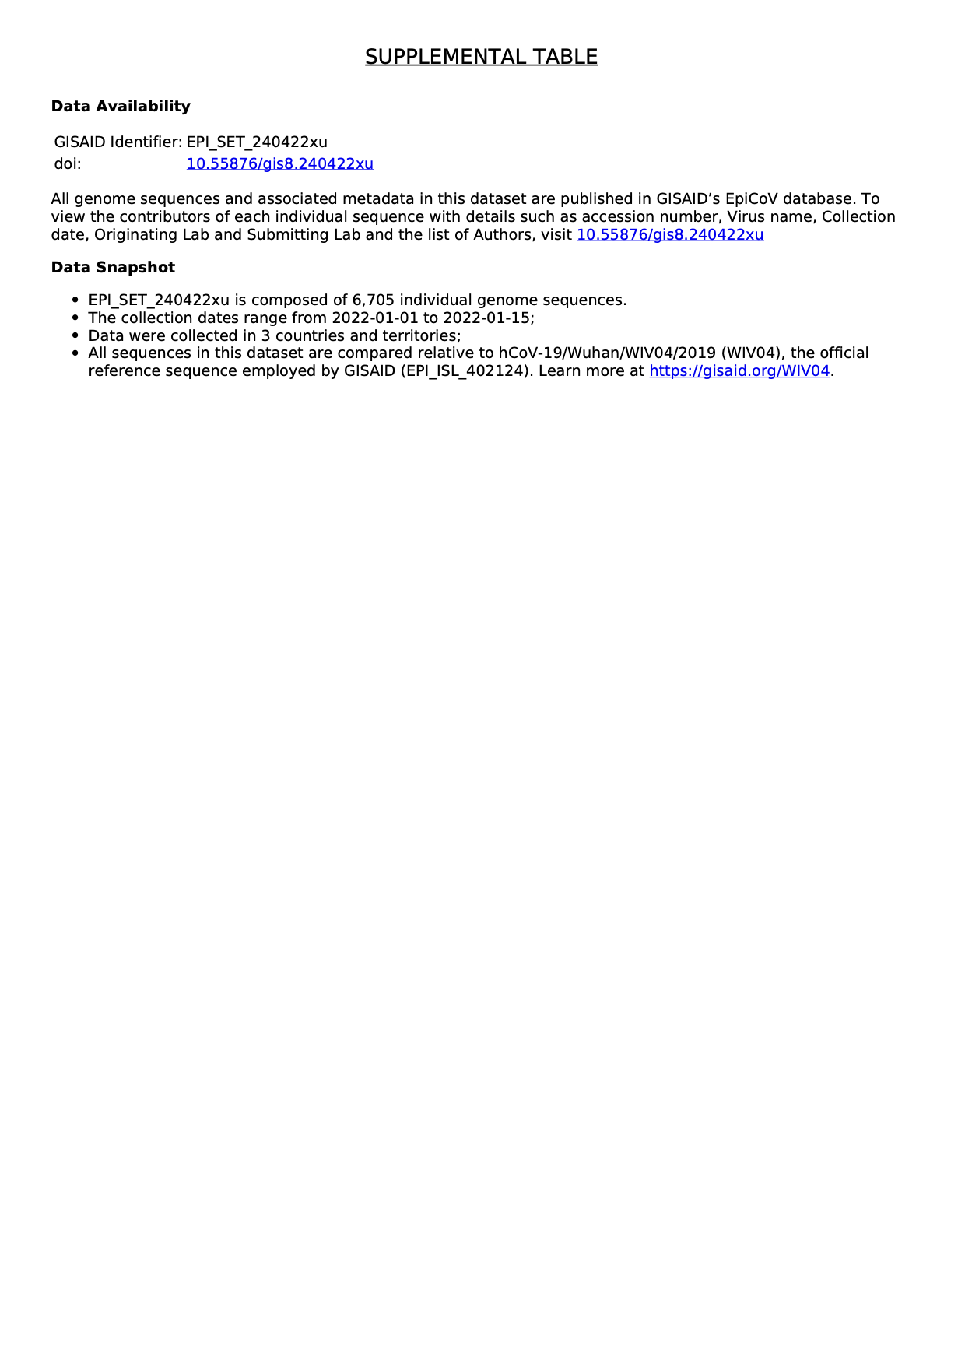

Table S6.
Bat dataset: bat group - NCBI Virus accession numbers.
NCBI Virus accession numbers of bat coronavirus sequences used in the bat dataset.

NC_030886.1

NC_025217.1

NC_014470.1

NC_009019.1

NC_009020.1

NC_009021.1

OR261262.1

OR261263.1

OR261264.1

OR261265.1

OR261266.1

OR261267.1

OR261268.1

OR233291.1

OR233292.1

OR233293.1

OR233294.1

OR233295.1

OR233296.1

OR233297.1

OR233298.1

OR233299.1

OR233300.1

OR233301.1

OR233302.1

OR233303.1

OR233304.1

OR233305.1

OR233308.1

OR233310.1

OR233311.1

OR233312.1

OR233313.1

OR233314.1

OR233316.1

OR233317.1

OR233318.1

OR233319.1

OR233320.1

OR233321.1

OR233322.1

OR233323.1

OR233324.1

OR233325.1

OR233328.1

OQ503495.1

OQ503496.1

OQ503497.1

OQ503498.1

OQ503499.1

OQ503500.1

OQ503501.1

OQ503502.1

OQ503503.1

OQ503504.1

OQ503505.1

OQ503506.1

OK017908.1

OQ401247.1

OQ401248.1

OQ401249.1

OQ401251.1

OQ405399.1

OP776338.1

OP776339.1

OP776340.1

OM995890.1

OM995891.1

LC663783.1

LC706863.1

LC706864.1

LC706865.1

LC663793.1

OK287354.1

OK287355.1

ON325306.1

ON325307.1

MZ293739.1

MZ293752.1

MZ293753.1

MZ293754.1

MZ293755.1

MZ293756.1

ON378802.1

ON378807.1

OM240725.1

MW681002.1

OK067319.1

OK067320.1

OK067321.1

OL674074.1

OL674075.1

OL674076.1

OL674077.1

OL674078.1

OL674079.1

OL674080.1

OL674081.1

MZ328294.1

MZ328297.1

OK017792.1

OK017793.1

OK017794.1

OK017795.1

OK017796.1

OK017797.1

OK017798.1

OK017799.1

OK017800.1

OK017801.1

OK017802.1

OK017803.1

OK017804.1

OK017805.1

OK017806.1

OK017807.1

OK017808.1

OK017809.1

OK017810.1

OK017811.1

OK017812.1

OK017813.1

OK017814.1

OK017815.1

OK017816.1

OK017817.1

OK017818.1

OK017819.1

OK017820.1

OK017821.1

OK017822.1

OK017823.1

OK017824.1

OK017825.1

OK017826.1

OK017827.1

OK017828.1

OK017829.1

OK017830.1

OK017831.1

OK017832.1

OK017833.1

OK017834.1

OK017835.1

OK017836.1

OK017837.1

OK017838.1

OK017839.1

OK017840.1

OK017841.1

OK017842.1

OK017843.1

OK017844.1

OK017845.1

OK017846.1

OK017847.1

OK017848.1

OK017849.1

OK017850.1

OK017851.1

OK017852.1

OK017853.1

OK017854.1

OK017855.1

OK017856.1

OK017857.1

OK017858.1

OK017859.1

OK017860.1

MW719567.1

MZ081376.1

MZ081377.1

MZ081378.1

MZ081379.1

MZ081380.1

MZ081381.1

MZ081382.1

MZ190137.1

MZ190138.1

MT726043.1

MT726045.1

MW703458.1

MW251308.1

MW218395.1

LC556375.1

MT350598.1

MN996532.2

MN611519.1

MN611520.1

MK211374.1

MK211375.1

MK211376.1

MK211377.1

MK211378.1

MK211379.1

KY352407.1

MF593268.1

MG772933.1

MG772934.1

MG762674.1

KX442564.1

KX442565.1

MG596802.1

MG596803.1

KY417142.1

KY417143.1

KY417144.1

KY417145.1

KY417146.1

KY417147.1

KY417148.1

KY417149.1

KY417150.1

KY417151.1

KY417152.1

KY938558.1

KU973692.1

KY770858.1

KY770859.1

KY770860.1

KU762338.1

KU182964.1

KT444582.1

KJ473811.1

KJ473812.1

KJ473813.1

KJ473814.1

KJ473815.1

KJ473816.1

KJ473820.1

KJ473822.1

KP886808.1

KP886809.1

KF636752.1

KJ473821.1

KF569996.1

KC881005.1

KC881006.1

KF367457.1

KC869678.4

JX993987.1

JX993988.1

HM211098.1

HM211099.1

HM211100.1

HM211101.1

GU190215.1

FJ588686.1

EF065505.1

EF065506.1

EF065507.1

EF065508.1

EF065509.1

EF065510.1

EF065511.1

EF065512.1

EF065513.1

EF065514.1

EF065515.1

EF065516.1

DQ412042.1

DQ412043.1

DQ071615.1

Table S7.
Bat dataset, human group - EPI_SET_240422qm, https://doi.org/10.55876/gis8.240422qm.
GISIAD supplemental table for human coronavirus sequences of bat dataset.
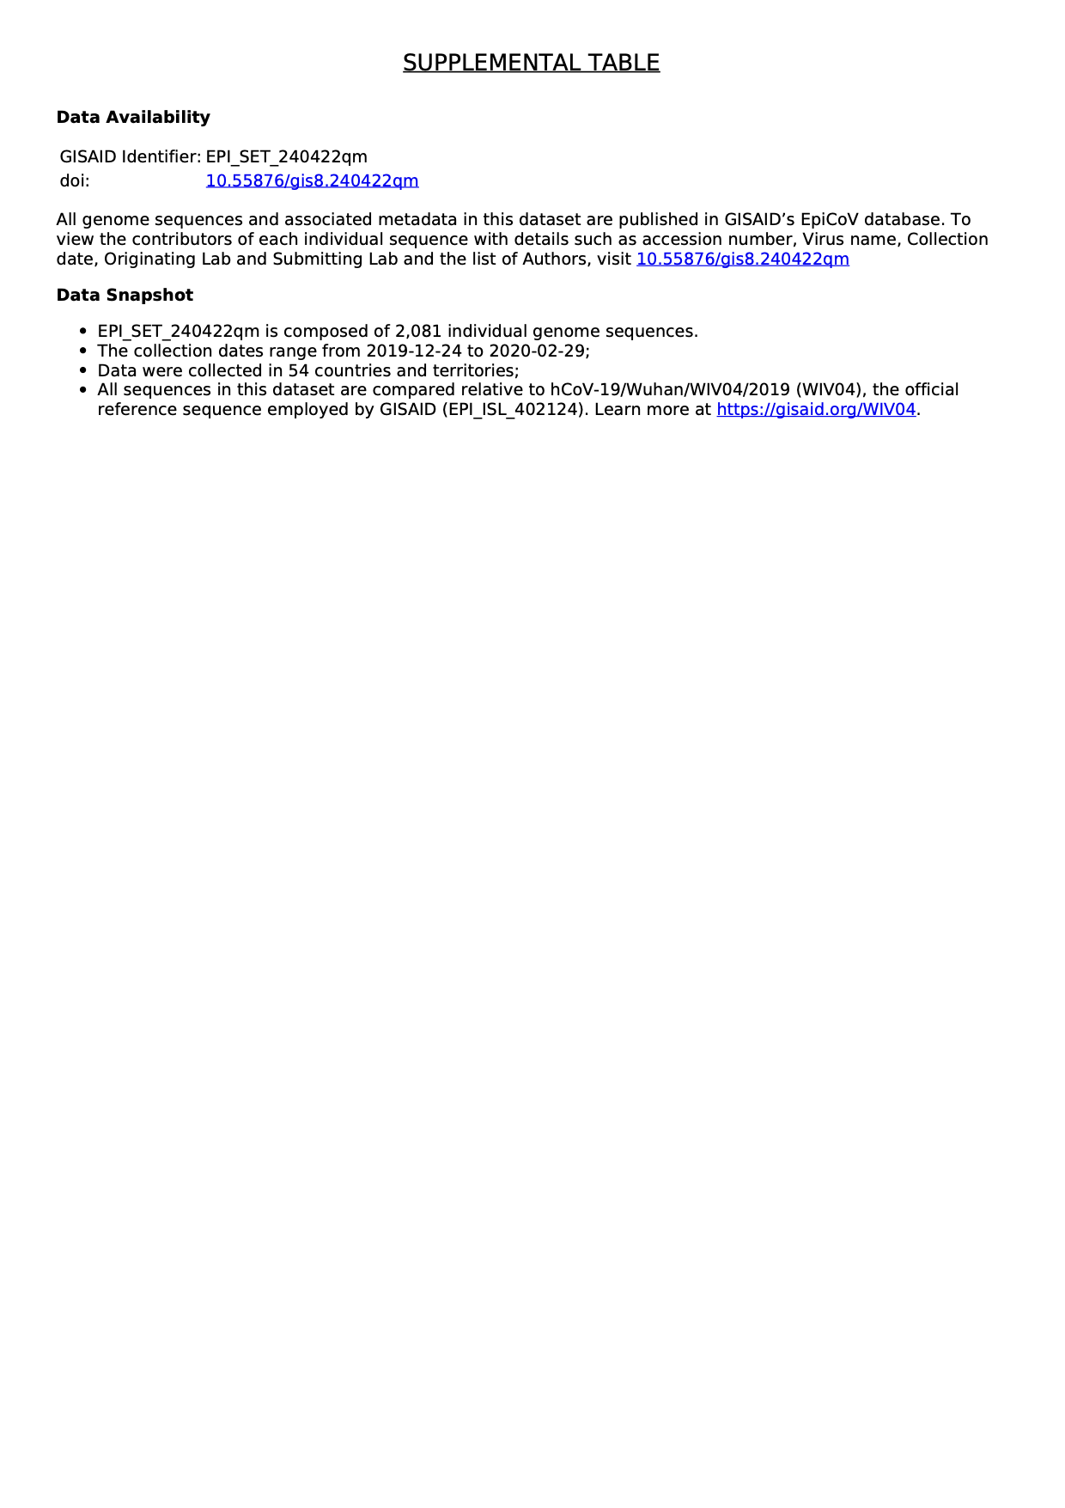

Table S8.
A list of enriched k-mers identified in the deer dataset.
Table containing sequences and statistics of k-mers enriched in deer dataset.

Please note that Table S8 is provided separately due to the large dataset involved.

Table S9.
A list of enriched k-mers identified in the bat dataset.
Table containing sequences and statistics of k-mers enriched in the bat dataset.

Please note that Table S9 is provided separately due to the large dataset involved.

Table S10.
Coordinates of mutated amino acids coupled with nucleotide mutations present in enriched k-mers identified in the deer dataset.
mutation | type | ref_nucleotide | ref_pos | mut_nucleotide | n_kmers | max_deer_RMSE | agg_mutation_freq | early_agg_mutation_freq | late_agg_mutation_freq | group | gene | ref_codon | ref_amino_acid | mut_codon | mut_amino_acid | Protein
C7267T | enriched | C | 7267 | T | 15 | 0,1564 | 0,1577 | 0,0007 | 0,0021 | eq_cov | orf1ab | CAC | His | TAC | Cys | nsp3
C7303T | enriched | C | 7303 | T | 15 | 0,5633 | 0,5655 | 0,0029 | 0,0015 | eq_cov | orf1ab | CAT | His | TAT | Cys | nsp3
C9430T | enriched | C | 9430 | T | 15 | 0,4917 | 0,5030 | 0,0189 | 0,0039 | eq_cov | orf1ab | CGT | Arg | TGT | Cys | nsp4
C9679T | enriched | C | 9679 | T | 15 | 0,1546 | 0,1548 | 5E-05 | 0,0003 | eq_cov | orf1ab | CTG | Leu | TTG | Leu | nsp4
G11083T | enriched | G | 11083 | T | 10 | 0,1265 | 0,1458 | 0,0145 | 0,0246 | dep_pref | orf1ab | GTA | Val | TTA | Leu | nsp6
T15096C | enriched | T | 15096 | C | 15 | 0,1040 | 0,1339 | 0,0724 | 0,0003 | eq_cov | orf1ab | AAT | Asn | AAC | Asn | RDRP
C20259T | enriched | C | 20259 | T | 15 | 0,1544 | 0,1548 | 0,0005 | 0,0002 | eq_cov | orf1ab | TTC | Phe | TTT | Phe | nsp15
C29679T | enriched | C | 29679 | T | 13 | 0,1247 | 0,1250 | 0,0004 | 0,0003 | dep_pref | intergenic | - | - | - | - | intergenic

Table S11.
Coordinates of mutated amino acids coupled with nucleotide mutations present in enriched k-mers identified in the bat dataset.
mutation | type | ref_nucleotide | ref_pos | mut_nucleotide | n_kmers | max_bat_RMSE | agg_mutation_freq | early_agg_mutation_freq | group | gene | ref_codon | mut_codon | Protein
C230T | enriched | C | 230 | T | 15 | 0,4382 | 0,6388 | 0,0000 | dep_pref | intergenic | - | - | -
T232C | enriched | T | 232 | C | 15 | 0,4382 | 0,6654 | 0,0000 | dep_pref | intergenic | - | - | -
C241T | depleted | C | 241 | T | 15 | 0,1329 | 0,0152 | 0,1884 | dep_pref | intergenic | - | - | -
C280T | enriched | C | 280 | T | 7 | 0,4275 | 0,6046 | 0,0000 | dep_pref | orf1ab | GTC | GTT | nsp1
A691T | enriched | A | 691 | T | 8 | 0,4356 | 0,6426 | 0,0000 | dep_pref | orf1ab | TCA | TCT | nsp1
T693A | enriched | T | 693 | A | 9 | 0,4356 | 0,6502 | 0,0000 | dep_pref | orf1ab | TTT | TAT | nsp1
C703T | enriched | C | 703 | T | 7 | 0,4164 | 0,6426 | 0,0005 | dep_pref | orf1ab | GGC | GGT | nsp1
A761G | enriched | A | 761 | G | 9 | 0,3549 | 0,6920 | 0,0000 | dep_pref | orf1ab | AGC | GGC | nsp1
A1124C | enriched | A | 1124 | C | 10 | 0,3845 | 0,5665 | 0,0000 | dep_pref | orf1ab | AGG | CGG | nsp2
G1126T | enriched | G | 1126 | T | 12 | 0,3845 | 0,5703 | 0,0000 | dep_pref | orf1ab | AGG | AGT | nsp2
A1540T | enriched | A | 1540 | T | 9 | 0,3683 | 0,5970 | 0,0000 | dep_pref | orf1ab | CCA | CCT | nsp2
C3037T | depleted | C | 3037 | T | 15 | 0,1312 | 0,0342 | 0,1932 | dep_pref | orf1ab | TTC | TTT | nsp3
C8782T | depleted | C | 8782 | T | 15 | 0,1281 | 0,0837 | 0,2307 | dep_pref | orf1ab | AGC | AGT | nsp4
C10594A | enriched | C | 10594 | A | 9 | 0,4248 | 0,6046 | 0,0000 | dep_pref | orf1ab | AAC | AAA | 3CL-PRO
C10789T | enriched | C | 10789 | T | 9 | 0,3757 | 0,5475 | 0,0010 | dep_pref | orf1ab | GAC | GAT | 3CL-PRO
A10888T | enriched | A | 10888 | T | 9 | 0,4194 | 0,5932 | 0,0000 | dep_pref | orf1ab | GGA | GGT | 3CL-PRO
G11083T | depleted | G | 11083 | T | 15 | 0,1611 | 0,0000 | 0,2278 | dep_ex | orf1ab | TTG | TTT | nsp6
G12205A | enriched | G | 12205 | A | 7 | 0,3872 | 0,6046 | 0,0000 | dep_pref | orf1ab | TTG | TTA | nsp8
G12211A | enriched | G | 12211 | A | 13 | 0,4221 | 0,6540 | 0,0000 | dep_pref | orf1ab | AAG | AAA | nsp8
A12235G | enriched | A | 12235 | G | 15 | 0,4624 | 0,6730 | 0,0000 | eq_cov | orf1ab | GAA | GAG | nsp8
A12250T | enriched | A | 12250 | T | 12 | 0,3898 | 0,5856 | 0,0000 | dep_pref | orf1ab | GCA | GCT | nsp8
T12304C | enriched | T | 12304 | C | 16 | 0,5001 | 0,7262 | 0,0000 | enr_pref | orf1ab | TAT | TAC | nsp8
T12313A | enriched | T | 12313 | A | 9 | 0,3710 | 0,5285 | 0,0000 | dep_pref | orf1ab | GCT | GCA | nsp8
T12340A | enriched | T | 12340 | A | 9 | 0,3925 | 0,5627 | 0,0000 | dep_pref | orf1ab | GTT | GTA | nsp8
C12400T | enriched | C | 12400 | T | 15 | 0,4571 | 0,6616 | 0,0000 | eq_cov | orf1ab | CTC | CTT | nsp8
A12634T | enriched | A | 12634 | T | 9 | 0,4651 | 0,6616 | 0,0000 | dep_pref | orf1ab | GCA | GCT | nsp8
T12680C | enriched | T | 12680 | C | 13 | 0,4356 | 0,6388 | 0,0000 | dep_pref | orf1ab | TTA | CTA | nsp8
G12694A | enriched | G | 12694 | A | 9 | 0,4087 | 0,5856 | 0,0000 | dep_pref | orf1ab | GAG | GAA | nsp9
T12748A | enriched | T | 12748 | A | 9 | 0,4544 | 0,6426 | 0,0000 | dep_pref | orf1ab | ACT | ACA | nsp9
C12754T | enriched | C | 12754 | T | 15 | 0,4544 | 0,6502 | 0,0000 | eq_cov | orf1ab | TGC | TGT | nsp9
C13009T | enriched | C | 13009 | T | 15 | 0,4382 | 0,6274 | 0,0000 | eq_cov | orf1ab | GCC | GCT | nsp9
A13021T | enriched | A | 13021 | T | 9 | 0,3952 | 0,5703 | 0,0000 | dep_pref | orf1ab | GTA | GTT | nsp9
G13126A | enriched | G | 13126 | A | 10 | 0,4571 | 0,6768 | 0,0000 | dep_pref | orf1ab | GGG | GGA | nsp10
A13327C | enriched | A | 13327 | C | 12 | 0,3979 | 0,5970 | 0,0000 | dep_pref | orf1ab | ACA | ACC | nsp10
T13345A | enriched | T | 13345 | A | 7 | 0,3657 | 0,5627 | 0,0000 | dep_pref | orf1ab | CCT | CCA | nsp10
T13387A | enriched | T | 13387 | A | 9 | 0,3845 | 0,5703 | 0,0000 | dep_pref | orf1ab | GGT | GGA | nsp10
C13436A | enriched | C | 13436 | A | 8 | 0,4033 | 0,5703 | 0,0000 | dep_pref | orf1ab | CTT | ATT | nsp10
T13521C | enriched | T | 13521 | C | 12 | 0,4191 | 0,5932 | 0,0005 | dep_pref | orf1ab | AGT | AGC | RDRP
C13548T | enriched | C | 13548 | T | 9 | 0,4490 | 0,6806 | 0,0000 | dep_pref | orf1ab | GAC | GAT | RDRP
T13578A | enriched | T | 13578 | A | 15 | 0,4786 | 0,6844 | 0,0000 | eq_cov | orf1ab | GCT | GCA | RDRP
A13581G | enriched | A | 13581 | G | 15 | 0,4786 | 0,6844 | 0,0000 | eq_cov | orf1ab | AAA | AAG | RDRP
T13599C | enriched | T | 13599 | C | 12 | 0,4140 | 0,6578 | 0,0000 | dep_pref | orf1ab | TGT | TGC | RDRP
T13602C | enriched | T | 13602 | C | 9 | 0,3764 | 0,6046 | 0,0000 | dep_pref | orf1ab | TGT | TGC | RDRP
C13743T | enriched | C | 13743 | T | 7 | 0,4356 | 0,6274 | 0,0000 | dep_pref | orf1ab | TTC | TTT | RDRP
T13746C | enriched | T | 13746 | C | 10 | 0,4356 | 0,6388 | 0,0000 | dep_pref | orf1ab | TTT | TTC | RDRP
A13756G | enriched | A | 13756 | G | 13 | 0,3898 | 0,5665 | 0,0000 | dep_pref | orf1ab | ATA | GTA | RDRP
C13761T | enriched | C | 13761 | T | 15 | 0,4140 | 0,5856 | 0,0000 | eq_cov | orf1ab | GAC | GAT | RDRP
A13917G | enriched | A | 13917 | G | 12 | 0,4329 | 0,6996 | 0,0000 | dep_pref | orf1ab | AAA | AAG | RDRP
C13923T | enriched | C | 13923 | T | 9 | 0,4329 | 0,6540 | 0,0000 | dep_pref | orf1ab | GAC | GAT | RDRP
G14137A | enriched | G | 14137 | A | 8 | 0,4194 | 0,6160 | 0,0000 | dep_pref | orf1ab | GTT | ATT | RDRP
G14335A | enriched | G | 14335 | A | 10 | 0,4087 | 0,5856 | 0,0000 | dep_pref | orf1ab | GTT | ATT | RDRP
C14408T | depleted | C | 14408 | T | 15 | 0,1281 | 0,0000 | 0,1812 | dep_ex | orf1ab | CCT | CTT | RDRP
T14496A | enriched | T | 14496 | A | 9 | 0,3898 | 0,6160 | 0,0000 | dep_pref | orf1ab | GGT | GGA | RDRP
G14622A | enriched | G | 14622 | A | 9 | 0,3898 | 0,5932 | 0,0000 | dep_pref | orf1ab | ACG | ACA | RDRP
C14697T | enriched | C | 14697 | T | 12 | 0,4651 | 0,6692 | 0,0000 | dep_pref | orf1ab | TTC | TTT | RDRP
T14749C | enriched | T | 14749 | C | 9 | 0,3657 | 0,5285 | 0,0000 | dep_pref | orf1ab | TTA | CTA | RDRP
T14778C | enriched | T | 14778 | C | 15 | 0,4705 | 0,7034 | 0,0000 | eq_cov | orf1ab | GGT | GGC | RDRP
C14793T | enriched | C | 14793 | T | 15 | 0,3818 | 0,5551 | 0,0000 | eq_cov | orf1ab | AGC | AGT | RDRP
C14805T | enriched | C | 14805 | T | 12 | 0,3818 | 0,6160 | 0,0778 | dep_pref | orf1ab | TAC | TAT | RDRP
T14808C | enriched | T | 14808 | C | 9 | 0,1216 | 0,1216 | 0,0000 | Unknown | orf1ab | TAT | TAC | nsp12
A14820G | enriched | A | 14820 | G | 15 | 0,4275 | 0,6502 | 0,0000 | eq_cov | orf1ab | CTA | CTG | RDRP
A14847C | enriched | A | 14847 | C | 11 | 0,4140 | 0,6464 | 0,0000 | dep_pref | orf1ab | CTA | CTC | RDRP
T14853C | enriched | T | 14853 | C | 14 | 0,4140 | 0,6008 | 0,0000 | dep_pref | orf1ab | TTT | TTC | RDRP
A15159G | enriched | A | 15159 | G | 9 | 0,4356 | 0,6160 | 0,0000 | dep_pref | orf1ab | CAA | CAG | RDRP
T15258C | enriched | T | 15258 | C | 15 | 0,4786 | 0,7452 | 0,0000 | eq_cov | orf1ab | TAT | TAC | RDRP
T15309C | enriched | T | 15309 | C | 12 | 0,4033 | 0,5703 | 0,0000 | dep_pref | orf1ab | GAT | GAC | RDRP
A15435G | enriched | A | 15435 | G | 9 | 0,4517 | 0,6388 | 0,0000 | dep_pref | orf1ab | GAA | GAG | RDRP
C15763T | enriched | C | 15763 | T | 9 | 0,5779 | 0,6882 | 0,0000 | Unknown | orf1ab | CTA | TTA | nsp12
G15768A | enriched | G | 15768 | A | 11 | 0,4087 | 0,6198 | 0,0000 | dep_pref | orf1ab | GTG | GTA | RDRP
A15777T | enriched | A | 15777 | T | 8 | 0,4060 | 0,5932 | 0,0000 | dep_pref | orf1ab | ATA | ATT | RDRP
G15906A | enriched | G | 15906 | A | 9 | 0,4813 | 0,6844 | 0,0000 | dep_pref | orf1ab | CAG | CAA | RDRP
G16221A | enriched | G | 16221 | A | 9 | 0,4248 | 0,6274 | 0,0000 | dep_pref | orf1ab | CCG | CCA | RDRP
G16377C | enriched | G | 16377 | C | 15 | 0,4490 | 0,7034 | 0,0000 | eq_cov | orf1ab | CCG | CCC | Hel
A16497T | enriched | A | 16497 | T | 9 | 0,4544 | 0,6958 | 0,0000 | enr_ex | orf1ab | GGA | GGT | Hel
T16590C | enriched | T | 16590 | C | 7 | 0,4087 | 0,5856 | 0,0000 | dep_pref | orf1ab | GGT | GGC | Hel
T16692C | enriched | T | 16692 | C | 12 | 0,4544 | 0,7034 | 0,0000 | dep_pref | orf1ab | GCT | GCC | Hel
C16806T | enriched | C | 16806 | T | 15 | 0,4221 | 0,6350 | 0,0000 | eq_cov | orf1ab | AAC | AAT | Hel
A16818G | enriched | A | 16818 | G | 12 | 0,3979 | 0,5970 | 0,0000 | dep_pref | orf1ab | CAA | CAG | Hel
A16821T | enriched | A | 16821 | T | 9 | 0,3979 | 0,5627 | 0,0000 | dep_pref | orf1ab | ATA | ATT | Hel
T16866G | enriched | T | 16866 | G | 12 | 0,4248 | 0,6388 | 0,0000 | dep_pref | orf1ab | GTT | GTG | Hel
C16870A | enriched | C | 16870 | A | 8 | 0,4248 | 0,6008 | 0,0000 | dep_pref | orf1ab | CGA | AGA | Hel
A16893G | enriched | A | 16893 | G | 12 | 0,3818 | 0,6008 | 0,0000 | dep_pref | orf1ab | TTA | TTG | Hel
T16908C | enriched | T | 16908 | C | 8 | 0,6008 | 0,7072 | 0,0000 | Unknown | orf1ab | TAT | TAC | nsp13
T17514C | enriched | T | 17514 | C | 8 | 0,3791 | 0,5551 | 0,0000 | dep_pref | orf1ab | TGT | TGC | Hel
T17529A | enriched | T | 17529 | A | 9 | 0,4409 | 0,6236 | 0,0000 | dep_pref | orf1ab | ACT | ACA | Hel
C18388T | enriched | C | 18388 | T | 7 | 0,3603 | 0,5171 | 0,0000 | dep_pref | orf1ab | CTA | TTA | ExoN
C18486T | enriched | C | 18486 | T | 12 | 0,4382 | 0,7490 | 0,0000 | dep_pref | orf1ab | CTC | CTT | ExoN
A18861T | enriched | A | 18861 | T | 15 | 0,4302 | 0,6388 | 0,0000 | eq_cov | orf1ab | GCA | GCT | ExoN
C18888T | enriched | C | 18888 | T | 9 | 0,3979 | 0,6084 | 0,0000 | dep_pref | orf1ab | CAC | CAT | ExoN
A19767T | enriched | A | 19767 | T | 8 | 0,3952 | 0,5627 | 0,0000 | dep_pref | orf1ab | TTA | TTT | nsp15
G20131T | enriched | G | 20131 | T | 12 | 0,4114 | 0,6350 | 0,0000 | dep_pref | orf1ab | GCC | TCC | nsp15
C20133A | enriched | C | 20133 | A | 12 | 0,4194 | 0,6046 | 0,0000 | dep_pref | orf1ab | GCC | GCA | nsp15
A20742G | enriched | A | 20742 | G | 11 | 0,4140 | 0,6236 | 0,0000 | dep_pref | orf1ab | CAA | CAG | nsp16
C20775A | enriched | C | 20775 | A | 11 | 0,4167 | 0,6008 | 0,0000 | dep_pref | orf1ab | GGC | GGA | nsp16
A23403G | depleted | A | 23403 | G | 15 | 0,1356 | 0,0000 | 0,1917 | dep_pref | spike | GAT | GGT | S
T26130A | enriched | T | 26130 | A | 11 | 0,4624 | 0,6540 | 0,0000 | dep_pref | orf3a | ATT | ATA | ORF3
G26144T | depleted | G | 26144 | T | 15 | 0,1227 | 0,0000 | 0,1735 | dep_pref | orf3a | GGT | GTT | ORF3
T26160A | enriched | T | 26160 | A | 12 | 0,4033 | 0,6312 | 0,0000 | dep_pref | orf3a | GTT | GTA | ORF3
T26168C | enriched | T | 26168 | C | 7 | 0,3925 | 0,5703 | 0,0000 | dep_pref | orf3a | GTA | GCA | ORF3
A26190G | enriched | A | 26190 | G | 15 | 0,4490 | 0,6730 | 0,0000 | eq_cov | orf3a | GAA | GAG | ORF3
T26331C | enriched | T | 26331 | C | 15 | 0,3925 | 0,5894 | 0,0000 | eq_cov | e | GTT | GTC | E
C26395T | enriched | C | 26395 | T | 11 | 0,4490 | 0,6654 | 0,0000 | dep_pref | e | CTT | TTT | E
T26397A | enriched | T | 26397 | A | 9 | 0,4409 | 0,6540 | 0,0000 | dep_pref | e | CTT | CTA | E
A26482C | enriched | A | 26482 | C | 8 | 0,4813 | 0,6806 | 0,0000 | dep_pref | intergenic | - | - | -
A26693G | enriched | A | 26693 | G | 7 | 0,4087 | 0,5856 | 0,0000 | dep_pref | m | TTA | TTG | M
T26714C | enriched | T | 26714 | C | 8 | 0,4651 | 0,6730 | 0,0000 | dep_pref | m | TGT | TGC | M
A26741T | enriched | A | 26741 | T | 9 | 0,4140 | 0,6046 | 0,0000 | dep_pref | m | ATA | ATT | M
C26801T | enriched | C | 26801 | T | 10 | 0,4755 | 0,6730 | 0,0005 | dep_pref | m | CTC | CTT | M
G27065A | enriched | G | 27065 | A | 11 | 0,4194 | 0,6046 | 0,0000 | dep_pref | m | TTG | TTA | M
T27071G | enriched | T | 27071 | G | 10 | 0,3603 | 0,5247 | 0,0000 | dep_pref | m | GCT | GCG | M
G27112A | enriched | G | 27112 | A | 8 | 0,4275 | 0,6046 | 0,0000 | dep_pref | m | AGT | AAT | M
T27113C | enriched | T | 27113 | C | 7 | 0,4167 | 0,5894 | 0,0000 | dep_pref | m | AGT | AGC | M
G27163A | enriched | G | 27163 | A | 7 | 0,4678 | 0,7072 | 0,0000 | dep_pref | m | AGT | AAT | M
T27164C | enriched | T | 27164 | C | 8 | 0,4705 | 0,7110 | 0,0000 | dep_pref | m | AGT | AGC | M
T27182A | enriched | T | 27182 | A | 15 | 0,4893 | 0,7034 | 0,0000 | eq_cov | m | CTT | CTA | M
C27725T | enriched | C | 27725 | T | 12 | 0,4060 | 0,6198 | 0,0000 | dep_pref | orf7a | ACA | ATA | ORF7a
T28144C | depleted | T | 28144 | C | 15 | 0,1497 | 0,0342 | 0,2345 | dep_ex | orf8 | TTA | TCA | ORF8
G28321A | enriched | G | 28321 | A | 10 | 0,4624 | 0,6540 | 0,0000 | dep_pref | n | ACG | ACA | N
C28435A | enriched | C | 28435 | A | 15 | 0,4194 | 0,5932 | 0,0000 | eq_cov | n | ACC | ACA | N
A28447G | enriched | A | 28447 | G | 10 | 0,4140 | 0,5894 | 0,0000 | dep_pref | n | CAA | CAG | N
A28547C | enriched | A | 28547 | C | 12 | 0,4544 | 0,6464 | 0,0000 | dep_pref | n | AGA | CGA | N
A28553G | enriched | A | 28553 | G | 15 | 0,4544 | 0,6464 | 0,0000 | eq_cov | n | ATT | GTT | N
T28570C | enriched | T | 28570 | C | 15 | 0,3683 | 0,5247 | 0,0000 | eq_cov | n | GGT | GGC | N
T28582G | enriched | T | 28582 | G | 9 | 0,3791 | 0,5703 | 0,0000 | dep_pref | n | GAT | GCG | N
G28621C | enriched | G | 28621 | C | 11 | 0,4033 | 0,5779 | 0,0000 | dep_pref | n | GGG | GGC | N
G28631T | enriched | G | 28631 | T | 7 | 0,3818 | 0,5627 | 0,0000 | dep_pref | n | GGA | TGA | N
C28657A | enriched | C | 28657 | A | 7 | 0,3683 | 0,5856 | 0,0000 | dep_pref | n | GAC | GAA | N
A28870T | enriched | A | 28870 | T | 11 | 0,4167 | 0,6160 | 0,0000 | dep_pref | n | CCA | CCT | N
C28887A | enriched | C | 28887 | A | 13 | 0,4060 | 0,6046 | 0,0000 | dep_pref | n | ACT | AAT | N
A28973G | enriched | A | 28973 | G | 13 | 0,4087 | 0,6502 | 0,0000 | dep_pref | n | ATG | GTG | N
G28975T | enriched | G | 28975 | T | 15 | 0,4087 | 0,6502 | 0,0019 | eq_cov | n | ATG | ATT | N
G29212A | enriched | G | 29212 | A | 12 | 0,6008 | 0,7452 | 0,0000 | Unknown | N | GCG | GCA | N
G29227A | enriched | G | 29227 | A | 15 | 0,4356 | 0,6198 | 0,0000 | eq_cov | n | TCG | TCA | N
A29306C | enriched | A | 29306 | C | 8 | 0,3818 | 0,5741 | 0,0000 | dep_pref | n | AAT | CAT | N
G29395A | enriched | G | 29395 | A | 11 | 0,4490 | 0,6502 | 0,0000 | enr_pref | n | AAG | AAA | N
G29399A | enriched | G | 29399 | A | 10 | 0,4114 | 0,5817 | 0,0000 | enr_ex | n | GCT | ACT | N
A29487G | enriched | A | 29487 | G | 7 | 0,3818 | 0,5399 | 0,0000 | enr_ex | n | AAA | AGA | N
C29518T | enriched | C | 29518 | T | 8 | 0,4487 | 0,6464 | 0,0005 | dep_pref | n | GAC | GAT | N
C29530A | enriched | C | 29530 | A | 8 | 0,4248 | 0,6008 | 0,0000 | dep_pref | n | GCC | GCA | N
C29541A | enriched | C | 29541 | A | 8 | 0,4060 | 0,5741 | 0,0000 | dep_pref | intergenic | - | - | -
A29542T | enriched | A | 29542 | T | 9 | 0,4060 | 0,5856 | 0,0000 | dep_pref | intergenic | - | - | -
A29567G | enriched | A | 29567 | G | 14 | 0,4490 | 0,6350 | 0,0000 | dep_pref | orf10 | ATA | GTA | ORF10
T29582A | enriched | T | 29582 | A | 7 | 0,4114 | 0,6540 | 0,0000 | dep_pref | orf10 | TTT | ATT | ORF10
T29597C | enriched | T | 29597 | C | 15 | 0,4463 | 0,6350 | 0,0000 | eq_cov | orf10 | TAT | CAT | ORF10
A29649G | enriched | A | 29649 | G | 13 | 0,4356 | 0,6236 | 0,0000 | dep_pref | orf10 | GAT | GGT | ORF10
G29651T | enriched | G | 29651 | T | 14 | 0,4436 | 0,6274 | 0,0000 | dep_pref | orf10 | GTA | TTA | ORF10
G29688A | enriched | G | 29688 | A | 15 | 0,4167 | 0,6008 | 0,0000 | eq_cov | intergenic | - | - | -
T29758G | enriched | T | 29758 | G | 8 | 0,4705 | 0,6654 | 0,0000 | dep_pref | intergenic | - | - | -

Table S12.
Recorded running times and peak memory usage for the datasets used in this study.
The computation times and memory usage were tested on a desktop PC with Intel Core i7-13700K 16 core 3.4 GHz CPU, 128 GB RAM and NVIDIA GeForce RTX 4090 GPU and a SSD hard drive.
Dataset | Step | Computing time | Total memory required
Deer | k-mer extraction | 28 min 19 s | 313 MB
Deer | Count matrix generation & rarity filter | 51 min 17 s | 23.5 GB
Deer | Over-represented k-mers identification | 13 min 27 s | 23.5 GB
Deer | Re-examination of rare k-mers | 1 h 05 min 23 s | 23.5 GB
Deer | k-mer mapping & mutation identification | 21 min 55 s | 23.5 GB
Deer | Selection of linearly independent k-mers | 1 min 27 s | 1.5 GB
Deer | k-mer importance for classification computation | 51 s | 2.6 GB
Deer | Model architecture selection | 33 s | 2.6 GB
Deer | Model evaluation with bootstrapping | 9 min 20 s | 2.6 GB
Bat | k-mer extraction | 2 min 03 s | 97 MB
Bat | Count matrix generation & rarity filter | 6 min 50 s | 6.7 GB
Bat | Over-represented k-mers identification | 50 s | 6.7 GB
Bat | Re-examination of rare k-mers | 47 min 24 s | 6.7 GB
Bat | k-mer mapping & mutation identification | 3 min 33 s | 6.7 GB
Bat | Selection of linearly independent k-mers | 2 h 33min 26 s | 84 GB
Bat | k-mer importance for classification computation | 15 s | 12.2 GB
Bat | Model architecture selection | 10 s | 12.2 GB
Bat | Model evaluation with bootstrapping | 6 min 20 s | 12.2 GB

Table S13.
Details of dense neural network (DNN) architecture, hyperparameters, and training.

Network architecture
Hyperparameter | Value
Number of hidden layers* | 2
Number of nodes for hidden layers | [1024, 256]
Number of nodes for output layer | 1
Activation function of hidden layers | GELU
Activation function of output layer | Sigmoid
Dropout ratio** | 0.3

Training
Hyperparameter | Value
Optimizer | AdamW
Learning rate | 1E-5
Weight decay rate | 0.004
Batch size | 8
Loss function | Binary crossentropy
Class weights | balanced
Validation split | 0.1
Training epochs | 50, with early stopping based on validation loss

*Hidden layer weights were constrained to maximum norm of 3.
**Dropout was used before every hidden layer and before the output layer.

