On the Rivers in the Euro-Atlantic Sky
Venugopal Thandlam^{1, 2, 3*}, Anna Rutgersson^{1,2} and Erik Sahlee¹

1. Department of Earth Sciences, Uppsala University, Sweden
2. Centre of Natural Hazards and Disaster Science, Uppsala, Sweden
3. Centre for Environment and Development Studies (CEMUS), Uppsala University, Sweden

*corresponding authors' email: venux4@gmail.com

Supplementary material

Table S1: Details of the variables and their units used in the study.
Parameter/Description | Variable | Units
Zonal wind | U | ms⁻¹
Meridional wind | V | ms⁻¹
Temperature | T | Kelvin
Specific humidity | Q | kgkg⁻¹
Integrated Vapor Transport | IVT | kgm⁻¹s⁻¹
Normalized Integrated Vapor Transport | nIVT | kgm⁻¹s⁻¹K⁻¹
Integrated Water Vapor | IWV | mm
Normalized Integrated Water Vapor | nIWV | mmK⁻¹
Geopotential | φ | m²s⁻²
Surface latent heat flux | L | Wm⁻²

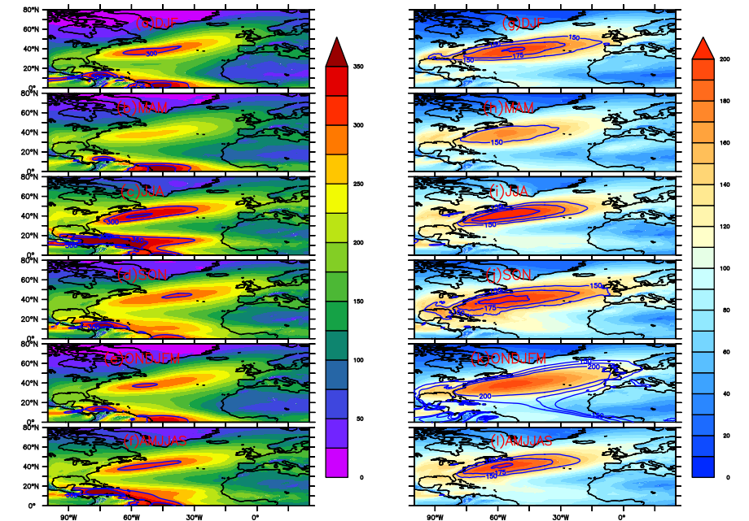
- (b)
Figure S1: Seasonal and half year climatology and standard deviation of IVT300 from ERA5.
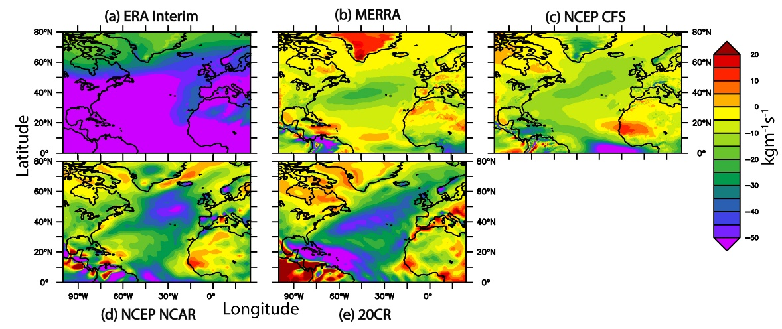
Figure S2: Bias in reanalysis datasets compared to ERA5

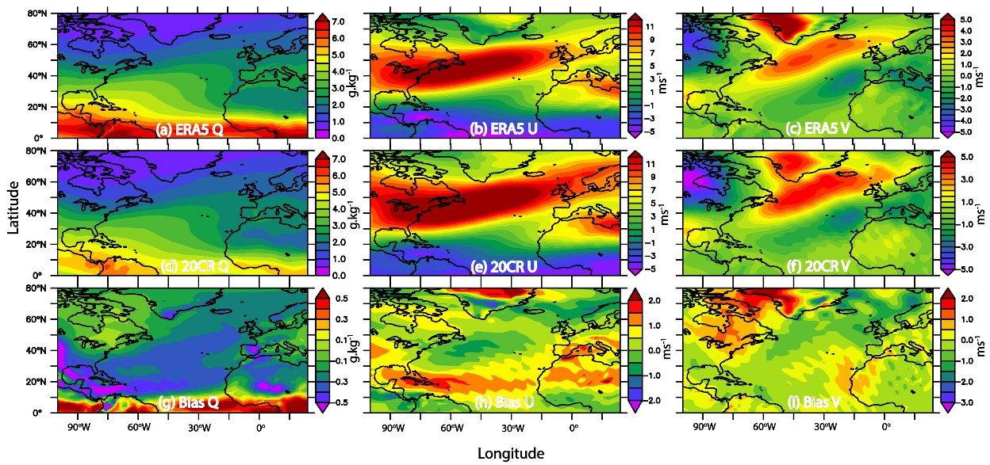
Figure S3: Bias in atmospheric parameters in 20CR used to map IVT300 during 1979-2014 as compared to ERA5.

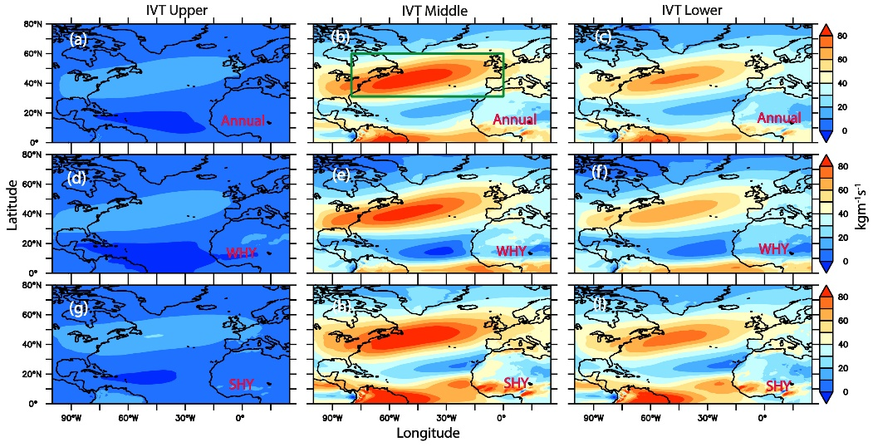
Figure S4: Annual, WHY and SHY variability of mean IVT in different layers of the atmosphere
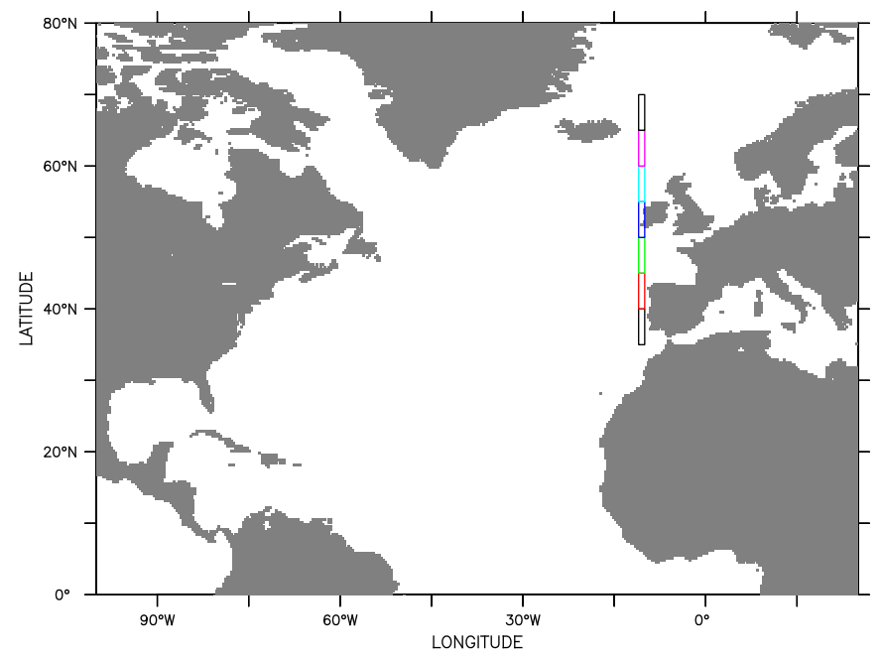
Figure S5: Bins used in computing the composite of GP and SLHF are represented in different colors along 11ºW.

